# Chapter 1: The Big Picture in a Tiny Nutshell

Published on April 2, 2020 by Ray Dalio

This chapter gives my description of the cause-effect relationships behind the archetypical rise and decline of the most powerful empires.  It is my distillation of the dynamics I saw in studying the three reserve currency empires (the Dutch, the British, and the American) and the six other significant empires (Germany, France, Russia, India, Japan, and China) over the last 500 years, as well as all of the major Chinese dynasties back to the Tang Dynasty around the year 600.  Besides seeing wealth and power shifts we see notable shifts in all dimensions of life, including technology, culture, and the arts.  These individual case studies will be provided in Part 2.  By going back and forth between this archetype and those cases, you will be able to see how the individual cases fit the archetype (which is essentially just the average of those cases) and how well the archetype describes the individual cases.

As I explained [in the introduction](https://www.linkedin.com/pulse/changing-world-order-ray-dalio-1f/), I’m on a mission to figure out how the world works and to gain timeless and universal principles for dealing with it well.  It’s both a necessity and a passion for me.  While the curiosities and concerns that I described earlier pulled me into doing this study, the process of conducting it gave me a much greater understanding of the really big picture on how the world works than I expected to get.  It made much clearer to me how peoples and countries succeed and fail over much bigger swaths of time, and it revealed giant cycles behind these ups and downs that I never knew existed.

Though the big picture synthesis that I’m sharing in the tiny nutshell that is this chapter is my own, you should know that I didn’t come up with it without a lot of help.  It came from my last 18 months of learning, which was the result of triangulating with remarkably informed scholars and practitioners, reading great history books by insightful authors, doing a lot of original source research with the help of my remarkable research team, and reflecting on the prior research I’ve done and the experiences that I have from investing globally over nearly 50 years. Still, even with all that help, drawing conclusions about the timeless and universal forces that have driven the successes and failures of countries through time is an audacious, humbling, and necessary endeavor that I can’t be sure that I got exactly right.  Still, I’m pretty sure that it’s by and large right, and I know that what I learned is essential for me to anticipate rather than be surprised by critically important events that have never happened in my lifetime but have happened repeatedly throughout history. My goal in presenting this to you is simply to pass along what I learned for you to assess for yourself.

**The Countries Shown in This Study**

To be clear, the leading powers covered in this study aren’t necessarily the best-off countries for two reasons. First, while wealth and power are what most people want and will fight over most, some people and their countries don’t think that these things are most important and wouldn’t think of fighting over them. For example, those who believe that having peace and savoring life are more important than having a lot of wealth and power wouldn’t think of fighting hard enough to gain enough of the wealth and power to make it into the group included in this study.  Second, this group of countries excludes what I will call the “boutique countries” (like Switzerland and Singapore), which score very high in wealth and living standards but aren’t large enough to become one of the biggest empires.

**How Their Wealth and Power Was Obtained**

Let’s start with the big picture basics.  Throughout recorded history various forms of groups of people (e.g., tribes, kingdoms, Countries) have gained wealth and power by building it themselves and/or taking it from others.  When they gathered more of it than any other group, they became the leading world power and then determined the world order.  When they lost that power—which has been true of every past empire—the wealth, power, and world order changed in very big ways that had big effects on economies, markets, and all aspects of life.  In this chapter we will examine how a number of forces come together to determine the ebbs and flows of this cycle, causing the archetypical empire’s wealth and power to rise, be sustained, and then decline.

Productivity is the force that causes the world’s total wealth, power, and living standards to rise over time as people learn how to do things better.  As we will see, productivity is upward trending because over time learning is gained more than lost, though it rises at different rates for different people for understandable reasons such as education, work ethic, the rate of development of new techniques and technologies, etc. These reasons are important for policy makers to understand in order to achieve the best possible outcomes for their countries and for investors and companies to understand in order to determine where the best long-term investments are.  While significant, these learnings and productivity improvements are evolutionary so that they are not what cause big shifts in who has what wealth and power.

The big swings in wealth and power are caused by a number of things, most importantly money and credit cycles, though I have identified 17 in total.  These big forces generally transpire in classic cycles that are mutually reinforcing in ways that tend to create a single very big cycle of ups and downs that has played out repeatedly throughout history.  This big archetypical cycle governs the rising and declining of empires, which influences everything about them including their currencies and markets (which I’m especially interested in).  As with the archetypical debt cycle I outlined in **Principles for Navigating Big Debt Crises**, this archetypical cycle represents the typical one that we can compare others to, including the one that we are now in. With that perspective in mind, we can attempt to squint into the future.

As of this writing, we are seeing all of these 17 forces in play, most importantly the debt cycle, the wealth gap cycle, and the global geopolitical cycle.  As mentioned in the introduction, we recently hit 0% interest rates while having large amounts of debt in an economic downturn.  This is leading to the creation of massive amounts of more government debt that central banks are printing money to monetize at the same time as there are big political and values gaps within countries, and there is an emerging world power (China) challenging the leading world power (the United States).  While this sort of configuration of events has not happened in our lifetime, it has happened many times in history (most recently in the 1930-45 period).  For reasons I will explain in this study, I believe that we are now seeing the archetypical big shift in relative wealth and power and, with this shift, we are seeing a profound shift in the world order that will affect all countries.

This big shift is not obvious because, while it is evolving at a fast pace, it is not happening in an abrupt way that bangs us over the head with its obviousness and because most people haven’t paid attention to the patterns in history so that they can put where we are in perspective.  So in this first chapter, I will describe in a very brief way how I see the archetypical mechanics behind rises and declines of empires and their markets working.

**To See the Big Picture, You Can’t Focus on the Details**

While I will attempt to paint this big sweeping picture accurately, I can’t paint it in a precise way, and, in order for you to see it and understand it, you can’t try to do so in a precise way.  That is because we are looking at evolution over long time frames.  To see it, you will have to let go of the details.  Of course, when the details are important, which they often have been, I will go from the very big, imprecise picture to a detailed one.

Looking at what happened in the past from this very big picture perspective will radically alter how you see things.  For example, because the span of time covered is so large, many of the most fundamental things that we take for granted and many of the terms we use to describe them did not exist over the full period of time.  As a result, I will be imprecise in my wording so that I can convey the big picture without getting tripped up on what might seem to be big things but in the scope of what we are looking at are relative details.

For example, I wrestled with how much I should worry about the differences between countries, kingdoms, nations, states, tribes, empires, and dynasties.  Nowadays we think mostly in terms of countries.  However, countries as we know them didn’t come into existence until the 17th century after Europe’s Thirty Years’ War.  In other words, before then there were no countries—generally speaking, though not always, there were kingdoms instead.  In some places, kingdoms still exist and can be confused with being countries, and some places are both.  Generally speaking, but not always, kingdoms are small, countries are bigger, and empires are biggest (spreading beyond the kingdom or the country).  The relationships between them are often not all that clear.  The British Empire was mostly a kingdom that gradually evolved into a country and then an empire that extended way beyond England’s borders so that its leaders controlled broad areas and many non-English peoples.  It’s also the case that each of these types of singularly controlled entities—e.g., countries, kingdoms, tribes, empires—controls its population in different ways, which further confuses things for those who seek precision.  For example, in some cases empires are areas that are occupied by a dominant power while in other cases empires are areas influenced by a dominant power that controls other areas through threats and rewards.  The British Empire generally occupied the countries in its empire while the American Empire has controlled more via rewards and threats—though that is not entirely true, as at the time of this writing the US has military bases in 70 countries.  So, though it is clear that there is an American Empire, it is less clear exactly what is in it.  Anyway, you get my point—that trying to be precise can stand in the way of conveying the biggest, most important things.  So in this chapter you are going to have to bear with my sweeping imprecisions.  You will also understand why I will henceforth imprecisely call these entities countries, even though not all of them were countries technically speaking.

Along these lines, some will argue that my comparing different countries with different systems in different times is impossible.  While I can understand that perspective, I want to assure you that I will seek to explain whatever major differences exist, that the timeless and universal similarities are much greater than the differences, and that to let the differences stand in the way of seeing those similarities that provide us with the lessons of history we need would be tragic.

**The Evolution and the Cycles around It**

As mentioned earlier, over long periods of time we evolve because we learn to do things better, which raises our productivity.  Over the long run, learning produces productivity gains and that is the most important force, though over the short run the swings around this uptrend are most important.  This is conveyed in the below chart, which shows estimated output (i.e., estimated real GDP) per person over the last 500 years.  As shown from this top-down, big picture perspective, output per person appears to be steadily improving though very slowly in the early years and faster after around 1800 when the slope up becomes much steeper, reflecting the faster productivity gains.  This shift from the slower productivity gains to faster productivity gains was primarily due to the improvements in broad learning and converting that faster learning into faster increases in productivity.  That was brought about by a number of factors going as far back as the invention of the printing press in Europe in the mid-15th century (it had been used in China substantially earlier), which increased the knowledge and education available to many more people and contributed to the European Renaissance, the Scientific Revolution, the Enlightenment, and the First Industrial Revolution in Britain.  That broader-based learning also shifted wealth and power away from 1) an agriculture-based economy in which agricultural land was the primary source of wealth and power that supported the monarchies, nobles, and the church, who owned the land and worked together to maintain the power system that allowed them to have the wealth and power to 2) an industrial-based economy in which inventive capitalists created and owned the means of production of industrial goods and worked together with those in government to maintain the power system that allowed them to have the wealth and power.  In other words, since the Industrial Revolution, which brought about that change, we have been operating in a system in which wealth and power have primarily come more from the combination of education, inventiveness, and capitalism, with those who run governments working with those who control most of the wealth and education.  While there have been deviations away from capitalism to communism (which didn’t work in the forms that have been tried) and socialism (which is essentially a hybrid wealth and opportunity distribution system that people can debate the merit of), the process of having educated people come up with innovations and own the means by which they are turned into production and of allocating resources and rewarding people by profit making (i.e., capitalism and government systems that work symbiotically with it) has been the formula for success.

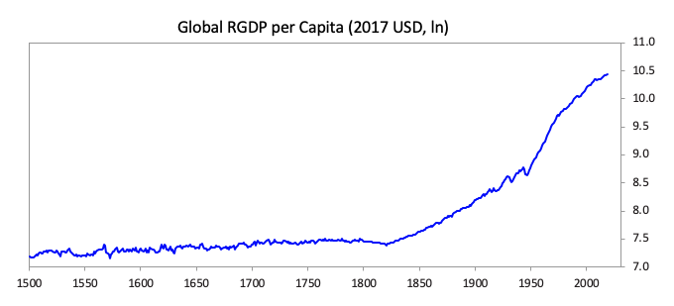

Underneath this relatively smooth upward trajectory of productivity are the turbulent times that include booms, busts, revolutions, and wars.  Because these turbulent times are small in relation to the evolutionary uptrend, they show up in the chart as relatively minor wiggles.  Yet these wiggles seem very big to us because we are so small and short-lived.  Take the 1929-45 depression and war period, for example.  To us around 15 years seems like a long time and the swings within it seem enormous.  The chart below shows the part of the prior chart that represents that 17-year period. As you can see, during the Great Depression period real output per person declined first by about 10%, which was followed by a recovery.  The US stock market fell by 85%.  Then the depression period was followed by a war that raised output of things that were used in the war.  Much of this equipment was blown up, so it would be a misnomer to call the war years a “productive period” even though when measured in output per person, it was.  And at the end of the war, global GDP per capita fell by about 12%, much of which was driven by declines in the economies of countries that lost the war.

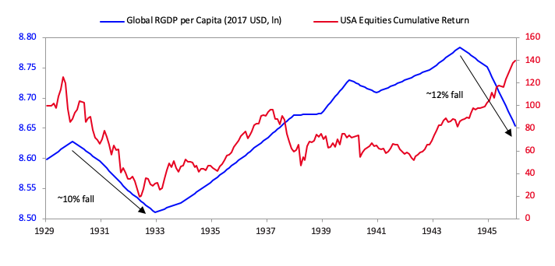

While the first charts I just showed you are for the whole world (to the best of our ability to measure it), they don’t show the shifts in wealth and power that occurred between countries.  The chart below shows you the relative wealth and power of the 11 leading empires over the last 500 years.[[1]](http://applewebdata/332792C3-30E8-4C04-877A-7F5D4411E9DB#_ftn1)  Each one of these indices of wealth and power is a composite of eight different measures that I will explain shortly.  Though these indices aren’t perfect because all data through time isn’t perfect, they are excellent in painting the big picture.  As you can see, nearly all of these empires saw periods of ascendancy followed by periods of decline.  The thicker lines are the four most important empires: the Dutch, British, American, and Chinese.  These empires held the last three reserve currencies—the US now, the British before it, and the Dutch before that.  China is included because it has risen to be the second-most powerful empire/country and because it was so consistently powerful in most years prior to around 1850.  To very briefly summarize what the chart shows:

* China was dominant for centuries (consistently outcompeting Europe in goods trade), though it entered a steep decline starting in the 1800s.
* The Netherlands, a relatively small country, became one of the world’s great empires in the 1600s.
* The UK followed a very similar path, peaking in the 1800s.
* Finally, the US rose to become the world’s superpower over the last 150 years, though particularly during and after WWII, and is now in relative decline while China is catching up once again.

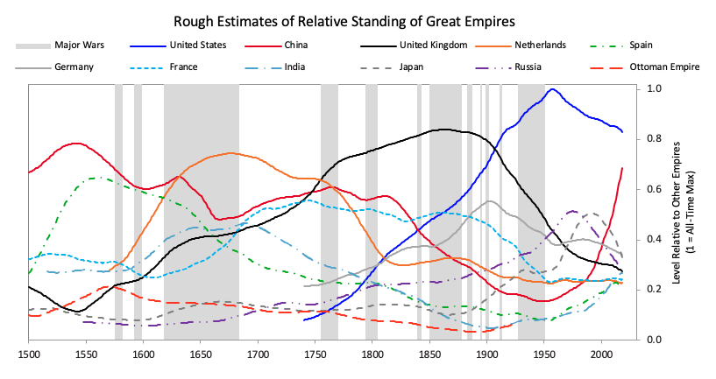

The next chart is the same chart going back to the year 600.  I included the one above because it is simpler, though with 11 countries, 12 major wars, and over 500 years, it can hardly be called simple.  The one below is more extensive.  I left out the shading of the war periods to lessen the confusion.  As shown, in the pre-1500 period, China was almost always most powerful, though the Middle Eastern caliphates, the French, the Mongols, the Spanish, and the Ottomans are also in the picture.

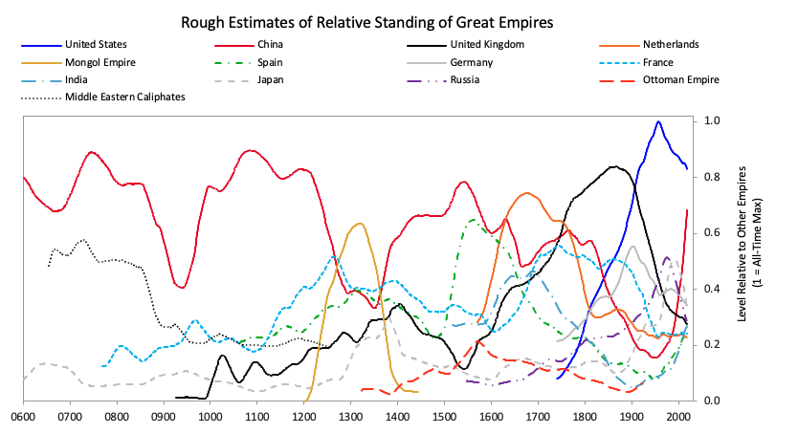

**Our Measures of Wealth and Power**

The single measure of wealth and power that I showed you for each country in the prior charts is made up as a roughly equal average of eight measures of strength.  They are: 1) education, 2) competitiveness, 3) technology, 4) economic output, 5) share of world trade, 6) military strength, 7) financial center strength, and 8) reserve currency.  While there are more measures of and influences on power that we will explore later, let’s begin by focusing on these key eight.

The chart below shows the average of each of these measures of strength, with most of the weight on the most recent three reserve countries (i.e., the US, the UK, and the Dutch).[[2]](http://applewebdata/36E3EAA2-35BD-42B8-BC96-E80E1C69BE67#_ftn1)

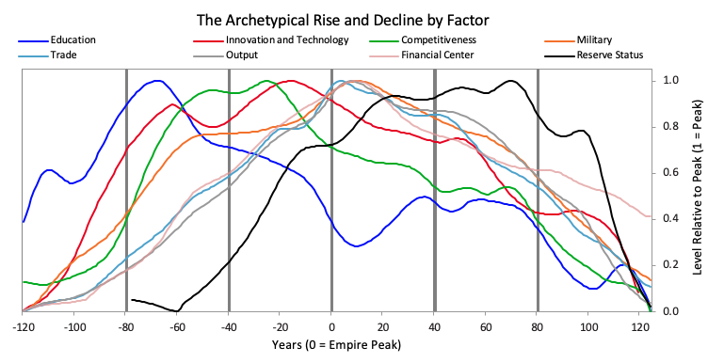

The lines on the chart do a pretty good job of telling the story of why and how the rises and declines took place.  Using these and referring to some additional factors that we will delve deeper into later, I will describe that cycle in a nutshell.  But before beginning its worth noting that all of these measures of strength rose and declined over the arc of the empire. That’s because these strengths and weaknesses are mutually reinforcing—i.e., strengths and weaknesses in education, competitiveness, economic output, share of world trade, etc., contribute to the others being strong or weak, for logical reasons.  For example, it makes sense that better educated people would produce societies that are more innovative, competitive, and productive.  I call this cyclical interrelated move up and down the Big Cycle.  Take note of the order of these items moving up and down in the chart because it is broadly indicative of the processes that lead to the rising and declining of empires.  For example, quality of education has been the long-leading strength of rises and declines in these measures of power and the long-lagging strength has been the reserve currency.  That is because strong education leads to strengths in most areas, including the creation of the world’s most common currency.  That common currency, just like the world’s common language, tends to stay around because the habit of usage lasts longer than the strengths that made it so commonly used.

**The Big Cycle**

Broadly speaking, we can look at these rises and declines as happening in three phases: 1) the ascent phase, which is characterized by the gaining of competitive advantages, 2) the top phase, which is characterized by sustaining the strength but eventually sowing the seeds for losing the competitive advantages that were behind the ascent, and 3) the decline phase, which is characterized by the self-reinforcing declines in all of these strengths.

In a nutshell, the ascent phase comes about when there is…

* Strong enough and capable enough leadership to provide the essential ingredients for success which include…
* Strong education.  By strong education I don’t just mean teaching knowledge and skills; I also mean teaching…
* Strong character, civility, and a strong work ethic, which are typically taught in the family as well as in school.  These lead to improved civility that is reflected in factors such as…
* Low corruption and high respect for rules, such as rule of law.
* People being able to work well together, united behind a common view of how they should be together and a common purpose, is also important.  When people have knowledge, skills, good character, and the civility to behave and work well together, and there is…
* A good system for allocating resources, which is significantly improved by…
* Being open to the best global thinking, the country has the most important ingredients in order to succeed.  That leads to them gaining…
* Greater competitiveness in the global market, which brings in revenues that are greater than expenses, which leads them to have…
* Strong income growth, which allows them to make…
* Increased investments to improve their infrastructures, education systems, and research and development, which leads them to have…
* Higher productivity (more valuable output per hour worked).  Increasing productivity is what increases wealth and productive capabilities.  When they achieve higher productivity levels they can become productive inventors of…
* New technologies.  These new technologies are valuable for both commerce and the military.  As these countries become more competitive in these ways, naturally they gain…
* A significant share of world trade, which requires them to have…
* A strong military to protect their trade routes and to influence those who are important to it outside its borders.  In becoming economically pre-eminent they develop the world’s leading…
* Financial centers for attracting and distributing capital. (For example, Amsterdam was the world’s financial center when the Dutch empire was pre-eminent, London was it when the British Empire was on top, and New York is now it because the US is on top, but China is beginning to develop its own financial center in Shanghai.) In expanding their trade globally these growing empires bring their…
* Strong equity, currency, and credit markets.  Naturally those dominant in trade and capital flows have their currency used much more as the preferred global medium of exchange and the preferred store hold of wealth, which leads to their currency becoming a reserve currency. That is how the Dutch guilder became the world’s reserve currency when the Dutch empire was pre-eminent, the British pound became the world’s reserve currency when the British empire was pre-eminent, and the US dollar became the world’s reserve currency in 1944 when the US was about to win World War II and was clearly pre-eminent economically, financially, and militarily. Having one’s currency be a reserve currency naturally gives that country greater borrowing and purchasing power.  As shown in the previous chart, gaining and losing of reserve currency status happens with a significant lag to the other fundamentals.

It is through the mutually reinforcing and unwavering improvements in these things that countries rise and sustain their powers.  Those who build empires allocate resources well by coordinating the economic, political, and military forces into a profitable economic/political/military system. For example the Dutch created the Dutch East India Company, the British created the British East India Company, the US created the military-industrial complex, and China has Chinese state capitalism.  Such economic, political, and military coordination has proved essential for all empires to profitably expand.

In a nutshell the top phase typically occurs because within the successes behind the ascent lie the seeds of decline. More specifically, as a rule:

* Prosperous periods lead to people earning more, which naturally leads them to become more expensive, which naturally makes them less competitive relative to those in countries where people are willing to work for less.
* Those who are most successful typically have their ways of being more successful copied by emerging competitors, which also contributes to the leading power becoming less competitive.  For example, British shipbuilders, who had less expensive workers than Dutch shipbuilders, hired Dutch shipbuilding architects to design ships that were more cost-effectively built than Dutch ships.  Because it takes less time and money to copy than invent, all else being equal, emerging empires tend to gain on mature empires through copying.
* Those who become richer naturally tend to work less hard, engage in more leisurely and less productive activities, and at the extreme, become decadent and unproductive. That is especially true as generations change from those who had to be strong and work hard to achieve success to those that inherited wealth—these younger generations tend to be less strong/battle-hardened, which makes them more vulnerable to challenges.  Over time people in the prosperous society tend to want and need more luxuries and more leisure and tend to get weaker and more overextended in order to get them, which makes them more vulnerable.
* The currencies of countries that are richest and most powerful become the world’s reserve currencies, which gives them the “exorbitant privilege” of being able to borrow more money, which gets them deeper into debt.  This boosts the leading empire’s spending power over the short term and weakens it over the longer run. In other words, when the borrowing and spending are strong, the leading empire appears strong while its finances are in fact being weakened.  That borrowing typically sustains its power beyond its fundamentals by financing both domestic over-consumption and the military and wars that are required to maintain its empire.  This over-borrowing can go on for quite a while and even be self-reinforcing, because it strengthens the reserve currency which raises the returns of foreign lenders who lend in it. When the richest get into debt by borrowing from the poorest, it is a very early sign of a relative wealth shift.  For example, in the 1980s when the US had a per capita income that was 40 times that of China’s, it started borrowing from Chinese who wanted to save in US dollars because the dollar was the world’s reserve currency.  This was an early sign of that dynamic beginning.  Similarly, the British borrowed a lot of money from its much poorer colonies, particularly during WWII, and the Dutch did the same before their top, which contributed to the reversals in their currencies and economies when the willingness to hold their currency and debt suddenly fell. The United States has certainly done a lot of borrowing and monetization of its debt, though this hasn’t yet caused a reduced demand for the US currency and debt.
* The leading country extends the empire to the point that the empire has become uneconomical to support and defend.  As the costs of maintaining it become greater than the revenue it brings in, the unprofitability of the empire further weakens the leading country financially. That is certainly the case for the US.
* Economic success naturally leads to larger wealth gaps because those who produce a lot of wealth disproportionately benefit.  Those with wealth and power (e.g., those who are commercially benefiting and those who run the government) naturally work in mutually supportive ways to maintain the existing system that benefits them while other segments of the population lag, until the split becomes so large that it is perceived as intolerably unfair.  This is an issue in the US.

The decline phase typically happens as the excesses of the top phase are reversed in a mutually reinforcing set of declines and because a competitive power gains relative strength in the previously described areas.

* When debts become very large, when the central banks lose their abilities to stimulate debt and economic growth, and when there is an economic downturn that leads to debt and economic problems and to more printing of money, which eventually devalues money.
* When wealth and values gaps get large and there is a lot of economic stress (wherever that stress comes from), there are high probabilities of greater conflict between the rich and the poor, at first gradually and then increasingly intensely. That combination of circumstances typically leads to increased political extremism—i.e., populism of both the left (i.e., those who seek to redistribute the wealth such as socialists and communists) and the right (i.e., those who seek to maintain the wealth in the hands of the rich such as the capitalists).  That happens in both democratically and autocratically run countries.  For example, in the 1930s increasingly extreme populists of the left became communist and those from the right became fascist.  Populists tend to be more autocratic, more inclined to fight, and more inclined to respect power than law.
* When the rich fear that their money will be taken away and/or that they will be treated with hostility, that leads them to move their money and themselves to places, assets, and/or currencies they feel are safer.  If allowed to continue, these movements reduce the tax and spending revenue in the locations experiencing these conflicts, which leads to a classic self-reinforcing hollowing out process in the places that money is leaving.  That’s because less tax money worsens conditions, which raises tensions and taxes, which causes more emigration of the rich and even worse conditions, etc. For example we are now seeing some of that happening via the rich leaving higher-tax states where there is financial stress and large wealth gaps.  When it gets bad enough, governments no longer allow it to happen—i.e., they outlaw the flows of money out of the places that are losing it and to the places, assets, and/or currencies that are getting it, which causes further panic by those seeking to protect themselves.
* When these sorts of disruptive conditions exist, they undermine productivity; that shrinks the economic pie and causes more conflict about how to divide the shrinking resources well, which leads to even more internal conflict that increasingly leads to fighting between the populist leaders from both sides who want to take control to bring about order.  That is when democracy is most challenged by autocracy.  This is why in the 1920s and 1930s Germany, Japan, Italy, and Spain (and a number of smaller countries) all turned away from democracy to autocratic leadership, and the major democracies (the US, the UK, and France) became more autocratic.  It is widely believed that, during periods of chaos, more centralized and autocratic decision making is preferable to less centralized and more democratic, debate-based decision making, so this movement is not without merit when there is unruly, violent crowd fighting.
* When a country gains economic, geopolitical, and military power that is large enough to challenge the existing dominant power, there are many areas of potential conflict between these rival world powers.  Since there is no system for peacefully adjudicating such disputes, these conflicts are typically resolved through tests of power.
* When a leading country’s costs of maintaining its empire abroad become greater than the revenue that the empire brings in, that economically weakens the country.  When that happens at the same time as other countries are emerging as rival powers, the leading power feels compelled to defend its interests.  This is especially threatening to the leading country both economically and militarily because greater military spending is required to maintain the empire, which comes when worsening domestic economic conditions are making it more difficult for government leaders to tax and making it more necessary for them to spend on domestic supports.  Seeing this dilemma, enemy countries are more inclined to challenge the leading power when that leading power is showing signs of weakness.  Then the leading power is faced with the difficult economic and military choice of fighting or retreating.
* When other exogenous shocks, such as acts of nature (e.g., plagues, droughts, or floods), occur during times of vulnerabilities such as those mentioned above, they increase the risks of a self-reinforcing downward spiral.
* When the leadership of the country is too weak to provide what the country needs to be successful at its stage in the cycle, which is also a problem.  Of course, because each leader is responsible for leading during only a tiny portion of the cycle, they have to deal with, and can’t change, the condition of the country that they inherit.  This means that destiny, more than the leader, is in control.

To summarize, around the upward trend of productivity gains producing wealth and living standards, there are cycles that produce 1) periods of building in which the country is fundamentally strong because there are a) relatively low levels of indebtedness, b) relatively small wealth, values, and political gaps, c) people working effectively together to produce prosperity within countries, d) good education and infrastructure, e) strong and capable leadership, and f) a peaceful world order that is guided by one or more dominant world powers.  These are the prosperous and enjoyable periods.  When they are taken to excess, which they always are, the excesses lead to 2) periods of destroying and restructuring in which the country’s fundamental weaknesses of a) high levels of indebtedness, b) large wealth, values, and political gaps, c) different factions of people unable to work well together, d) poor education and poor infrastructure, and e) the struggle to maintain an overextended empire under the challenge of emerging powerful rivals lead to a painful period of fighting, destroying, and restructuring that establishes the new order that sets the stage for the new period of building.

Looked at even more simply, the items shown below are the 17 main forces that drive the rises and declines of countries.  For any country, the more items it has on the left, the more likely it will ascend, and the more items it has on the right, the more it is likely to decline.  Those that make it to the top acquire the characteristics on the left (which causes them to ascend) but with time they move to the right, which makes them more prone to decline, while new competitive countries acquire the ones to the left until they are stronger, at which time the shift occurs.

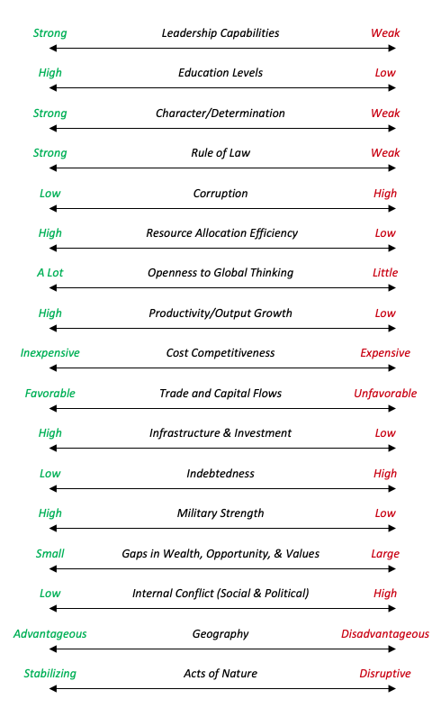

That, in a nutshell, is what makes the cycles of rising and declining empires occur. I’d like you now to go through a little exercise of ticking off where each of those measures is for each country you’re interested in. Rank each country on a 1-10 scale for each attribute, beginning with 10 on the far left and 1 on the far right. If you add these all up, the higher the number, the greater the probability of the country rising on a relative basis. The lower the number, the more likely it will fall. We will actually do that later in this study for each of the largest countries as well as look at some of the key timing indicators. However for now, you might want to do it in your own head. For example, calculate where the United States is, where China is, where Italy is, where Brazil is, and so on.

Because all of these factors, both ascending and descending, tend to be mutually reinforcing, it is not a coincidence that large wealth gaps, debt crises, revolutions, wars, and changes in the world order have tended to come together.  They come as a perfect storm.  Most simply one can think of the big cycles of each empire’s rise and decline as looking like those in the chart below.  The bad periods of destruction and restructuring via depression, revolution, and war that largely tear down the old system and set the stage for the emergence of a new system, typically take about 10 to 20 years, though variations in the range can be much larger.  They are depicted by the shaded areas in the chart.  They are followed by more extended periods of peace and prosperity in which smart people work harmoniously together and no country wants to fight the world power because it’s too strong, which typically last for about 40 to 80 years, though variations in the range can be much larger. Within these cycles are smaller cycles like the short-term debt/business cycle that last about 7 to 10 years.

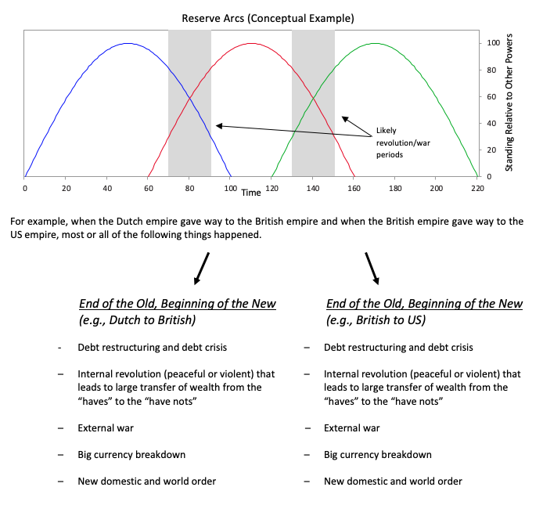

The last period of destroying and restructuring happened in 1930-45, which led to the new period of building that began in 1945.  More specifically, the 1930-45 depression, which was due to the breakdown and restructuring of the money and credit system, led to the new US dollar-based global monetary system (Bretton Woods) that was created in 1944.  The large wealth gaps that came about in the Roaring ’20s were narrowed by the depression and war, which led to radical changes in how wealth and power were distributed, and the global war changed world leadership and the world order.  So, in 1945 there was a new beginning with a new money and credit system that was US dollar-based and a new world order that was the American world order.  That new American world order was the natural consequence of the US being the richest country (it then had 80% of the world’s gold stock and gold was then money), the dominant economic power (it then accounted for half of world production), and the dominant military power (it then had a monopoly on nuclear weapons and had the strongest conventional forces).  It is now 75 years later and conditions have evolved in a number of measurable ways that we will explore in subsequent chapters.  That will bring us up to date.  Then we can attempt to squint into the future.

**That’s it in a nutshell.**

In the next chapters in Part 1, we will look at each of these drivers more closely and, in the last chapter, I will conclude by bringing all this together to give you my hazy look into the future with some suggestions about what each of us might do to make our futures better given the circumstances we find ourselves in.  Then in Part 2, you will get each of the cases.

I will try to pass pieces of this study along to you about once a week (I’m shooting for every Wednesday or Thursday) until we reach the point of diminishing returns.

[[1]](http://applewebdata/332792C3-30E8-4C04-877A-7F5D4411E9DB#_ftnref1) These indices were made up of a number of different statistics, some of which were directly comparable and some of which were broadly analogous or broadly indicative. In some cases a data series that stopped at a certain point had to be spliced with a series that continued back in time. Additionally, the lines shown on the chart are 30-year moving averages of these indices, shifted so that there is no lag.  I chose to use the smoothed series because the volatility of the unsmoothed series was too great to allow one to see the big movements.  Going forward, I will use these much smoothed versions when looking at the very long term and much less smoothed or unsmoothed versions when looking at these developments up close because the most important developments were best captured this way.

[[2]](http://applewebdata/36E3EAA2-35BD-42B8-BC96-E80E1C69BE67#_ftnref1) We show where key indicators were relative to their history by averaging them across the cases. The chart is shown such that a value of “1” represents the peak in that indicator relative to history and “0” represents the trough. The timeline is shown in years with “0” representing roughly when the country was at its peak (i.e., when the average across gauges was at its peak).  In the rest of this section, we walk through each of the stages of the archetype in more detail. While the charts show the countries that produced global reserve currencies, we’ll also heavily reference China, which was a dominant empire for centuries, though it never established a reserve currency.

**Disclosures**

Bridgewater Daily Observations is prepared by and is the property of Bridgewater Associates, LP and is circulated for informational and educational purposes only.  There is no consideration given to the specific investment needs, objectives or tolerances of any of the recipients.  Additionally, Bridgewater's actual investment positions may, and often will, vary from its conclusions discussed herein based on any number of factors, such as client investment restrictions, portfolio rebalancing and transactions costs, among others.  Recipients should consult their own advisors, including tax advisors, before making any investment decision.  This report is not an offer to sell or the solicitation of an offer to buy the securities or other instruments mentioned.

Bridgewater research utilizes data and information from public, private and internal sources, including data from actual Bridgewater trades.  Sources include the Australian Bureau of Statistics, Bloomberg Finance L.P., Capital Economics, CBRE, Inc., CEIC Data Company Ltd., Consensus Economics Inc., Corelogic, Inc., CoStar Realty Information, Inc., CreditSights, Inc., Dealogic LLC, DTCC Data Repository (U.S.), LLC, Ecoanalitica, EPFR Global, Eurasia Group Ltd., European Money Markets Institute – EMMI, Evercore ISI, Factset Research Systems, Inc., The Financial Times Limited, GaveKal Research Ltd., Global Financial Data, Inc., Haver Analytics, Inc., ICE Data Derivatives, IHSMarkit, The Investment Funds Institute of Canada, International Energy Agency, Lombard Street Research, Mergent, Inc., Metals Focus Ltd, Moody’s Analytics, Inc., MSCI, Inc., National Bureau of Economic Research, Organisation for Economic Cooperation and Development, Pensions & Investments Research Center, Renwood Realtytrac, LLC, Rystad Energy, Inc., S&P Global Market Intelligence Inc., Sentix Gmbh, Spears & Associates, Inc., State Street Bank and Trust Company, Sun Hung Kai Financial (UK), Refinitiv, Totem Macro, United Nations, US Department of Commerce, Wind Information (Shanghai) Co Ltd, Wood Mackenzie Limited, World Bureau of Metal Statistics, and World Economic Forum.  While we consider information from external sources to be reliable, we do not assume responsibility for its accuracy.

The views expressed herein are solely those of Bridgewater as of the date of this report and are subject to change without notice.  Bridgewater may have a significant financial interest in one or more of the positions and/or securities or derivatives discussed.  Those responsible for preparing this report receive compensation based upon various factors, including, among other things, the quality of their work and firm revenues.