# The Mechanics of the War Economy

Published on March 29, 2020; By Ray Dalio

What is happening now would have been unimaginable not long ago.  It was only unimaginable because it had never happened in our lifetimes. However, if one studied history one would have seen that it happened so regularly in the past that one would have considered it inevitable.

More specifically, the executive and legislative branches of government who control fiscal policy (i.e., the amount and type of government spending and taxing) and the central banks who control monetary policies (i.e., the amount and type of money and credit) announced unprecedented amounts of both fiscal and monetary stimulation that will include massive amounts of helicopter money (i.e., direct distributions of cash to citizens).  That was most notable with the recent announcements from the U.S. President, Congress, and Federal Reserve. The particulars of how this tsunami of money and credit will flow is extremely important but I won’t get into that now. What I will do is try to convey the very big picture implications of this, focusing on the mechanics as well as the implications.  Because this tsunami is far bigger than anything that has ever happened in our lifetimes, we need to broaden our perspective to see cases that occurred before our lifetimes.

**My Approach**

Before I get into the examination of what is happening now, I’d like to explain why I’m looking into such long-ago history to gain my perspective. While it might seem that long-ago cases are of little use, I learned the hard way that the opposite is true.  I have found that the biggest and most painful mistakes that I made in the markets came because I didn’t study time periods that happened before my lifetime.  When I made mistakes because I didn’t know how to judge things that hadn’t happened to me before, I always found what I had missed and needed to understand by looking at history. That made me wish I had studied these historical cases before making my mistakes.  It’s this process of making mistakes, reflecting on them, and then improving as a result of what I learn that’s behind my principle Pain + Reflection = Progress.

For example, most recently I made the painful mistake of not having a well-thought-out game plan for dealing with pandemics; that painful mistake has compelled me and my partners at Bridgewater to look into history to study past epidemics and pandemics and their effects on economies and markets throughout history. This was eye opening.  As I dug into history, lo and behold, I saw that infectious diseases and other acts of nature (like droughts and floods) were repeatedly as big or bigger than any other thing affecting economics and markets, including wars and revolutions, and that I need to have systematic plans for dealing with them. How could I have overlooked pandemics?  While I’m kicking myself, I am now building (with my great partners at Bridgewater) a systematic process for dealing with them in the future, just as we have for many other things.This has helped us a lot.  For example, my study of all debt crises going back over 100 years (which you can see in my book Big Debt Crises that you can get for free at www.economicprinicples.org) led us to navigate the 2008 financial crisis well when most others struggled.

For these reasons, I believe that understanding the future lies in understanding the lessons that are embedded in history.

As for what I will show you, please understand that I’m never sure that what I think is correct. I will continue to make mistakes (as well as have successes) and my goal isn’t to have you believe me.  My goal is simply to pass along how I believe economic and market machines work and convey my most important principles for dealing with them for you to take or throw away as you like.  I hope that my doing that will help you to have your own perspective and principles that will serve you well.

Consistent with that goal, about 18 months ago I was compelled to study what causes the rises and declines of reserve currencies and the empires behind them. Doing this study (which I’m still working on) was eye-opening and very important in shaping my perspective about what is now happening.   **If you are interested in knowing what I believe are the most relevant lessons in history that are incredibly important to understand now, I urge you read that study which I will put out in weekly installments.**It’s called “The Changing World Order” and a new part will come out each Wednesday here on Linkedin and at principles.com.

**The Relevant Lessons In History That Pertain to What Just Happened**

The U.S. (and other countries) fiscal policy makers (the president and Congress) and the monetary policy makers (the Fed and other central bankers) just created a huge fiscal and monetary policy stimulation that will lead to huge supports and, along with these, huge budget deficits, debts, and the monetizations of these debt.  While these are unprecedented in our lifetimes, they are not unprecedented in history.  Let’s start by looking at the 1930-45 period and then look beyond it.

As you know from my prior writings I believe that the 1930-45 period is the most recent analogous period to now because then, like now, interest rates hit the 0% floor, monetary policies were ineffective, debts were high, the global economy was weak, there were large wealth and political gaps, and a rising world power was emerging to challenge the existing world power.  In response to these things, especially in the war years, there was an enormous amount of fiscal spending that produced a lot of government debt that needed to be sold when there wasn’t enough free market demand to buy, so central banks needed to monetize that debt in one way or another. The deficit that the US government is now going to have will be over 20% of GDP and the amount of printing g of money and debt-buying that the Fed will do will bring its debt holdings to something like 30% of GDP, which is greater than it was at its peak in World War II.

Now the obvious questions that we need good answers for are what are the implications of this? With all of this debt and money creation, will interest rates and inflation go up?   Who will bear the burden of all of this debt and money printing and when?  What else might we expect?

As you will see, the 1930-45 period interest rates didn’t rise.  You will also see that in other cases they didn’t rise. You will see why that is and why I expect that they needn’t rise.  If you read my more comprehensive piece “The Changing World Order” you will see that while there is not a significant immediate risk, there is an increased longer term risk that money and credit will not be perceived as a good storehold of wealth. This would likely eventually lead to a big movement out of it, which would put central banks in the position of having to choose between raising interest rates or having their currencies devalue against alternative store-holds of wealth.  I won’t get into that longer picture in this piece, as focusing on the mechanics of absorbing the tsunami is my only goal for today.

The cases I will now show you will display the tremendous powers central governments have to be very stimulative, get very deeply into debt, and have central banks buy that debt or facilitate the buying of that debt by others in order to keep interest rates down and the economy operating in an orderly way.

**How It Was Done**

Mechanically in the 1930-45 period, it was done by the Fed instituting a policy of yield curve control. More specifically it made a credible pledge to buy bonds to put a lid on interest rates (which is similar to what the Bank of Japan, and to a lesser extent the ECB, is doing now).   As a result, the government’s immense borrowing needs were accompanied by the Fed’s unlimited commitment to keep a lid on bond yields of 2.5%. These actions created a semiautomatic coordination of monetary and fiscal policy of the sort I described in the MP3 section of my book Principles for Navigating Big Debt Crises.

The below charts show the large increases in both government debt and the monetary base during each of the US’s major conflicts.  Note that the same types of increases in government debts and central banks’ monetization of them happened in World War II and the Civil War.  The same has been true for virtually all countries’ war periods throughout time. Let’s look at these cases a bit more closely because during such turbulent times other forms of government controls were put in place that could conceivably be considered if the difficult times ahead require greater controls.

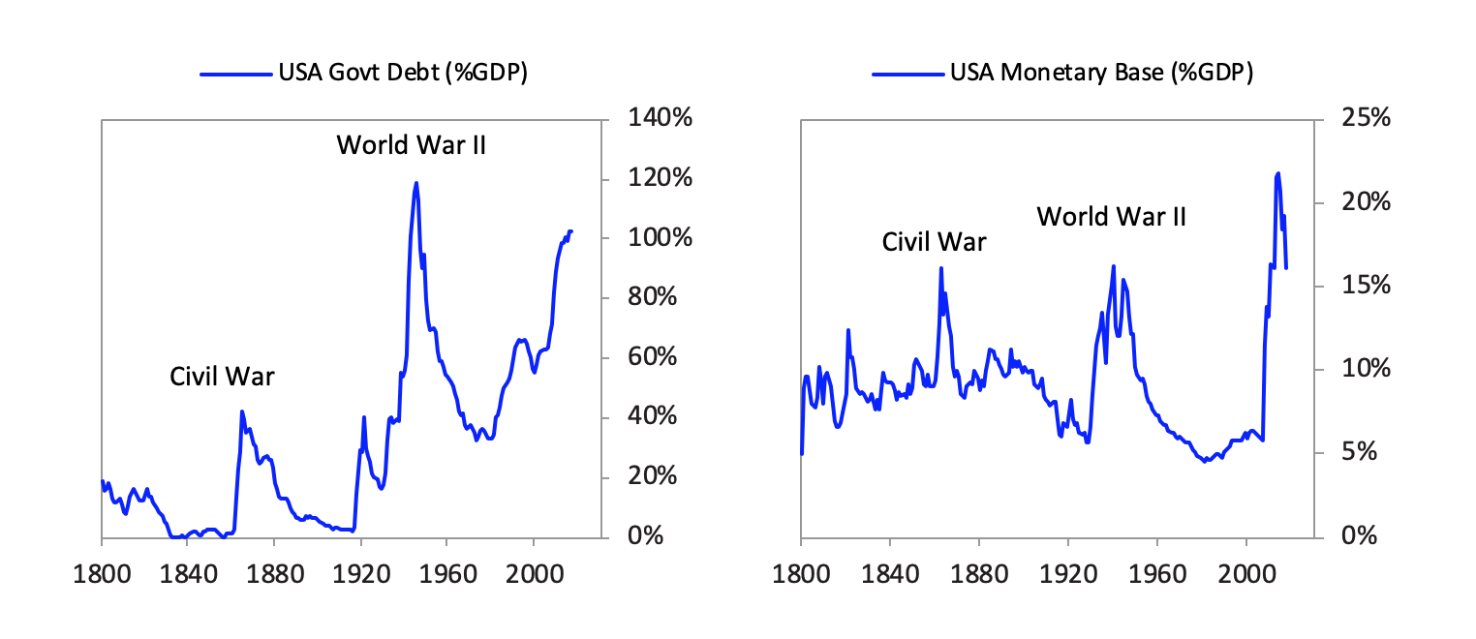

For those who are interested in getting a richer but more wonky picture of how all this happened I elaborate in the next sections.

**During World War II**

The war case is the most applicable analogous case. In that case, as government spending on the war rose a lot, all policy makers in all countries raised taxes, borrowed, and printed money. That’s what they always do in that sort of situation.  You should expect that in this situation.

More specifically, immediately following the US entry into the war, policy makers started hiking corporate and personal tax rates and issuing debt to the public.  The following table shows the sources of government financing for the US and other countries in the war, using data only from actual war years (i.e., 1941-45 for the US) and omitting years for which data was extremely unreliable (i.e., 1945 in Germany and Japan).  As you can see, they all taxed, borrowed, and printed a lot.

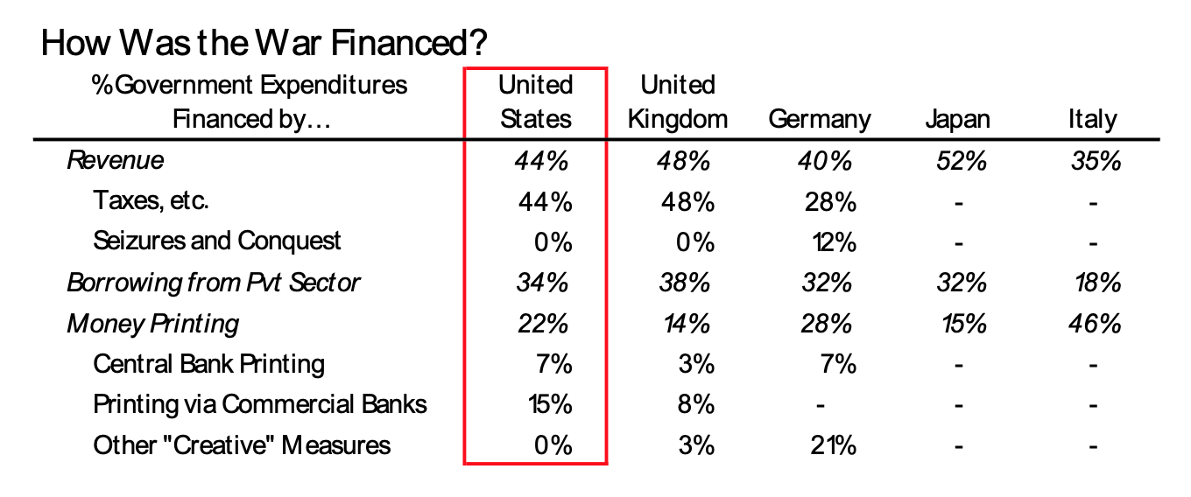

**How the Fed’s WWII-Era Yield Curve Control Worked**

It’s worth understanding the mechanics of how the Fed kept rates down despite all the pressure for them to rise.  It did that via yield curve control, which kept interest rates anchored even when there were massive shifts in growth, inflation, and government bond issuance. In the charts below you can see how long-term bond yields stayed stable around 2% through the huge economic swings of the war (with its massive growth boom and the price controls required to keep inflation from skyrocketing), the postwar slump, and the recovery that followed. Inflation reached a postwar extreme of close to 20% in 1947 and a low of about -3% in 1949, while yields barely budged.

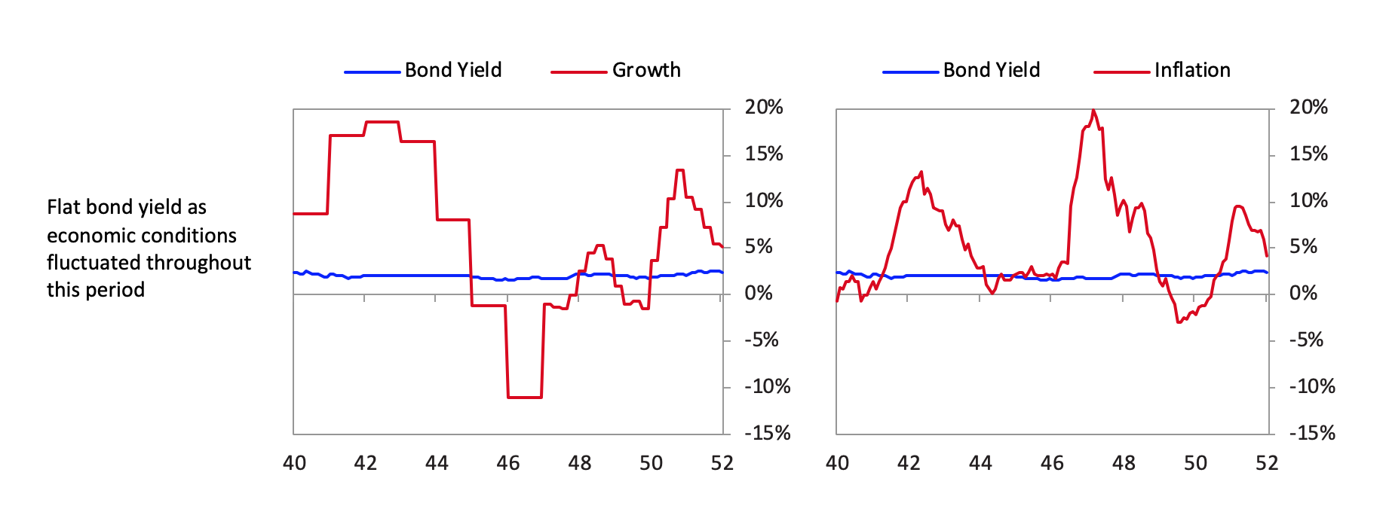

**Here’s how the policy worked.**

First, there was a credible long-term Fed commitment to its rate cap regime.  It implemented a series of rate caps across the curve; for simplicity, below we show a few points on the curve.  As you can see, yields on longer-term bonds were set consistently higher than short-term yields.  So as long as investors believed the rate structure would be maintained, there was essentially an arbitrage encouraging investors to borrow short and lend long. That was the case during the war. After the war, the ironclad commitment to maintain the peg began to come into doubt, particularly as the economy recovered and inflationary pressures rose.  In 1947, the Fed raised its long-rate caps and allowed greater flexibility for the short rate to rise a bit.  The peg gradually lost its effectiveness, and the policy finally came to an end in the 1951 Treasury-Fed Accord.

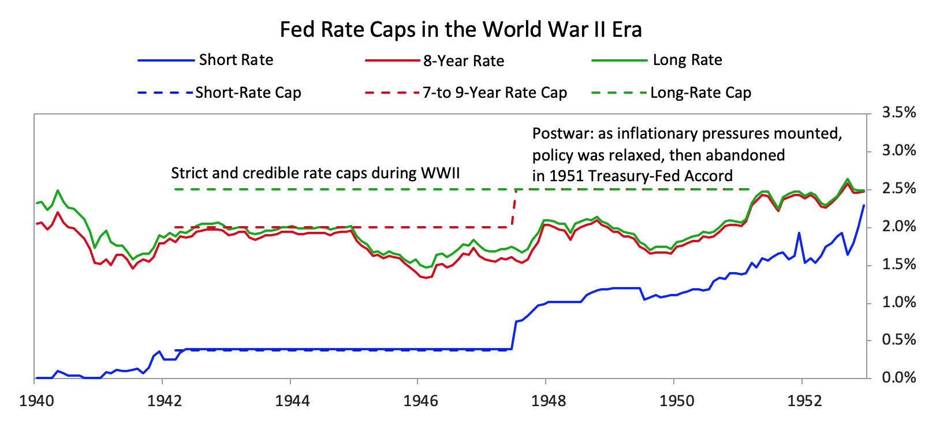

While the Fed didn’t use its balance sheet to buy many bonds, it printed and spent lots of money on the short end of the curve so that there was liquidity searching for yield, which could be gotten in the higher-yielding bonds.  While over this period the Fed balance sheet rose rapidly, the Fed’s holdings were almost entirely short-term, and the banks bought the bonds to get the yield pickup, supporting the lid on rates.  The Fed bought up bills from the private sector, provided banks with cheap liquidity, and cut their reserve requirements.  All of these policies created ample liquidity seeking yield.  The chart below shows how the Fed’s balance sheet ballooned during the war, but mostly at the short end of the curve.  After the war, as it became less clear that the yield curve policy would be sustained (i.e., credibility waned), the Fed was forced to do more actual bond purchases in order to maintain its desired bond yield.

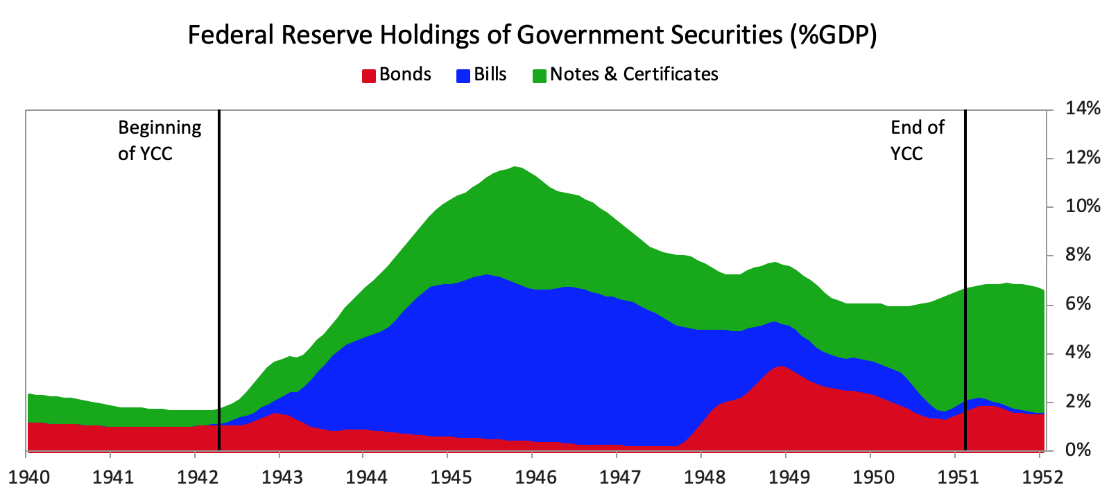

A credible Fed commitment to a stable, upward-sloping yield curve and ample short-term liquidity brought private sector players to buy government bonds.  The chart below shows the change in government bond holdings during the war and in its aftermath.  A wide range of private sector players stepped in to buy government bonds, including banks, patriotic households, and other long-term investors like insurers.

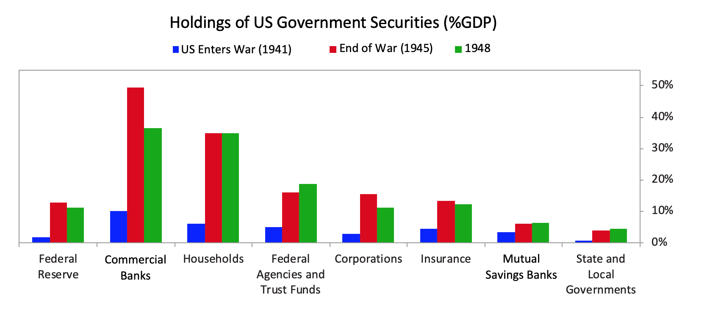

Consistent with the Fed being able to support the Treasury without relying primarily on large-scale purchases directly, there was comparatively little pressure on the dollar.  Gold prices were largely flat over the war though they rose during the postwar period. The eventual peg under the Bretton Woods system restored the gold price to its prewar level though gold remained illegal for US citizens to own.

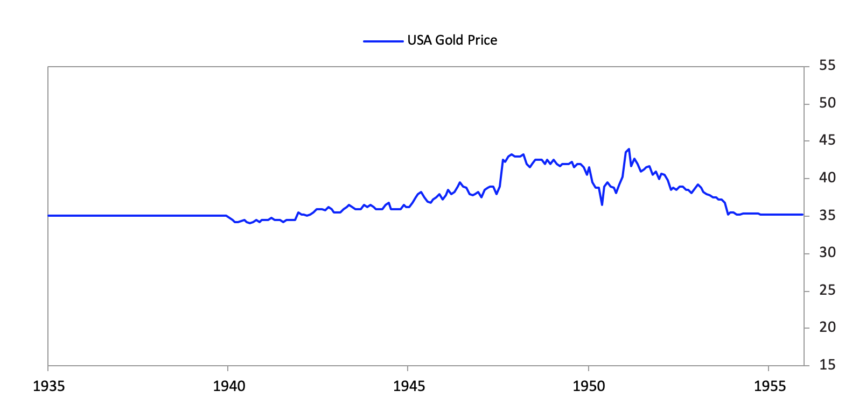

A key part of the Fed’s WWII strategy was relying on the banks to buy long-term bonds.  Banks were especially important because the Fed could impact their liquidity position directly through its policy, and credible commitment to the rate structure ensured that they’d be incentivized to use their liquidity to buy bonds.  From the Fed’s 1942 annual report:

“As has been indicated, commercial banks are certain to be called upon to take a share of the public debtin the next two years, and the Federal Reserve authorities will have to provide the necessary reserves.  This could be done by having the banks borrow from the Federal Reserve Banks.  To facilitate this, discount rates have been reduced, particularly for advances to banks on short-term Government securities. This should encourage the banks to feel free to make full use of their existing reserves with the assurance that in case they should run short they could get accommodation from the Reserve Banks at preferential rates.  They could also obtain these funds by selling Treasury bills at the standing 3/8 per cent rate.  A considerable amount of reserves will have to be provided, however, by other Federal Reserve purchases of Government securities, by reductions of reserve requirements, or by a combination of the two.”

As we’ve described previously, once rates are at zero and asset purchases have already squeezed risk premiums across financial markets, the most effective form of stimulation is for monetary policy to be coordinated with fiscal policy, or what we’ve called “MP3.” To avoid getting new liquidity stuck in cash, money is channeled into government bonds, and the government’s spending can proactively be directed into the real economy, providing effective stimulation.

In this way, the Fed’s WWII yield targeting program helped indirectly finance one of the biggest government fiscal deficit expansions ever.  While this occurred in a total war context that transformed the economy, it is still instructive as to the power of such policies both to control yields and to support and revitalize the economy.  In the WWII case, it was this stimulus that finally propelled the economy out of the Depression era.  You can see how issuance ballooned to fund the war effort (left chart), such that government debt rose by around 70% of GDP by war’s end (right chart).

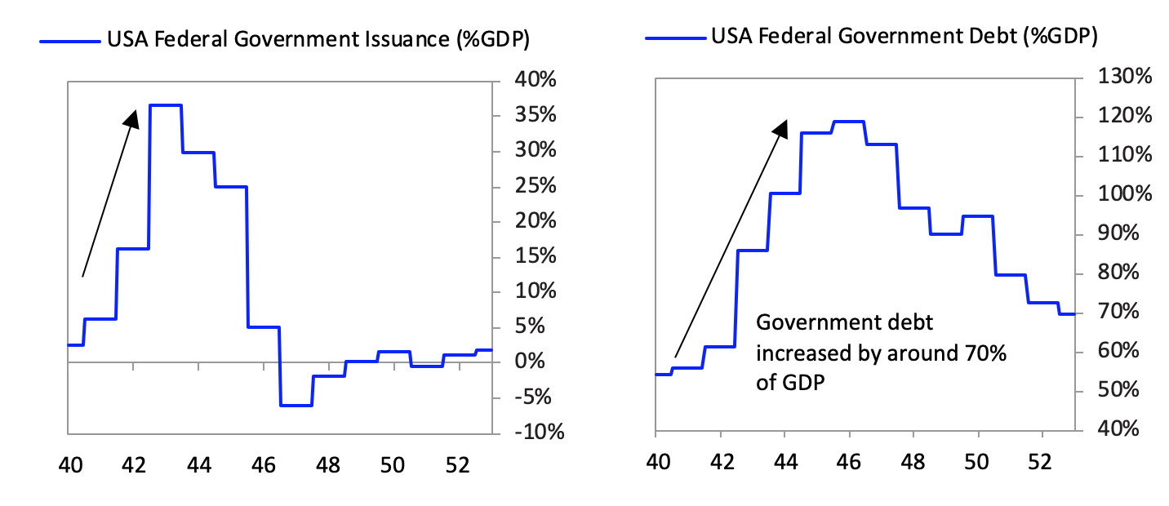

Of course, the net stimulative impact of the war for the US depended significantly on the facts that it was overwhelmingly not fought on US soil and that the US emerged as a significant victor—for the countries that lost the war (like other major conflicts), the human and economic costs were massive.  In World War II, Germany’s and Japan’s GDP per capita fell by at least half, and their currencies collapsed in the aftermath of the war, as the charts below show.

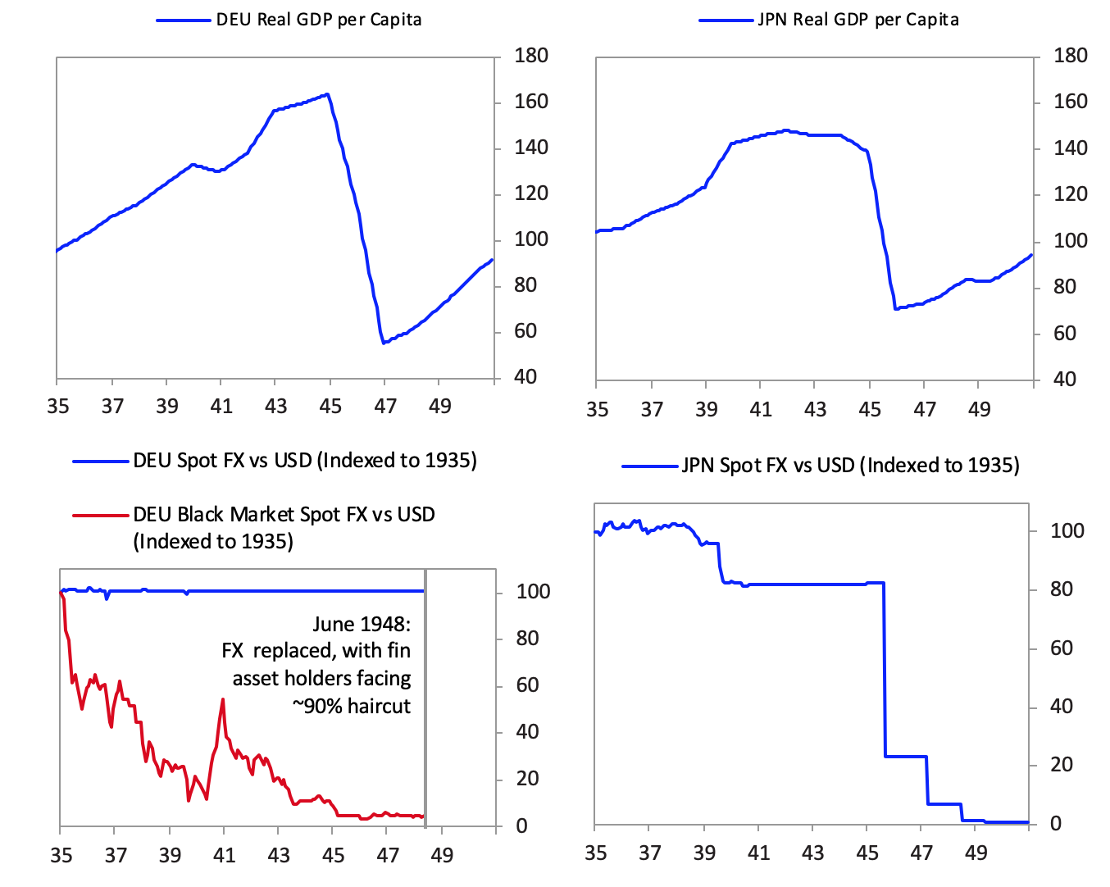

**Regulations and Taxes**

We should talk about various types of controls and taxes because we could see versions of these develop if this “war” intensifies.

In addition to the big fiscal spending and big monetizations of debt, policy makers in WWII introduced a series of controls.  These controlled the economic behavior of private individuals and companies in order to direct needed resources to the war effort, including rationing, production controls, price and wage controls, and import and export controls.  In addition to controls on economic activity, there were major restrictions on assets and markets in the US and all other combatants, which involved confiscatory levels of taxation at the same time as there were FX controls to keep money from leaving and restrictions on what assets one could hold (for example, in the US and many other combatant countries it was illegal for private individuals to hold gold).  For the limited foreign trade that still occurred, it remained near-impossible to convert the currencies involved—for example, the UK obligated its trading partners, mostly Commonwealth countries, to hold any surpluses from trade in pounds sterling.

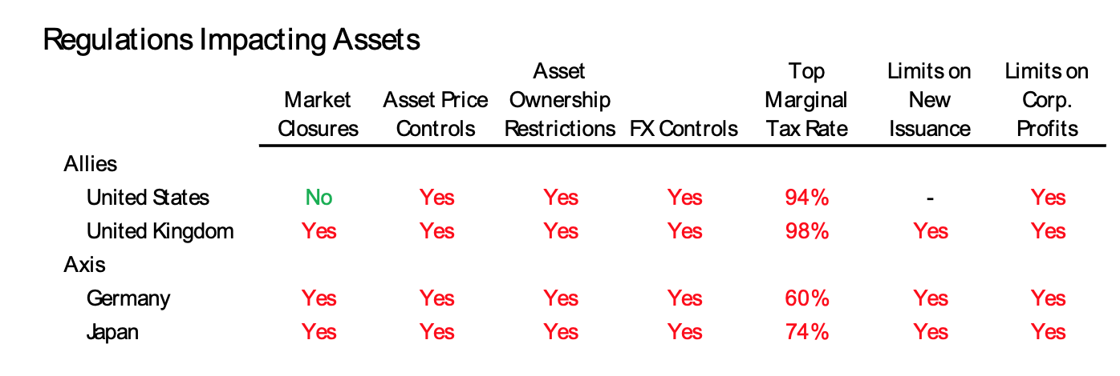

Beyond these restrictions, the direct role of government in these economies expanded massively to fund the military.  The chart below gives a picture of the degree of government spending ramp-up that happened across the combatants.

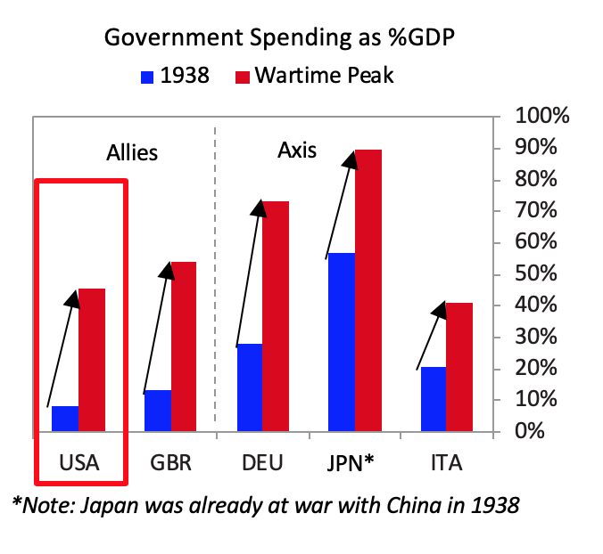

In the US, to meet this huge production need, Roosevelt had to totally retool the economy to shift toward wartime production.  He instituted a number of policies to facilitate this, starting even before the US’s official entry into the war:

* **At first, US policy makers began by using trade controls to support the Allies.  In March 1941, Congress passed the Lend-Lease Act, which allowed Allied nations to request supplies from the US government while postponing payment until after the war (or in some cases avoiding payment entirely).  In addition, it passed a series of restrictions on trade with Japan (including an embargo of scrap iron and oil in 1940 and a freeze of Japanese assets in July 1941).**
* **After the bombing of Pearl Harbor in December 1941, the government implemented most other classic wartime restrictions, like price and wage controls.  To facilitate this retooling of the economy, Roosevelt created the War Production Board in January 1942, which had the power to allocate scarce resources and order that plants be converted as needed.  War procurement was largely done on a cost-plus-a-fixed-fee basis versus competitive bidding, to explicitly incentivize high production versus efficient production. In addition, low interest rate loans were provided by the government to finance retooling factories.**

Let’s now look at how the World War I deficits were created and monetized.

**Two Other Cases**

**During World War I**

Financing for WWI across the major participants was similar to WWII with money printing comprising around a fifth of the financing for the US and UK, and with those countries tilting a bit more toward borrowing and a bit away from raising taxes compared to WWII.

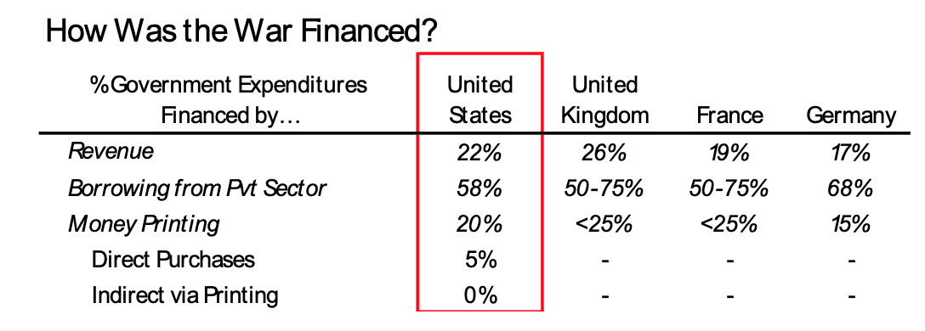

Taxation was politically controversial during WWI.  Many governments were reluctant to raise taxes because policy makers thought the war would be short and cheap and because low taxes had propaganda value (not raising taxes demonstrated financial strength). They were also less worried about money printing and deficit financing than they might have been during peace time because, based on the precedent of the Franco-Prussian War nearly half a century earlier, each side hoped to force the other to pay for the war once it was over and planned to remove the new notes from circulation.

Because the European countries at war could not produce all the goods and materials needed to fight, they typically   developed significant trade deficits that they financed by borrowing extensively from their allies, spending down gold reserves, and selling locally denominated securities in foreign markets.  To help support these deficits, all the major powers implemented some forms of controls and restrictions: all powers closed down markets at the start of the war to avoid fire sales, and most combatants both suspended gold standard convertibility and had some limitations on gold being exported abroad.  And while taxes rates didn’t reach the extremes of World War II, both the US and the UK saw top marginal tax rates above 50% during the wartime peaks.

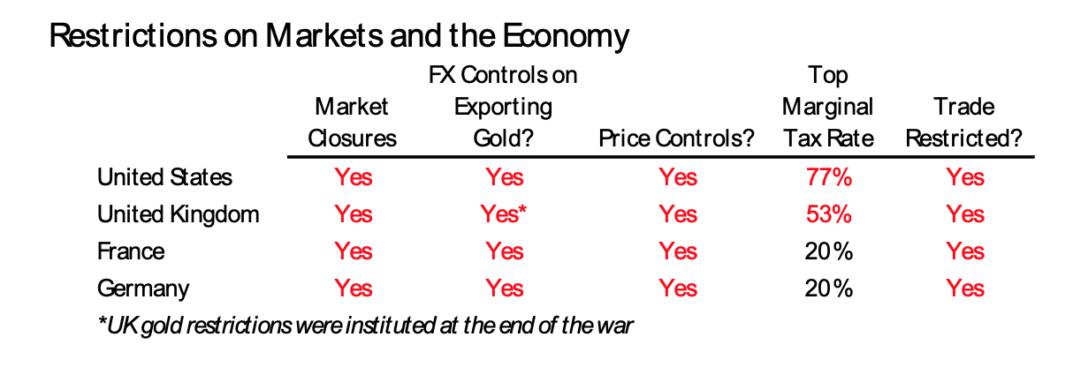

Below, we’ll provide more color on the debt and money financing used to cover war costs.

France

* **The war was initially expected to be short and so was funded with short-term debt.  When it was clear it would last longer than expected, the government issued long-term loans between 1915 and 1918.  Well-developed capital markets (capitalization of French securities represented around 140% of GDP and securities issued were around 10% of GDP for years before the war) and widespread trust in the state allowed it to borrow at relatively low rates.  The government also relied on monetary financing from the Banque de France and the Banque de l’Algérie, which provided the state with renewable short-term loans (advances). The state also relied on short-term (three-month to one-year maturity) “National Defense Bonds” that it could roll over and partially consolidate in an annual perpetual flotation.**

United Kingdom

* **In the first weeks of the war, the government paid for its expense with short-term treasury bills and ways and means advances from the Bank of England, but this method of financing was merely a temporary expedient.  The war was mostly financed by borrowing.  The government floated three long-term “war loans” in 1914, 1915, and 1917, supplemented by shorter-term borrowing.  After the third war loan, partly to allow for the tailoring of rates and duration to demand and partly due to borrowing costs in light of the US’s entrance into the war, the Treasury mostly relied on short-term (three- to six-month maturity) and medium-term (ten-year maturity at most) bonds and borrowing from the BoE to fund the expenditure.  While mostly relying on borrowing, the government also used an expansion of the money supply, which doubled over the course of the war, to finance the deficit.**

Germany

* **To raise immediate cash, the state sold short-term bills to the Reichsbank or domestic private financial institutions.  It then issued a long-term war loan to the general public each spring and fall (nine in total during the war) and used the proceeds to pay off its short-term debt.  The Reichsbank printed money to buy any such debt not purchased by German banks or put on the underdeveloped Berlin money market.  While this was just around 15% of the total cost of the war, with the very high war costs it meant German currency in circulation rose 599% during the war (by contrast Britain saw an increase of 91% and France of 386%).**

United States

* **For the US, which only joined the war in the later years, the majority of the war cost was met by borrowing from the public. The Treasury launched a massive national campaign, enlisting prominent artists and movie stars, to encourage the public to buy patriotically named “Liberty Bonds” and, after the armistice, “Victory Bonds.” The remainder of the war cost was financed through money creation, around 20% of the total cost.**

You get the idea.  Now let’s look at how the Civil War was financed.

**During The US Civil War**

Both the Union and the Confederacy financed their war efforts through a mixture of taxation, money printing, and private borrowing.  However, the more advanced nature of the Northern economy (it had over 70% of the population and over 85% of factories) helped it fund the war in a more balanced way, without facing runaway inflation.  The greater productive capacity of the Union economy (which remained relatively unscathed by fighting) likely also reduced the severity of goods shortages and tempered inflationary pressures.

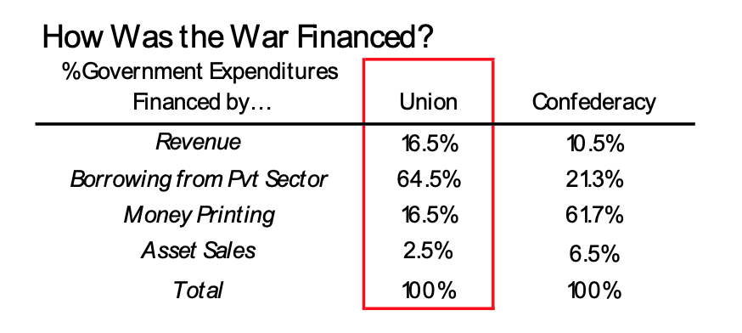

Below we give some additional color on how each funding source operated during this time.

**Taxation**

As is common during wars, taxes were hiked but played only a subordinate role in war funding.  In the Civil War the relative role of tax revenue in funding the war was conditioned by (1) whether there were liquid assets to tax, and (2) political will to tax the assets.  Because the North was both willing and able to tax, it raised more money via taxation and did so earlier.  The North’s political centralization and protectionist sympathies meant that taxation played a meaningful part in Union war funding.  By July 1861, the Union had already raised tariffs and imposed an income tax (a relatively controversial measure).  Throughout the war the Union would continue to expand and increase both income and consumption taxes.  By contrast, the South was both less willing and less able to raise taxes.  As a result, they only raised meaningful funds later in the war when (pushed by desperation) they were both more aggressive in the levels of taxation they imposed on the population and more creative in the forms of payment they accepted.

Bonds

The massive cost of modern wars means that governments are usually pushed to borrow heavily while turning to unconventional means of keeping borrowing manageable—these include appealing directly to the public and strong-arming banks to increase purchases.  Faced with exploding budget deficits, the Union’s war funding fit this template closely (unlike the South, which lacked equivalent capital market access).

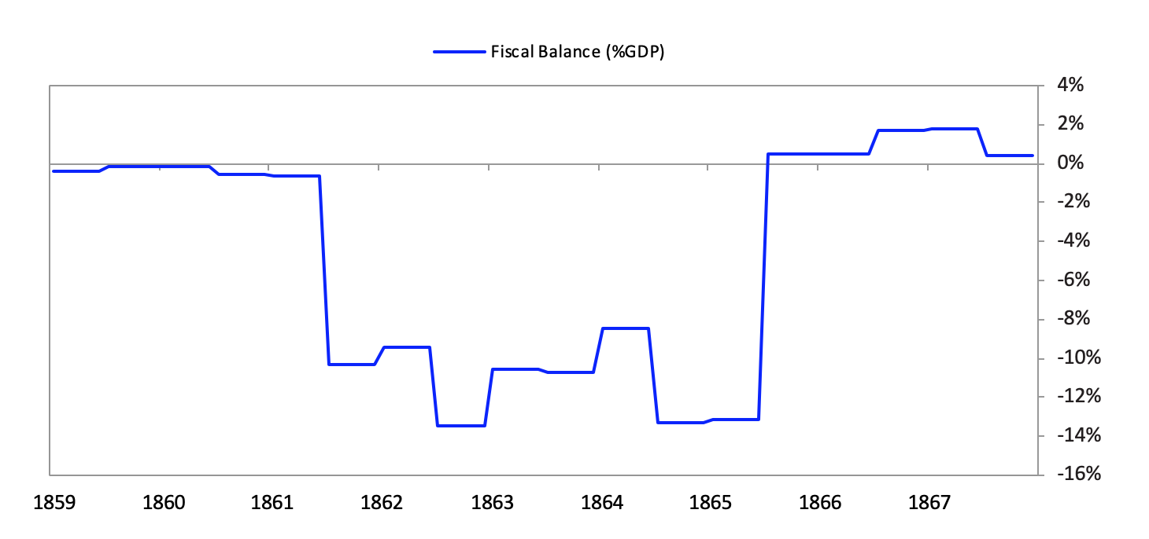

Initially the Union relied solely on sales to national banks (which would go on to resell the bonds).  However, this approach rapidly encountered problems, as banks were unwilling to use their limited gold to acquire low-yield bonds that they believed had a slim chance of resale.  Because normal capital markets lacked the financial firepower and/or willingness to meet the needs of the government, the Union turned to alternative tactics.  These took four main forms:

* **The Union broke the peg to goldin 1861, allowing bonds to be purchased with the new greenback.  This increased liquidity and allowed a greater number of bond purchases, pushing yields down.**
* **The government marketed bonds to the public, casting purchases as a patriotic act.  Bonds were structured so as to entice ordinary civilians: they were issued in small denominations—as low as 50 dollars—and could be purchased via payment plans.**
* **Banks were encouraged to purchase government securities.  Banking reforms in 1863, 1864, and 1865 created incentives for state banks to convert to national banks which had to purchase Union securities.  The legislation also placed a tax on notes issued by state banks (effectively driving them out of circulation).  Instead, national banks could issue national bank notes backed by a deposit of Union securities at the Treasury.  The legislation significantly supported the purchase of US securities, further pushing down yields.**
* **The Union also attempted to sell bonds on the international market.  However, international investors were only willing to engage in meaningful loans close to the end of the war in 1864 when Union victory appeared close to inevitable.**

**Money Printing in the Civil War**

The Union, unprepared for the newly intense nature of the conflict, planned to fund itself (as it had during the

Mexican-American war) by borrowing money to finance the conflict and using taxation to cover regular expenditures.  As it transpired, both the length and intensity of the war caused costs to go far beyond initial estimates.  By the end of 1861, it became apparent that issuing bonds would not be enough.  Increasing concern about a war with England and a growing current account deficit (which was settled in specie) put pressure on gold reserves.  Banks that had been supplying gold to the government in exchange for treasury notes and bonds found that they were unable to resell government bonds on the secondary market and were facing increasing redemptions.  New York banks led the charge in suspending specie payment, and the Treasury swiftly followed suit.  As the notes used to pay Union soldiers became unredeemable and their value deteriorated, Congress scrambled to find a new way to fund the war effort.  The peg had effectively broken, and in 1862 the government moved to print $150 million in United States notes (greenbacks) and made these notes lawful currency.

The value of the greenback relative to gold fell over the course of the war before rallying near the end.  Initially greenbacks could be converted into bonds which paid interest in gold (a quirk that had been introduced to establish the “soundness” of the currency).  The suspension of convertibility and the massive expansion of the money supply (increasing to a total of $450 million by 1863) helped to guide the currency downward.  However, because the Union had a made promise to redeem greenbacks at par with gold, the value of greenbacks rallied whenever the end of the war (and Union victory) seemed more likely.  By contrast, the Confederate currency consistently devalued due to both overprinting and vanishing prospects as the war went on.

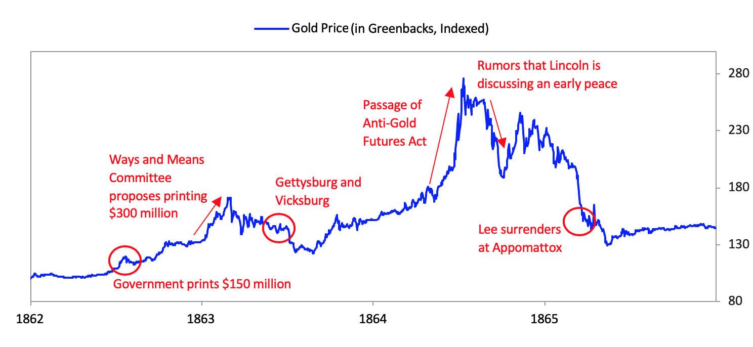

Besides being interesting, these stories could be harbingers of what’s to come.

**References:**

Baubeau, Patrice. “War Finance (France).” 1914-1918-Online. International Encyclopedia of the First World War. <https://encyclopedia.1914-1918-online.net/article/war_finance_france>.

Board of Governors of the Federal Reserve System (U.S.) and Federal Reserve Board. Federal Reserve Bulletin(March 1921): 302. <https://fraser.stlouisfed.org/files/docs/publications/FRB/pages/1920-1924/26810_1920-1924.pdf>

Broadberry, Stephen, and Mark Harrison, ed.  The Economics of World War I. Cambridge: Cambridge University Press, 2005.

Broadberry, Stephen, and Peter Howlett. “The United Kingdom During World War I: Business as Usual?” Working paper, June 2003. <https://warwick.ac.uk/fac/soc/economics/staff/sbroadberry/wp/wwipap4.pdf>.

Crabbe, Leland. “The International Gold Standard and U.S Monetary Policy from World War I to the New Deal.” Federal Reserve Bulletin(June 1989): 423-440. <https://fraser.stlouisfed.org/files/docs/meltzer/craint89.pdf>

Ferguson, Niall. “Earning from History? Financial Markets and the Approach of World Wars.” Brookings Papers on Economic Activity(Spring 2008): 431-490. <https://www.brookings.edu/wp-content/uploads/2008/03/2008a_bpea_ferguson.pdf>

Geyer, Michael, and Adam Tooze, ed. The Cambridge History of the Second World War, Vol 3. Total War: Economy, Society and Culture. Cambridge: Cambridge University Press, 2015.

Goldin, Claudia, and Frank Lewis. “The Economic Cost of the American Civil War: Estimates and Implications.” Journal of Economic History35, no. 2 (1975): 299-326.

Grampp, William. “The Italian Lira, 1938-45.” Journal of Political Economy54, no. 4 (1946): 309-333.

Hardach, Gerd. “Financial Mobilisation in Germany 1914-1918.” eabhPapers, no. 14-08, September 2014. <http://bankinghistory.org/wp-content/uploads/eabhpapers14_08.pdf>

Harrison, Mark, ed.The Economics of World War II. Cambridge: Cambridge University Press, 1998.

Hautcoeur, Pierre-Cyrille. “Was the Great War a Watershed? The Economics of World War I in France.” The Economics of World War I, edited by Stephen Broadberry and Mark Harrison, 169-205. Cambridge: Cambridge University Press, 2005. <http://www.parisschoolofeconomics.com/hautcoeur-pierre-cyrille/WorldWar1.pdf>.

Horn, Martin. “War Finance (Great Britain and Ireland).” 1914-1918-Online. International Encyclopedia of the First World War. <https://encyclopedia.1914-1918-online.net/article/war_finance_great_britain_and_ireland>.

Johnson, Zdenka. “Financing the German Economy During the Second World War.” West Bohemian Historical Review VII, no. 1 (2017): 115–143.

Lindholm, Richard. “German Finance in World War II.” American Economic Review37, no. 1 (1947): 121-134.

Meagher, Thomas. Financing Armed Conflict, Volume 1: Resourcing US Military Interventions from the Revolution to the Civil War. London: Palgrave Macmillan, 2017.

Meagher, Thomas. Financing Armed Conflict, Volume 2: Resourcing US Military Interventions from the Spanish-American War to Vietnam. London: Palgrave Macmillan, 2017.

Mitchell, B.R. International Historical Statistics: Europe 1750-1993. London: Palgrave Macmillan, 2000.

Nakamura, Takafusa, and Konosuke Odaka, ed. The Economic History of Japan: 1600-1990. Vol. 3, Economic History of Japan 1914-1955: A Dual Structure. Translated by Noah S. Brannen. Oxford: Oxford University Press, 2003.

Piketty, Thomas. Capital and Ideology. Translated by Arthur Goldhammer. Cambridge: Harvard University Press, 2020.

Rockoff, Hugh. “Until It’s Over, Over There: The U.S. Economy in World War I.” NBER Working Paper Series, Working Paper 10580, National Bureau of Economic Research, Cambridge, Massachusetts, June 2004. <https://www.nber.org/papers/w10580.pdf>

Smith, Gregor, and R. Todd Smith. “Greenback-Gold Returns and Expectations of Resumption, 1862–1879.” The Journal of Economic History57, no. 3 (1997): 697-717.

Zielinski, Rosella Cappella. How States Pay for Wars. Ithaca: Cornell University Press, 2016.