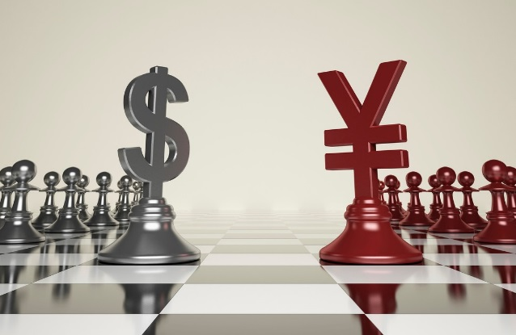

# A US-China Trade War Would Be a Tragedy

* Published on Published on March 5, 2018

[Ray Dalio](https://www.linkedin.com/in/raydalio/)

The markets’ reactions to newly imposed tariffs and, more importantly, the possibility of a US-China trade war convey appropriate tip-of-the-iceberg concerns of what a trade war would mean for the US, China, and world economies and markets. To me, these concerns are reminiscent of the markets’ first reactions to the possibility of a military war with North Korea—i.e., the seemingly aggressive posture of Donald Trump conjures up pictures of war that are very scary, so the markets react, but that doesn’t mean that such a war is likely (at least in the near term).

While I’m not a geopolitical analyst, here’s my thinking based on the time I’ve spent in both the US and China. Take it with a grain of salt.

The Chinese way of negotiating is more through harmony than through confrontation, until they are pushed to have a confrontation, at which time they become fierce enemies. They are more long-term and strategic than Americans, who are more short-term and confrontational, so how they approach their conflicts is different. The Chinese approach to conflict is more like playing Go without direct attack and the American approach is more like playing chess with direct attack. The Chinese prefer to negotiate by finding those things that the people they are negotiating with really want and that the Chinese are comfortable giving up, in exchange for those people they are negotiating with doing the same. Because there are now many such things that can be exchanged to help both parties (e.g., opening the financial sector in China, Chinese investment in the US, agricultural product imports to China, etc.), there is plenty of room for there to be big win-wins.

For these reasons, it’s in the Trump administration’s interests to make clear what it wants most and, if they can’t do that, to not be aggressive until they figure out what beneficial exchanges are. Of course, trade is extremely complex because there are all sorts of interconnections globally, so being clear without adequate time and exchanges of thinking isn’t easy.

However, as important as the real trade issues is politics, which is especially important at this very political moment in both countries (i.e., ahead of “elections”). Politics can make politicians act tougher than they should be if they were operating solely in their country’s best interests because looking tough with a foreign enemy builds domestic support. Politically for Donald Trump, two of his three biggest strongman promises were 1) to build the wall with Mexico and 2) to reduce the trade deficit with China, by getting tough with them both. Xi Jinping has similarly made commitments to be strong in dealing with adversaries, including the US.

For these reasons, it seems to me that good deals are to be had for both countries, while a trade war has the risk of tit-for-tat escalations that could have very harmful trade and capital flow implications for both countries and for the world. At the same time, I think and hope that both sides know this, and I believe that what is happening now is more for political show than for real threatening. The actual impacts of the tariffs that have been announced on the US-China trade balance will be very small. If tariffs are imposed as indicated, I would hope and expect the Chinese response to be small and symbolic so that both sides will have rattled their sabers without actually inflicting much harm. What will come after that will be more important. I wouldn’t expect it to amount to much anytime soon. If on the other hand we see an escalating series of tit for tats, then we should worry.