# Looking Back on the Last 40 Years of Reforms in China

Published on January 3, 2019 by Ray Dalio

As the end of 2018 marks the 40th anniversary of Deng Xiaoping and China’s other leaders opening up and reforming China and since this is also a time of greater questioning of China’s economic future, it is a good time to reflect on how China’s last 40 years have gone and why.

The table below shows just a few representative statistics. These results speak for themselves. To have such rates of improvements in so many areas and for so many people has made it the greatest economic miracle ever. Clearly whatever they did worked great. So, what was behind these accomplishments and will they continue?

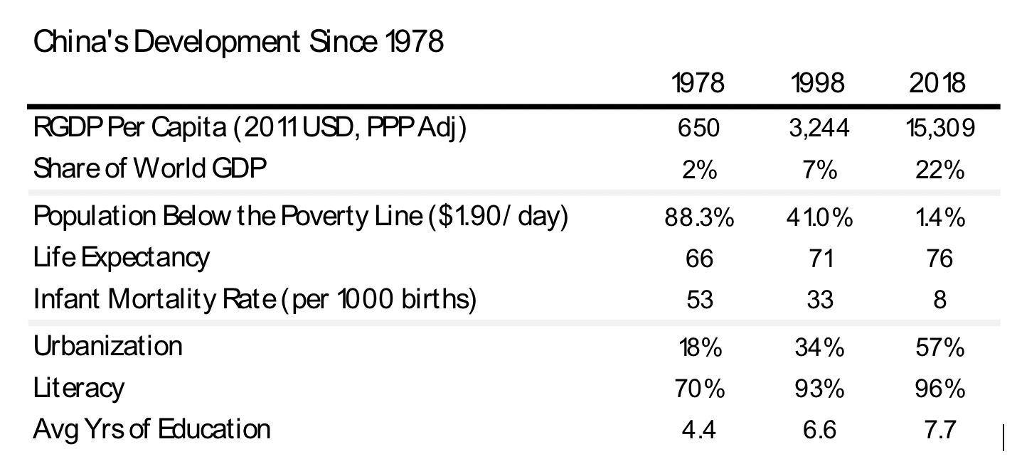

Since I have been fortunate to have experienced 34 years of this 40 years in an up close and intimate way, and since I study what makes countries succeed and fail, I have some experiences and thoughts to share    This is a retrospective look at China. A more comprehensive report about the current state of the economy and what is likely to come will follow shortly.

From what I have seen, I believe that the very impressive results that the Chinese leadership and the Chinese people produced came about primarily because of the powerful combination of a) China’s opening up and reforming following an extended period of isolation that led to a fast catching up (especially in the coastal regions of China) with the advanced developed world, and b) the power of the Chinese culture and it’ related ways of operating.

My first exposure to this came in 1984 when China was just opening. I was invited by CITIC (which was the only “window company,” which means the only company that was allowed to freely deal with the outside world) to teach them how the world financial markets work.  I immediately got a taste for the culture and could see that China was undeveloped for different reasons than other underdeveloped countries. In China’s case, the people and culture were highly developed and suffered from isolation from the advances that occurred in the rest of the world (whereas in most other developed countries the reverse was the case).

As an example of how undeveloped China was at the time because of lack of contact with the outside world, I gave senior people $10 calculators which they then thought were miraculous. To give you an idea of the rate of progress since then, some of those people are now overseeing the development of some of the most cutting-edge technologies in the world.

Back in 1984, I saw that there was nothing about the Chinese people that prevented them from being as successful as those in the developed world, and I knew that China was opening its door, I could imagine the essence of the big changes that would occur. Because the closed door was a barrier that led to two different economic levels to exist between China and the developed world, the removal of that barrier would naturally equalize their economic levels like unconstrained water naturally seeks the same level. I remember being on the 10th floor of CITIC’s “Chocolate Building,” giving a lecture and pointing out the window to the two-story hutongs (poor neighborhoods) and telling my audience that it would not be long before the hutongs would be gone and skyscrapers would be there in their place. They didn’t believe me and told me “you don’t know China,” and I told them they did not know the power of the economic arbitrages that would happen as a result of opening up. That opening was the biggest force behind the high rates of improvement that we saw over the last 40 years.

While the opening up created a great natural opportunity, the Chinese made the most of it. They did that by making and implementing reforms that were driven by uniquely Chinese cultural influences. These reforms freed up the Chinese people to realize their potential.

When I first came to China, in addition to seeing that it was undeveloped because of its isolation, I saw that it was underdeveloped because it was run by an old-style communist system that provided little incentives or efficiencies. For example, people couldn’t choose their own careers and jobs, there were no private businesses allowed, government businesses (i.e., all business) were inefficiently run, and there were little or no incentives for working hard and doing a good job. In the years that followed, I saw numerous excellent and rapid reforms change all that. Even more important than my getting to see the particular reforms that they made, I got to see how they make reforms – I.e., how they come up with numerous big reform ideas, plan them out, get behind them, and then get them done.  The demonstrated ability of the Chinese to go from visualizations to actualizations is quite amazing.

For example, in 1989 I was introduced by my CITIC friend and contact Wang Li to a group of seven good people (which she was one of) who were appointed by nine companies at the request of the visionary reformer Wang Qishan to create an organization (the Stock Exchange Executive Council) to set up the first financial markets in China. China was still very poor, so their office was in a dingy hotel and they lacked adequate funding. Still they had what mattered most—i.e., a clear mission to create big changes, smart people of good character, open-mindedness to allow rapid learning and determination to achieve their goals. Over the decades that followed, I saw how they and many others built the Chinese financial markets to become among the largest in the world, and I got to participate in small ways, which has been one of the great joys of my life. Through all this I gained a love and respect for the Chinese people, the Chinese culture, and their rapid rates of improvements that these forces brought about. .

As an extension of these sentiments in 1995, I had my 11-year-old son Matt live with an extraordinary and humble Chinese woman, Madame Gu, and go to a poor local school (Shi Jia Hu Tong Xiao Xue). All schools in China, like most everything else, were poor then. Though this school was poor (e.g., there wasn’t heat until late November so students wore their coats in classes), I saw how they had smart and caring educators who provided the children with an excellent, complete education that included character development. While Matt’s lifestyle was poor (e.g., he couldn’t take hot showers because the old apartment building he lived in only had hot water two days a week) he was superbly educated, loved, and better developed than in our rich Greenwich community. The experience changed his life forever and led him to set up a foundation to help Chinese orphans that he ran for 12 years that brought him and me into many more experiences with Chinese people and Chinese culture in China.

Through experiences like these and by getting to know some of the Chinese leaders, I learned a lot more about the Chinese culture, about how it operates today and about how it evolved over thousands of years —-from notions of how family members and others should behave with each other, through Confucian thinking, through Neo-Confucian thinking, through various dynasties and with the lessons these events provided about how leaders should lead and how followers should follow. These values and ways of operating are what I’m referring to when I refer to the Chinese culture, which I saw manifested over and over. I For example, I could see how that Chinese culture connected Lee Kuan Yew and Deng Xiaoping so that they together could explore how China could have a “socialist market economy with Chinese characteristics.” Though I’m no expert on Chinese culture and its way of operating, I do believe that I have some sense of it that might be helpful to those who haven’t had such exposures to it.

Most importantly, if you haven’t spent time in China, you need to get any stereotypes you might have out of your mind because it’s not how it was. This is not your father’s communism. It is “socialism with Chinese characteristics” that has been significantly and very effectively reformed, which has made it much more vital, creative, and economically free.

Before I share more of my thinking about this, I’d like to pass along [Xi Jinping’s far more important observations about the last 40 years of reforms](https://www.transcend.org/tms/2018/12/xi-jinpings-speech-on-40th-anniversary-of-chinas-reforms-opening-up-full-text/) and what to expect in the future. It is worthwhile reading for those who want to understand his perspective, which is most important.

President Xi refers a lot to “Chinese characteristics,” though he doesn’t define them.  While what defines Chinese culture would be better described by Chinese who are more knowledgeable than I am, I will refer you to the book Chinese Characteristics ([here](http://library.umac.mo/ebooks/b26028645.pdf)) – an American observer writing about Chinese culture in the late 1800s, some of which I think resonates today (though I’ll note that don’t agree with everything in the book, some of which is very outdated). Still, I will inadequately describe what I think Chinese culture most fundamentally is. As I’m not a Chinese scholar so that my comments are made solely on the basis of my contacts and my limited research, please take what I’m saying with a grain of salt.

From my experiences and from what I am told by Chinese who should know, I believe Chinese leadership seeks to run the country the way they believe a good family should be run, from the top down, maintaining high standards of behavior, putting the collective interest ahead of any individual interest, with each member knowing their place and having filial respect for those in the hierarchy so the system works in an orderly way. One of China’s leaders who explained this concept to me told that the word “country” consists of two characters, state and family, which influences how they view their role in looking after their state/family. One might say that the Chinese government is paternal. For example, it regulates what types of video games are watched by children and how many hours a day they play them. As a broad generalization, when the interest of the country (like the family) is at odds with the interest of the individual, the interest of the country (like the interest of the family) should be favored over the interest of the individual. Individuals are parts of a greater machine. As a result of this perspective, the system seeks to develop, promote and reward good character and good citizenship. For example it gives people a social credit score that rates the quality of their citizenship. And each person is expected to view themselves as parts of the greater whole. This management from the top down includes visualizing what China 5, 10 and 20 years in the future should be like and then making and managing detailed multiyear plans to build out that vision, with the goal being to make China as great as it can be. China is run more like a giant company with many subsidiaries, some within the government’s direct control and some within its indirect control.

Over those 40 years, the economic system was reformed to allow much more market-oriented and freer pursuit of self-interest as long that pursuit is pursed with good citizenship (including respect for the ruling system and its rules),. That included having growth of the private sector and private property.

So what we have seen over the last 40 years is China making many big, practical reforms around a traditional Chinese way of operating. As Xi said in a recent speech, “we will reform the things that should be reformed and not reform the things that shouldn’t be reformed,” referring to having big changes while maintaining the traditional Chinese style governance system.

While Chinese culture has been evolving, it has at its most fundamental level been operating in similar ways for many hundreds or even thousands of years and the results of operating that way are knowable in an approximate way. I have recently been researching the rise and fall of reserve currencies, which led me to study the rises and declines of the world’s most powerful countries. That led my research team and me to put together the following indices of the relative powers of leading countries since 1500. These indices are a combination of six sub-indices that measure six different types of power: 1) innovation & competitiveness, 2) domestic output, 3) share of world trade, 4) financial-center size and power, 5) military strength, and 6) reserve-currency status—and they show when different countries reached their peaks relative to the rest of the world. As shown, China was either the number one or number two most powerful country from 1500 to at around1800 when it went into relative decline that continued until around 40 years ago when the opening up and reforming led to the previously described strong ascent to being the second-most powerful country in the world and on the path to being the most powerful one. I believe that excellent performance was largely the result of China’s powerful culture and its reforms.

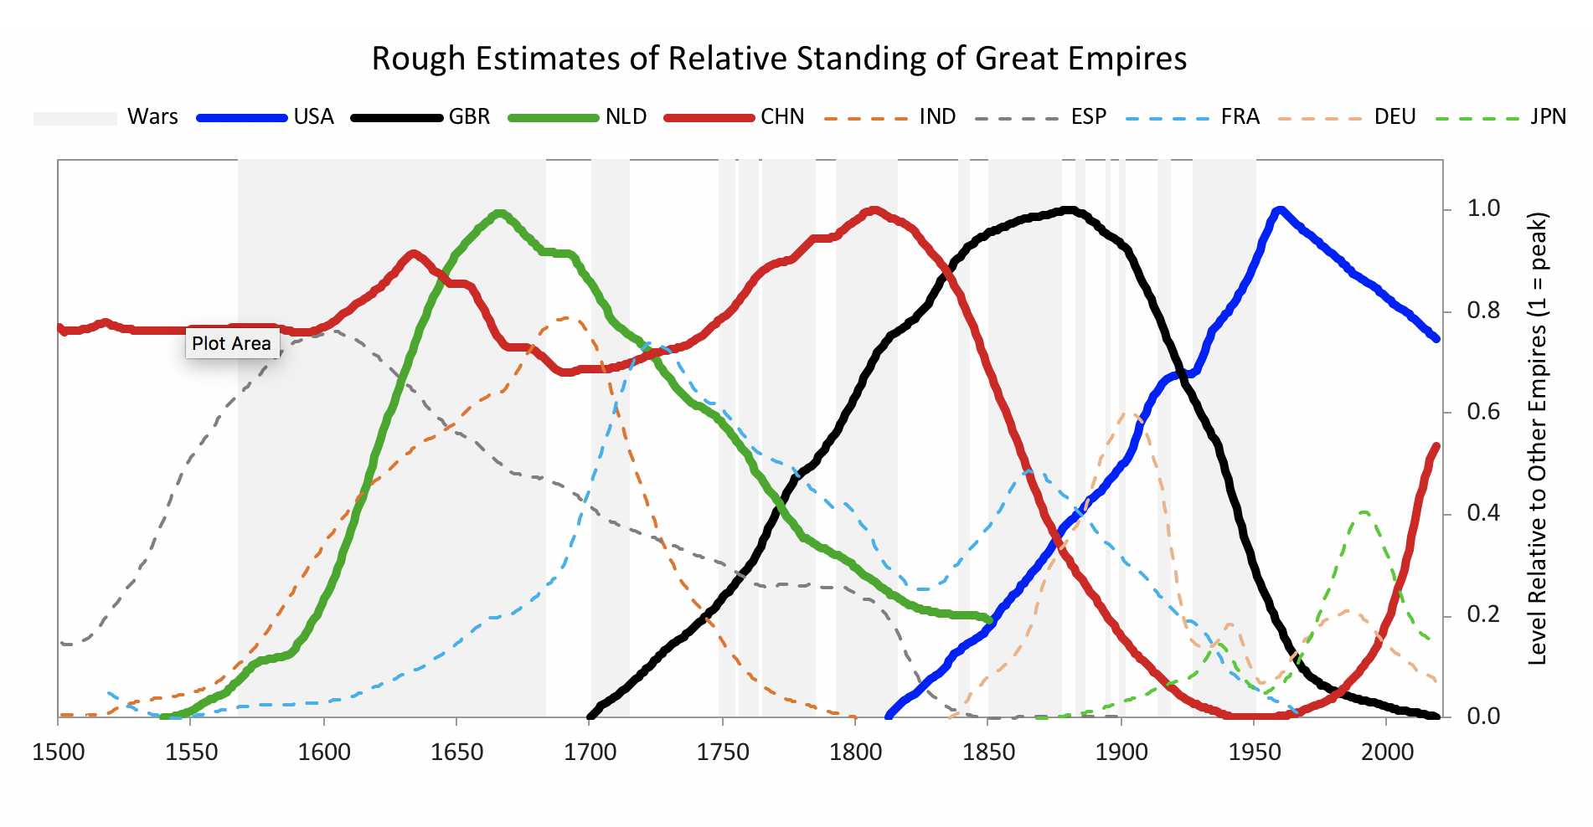

The chart below shows each of the six measures of Chinese strength going back to 900.

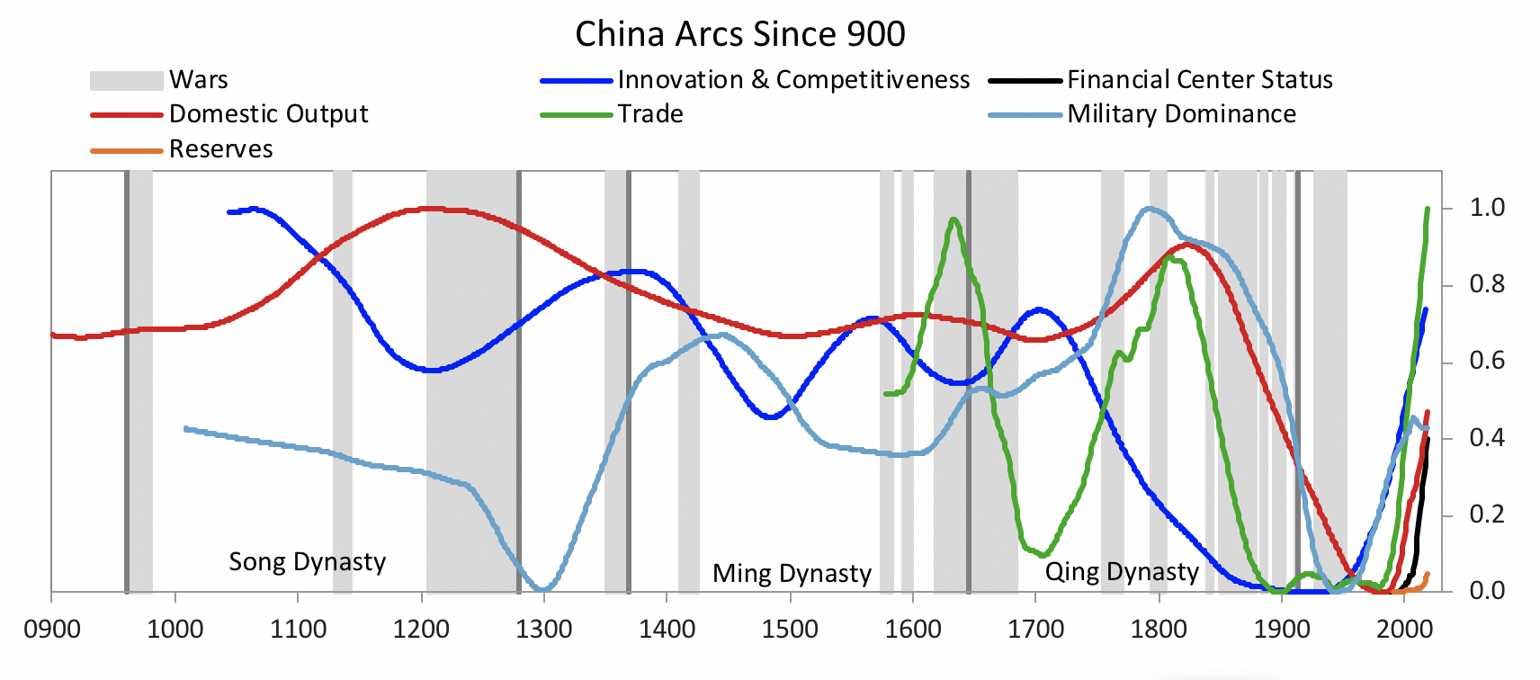

The next chart shows our overall index going back to the year 900. As you can see, China has been a very successful country through the millennia except for the more recent 150 years or so (for reasons I won’t delve into now).

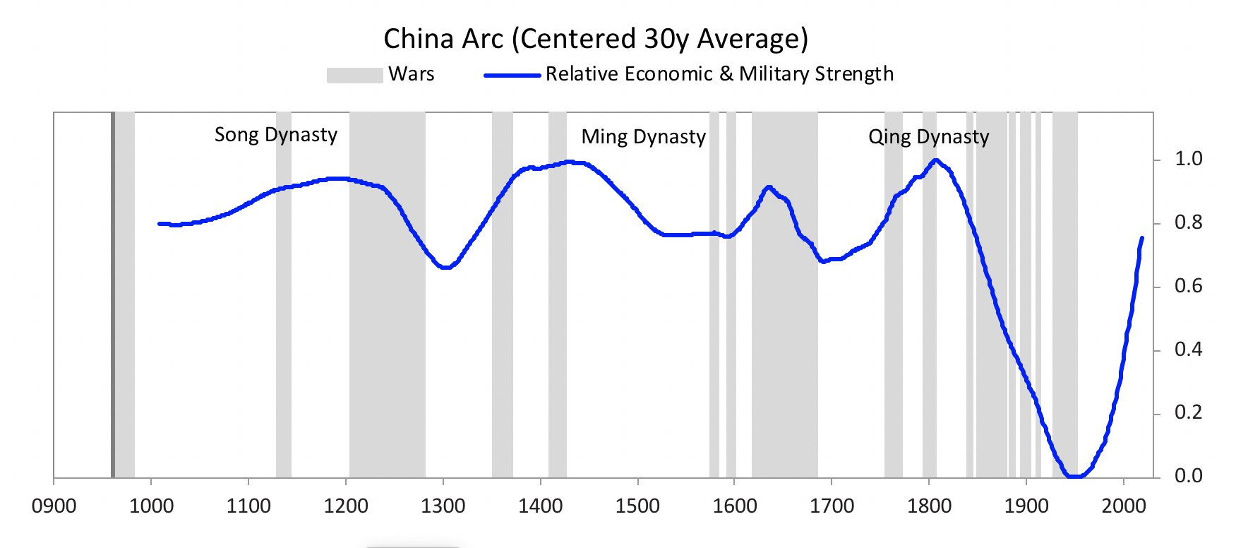

Given that impressive track record and how deeply imbued the culture behind it is, we shouldn’t expect China’s most fundamental ways of operating to change much. As a result, while trade deals can be made, attempts to change “Chinese characteristics”,—most importantly to change the top-down government management of most/all aspects of the system pursuit of making China as great as it can be—won’t work.

While considerable attention is now being paid to the trade war, what is more important is that China and the US are in a competition of cultural approaches, with the US approach being more opposite than similar to the Chinese approach Most fundamentally, the US is a country in which individuals, individualism, and individual property rights are perceived to be of paramount importance it is directed from the bottom up (e.g., through “one man, one vote” democracies that empower people to choose their leaders), being revolutionary is considered a good thing, and conflict is valued more than harmony. Rather than respecting top down control most American have a strong preference to keep government from interfering with their most individual choices. Character development is a personal or family issue, not a government issue (which leaves it largely neglected in areas with broken families, especially if they’re poor). Rather than there being a long-term top down vision for the country and a plan to achieve that vision, in the capitalist and democratic system such directions are more bottom up determined based on commercial and popularity considerations.

I’m not saying which system is better. Each culture/system has its pros and cons that I’m not going to get into now. I believe that the important thing to know are that while there will be trade wars and trade truces they aren’t the most important things. The most important things are that 1) China has a culture and system that has worked well for it for a long time so it shouldn’t be expected to change much, 2) the U.S. has the same, 3) these systems (and those of other countries) will be both competing and cooperating, and how well they do that will be an important influence on global conditions, 4) how well each system works in practice will have a far greater influence on where each country stands in the future than the terms of the deals that they strike with each other, so each would do well to examine its own weaknesses and come up with reforms to rectify them, and 5) there is a lot to respect about the Chinese culture and approach that led to its remarkable accomplishments, 6) we would do well to learn from each other, cooperate and compete to bring each other up rather than to tear each other down, and 7) China is a place we need to continue to evolve with and invest in.