# Watch Out for the Effects of Tax Reform on Tax Migration, the Fiscal Conditions of Affected States and Cities, and Polarity in America

Published on December 5, 2017

## [Ray Dalio Influencer](https://www.linkedin.com/in/raydalio/)

**Chairman & Chief Investment Officer at Bridgewater Associates, L.P.**

While we have talked a lot about the effects of growing wealth and opportunity disparities in America, we haven’t talked enough about the tax migration that is taking place because of growing differences in state and local tax rates. This tax migration issue is especially important to focus on now because of the expected elimination (under the new tax legislation) of the deductibility of state and local taxes (SALT) against federal income taxes.

The dynamic that I’m referring to is the inevitable and self-reinforcing process in which those high SALT locations that a) have big disparities in income and fiscal shortfalls and b) can neither cut their financial supports to the “have-nots” (because their conditions are already unacceptably low) nor raise taxes on the “haves” (because they will move due to tax rates) suffer from tax migration. Of course, those low SALT locations with the opposite circumstances benefit from this migration.

The dynamic works as follows. As state and local tax rates and debts rise because there are shortfalls that can’t be narrowed, it is financially smart for high income taxpayers to escape these taxes and debt burdens by moving to lower tax and less indebted locations, so they do. As they do, property values decline, further raising the costs of staying in the high SALT location. In other words, the financial cost of being in one of those high tax locations equals the tax rate difference plus the property value decline, which can be substantial. Also, the reduced population of higher income and higher spending folks leads to reduced spending in these locations, which further depresses the high SALT economies. Also, the fiscal conditions of these locations suffer. Because both the remaining high income and low income folks are increasingly stressed and tend to blame the other, tensions rise, which makes these environments even more inhospitable, which further contributes to high income earners’ emigration. Realizing this, other locations increasingly appeal to the “haves” by offering tax incentives and creating environments in which they are more comfortable living with other “haves.” For these reasons, this “hollowing out” dynamic is self-reinforcing. Of course, the reverse is true in states that attack these rich tax migrants. This dynamic causes even greater polarity. Because the rich and the poor typically have different values, which are also reflected in different laws and different politics, it probably will make the polarity greater and conflicts even more intractable.

It appears to us that the expected new tax law that eliminates the state and local deductions against one’s federal income taxes will significantly contribute to this dynamic. Consider the fact that this change in SALT deductibility is one of the largest increased sources of revenue in the tax bill, accounting for nearly $1 trillion in new taxes over the next 10 years. In other words, it is expected that those people who stay in high tax states will pay nearly $1 trillion more to stay there. Of course, these changed rates will prompt more people in high SALT locations to consider moving. To the extent they do move, it would increasingly lead to more prosperous states that are occupied by, and cater to, more rich people and more depressed states that are occupied by, and cater to, more poor people, and increased polarity between them.

While we are talking about the tax migration, we see such location cost arbitrage motivated migrations happen all the time, so we should be well acquainted with them. For example, in New York City we saw migration from the Upper East Side to Downtown and then to Brooklyn brought about by cost arbitrages. Every area in the world has this sort of cost and desirability motivated migration going on constantly. Cost differences drive migrations that change the characters and costs of neighborhoods and happen in self-reinforcing ways until the cost differences change to make the newly hot neighborhoods expensive and other areas relatively cheap, so the immigration shifts to emigration.

**Estimating the Impact of Cutting the SALT Deductions**

We played around with the numbers to get a feel for the directions and the impacts of this, and we show our scratch pad estimates below. We will first show our very rough estimates of the impact of ending deductibility on state tax revenues and migration patterns.

First, to summarize, we estimate that:

* **Ending SALT deductibility will result in a sizable increase in the effective tax rate faced by high earners in high tax states (3-5% for most making over $500,000), notable outbound migration of high income filers (we estimate 1-2.5% will leave for most states we looked at), and a hit to state tax revenues (around 1%).** In our opinion, these numbers understate the impacts, especially for the highest taxpayers (who pay the most taxes), because it is the nominal level of dollars of increased taxes that matters more than percentages, and we don’t fully account for all the second- and third-order consequences previously mentioned. In terms of economic impact, we estimate that it is the present value of all future year tax differences (and other costs such as declining real estate values) that is the best gauge of the cost of staying, and these are very big numbers. As I just noted, the effects on property values and living conditions are not properly considered in our estimates. Already, without the SALT deductibility changes, some higher SALT states are experiencing notable outbound migration (shown further below), which is straining tax revenues and risks the strengthening of a downward spiral where states adjust by cutting spending/raising taxes, which encourages even more people to leave.
* Still, the table below conveys a rough picture of where the vulnerabilities lie. It shows a) the existing marginal tax rate, b) the effective tax rate with the deduction, c) the effective increase in the tax rate due to the elimination of the deduction, d) that increase relative to the US average and e) relative to states they are likely to emigrate to (e.g., their neighbors), f) the estimated medium-term size of the migration as a percent of the high earning population,* g) the estimated number of high earners leaving, h) the lost tax revenue to the state, and i) that lost tax revenue relative to the total tax revenue of the state. To be clear, these are VERY IMPRECISE ESTIMATES.

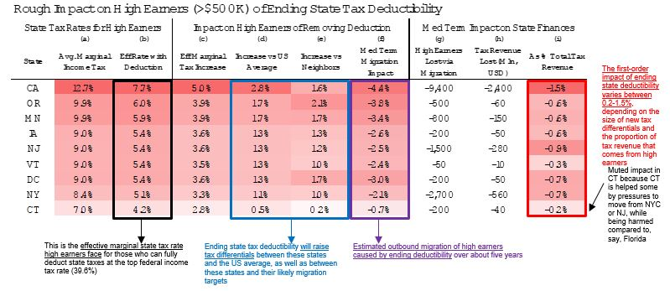

We looked at a number of factors to come up with our rough estimates, so we will show you some.

While the previous table looks at the impact of migration on state budgets, below we show a simpler cut: our rough estimates of how relative incomes between states will change when people in high tax states get a greater tax increase than people in low tax states. The chart on the left shows the absolute levels in real per capita earnings by state versus the national average before and after the tax change. These numbers are adjusted by what the Bureau of Economic Analysis believes about relative price levels between states (trying to get at some measure of competitiveness). The chart on the right shows the net shift that occurs with the tax change. As you can see, states with both higher than average incomes and higher than average taxes (especially New York, Connecticut, New Jersey, and California) are most vulnerable by this measure.

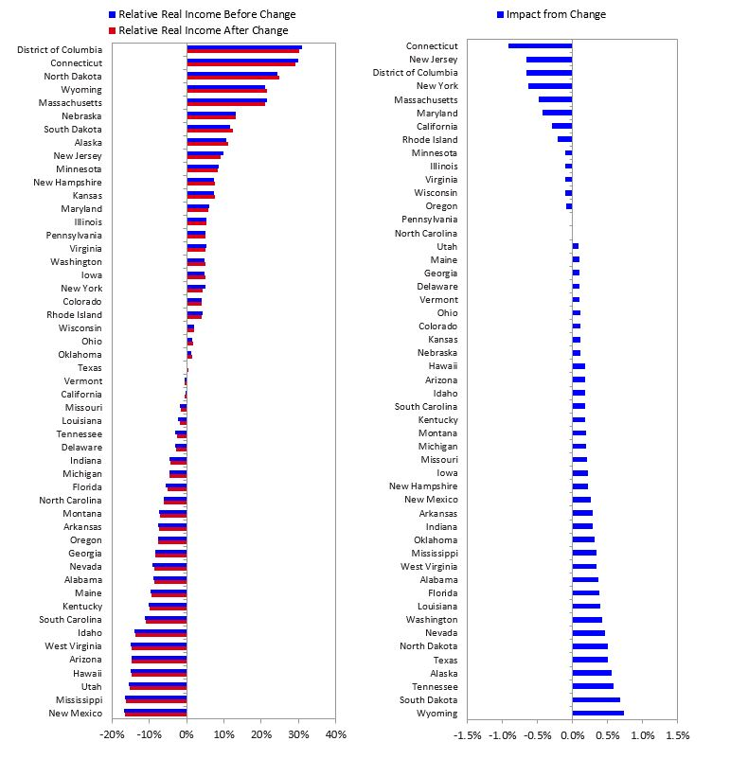

The vulnerability of a state to tax emigration is also affected by tax revenue being concentrated in the hands of those high income earners who are most affected by the changes. This concentration is shown below for the states with the highest income taxes.

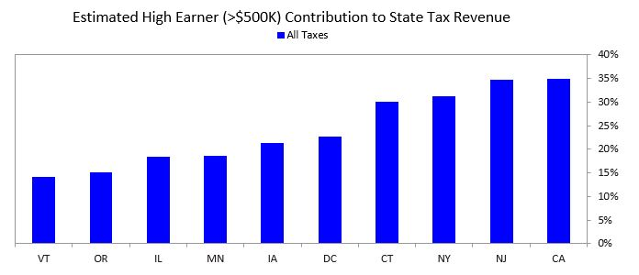

For these states, the high earning taxpayers are a very small proportion of the population—from 0.5% of households in Vermont to 1.7% in DC and Connecticut. That means that it would take only a tiny percentage of the population to move to have a devastating effect on the state’s finances. Clearly, all of these states are very vulnerable.

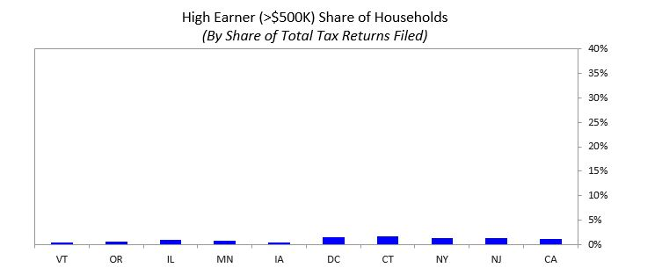

The next two tables show the states where people have been leaving fastest from and going fastest to, and a number of influences on these movements, such as economic conditions and the tax burden.

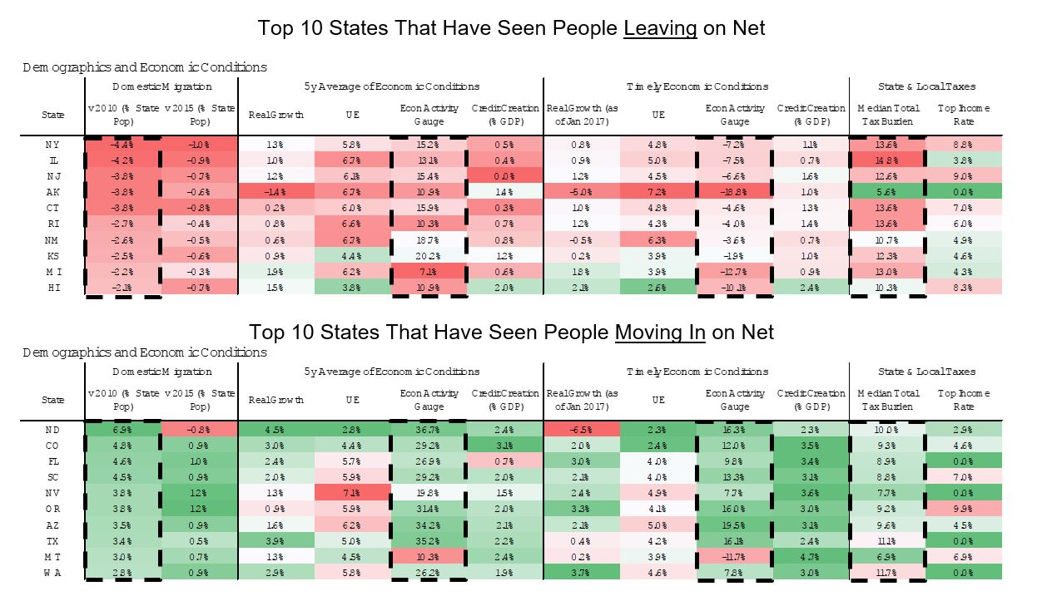

As you can see, everything points toward states like New York, Connecticut, New Jersey, California, and Illinois being the most vulnerable, and states like Florida, Texas, Nevada, Washington, and Arizona benefiting the most from this shift. Our look at these states’ finances and their muni bond markets will follow in the next few days.

As for the effects of the budget changes, below we show where the money is expected to come from and where it is expected to go.

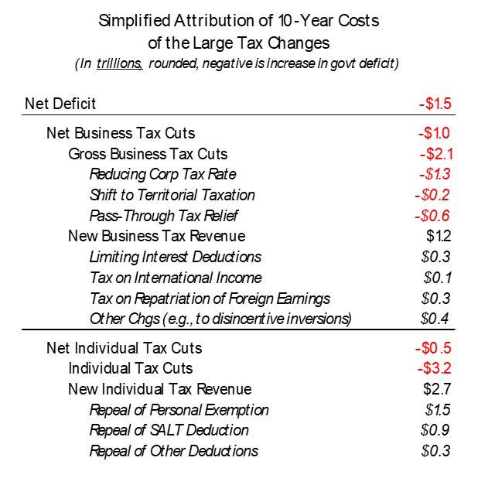

So, our big picture perspective is that, on the margin, the tax law changes are going to be significant and bad for high SALT locations and good for low SALT locations, and are going to be good for businesses and business owners (and hopefully those who the money trickles down to), so those businesses in low SALT states will get a double whammy benefit.