# Our Biggest Economic, Social, and Political Issue “The Two Economies: The Top 40% and the Bottom 60%”

* Published on Published on October 23, 2017

## [Ray Dalio](https://www.linkedin.com/in/raydalio/)

To understand what’s going on in “the economy,” it is a serious mistake to look at average statistics. This is because the wealth and income skews are so great that average statistics no longer reflect the conditions of the average man. For example, as shown in the chart below, the wealth of the top one-tenth of 1% of the population is about equal to that of the bottom 90% of the population, which is the same sort of wealth gap that existed during the 1935-40 period.

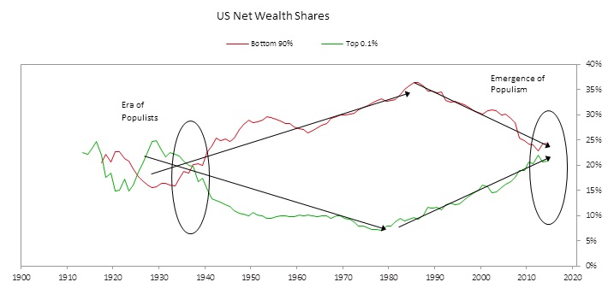

To give you a sense of what the picture below the averages looks like, we broke the economy into two economies—that of the top 40% and that of the bottom 60%.* We then observed how conditions of the majority of Americans (the bottom 60%) are different from the conditions of those of the top 40%, as well as different from the picture conveyed by the average statistics. We focused especially on the bottom 60% because that’s where the majority of Americans are and because the picture of this economy is not apparent to most people in the top 40%.

The Bottom 60% Compared with the Top 40% and the “Average”

We will start off looking at income and the economic picture and then turn to some related lifestyle and political differences.

* There has been no growth in earned income, and income and wealth gaps have grown and are enormous. Since 1980, median household real incomes have been about flat, and the average household in the top 40% earns four times more than the average household in the bottom 60%. While they’ve experienced some growth recently, real incomes have been flat to down slightly for the average household in the bottom 60%since 1980 (while they have been up for the top 40%). Those in the top 40% now have on average 10 times as much wealth as those in the bottom 60%. That is up from six times as much in 1980.

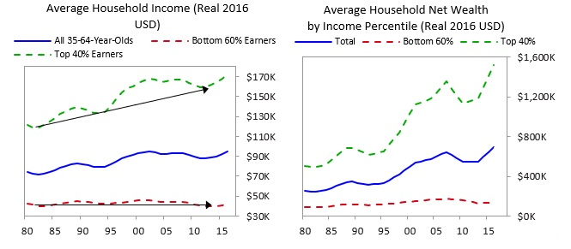

* Only about a third of the bottom 60% saves any of its income (in cash or financial assets). As a result, according to a recent Federal Reserve study, most people in this group would struggle to raise $400 in an emergency.

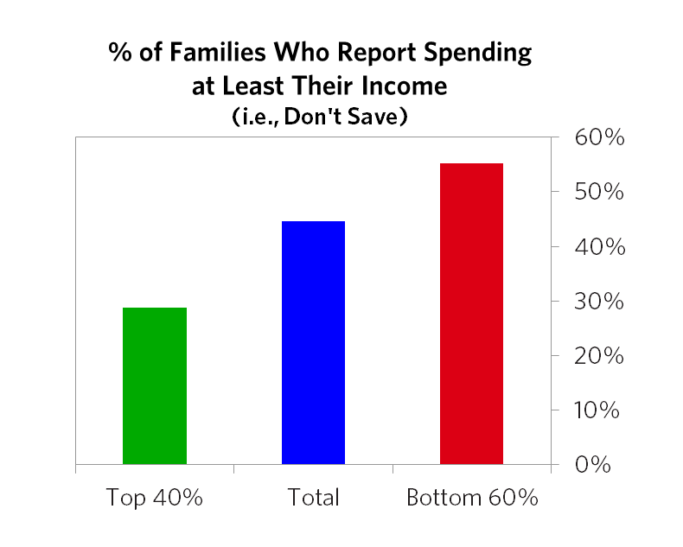

* The rates of income and wealth changes of the middle class have been worse than those changes in any of the other groups, once you account for the social safety net and taxes. The charts below show income, adding in the impact of taxes, tax credits, benefits, and transfers (including non-monetary government transfers like Medicaid and employer health insurance). Unlike the picture of real earned incomes shown earlier, all the quintiles had seen some growth until 2008. This was primarily driven by increases in transfers, benefits, and social programs (especially medical benefits). It also lights up some differences within the bottom 60%. Note that while the conditions of those in the bottom quintile of society are terrible, and worse than those of the middle class by most measures (e.g., income, health, death rates, incarceration rates, etc.), the rate of change in these conditions has been worse for the middle class. More specifically, the middle class has experienced less post-tax and transfer income growth than the bottom quintile since 1980 (see chart on the right), partially because government support to the bottom has provided more of a cushion—though in both cases, income growth has been very low.

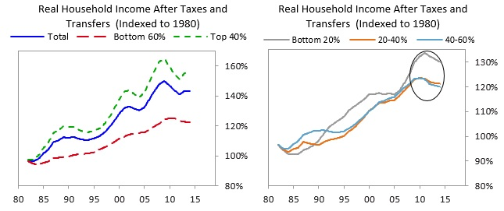

* The middle class has been especially hard-hit by manufacturing jobs declining about 30% since 1997, which is shown in the below chart.

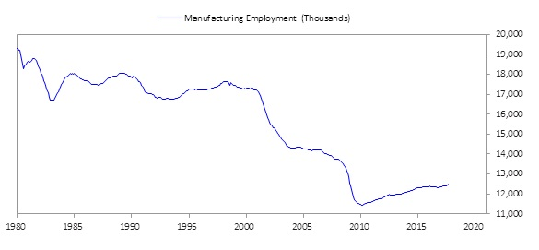

* Those in the top 40% have benefited disproportionately from changes in asset values relative to those in the bottom 60%, because of their asset and liability mix. The balance sheets of these two groups, shown below, are sharply different. Though the bottom 60% has a small amount of savings, only a quarter of it is in cash or financial assets; the majority is in much less liquid forms of wealth, like cars, real estate, and business equity. For the bottom, debt is skewed toward more expensive student, auto, and credit card debt.

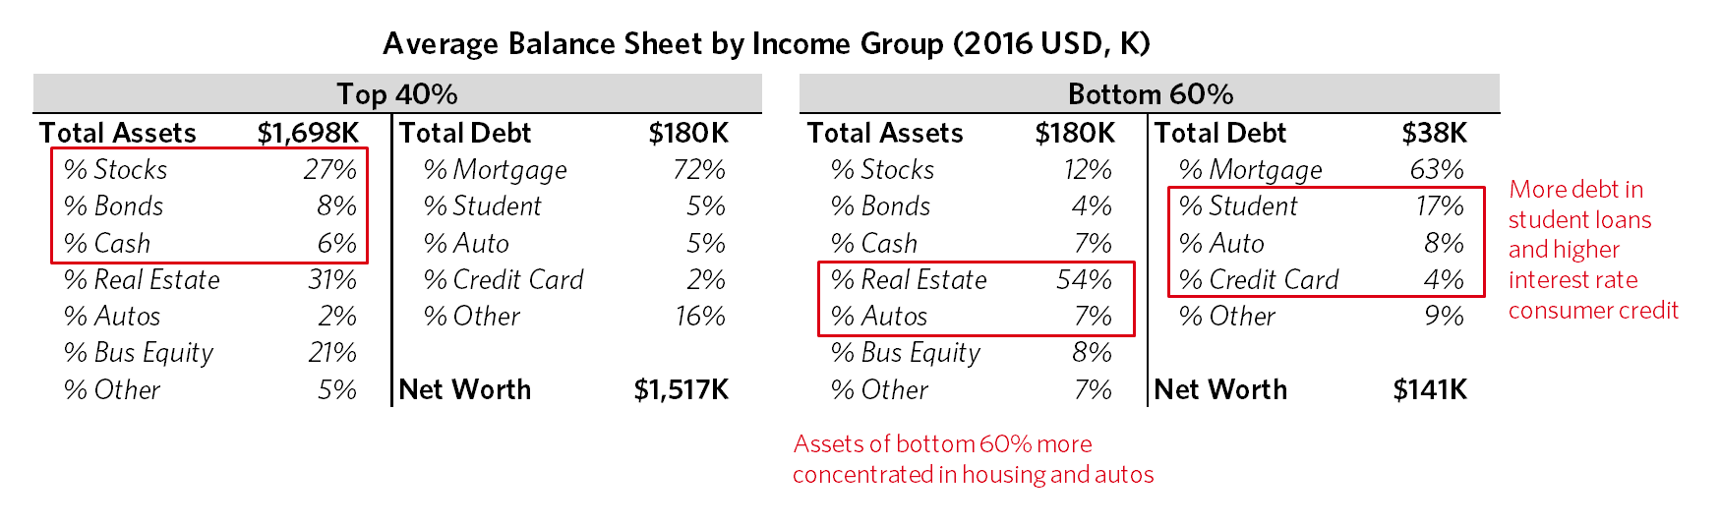

* The increasing disparity in financial conditions is a major cause of the slowing of growth, because those in lower income/wealth groups have higher propensities to spend than those in higher income/wealth groups. Said differently, if you give rich people more money, they probably won’t spend much of it, whereas if you give poorer people more money, they will probably spend more of it, each motivated by the extent of their unmet needs and desires.**
* Retirement savings for the bottom 60% are not even close to adequate and aren’t much improved as the economy and markets have recovered. Only about a third of families in the bottom 60% have retirement savings accounts—e.g., pensions, 401(k)s—which average less than $20,000. Further, as we do projections of pension finance, it appears unlikely that pension retirement benefits will be fully met.

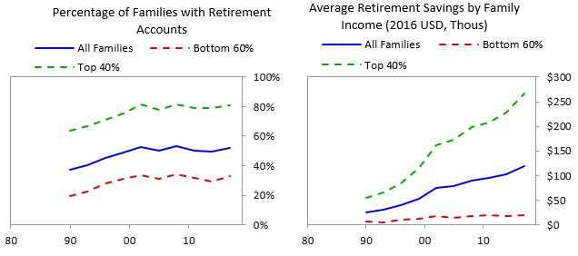

* Death rates are rising and mental and physical health is deteriorating for those in the bottom 60%. For those in the bottom 60%, premature deaths are up by about 20% since 2000. The biggest contributors to that change are an increase in deaths by drugs/poisoning (up two times since 2000) and an increase in suicides (up over 50% since 2000). The odds of premature death for those in the bottom 60% between the ages of 35 and 64 are more than two times higher, compared to those in the top 40%.
* The US is just about the only major industrialized country with flat/slightly rising death rates.

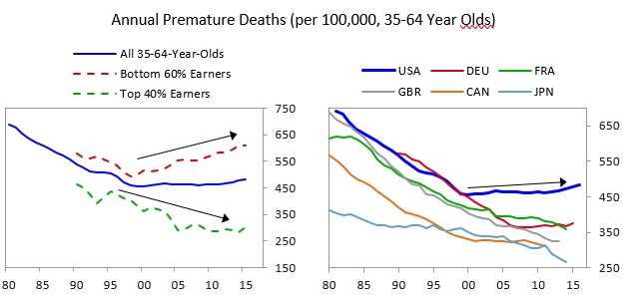

* The top 40% spend four times more on education than the bottom 60%. This creates a self-perpetuating problem, because those at the bottom get a much worse education than those at the top.

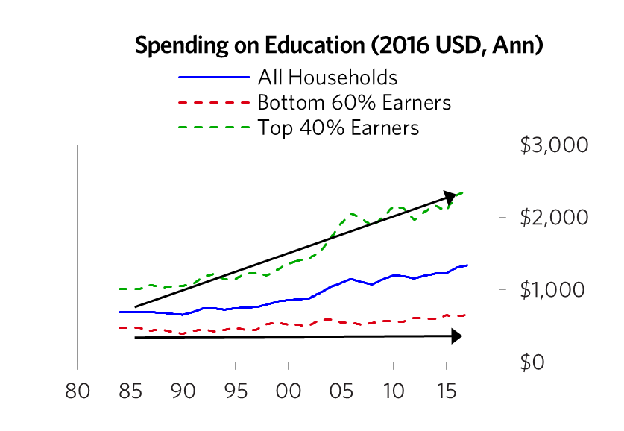

* The bottom 60% increasingly believe others will take advantage of them: the percentage is 49% today versus 40% in 1990.

While conditions for the lowest income groups have long been bad, conditions of non-college-educated whites (especially males) have deteriorated significantly over the past 30 years or so. This is the group that swung most strongly to help elect President Trump. More specifically:

* Now, the average household income for main income earners without a college degree is half that of the average college graduate.
* The share of whites without college degrees who describe themselves as “not too happy” has doubled since 1990, from 9% to 18%, while for those with college degrees it has remained flat, at around 7%.
* Since 1980, divorce rates have more than doubled among middle-age whites without college degrees, from 11% to 23%.
* Prime working-age white males have given up looking for work in record numbers; the number of prime-age white men without college degrees not in the labor force has increased from 7% to 15% since 1980.
* More broadly, men ages 21 to 30 spend an average of three fewer hours a week working than they did a decade ago; most of that time is spent playing video games.
* The probability of premature death for whites without college degrees between the ages of 35 and 64 is nearly three times higher than it is for whites with college degrees, and the rate of premature deaths is up by about 25% since 2000 (while it is down for virtually every other demographic group). The US white population is unique among large groups in the developed world for seeing increases in their death rates. Below, we show premature deaths among working-age whites between the ages of 35 and 64. Again, the average obscures the picture. America’s non-white population isn’t seeing such a rise in premature deaths.

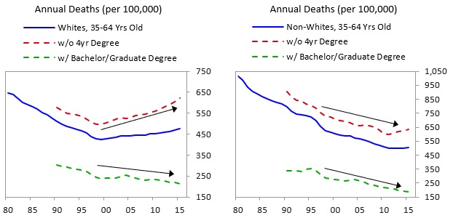

The polarity in economics and living standards is contributing to greater political polarity, as reflected in the below charts.

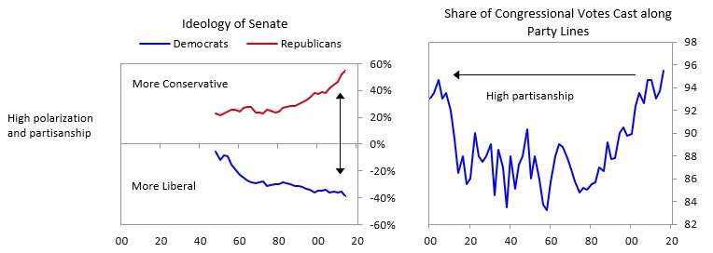

It is also leading to reduced trust and confidence in government, financial institutions, and the media, which is at or near 35-year lows.

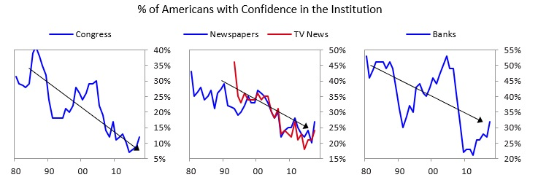

### In Summary

Average statistics camouflage what is happening in the economy, which could lead to dangerous miscalculations, most importantly by policy makers. For example, looking at average statistics could lead the Federal Reserve to judge the economy for the average man to be healthier than it really is and to misgauge the most important things that are going on with the economy, labor markets, inflation, capital formation, and productivity, rather than if the Fed were to use more granular statistics. That could lead the Fed to run an inappropriate monetary policy. Because the economic, social, and political consequences of an economic downturn would likely be severe, if I were running Fed policy, I would want to take this into consideration and keep an eye on the economy of the bottom 60%. By monitoring what is happening in the economies of both the bottom 60% and the top 40% (or, even better, more granular groups), policy makers and the rest of us can give consideration to the implications of this issue. Similarly, having this perspective will be very important for those who determine fiscal policies and for investors concerned with their wealth management. We expect the stress between the two economies to intensify over the next 5 to 10 years because of changes in demographics that make it likely that pension, healthcare, and debt promises will become increasingly difficult to meet (see “The Coming Big Squeeze”) and because the effects of technological changes on employment and the wealth gap are likely to intensify. For this reason, we will continue to report on the conditions of “the top 40%” and “the bottom 60%” separately (as well as on the averages), and we encourage you to monitor them too.

### Appendix: Other Interesting Charts and Data

As shown below, the percentage of children who grow up to earn more than their parents has fallen significantly in the US over the past 50 years. The first chart shows that only 50% of all children born in 1980 (i.e., those currently in their 30s) will earn more than their parents. Survey data shows the same picture—the bottom 60% are more likely to think that they are worse off than their parents than the top 40%.

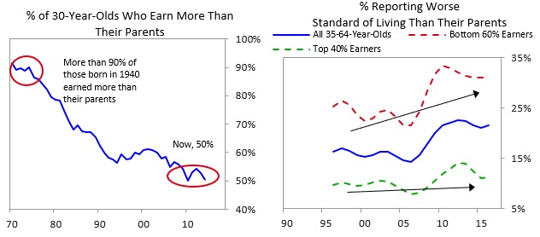

The two charts below show income shares and average versus median incomes. As you can see, income has become increasingly concentrated, with the top 40% of earners gaining share over the past 35 years. This is also reflected in average versus median incomes, as the distribution of incomes has caused the average income to significantly diverge from the median.

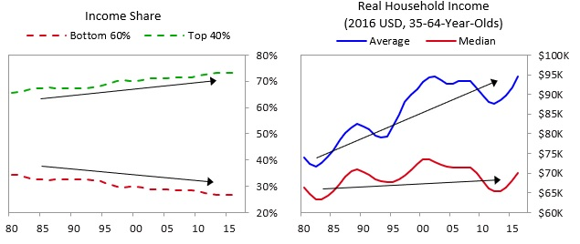

The chart below shows the levels and shares of wealth for the top 40% versus the bottom 60% of income earners.

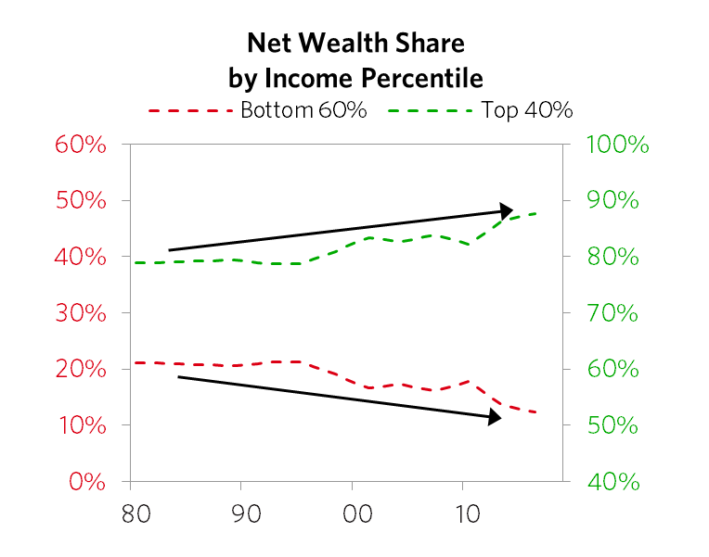

Most people in the bottom half have virtually no savings and minimal financial security, as the chart below demonstrates. Over half of the bottom 60% don’t save any money on a monthly basis, resulting in their having no room to cover unexpected expenses.

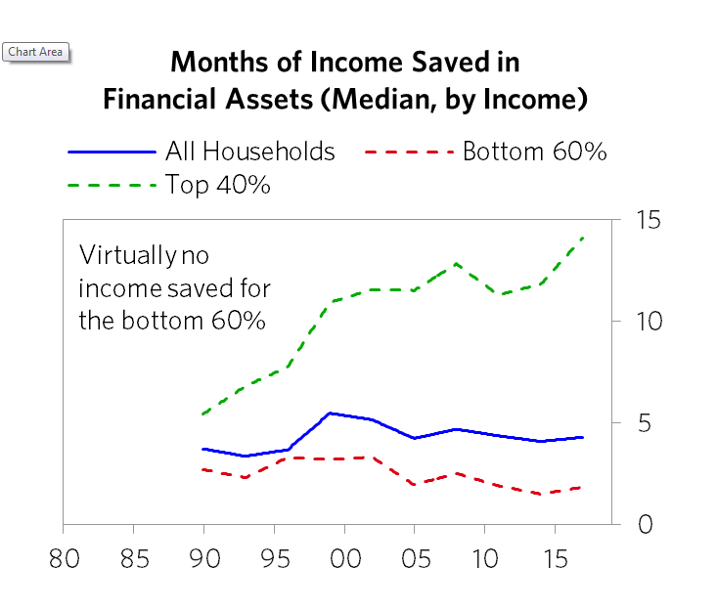

While there are a lot of factors contributing to flat/declining real wages, much of the weakness has been driven by the decline of middle-income occupations, like manufacturing. Many of the good jobs available to a high school graduate two decades ago have disappeared, and those that remain have seen below-average wage growth. The factors behind this are multifaceted—including technology replacing people, increasing globalization causing middle-class jobs to shift to emerging countries (principally China), and other macroeconomic shifts—which we won’t go into depth on here.

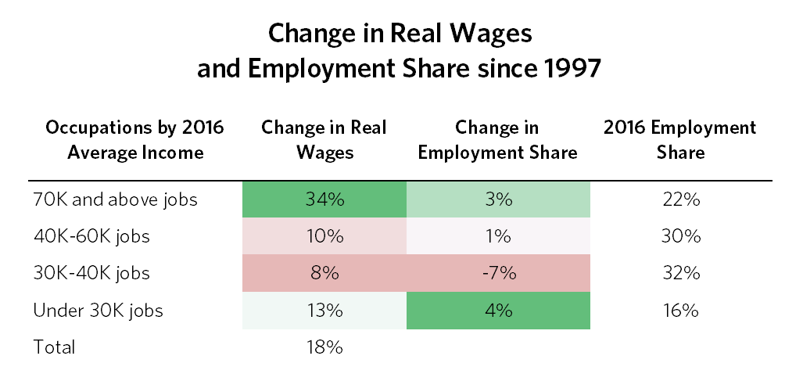

Those jobs have largely been replaced by two sets of jobs: higher-skill jobs, which aren’t accessible to non-college-educated workers, or low-skill jobs, which pay lower wages and which have experienced below-average real wage growth over the past several decades.

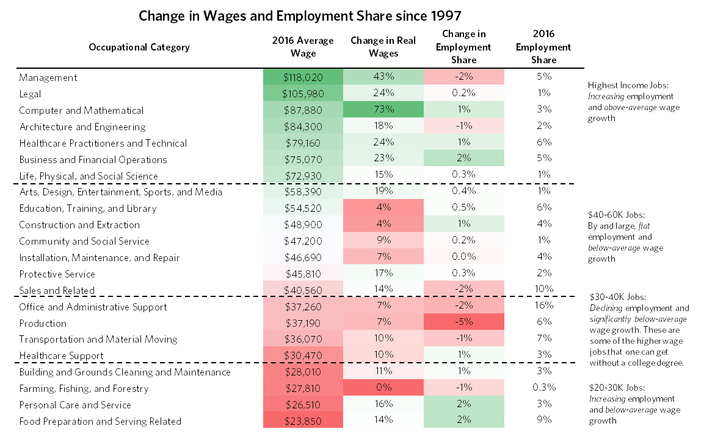

As job prospects have weakened, particularly for those without a four-year college degree, prime-age workers have increasingly dropped out of the labor force. As shown below, the share of prime-age men who are not in the labor force has doubled since 1980 and is now around 12%, with a large and widening divergence between those with a degree and those without. The decline in labor force participation among prime-age men has occurred throughout the developed world, but has been most pronounced in the US.

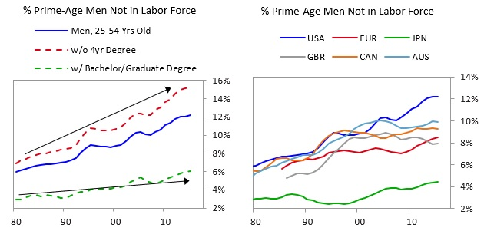

### More Detail on Health and Social Changes

The increase in premature deaths among the bottom 60% is largely because of an increase in deaths by drugs/poisoning (up two times since 2000) and an increase in suicides (up over 50% since 2000). Notably, while the increase in drug-related deaths is concentrated in the bottom 60% of earners, the rise in suicides is broader and doesn’t look as directly connected to income.

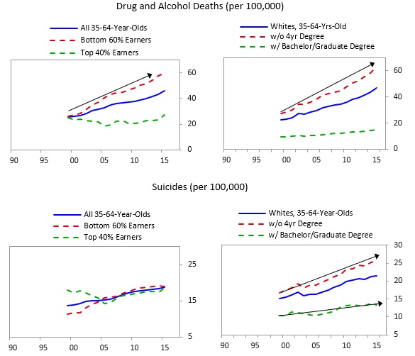

While many of the major causes of death have been flat or falling over the last 15 years, deaths from drugs and alcohol more than offset it among the bottom 60%. And the rise in drug-related deaths is not happening across the world—the phenomenon is unique to the US.

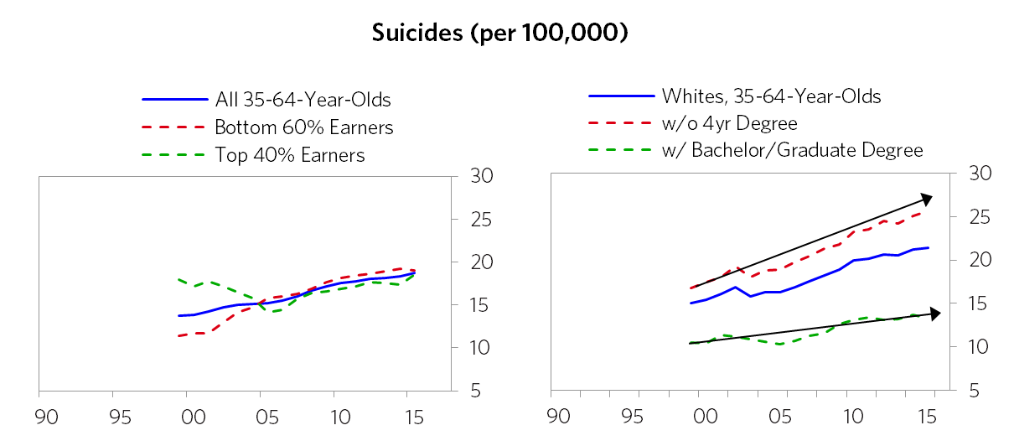

Overall, the US healthcare system is very expensive, is worse by many measures, and is generally failing the bottom 60%. The US spends about twice as much per person on healthcare compared to its developed world peer average.

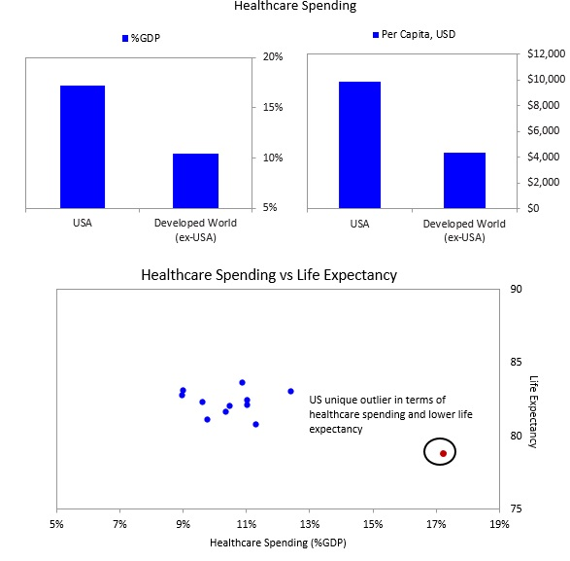

On many (but not all) measures of quality, US healthcare lags behind its developed world peers. Overall, public health is much worse in the US compared to other developed countries.

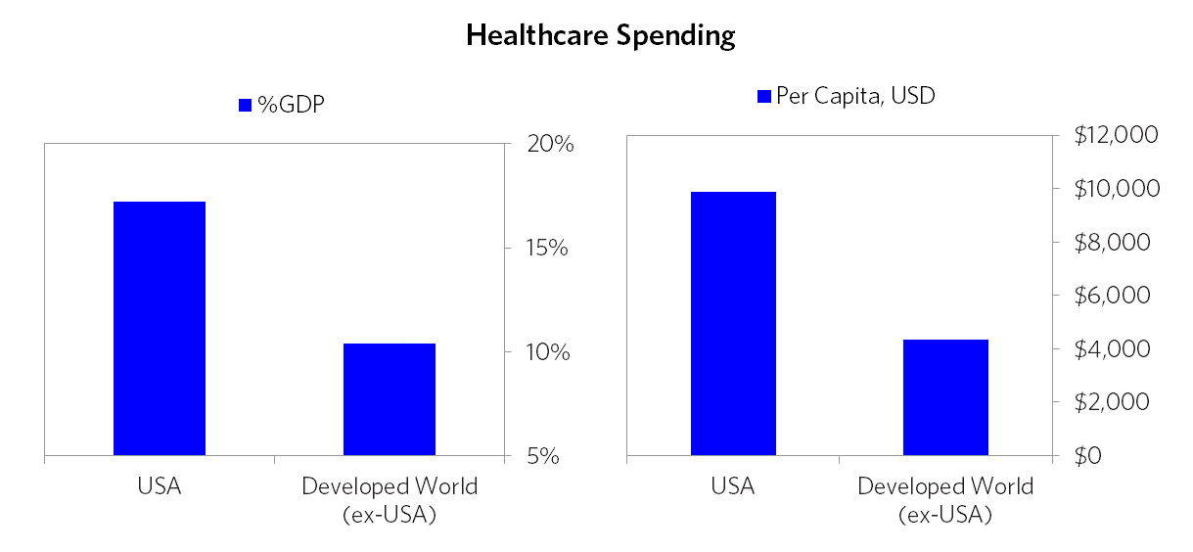

About 12% of the bottom 60% remain uninsured, and their spending on healthcare in total (including insurance) is about half that of the top 40%. The lack of access contributes to people skipping care: approximately one in every five patients in the US reports skipping medical tests, treatment, or follow-ups due to costs. This is nowhere near as prevalent in the rest of the developed world.

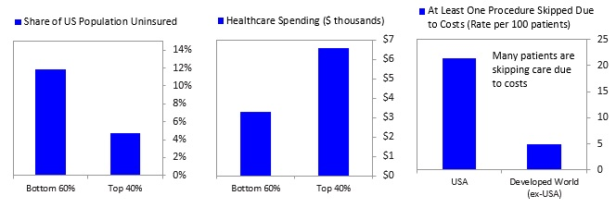

Other Social Indicators of a Growing Divide

* Along with spending, there is a meaningful gap in college graduation rates between those with parents in the top 50% versus the bottom 50%. Only 20% of students from families in the bottom 50% graduate college, compared to about 50% for those from families in the top 50%.
* Families of those who have not gone to college are breaking up at an accelerating rate that is now nearly twice that of those who have gone to college.

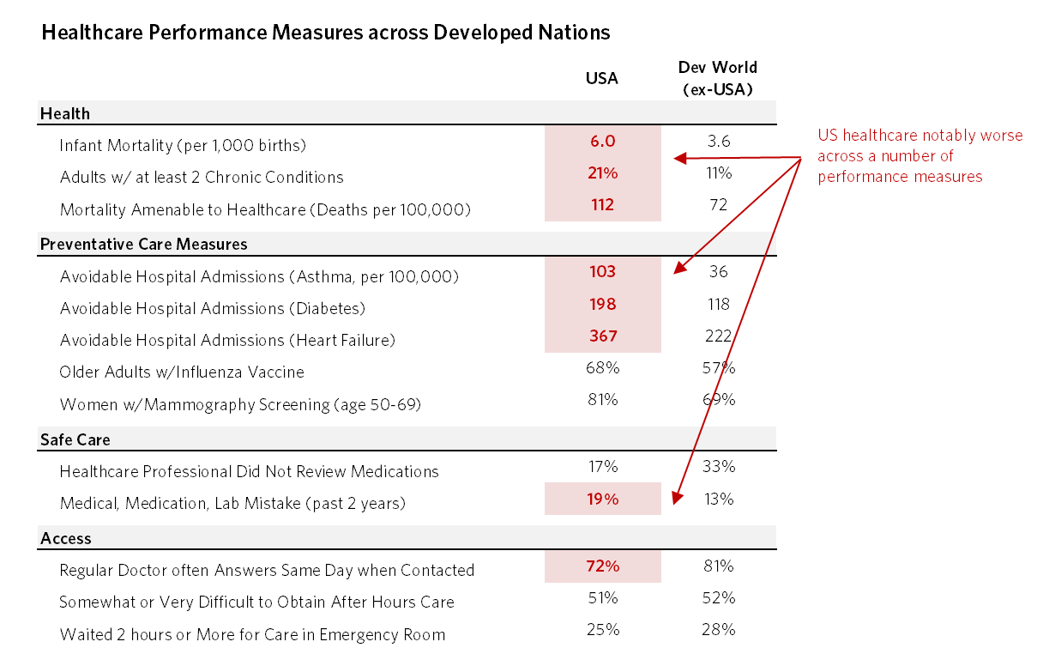

Relatedly, people living in small towns and rural areas are seeing their communities in decline. In these communities, white workers without a college education make up a large share of the population and were disproportionately dependent on manufacturing jobs that have decreased. Employment in these areas has not recovered since 2008, and population growth, which has been weak compared to the rest of America for decades, is falling. Notably, those communities have tended to have fewer people with four-year degrees, and this gap in education has expanded as economic opportunities in non-metro areas have declined.

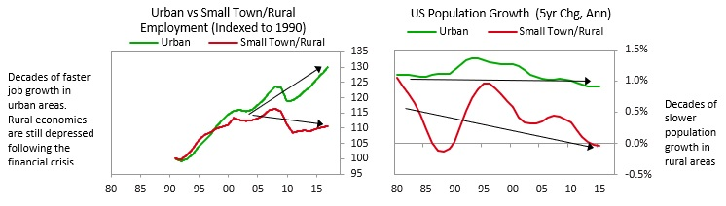

*While in our analytical work we look at economic statistics much more granularly (often in quintiles to divide into different groups, which gives us a much richer picture than is conveyed in these top 40% and bottom 60% groups), showing more groups and greater granularity would have created greater length and confusion. Still, I encourage you to look at the economy more granularly than shown here.

**To be clear, while my goal is simply to convey what is, rather than delve into what to do about it, I do want to be clear that giving money to be used for consumption rather than for improving production or cutting costs to improve efficiency (e.g., reducing incarceration rates and costs) will diminish the value of money and not increase the size of the pie. For that reason, some mix of a) directing resources so that they are used productively to generate more than enough income or savings in order to pay for themselves and b) productive wealth transfers appears inevitable. Hopefully the first of these paths will be maximized, though that seems unlikely based on existing political fragmentation and its trends.