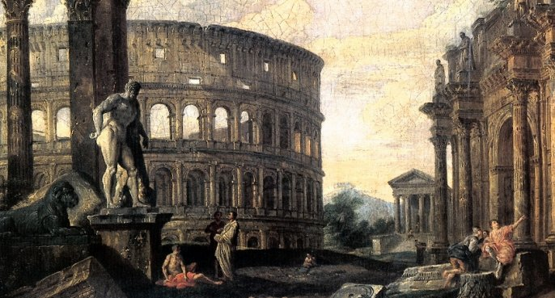

# The Seven Signs of an Empire’s End

* Published on Published on January 1, 2018

[Ernest Richard Rugenstein, Ph.D. Cultural History](https://www.linkedin.com/in/errugenstein/)

I teach history at a local college. When people ask me what “type” of history I usually say whatever my department chair needs. My Ph.D., graduate courses and experience allow me to teach American History, World History, Native American Cultural History, and the history of different time periods and locations (i.e. Medieval History or European History).

In class we discuss a number of different dynasties/empires throughout the world. These dynasties rise for different reasons and are of different sizes. Typically, a dynasty has its start on some sort of hereditary leadership based on family, power, or religiosity of the leader. Other times it could be by consensus of a nationality or ethnicity and over time land is captured and the population rises. In some instances, major minorities in the area are absorbed (Sorbs in Germany) and at other times semi-autonomous regions are created. We can name empires such as the Assyrian, Harrapan, Babylonian, Persian, Ottoman, Austro-Hungarian (Austrian), British, Napoleon, Russian, even the short lived 2nd Reich, the German Empire, all of which had humble beginnings and then rose to a world superpower.

Looking at world superpowers we see certain aspects in their demise. The one thing we find from history is that all empires, governments, countries, nation-states, rise and fall. It doesn’t matter “who” they are, there reason for creation or their ideology, all of them have a time of rise and progress when they get stronger and more powerful. Then they reach an apogee. They become the most powerful, influential and advanced as they will be. This rise might take centuries, at other times the circumstances are right and in a few decades, they are unassailable.

Next, there is a time of social and state consistency, the time of “Pax-Romana.” This time could last for centuries or decades or in some case just a number of years. However, regardless of the power, ideology or wealth they all begin to fall. It’s inevitable. By the way, all try to convince their populations, it won’t happen to them and it’s because the deity is on their side.

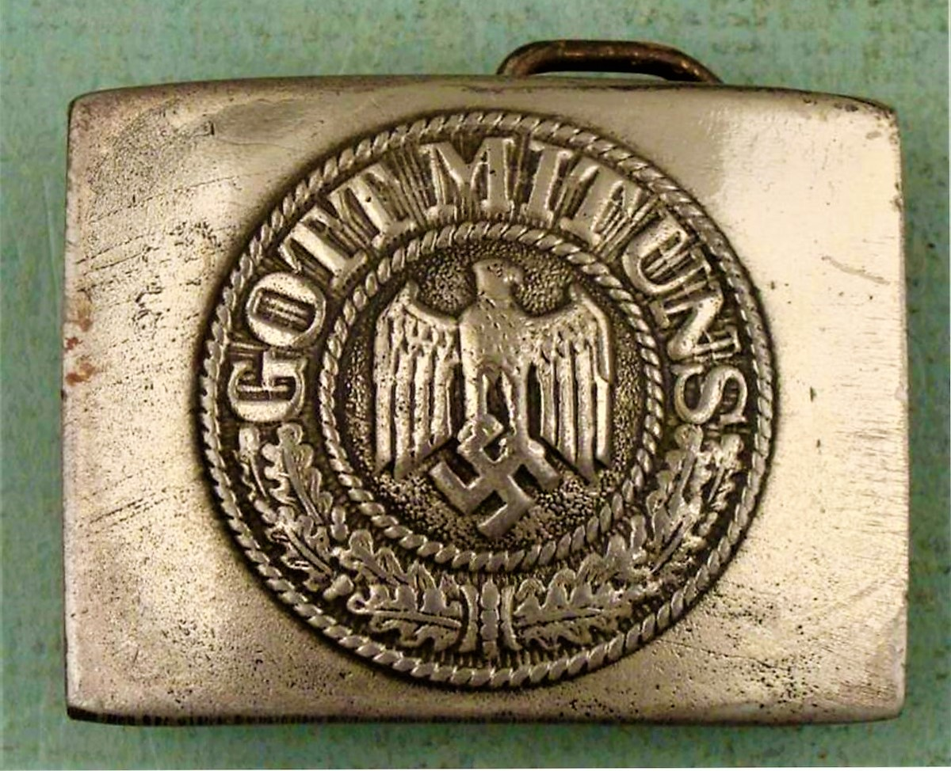

As I’ve said, all “empires” fall and for the same reasons. Some will argue with this but history seems to bear this out. As always some will say that this won’t happen to our country, we’re different, or there’s never been a country like us, or because of race, religion, creed, or something like that. It all sounds good, but it doesn’t matter, they all fall.

First, they become fixated on some form of ideology or mix of ideologies. This can be religion, economics, societal (centralized or decentralized), and of course politics. It can run its course from jingoism to cosmopolitanism; from condemning a religion or raising one to supersede the ideals of the state. Corresponding examples would be the Jewish religion in NAZI Germany or Christianity in Constantine’s “Roman Empire.” Over time this ideology/ies becomes part of the social construct of national identity. It begins to divide people into who belongs and who doesn’t belong and the beginnings of domestic Social Darwinism.

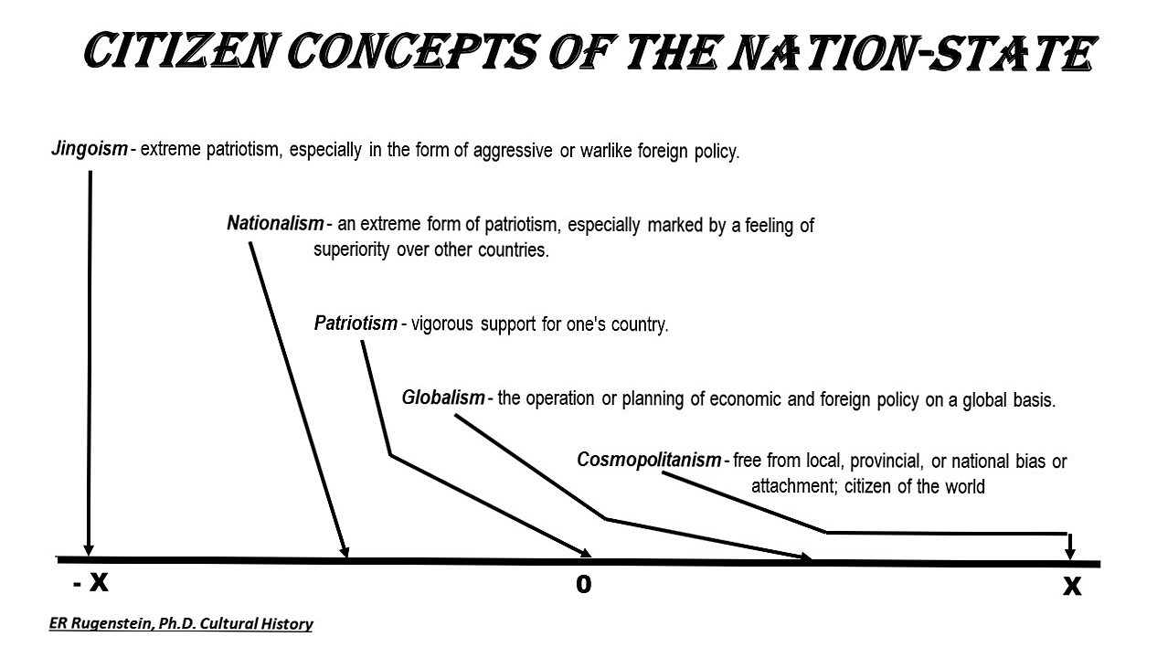

Second, is the superiority of amusement. During the Roman time period it was called moral decline, but in reality, that is just a small contributing factor. By far it was the “bread and circuses” of the masses that help bring about its demise. Along with this was the lack of emphasis of education and training. During this time citizenry became more interested in being “happy” than to see what was going on around them. They became more involved in amusing themselves with the pleasure of the empire and becoming less connected to involvement in their duties as citizens of their country. They followed who ever gave them a sense of protection and safety and played into their pleasure and wants regardless of the consequences.

One example of this is the need for mercenaries. Citizens less and less filled the ranks of the military and the government used mercenaries to do the job the citizen army no longer did. Some of the ranks of these mercenaries were ex-enemies of the empire and all of them were paid better and treated better than the troops. We see similar circumstances with the Ostrogoths of the Romans or the Yayas of the Ottomans.



Third, government corruption. This can come in many forms although it seems typically a combination of some mixture of oligarchs, plutocrats, and kleptocrats taking control of the government. It doesn’t matter the type of government either. They can be democratic with a parliament, an autocratic monarchy or any combination of political-economic union of governing. Regardless of the type of the government the overall effect is that the rich/powerful and their associates acquire more wealth and power while the poor and ignorant become locked in a cycle. When this occurs the under-privileged have nothing to lose if they revolt literally or figuratively. Anecdotally, it seems from pre-historic/Biblical times up to modern instances that when women enter into the revolt governments are doomed. Again, anecdotally.



Fourth, degrading public health. This can come in the form of plagues, diseases, substance addictions/abuses, and unintentional societal poisoning. It’s not that this can’t happen to many different societies, it’s the failure of society to address the problem. In some societies this takes the form of pandemics such as plaques and social diseases. Other times it could be poisoning through ignorance such as with the lead pipes of Rome or the nuclear testing and the spread of cancers across different parts of the US and the former Soviet Union. In fact, some could even point to the EPA’s Super FundSites or events such as Love Canal and Flint, Michigan as examples. Then there are the problems of wide spread drug abuse/addiction from the opium that destroyed China and caused the Opium Wars to the current heroin epidemic in the western hemisphere and the failure of battlers with the drug cartels of central America.



The fifth one could be considered nutritional challenges and stratification. This can come about for a number of reasons. It can be caused from exhaustion of the soil from over farming, drought, floods, or even over irrigation. Hurricanes and in some parts of the world, Tornados can also cause havoc for farming on land or in the sea. The result is food challenges for the population and of course along with this the stratification of the have and havenots. Added pressure such as this can intensify the burdens on society and the government which are trying to control or manage the situation. Worst yet, is if the governing authorities do nothing and let the lower classes suffer and ferment.

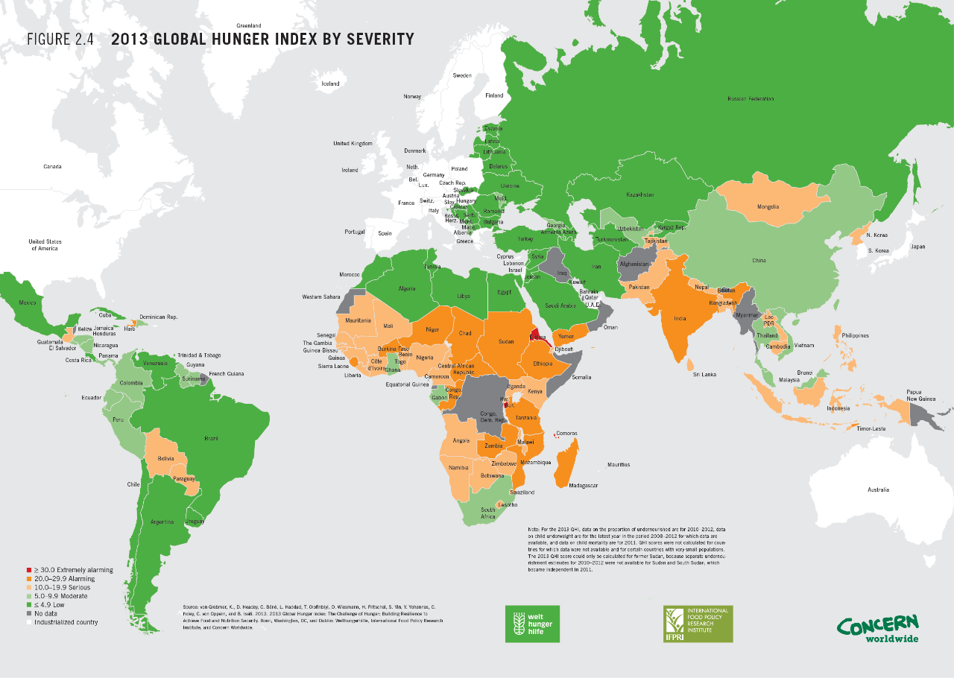

Over expansion along with jingoism or even nationalism makes up aspects of the sixth sign. The regime becomes over extended and over involved in the world. In fact, they strive for hegemony over their neighbors and promote fear over their enemies. We can look historically at empires from Assyria to Persia to the Ottoman Empire to the former Soviet Union. Of course, let’s not forget US Manifest-Destiny and the US hegemony over Cuba and its creation of colonies in the Pacific. This ever increasing of empire either physically or economically takes its toll on the population and constantly involved more and more of the governments priorities to control its possessions. Massive amounts of government wealth go towards control and propping up of territories militarily. This money all comes at the expense of infrastructure, the hindrance of research and development and limiting the betterment and expansion of education.

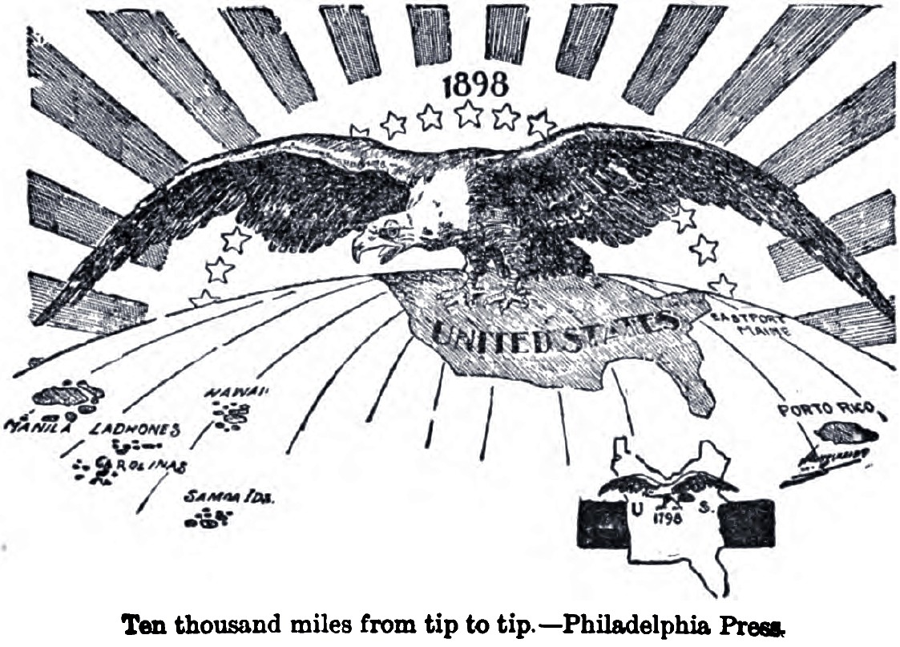

The last and seventh sign is the constant feeling of perpetual external warfare against the “nation-state.” For the Assyrians it was the Medes and the Chaldeans with the Hittites mixed in, for Rome it was the German Invasions. For the German Empire, Austro-Hungarian Empire, Russian Empire, and the Ottoman Empire the Great Warwas the culprit. Overexpansion and the need to control your interest requires constant conflict. Populations lose their incentives to plan for the future when they don’t know what the future might be or who may invade it. This can make a lasting impact on a country.

When we think of the first Industrial Revolution we think of Great Britain, or as Napoleon said, “A nation of Shopkeepers. . .” But why didn’t the Industrial Revolution begin in France. It had the Napoleonic Code with free contracts, open markets, and clear uniform regulations. The government had standardized weights and measures, even establishing technical schools. The there was a centralized Bank of France and an encouragement of inventors and inventions which were publicly honored. So why Great Britain instead of France.

France had years of war which brought about heavy debts. High unemployment in some sectors of the economy and in some regions of the country were limited in development. Also, the returning soldiers created economic and social problems in some sections of the country. When a regime is constantly experiencing warfare or some form of perpetual warfare it cannot use its time, talent, and resources to move forward and it will eventually harm the society overall.

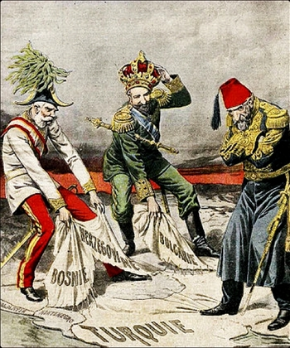

Nations, regimes, countries all suffer from these situations. One, two or even three of these signs doesn’t matter to a superpower, but when they all come into alignment, when they all occur then the result seems inevitable.

All empires no matter how strong, powerful, or unique eventually fall. . .