**The Key to Understanding Household Consumption Patterns in China**

The Year of the Snake does not look auspicious for conspicuous consumption in China. The country’s newly-installed top leader, Xi Jinping, is urging officials to curb their appetite for lavish banquets. A broader anti-corruption campaign has also hit the market for the expensive luxury goods used for gift-giving. But these are political ripples on the surface of a huge wave of rising Chinese consumer spending. Even if China’s economic growth slows significantly, over the next decade hundreds of millions of people will join the modern consumer economy. My model of China’s household income distribution indicates that the fastest growth in demand will no longer be for basic consumer goods, but for goods and services favored by the newly affluent, such as international air travel and high-end beauty products. Catering to the Chinese nouveau riche is a growth market for which the best days are yet to come.

A framework for analyzing consumer spending starts with the simple observation that the propensity to spend on certain goods does not rise proportionally with income, but moves in steps. Households that are barely above a certain income threshold are much more likely to buy say, a car, than households just below it. This gives rise to what I call the “acceleration phenomenon”. The acceleration phenomena causes demand for certain goods and services to grow at a disproportional rate to household average income when a percentage of the population’s income crosses certain income thresholds. The acceleration phenomenon has clearly had powerful effects in China as passenger car sales grew more than 20% a year over the past decade[1], while real urban incomes grew just 9%. How this works in theory is shown in the figure below, using a stylized income distribution and a hypothetical threshold of US$15,000.

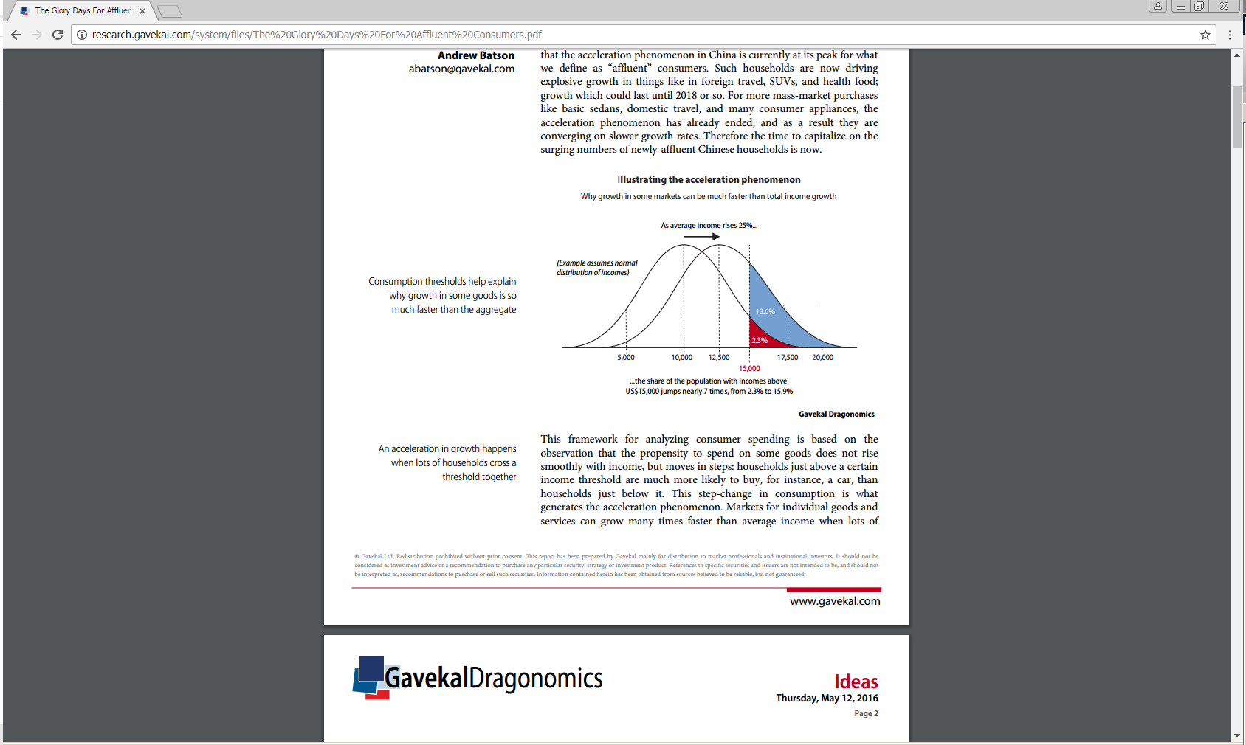

This theory does not tell us much about the actual dynamics of the acceleration phenomenon in China, since it occurs for different product categories at different income levels. The largest of which tend to come in the early stages of acceleration. To put this theory to work, one would need to know two things: the shape of China’s income distribution curve and the relevant thresholds for consumer spending. Using income data from the China’s National Bureau of Statistics and the World Bank[2], I created real household income distribution curves for China (see the appendix for the technical details). The main difference between theory and reality is immediately obvious from the chart shown below. Rather than being a smooth, normally-distributed hump, China’s household income distribution is negatively skewed with a long right tail. This reflects the degree of household income inequality. As such, the actual acceleration phenomenon will not occur as shown in the chart above because of the difference in the shape of the distribution.

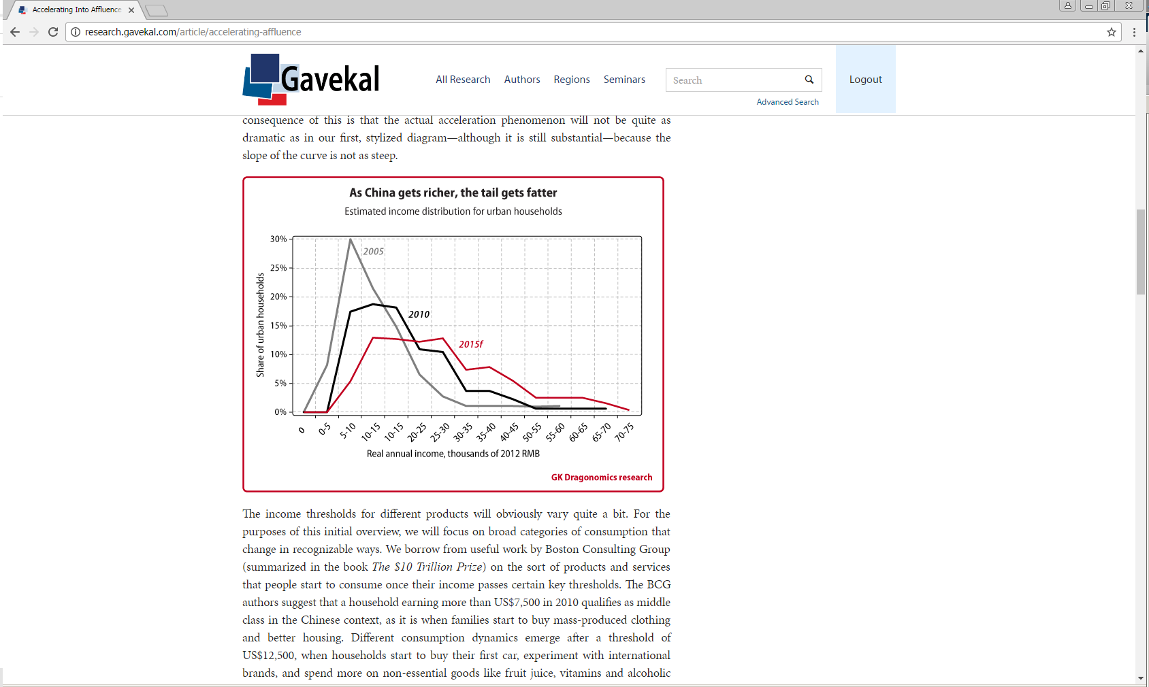

The income thresholds for different products will obviously vary quite a bit. For the purposes of this analysis, I will focus on broad categories of consumption that change in recognizable ways. I use work done by the Boston Consulting Group[3] (summarized in the book, “The $10 Trillion Prize”) to define the products and services where people begin to consume once their income passes certain key thresholds. The BCG authors suggest that a household earning more than US$7,500 in 2010 qualifies as middle class, in the Chinese context, as it is when families start to buy mass-produced clothing and better housing. Different consumption dynamics emerge after a threshold of US$12,500, when households start to buy their first car, experiment with international brands, and spend more on non-essential goods like fruit juice, vitamins and alcoholic drinks. After crossing the threshold of US$19,000, households start to spend more on travel, recreation, fancier household goods and small luxuries such as coffee and wine. Assuming that BCG’s income thresholds are plausible, I adjust household income and consumer goods and services using 2012 prices and exchange rates. These thresholds are used to divide China’s consumer population into three major categories: Emerging Consumers (household income above US$8,100 but less than US$13,500), Established Consumers (US$13,500-$20,550) and Affluent Consumers (over US$20,550).

Using these household income thresholds distributions, one can start to pinpoint just how the acceleration phenomenon has played out in China, and where it is headed next. In 2012 China was home to 75 million Emerging Consumer households, 51 million Established Consumer households, and 57 million Affluent Consumer households, leaving 265 million households below the Emerging Consumer threshold. In order to forecast the growth of these household groups, I assume conservative rates of real income growth (falling to 5% by 2020 from over 10% in recent years), RMB appreciation of 2% per year relative to USD (down from 3.3% during 2005-2012) and urbanization in line with UN projections. Given these assumptions, by 2020 the number of Emerging Consumer households is modeled to rise 9% to 82 million, Established Consumer households to rise 43% to 72 million, and Affluent Consumers to rise 223% to 184 million, while the number of non-consuming households will shrink to 120 million. Assuming the variables used to estimate these growth rates are fairly accurate, the percentage of households whose income is greater than the Affluent consumer spending threshold will grow at a faster rate relative to the other two categories.

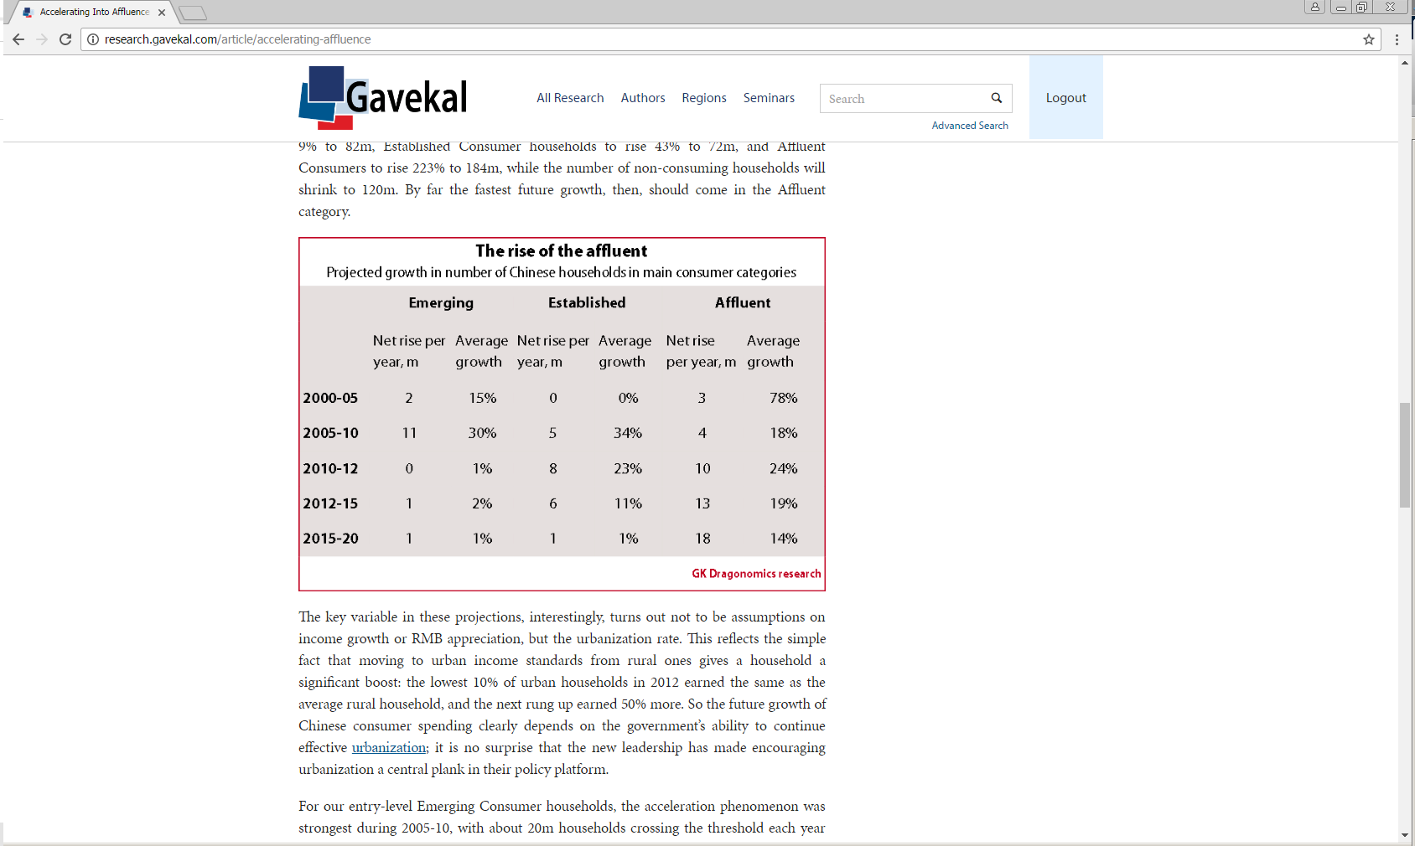

The key variable in these projections, interestingly, turns out not to be assumptions on income growth or RMB appreciation, but the urbanization rate. This reflects the simple fact that urban income standards are higher than rural ones giving households a significant initial boost. The lowest income decile of urban households in 2012 earned the same as the average rural household and the next income decile up earned 50% more. Given this shift in initial real income, the future growth of Chinese consumer spending clearly depends on the government’s ability to continue its effective urbanization project. It is no surprise that the new leadership has made encouraging urbanization a central plank in their policy platform.

For our entry-level Emerging Consumer households, the acceleration phenomenon was strongest during 2005-10, with about 16 million households crossing the threshold each year and their total number growing at 30% a year. As the table above shows, the net annual increase in Emerging households was a smaller 11 million, because 5 million households each year moved up into the Established category. These years saw a boom in modern retailing and sporting goods. However, the growth phase for this category of consumers is probably over. The character of the new Emerging Consumers will also change, as the majority of those crossing this threshold in coming years will originate from rural areas and smaller cities.

China’s Established Consumers have come into their own more recently, with the acceleration phenomenon kicking in strongly in the latter years of the last decade. Those were the boom years for China’s auto market as the totemic purchase for these consumers was a car. An international comparison of car ownership and income levels suggests that vehicle ownership takes off somewhere around US$4,000 or US$5,000 per capita which is near the US$13,500 household income of the Established consumer category. The stock of passenger cars in private ownership indeed corresponds well with my estimates for the number of households above this threshold as shown in the chart below.

Still, the high-growth phase is probably close to over for Established Consumers as the 20% plus annual growth in the net size of this group will slow to 11% in 2012-15 and to just 1% in 2015-20. Around 20 million households will cross the threshold every year. However, the net increase will slow from 8 million to 6 million between 2012 and 2015 and then to 1 million between 2015 and 2020. Yet the number of Established and Affluent households that can afford a car will rise significantly, from 107 million today to 164 million in 2015 and to 256 million by 2020. Assuming consumer preferences of certain goods and services remain constant, growth rates in auto sales should exceed nominal GDP growth for the next decade. There is no guarantee that China will follow the patterns of car ownership seen in other countries, but the limiting factors will be government policy and urban planning, not incomes or affordability.

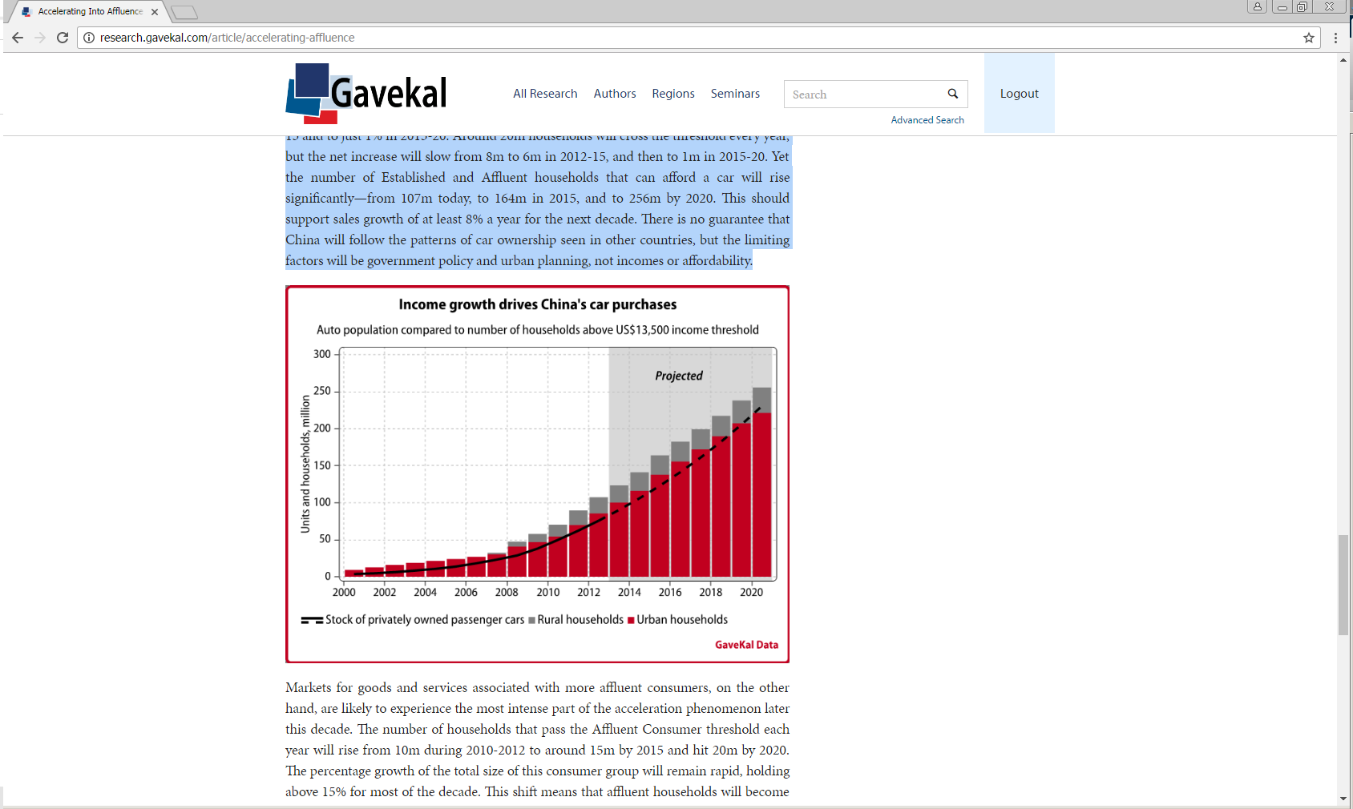

Markets for goods and services associated with more affluent consumers are likely to experience the most intense part of the acceleration phenomenon later this decade. The number of households that pass the Affluent Consumer threshold each year will rise from 10 million between 2010 and 2012 to around 15 million by 2015 and hit 20 million by 2020. The percentage growth of the total size of this consumer group will remain strong, holding above 15% for most of the decade. This shift means that affluent households will become the fastest growing part of China’s consumer economy, with significant implications for the type of products that will experience rapid growth. For Affluent Consumers, experiences begin to trump products as a source of satisfaction and prestige from foreign travel to ballet classes for their darling youngsters. The first stages of this shift are apparent in some statistics from Boeing, air travel between China and Europe/North America grew 17% in 2011 to 179 million trips. As China’s Affluent Consumer households grow in number, the shift towards greater consumption of services should also accelerate. Unfortunately this trend will be difficult to monitor, as there are few high-frequency gauges of activity in China’s service sector.

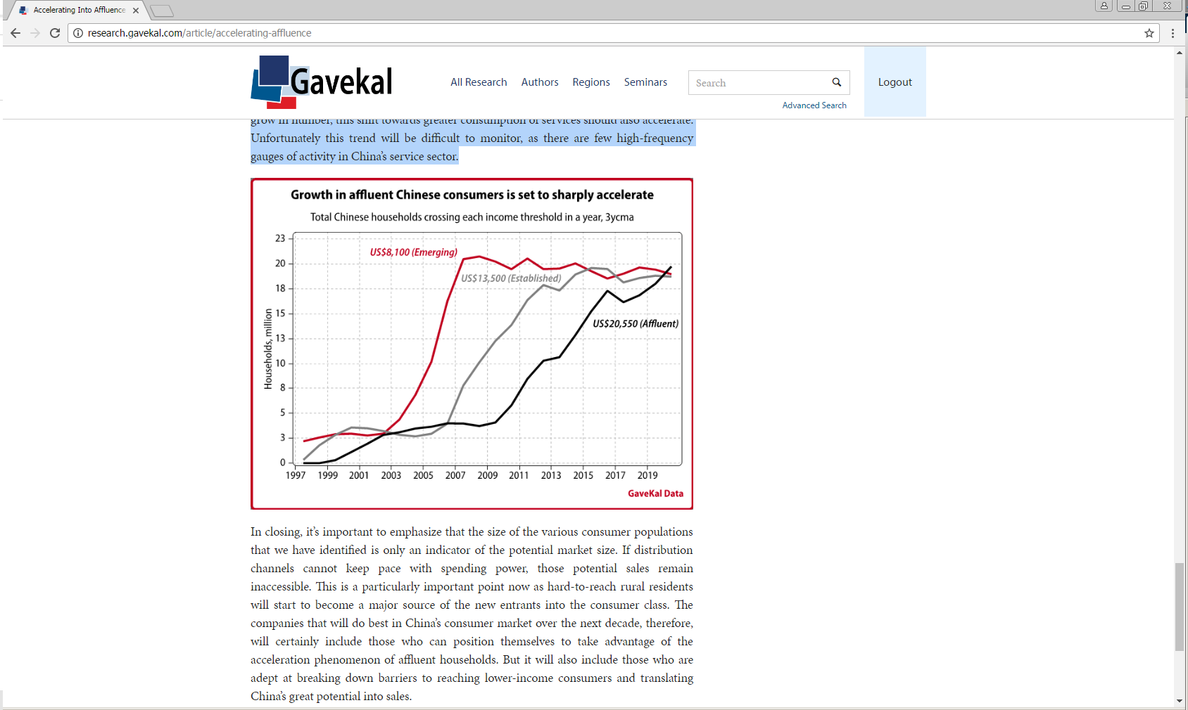

In closing, it’s important to emphasize that the size of the various consumer populations that we have identified is only an indicator of the potential market size. If distribution channels cannot keep pace with spending power, those potential sales remain inaccessible. This is a particularly important point now as hard-to-reach rural residents will start to become a major source of the new entrants into the consumer class. The companies that will do best in China’s consumer market over the next decade, therefore, will certainly include those who can position themselves to take advantage of the acceleration phenomenon of affluent households. But it will also include those who are adept at breaking down barriers to reaching lower-income consumers and translating China’s great potential into sales.

**Brian Fagan**

**MacKay Shields, March 2013**

About the Author: Brian joined the Global Fixed Income group at MacKay Shields in July of 2013 as a macroeconomic and quantitative research analyst. In this role, he works with the firm’s Chief Investment Officer designing and managing corporate cash and derivative fixed income strategies. Prior to joining the firm, he was in the New York Life Investment Analyst Program as an emerging market corporate research analyst from 2011 to 2013. Prior started his career at AllianceBernstein, where he was a member of the Global Analytics team as quantitative risk analyst. Brian received a B.S. in Applied Mathematics, magna cum laude, from Manhattan College in 2010. Brian is a level III candidate in the CFA program.

**Technical appendix (Updated in May of 2016)**

The basis for our income distribution model is the official data on the income of urban and rural households from the National Bureau of Statistics’ household survey. Historically, income distribution by quintile was reported separately for urban and rural households, but in 2013 the NBS also began reporting a unified nationwide income distribution. Unfortunately, this income distribution is less detailed than the combination of the urban and rural distributions, and also difficult to reconcile with those separate reports. Given the opaque nature of sampling techniques used by China’s NBS, I use the separate urban and rural income distributions rather than the unified one and add additional detail from the World Bank’s PovcalNet[4] database. This database has access to more NBS household survey data than other public sources. Although there is missing data for some years, requiring interpolation, and is only available up to 2012, it allows a more finely grained picture of the income distribution. This allowed me to see, for instance, that the top 10% of urban households (or roughly the top 5% of all households) earn 28% of total household income.

However, the income reported in the household survey appears to be somewhat incomplete. In the national accounts, total household income ends up being 30-40% larger than the total income implied by the household survey. In 2013, the flow of funds shows total household income of RMB35.7trn, while the household survey shows total income of only RMB24.9trn. The main difference between the two is that the household survey captures mainly cash income, while the flow of funds captures a broader range of compensation, including employee benefits, and has better sources for some income that is under-reported in the survey. The flow of funds should thus be the most accurate measure of total income, but it lacks data on the distribution of income. The difficulty then is how to allocate the additional income found in the flow of funds across different income groups, and there is no clear-cut method for doing so. The best source I could find was the work of Chinese economist Wang Xiaolu[5], who conducted private surveys to estimate the extent of household income not reported to the government, and estimated how the income distribution would change as a result.

I did not directly borrow Wang’s results for two reasons. First, Wang’s survey and methodology implies that total household income in 2008 was 30% higher than shown in the national accounts, and 70% higher than shown in the NBS household survey. To me, this is simply implausible. While there is still some under-estimation of household consumption in China’s national accounts, there is no credible evidence that such massive sums are going missing. Second, Wang’s results imply an extreme level of income inequality that is also implausible. His income distribution gives a Gini coefficient of 0.65 for 2010, while the official household survey has a Gini of 0.46, and independent household surveys[6] yield Gini coefficients of 0.50- 0.58. Nonetheless, Wang’s survey results at least provide some objective basis for understanding how much of the income missing from the household survey accrues to different groups. In order to incorporate conservative measures while using meaningful trends in my model, I used Wang’s adjustments but constrained them so that the total household income stayed consistent with the national accounts data. This reduced his adjustments by roughly half for most years. For instance, in my model around 40% of missing income is allocated to the top 10% of urban households in 2008, raising their average income by 207%, while Wang allocated 63% of missing income to that 10% of households, raising their average income by 320%. By making this adjustment, the Gini coefficient for 2010 was 0.57 which is within the range of independent survey estimates.

After making these adjustments to the official data, I end up with per capita income by decile for each year from 1995 to 2015, deflated to constant 2015 prices. I then simulated a frequency distribution to estimate how many individuals would be at given income levels each year. To start, I began with 20 data points (10 deciles each for urban and rural households), and interpolate data points between the average to generate a curve. Lacking detailed data on the top of the income distribution, I assumed the shape of the distribution of the top 5% of both urban and rural household incomes was exponential. The income of the 96th percentile is 6.4% higher than the 95th percentile, the 97th is 6.5% higher than the 96th, and so on up to the top 0.1%. Using this simulation I then estimated the number of households above or below a given income threshold for a given year. This is the basis of the acceleration phenomenon.

Finally, in my model I chose to set the “affluent” threshold as the highest income threshold. If I set an income threshold above “affluent,” the output would indeed show that the acceleration phenomenon has a next stage, as the number of households above that threshold will start to rise rapidly at some point. However, it is not clear that affluent households today make near automatic purchases of a few types of goods when they achieve even higher income levels, in the way that they did when they could first afford a car or a foreign vacation. It is the strength of the association between income thresholds and changes in purchases of certain goods and services that matters. The strength between these variables weakens as incomes get higher and choice and taste play a greater role. In order to understand the changing dynamics of consumer purchases and its effect on certain goods and services, accurately measuring acceleration phenomenon is crucial. This tool is less useful when majority of a country’s household income distribution is already part of the modern consumer economy and the growth in real wages remains relatively unchanged over a given time period.

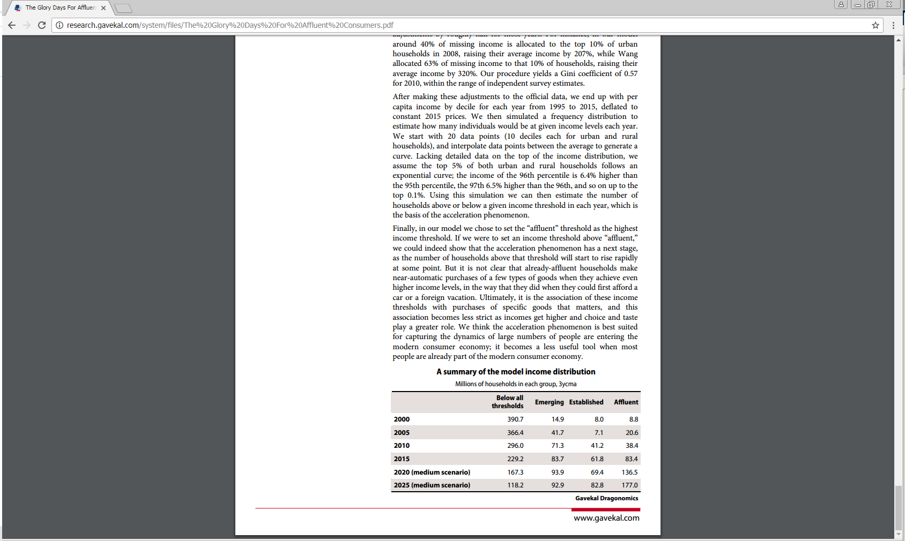

1. Haver Analytics, China Association of Automobile Manufacturers
2. <http://iresearch.worldbank.org/PovcalNet/povOnDemand.aspx>
3. <http://www.bcg.com.cn/export/sites/default/en/files/publications/reports_pdf/BCG_The_Age_of_the_Affluent_Nov_2012_ENG.pdf>
4. <http://iresearch.worldbank.org/PovcalNet/povOnDemand.aspx>
5. <http://faculty.econ.ucdavis.edu/faculty/woo/9.Wang-Woo.Hidden%20Income%20in%20China.2010-12-25.pdf>
6. <http://www.pnas.org/content/111/19/6928>