# CONVERTIBLE BONDS AND THE TERM STRUCTURE OF VOLATILITY

By [Peter Zeitsch](https://insight.factset.com/author/peter-zeitsch), Tom P. Davis, PhD, CFA  |  December 16, 2019

The aim of any convertible bond (CB) model should be to capture the hybrid nature of the risk. Pricing models generally split the exposure into fixed income and equity components. The focus here is the equity, which is a long-dated option embedded in the bond. Maturities for exchange-traded options don’t usually trade beyond one to two years. With CB maturities invariably being at least three years, the CB option has a unique tenor. Irrespective of the approach chosen to price the bond, all models require a view of the issuer credit risk and equity volatility. Corporate debt and CDS trade to similar maturities to CBs, whereas vanilla equity volatility markets do not. Consequently, marking the volatility is problematic. There are in excess of 1,800 daily closing CB prices maintained by FactSet. Rather than derive a theoretical price from short-dated volatilities, the credit risk can be marked to term and the volatility can be implied from the bond price itself. The result is a full risk neutral calibration. The equity implied volatility term structure has now also been substantially extended. The question is then: Do the two markets agree?

#### THE VOLATIVITY SURFACE

To answer the question, we need to first define what that agreement might look like. Any model that we choose that has dynamics for both equities and volatilities will typically have a negative correlation between the two. This price action is readily observed in the market. For equities, just plot the S&P 500 against the VIX index of implied volatilities and the relationship is clear. In terms of equity options, the idea is that (on average) the volatility will decrease when the forward increases and vice versa. As option tenor increases, the forward naturally increases and the volatility should decrease. In other words, long-dated vols generically trade at lower levels than short-dated vols. Returning to convertible bonds, the question is: Does the negative correlation between prices and vols hold across asset classes? If we link exchange-traded equity volatilities to CB implied volatilities, do we obtain “VIX-like” price action? The answer is yes, we do. The asset classes are consistent.

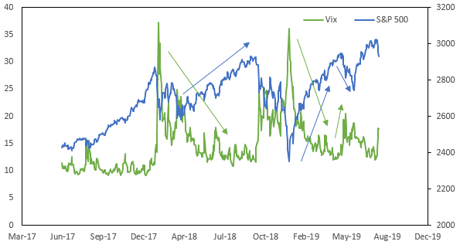

To illustrate this, take the Chesapeake 5.5% 2026 CB. The CDS for this name trades in the market. As this is the spot price of the credit risk, it allows the credit component of the CB to be explicitly priced. Marking to the CDS, the volatility is then implied from the bond price. FactSet maintains closing prices back to February 2018. Across the entire time series, the CB implied volatilities are lower than exchange-traded volatilities. Furthermore, the implied volatilities track the exchange-traded volatilities with correlations ranging from 47% to 51%. The result is a consistent view of implied volatility that now extends to 8-year maturities that agree with the expected term structure.

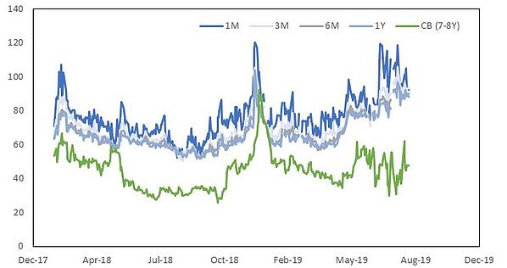

#### ****THE ARBITRAGE****

The next question is: When does this break down? Alternatively, if the volatility term structure should hold, when price dislocations occur, how do you monetize them? Dish Network Corp has two outstanding CBs; the Dish 2.375% 2024 and Dish 3.375% 2026 bonds. Take the shorter-dated bond. Plot the exchange traded volatilities and the CB implied volatilities. Also, plot the share price against the bond price for the same dates.

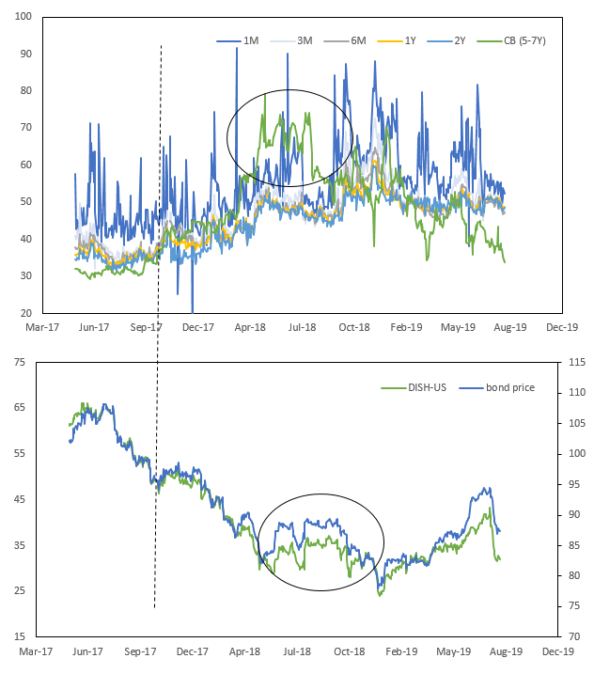

Up until September 2017, the CB implied vols traded below the exchange-traded volatilities. At the same time, you can see that the bond price closely tracks the share price. That breaks down in the 4th quarter of 2017. The CB vols trade up and the CB price starts to split from the equity price, essentially the bond is richer. By mid-2018, that dislocation peaks with 6Y volatility trading higher than 3M vols. So, what’s it worth? About six points. The bond price trades up from 83 to 89 before trading back down. By the third quarter of 2018, the message is clear: The Dish 24 bond is too rich. Sell the bond.

Now let’s say you can’t actually trade on this; maybe the transaction costs are too high or it’s against your fund’s mandate. What can you do? Sell protection on the CDS. See below. The CB implied vols and the 5Y CDS track closely. As a spread product, volatilities increase with the forward rate. What else does it tell us? In 2019, the CB implied volatilities have traded down by 30 vol points. They are now below exchange trade levels. For the first half of 2019, the CDS was unchanged. The signal was that the CDS was too wide. The CDS finally tightened in the third quarter. In effect, the CB implied vols are acting as a leading indicator. Cutting to the chase, the CDS has begun to widen again while the implied CB volatilities continue to decrease. Again, the signal is to sell protection.

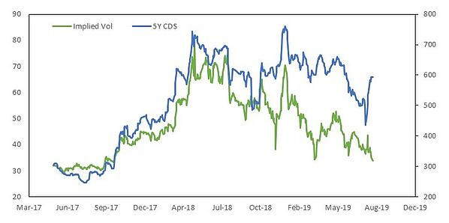

#### ****CONCLUSION****

In conclusion, the CB implied volatilities themselves are VIX-like. For the two DISH bonds mentioned above, the implied volatility for the longer-dated bond does indeed trade at lower volatility than the shorter-dated security. By inferring equity vols from these CB prices, we can extend the DISH equity vol surface out to 10y maturity—something impossible based on exchange-traded options alone.

