**Lab-Grown Meat Is Healthier.**

**It’s Cheaper. It’s the Future**

##### In Brief

* Since 2013, the price of lab-grown meat has dropped from around $325,000 for five ounces to just $11.36, making it 30,000 times cheaper than it was previously.
* Not only could lab-grown meat help us eradicate global famine, it's also better for the environment than traditional meat production.

## Going Meatless

The concept of lab-grown meat isn’t new, and several companies are hoping to perfect the process. [Memphis Meats](https://futurism.com/eating-lab-grown-pork-next-five-years/) is developing a way to create meat without slaughtering animals, [Tyson Foods](https://futurism.com/lab-grown-meat-tyson-is-making-a-massive-investment-in-a-meatless-future/) has launched a venture capital fund investing in the future of meatless meat, and Mosa Meat hopes to serve the first lab-made burger in just five years.

But the challenge isn’t necessarily creating the best looking and tasting meatless alternative — it’s pulling down the cost of production so that consumers will see it as a viable alternative to the real thing.

In 2013, it [cost around $325,000](http://www.nytimes.com/2013/05/14/science/engineering-the-325000-in-vitro-burger.html) to engineer a five-ounce in vitro hamburger constructed from pieces of beef muscle tissue all grown in a lab. Now, with advances in the industry steadily pushing this field forward, the price has been whittled down to just $11.36 — that’s 30,000 times less than when it was first introduced.

This makes lab-grown meat just three or four times more expensive than traditional ground beef, so if the biggest barrier to getting engineered meat to market is cost, then it looks like we’re well on our way.

## The Future of Meat

Assuming the most ideal growing environment, stem cells can produce a lot of meat. A single turkey cell could theoretically be used to produce enough muscle to manufacture 20 trillion turkey nuggets. Given the growing demand for food worldwide, something like this has the potential to address pressing concerns about the industrial food system.

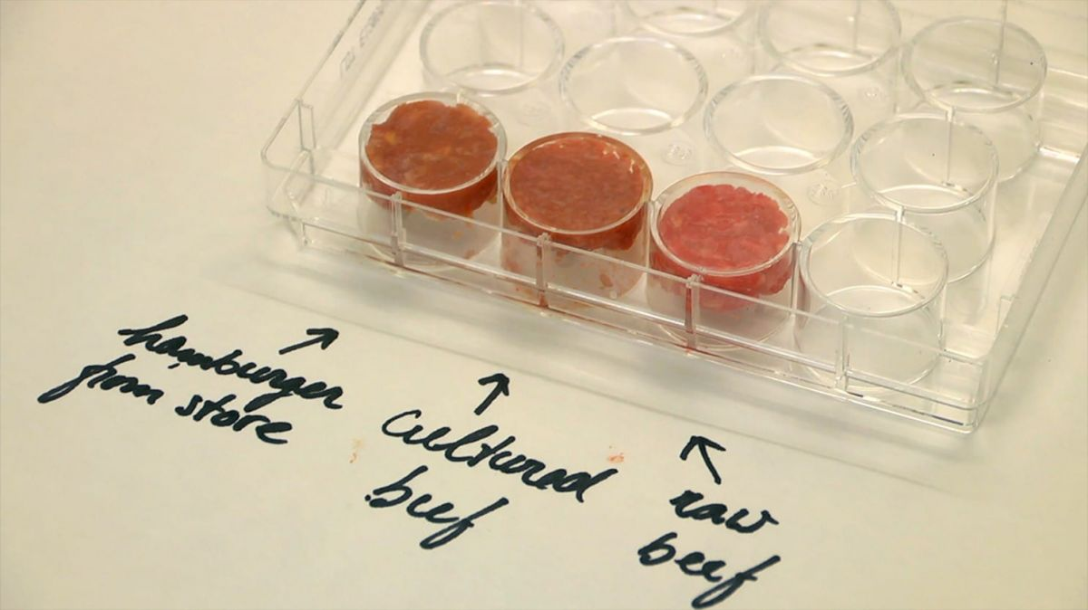Image Credit: Maastricht University

Switching to in vitro meat will also have major environmental benefits. Today, the industrial food system’s objective is to meet the growing demand for food by raising livestock on a small amount of land and producing meat at a very affordable price. This has led to mass production livestock farms that emit massive amounts of greenhouse gases. Growing meat in labs could reduce this by 90 percent and lower land use by 99 percent.

Looks like lab-grown meat is full of benefits, so now we just need to make it economically viable and convince people to take that first bite of a lab-grown burger.