It may not be as crazy as it sounds. According to NOAA, there is about 20 million tons of gold in the ocean. As people have discovered for over a century, it is so dilute that any method for extracting it would cost more than the gold it produced. Let’s imagine that after a fairly significant expenditure on research and development, we developed a technology that could extract the gold at a very low cost. How profitable would it be?

The gross profit would be the current price of gold less the cost to extract it. Unfortunately, price is a function of supply and demand. Two problems arise immediately after this technology is introduced. First, supply floods the market (because we are greedy) and decreases the equilibrium price of gold. Second, if our technology is imitable or substitutable (the terms used by Dr. Jay Barney), others will develop a method similar to it and continue to push the equilibrium price all the way down to the cost of production. See the sketch below:

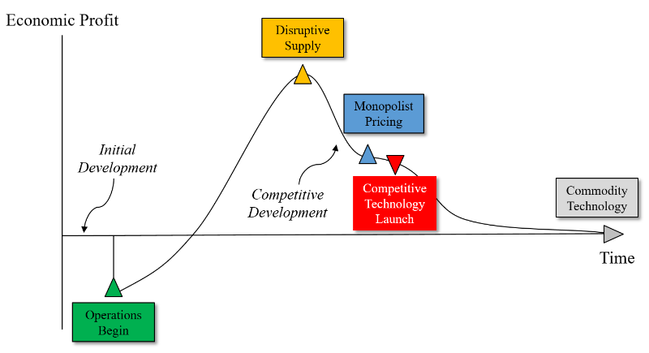

The first problem is not a deal breaker. If we have the capacity to push every other player out of the market, we will be able to set prices above our costs. Therefore, the second issue of competition is the most concerning. We developed this technology, why can’t someone else? Patent protections or trade secrets may keep our business protected, but the competitors will ultimately acquire the means to imitate or substitute for our process. The ultimate conclusion of this thought experiment is that technical innovation cannot produce a competitive sustainable advantage. Although the economic profit of bringing an innovation to market may initially be very lucrative, it is transitory.

It is helpful to understand that technical innovation only provides the opportunity to create sustainable competitive advantage. It is not the advantage in itself. With this understanding, I can explain that synthetic biology can provide the opportunity to develop a product which is unique. Leveraging this distinctiveness to create irreplaceable value for customers should be the primary objective. That is, only a synthetic biology product that can be differentiated from a firm using identical technology will have sustainable value.

"I failed 3 times in college. I applied 30 times to get a job but I was always rejected. When KFC came to China for the first time, we were 24 to apply and I was the only one dismissed. I wanted to go into the police but I was the only one not accepted. I applied 10 times to Harvard University in the US and I was rejected. "

Jack Ma, Alibaba Creator and 22nd World’s richest man according to fortune and according to Forbes 2015 list with $29.8 billion net worth. Moral of the story, never give up because you failed once or twice, know that failure is sometimes the universe telling you that your mission in life is somewhere else.

<http://www.bloomberg.com/news/articles/2016-05-03/super-rich-were-first-to-bail-when-lehman-collapse-ripped-stocks>

<http://areas.kenan-flagler.unc.edu/Accounting/TaxCenter/taxsym2016/Documents/Who%20Sold%20During%20the%20Crash%20of%202008-9.pdf>

<http://www.oliverwyman.com/content/dam/oliver-wyman/global/en/2015/mar/Bringing_Light_Upon_The_Shadow.pdf>