**Recent Evolution of Distressed Exchange Offers**

The number and proportion of distressed exchanges relative to the total number of defaults in the U.S. is rising (Chart 1). Over the past 12-18 months, the increase in distressed exchanges was driven by the drop in commodity prices on commodity dependent companies. Typically, a distressed exchange occurs when a company offers creditors new or restructured debt that amounts to a smaller financial obligation relative to the original obligation. However, distressed exchanges can also result from a reduction of the effective interest rate on the debt, a subordination of claims, or an extension of time to repay the debt. In doing so, a company can avoid a bankruptcy or push it off until market conditions improve. In 2015, distressed exchanges represented 21 of 48 U.S. corporate defaults, or 43.8%, compared with an average of about 22% of total US defaults from 1988 through 2015.

**Chart 1**

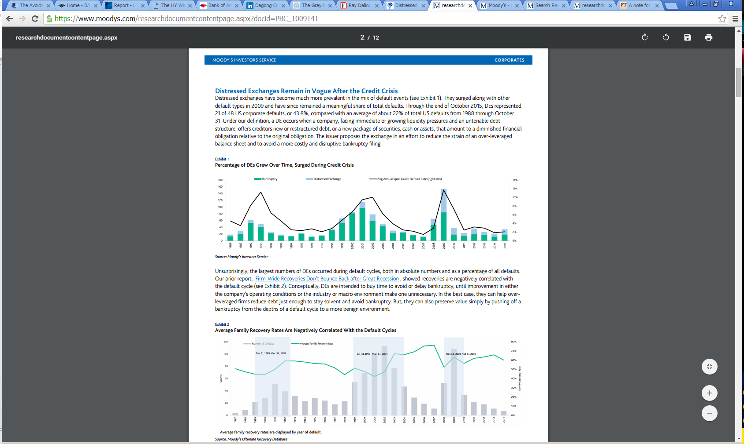

The largest numbers of distressed exchanges occur during default cycles, both in absolute numbers and as a percentage of all defaults. Distressed exchanges are intended to buy time to avoid or delay bankruptcy, until improvement in either the company's operating conditions or the industry or macro environment make one unnecessary. In the best case, they can help overleveraged firms reduce debt just enough to stay solvent and avoid bankruptcy. But, they can also preserve value simply by pushing off a bankruptcy from the depths of a default cycle to a more benign environment.

**Distressed Exchanges in the Energy Sector**

The Exploration and Production of Oil (E&P) sector has seen a surge of distressed exchanges, with creditors now willing to swap principal to improve their payment-priority position in the midst of a protracted slump in commodity prices. In most instances, creditors have been swapping senior unsecured debt for smaller amounts of secured debt, with second or third liens. If successful, this lessens the probability of default for the issuer, in addition to increasing the recovery rate (assuming the new security ranks higher in repayment priority) for the new debt versus the exchanged instrument. If the only improvement is that the new debt is secured by a second or third lien, versus being unsecured, but remains at the same relative rank on the balance sheet, then the improvement in ultimate recovery is negligible.

The current spate of E&P distressed exchanges offers an interesting example of behavior when an entire industry segment is under stress (see Table 1). The below table shows global U.S. dollar denominated distressed exchanges of high yield issuers since the beginning of 2015. The total par amount of distressed exchange offers was $17.5 billion. Over this time period, 69% of distressed exchanges were from issuers in a commodity industry. Just to add color to a few notable distressed exchanges, Halcon Resources (highlighted in yellow) had two distressed exchanges, in May and June, last year. The first distressed exchange offer was $227 million senior unsecured notes for Halcon common equity and the second exchange was for $1.57 billion existing senior unsecured notes for $1.02 billion senior secured third lien notes. Also, Exco Resources (highlighted in red), had a distressed exchange in October for $577 million of its existing unsecured notes for $291 million of new second lien debt.

**Table 1**



Many E&P companies raised cash in early 2015 through the issuance of equity, unsecured debt and even secured debt (stressed high yield issuers), with that cash going to fund operations, capital expenditures and wait out the downturn. Lower oil prices reduce companies' borrowing bases, since asset values are based on discounted cash flow analysis, which banks use to determine revolver borrowing base availability, usually every six months. As commodity hedges roll off and as commodity prices continue to stay low, banks will reduce the borrowing base of high yield E&P companies. If this occurs, recovery rates for new secured debt tranches that replaced unsecured debt in distressed exchanges will improve, assuming there is less senior secured debt above.

**Second Time a Charm for Creditors?**

On a historical basis, would the recovery rate on the original exchanged debt fared better had a company simply declared bankruptcy instead of consummating a distressed exchange first and then suffering a subsequent bankruptcy? According to Moody’s, they examined 20 defaulted issuers in the Ultimate Recovery Database between 1988 and 2015 that had senior unsecured and subordinated bonds affected in the first round of distressed exchanges, and then were also part of a bankruptcy filing. Those were compared with recovery rates of similarly positioned unsecured and subordinated debt instruments that went through a bankruptcy only once. The debt creditors benefited more from a one-time default, whether it was a distressed exchange or a bankruptcy, but certainly realized higher recoveries in the case of distressed exchanges. However, when a company started off fixing its problems with a distressed exchange and subsequently filed for a bankruptcy protection, its senior unsecured and subordinated bonds, on average, realized much worse recoveries (Chart 2).

**Chart 2**



It is also worth pointing out that recovery rates from 2014 to 2015 were lower (Chart 3). Chart 3 presents average recovery rates, measured by trading prices, for debt defaulted in the past two years. Except for distressed exchanges, recovery rates for defaulted debt equal the average trading price over 30 days after the default. For distressed exchanges, the recovery rate equals the price on the exchange date. On a volume weighted basis, the recovery rate for Senior Unsecured Bonds declined from 40.8% to 33.3%. Also, the recovery rate for Senior Subordinated Debt declined from 24.3% to 20.3%.

**Chart 3**

