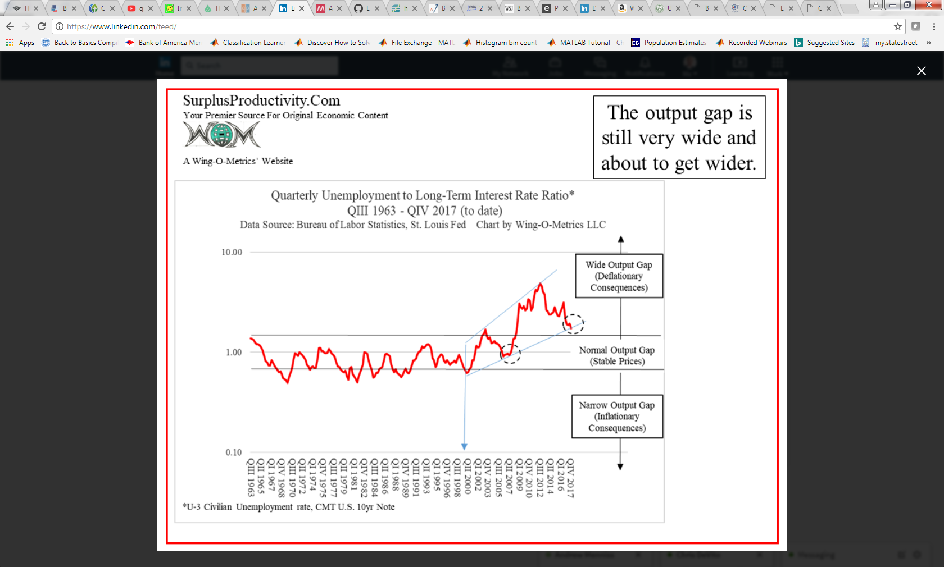

Much like in 2005 - 2006, the output gap looks primed to get much wider from here resulting in a very sharp drop in the 10yr UST yield.

This is exactly what the "labor futurists" have been predicting for about 4 years now--Oxford Martin, Erik-Brynjolfsson-Andrew-McAfee, and to a degree, McKinsey--that supply growth would accelerate with technological change, while pressure on jobs from automation would cause demand growth to stagnate. What prevented it from breaking out, apparently, was slow productivity growth and slow adaptation of automation. All of that appears to be changing now. Tax cuts can't stop it, and for the most part, don't even help.