# Color on Four Macro Topics

Published on September 20, 2019

## [By Jens Nordvig](https://www.linkedin.com/in/jensnordvig/) Founder & CEO at Exante data

**Barron's recently published a profile of Exante, and we have received many questions about some of the macro views discussed.**

**Our analytics are normally reserved for clients. But here we present quick snapshots of analytical outputs on four specific topics (USD intervention, the CNY outlook, Brexit & Broad EM Trends).**

**1. Dollar Intervention**

**Barron’s: The dollar has been strengthening all year, despite the Fed’s interest-rate cut and the tariff war. When will it reverse?**

**Nordvig**: There’s a huge debate about whether the U.S. could potentially intervene in the currency market. We know that [White House economic adviser Larry] Kudlow and others said, “We have now decided not to intervene.” That also means it was debated at a meeting, and that’s a pretty big deal. We provide our analytics to central banks around the world. They’re not prepared for intervention. It could create incredible volatility in the currency market that we’ve not seen for decades.

**More color...**The US has engaged in very limited dollar intervention in recent decades. Both the 2000 EUR intervention and the 2011 JPY intervention were largely symbolic (small amounts for a short period, as part of a global signal). The last period of sustained FX selling was in the mid-1990s and the last period of sustained buying of foreign currencies was in the 1980s. Hence, USD weakening currency intervention is hardly something we are used to.

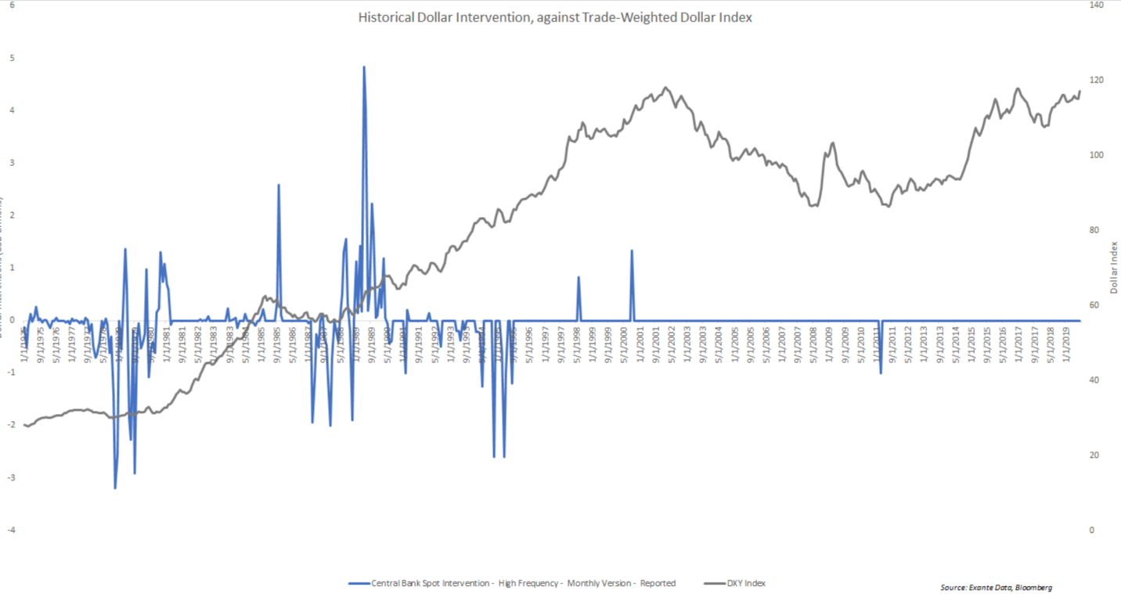

Nevertheless, in a July 2019 survey that we conducted among 100 large players in the FX market, a significant proportion of market participants (34%) said that US currency intervention was likely ahead of the 2020 election. This is clearly a new risk that FX market participants have to take seriously, especially if the dollar continues to gain in key crosses.

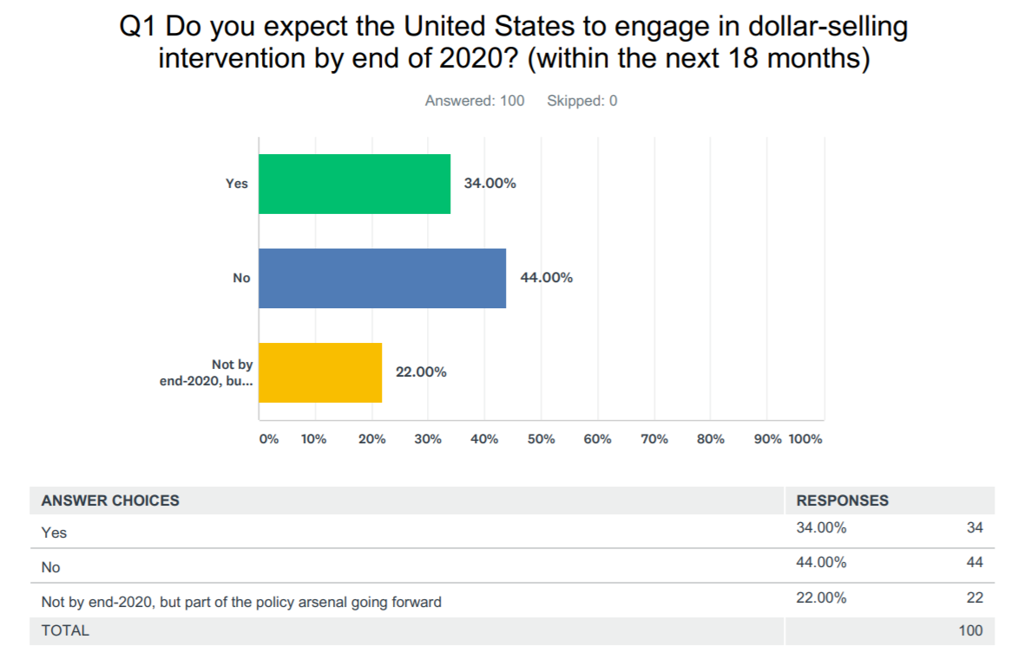

**2. The Yuan Outlook**

**Barron's**: You correctly forecast that the yuan would break through seven to the dollar. Now it’s at 7.15.

**Nordvig**: One of the first models we built at Exante in 2016 was a real-time intervention model for China. We know every day, with decent precision, exactly how the PBOC intervenes in the currency market. Recently, they’re controlling the currency by sending signals through the newswires and through the daily fixing. It’s really extraordinary. Here’s one of the biggest currencies in the world, in the middle of a trade war, and the Chinese authorities can get it to trade exactly where they want to without spending a dollar on it. That’s important for investors. Because if they were bleeding billions of reserves, as they did back in 2015 and 2016, it would suggest that the currency needs to move a lot more to reach organic equilibrium. The yuan is exactly where they want it. While they’re losing exports to the U.S., they’re gaining exports to Europe and other parts of the world.

One thing that’s new in the past year or so is they’re starting to attract central bank money to their bonds. The central bank of Russia has moved most of its reserves from the U.S. to China, and Brazil and Switzerland are starting to allocate their reserves to China. Globally, if they’re allocating 10% of assets to the yuan, it’s more than 10% of $10 trillion. That makes it easier to control [the currency] than if China is facing the negative trade shock alone.

**More color...**

The transformation of the Yuan into a reserve currency may play a critical role in China's ability to prevent depreciation in the trade war environment.

The chart shows the ups and downs in foreign purchases of Chinese bonds over the past 2-3 years. The spike in inflows in 2018 was related to Russian buying, and the spike in May (when trade tension was actually accelerating) was related to a number of other central banks starting CNY purchases (we detected that via certain metrics within Global Flow Analytics).

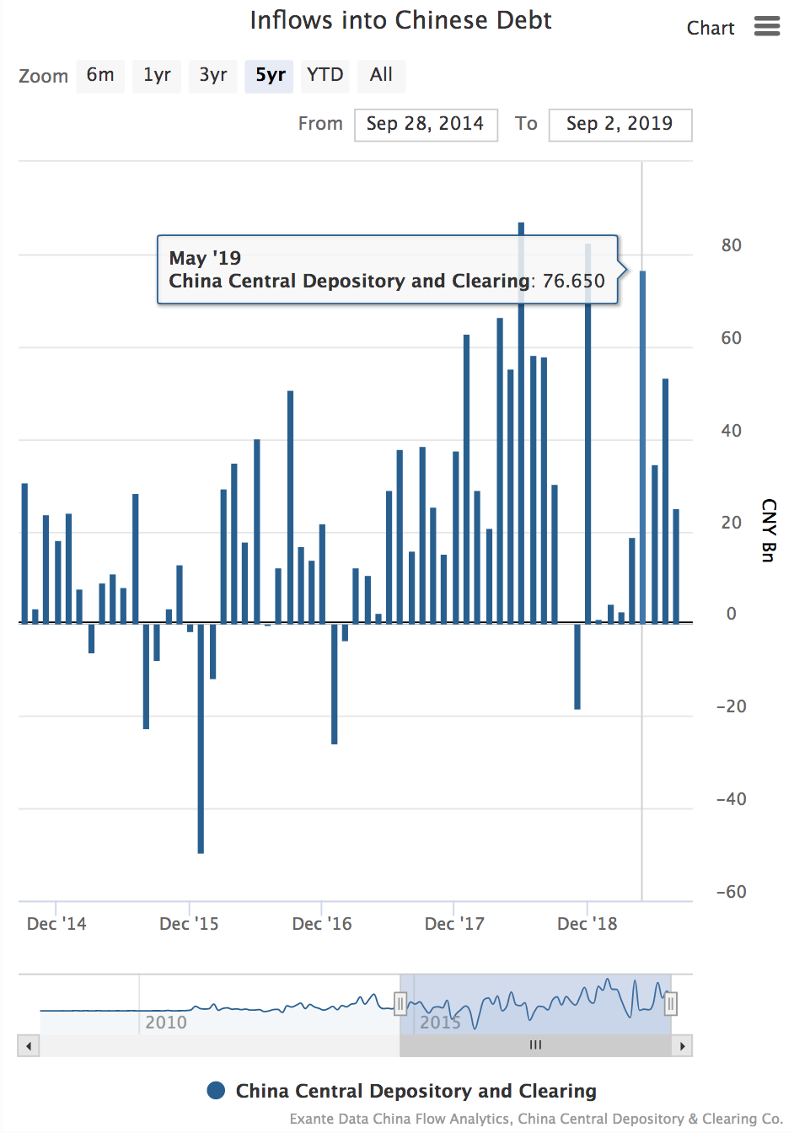

**3. The Sterling Risk Premium**

**Barron's**: What’s your projection for the euro, given the widespread expectation of a September stimulus package from the European Central Bank?

**Nordvig**: Everything points to rate cuts and asset purchases. [Incoming ECB President Christine] Lagarde was very explicit that we haven’t reached the lower bound [of interest rates]. The rates that banks pay to the ECB started to go negative in 2014, and more so in 2015 and 2016. The ECB will try to sweeten the deal for banks; only the marginal amount of the deposits they stick into the ECB may actually pay the negative rate.

I think [the euro] will trade lower in coming months. We’re about to break the very important psychological level of $1.10, for the first time since early 2017. People got very worried about the dollar weakening because the Fed was going to cut rates. It’s not materializing. We track the global fixed-income and currency exposures of all the “real money” institutions—the BlackRocks, Pimcos, Avivas, and so forth. They got significantly long the euro from March to July. Now we’re heading into this European Central Bank easing. I think $1.05 is a little bit too far. But with what’s going on at the ECB and essentially the real money community being [positioned] the wrong way, [the euro’s situation] could be quite painful.

As for sterling, we are getting close to a point where [United Kingdom Prime Minister] Boris Johnson is overplaying his hard Brexit strategy, and there is actually a long opportunity.

**More color...**

We have been tracking the 'Brexit' premium embedded in GBP, via our FX factor models. The below chart shows the part of EURGBP movements since 2016, which cannot be explained by standard macro drivers, using an out-of-sample projection methodology. As hinted in the article, we have indeed seen the GBP risk premium moderate in recent weeks, as Boris Johnson's 'hard Brexit strategy' seems to be running into trouble. But from a levels perspective, the premium is still very elevated, meaning that a move to 'soft-Brexit' would create much more follow through.

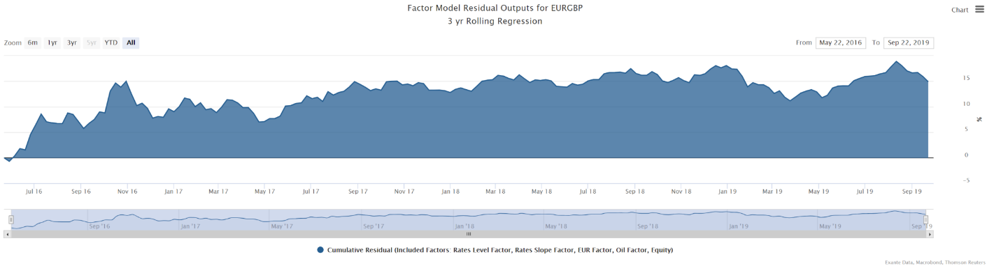

**4. EM and the ECB**

**Barron's**:  What are you advising clients?

**Nordvig**: ...[In EM Space] We’re focused on Indonesia, Russia, the Philippines, Mexico, and Brazil. We like their inflation dynamics. In emerging markets, there’s yield, and the currencies are quite cheap. If you avoided minefields like Argentina this year, or Turkey last year, the EM trade generally worked. I’d argue that the ECB [stimulus] around the corner will be a positive catalyst for many of these trades.

**More color...**

We now have the ECB QE announced, and while the QE amounts were moderate, we think renewed portfolio substitution effects in the Eurozone will generate EM support (the first chart below shows that there is clearly a trend in that direction already).

This is especially the case since peripheral debt is no longer offering meaningful yield pickup for European investors (as illustrated in the second chart below).

That said, a lot depends on global growth sentiment (especially for the FX dimension, but also for the duration trade). It would be very helpful for EM FX, if global growth just stabilized.

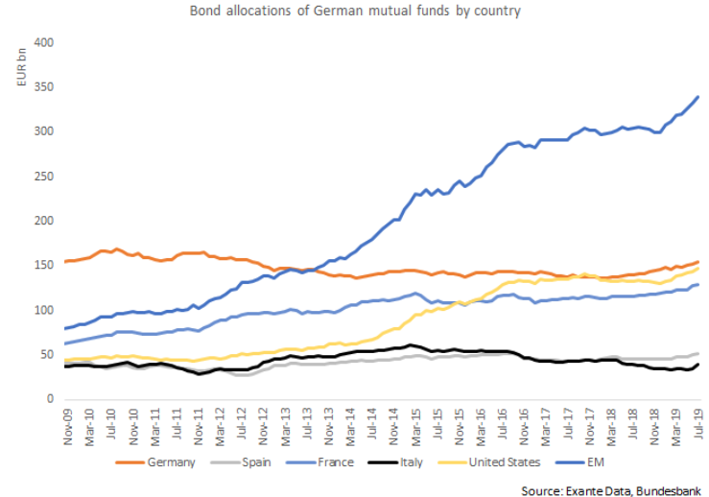

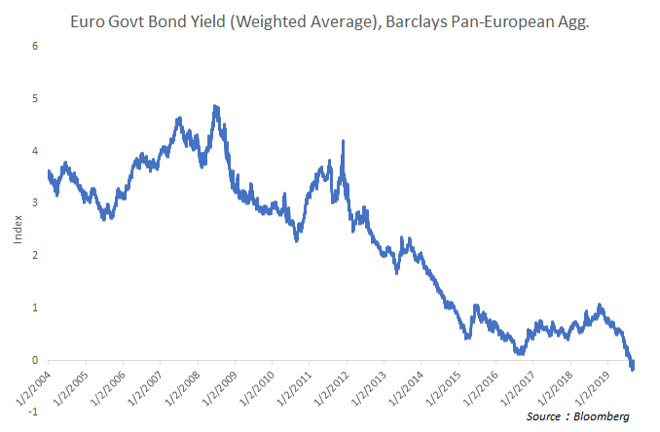

Those were just four brief points. There are a number of other issues discussed in the Barron's article. You can also follow us on @exantedata or reach out to us direct.

Jens Nordvig, Founder & CEO, Exante Data Inc.