# Exante Data Trade War Round-Table at Harvard Club: Key Takeaways

Published on June 24, 2019 by Jens Nordvig Founder & CEO of Exante Data

Last week, we hosted a round-table discussion at the Harvard Club on the impact of the trade war on China, the US and the rest of the world.

The round-table involved three presentations, which we summarize below:

**Brad Setser (Senior Advisor to Exante Data Inc.)** focused his presentation on his estimates of the impact of US import tariffs on China.

He showed that despite a large expected hit to Chinese exports to the US ($300bn over 2 years), the key for China's overall balance of payments and thus USDCNY will be the extent to which Chinese exports to the rest of the world increase as a result of trade diversion and the rewiring of supply chains.

**Accounting for such "trade diversion," the actual hit to China's global exports would be somewhat more manageable at about $130 billion (or 1% of GDP) even in the "25% on everything" scenario.**

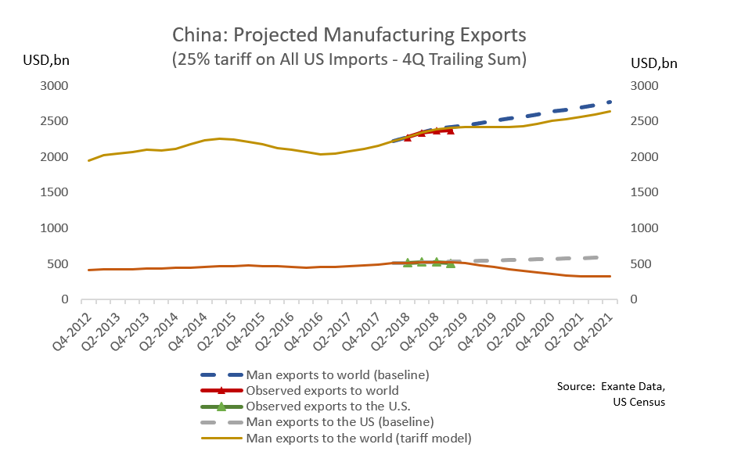

The discussion/Q&A highlighted, the key factor will be the extent to which the tariffs simply lead to a rerouting of Chinese export capacity that serves US final demand vs. a more global/general rerouting of supply chains that run through China to meet final demand in Europe and other advanced economies. In the latter scenario, the hit to China's global exports and GDP are likely to be larger and the pressure to allow the currency to adjust more powerful. The discussants also noted the potentially large impact of US measures against Huawei and ZTE relative to the tariffs, which, though hard to model, could be somewhere in the $30-50 billion range.

I**n terms of implications for USDCNY our view is that based on the expected impact from the trade war shock modeled above, holding 7.0 is manageable. In addition, there are few signs of significant intervention in in May-June, hence our capital flow tracking does not suggest that pressures are unsustainable in any way as things stand.**The question, therefore is not whether the PBOC will be forced to devalue but rather such an outcome is desired by Chinese authorities.

**Amit Khandelwal (Professor, Columbia Business School)**focused on the results obtained with his co-authors in a recent NBER working paper ([link](https://t.sidekickopen75.com/s1t/c/5/f18dQhb0S7lM8dDMPbW2n0x6l2B9nMJN7t5XWPdSD1CN1qMGgKd77LTV1tn2F2bCS-n103?t=https%3A%2F%2Fwww.nber.org%2Fpapers%2Fw25638&si=8000000000476204&pi=11c0d610-c2d7-437c-e091-6706aed8f43a)). As with other recent academic work on the subject, Amit's work shows that, at least for the tariffs implemented in 2018, and somewhat contrary to expectations from trade theory, Chinese exporters did not reduce export prices at all in response to the trade war. **Instead, the entire cost increase resulting from the tariffs was borne by US consumers and producers ($70bn annualized or roughly 0.4% of GDP). However, the overall impact on the US economy from the tariffs imposed thus far is actually smaller because some US producers gain through import substitution and the scope to raise prices given the higher cost of imported goods, while the government also collects tariff revenue.**

Much of the discussion/Q&A focused on whether this modest direct impact fully captures the impact of a "full trade war" scenario of 25% tariffs on all imports from China. As some participants pointed out, there could be non-linearity with respect to the tariff tranches and tariff rates. Others noted that there were important second round/sentiment effects and that the assumption that the government would fully refund all tariff revenue to consumers via tax cuts/income transfers was overly restrictive.

Amit's work and the discussion also highlighted spacial and sectoral distributional impacts of the tariffs to date and Chinese retaliation. For instance, Amit and his coauthors show that**the US counties that benefit the most from Trumps import tariffs are those with the most "swing voters" in the 2016 election suggesting that the Administration may have targeted the tariffs for political gain.**

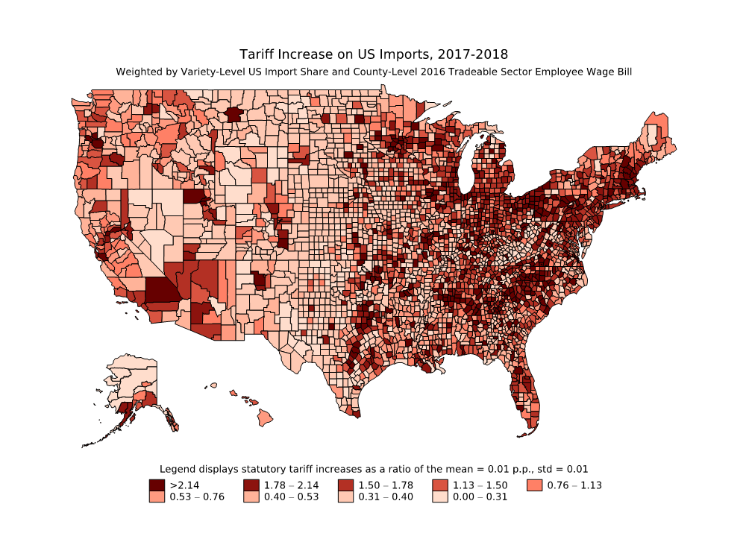

**Jens Nordvig and Alex Etra (both Exante Data Inc.)**focused on detecting global winners and losers in the trade war.

We showed an analysis, in which we tracked the impact of US tariffs at the detailed product-level on a) imports from China and b) US imports from the rest of the world. In particular we focused on quantifying the trade diversion one would expect to see in a simplified model.

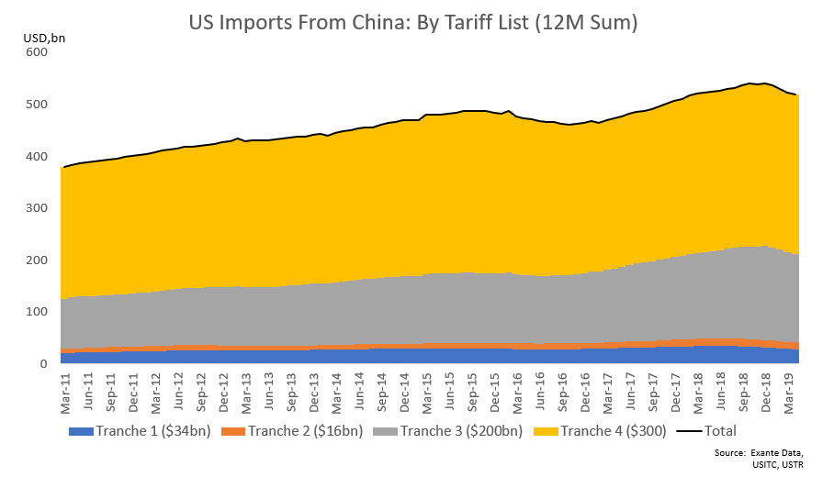

Identifying and isolating such diversion is methodologically tricky given a variety of contaminating factors (front loading effects, global price swings, etc.). But our preferred approach compares the performance of imports from China and from the rest of the world relative to an expected baseline consistent with trend nominal growth (i.e. what is the expected change in imports over time absent the tariffs) while at the same time stripping out oil imports (which are impacted by price swings and can swing overall import growth numbers). **In contrast to expectations and other sell-side findings, we see limited signs of diversion to date in the aggregate, and imports from the rest of the world appear to be performing in-line with their pre-tariff trend (rather than receiving an extra boost from diversion). See the chart below for reference.**

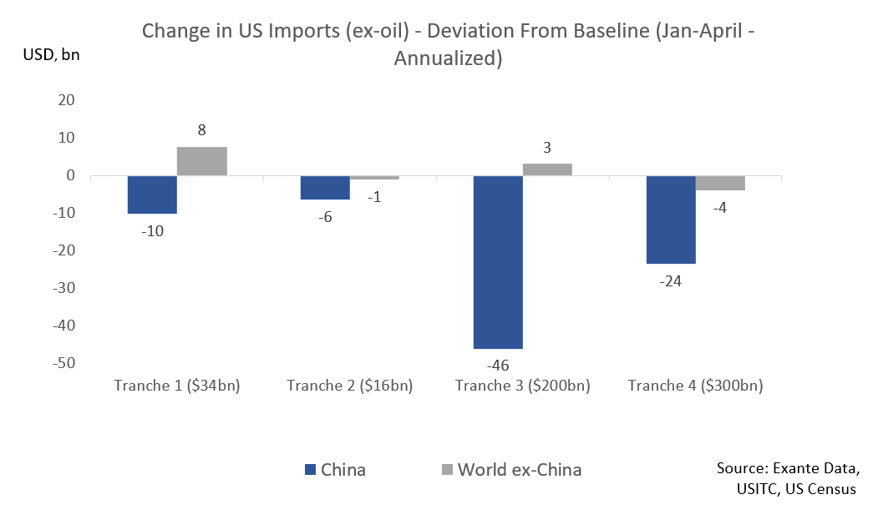

Although we do not find convincing evidence for large scale diversion to date in the aggregate, we also modeled which countries we expect should benefit from diversion over time as supply chains are re-routed as they take market share from China in specific product categories. **We find the biggest potential gains (as a share of GDP) accrue to Mexico and Vietnam (2%), Canada (1.5%), followed by Malaysia.**A detailed look at imports at the country-level shows some potential signs of diversion in Taiwan, Korea and Vietnam but of much smaller magnitudes to date.

We will continue to monitor this data closely every month as more data becomes available and we continue to track the trade war impact and its fallout. Until then, please feel free to reach out if you have questions or would like more details on the presentations or our data.