# "The Quiet Panic"

# Kyle Bass, managing partner of Hayman Capital Management

# All,

For the better part of the last 36 years, since Hong Kong pegged its currency to the USD and ceded monetary policy to the Fed, Hong Kong has been a financial and political oasis for investment into mainland China and Southeast Asia. Today, newly emergent economic and political risks threaten Hong Kong’s decades of stability. These risks are so large that they merit immediate attention on both fronts. In this letter, we will discuss the origins of Hong Kong’s impending crisis, a brief history of Hong Kong, the economics of currency boards/pegs, the agreement that governs the United States economic and political relationship with Hong Kong, and how Xi Jinping’s China is forcing the Hong Kong Government to violate the agreement that requires Hong Kong to maintain its autonomy or lose most-favored-nation trading status and be treated as China itself is treated.

**Economic Risk**

**The Economics of Hong Kong Have Changed Dramatically Since the Global Financial Crisis**

Hong Kong was once vitally important to China’s economic position. At its apex in 1993, Hong Kong’s economy represented more than 25% of China’s GDP and was the most active port in the world.

[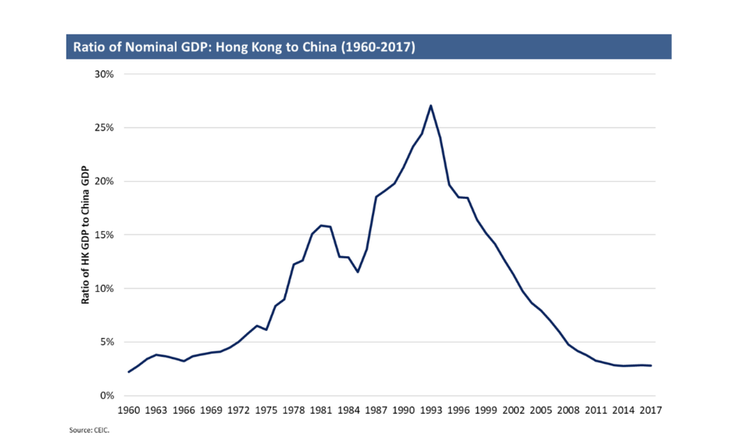](https://www.zerohedge.com/s3/files/inline-images/Screen%20Shot%202019-04-25%20at%202.43.49%20PM.png?itok=mOwXabs8)

Since China’s ascension into the World Trade Organization (WTO) in 2001, China has spent heavily on its own port infrastructure and therefore is much less economically reliant on Hong Kong today. As the chart below shows, Hong Kong was once a large exporter of goods (primarily settled in US dollars) with a significantly positive trade and current account surpluses. Hong Kong was widely known as China’s southern port. As China built out its own port infrastructure, Hong Kong was forced to re-invent its economy into a service exporting economy. Hong Kong transitioned from a major global exporter to a net importer of goods while simultaneously becoming a services exporter primarily to mainland China. In economic terms, this transformation has taken place rather suddenly over the past decade.

[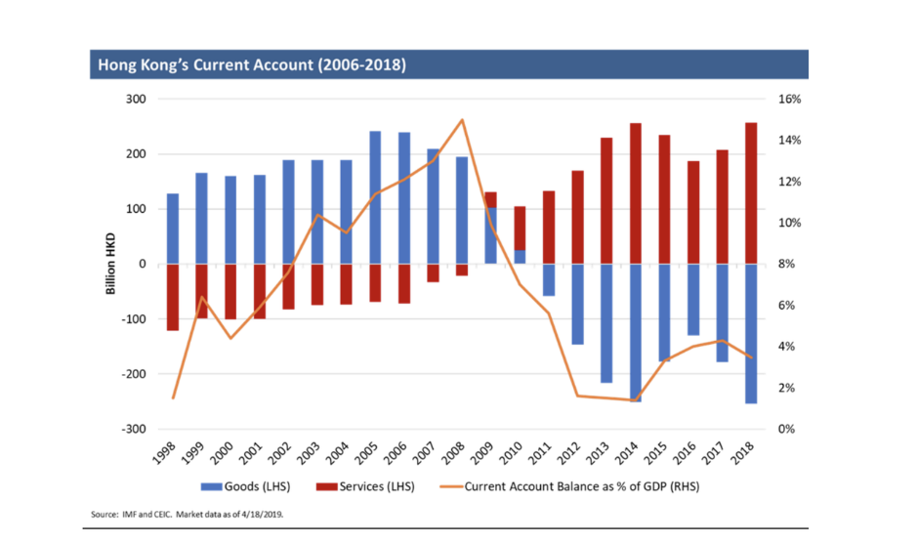](https://www.zerohedge.com/s3/files/inline-images/Screen%20Shot%202019-04-25%20at%202.46.52%20PM.png?itok=y5FWA4ka)

**Hong Kong’s Golden Years (2008-2018)**

As the global financial crisis metastasized throughout 2008, Hong Kong became the world’s top beneficiary of the United States’ emergency monetary policy. Since Hong Kong’s currency is pegged to the US dollar, Hong Kong’s interest rates must move with its anchor currency’s rates. Its currency peg to the USD forced Hong Kong to import US monetary policy, while its largest trading partner (China) was preparing to grow credit to the tune of half its economic output in a desperate effort to stimulate GDP growth. Thus, in 2008, interest rates in Hong Kong collapsed essentially to zero in lock-step with US interest rates, while China began an aggressive credit expansion. It’s no wonder why Hong Kong real estate became the most expensive (per square meter) in the world. Free money in Hong Kong and double-digit credit growth in China drove the greatest economic expansion Hong Kong will ever experience. Its cup ran over. These ten years will prove to be the best decade in Hong Kong’s existence.

[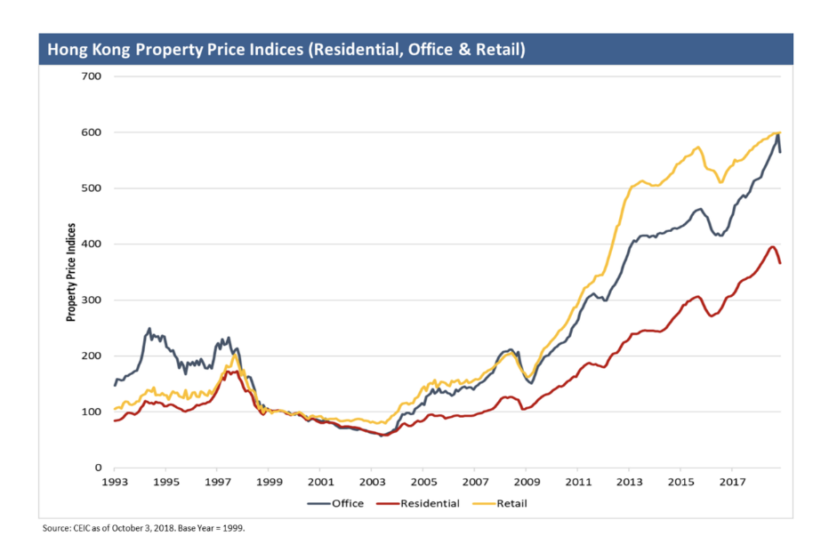](https://www.zerohedge.com/s3/files/inline-images/Screen%20Shot%202019-04-25%20at%202.48.04%20PM.png?itok=rYEEUWha)

As a result of free money (Hong Kong’s overnight lending rate was roughly 0.5% for 8 years), Hong Kong’s residents, banks, and companies did what anyone would expect them to do: they borrowed, geared, and levered. Hong Kong private sector leverage is now the highest of any nation in the world. In 2010, Hong Kong grew its GDP 7% while its interest rates stayed at emergency levels with the US at zero.

[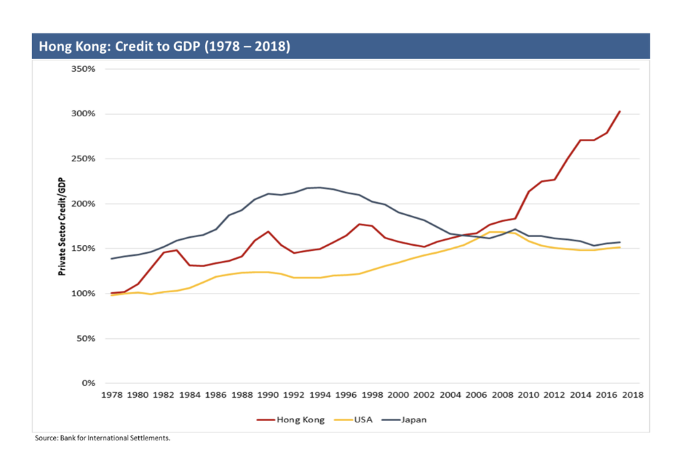](https://www.zerohedge.com/s3/files/inline-images/Screen%20Shot%202019-04-25%20at%202.49.00%20PM.png?itok=wOJVBvFq)

Remember when Iceland, Ireland, and Cyprus fell like dominos on the front-end of the European banking crisis? The primary determinant of the sovereign’s failures in each case was the fact that each country had allowed their banking sectors to grow to almost 1,000% of GDP. A small bump in the economic road could cripple the sovereign, forcing it to intervene and save bank depositors. Hong Kong is in as precarious a situation as Iceland, Ireland, and Cyprus were leading up to the crisis. In fact, Hong Kong’s banking system is one of the most levered in the world at approximately 850% of GDP (with 280% of GDP being lent directly into mainland China).

To add insult to injury, two of the largest banks in Hong Kong are orphaned subsidiaries of British financial institutions (Standard Chartered and HSBC) that now lack any meaningful British depositors. If and when they encounter serious difficulty, British taxpayers will not come to their rescue. The Chinese government will most likely have to step in to save Chinese and Hong Kong depositors, but may not bail out foreign depositors. They will surely not bail out equity holders of foreign banks operating in Hong Kong. The moral of the story for Hong Kong depositors is to be extremely wary of which currency and which bank they keep their savings in.

[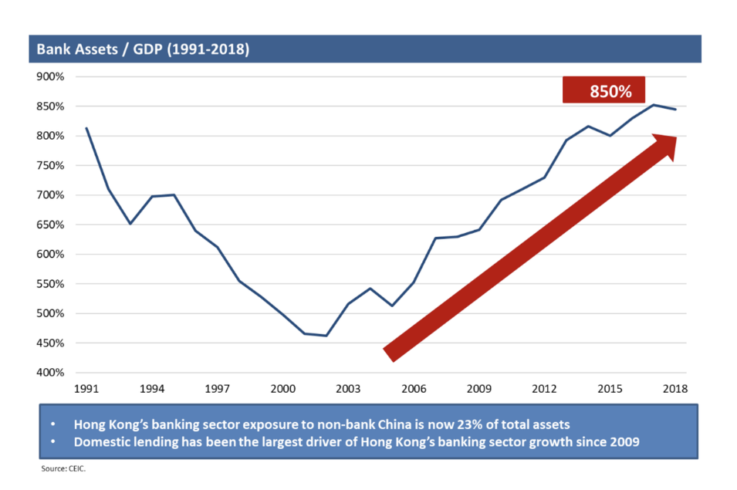](https://www.zerohedge.com/s3/files/inline-images/Screen%20Shot%202019-04-25%20at%202.49.57%20PM.png?itok=Qdqcml3S)

**The Elephant in the Room**

Herein lies one of the key problems for the Hong Kong Monetary Authority (HKMA). The highest leverage on record, mortgage loans that float and reset monthly, and rising rates put the HKMA into a classic prisoner’s dilemma. Today, the difference between Hibor and US Libor is a staggering -80 basis points. In a large economy whose currency is freely convertible, the natural flows of capital go from the lower yielding currency to the higher yielding currency (depositors can freely convert and immediately receive higher overnight deposit rates). If this situation persists, the monetary authority will first exhaust the excess reserves (or as the HKMA calls them the “aggregate balance”). Once depleted, the pressure on the currency board will become untenable and the peg will break. Below is a chart of Hong Kong’s aggregate balance.

The HKMA has spent 80% of their reserves over the past year or so. If the aggregate balance goes to zero, we expect Hong Kong rates will spike (as you see we are in the convex portion of the scatterplot today) and their banking system could collapse. Hong Kong currently sits atop one of the largest financial time bombs in history.

[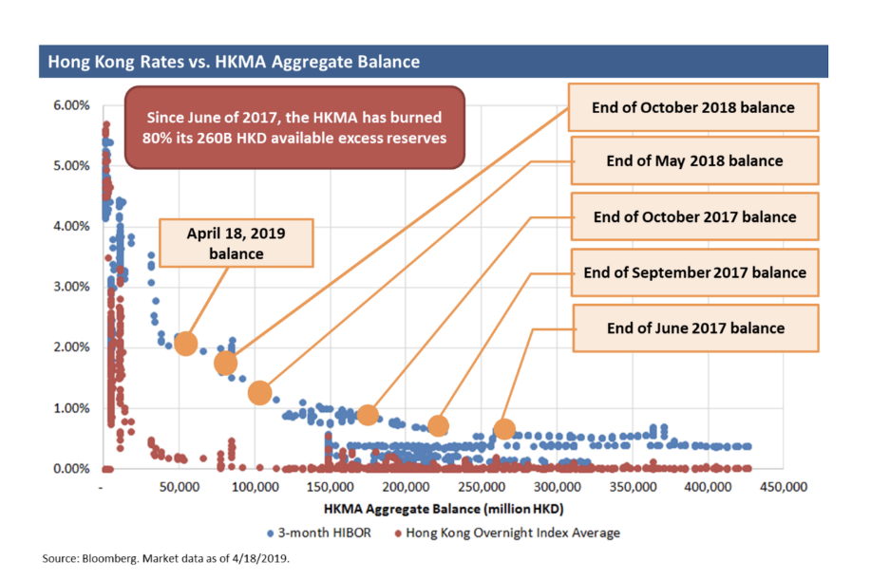](https://www.zerohedge.com/s3/files/inline-images/Screen%20Shot%202019-04-25%20at%202.51.02%20PM.png?itok=6n0VR7yF)

**A Brief History of Hong Kong (from 1841 to today)**

Hong Kong was governed by the British from 1841 until 1997 as a result of the defeat of the Qing Empire in the first and second rounds of the Opium Wars (in 1842 and 1860). In 1898, Britain formalized its rule over the entirety of the Hong Kong area (which included Hong Kong Island, Kowloon Peninsula, and the balance of the New Territories) by arranging a 99-year lease. As early as 1982, secret discussions between British Prime Minister Margaret Thatcher and China’s “Uncle” Deng Xiaoping were had on the mechanics of the handover which would officially take place in 1997. At the conclusion of these discussions in December 1984, Britain’s 150-year rule over Hong Kong was put on a timeline to end on July 1st, 1997.

[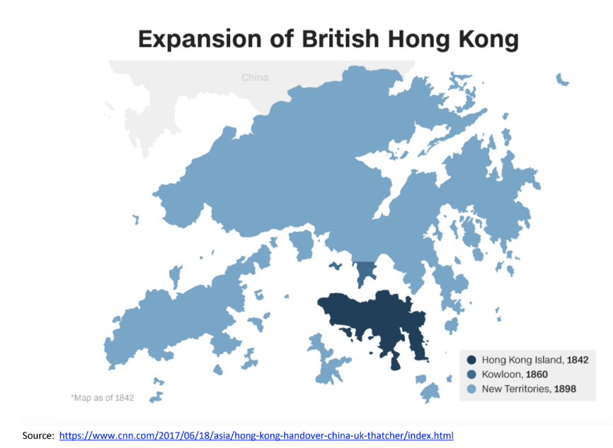](https://www.zerohedge.com/s3/files/inline-images/Screen%20Shot%202019-04-25%20at%202.52.26%20PM.png?itok=j5uIXCyL)

**The Handover of Hong Kong to the Chinese Sparked the Asian Crisis of 1997-1998**

36 years ago, Margaret Thatcher was engaged in negotiations with Deng Xiaoping regarding the economic and political future of Hong Kong. In 1983, investors were gravely concerned that if and when Hong Kong was handed back to the Chinese, that the British rule of law and democratic system would be tossed aside, and the heavy hand of Communist China would dominate every aspect of life in Hong Kong. As a result, from 1978-1984 Hong Kong’s currency devalued by a staggering 47% to the US Dollar and as much as 54% versus the British Pound.

[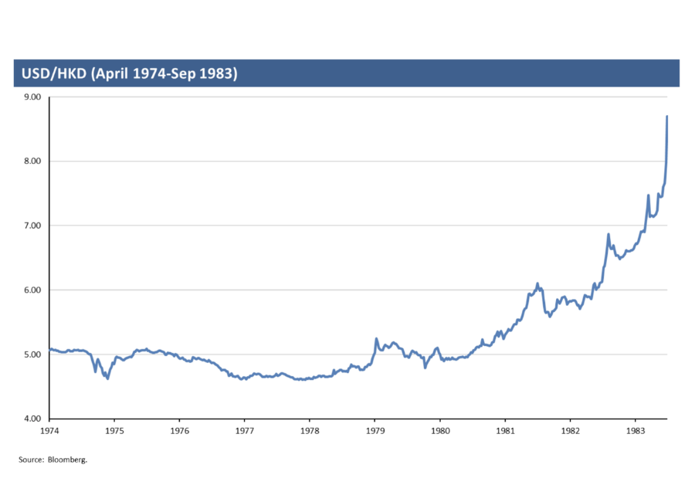](https://www.zerohedge.com/s3/files/inline-images/Screen%20Shot%202019-04-25%20at%202.53.34%20PM.png?itok=3j1e8IQV)

In September of 1983, the South China Morning Post declared that the currency was in “free-fall” and that Hong Kong was becoming a banana republic. Then, after denying the plans in the press on multiple occasions, the Hong Kong government pegged the local currency to the USD. The peg was entered into hastily to calm investors’ minds and restore some sense of order and confidence. The day after the handover from the British to the Chinese happened to be the day the Thai Bhat broke its peg to the USD and began a tumultuous 53% devaluation. Investors in various Asian nations were actively selling domestic investments and currencies to move to the safe haven of US Dollars (they had also borrowed heavily in US dollars which intensified the situation). The Asian Financial Crisis of 1997 was in part sparked by the lack of trust in the Chinese as they took over control of Hong Kong.

[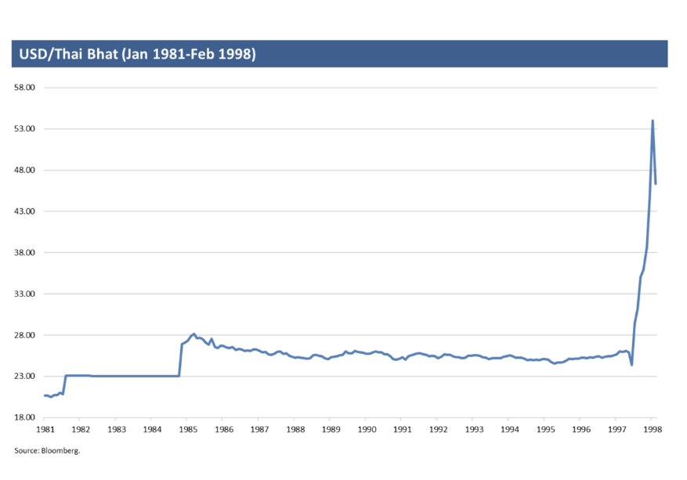](https://www.zerohedge.com/s3/files/inline-images/Screen%20Shot%202019-04-25%20at%202.54.22%20PM.png?itok=0iXrr1AK)

**The Economics Behind Currency Boards/Pegs**

The harsh reality is that economic relationships between pegged regimes must be harmonized or they are destined to fail. Norman Chan, the soon-to-be-retired CEO of the HKMA, admitted this in 2017 when he set the four conditions that need to be present for the Hong Kong Dollar to be reset and re-pegged to the Chinese RMB.

Business cycles and economies must be synchronized or stresses will emerge in the fixed nature of a currency board or peg. If one of the economies is growing while the other is contracting (one demands higher interest rates while the other needs lower interest rates), the resultant lack of synchronicity of pegged economies in a rigid exchange regime builds pressure-cooker like imbalances over time. The economy that has elected to peg (HK) to the anchor currency (USD) must import (or mirror) the monetary policy (primarily interest rates) of that country. This means that if overnight rates diverge between the two, the divergence will cause large capital flows one way or the other, which immediately puts pressure on the currency board/peg. On the strong side of the peg (ie when outside capital is flowing into the pegged currency), the central bank can easily flood the system with liquidity (print local currency) to lower rates and discourage additional capital flows into the pegged currency. On the weak side of the board/peg, the pegged regime can spend available excess reserves (think rainy day savings) to defend the peg. If currency boards were perfect, the Argentinian Peso would be still be 1-to-1 to the US Dollar like it was in 2001. Instead, today it takes 43 pesos to buy one dollar.

[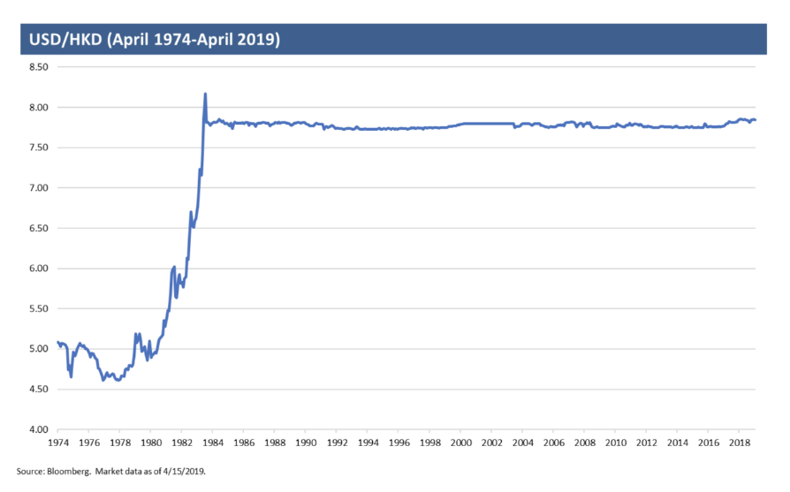](https://www.zerohedge.com/s3/files/inline-images/Screen%20Shot%202019-04-25%20at%202.55.47%20PM.png?itok=jKCZpMIT)

**The Inmate is Now Running the Asylum**

Currency pegs and currency boards are rigid financial ideas that are an attempt to bring confidence and fiscal discipline into an emerging economy. Some say they are a substitute for a disciplined monetary policy rule for undisciplined monetary policy. The funny thing about the history of such relationships is that they ***almost exclusively assume and rely on the discipline on the anchor’s side.*** Historically, the anchor currency (predominantly the USD) has been the regime with policy stability and relative fiscal discipline. The Global Financial Crisis forced the United States to take interest rates to zero for the first time in its history. All prior studies on currency boards, inflation, and the relationships between the pegged economy and the anchor economy need to be tabled for this discussion. The inmate (the anchored currency) is now running the asylum.

Currency boards have historically been implemented by small developing economies like Brunei, Antigua, Barbuda, Djibouti, and the Baltics. The exceptions to this rule have been only Argentina and Hong Kong. We know how Argentina’s currency board played out at the turn of the century and now Hong Kong’s imbalances are coming to a boil. The HKMA’s decision to hold firm on the peg during the 1997-98 Asian financial crisis cost them dearly. Back then, they had two choices: i) maintain the peg by moving overnight rates up as high as 20% and accept the resultant deflationary bust (which they experienced from 1997-2003 with their real estate markets falling approximately 70%) or ii) free-float the currency and allow it to make the adjustment quickly (e.g. Russia in 2015-2016).

Given the lack of synchronicity between the United States and Hong Kong, the pegged exchange rate doesn’t make economic sense any more. The divergence between the economic cycles of the US, China, and Hong Kong will ultimately tear the currency board apart. If you are currently a saver with your savings or investments denominated in HKD, why on earth would you not convert to USD and earn an extra return while also avoiding a catastrophic currency devaluation?

Investors must pay keen attention to the balances and imbalances that matter and avoid listening to “others” telling them that everything is going to be fine. One only needs to look back at major dislocations in history to learn that the architects and keepers of the sovereign have no incentive to warn investors of the risks. In early 2015, European Commission President Jean-Claude Juncker said, “There will be no default.” He was referring to Greece’s acute debt management problems. When rumors of a secret meeting between Euro area finance ministers were confirmed immediately after Juncker denied the meeting even happened, he was quoted saying something profound for a public official to admit to. When confronted by the same reporters he had just lied to, he said, “when it becomes serious, you have to lie.” Greece went on to default on its sovereign debt later in 2015. Private sector bondholders lost 80% of their money. Neither central bank presidents, monetary authority heads, currency board architects, treasury officials, nor the IMF will ever explain the potential risks of default or currency board/peg failure until it’s too late. Doing so is antithetical to their mission to promote and maintain stability.

**Political Risk**

**China’s Massive Miscalculation in Hong Kong: Trouble with The United States - Hong Kong Policy Act of 1992**

In September of 1991, Senator McConnell (R-KY) introduced the United States-Hong Kong Policy Act (S.1731). The Act was designed to maintain bilateral free-trade and to respect Hong Kong as its own separate customs territory (as it was handed from the British to the Chinese in 1997) while treating it as its own sovereign nation as long as it maintains its autonomy.

As if the dire financial situation in Hong Kong wasn’t enough, Xi is “proposing” – or, rather, requiring - the Hong Kong government to overhaul its extradition laws by introducing legislation intended to instruct Hong Kong to send “fugitives” to jurisdictions it doesn’t have rendition agreements with (including mainland China). The administration of Hong Kong Chief Executive Carrie Lam (handpicked by Xi) has devised a cover story that stipulates, “the reason for the justification for the extradition must be an act that is considered to be criminal in both Hong Kong and China. The courts in Hong Kong will be the gatekeeper as there will be a court procedure in deciding whether the extradition is allowed.” The key problem with this perfunctory exhibition of “judicial review” is the fact that China itself can drum up a charge that is illegal in China and Hong Kong and immediately demand an extradition. The presumption will be guilt if the alleged offense is a criminal offense in both jurisdictions.

US Congressman James McGovern (D-Mass) said in a statement this month that “the people of Hong Kong and foreigners residing in Hong Kong – including 85,000 Americans – must be protected from a criminal justice system in mainland China that is regularly employed as a tool of repression.” The Hong Kong autonomy issue is one of the rare places where both sides of the United States political spectrum are in agreement. The United States will not stand silent while this new proposal becomes law. This has major implications for the 1992 Policy Act continuing to stand and US-Hong Kong trading relations remaining unobstructed.

**US Consul General Berated**

US Consul General Kurt Tong gave a speech in February at The American Club of Hong Kong that was critical of China’s overreach. In this controversial speech he carefully said:

*Indeed, financial market transparency, open access to business and government information, and a fair playing field are some of the key foundations on which Hong Kong commerce is built. Hong Kong’s****fair and independent judiciary****reinforces that system. We all want this system to continue to prevail.*

*I have been sometimes asked why, as America’s representative in Hong Kong, I occasionally engage in dialogue with Mainland Central Government officials in addition to my Hong Kong Government counterparts. For my part, one purpose of such conversations is to point out to Mainland policymakers the risks that****ongoing political tightening****poses for the realization of Beijing’s own goals for Hong Kong’s contribution to Chinese economic development.*

*I let them know that, in my view, there needs to be consistency between the political and economic institutions of the city in order to sustain the confidence of the international business community, as well as Hong Kong’s foreign government partners, in the city’s future. Absent a strong international presence in Hong Kong’s economy, it is clear, the city would offer much less value to the rest of China.*

Tong was attacked by the Chinese Communist Party and asked to apologize for his speech that questioned Hong Kong’s autonomy from Beijing. In fact, the Chinese Foreign Ministry Office called his remarks “distortion and defamation”. Seeing how he handled his words above with kid gloves, it’s interesting to observe how incredibly sensitive the CCP is about the word “autonomy”.

This March, a delegation of pro-democracy Hong Kong politicians met with Speaker of the House, Nancy Pelosi regarding the new proposals on extradition. Civic Party leader Dennis Kwok said, “Speaker Pelosi is fully aware of developments in that area. She expressed concern – deep concern – about the implications of such legislative amendments.” Under the one country, two systems framework, Beijing agreed to give the Hong Kong Special Administrative Region autonomy over its legislative, economic, and judicial affairs. Both sides of the aisle and many in the US Government are now realizing that China will be in **full breach**of this agreement by infringing on the autonomy of Hong Kong.

Consequences of a material breach of this agreement are as follows:

*It Directs the President to report to the Congress whenever he determines that: (1) Hong Kong is not legally competent to carry out its obligations under an international agreement; or (2) the continuation of such obligations is not appropriate under the circumstances.*

*Authorizes the President, upon determining that Hong Kong is****not sufficiently autonomous****to justify treatment under a U.S. law different from that accorded China, to suspend such application of the law.*

**US State Department Weighs in on 1992 US-HK Policy Act (for the period covering May 2018 through March 2019)**

One month ago, in annual report on Hong Kong that the US State Department [sends to the President](https://www.state.gov/p/eap/rls/reports/2019/290526.htm), it is stated that, “[d]uring the period covered by this report, the Chinese mainland central government implemented or instigated a number of actions that appeared inconsistent with China's commitments in the Basic Law, and in the Sino-British Joint Declaration of 1984, to allow Hong Kong to exercise a high degree of autonomy.

The tempo of mainland central government intervention in Hong Kong affairs — and actions by the Hong Kong government consistent with mainland direction - increased, accelerating negative trends seen in previous periods.” While the language was aggressive, the report stopped short of recommending a rescission of the 1992 US-HK Policy Act and therefore justified continued special treatment by the United States for bilateral agreements and programs per the Act.

If the Chinese government is successful in moving the Hong Kong legislation from proposal to law, it will become incredibly difficult for the State Department to not recommend rescission. Today, President Trump holds the keys to deciding whether or not the agreement will stand. Despite the State Department’s recommendation, the President has the sole power to make the decision.

**The UK Thinks One Country One System**

The United Kingdom has also begun a significant push-back on Hong Kong in a new report issued this month by the UK Foreign Affairs Committee. The report titled [“One Country, One and a Half Systems”](http://tinyurl.com/y5l3em4c) focuses on Hong Kong’s autonomy being at risk. Furthermore, it is said that, “[w]e also believe that the Chinese government’s approach to Hong Kong is moving closer to**“One Country, One System” than it is to maintaining its treaty commitments under the Joint Declaration.”**(Emphasis mine)

**The (HK) Buck Stops Here**

On the financial front, the leveraged and vulnerable financial structure of the Hong Kong economy is the polar opposite of the average investor’s availability heuristic. Thirty-six years of relative stability won’t beget another decade of stability if our analysis is even partially correct. Meanwhile, China’s extradition overreach is causing tectonic shifts in the fundamental agreements that govern the economic relationships between the United States, the United Kingdom, and Hong Kong.

These shifts have just begun. Investors, Hong Kong depositors, and policy makers alike need to pay strict attention to the outcome of this legislative dance between China and Hong Kong. Hong Kong is currently the center of China’s ability to raise US Dollars in Asia. China is desperately short of US dollars and, therefore, needs Hong Kong to remain a non-tariffed most-favored-nation trader with the United States and the United Kingdom.

Financial teetering coupled with political uncertainty could abruptly change the complexion of the foundation of investments in Hong Kong and throughout Asia. With all of this in mind, over the past several years, we at Hayman have carefully observed, analyzed, and planned for this type of macro instability. We have devised a portfolio structure that will efficiently hedge investors invested in Hong Kong, China, and the rest of Asia with a carefully constructed set of positions that produce a positive carry but also maintain a massive asymmetry to a negative outcome in Hong Kong and/or China.

Sincerely,

J. Kyle Bass

Managing Partner

Hayman Capital Management, L.P.