# Rieger Report: The Flattening....a muni horror movie?

Published on April 18, 2018

[James (J. R.) Rieger](https://www.linkedin.com/in/james-j-r-rieger-2018/)

Investment grade municipal bonds have seen yields flatten and long non-call par bond yields are inverted. Will this end badly for the long end? I don't think we are looking at a 'chain saw massacre' any time soon. The primary driver of yields on the long end of the muni market remains a technical supply shortage vs demand for good quality bonds.

**Chart 1: MBIS Yield Curve**

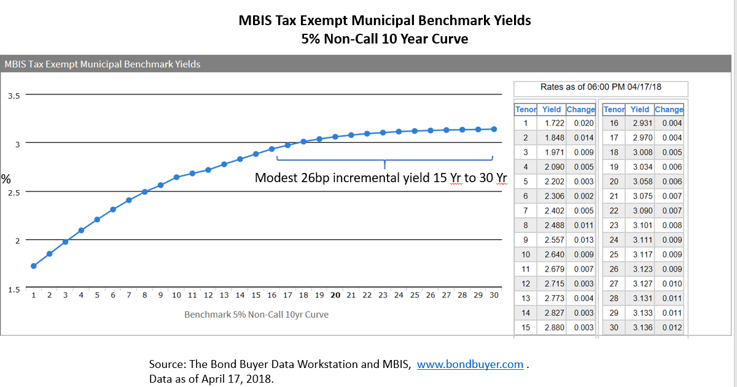

The flattening of the muni curve over the last several weeks has been a significant 29bps and this is something to keep an eye on going forward.

**Chart 2: The two year to thirty year yield spread for municipal bonds:**

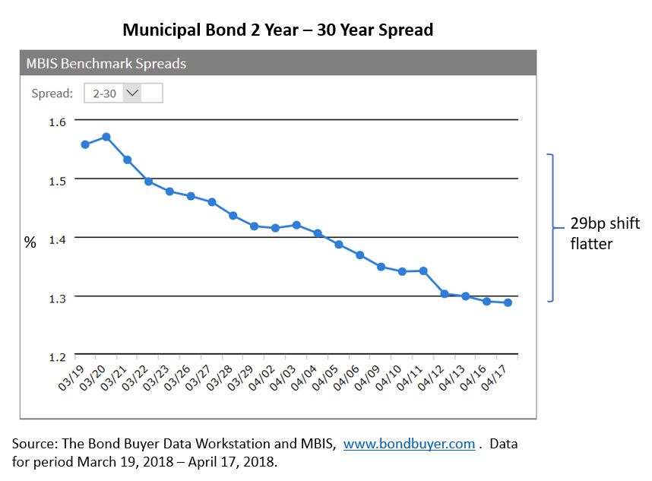

The muni market is a premium bond market (higher coupon than yield) but there are par bonds in the market place. That said, the non-call par bond muni bond market is a very small part of the market and that is most likely the reason for the long end to be slightly richer.

**Chart 3: Par bond equivalents tracked by MBIS**

