**How are ETFs created and how do they work?**

**ETFs begin with an idea and a sponsor**

An ETF originates with a sponsor that chooses an investment objective, which is typically to generate the returns of a stated benchmark index. Sponsors that elect to track or mimic the returns of an index do so by replicating the index or by selecting a representative sample. A sponsor would elect the sampling method if securities within the index are too numerous, difficult to obtain, or have ownership restrictions.

The sponsor of an actively managed ETF (seeks excess returns) would determine an investment objective and select securities and manage them in accordance with its investment objective, much like an actively managed mutual fund.

**Establishing important relationships and acquiring SEC approval pre-launch**

After an idea for an ETF has been formulated, there are several steps a firm must take before filing a prospectus. A firm would need to establish a Trust (e.g. iShares Trust) and fund advisor (e.g. BlackRock Fund Advisors) and have them be registered with the SEC. Then collectively with a registered distributor (e.g. BlackRock Investments LLC), form 40-APP would be filed with the SEC seeking exemptive relief from a number of provisions of law and rules promulgated thereunder.

Additionally, an ETF would need to select and contract with authorized participants to serve as the intermediary between the ETF and end users of its shares, an exchange to list with, as well as other third parties including custodians, administrators, and transfer agents among others for additional supporting services.

The largest authorized participants tend to be the investment banks, though a public list is not available. In the US, the New York Stock Exchange (NYSE) is the leading exchange in terms of AUM listed as well as number of ETF listings. BlackRock is the largest distributor of ETFs, while State Street is the largest custodian, administrator, and transfer agent by AUM (Chart 10 and Tables 8-11).

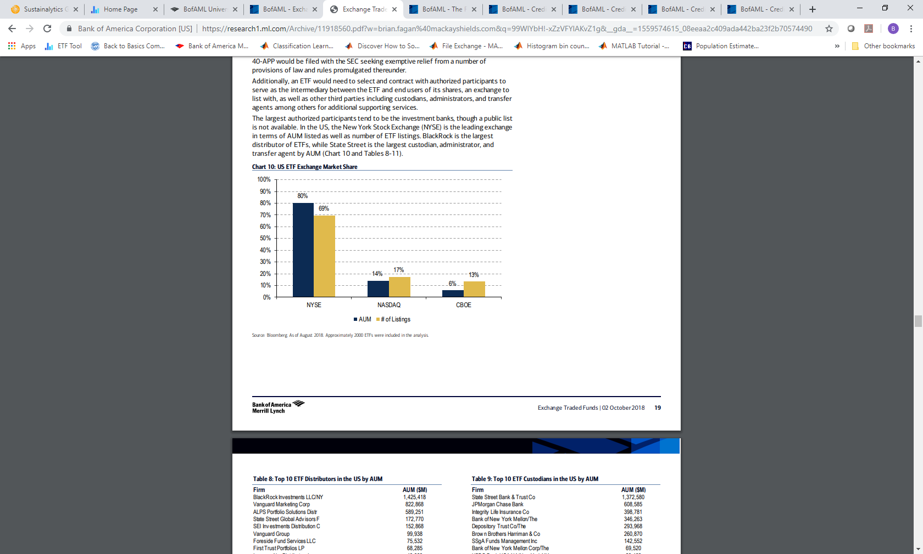

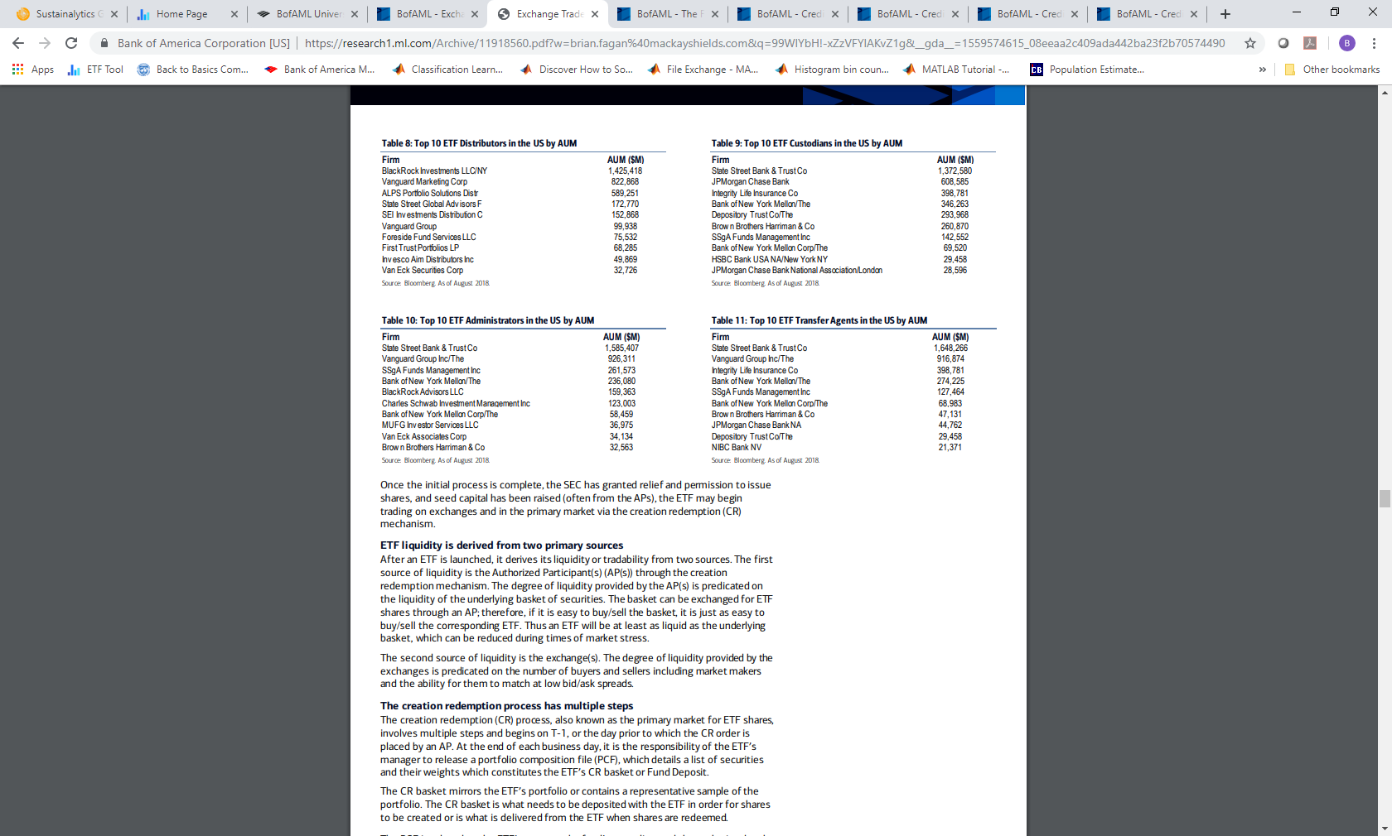

Once the initial process is complete, the SEC has granted relief and permission to issue shares, and seed capital has been raised (often from the APs), the ETF may begin trading on exchanges and in the primary market via the creation redemption (CR) mechanism.

**ETF liquidity is derived from two primary sources**

After an ETF is launched, it derives its liquidity or tradability from two sources. The first source of liquidity is the Authorized Participant(s) (AP(s)) through the creation redemption mechanism. The degree of liquidity provided by the AP(s) is predicated on the liquidity of the underlying basket of securities. The basket can be exchanged for ETF shares through an AP; therefore, if it is easy to buy/sell the basket, it is just as easy to buy/sell the corresponding ETF. Thus an ETF will be at least as liquid as the underlying basket, which can be reduced during times of market stress.

The second source of liquidity is the exchange(s). The degree of liquidity provided by the exchanges is predicated on the number of buyers and sellers including market makers and the ability for them to match at low bid/ask spreads.

**The creation redemption process has multiple steps**

The creation redemption (CR) process, also known as the primary market for ETF shares, involves multiple steps and begins on T-1, or the day prior to which the CR order is placed by an AP. At the end of each business day, it is the responsibility of the ETF’s manager to release a portfolio composition file (PCF), which details a list of securities and their weights which constitutes the ETF’s CR basket or Fund Deposit. The CR basket mirrors the ETF’s portfolio or contains a representative sample of the portfolio.

The CR basket is what needs to be deposited with the ETF in order for shares to be created or is what is delivered from the ETF when shares are redeemed. The PCF is relayed to the ETF’s agent or the fund’s custodian, and then submitted to the National Securities Clearing Corporation (NSCC) or the clearing house responsible for guaranteeing settlement to check for errors. If accepted, the PCF is made available to Authorized Participants.

Authorized Participants are large financial institutions, members of the NSCC and Depository Trust Company (DTC) that enter into agreements with distributors to create and redeem ETF shares in large blocks, known as creation units, which are typically 50,000–100,000 shares. APs are the only entities that can directly request creation and redemptions of ETF shares, which may only be created and redeemed in units.

Throughout the day, APs accumulate creation and redemption orders based on market demand from their clients. However, like the primary market in mutual funds, the ETF primary market transacts only once per day at NAV (typically 4pm for equity ETFs), at which time the AP submits its orders to the distributor, who notifies the agent who delivers the orders or instructions to NSCC.

The instructions identify the AP involved, the number of creation redemption units and any necessary cash amount. CR baskets often have cash components to account for accumulated dividends and accrued fund expenses as of the market close on T as well as to ensure equality between the ETF NAV and the CR basket.

After receiving CR orders, the NSCC validates and checks the orders, then distributes a file with accepted CR instructions to the ETF agent and the AP. The instructions serve as the contract for the CR activity. The transaction fee owed by the AP to the ETF for the order is then processed through the NSCC and the order is solidified.

The NSCC provides insurance to the ETF if an AP defaults after agreeing to create or redeem, that is if the AP fails to deliver securities or shares, the NSCC will make the ETF whole. Transaction fees charged by the ETF are generally small and cover costs to the ETF in the creation/redemption of units. For example, the creation fee for SPY is $3,000 and can be scaled, i.e. that fee can pay for one unit or several units.

Exhibit 1 below is a simplified representation of the creation redemption process. An investor gives cash to the market maker which can also be an AP. The market maker takes the cash and buys the underlying securities of the ETF in the secondary market.

The market maker/AP then takes the securities which make up the specified creation basket and delivers that basket of securities to the ETF, which in return delivers a creation unit or units depending upon the size of the deposit. The market maker then takes shares from the unit it receives and delivers them to its client(s) or the investor. The reverse would occur if the investor wanted to sell ETF shares.

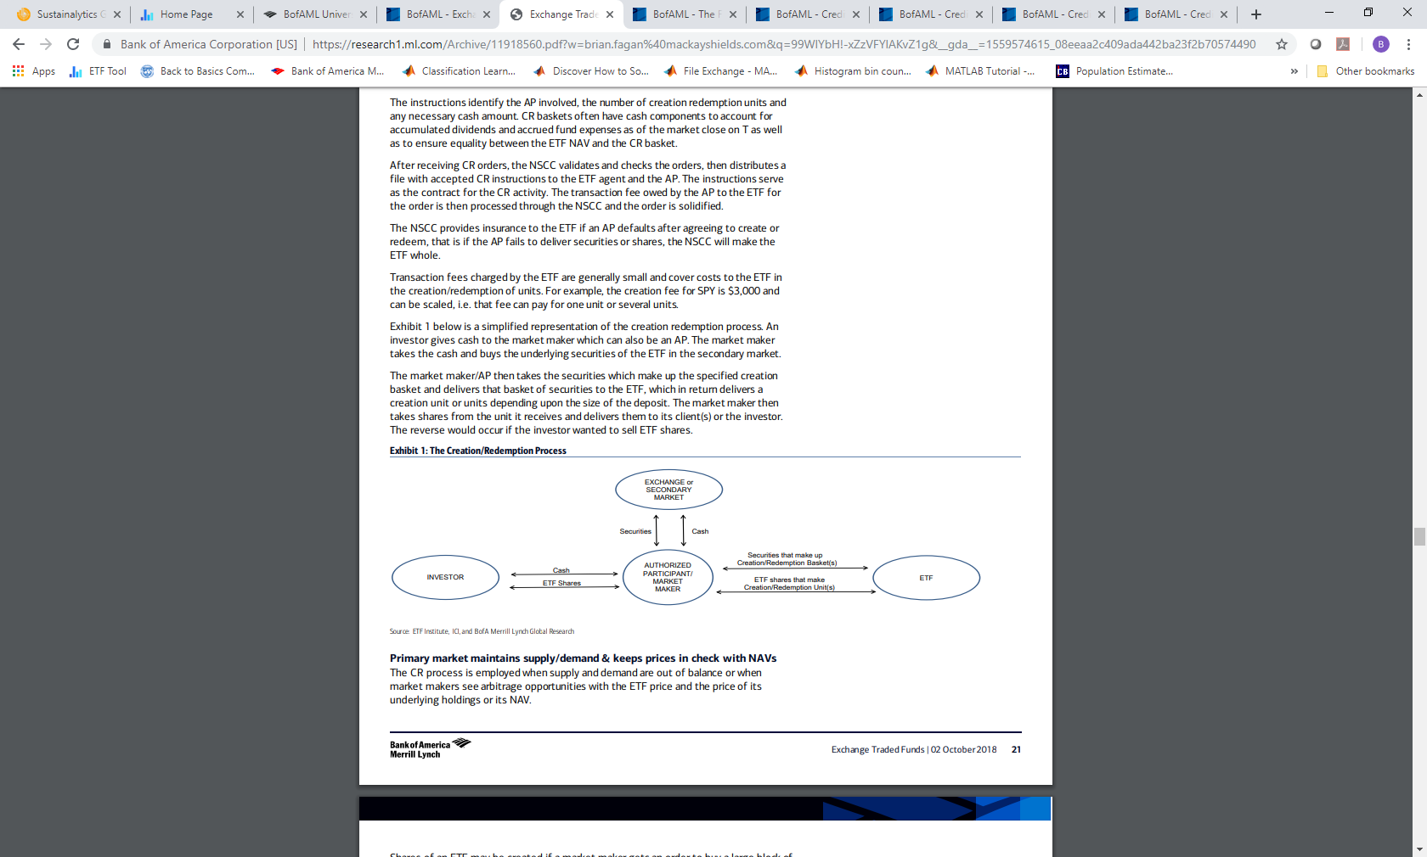

**Primary market maintains supply/demand & keeps prices in check with NAVs**

The CR process is employed when supply and demand are out of balance or when market makers see arbitrage opportunities with the ETF price and the price of its underlying holdings or its NAV.

Shares of an ETF may be created if a market maker gets an order to buy a large block of ETF shares while there are not enough asks on the other side of the trade. A market maker could still fill client orders by selling them the shares of the ETF (borrowed shares) and simultaneously buying the CR basket.

Effectively, the market maker is short the ETF shares and the client is long, so at the end of the day the market maker could exchange the basket for shares through an AP and cover its short position in the ETF shares. Thus new shares of the ETF would be created and classified as an inflow for that particular ETF.

A similar transaction could occur if a client sought to sell a large block of shares, except the market maker would be long the ETF and could trade in the ETF shares at the end of the day for the underlying securities, which would be an outflow.

Because ETF prices are market determined, there are differences between an ETF’s NAV and its market price. However, the CR mechanism allows market participants to arbitrage any differences and therefore keep prices in check with their NAVs. Closed-end funds often can trade at large discounts or premiums to their NAVs because there is no creation redemption mechanism to keep prices in check.

For example, a market participant or market maker notices an ETF trading at a premium to NAV; it then shorts the ETF shares and simultaneously buys the underlying securities. At the end of the day the market maker could deliver the securities to an AP in exchange for newly created ETF shares which would be used to cover his/her short position.

The shares the market maker receives will be priced at NAV, and because the proceeds of the short sale were greater than NAV, when the short position is closed, a spread will have been captured. The creation of ETF shares by the arbitrageur increases supply, which drives the ETF per share price down toward NAV.

The opposite would occur if an ETF was trading at a discount to NAV. The market maker would buy the ETF shares and short the underlying securities. At the end of the day the market maker would deliver the shares to an AP and get the securities in return which would be used to cover the short positions and capture a spread.

The redemption of ETF shares by the arbitrageur decreases supply, which drives the ETF per share price up toward NAV. This practice keeps ETF prices in check and minimizes tracking error.

Arbitrage opportunities rarely exist in highly liquid US securities, and for it to make sense, the spread would need to be above the costs associated with creating or redeeming including taxes. There are generally more arbitrage opportunities in international and less liquid/fixed income ETFs.

**The majority of ETF transactions occur in the secondary market**

The vast majority of transactions occur in the secondary market remote from the CR process and therefore the mechanics require little explanation as they are similar to any stock transaction, meaning they trade and settle similar to a stock.

According to a study conducted by the Investment Company Institute (ICI) that looked at ETF trading activity in 2013 and 2014, primary market trading accounted for roughly 10% of all trading versus 90% secondary. Equity ETF primary market trading relative to total trading was 9%. Bond ETF primary market trading relative to total was 19%.

The reason why investors use the primary market more for bond ETFs is because many bond ETFs lack scale relative to older equity ETFs so investors prefer to create shares rather than buy a big block on an exchange which could distort price.

The study also found that a majority of ETFs have no primary market activity whatsoever on a given day. For equity and bond ETFs, roughly 80-90% of the days had no primary market activity.