# Stacked Regressions to Predict House Prices

## Serigne

**July 2017**

**If you use parts of this notebook in your scripts/notebooks, giving some kind of credit would be very much appreciated :) You can for instance link back to this notebook. Thanks!**

This competition is very important to me as it helped me to begin my journey on Kaggle few months ago. I've read some great notebooks here. To name a few:

1. [Comprehensive data exploration with Python](https://www.kaggle.com/pmarcelino/comprehensive-data-exploration-with-python) by **Pedro Marcelino** : Great and very motivational data analysis
2. [A study on Regression applied to the Ames dataset](https://www.kaggle.com/juliencs/a-study-on-regression-applied-to-the-ames-dataset) by **Julien Cohen-Solal** : Thorough features engeneering and deep dive into linear regression analysis but really easy to follow for beginners.
3. [Regularized Linear Models](https://www.kaggle.com/apapiu/regularized-linear-models) by **Alexandru Papiu** : Great Starter kernel on modelling and Cross-validation

I can't recommend enough every beginner to go carefully through these kernels (and of course through many others great kernels) and get their first insights in data science and kaggle competitions.

After that (and some basic practices) you should be more confident to go through [this great script](https://www.kaggle.com/humananalog/xgboost-lasso) by **Human Analog** who did an impressive work on features engineering.

As the dataset is particularly handy, I decided few days ago to get back in this competition and apply things I learnt so far, especially stacking models. For that purpose, we build two stacking classes ( the simplest approach and a less simple one).

As these classes are written for general purpose, you can easily adapt them and/or extend them for your regression problems. The overall approach is hopefully concise and easy to follow..

The features engeneering is rather parsimonious (at least compared to some others great scripts) . It is pretty much :

* **Imputing missing values** by proceeding sequentially through the data
* **Transforming** some numerical variables that seem really categorical
* **Label Encoding** some categorical variables that may contain information in their ordering set
* [**Box Cox Transformation**](http://onlinestatbook.com/2/transformations/box-cox.html) of skewed features (instead of log-transformation) : This gave me a **slightly better result**both on leaderboard and cross-validation.
* **Getting dummy variables** for categorical features.

Then we choose many base models (mostly sklearn based models + sklearn API of DMLC's [XGBoost](https://github.com/dmlc/xgboost) and Microsoft's [LightGBM](https://github.com/Microsoft/LightGBM)), cross-validate them on the data before stacking/ensembling them. The key here is to make the (linear) models robust to outliers. This improved the result both on LB and cross-validation.

To my surprise, this does well on LB ( 0.11420 and top 4% the last time I tested it : **July 2, 2017** )

**Hope that at the end of this notebook, stacking will be clear for those, like myself, who found the concept not so easy to grasp**

In [1]:

#import some necessary librairies

import numpy as np # linear algebra

import pandas as pd # data processing, CSV file I/O (e.g. pd.read\_csv)

%matplotlib inline

import matplotlib.pyplot as plt # Matlab-style plotting

import seaborn as sns

color = sns.color\_palette()

sns.set\_style('darkgrid')

import warnings

def ignore\_warn(\*args, \*\*kwargs):

pass

warnings.warn = ignore\_warn #ignore annoying warning (from sklearn and seaborn)

from scipy import stats

from scipy.stats import norm, skew #for some statistics

pd.set\_option('display.float\_format', lambda x: '**{:.3f}**'.format(x)) #Limiting floats output to 3 decimal points

from subprocess import check\_output

print(check\_output(["ls", "../input"]).decode("utf8")) #check the files available in the directory

sample\_submission.csv

test.csv

train.csv

In [2]:

#Now let's import and put the train and test datasets in pandas dataframe

train = pd.read\_csv('../input/train.csv')

test = pd.read\_csv('../input/test.csv')

In [3]:

##display the first five rows of the train dataset.

train.head(5)

Out[3]:



5 rows × 81 columns

In [4]:

##display the first five rows of the test dataset.

test.head(5)

Out[4]:



5 rows × 80 columns

In [5]:

#check the numbers of samples and features

print("The train data size before dropping Id feature is : **{}** ".format(train.shape))

print("The test data size before dropping Id feature is : **{}** ".format(test.shape))

#Save the 'Id' column

train\_ID = train['Id']

test\_ID = test['Id']

#Now drop the 'Id' colum since it's unnecessary for the prediction process.

train.drop("Id", axis = 1, inplace = True)

test.drop("Id", axis = 1, inplace = True)

#check again the data size after dropping the 'Id' variable

print("**\n**The train data size after dropping Id feature is : **{}** ".format(train.shape))

print("The test data size after dropping Id feature is : **{}** ".format(test.shape))

The train data size before dropping Id feature is : (1460, 81)

The test data size before dropping Id feature is : (1459, 80)

The train data size after dropping Id feature is : (1460, 80)

The test data size after dropping Id feature is : (1459, 79)

# Data Processing

## Outliers

[Documentation](http://ww2.amstat.org/publications/jse/v19n3/Decock/DataDocumentation.txt) for the Ames Housing Data indicates that there are outliers present in the training data

Let's explore these outliers

In [6]:

fig, ax = plt.subplots()

ax.scatter(x = train['GrLivArea'], y = train['SalePrice'])

plt.ylabel('SalePrice', fontsize=13)

plt.xlabel('GrLivArea', fontsize=13)

plt.show()

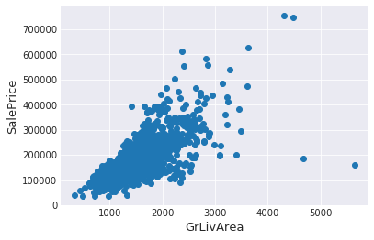

We can see at the bottom right two with extremely large GrLivArea that are of a low price. These values are huge oultliers. Therefore, we can safely delete them.

In [7]:

#Deleting outliers

train = train.drop(train[(train['GrLivArea']>4000) & (train['SalePrice']<300000)].index)

#Check the graphic again

fig, ax = plt.subplots()

ax.scatter(train['GrLivArea'], train['SalePrice'])

plt.ylabel('SalePrice', fontsize=13)

plt.xlabel('GrLivArea', fontsize=13)

plt.show()

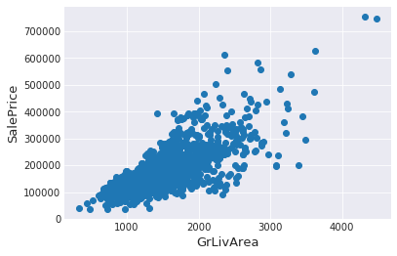

### Note:

Outlier’s removal is note always safe. We decided to delete these two as they are very huge and really bad (extremely large areas for very low prices).

There are probably others outliers in the training data. However, removing all them may affect badly our models if ever there were also outliers in the test data. That's why, instead of removing them all, we will just manage to make some of our models robust on them. You can refer to the modelling part of this notebook for that.

## Target Variable

**SalePrice** is the variable we need to predict. So let's do some analysis on this variable first.

In [8]:

sns.distplot(train['SalePrice'] , fit=norm);

# Get the fitted parameters used by the function

(mu, sigma) = norm.fit(train['SalePrice'])

print( '**\n** mu = **{:.2f}** and sigma = **{:.2f}\n**'.format(mu, sigma))

#Now plot the distribution

plt.legend(['Normal dist. ($\mu=$ **{:.2f}** and $\sigma=$ **{:.2f}** )'.format(mu, sigma)],

loc='best')

plt.ylabel('Frequency')

plt.title('SalePrice distribution')

#Get also the QQ-plot

fig = plt.figure()

res = stats.probplot(train['SalePrice'], plot=plt)

plt.show()

mu = 180932.92 and sigma = 79467.79

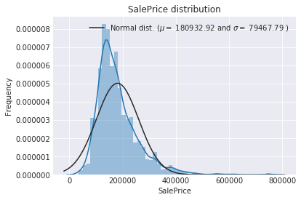

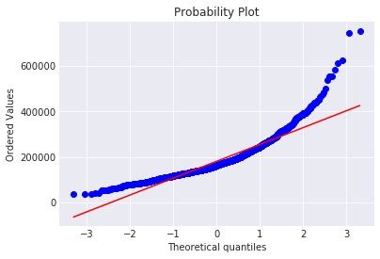

The target variable is right skewed. As (linear) models love normally distributed data, we need to transform this variable and make it more normally distributed.

**Log-transformation of the target variable**

In [9]:

#We use the numpy fuction log1p which applies log(1+x) to all elements of the column

train["SalePrice"] = np.log1p(train["SalePrice"])

#Check the new distribution

sns.distplot(train['SalePrice'] , fit=norm);

# Get the fitted parameters used by the function

(mu, sigma) = norm.fit(train['SalePrice'])

print( '**\n** mu = **{:.2f}** and sigma = **{:.2f}\n**'.format(mu, sigma))

#Now plot the distribution

plt.legend(['Normal dist. ($\mu=$ **{:.2f}** and $\sigma=$ **{:.2f}** )'.format(mu, sigma)],loc='best')

plt.ylabel('Frequency')

plt.title('SalePrice distribution')

#Get also the QQ-plot

fig = plt.figure()

res = stats.probplot(train['SalePrice'], plot=plt)

plt.show()

mu = 12.02 and sigma = 0.40

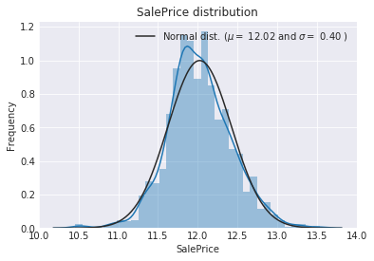

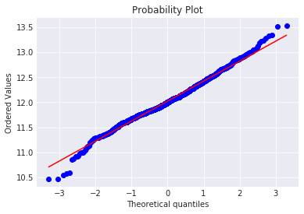

The skew seems now corrected and the data appears more normally distributed.

## Features engineering

let's first concatenate the train and test data in the same dataframe

In [10]:

ntrain = train.shape[0]

ntest = test.shape[0]

y\_train = train.SalePrice.values

all\_data = pd.concat((train, test)).reset\_index(drop=True)

all\_data.drop(['SalePrice'], axis=1, inplace=True)

print("all\_data size is : **{}**".format(all\_data.shape))

all\_data size is : (2917, 79)

### Missing Data

In [11]:

all\_data\_na = (all\_data.isnull().sum() / len(all\_data)) \* 100

all\_data\_na = all\_data\_na.drop(all\_data\_na[all\_data\_na == 0].index).sort\_values(ascending=False)[:30]

missing\_data = pd.DataFrame({'Missing Ratio' :all\_data\_na})

missing\_data.head(20)

Out[11]:



In [12]:

f, ax = plt.subplots(figsize=(15, 12))

plt.xticks(rotation='90')

sns.barplot(x=all\_data\_na.index, y=all\_data\_na)

plt.xlabel('Features', fontsize=15)

plt.ylabel('Percent of missing values', fontsize=15)

plt.title('Percent missing data by feature', fontsize=15)

Out[12]:

<matplotlib.text.Text at 0x7fdff536d898>

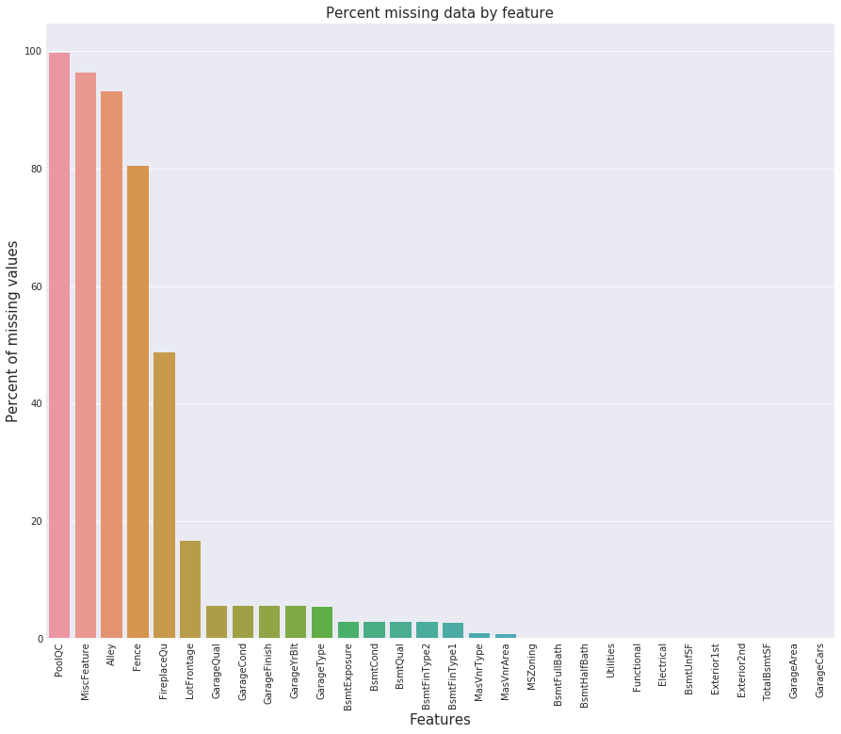

**Data Correlation**

In [13]:

#Correlation map to see how features are correlated with SalePrice

corrmat = train.corr()

plt.subplots(figsize=(12,9))

sns.heatmap(corrmat, vmax=0.9, square=True)

Out[13]:

<matplotlib.axes.\_subplots.AxesSubplot at 0x7fdff54a14a8>

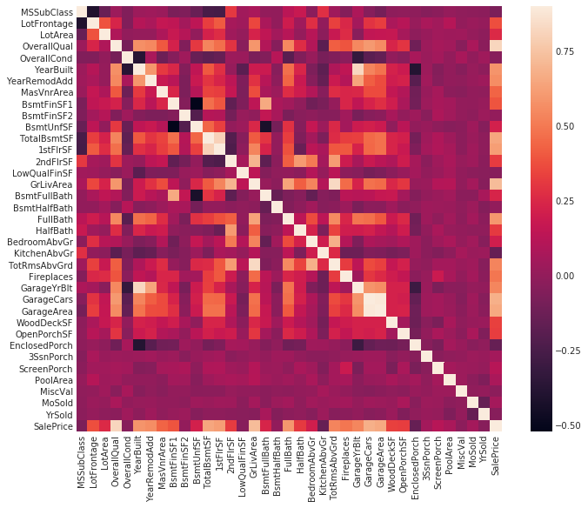

### Imputing missing values

We impute them by proceeding sequentially through features with missing values

* **PoolQC** : data description says NA means "No Pool". That make sense, given the huge ratio of missing value (+99%) and majority of houses have no Pool at all in general.

In [14]:

all\_data["PoolQC"] = all\_data["PoolQC"].fillna("None")

* **MiscFeature** : data description says NA means "no misc feature"

In [15]:

all\_data["MiscFeature"] = all\_data["MiscFeature"].fillna("None")

* **Alley** : data description says NA means "no alley access"

In [16]:

all\_data["Alley"] = all\_data["Alley"].fillna("None")

* **Fence** : data description says NA means "no fence"

In [17]:

all\_data["Fence"] = all\_data["Fence"].fillna("None")

* **FireplaceQu** : data description says NA means "no fireplace"

In [18]:

all\_data["FireplaceQu"] = all\_data["FireplaceQu"].fillna("None")

* **LotFrontage** : Since the area of each street connected to the house property most likely have a similar area to other houses in its neighborhood , we can **fill in missing values by the median LotFrontage of the neighborhood**.

In [19]:

#Group by neighborhood and fill in missing value by the median LotFrontage of all the neighborhood

all\_data["LotFrontage"] = all\_data.groupby("Neighborhood")["LotFrontage"].transform(

lambda x: x.fillna(x.median()))

* **GarageType, GarageFinish, GarageQual and GarageCond** : Replacing missing data with None

In [20]:

for col **in** ('GarageType', 'GarageFinish', 'GarageQual', 'GarageCond'):

all\_data[col] = all\_data[col].fillna('None')

* **GarageYrBlt, GarageArea and GarageCars** : Replacing missing data with 0 (Since No garage = no cars in such garage.)

In [21]:

for col **in** ('GarageYrBlt', 'GarageArea', 'GarageCars'):

all\_data[col] = all\_data[col].fillna(0)

* **BsmtFinSF1, BsmtFinSF2, BsmtUnfSF, TotalBsmtSF, BsmtFullBath and BsmtHalfBath** : missing values are likely zero for having no basement

In [22]:

for col **in** ('BsmtFinSF1', 'BsmtFinSF2', 'BsmtUnfSF','TotalBsmtSF', 'BsmtFullBath', 'BsmtHalfBath'):

all\_data[col] = all\_data[col].fillna(0)

* **BsmtQual, BsmtCond, BsmtExposure, BsmtFinType1 and BsmtFinType2** : For all these categorical basement-related features, NaN means that there is no basement.

In [23]:

for col **in** ('BsmtQual', 'BsmtCond', 'BsmtExposure', 'BsmtFinType1', 'BsmtFinType2'):

all\_data[col] = all\_data[col].fillna('None')

* **MasVnrArea and MasVnrType** : NA most likely means no masonry veneer for these houses. We can fill 0 for the area and None for the type.

In [24]:

all\_data["MasVnrType"] = all\_data["MasVnrType"].fillna("None")

all\_data["MasVnrArea"] = all\_data["MasVnrArea"].fillna(0)

* **MSZoning (The general zoning classification)** : 'RL' is by far the most common value. So we can fill in missing values with 'RL'

In [25]:

all\_data['MSZoning'] = all\_data['MSZoning'].fillna(all\_data['MSZoning'].mode()[0])

* **Utilities** : For this categorical feature all records are "AllPub", except for one "NoSeWa" and 2 NA . Since the house with 'NoSewa' is in the training set, **this feature won't help in predictive modelling**. We can then safely remove it.

In [26]:

all\_data = all\_data.drop(['Utilities'], axis=1)

* **Functional** : data description says NA means typical

In [27]:

all\_data["Functional"] = all\_data["Functional"].fillna("Typ")

* **Electrical** : It has one NA value. Since this feature has mostly 'SBrkr', we can set that for the missing value.

In [28]:

all\_data['Electrical'] = all\_data['Electrical'].fillna(all\_data['Electrical'].mode()[0])

* **KitchenQual**: Only one NA value, and same as Electrical, we set 'TA' (which is the most frequent) for the missing value in KitchenQual.

In [29]:

all\_data['KitchenQual'] = all\_data['KitchenQual'].fillna(all\_data['KitchenQual'].mode()[0])

* **Exterior1st and Exterior2nd** : Again Both Exterior 1 & 2 have only one missing value. We will just substitute in the most common string

In [30]:

all\_data['Exterior1st'] = all\_data['Exterior1st'].fillna(all\_data['Exterior1st'].mode()[0])

all\_data['Exterior2nd'] = all\_data['Exterior2nd'].fillna(all\_data['Exterior2nd'].mode()[0])

* **SaleType** : Fill in again with most frequent which is "WD"

In [31]:

all\_data['SaleType'] = all\_data['SaleType'].fillna(all\_data['SaleType'].mode()[0])

* **MSSubClass** : Na most likely means No building class. We can replace missing values with None

In [32]:

all\_data['MSSubClass'] = all\_data['MSSubClass'].fillna("None")

Is there any remaining missing value ?

In [33]:

#Check remaining missing values if any

all\_data\_na = (all\_data.isnull().sum() / len(all\_data)) \* 100

all\_data\_na = all\_data\_na.drop(all\_data\_na[all\_data\_na == 0].index).sort\_values(ascending=False)

missing\_data = pd.DataFrame({'Missing Ratio' :all\_data\_na})

missing\_data.head()

Out[33]:



It remains no missing value.

### More features engineering

**Transforming some numerical variables that are really categorical**

In [34]:

#MSSubClass=The building class

all\_data['MSSubClass'] = all\_data['MSSubClass'].apply(str)

#Changing OverallCond into a categorical variable

all\_data['OverallCond'] = all\_data['OverallCond'].astype(str)

#Year and month sold are transformed into categorical features.

all\_data['YrSold'] = all\_data['YrSold'].astype(str)

all\_data['MoSold'] = all\_data['MoSold'].astype(str)

**Label Encoding some categorical variables that may contain information in their ordering set**

In [35]:

from sklearn.preprocessing import LabelEncoder

cols = ('FireplaceQu', 'BsmtQual', 'BsmtCond', 'GarageQual', 'GarageCond',

'ExterQual', 'ExterCond','HeatingQC', 'PoolQC', 'KitchenQual', 'BsmtFinType1',

'BsmtFinType2', 'Functional', 'Fence', 'BsmtExposure', 'GarageFinish', 'LandSlope',

'LotShape', 'PavedDrive', 'Street', 'Alley', 'CentralAir', 'MSSubClass', 'OverallCond',

'YrSold', 'MoSold')

# process columns, apply LabelEncoder to categorical features

for c **in** cols:

lbl = LabelEncoder()

lbl.fit(list(all\_data[c].values))

all\_data[c] = lbl.transform(list(all\_data[c].values))

# shape

print('Shape all\_data: **{}**'.format(all\_data.shape))

Shape all\_data: (2917, 78)

**Adding one more important feature**

Since area related features are very important to determine house prices, we add one more feature which is the total area of basement, first and second floor areas of each house

In [36]:

# Adding total sqfootage feature

all\_data['TotalSF'] = all\_data['TotalBsmtSF'] + all\_data['1stFlrSF'] + all\_data['2ndFlrSF']

**Skewed features**

In [37]:

numeric\_feats = all\_data.dtypes[all\_data.dtypes != "object"].index

# Check the skew of all numerical features

skewed\_feats = all\_data[numeric\_feats].apply(lambda x: skew(x.dropna())).sort\_values(ascending=False)

print("**\n**Skew in numerical features: **\n**")

skewness = pd.DataFrame({'Skew' :skewed\_feats})

skewness.head(10)

Skew in numerical features:

Out[37]:



**Box Cox Transformation of (highly) skewed features**

We use the scipy function boxcox1p which computes the Box-Cox transformation of 1+x1+x.

Note that setting λ=0λ=0 is equivalent to log1p used above for the target variable.

See [this page](http://onlinestatbook.com/2/transformations/box-cox.html) for more details on Box Cox Transformation as well as [the scipy function's page](https://docs.scipy.org/doc/scipy-0.19.0/reference/generated/scipy.special.boxcox1p.html)

In [38]:

skewness = skewness[abs(skewness) > 0.75]

print("There are **{}** skewed numerical features to Box Cox transform".format(skewness.shape[0]))

from scipy.special import boxcox1p

skewed\_features = skewness.index

lam = 0.15

for feat **in** skewed\_features:

#all\_data[feat] += 1

all\_data[feat] = boxcox1p(all\_data[feat], lam)

#all\_data[skewed\_features] = np.log1p(all\_data[skewed\_features])

There are 59 skewed numerical features to Box Cox transform

**Getting dummy categorical features**

In [39]:

all\_data = pd.get\_dummies(all\_data)

print(all\_data.shape)

(2917, 220)

Getting the new train and test sets.

In [40]:

train = all\_data[:ntrain]

test = all\_data[ntrain:]

# Modelling

**Import librairies**

In [41]:

from sklearn.linear\_model import ElasticNet, Lasso, BayesianRidge, LassoLarsIC

from sklearn.ensemble import RandomForestRegressor, GradientBoostingRegressor

from sklearn.kernel\_ridge import KernelRidge

from sklearn.pipeline import make\_pipeline

from sklearn.preprocessing import RobustScaler

from sklearn.base import BaseEstimator, TransformerMixin, RegressorMixin, clone

from sklearn.model\_selection import KFold, cross\_val\_score, train\_test\_split

from sklearn.metrics import mean\_squared\_error

import xgboost as xgb

import lightgbm as lgb

**Define a cross validation strategy**

We use the **cross\_val\_score** function of Sklearn. However this function has not a shuffle attribut, we add then one line of code, in order to shuffle the dataset prior to cross-validation

In [42]:

#Validation function

n\_folds = 5

def rmsle\_cv(model):

kf = KFold(n\_folds, shuffle=True, random\_state=42).get\_n\_splits(train.values)

rmse= np.sqrt(-cross\_val\_score(model, train.values, y\_train, scoring="neg\_mean\_squared\_error", cv = kf))

return(rmse)

## Base models

* **LASSO Regression** :

This model may be very sensitive to outliers. So we need to made it more robust on them. For that we use the sklearn's**Robustscaler()** method on pipeline

In [43]:

lasso = make\_pipeline(RobustScaler(), Lasso(alpha =0.0005, random\_state=1))

* **Elastic Net Regression** :

again made robust to outliers

In [44]:

ENet = make\_pipeline(RobustScaler(), ElasticNet(alpha=0.0005, l1\_ratio=.9, random\_state=3))

* **Kernel Ridge Regression** :

In [45]:

KRR = KernelRidge(alpha=0.6, kernel='polynomial', degree=2, coef0=2.5)

* **Gradient Boosting Regression** :

With **huber** loss that makes it robust to outliers

In [46]:

GBoost = GradientBoostingRegressor(n\_estimators=3000, learning\_rate=0.05,

max\_depth=4, max\_features='sqrt',

min\_samples\_leaf=15, min\_samples\_split=10,

loss='huber', random\_state =5)

* **XGBoost** :

In [47]:

model\_xgb = xgb.XGBRegressor(colsample\_bytree=0.4603, gamma=0.0468,

learning\_rate=0.05, max\_depth=3,

min\_child\_weight=1.7817, n\_estimators=2200,

reg\_alpha=0.4640, reg\_lambda=0.8571,

subsample=0.5213, silent=1,

random\_state =7, nthread = -1)

* **LightGBM** :

In [48]:

model\_lgb = lgb.LGBMRegressor(objective='regression',num\_leaves=5,

learning\_rate=0.05, n\_estimators=720,

max\_bin = 55, bagging\_fraction = 0.8,

bagging\_freq = 5, feature\_fraction = 0.2319,

feature\_fraction\_seed=9, bagging\_seed=9,

min\_data\_in\_leaf =6, min\_sum\_hessian\_in\_leaf = 11)

### Base models scores

Let's see how these base models perform on the data by evaluating the cross-validation rmsle error

In [49]:

score = rmsle\_cv(lasso)

print("**\n**Lasso score: **{:.4f}** (**{:.4f}**)**\n**".format(score.mean(), score.std()))

Lasso score: 0.1115 (0.0074)

In [50]:

score = rmsle\_cv(ENet)

print("ElasticNet score: **{:.4f}** (**{:.4f}**)**\n**".format(score.mean(), score.std()))

ElasticNet score: 0.1116 (0.0074)

In [51]:

score = rmsle\_cv(KRR)

print("Kernel Ridge score: **{:.4f}** (**{:.4f}**)**\n**".format(score.mean(), score.std()))

Kernel Ridge score: 0.1153 (0.0075)

In [52]:

score = rmsle\_cv(GBoost)

print("Gradient Boosting score: **{:.4f}** (**{:.4f}**)**\n**".format(score.mean(), score.std()))

Gradient Boosting score: 0.1177 (0.0080)

In [53]:

score = rmsle\_cv(model\_xgb)

print("Xgboost score: **{:.4f}** (**{:.4f}**)**\n**".format(score.mean(), score.std()))

Xgboost score: 0.1161 (0.0079)

In [54]:

score = rmsle\_cv(model\_lgb)

print("LGBM score: **{:.4f}** (**{:.4f}**)**\n**" .format(score.mean(), score.std()))

LGBM score: 0.1148 (0.0069)

## Stacking models

### Simplest Stacking approach : Averaging base models

We begin with this simple approach of averaging base models. We build a new **class** to extend scikit-learn with our model and also to laverage encapsulation and code reuse ([inheritance](https://en.wikipedia.org/wiki/Inheritance_(object-oriented_programming)))

**Averaged base models class**

In [55]:

class **AveragingModels**(BaseEstimator, RegressorMixin, TransformerMixin):

def \_\_init\_\_(self, models):

self.models = models

# we define clones of the original models to fit the data in

def fit(self, X, y):

self.models\_ = [clone(x) for x **in** self.models]

# Train cloned base models

for model **in** self.models\_:

model.fit(X, y)

return self

#Now we do the predictions for cloned models and average them

def predict(self, X):

predictions = np.column\_stack([

model.predict(X) for model **in** self.models\_

])

return np.mean(predictions, axis=1)

**Averaged base models score**

We just average four models here **ENet, GBoost, KRR and lasso**. Of course we could easily add more models in the mix.

In [56]:

averaged\_models = AveragingModels(models = (ENet, GBoost, KRR, lasso))

score = rmsle\_cv(averaged\_models)

print(" Averaged base models score: **{:.4f}** (**{:.4f}**)**\n**".format(score.mean(), score.std()))

Averaged base models score: 0.1091 (0.0075)

Wow ! It seems even the simplest stacking approach really improve the score . This encourages us to go further and explore a less simple stacking approch.

### Less simple Stacking : Adding a Meta-model

In this approach, we add a meta-model on averaged base models and use the out-of-folds predictions of these base models to train our meta-model.

The procedure, for the training part, may be described as follows:

1. Split the total training set into two disjoint sets (here **train** and .**holdout** )
2. Train several base models on the first part (**train**)
3. Test these base models on the second part (**holdout**)
4. Use the predictions from 3) (called out-of-folds predictions) as the inputs, and the correct responses (target variable) as the outputs to train a higher level learner called **meta-model**.

The first three steps are done iteratively . If we take for example a 5-fold stacking , we first split the training data into 5 folds. Then we will do 5 iterations. In each iteration, we train every base model on 4 folds and predict on the remaining fold (holdout fold).

So, we will be sure, after 5 iterations , that the entire data is used to get out-of-folds predictions that we will then use as new feature to train our meta-model in the step 4.

For the prediction part , We average the predictions of all base models on the test data and used them as **meta-features** on which, the final prediction is done with the meta-model.

Faron

(Image taken from [Faron](https://www.kaggle.com/getting-started/18153" \l "post103381" \t "_self))

kaz

Gif taken from [KazAnova's interview](http://blog.kaggle.com/2017/06/15/stacking-made-easy-an-introduction-to-stacknet-by-competitions-grandmaster-marios-michailidis-kazanova/)

On this gif, the base models are algorithms 0, 1, 2 and the meta-model is algorithm 3. The entire training dataset is A+B (target variable y known) that we can split into train part (A) and holdout part (B). And the test dataset is C.

B1 (which is the prediction from the holdout part) is the new feature used to train the meta-model 3 and C1 (which is the prediction from the test dataset) is the meta-feature on which the final prediction is done.

**Stacking averaged Models Class**

In [57]:

class **StackingAveragedModels**(BaseEstimator, RegressorMixin, TransformerMixin):

def \_\_init\_\_(self, base\_models, meta\_model, n\_folds=5):

self.base\_models = base\_models

self.meta\_model = meta\_model

self.n\_folds = n\_folds

# We again fit the data on clones of the original models

def fit(self, X, y):

self.base\_models\_ = [list() for x **in** self.base\_models]

self.meta\_model\_ = clone(self.meta\_model)

kfold = KFold(n\_splits=self.n\_folds, shuffle=True, random\_state=156)

# Train cloned base models then create out-of-fold predictions

# that are needed to train the cloned meta-model

out\_of\_fold\_predictions = np.zeros((X.shape[0], len(self.base\_models)))

for i, model **in** enumerate(self.base\_models):

for train\_index, holdout\_index **in** kfold.split(X, y):

instance = clone(model)

self.base\_models\_[i].append(instance)

instance.fit(X[train\_index], y[train\_index])

y\_pred = instance.predict(X[holdout\_index])

out\_of\_fold\_predictions[holdout\_index, i] = y\_pred

# Now train the cloned meta-model using the out-of-fold predictions as new feature

self.meta\_model\_.fit(out\_of\_fold\_predictions, y)

return self

#Do the predictions of all base models on the test data and use the averaged predictions as

#meta-features for the final prediction which is done by the meta-model

def predict(self, X):

meta\_features = np.column\_stack([

np.column\_stack([model.predict(X) for model **in** base\_models]).mean(axis=1)

for base\_models **in** self.base\_models\_ ])

return self.meta\_model\_.predict(meta\_features)

**Stacking Averaged models Score**

To make the two approaches comparable (by using the same number of models) , we just average **Enet KRR and Gboost**, then we add **lasso as meta-model**.

In [58]:

stacked\_averaged\_models = StackingAveragedModels(base\_models = (ENet, GBoost, KRR),

meta\_model = lasso)

score = rmsle\_cv(stacked\_averaged\_models)

print("Stacking Averaged models score: **{:.4f}** (**{:.4f}**)".format(score.mean(), score.std()))

Stacking Averaged models score: 0.1085 (0.0074)

We get again a better score by adding a meta learner

## Ensembling StackedRegressor, XGBoost and LightGBM

We add **XGBoost and LightGBM** to the**StackedRegressor** defined previously.

We first define a rmsle evaluation function

In [59]:

def rmsle(y, y\_pred):

return np.sqrt(mean\_squared\_error(y, y\_pred))

### Final Training and Prediction

**StackedRegressor:**

In [60]:

stacked\_averaged\_models.fit(train.values, y\_train)

stacked\_train\_pred = stacked\_averaged\_models.predict(train.values)

stacked\_pred = np.expm1(stacked\_averaged\_models.predict(test.values))

print(rmsle(y\_train, stacked\_train\_pred))

0.0781571937916

**XGBoost:**

In [61]:

model\_xgb.fit(train, y\_train)

xgb\_train\_pred = model\_xgb.predict(train)

xgb\_pred = np.expm1(model\_xgb.predict(test))

print(rmsle(y\_train, xgb\_train\_pred))

0.0785165142425

**LightGBM:**

In [62]:

model\_lgb.fit(train, y\_train)

lgb\_train\_pred = model\_lgb.predict(train)

lgb\_pred = np.expm1(model\_lgb.predict(test.values))

print(rmsle(y\_train, lgb\_train\_pred))

0.0719406222196

In [63]:

*'''RMSE on the entire Train data when averaging'''*

print('RMSLE score on train data:')

print(rmsle(y\_train,stacked\_train\_pred\*0.70 +

xgb\_train\_pred\*0.15 + lgb\_train\_pred\*0.15 ))

RMSLE score on train data:

0.0752452023077

**Ensemble prediction:**

In [64]:

ensemble = stacked\_pred\*0.70 + xgb\_pred\*0.15 + lgb\_pred\*0.15

**Submission**

In [65]:

sub = pd.DataFrame()

sub['Id'] = test\_ID

sub['SalePrice'] = ensemble

sub.to\_csv('submission.csv',index=False)

**If you found this notebook helpful or you just liked it , some upvotes would be very much appreciated - That will keep me motivated to update it on a regular basis** :-)