# Why I'll Never Live In Silicon Valley

# Published on April 3, 2018

# [Ben Taylor [DeepLearning]](https://www.linkedin.com/in/bentaylordata/)

I don't have to. The end.

Someone requested this brain dump from the bay area so here it comes out of my left ear onto your screen.

Most people have no idea what makes a job good or bad, they really don't. They work for one employer out of school and stay there. Is their job great? Maybe. Does there job suck? Probably. To really know you have to sample the market and try multiple jobs, maybe even multiple locations. I have had jobs where I have been bored out of my mind working in a billion dollar technology room surrounded by robots and automation. I have also had jobs where I have been challenged to my limits, paid well, and stressed AF hating my weekly grind speeding in my AMG Mercedes. The later situation can lead to divorce BTW.

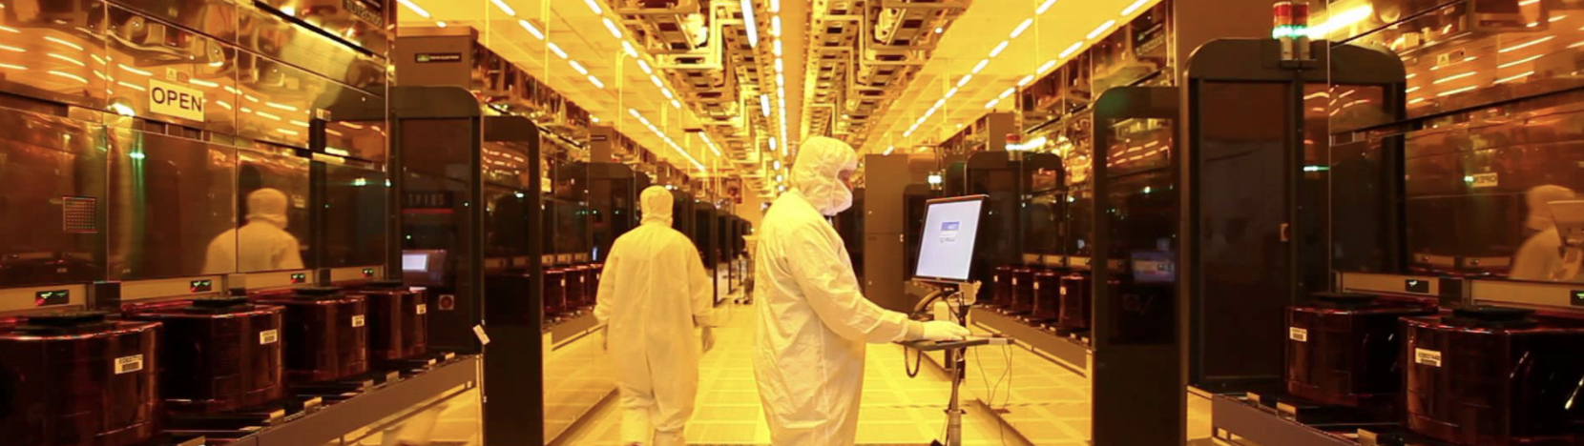

The first time I had what I considered to be a great job was when I worked at the Sequoia-backed startup called HireVue. Intel/Micron wouldn't let me wear my flipflops to work and there was a large market pay gap I was dealing with between my current pay and the data science market. I was even willing to take a $20K drop in salary for those damn flipflops and here was [Eli Ribble](https://www.linkedin.com/in/eliribble/) at HireVue, barefoot, interviewing me. After joining HireVue I finally found a balance between being challenged, skiing when I needed it, enjoying my coworkers, and changing the world. Did I mention I skied a lot? This is Utah powder, the legendary 4% powder density, none of that Sierra cement I was used to living in Reno.



This is a very simple idea, ask yourself do you **work to live**? Or do you **live to work**? At HireVue I was committed, passionate, and working all the time. I even pulled multiple all-nighters my first year to meet some high-pressure deadlines. Despite that, I felt like HireVue was enabling me to live the life I wanted. At Intel/Micron we had a downed fab event where I was on an active conference call for 20 straight hours on Sunday working to get things running again. I can't go into details, but I was able to pull a real rabbit out of my hat and for that contribution I was given $100 gift card. #WorkToLive.

If I loved HireVue so much why did I leave? You can blame Amazon, Google, IBM, and Microsoft for that. The amount of confusion and effort needed to ship useful AI into production was still too difficult in 2016. I felt like the companies we typically rely on were failing to deliver on what I thought was common sense. Google was attempting to win market share by whitepaper, IBM by marketing, Microsoft by integrations, and Amazon was late to the party. Since leaving HireVue a year ago ALL of these players have leveled up and improved. It isn't a walk in the park to compete against them, which I appreciate, but it isn't impossible either.

**What about the peer network in the bay area?**

Some people think that by leaving the bay area that they will somehow leave the innovation tech center and miss out on the peers in those circles. If you hustle and have an obsession in your domain you don't need anyone. With the internet and the wealth of knowledge at your fingertips, you can learn what you need and go beyond what people know. You can also network and chat with talent anywhere online. To think that most of the world's AI talent is bottled up in the valley is naive. I have been very impressed interacting with people in Australia, Norway, Germany, and Singapore. I do take frequent, almost monthly, trips to LA, San Fransisco, and other tech centers to meet with prospects and speak. So you may still travel there, but living there isn't required.

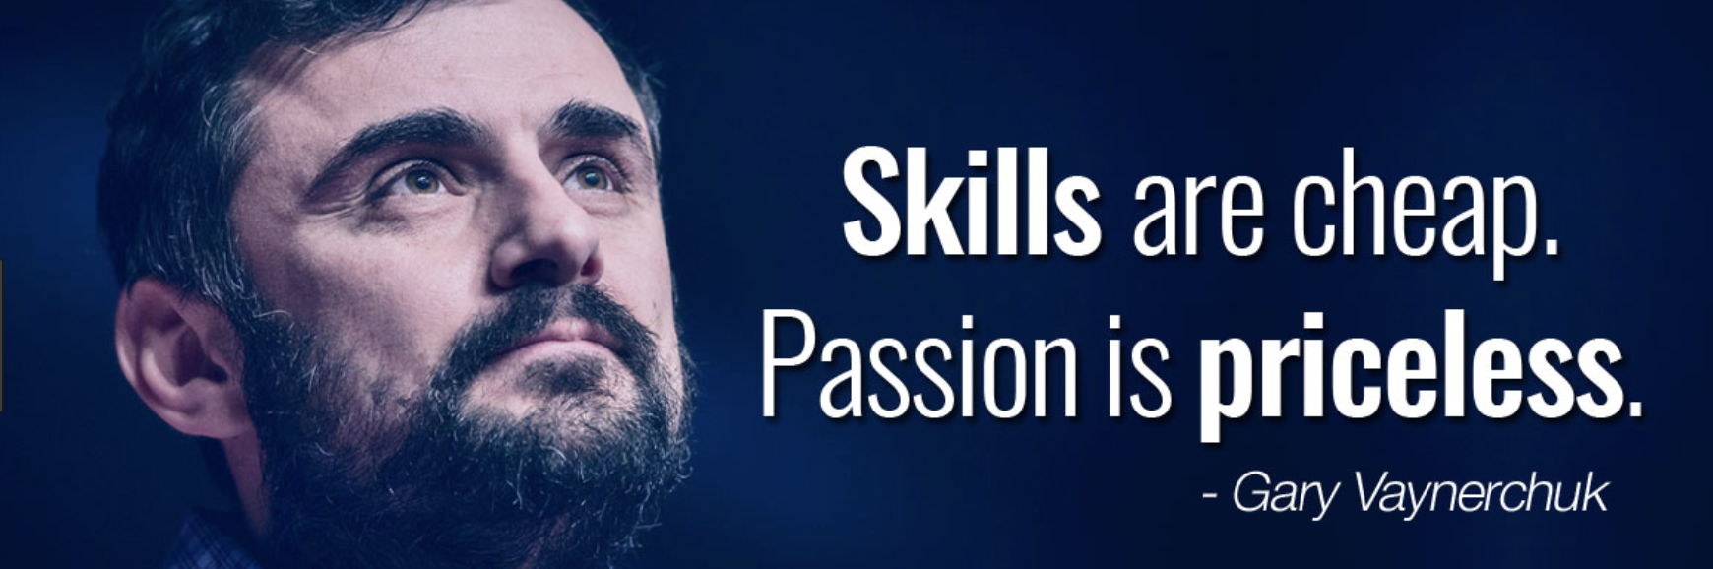

Some think that living in the bay area is required to raise money there. Maybe, if you want a VC parachute to test your risky idea. If you really believe in your idea go and find a customer who believes in it, someone who can pay you and bootstrap. I am so grateful we have bootstrapped our startup. A startup is a series of mistakes in the right direction and being bootstraped you feel all of them.

Also, I know skiing isn't the silver bullet for everyone. Maybe surfing, mountain biking, climbing, hiking, kayaking, or biking around Central Park in Manhattan is. Maybe the bay area is too. Who cares, just make sure you care and you love what you do when you aren't working. Whatever it is, figure out if you have the passion and commitment to work and live wherever you want. If you have that commitment PM me so we can grab a coffee when I am in your city of choice. I respect those crazy enough to think they can change the world.

I'm sure there will be plenty of people that disagree, please disagree in the comments below.