# The Fed and the meaning of "credo"

By Lale Topcuoglu on April 13th 2020

**The term "credit" was first used in English in the 1520s. The term came "from Middle French crédit (15c.) "belief, trust," from Italian credito, from Latin creditum "a loan, thing entrusted to another," from past participle of credere "to trust, entrust, believe"(Source:Wikipedia)**

Re-reading the Fed’s announcements, I am even more convinced that the Fed is trying to achieve two goals here.

1) Be the lender of last resort but backstopping funding markets in certain markets (agency ABS, Corps that have lost access to the prime money market funds & small /medium sized businesses),

2) Unclog the dealer balance sheets via temporary relaxation in select regulatory ratios and provide liquidity to money markets funds should investors continue to redeem assets by direct secondary market purchases.

Addressing the 2008 crisis was simpler in a way because the subprime assets were clogging the banks' balance sheets, eroding their equity capital (creating insolvency risk) and investors holding these asset were unable to find liquidity. Fed programs were announced to target these areas of stress. In 2020, we have slightly different issues. Less liquidity in the largest part of the markets (Treasuries, commercial paper, corporate debt) which has paralyzed investors (ETFs, Hedge fund RV desks, corporate borrowers, money markets funds) driven by regulatory constraints on banks (very limited ability to warehouse risk anymore) and the growth of shadow banking. The growth in the shadow banking (via BDCs, interval funds, and all of the different ways lending risk is diced, packaged and resold) is an important factor behind the wide range of the policy tools that had to be announced. The Fed had to get more involved as market liquidity improvement could not be transmitted via dealer's balance sheet anymore. Furthermore, we have a severe income loss to small /medium sized businesses and households (Stay-at-home orders remain in effect for ~95% of the US population). Consequently, the Fed had to modify and add new programs to address each stress point.

The table below (Source: JP Morgan, Federal Reserve, Treasury) outlines the 2020 programs vs. 2008's GFC. It does not take much to note the broader scope which was necessary this time around. The markets have read Fed’s flexibility that other lower rated assets can (soon) be incorporated into the mix. You never say never with the Fed however, so far they have been very thoughtful about the assets included in the program.

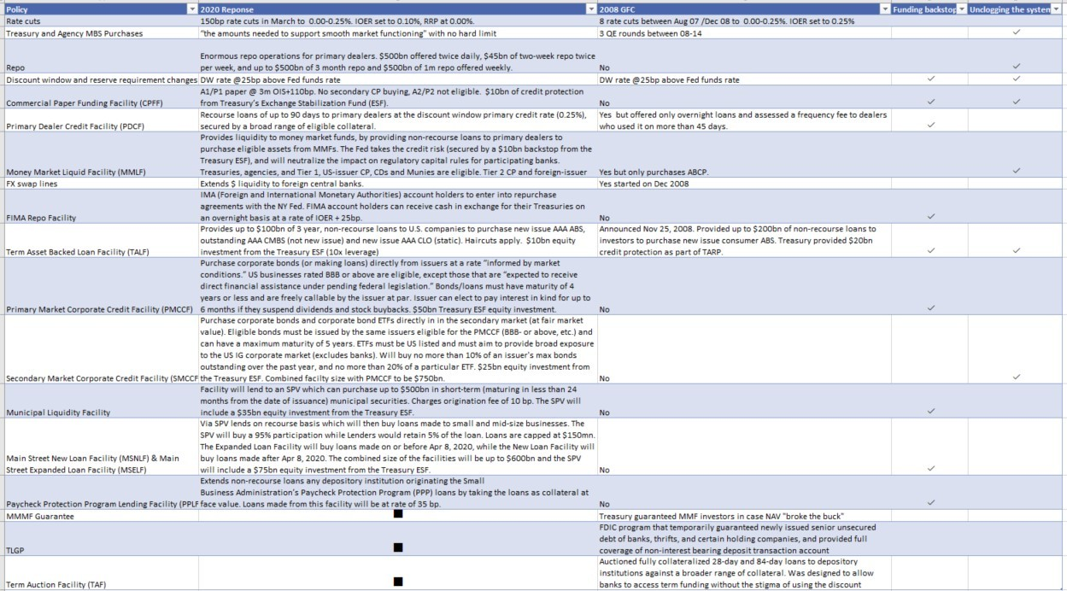

Three quick side notes on the most common questions we have received.

1) Re: HY ETFs (~5% of the HY market) made it to the list but it is not a priority.  The Fed Term sheet specifically notes “ The preponderance of ETF holdings will be of ETFs whose primary investment objective is exposure to U.S. investment-grade corporate bonds, and the remainder will be in ETFs whose primary investment objective is exposure to U.S. high-yield corporate bonds."

2) AAA CLOs also made it to the list but only static CLOs are included which represent a very small percentage of the current CLO market.

3) Fed may buy non-IG rated corporates. These include companies that were rated Investment Grade on March 22 but since have been downgraded to HY. These include Western Midstream, Delta Airlines, Ford, Macy’s and Continental Resources with an aggregate bond debt of ~$90bn. Let’s play a game – can you spot the names where there may be some national/strategic importance to its survival?

PS: JPM Research did all the hard lifting on the program comparisons. I merely simplified and added some thoughts. Want to make sure credit goes to where it’s due.