# "Why Aren't Wages Growing?"

Published on January 10, 2018

By [Guy Berger, Ph.D.](https://www.linkedin.com/in/guyberger/)

One of the frustrating features of the current US economic expansion, even as employment has steadily risen, is pay.  Sometimes people ask me, “why isn’t pay going up?” or “when are wages going to finally increase?”

This short primer is intended to answer those questions.

**First things first:**nominal pay in the United States is currently going up for the typical worker, and has been going up continuously over the past decade. Nevertheless, the gripes about weak pay growth are understandable given that:

1. The pace of wage growth has been pretty disappointing relative to historical norms
2. At times (but not currently) pay growth has fallen below inflation.

### Gripe 1: Disappointing Pace of Change

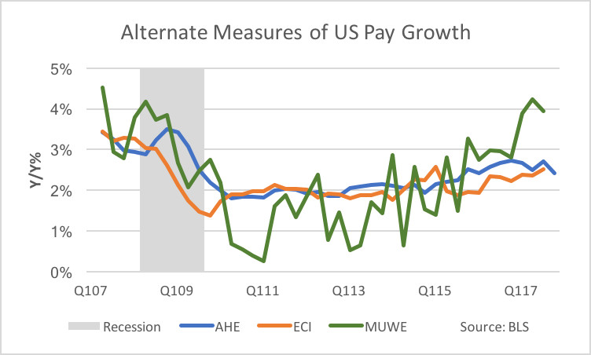

The chart on the right shows three different measures of pay growth collected by the Bureau of Labor Statistics - they are somewhat different conceptually and are collected in different ways. I have a little glossary at the bottom explaining them.

All three agree that pay growth has accelerated over the past few years, at least to a modest degree.  They diverge on the magnitude or the timing.

For instance, the private sector average hourly earnings (AHE) data reported in the monthly BLS employment rose to 2.5% Y/Y in early 2015 and have basically been stuck there, well below the 3.5% pace we saw prior to the great recession. This is not the pay series that economists take most seriously (they prefer the employment cost index (ECI)), but its inclusion within the monthly BLS employment report means it gets by far the most attention. So it's not surprise that its recent flatlining around 2.5% growth has translated in the public imagination to "we're not seeing wage growth."

Meanwhile, median usual weekly earnings (MUWE) for full-time wage and salary workers have accelerated sharply over the past year, to over 4% Y/Y, and are nearly back to pre-recession normal. (Median usually weekly earnings for part-time workers aren't on the chart but are also growing at over 4%.)

**Bottom Line:**Wage growth is positive, and probably accelerating as we speak, but we're probably not fully "back to normal". We should expect this trend to continue as the labor market tightens further.

### Gripe 2: Pay Hasn't Always Kept Up with Inflation

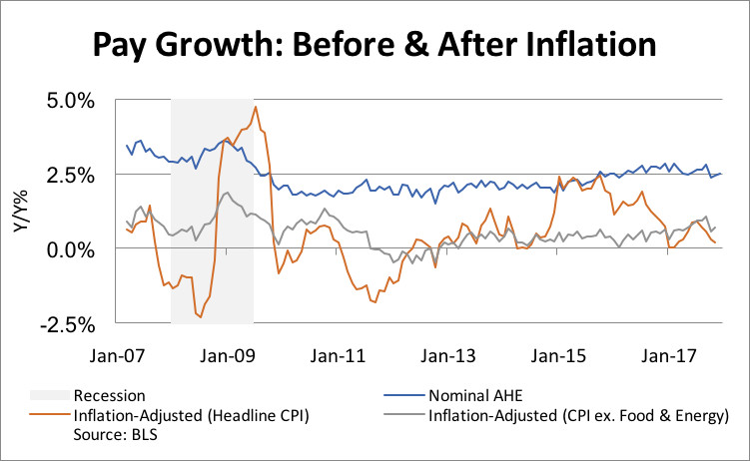

Because of volatility in oil prices over the past decade, inflation has fluctuated sharply during the US expansion. That means that, even as nominal pay growth was pretty steady around 2% in 2010-2014 and has risen modestly since, inflation-adjusted pay growth has been all over the map.

For instance, in 2011, when oil prices rocketed up, workers actually saw inflation-adjusted pay decline (growth less than 0%). Meanwhile, after the oil price crash of 2014-15, inflation-adjusted pay grew at 2.5%, better than in the pre-2008 expansion.

Currently inflation is a little below nominal pay growth, which means that inflation-adjusted pay growth is positive but very low - comparable to where it was before the 2008 recession.

(Side point: the fact that inflation is a lot lower in the 2010s than it was in the 1970s, 1980s and 1990s explains why nominal pay growth is unlikely to match the levels seen back in those days.)

### If Wages Are Growing Somewhat, Are We at "Full Employment"?

There's a common-sense concept in macroeconomics of "full employment" - the level of employment / unemployment / underemployment at which inflation is slow and steady. The presumption is once the labor market gets past full employment, inflationary pressures within the economy start building and the economy "overheats".

Wage growth on its own can't tell us whether we're there yet, because we also need to know what's happening to overall prices. And it seems like, despite some grumbling from employers, prices that consumers face aren't budging that much. The underlying trend in inflation is still probably too low. Which means the labor market can run a little hotter, and pay can accelerate further before we have to turn on the brakes.

### Short Glossary of Wage/Pay Jargon

**Average Hourly Earnings (AHE):** This is the most commonly reported/cited measure of wages, as it's reported on a monthly basis within the BLS employment report. It covers only private sector worker and their regular earnings, i.e. no benefits or special cash bonuses. It's vulnerable to fluctuations in the pay level of new jobs created, i.e. if recently created jobs are higher-than-average-paying (lower-than-average-paying), then pay growth will be exaggerated (underestimated). Data is collected from employers.

**Employment Cost Index (ECI):**Policymakers consider this to be the best overall gauge of wage pressures. It includes government workers; it includes benefit costs and certain types of bonuses; and it accounts for fluctuations in the pay distribution of recently created jobs. Data is collected from employers.

**Median Usual Weekly Earnings (MUWE):**This includes only wages and salaries. Data is collected by phone from workers. Note that because this data series is "weekly" rather than "hourly", it's susceptible to fluctuations in hours worked.