OUTPERFORMING THE HIGH YIELD BOND MARKET: WIN BY NOT LOSING

The Conventional way to add value over market returns has been to select a portfolio of securities that are expected to outperform the market index. This paper proposes an unconventional investment strategy based on a powerful concept: the bonds you do not own are more important than the ones you do.
The prevailing model for thinking about corporate bonds has been derived from strategies that have been effective for equity markets, yet it is profoundly true that bonds are different from equities and behave differently. The equity approach has never been comfortable, but it has not often been questioned.
In the nature of things, equities possess unlimited upside potential, so picking just a few winners can offset a significant number of losers. Historically, the distribution of returns has tilted towards positive returns. Therefore, conventional methods have a good chance of success.
High Yields bonds present a fundamentally different situation. Upside potential is constrained as bond prices approach par. Rare is the bond that produces a better than 50% benchmark-relative gain. Losers of that magnitude are a much more common occurrence. The distribution of returns within the bond universe is skewed toward negative returns.

THE CONVENTIONAL APPROACH

Over the past three decades, the “disintermediation” process shifted the provision of corporate credit from the banking system to the corporate bond market and institutional investors. During this time, the high yield bond market has grown from virtually nothing to approximately $1.3 trillion in outstanding issues. The blueprint for bond analysis has been, not surprisingly, based on the more familiar corporate analysis model developed for equity markets. This analytical process assumes detailed understanding of companies and industries, and relies on highly specialized analysts. The goal is to identify those opportunities with the greatest upside potential. For the equity market with its large dispersion between the best and the rest, this process makes perfect sense. One or two big winners compensate for a number of poor performers.
Transferring this model to the high yield bond market has unwittingly caused the goal of analysis to be driven by the process rather than by the true character of the market. As a consequence, the goal of bond analysis has been to predict the best performing bonds. These, by definition, will be among the highest yielding bonds.
Over time, few high yield investors have discovered that this process is flawed. The upside potential of a bond is structurally capped, but the downside risk is a total loss. A bond is generally issued at par and is expected to mature at par. In the meantime, it could advance in price to 110, 115, or even 140, but it will eventually mature at 100 if all goes well. There is always the threat of default, however, and the bond can lose all of its value. The highest yielding bonds, assuming some degree of efficiency in pricing, are also the riskiest and most prone to losses. With this lesson painfully learned, most experienced high yield managers have gravitated toward a style of investing that avoids the highest yielding bonds, and they focus on a more conservative subset. In addition, the financial crisis of 2008 has compelled most to rely on greater diversification to mute risk. Bond portfolios of 250 to 300 issues are not uncommon.

BUT LOOK AT IT THIS WAY

While I believe these adjustments are beneficial, they do not address the heart of the problem. The high yield bond market is fundamentally different from the equity market and requires a completely different strategy. This paper will show that, unlike equities, most high yield bonds have similar returns and are therefore essentially fungible. At the extremes, the big winners and big losers, bonds are difficult to distinguish before the fact, and are therefore statistically more likely to be losers. Moreover, I assert that it is possible to outperform the market by abandoning the goal of “pick winners”. The goal of the process should be to avoid losses.
This approach turns the equity model on its head. Rather than specialist analysts grinding away on myriad company or industry details to build a case to buy a given bond, the most valuable skill required is the seasoned generalist’s robust negative analysis, seeking reasons to reject a bond. Instead of counting a bond “in” (potential big winners and losers being tough to distinguish), eliminating those that might hurt performance (because the remaining bonds are largely unchangeable) should be the focus of the process. Under this regime, sufficient diversification can be attained with fewer bonds, so the potential for adding value over the benchmark improves.

IS FUNDAMENTAL ANALYSIS RELEVANT?

This paper posits a new approach to bond investment strategy, and I have engaged in some sophisticated quantitative analysis to demonstrate the value of the proposition. I do not believe, however, that applying a simple or complex set of quantitative rules will result in outperformance.
Fundamental analysis remains critically important. Constantly shifting landscape, accounting rule changes, economic and competitive pressures, and structural adjustments in the market preclude a formulaic approach to bond analysis. My research does, however, suggest that analytical resources can be effectively deployed when the focal point of the process is avoiding losses, rather than hitting big winners.

METHODOLOGY

To test my observations, I sought hard evidence about the risk and return features of the overall market, and the optimum opportunity set within the market. I compared the price, rating, and Option-Adjusted Spread (OAS) of the roughly 1,500 bonds in the Bank of America Merrill Lynch U.S. High Yield Bond Index at the beginning of the year and at year-end for the past thirteen years. I performed a number of analyses, described below.

MIDDLE OF THE ROAD AND OVER THE YELLOW LINE

Unlike equities that exhibit a log-normal distribution, high yield bond returns are mostly concentrated in a narrow range, but are negatively skewed. Figure 1 shows the distribution of yearly returns for all the bonds in the Bank of America Merrill Lynch U.S. High Yield Bond Index in 2012.
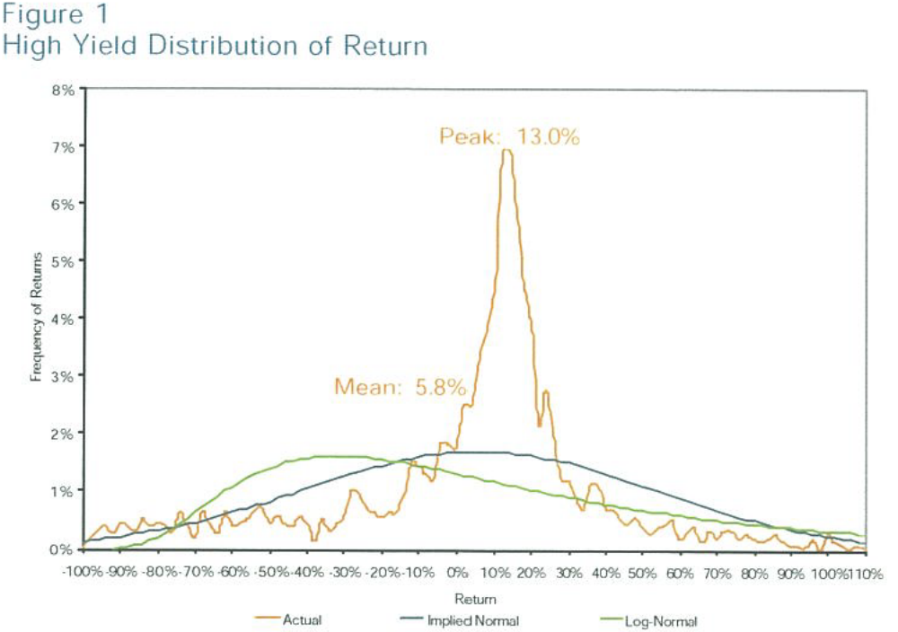
The distribution shown above is truncated at 110% (97% of all bonds) for clarity. However, the analysis was done on the whole data set. The blue line shows the distribution of returns implied by the standard deviation and the mean. The green line is the same but for a log-normal distribution. It is immediately clear that neither of them fits the actual distribution, even remotely. Two overwhelming differences underpin my argument: the distribution is negatively skewed and leptokurtic (i.e, has a steep peak).
The preponderance of returns is around 13%, yet the mean return is only 5.8%. This negative skew results from the greater number of poor outcomes relative to exceptionally good outcomes. By sheer weight of numbers, negative “tail” returns demolish more than half the return generated at the peak frequency, dragging the mean down 700 basis points. Although there are some returns as high as 650% (not shown on chart) the number of outsized winners is extremely low and weigh very little on the distribution as a whole. The second observation, the higher than expected peak frequency of returns, indicates the notable concentration of returns. The leptokurtic distribution reinforces my argument that most “good” bonds are fungible. These observations hold true overtime as seen in Figure 1b.
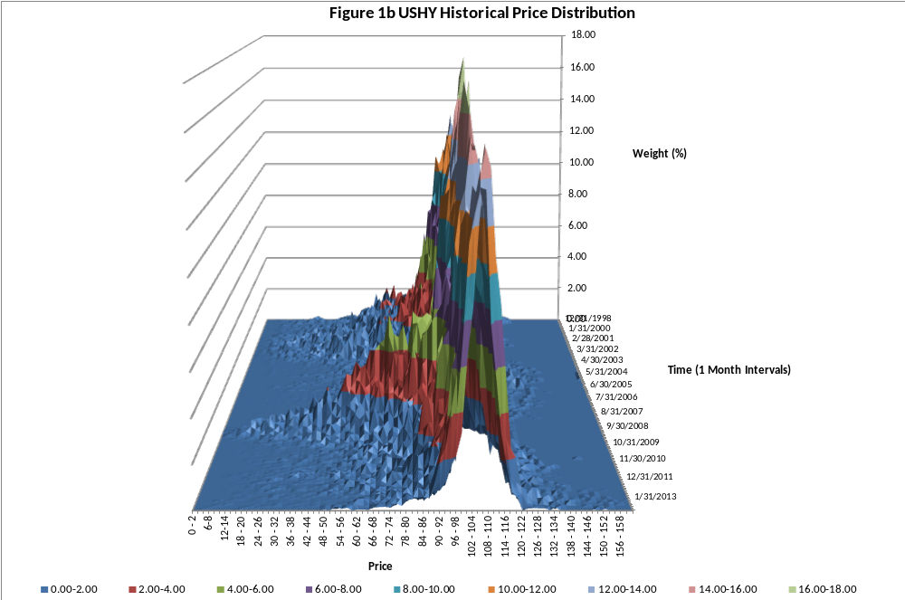
The ultimate investment strategy, of course, is unfailingly selecting those bonds in the positive return tail, but as previously noted, the odds do not favor this attempt. The shape of the distribution suggests an alternative strategy; eliminate bonds that are apt to fall in the extremes; hold only bonds likely to reside in the center. Since the two tails contain moor poor outcomes than good ones, the mean return of the remaining bonds will be higher. As a bonus, risk will be significantly reduced as the tails contain most of the fluctuation in returns.

IMPROVING THE MEAN RETURN

Figure 2 shows this strategy graphically. The cut-off points for eliminating the tails have been set at 15% higher and lower than the mean. This exercise creates three subsets: “winners”, “losers” and “target”.
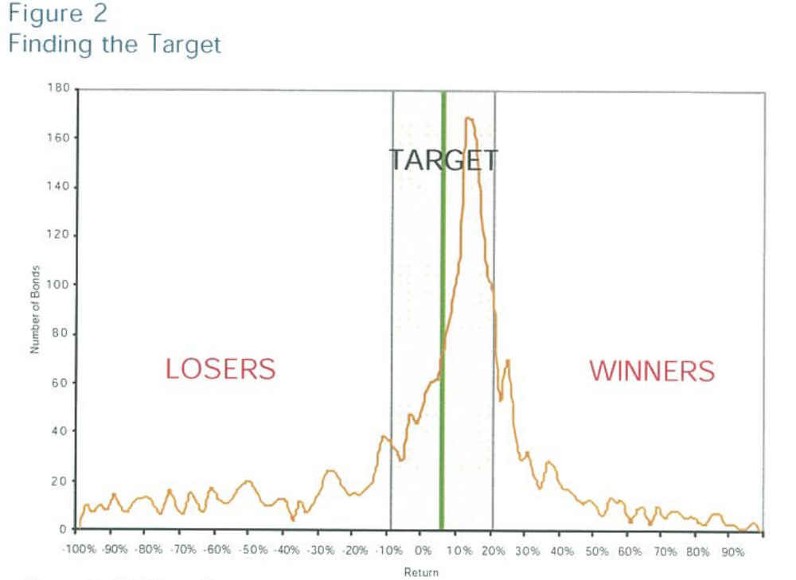
Because there are more losers than winners, cutting off both tails will result in a higher mean return. The mean return of the target distribution at various cut-off points (i.e., the mean of the target area as a function of size) is plotted in Figure 3. In my example, if the target bonds are those that return in the band 15% either side of the mean, the new mean return of 9.0% is a 50% improvement over the mean return that includes the tails (5.8%).
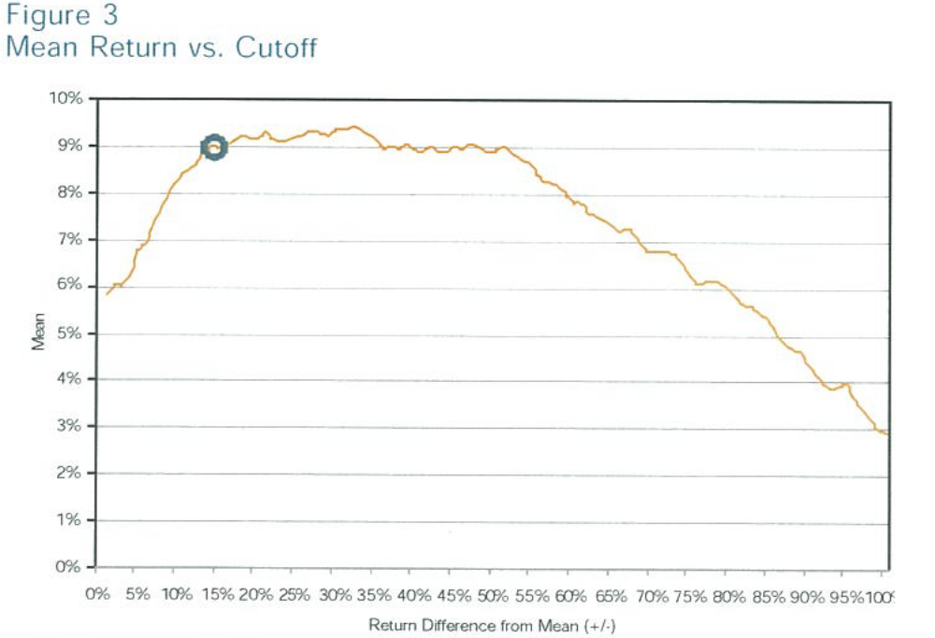
Increasing the distance between the cut-offs results in an increase in the mean return as more of the peak distribution enters the target area. As the cut-offs continue to increase, the asymmetry in the distribution becomes apparent as more negative than positive returns enter the target area and consequently the mean starts to drop.
As shown in Table 1, applying the same +/- 15% cut-off results is an improvement in mean return in thirteen of the last fourteen years (Inception date of the index is 12/31/1998) and very significant decrease in risk every year.
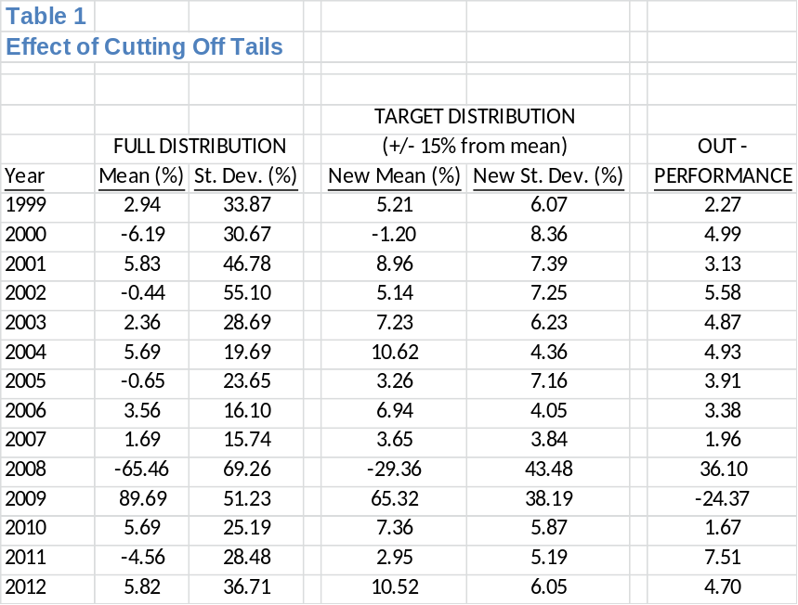

ACHIEVING MORE WITH LESS

Removing the tail risk has a significant effect on the number of bonds required for sufficient portfolio diversification. Figure 4 shows the results of a Monte Carlo simulation used to calculate the volatility among portfolios created by random selection of bonds from the universe shown in Figure 1. As such, Figure 4 displays volatility as a function of the return cut-off and the number of bonds in the portfolio. The calculation was performed for various numbers of bonds in the portfolio and different return cut-offs. One thousand individual portfolio combinations of randomly selected bonds comprise each group. Volatility of returns in each group is represented by a color, red (highest) through violet (lowest). The highest volatilities among portfolio returns are the groups with highest cut-off, meaning that they are picked from the full bond universe, and that they contain the fewest number of bonds. The volatility then decreases as the return cut-off is lowered and/or the number of bonds increased. For example, the group of randomly selected portfolios with 300 bonds and a return cut-off of 100% (97% of the bonds included) has the same volatility (2%) as a group with 50 bonds and a return cut-off of 40%.
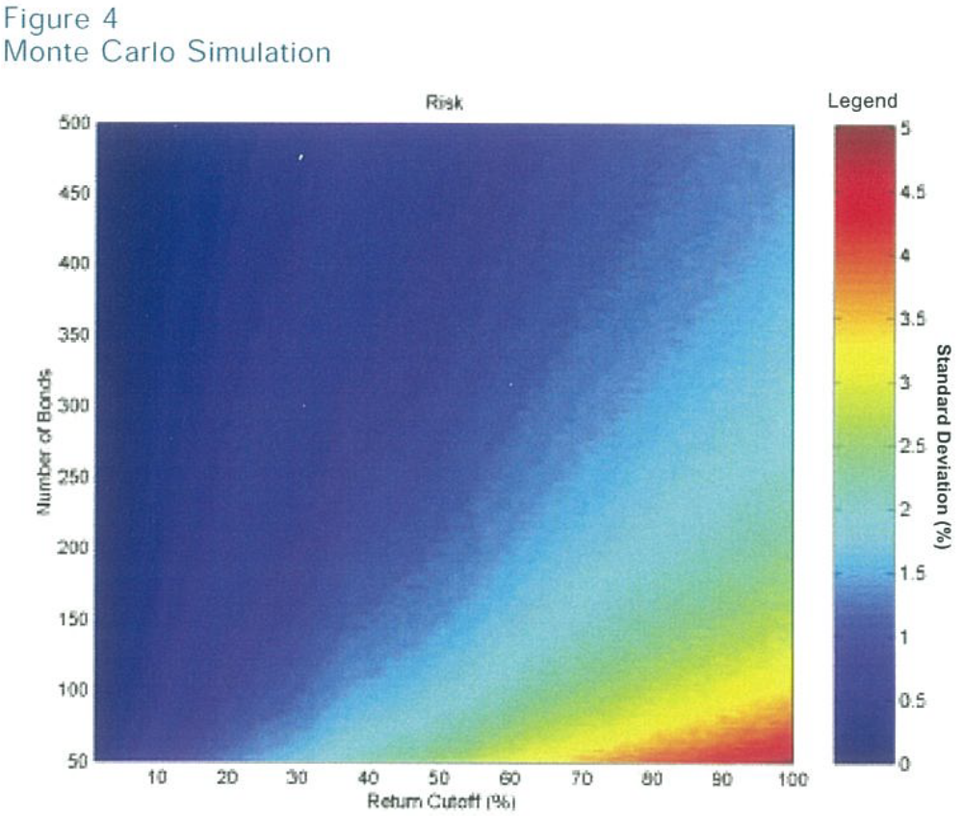

CAN IT BE DONE?

Clearly, removing both the high and low return tails from the portfolio is advantageous, but can it be done in practice? It would require predicting which bonds will finally fall in the target area. Fortunately, these bonds and tail bonds have some quite distinct properties.
For example, using price as an indicator, Figure 5 shows the beginning-year price distribution in the eventual return tails and target area. The distributions of prices in the two tails are similar to each other but very different from the distribution of prices in the target area. Generally, the bonds that ended the year as extreme winners or losers began the year as low-priced bonds.
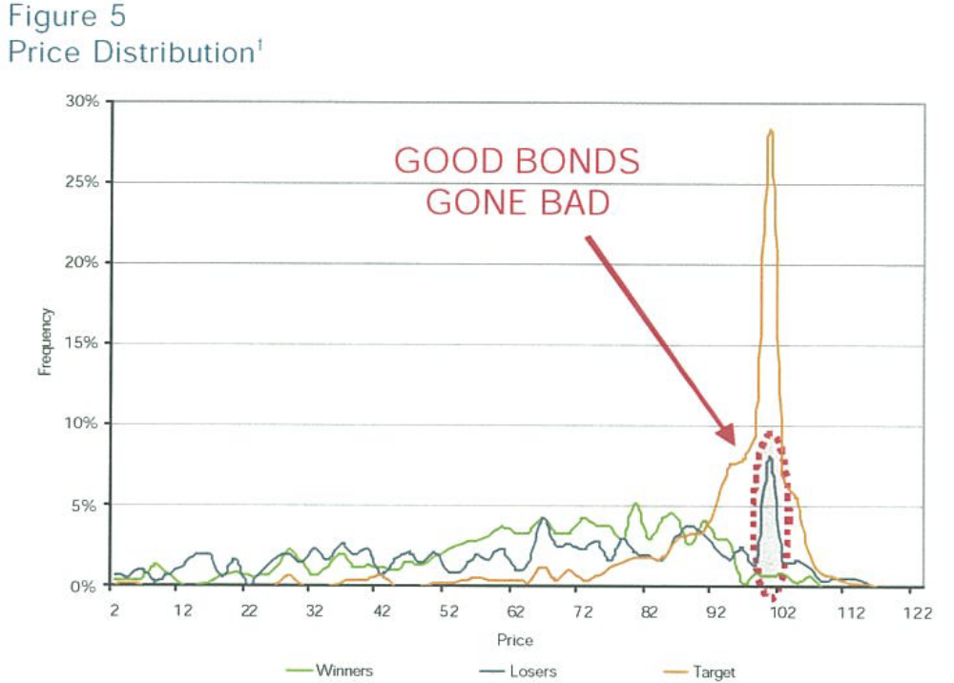
Unfortunately, a small but not insignificant amount of the loser bonds (shaded area) mimic target bonds. It is precisely this area where the analyst’s risk oversight can add the most value. Skill at uncovering the latent weakness in apparently sound bonds – after all, the market has priced them with the solid citizens – can excise still more negative drag on returns. Indeed, avoiding those “good bonds gone bad” is a lynchpin in achieving outperformance.
Taking another indicator, distributions of OAS for bonds in the index, divided into the three relevant sections (Figure 6) again shows that the winners and losers are like each other but different from the target distribution. The message is similar: the target group of bonds will exhibit moderate OAS at the time of purchase, but again, there is a small, anomalous, contrary collection of bonds.
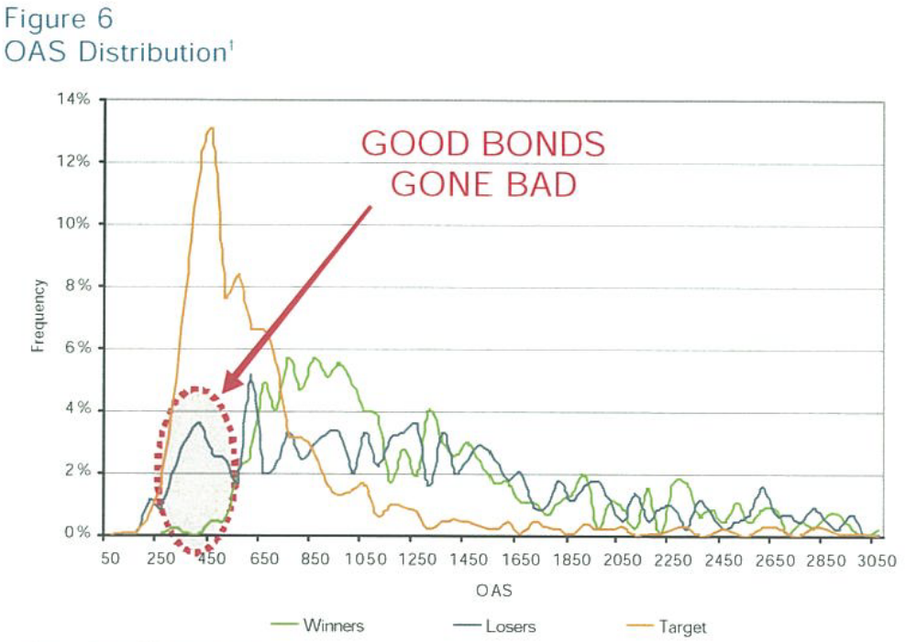
Finally, a similar pattern emerges when analyzing the distribution of ratings at the beginning of the year for the three groups (Figure 7), although the differences are not as great.
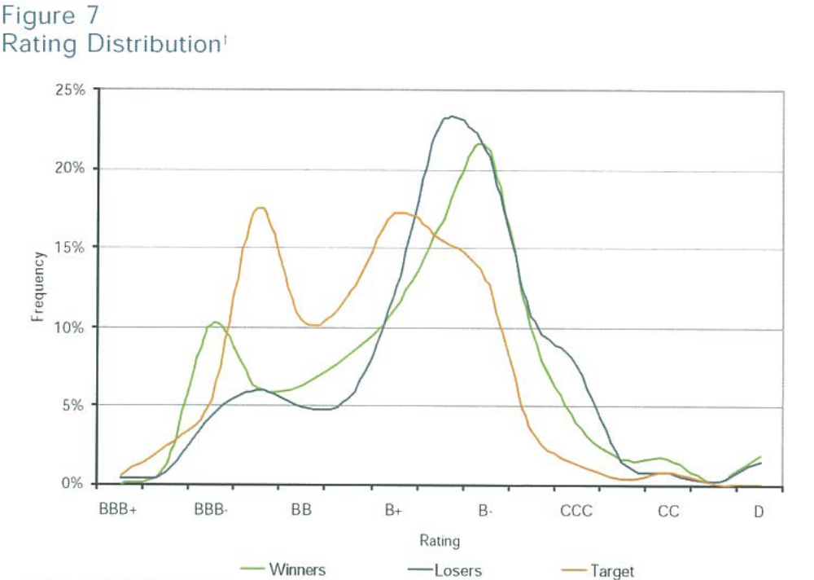
Since bonds that produced returns in the extreme tails exhibit certain easily identifiable characteristics before the fact, I can gauge the effect of a simple filter to remove bonds with those identifiers. Figures 6 and 7 indicate that bonds with an OAS greater than 1000 and rated less than B are the most likely to end up in the tails. Figure 8 shows the resulting filtered distribution together with the full distribution.
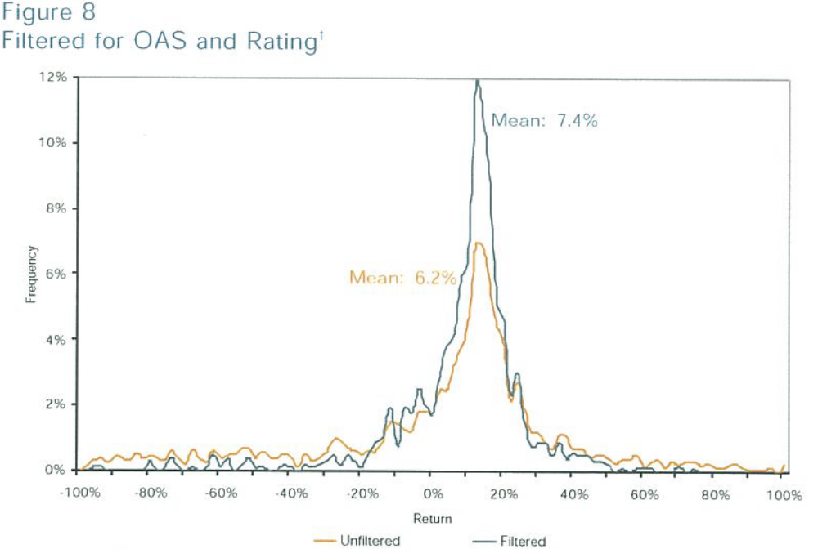
The effect on the distribution of returns of filtering the bonds by OAS and bond rating at the beginning of the year is significant. The filtered set of bonds outperforms the full set by 120 basis points. Furthermore, the risk has been decreased form 45% to 19%.
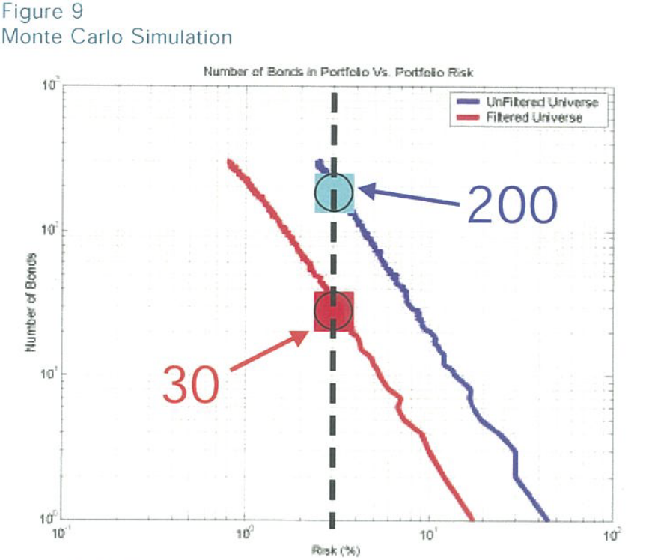
Figure 9 shows the results of a Monte Carlo simulation performed to determine the expected volatility of randomly chosen, equal-weighted portfolios as a function of the number of bonds held. The results are striking. A portfolio of only 30 bonds, randomly selected from the filtered distribution, will have an expected 3% risk. On the other hand, it would take 200 randomly chosen bonds from the full index to achieve a comparable risk level. These results are applicable in all other years studied. Figure 10 plots the relative return of the filtered distribution of bonds versus the difference between the standard deviation of the filtered distribution and that of the index.
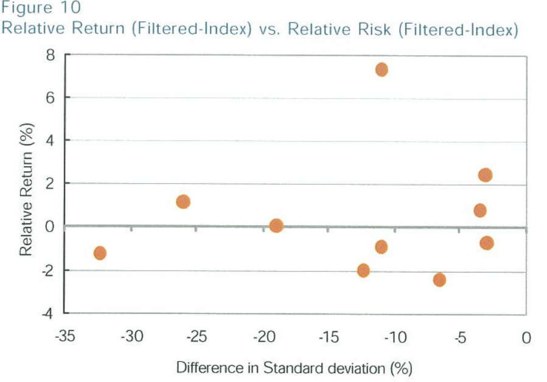
A simple filter confirms the observation that tail bonds share quantifiable characteristics and that eliminating such bonds improves mean performance. Nevertheless, I do not advocate relying on filters for two reasons. The filter is straightforward: as market conditions change, the use of any static set of trading rules is bound eventually to fail. The second reason, as seen in Figure 10, is that applying this simple set of rules leads to underperformance against the benchmark half the time in non-risk-adjusted terms.

WIN BY NOT LOSING

Although a simple filter will not work at all times, the basic strategy of avoiding the tails will always work. The asymmetry of the return distribution is the result of the basic structure of bonds, issued at par and, at best, maturing at par. This fact will never change but the methods for avoiding the tails will. An investment strategy oriented toward rejecting the high-risk/low-probability bonds out of hand, and strenuously avoiding “good bonds gone bad” should consistently add value. The most important bond is one you don’t own.

*Please note that all of the graphs and simulations in this article were created using Matlab. If you would like to get a deeper understanding of the process outlaid above, please contact the author for read-only access to his code.

Brian Fagan
Mackay Shields, September 2013

ABOUT THE AUTHOR
Brian formally joined MacKay Shields in July 2013 as a Quantitative Research Associate in the Global Fixed Income group. Brian’s research focuses U.S. and emerging market corporate bond and currency strategies. Performing ongoing macro-economic research and portfolio risk oversight are other areas of responsibility. From July 2011 – 2013, he was an Analyst in the New York Life Investments Analyst Program. As an analyst, Brian worked for the Global Fixed Income team at Mackay Shields where his research focused on emerging market sovereign, quasi-sovereign and corporate bonds. From June 2010 – 2011, Brian was a Global Analytics Associate at AllianceBernstein where he helped build a fixed-income and currency attribution system. Brian received a BS in Finance from Manhattan College, Cum Laude, in 2010.

