Dolly Key Coding Manual
Last Updated 12.27.2023
Project
In this study, participants were shown a puzzle that looked like a dollhouse where the goal was to open all 5 boxes. After practice, all participants received pedagogical instruction on a solution to that later did not work (i.e., use keys matching the color of the box). We are interested in quantifying exploration and imitation based on which keys children used.

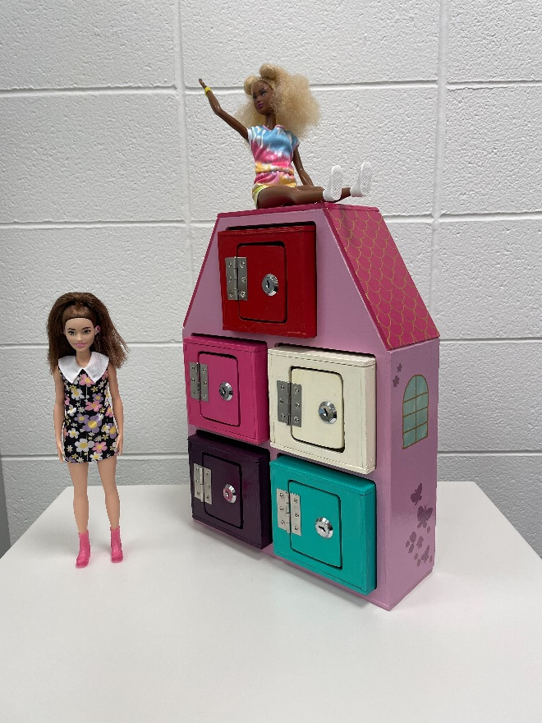
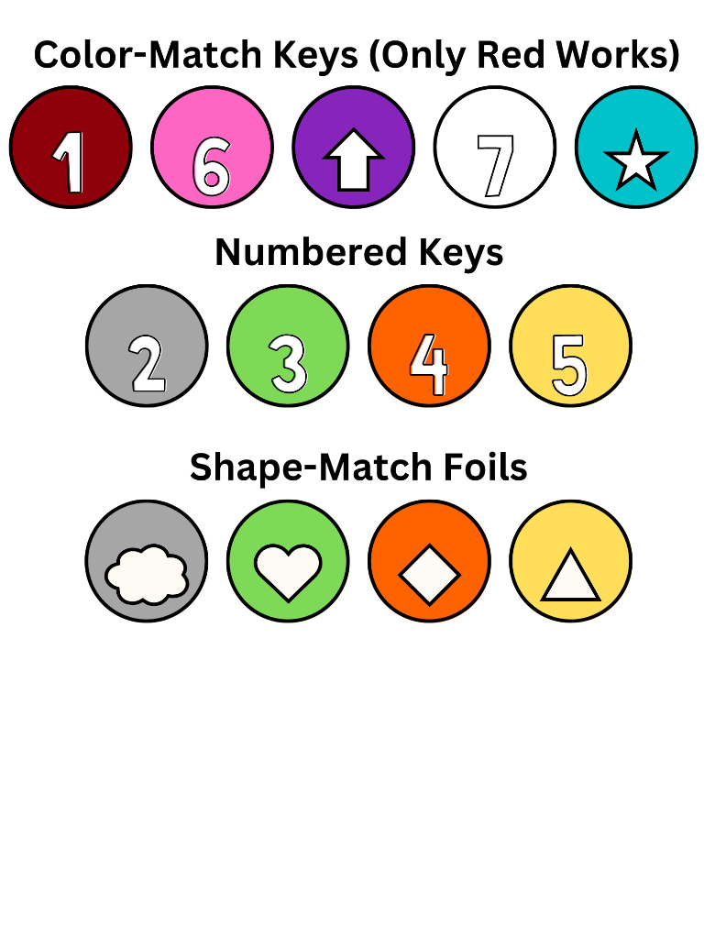
For this coding project, you will be building on existing coding so that we can capture the full set of keys that participants attempted to use. You will need to first do some work to merge your file with the previous coders and then code new information about the non-color matched keys that participants used.

Table of Contents

Setting Up Coding 3
Opening the Coding Log 3
Opening Old Coding Files 3
Checking Previous Coding 3
Merging Color-Matched & Color-Adjacent Files 4
Adding Columns for Exploratory Attempt Coding 5
Saving Your Coding 5
Finding Participant Videos 6
Components of Datavyu 6
Coding Definitions 7
Attempts Overview 7
Coding Color-Matched Attempts 8
Coding Color-Adjacent Attempts 8
New – Labeling Colors for Old Coding 9
New – Coding Exploratory Attempts 10

Setting Up Coding

Opening the Coding Log
- Open the coding sheet:

TECL-Drive\Mia\Gender Projects\Dolly\Coding\
2. Key Coding\Dolly_KeyCodingLog_[initials]_[date].xlsx

There are several versions of the coding log saved as a fail-safe in case a file gets deleted or corrupted. View the coding log as “Read Only” unless you are updating it after finishing coding. Others may be using the sheet, so you don’t want to block it for editing. coding log doesn’t get written-over while you work.

- Select the first participant assigned to you in the coding log that hasn’t been coded yet.

Opening Old Coding Files
Previous coding began with Coding Color-Matched Attempts (as well as other information). Once this pass was almost but not completely finished, we added Coding Color-Adjacent Attempts. Because of this, these files are combined for some participants but separate for others.

You can find the existing coding for your participants under:

TECL-Drive\Mia\Gender Projects\Dolly\Coding\1. Ratio Coding\Datavyu Files

Checking Previous Coding
To check whether the coding for “ColorTry” and “ColorTryAdj” was done in separate files, start by opening the file in the main folder for coding (i.e., not in the “Color Adjacent Files” subfolder) and look to see whether the primary file listed includes “ColorTryAdj” columns AS WELL AS coding in the other columns:

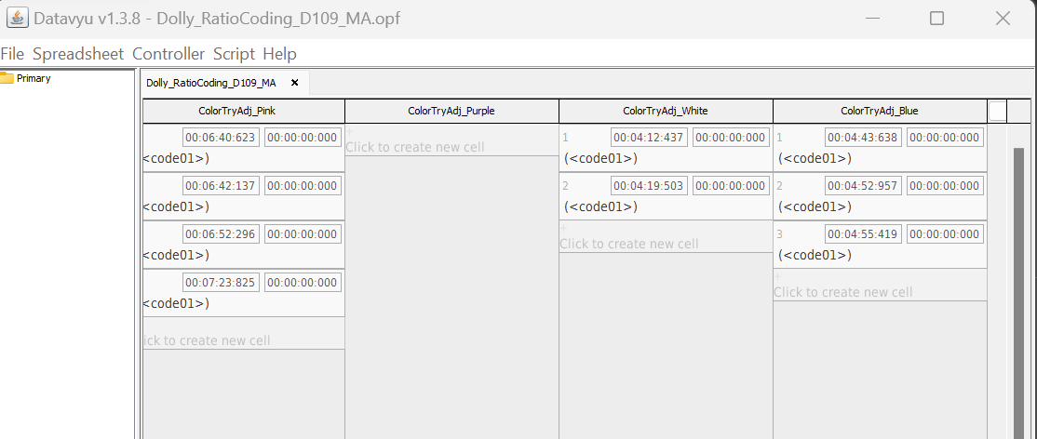

If these columns are not in the primary file, they may be coded SEPARATELY in a different file that ONLY contains coding for the ColorTryAdj columns:

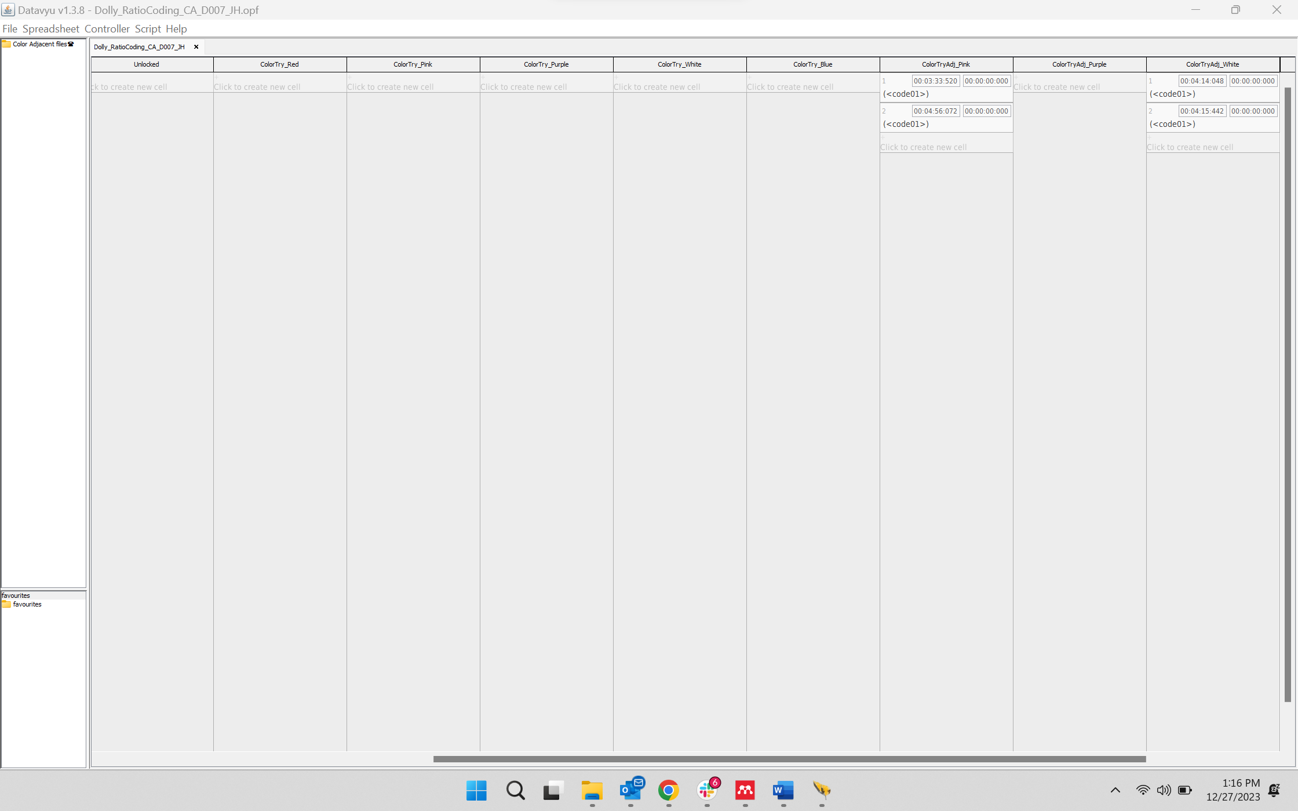

Merging Color-Matched & Color-Adjacent Files
If you find that the information is coded separately, you will have to merge them yourself. Open both files at the same time so you can reference both as you go.

- You will start by adding the missing columns from the first coding pass. In the fuller coding pass, click the “+” next to the column that is the furthest to the right:

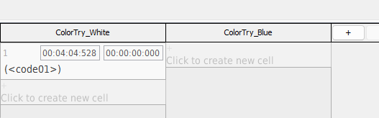

Then, you will add the four columns for the ColorAdj coding. It is CRITCAL, that you type the names IDENTICALLY and in the same order so that the columns in the output file are in the same order for every participant. Otherwise, the formulas we use to compile coding data will not clean the coding correctly:
  - ColorTryAdj_Pink
  - ColorTryAdj_Purple
  - ColorTryAdj_White
  - ColorTryAdj_Blue

- Next, you will need to transfer the codes from the ColorAdj file into the fuller file. Unfortunately, I think you have to do this manually and will have to copy/paste the onsets for each cell one-by-one. If you find a better way, please tell me!

Save the edits you have done as a new file to avoid overwriting the old one. Use this naming system:
Dolly_RatioCoding_Full_[Participant #]_[OG Coder’s Initials]

For example, D004 coded by Mia Radovanovic would be: Dolly_RatioCoding_Full_D004_MR and you’ll upload it to “Combined Files” subfolder in the folder you are in.

Some participants may have been coded by two different people; you will know this if the initials on the two files don’t match. In this case, you will put two sets of initials on the final merged file. So, for example, if Mia Radovanovic did the primary coding for D004 but Josie Hatfield did the ColorTryAdj coding, it would be: Dolly_RatioCoding_Full_D004_MR_JH

Adding Columns for Exploratory Attempt Coding
Once you have a combined file for the original coding that you can add to, your own coding can begin. The first thing you will do is add the columns that you need for coding by clicking the “+” next to the last column that already exists in the file:

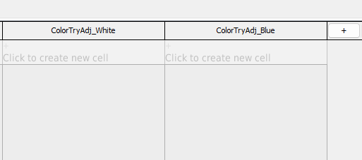

Then, you will add five columns for the additional coding you will do. It is CRITCAL, that you type the names IDENTICALLY and in the same order so that the columns in the output file are in the same order for every participant. Otherwise, the formulas we use to compile coding data will not clean the coding correctly:
- ColorTryExp_Pink
- ColorTryExp_Purple
- ColorTryExp_White
- ColorTryExp_Blue
- ColorTryExp_Red

Saving Your Coding
Save this as a separate file immediately to make sure you do not overwrite the original coding so that we have a record of the coding that has already been done. Use this naming system:

Dolly_KeyCoding_[Participant #]_[Your Initials]

So, for example, D004 coded by Mia Radovanovic would be: Dolly_KeyCoding_D004_MR and you’ll upload it to:

TECL-Drive\Mia\Gender Projects\Dolly\Coding\2. Key Coding\Datavyu Files

When you finish coding, you’ll also go to “File > Export File” to export a CSV version of the coding. You’ll upload this file to:

TECL-Drive\Mia\Gender Projects\Dolly\Coding\2. Key Coding\Exports

You’ll upload to either the Primary or Reliability folder depending on which participant you’re coding, see coding log to do this correctly.

Finding Participant Videos

TECL-Drive\Mia\Gender Projects\Dolly\Data\2. Dolly\Participant Videos

DO NOT CODE straight from the server or Datavyu could crash, and you will lose your coding. For privacy, FULLY delete the video from your desktop AND your recycling bin when finished.

Components of Datavyu
The Controller: If the controller doesn’t show up automatically you can find it by clicking on the main window and then looking under Controller in the top left bar (by File)
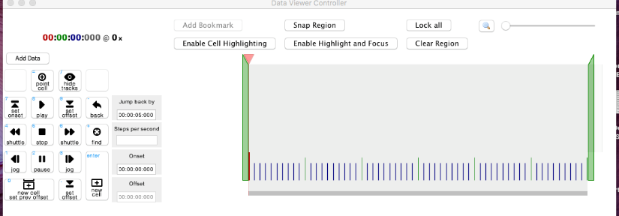

Click “Add Data” on the controller and select a video file from the Participant Data folder:
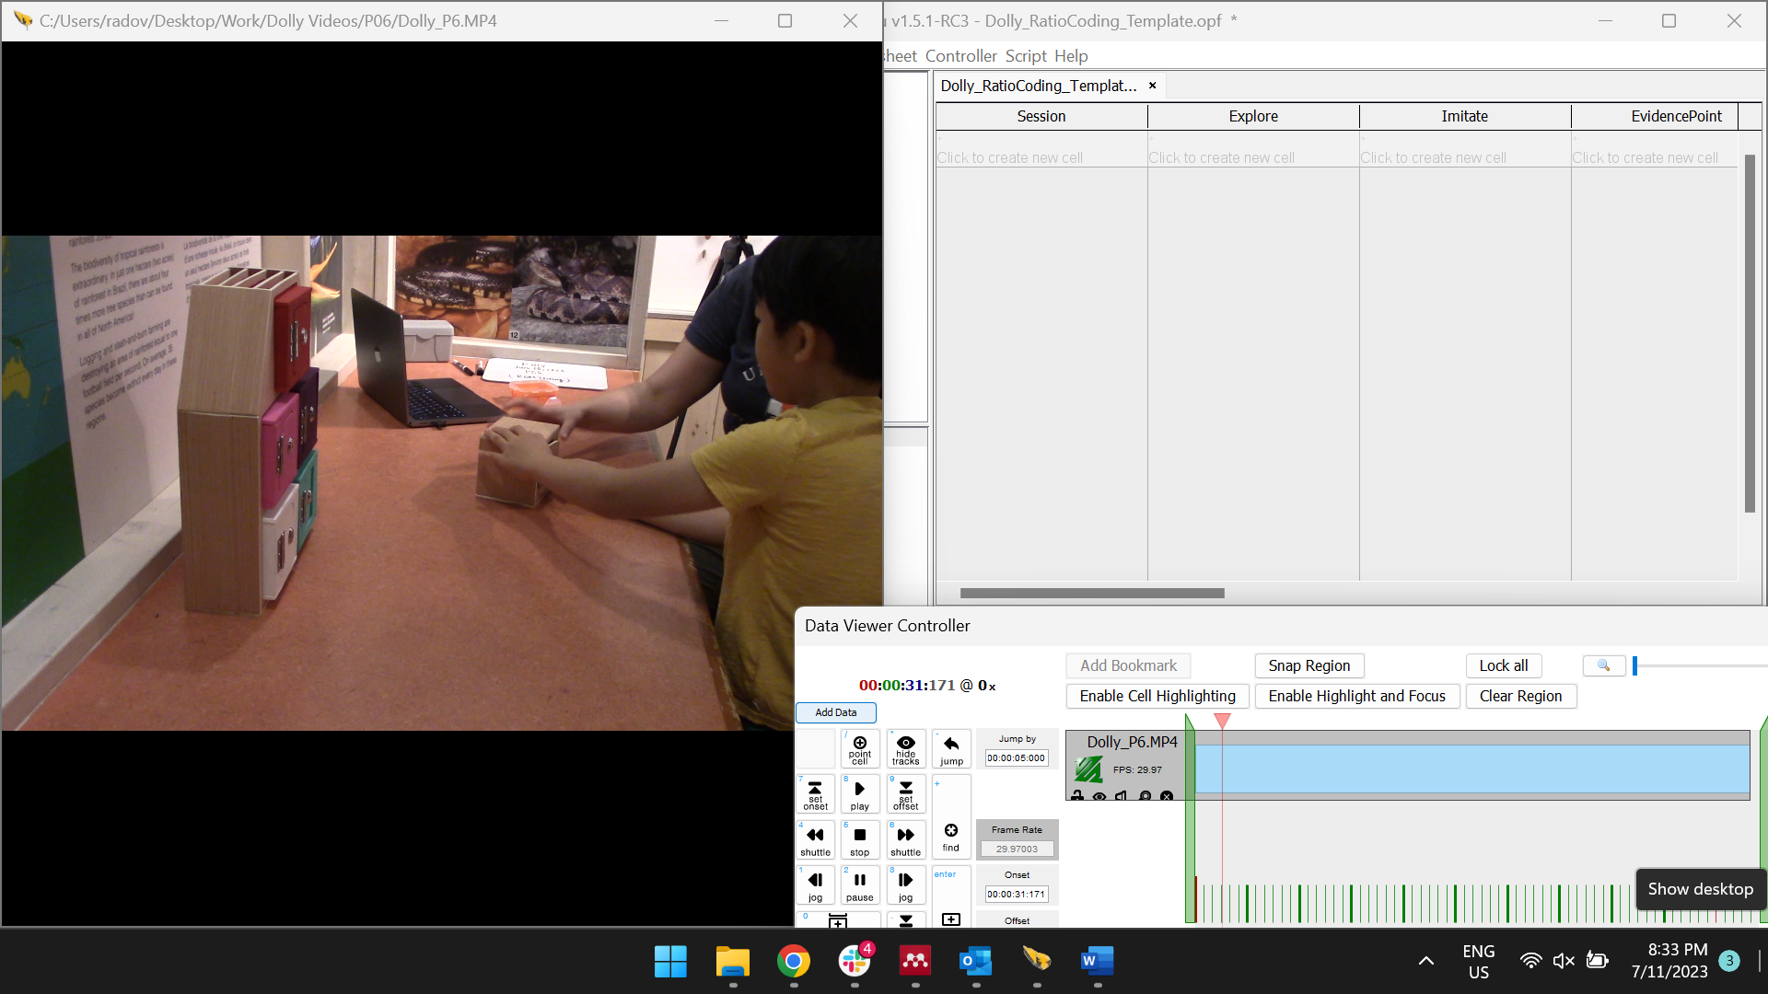

Datavyu Tips
- Use the small numerical keypad on the right of your computer keypad to control the movie rather than the numerical keys on the screen
- The cell you are working in has to be highlighted with a blue box around it, otherwise it won’t keep track of your codes. Highlight it by clicking on it.
- Datavyu controls:
  - 8 = play
  - 5 = stop
  - 7 = onset (start of event)
  - 9 = offset (end of event)
  - 1 = rewind slow motion
  - 3 = fast forward slow motion
- Use ‘snap region’ on controller to check your work
- Use the “Resize video” magnifying glass button to enlarge participant video.

Coding Definitions

Attempts Overview
The basic “unit” of your coding will be attempts and then we will subdivide this into three different categories (for each of the boxes).

For these codes, we’ll only need an onset (as we want to count the attempts, not the total duration of time they spent unlocking). Locate the correct set of columns for the attempt you are coding (either ColorTry for color-matched, ColorAdjTry for keys close in color, or ColorTryExp for keys that don’t match color) and then find the corresponding column for the color box that corresponds to the participant’s actions
- Onset: The moment that the participant first put the key in the lock.

Rules for what counts as an attempt:
- Failed attempts (e.g., inserting the key partially) count as attempts.
- However, participants MUST establish contact between the metal lock and the metal key. If they simple get the key close to the lock but only touch the wood, this does not count as an attempt.

Rules for coding repeated tries with the same key/box:
- It will be easy to identify separate attempts when children remove keys from the lock between attempts, if they take the same key in and out of the lock between tries, code these as separate attempts
- If the child keeps the key in the lock and tries repeatedly, but removes their hand from the key between attempts, code these as separate attempts
- If the child places the key in the lock but does not make an initial attempt to turn the key, then removes their hand from the key to re-adjust their grip before making their first turn, only code this as one attempt and not two
- If the child tries repeatedly or forcefully but does not lift their hand from the key OR remove the key from the lock, DO NOT code these as separate onsets because it will be too hard to visualize reliably
- If the child takes their hand off the key, but they only remove the key from the lock the next time they touch it, instead of trying to unlock, DO NOT code the second touch as a separate attempt.

Attempts after unlocking:
- If the child takes the key out of the box after unlocking, but the door is still open, DO NOT code any attempts that occur after this if the door is already open.
- If the lock becomes locked again after being unlocked, DO code new attempts, whether the door was completely open beforehand or not

Equation for weighted score:
((# of boxes keys attempted on)/4)*(total attempts)

Coding Color-Matched Attempts
There is one column for each colored box labeled “ColorTry” so that we can more efficiently code attempts on each box. For each box, we will only code an attempt if they use the color-matched key on the box it corresponds to. Guide to this coding below:
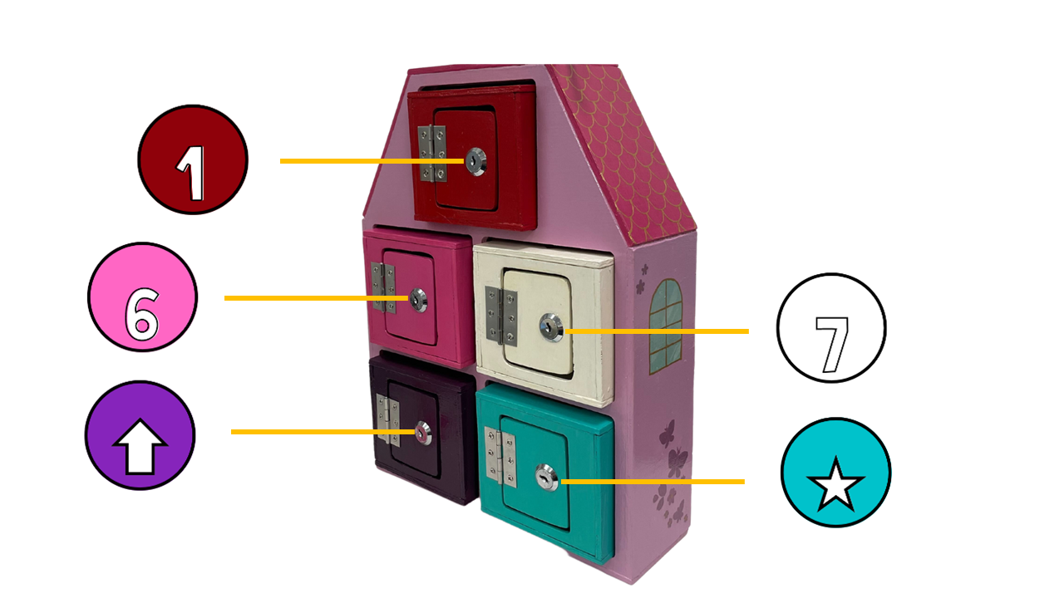

Coding Color-Adjacent Attempts
There is also a column for each box (except for the red) labeled “ColorTryAdj” so that we can capture children’s “micro-exploration” (i.e., sticking with color rule but considering that maybe they are just matching the wrong color). Use this as a guide for this additional coding:
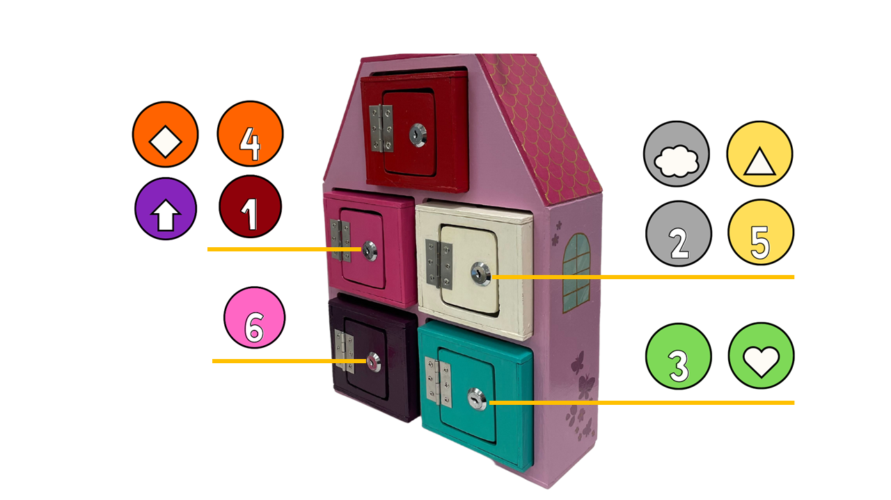

New – Labeling Colors for Old Coding
Originally, coders did not label the color keys that were attempted. The first thing that you will do is go through the existing codes and label the keys that participants used for existing coding. Use these names and make sure to match spelling/spacing/capitalization:

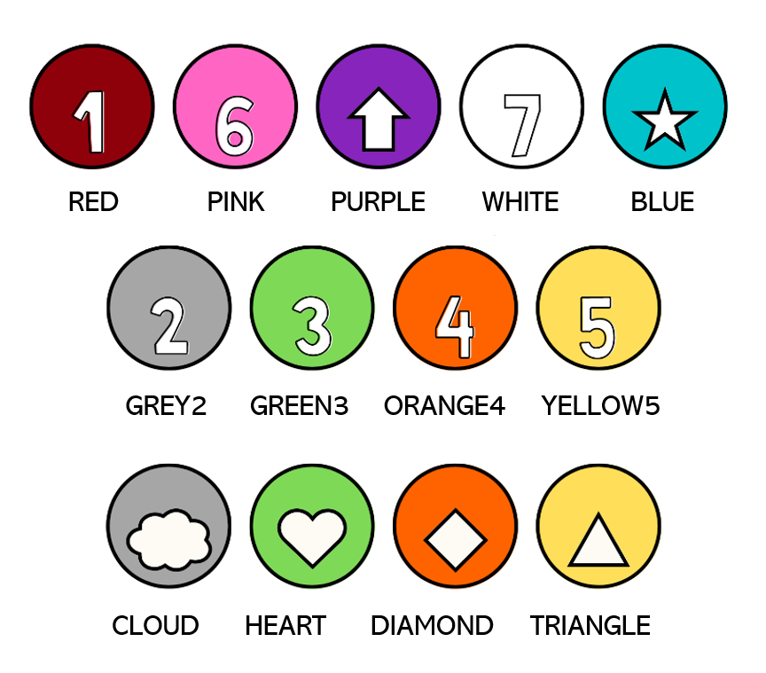

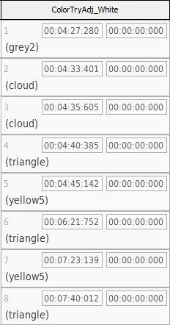
To do this, you will overwrite the code in Datavyu that probably says “<code01>” and write in the name in LOWERCASE provided above.

For example:

New – Coding Exploratory Attempts
The last sets of columns for each box are labeled “ColorTryExp” so that we can capture children’s “macro-exploration” (i.e., deviating entirely from the color rule).

This can include color-matched keys being used on boxes that they don’t match the color of or novel keys that don’t match any of the boxes. These keys will essentially be any keys that ARE NOT listed as the color matched keys (see ColorTry figure) or as color-adjacent keys (see ColorTryAdj figure).

For example, for the BLUE box attempts should be divided:

