CIC & FIR Low-Pass Decimation Filter
Digital Decimation Filter Design Challenge · B Charan

Objective
The aim of this project is to build a low-pass decimation filter that takes in a 1-bit stream at 4.096 MHz and brings it down to a 20-bit sample at 2 kHz. That is a total decimation of 4.096 MHz / 2 kHz = 2048.
The final design is a 5th-order CIC that decimates by 512, followed by a 25-tap FIR that corrects the droop of the CIC and also decimates by 4. Together this gives 512 × 4 = 2048, which is the full decimation required.
The constraints from the problem statement are:
Table 1. Constraints from the problem statement.
Parameter | Value
Oversampling ratio | 2048 (4.096 MHz in, 2 kHz out)
Test tones | 10 Hz, 500 Hz, 990 Hz
Output width | 20 bits maximum, no overflow clipping
Scoring | SNDR from the provided fft_2.m, last 2000 output samples, Hann window
Target | Synthesizable RTL

Task 1: Standalone CIC decimator

How a CIC works
A CIC filter is built in three steps. Taking the simplest first-order case:
- Integrator: an accumulator that keeps adding every incoming sample to a running sum.
- Decimator: out of every N samples, N − 1 are thrown away and only one is kept.
- Comb: the kept sample has the previous comb input subtracted from it.
After these steps the output is the same signal, now at a lower rate, with much less high-frequency noise. The transfer function of one stage splits neatly into the integrator part and the comb part:

Figure 1. Transfer function of a CIC stage, split into integrator and comb.
Each integrator and comb stage increases the gain (power) of the signal, so the number of bits needed grows with every stage. This is why the registers in the design are much wider than the 2-bit input.
In our design we use 5 stages, so the data follows the path below. The five integrators run on every clock at 4.096 MHz. After that only 1 sample in every 2048 is kept, and the five combs and the final slice run at 2 kHz.
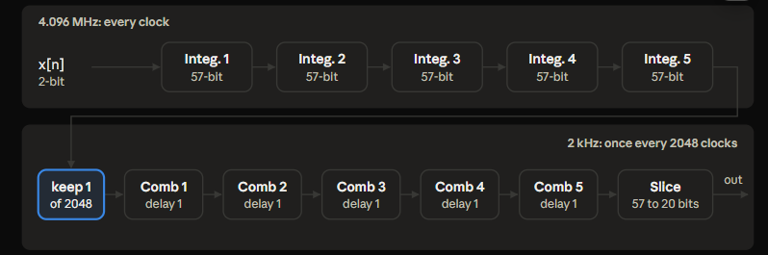
Figure 2. Data path of the 5-stage CIC: 5 integrators (57-bit), keep 1 of 2048, 5 combs, slice from 57 to 20 bits.

Why a CIC alone is not enough
The CIC passes DC at full gain and has a null at every multiple of the output rate, which removes the noise that would fold back into the band. But in between, the response droops. The higher the frequency inside the band, the more the signal gets attenuated.
For the 990 Hz tone, using only the CIC causes about −19.2 dB of loss because of this droop. This is the reason we need an FIR after the CIC, which is done in Part B.

How the bits are used
The CIC registers are 57 bits wide. At the output, these 57 bits are split up like this:
- Bit [56] is the sign/guard bit. It is used only for overflow detection.
- Bits [55:36] are the 20 bits kept as the output. Bit 55 is the output sign bit and bits [54:36] are the magnitude bits.
- Bits [35:0] are the 36 bits that are dropped.
The table below follows the bits through each block of the design.
Table 2. Bit usage in each block of the Task 1 CIC.
Block | Width | What happens to the bits
Input din | 2 → 57 | Sign-extended (MSB copied up) so the input matches the integrator width.
5 integrators | 57 each | Nothing dropped. They wrap around in two's complement and can overflow, which is fine.
Decimation counter | 11 | Counts 0 to 2047, and tick fires once per 2048 clocks. Only control, not data.
5 combs | 57 each | Nothing dropped. comb[k+1] = comb[k] − prev[k] wraps too. The wrap-around cancels in the subtraction, and the true result (≤ 2⁵⁵) fits in 57 bits.
Round (+ half) | 57 | half = 2³⁵, added in full 57-bit width, so it can't overflow.
Shift (rnd[56:36]) | 57 → 21 | This is where bits are dropped. It's just a part-select. Bits [35:0] aren't connected to anything, so it costs no hardware and is equal to dividing by 2³⁶.
Saturate (scaled → sat) | 21 → 20 | scaled[20:19] is checked. If both bits are equal, the top bit is a redundant sign copy and scaled[19:0] passes through. Otherwise the output clamps to 0x7FFFF or 0x80000.
Output reg dout | 20 | Loaded only on tick. outready is a 1-clock pulse that follows it.

Code
Block 1, integrators. On reset all five integrators are cleared. On every enabled clock, the first integrator adds the input, and each following integrator adds the output of the one before it.
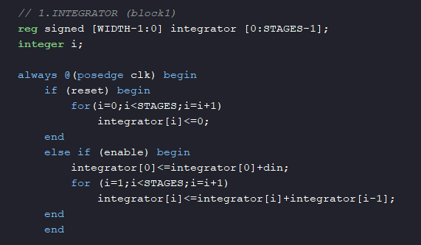
Figure 3. Integrator block.
Block 2, decimation counter. The counter runs from 0 to DECIMATION − 1. sample_out goes high on the last count, which is the one clock where a sample is kept.
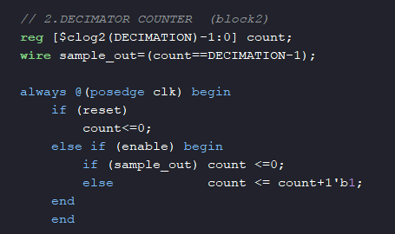
Figure 4. Decimation counter block.
Block 3, combs. The comb chain is combinational: each comb subtracts its stored delay value from its input. The delay registers are only updated when sample_out is high, so the combs effectively run at the decimated rate.
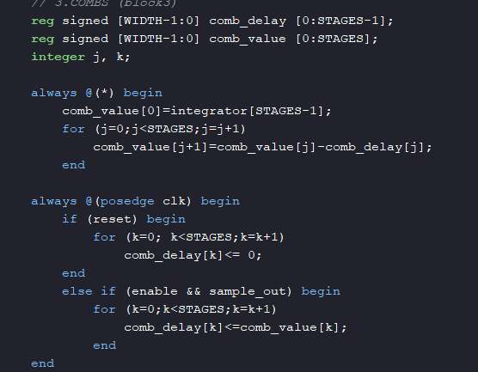
Figure 5. Comb block.

Results of using CIC (2048)
The output of the testbench was analysed with fft_2.m for each of the three tones. The spectra are shown below.
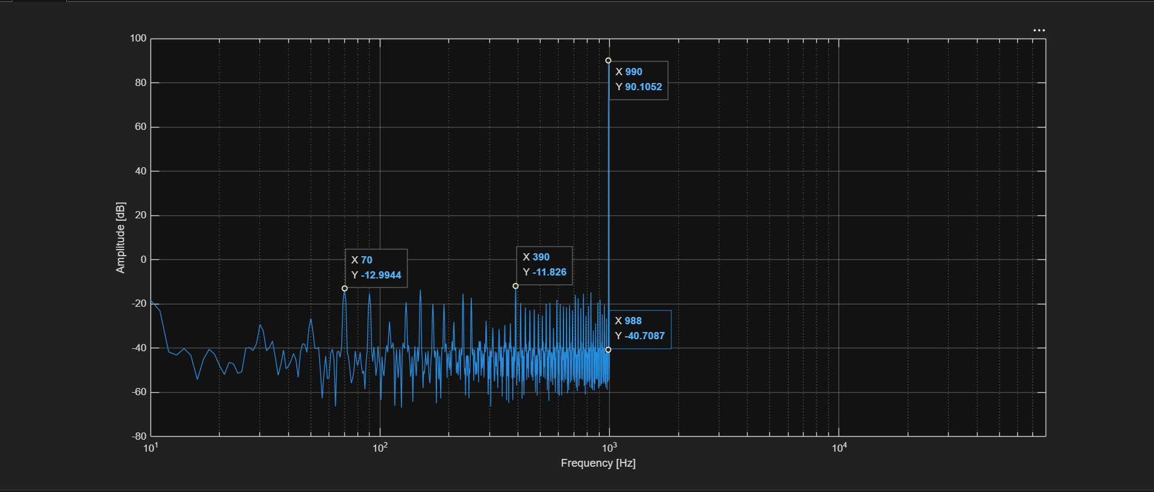
Figure 6. Output spectrum with only the CIC, 990 Hz input.
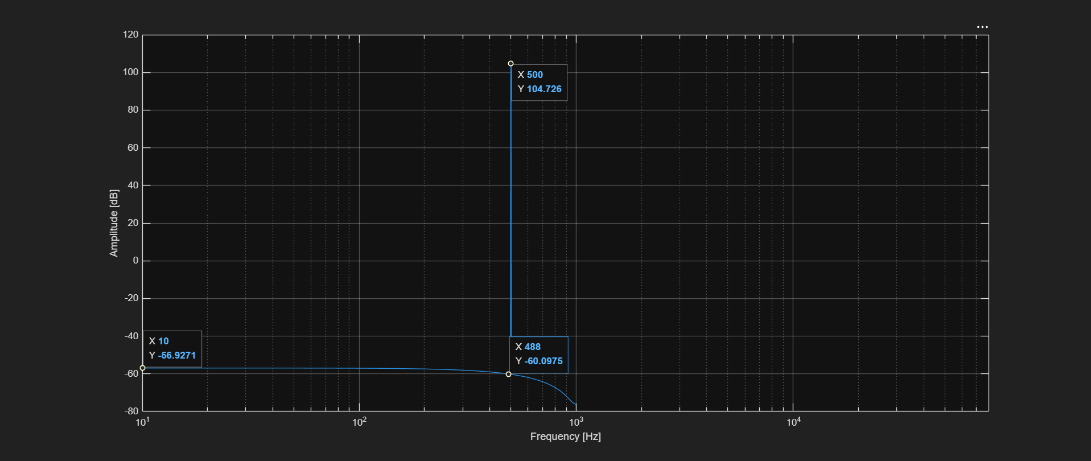
Figure 7. Output spectrum with only the CIC, 500 Hz input.
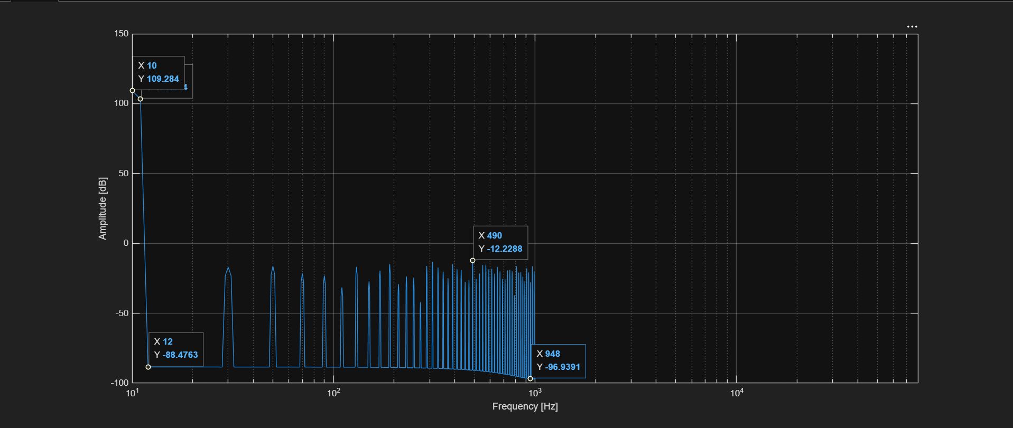
Figure 8. Output spectrum with only the CIC, 10 Hz input.
The SNDR reported by fft_2.m for each run (2000 samples analysed, output rate 2000 Hz):
Table 3. Task 1 SNDR (CIC only, R = 2048).
Signal frequency | Samples analysed | Output rate | SNDR
10 Hz | 2000 | 2000 Hz | 111.22 dB
500 Hz | 2000 | 2000 Hz | 136.83 dB
990 Hz | 2000 | 2000 Hz | 91.57 dB

The 990 Hz result is clearly the weakest of the three, which matches the droop of about −19.2 dB at that frequency described above.

Task 2: CIC with FIR droop compensator
The FIR in this part does two jobs. It flattens the passband droop left by the CIC, and it also cleans up the band that would otherwise alias when the final decimation by 4 happens.
The flowchart below shows how the data moves in Part B. The 1-bit stream at 4.096 MHz goes into the CIC (N = 5, R = 512, 47-bit registers), which outputs 30-bit samples at 8 kHz into the FIR. Inside the fir_comp module, the FIR filter is followed by a "keep 1 in 4" stage built from a 2-bit counter and a right shift by 25. The final output is 20-bit signed at 2 kHz, and 512 × 4 = 2048 matches the OSR.
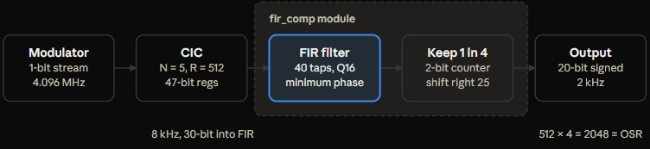
Figure 9. Part B data flow.
The droop compensator is designed against the magnitude response of the CIC, with N = 5, R = 512 and F_{s} = 8 kHz:
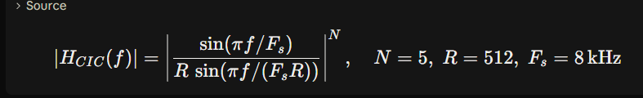
Figure 10. Magnitude response of the CIC that the compensator has to undo.
The FIR itself is a weighted sum of the current and past input samples, where h[k] are the filter coefficients:
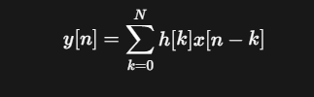
Figure 11. FIR equation.
The main code is shown below. The combinational block multiplies every stored sample by its coefficient and adds them up into a 52-bit sum. On each valid input, the new 8 kHz sample is shifted into the delay line. A 2-bit counter keeps 1 of every 4 results, and the output is taken as sum[44:25], which is a right shift by 25 to remove the Q16 coefficient scale and bring 30 bits down to 20.
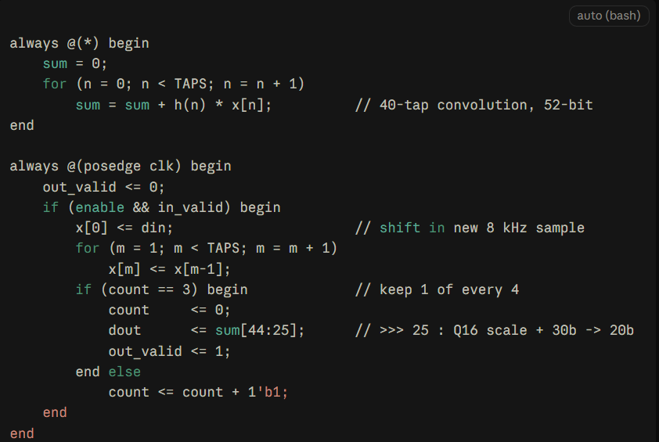
Figure 12. Main FIR code.

Results
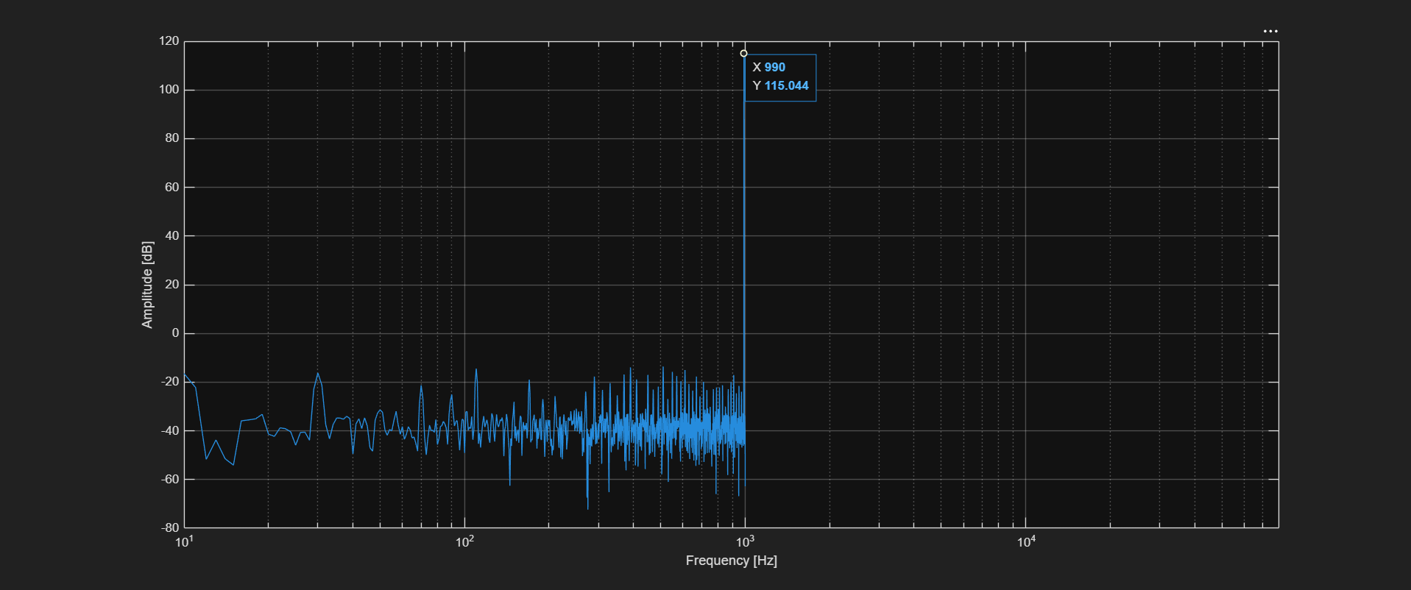
Figure 13. Output spectrum with CIC + FIR, 990 Hz input.
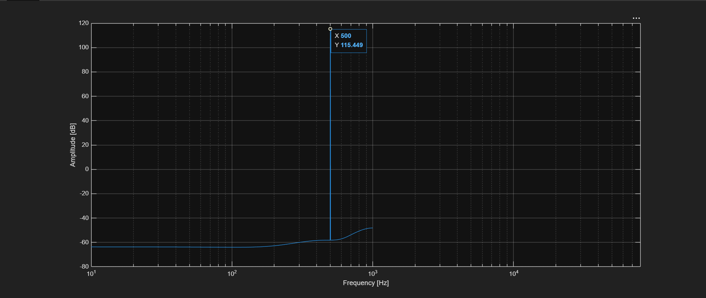
Figure 14. Output spectrum with CIC + FIR, 500 Hz input.
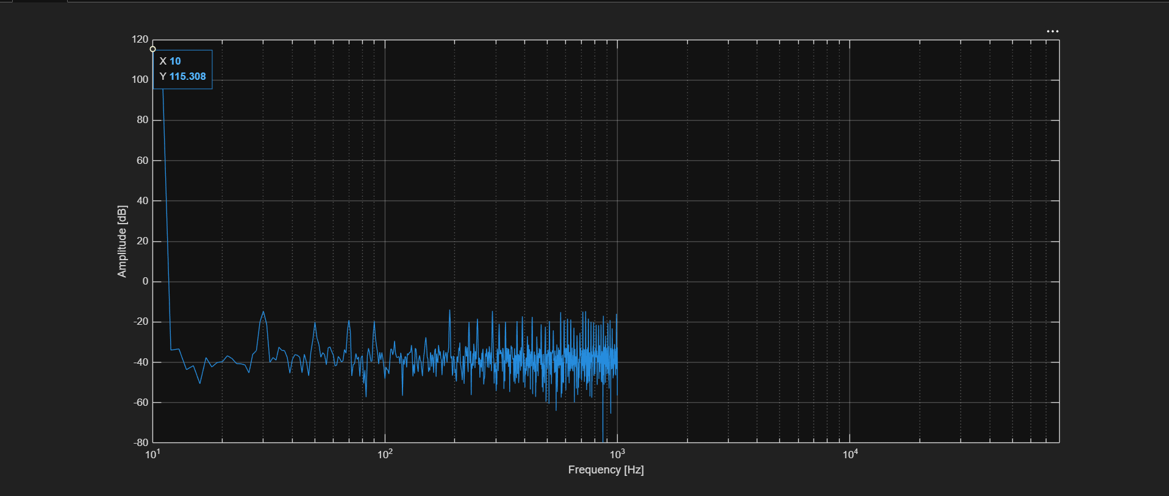
Figure 15. Output spectrum with CIC + FIR, 10 Hz input.
Table 4. Task 2 SNDR (CIC 512 + FIR ÷4).
Signal frequency | Samples analysed | Output rate | SNDR
10 Hz | 2000 | 2000 Hz | 117.06 dB
500 Hz | 2000 | 2000 Hz | 142.36 dB
990 Hz | 2000 | 2000 Hz | 117.12 dB

The 990 Hz tone, which was the weakest with the CIC alone, is now at the same level as the 10 Hz tone.
To choose the filter length, the compensator error was checked for different filter orders. The table lists the maximum error over 0–990 Hz, the error at each test tone, the largest quantised coefficient, the bits needed for the coefficients, symmetry and the DC error.
Table 5. Compensator error for different filter orders.
Order | Taps | Max error (0–990 Hz) | 10 Hz | 500 Hz | 990 Hz | max |q| | Bits | Sym | DC
10 | 11 | 1.333 dB | −1.178 | 0.721 | −1.333 | 43035 | 17 | 0 | −1.20
20 | 21 | 0.544 dB | 0.304 | −0.178 | −0.544 | 43079 | 17 | 0 | 0.32
24 | 25 | 0.409 dB | 0.209 | 0.126 | −0.409 | 43088 | 17 | 0 | 0.23
25 | 26 | 0.409 dB | 0.209 | 0.126 | −0.409 | 43088 | 17 | 0 | 0.23
30 | 31 | 0.277 dB | −0.130 | −0.095 | −0.277 | 43097 | 17 | 0 | −0.15
35 | 36 | 0.216 dB | −0.095 | 0.074 | −0.216 | 43102 | 17 | 0 | −0.11
39 | 40 | 0.169 dB | −0.074 | −0.059 | −0.169 | 43105 | 17 | 0 | −0.09
40 | 41 | 0.150 dB | 0.063 | 0.046 | −0.150 | 43106 | 17 | 0 | 0.08
45 | 46 | 0.122 dB | 0.049 | −0.038 | −0.117 | 43109 | 17 | 0 | 0.06
50 | 51 | 0.103 dB | −0.033 | 0.032 | −0.081 | 43112 | 17 | 0 | −0.05
55 | 56 | 0.093 dB | −0.026 | −0.028 | −0.061 | 43114 | 17 | 0 | −0.04
60 | 61 | 0.080 dB | 0.018 | −0.020 | −0.039 | 43116 | 17 | 0 | 0.03

Filter design
The filter was set up in MATLAB's filterDesigner as an Arbitrary Response FIR:
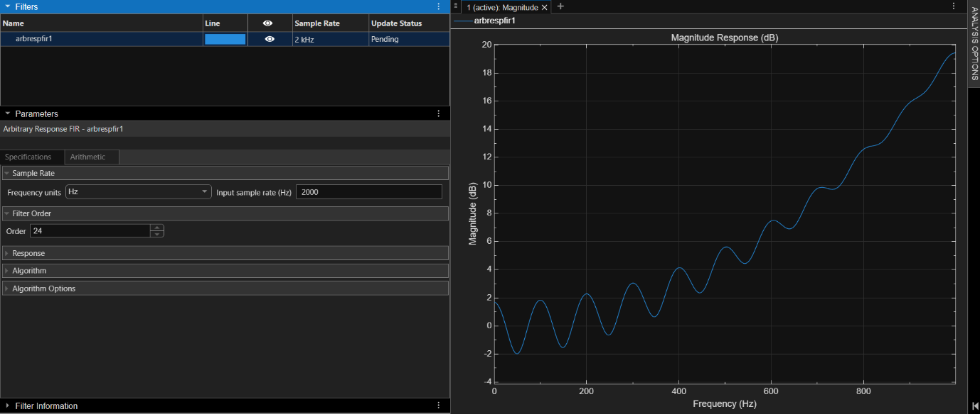
Figure 16. Filter design in filterDesigner.
The plot below compares the CIC alone, the compensator alone, and the CIC × compensator. The CIC falls off towards 1 kHz, the compensator rises to mirror it, and their product stays flat around 0 dB across the band.
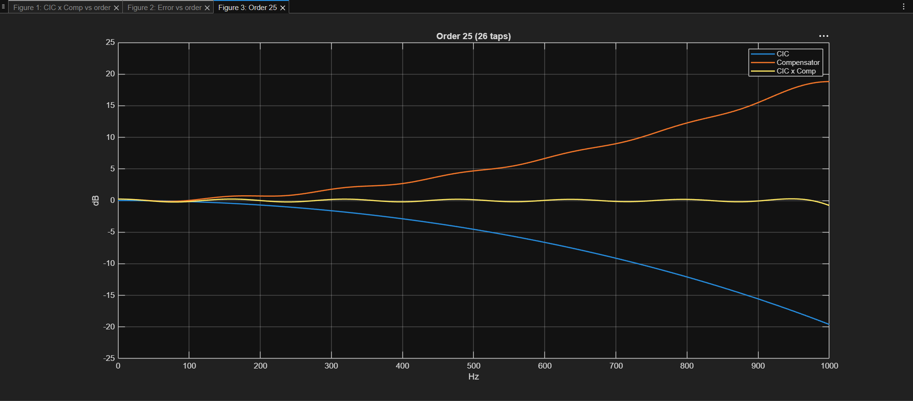
Figure 17. CIC × compensator, CIC only, and compensator only.
The final parameters of the compensator FIR:
Table 6. FIR compensator parameters.
Parameter | Value
Structure | Direct-form FIR, minimum phase (not symmetric)
Taps / coefficients | 25 (order 24)
Prototype | Least-squares linear-phase FIR, order 78 (79 taps), fitted to 1/|H_{CIC}|²
Band weights | Passband 1, stopband 10⁴
Number format | Q16: integer = round(h × 65536), 65536 = 1.0
Storage | Constant function h(k) / case ROM (FPGA and ASIC safe)
Design files | design_fir_comp.m (MATLAB, needs Signal Processing Toolbox)
filterDesigner equivalent | Arbitrary Response FIR, least squares, Fs 8000, order 78, bands 0–995 Hz (1/|H_{CIC}|²) and 1500–4000 Hz (0), then min-phase in MATLAB

Appendix: Final Verilog code
Full cic_top.v, containing the top module cic_top, the CIC decimator cic_core (÷512) and the FIR decimator fir_comp (÷4).
module cic_top #(
parameter OUT_WIDTH = 38 // = TB's cicout[37:0]
)(
input wire clk,
input wire reset,
input wire enable,
input wire signed [1:0] din,
output wire signed [OUT_WIDTH-1:0] dout,
output wire outready
);

reg signed [1:0] din_r;
always @(negedge clk) din_r <= din;

wire signed [29:0] cic_out;
wire cic_valid;
wire signed [19:0] fir_out; // final result, 20 bits

cic_core #(.STAGES(5), .DECIMATION(512)) u_cic (
.clk(clk), .reset(reset), .enable(enable),
.din(din_r),
.dout(cic_out), .outready(cic_valid)
);

fir_comp u_fir (
.clk(clk), .reset(reset), .enable(enable),
.din(cic_out), .in_valid(cic_valid),
.dout(fir_out), .out_valid(outready)
);

assign dout = fir_out; // sign-extends 20 -> 38 bits

endmodule

// CIC decimator (512)

module cic_core #(
parameter STAGES = 5,
parameter DECIMATION = 512,
parameter IN_WIDTH = 2,
parameter M = 1,
parameter OUT_BITS = 30
)(
input wire clk,
input wire reset,
input wire enable,
input wire signed [IN_WIDTH-1:0] din,
output reg signed [OUT_BITS-1:0] dout,
output reg outready
);

// Hogenauer: N*log2(R*M) + Bin = 5(9)+2=47..
localparam WIDTH = STAGES*$clog2(DECIMATION*M) + IN_WIDTH;

// 1.INTEGRATOR (block1)
reg signed [WIDTH-1:0] integrator [0:STAGES-1];
integer i;

always @(posedge clk) begin
if (reset) begin
for(i=0;i<STAGES;i=i+1)
integrator[i]<=0;
end
else if (enable) begin
integrator[0]<=integrator[0]+din;
for (i=1;i<STAGES;i=i+1)
integrator[i]<=integrator[i]+integrator[i-1];
end
end

// 2.DECIMATOR COUNTER (block2)
reg [$clog2(DECIMATION)-1:0] count;
wire sample_out=(count==DECIMATION-1);

always @(posedge clk) begin
if (reset)
count<=0;
else if (enable) begin
if (sample_out) count <=0;
else count <= count+1'b1;
end
end

// 3.COMBS (block3)
reg signed [WIDTH-1:0] comb_delay [0:STAGES-1];
reg signed [WIDTH-1:0] comb_value [0:STAGES];
integer j, k;

always @(*) begin
comb_value[0]=integrator[STAGES-1];
for (j=0;j<STAGES;j=j+1)
comb_value[j+1]=comb_value[j]-comb_delay[j];
end

always @(posedge clk) begin
if (reset) begin
for (k=0; k<STAGES;k=k+1)
comb_delay[k]<= 0;
end
else if (enable && sample_out) begin
for (k=0;k<STAGES;k=k+1)
comb_delay[k]<=comb_value[k];
end
end

// 4. OUTPUT (block4)
// Gain = 512^5 = 2^45, input avg <= 0.5 -> |comb| <= 2^44.
// Keep 30 bits [45:16]: bit 45 is the sign, no overflow possible.
always @(posedge clk) begin
if (reset) begin
dout<=0;
outready<=0;
end
else begin
outready<=0;
if (enable && sample_out) begin
dout<=comb_value[STAGES][WIDTH-2-:OUT_BITS];
outready<=1;
end
end
end

endmodule

// FIR Decimator 4x

module fir_comp (
input wire clk,
input wire reset,
input wire enable,
input wire signed [29:0] din,
input wire in_valid,

output reg signed [19:0] dout,
output reg out_valid
);

localparam TAPS = 25;
// coefficients (Q16) - constant ROM, synthesizable for FPGA and ASIC
function signed [17:0] h;
input integer k;
case (k)
0: h = 1205; 1: h = 4680; 2: h = 10299; 3: h = 16316;
4: h = 19548; 5: h = 17402; 6: h = 9848; 7: h = 76;
8: h = -7217; 9: h = -8754; 10: h = -4815; 11: h = 1126;
12: h = 4933; 13: h = 4620; 14: h = 1330; 15: h = -2021;
16: h = -3134; 17: h = -1816; 18: h = 363; 19: h = 1646;
20: h = 1415; 21: h = 315; 22: h = -601; 23: h = -790;
24: h = -438;
default: h = 0;
endcase
endfunction
reg signed [29:0] x [0:TAPS-1];
reg [1:0] count;

reg signed [51:0] sum;
integer n;

always @(*) begin
sum = 0;
for (n = 0; n < TAPS; n = n + 1)
sum = sum + h(n) * x[n];
end

integer m;

always @(posedge clk) begin
if (reset) begin
for (m=0;m<TAPS;m=m+1)
x[m]<=0;
count<=0;
dout<=0;
out_valid<=0;
end
else begin
out_valid <= 0;

if (enable && in_valid) begin
x[0] <= din;
for (m=1;m<TAPS;m=m+1)
x[m]<=x[m-1];
if (count==3) begin
count<=0;
dout <=sum[44:25];
out_valid <= 1;
end
else
count<=count+1'b1;
end
end
end

endmodule

