Duy Hoang

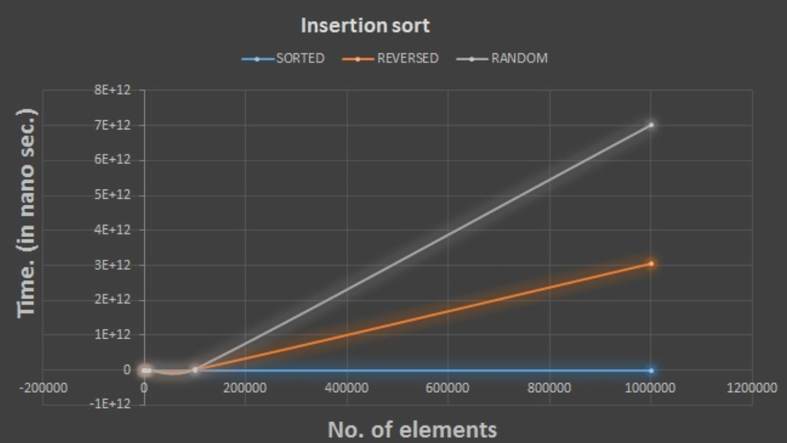
1. Insertion Sort Performance Analysis
Graphs: The initial graph illustrates the performance of the Insertion Sort algorithm across various input types: sorted, reversed, and random. The time complexity of Insertion Sort is significantly influenced by the initial arrangement of the array:

Best Case (Sorted Input): When the data is already sorted, the Insertion Sort algorithm operates at its best, demonstrating a time complexity of O(n), which is linear. This is represented by the blue line on the graph, where the runtime remains relatively stable as the input size increases.

Average Case (Random Input): The runtime for random input escalates more sharply. As the number of elements increases, the runtime exhibits a quadratic growth pattern, with a theoretical time complexity of O(n^2). This trend is illustrated by the grey line in the graph.

Worst Case (Reversed Input): In the scenario where the input is reversed, each element must be repositioned correctly, leading to the worst-case situation. This results in a clearly quadratic time complexity of O(n^2). The orange line reflects this behavior, indicating a significant rise in runtime as the number of elements increases.

Theoretical Time Complexity: The Insertion Sort algorithm has a time complexity of O(n^2) in both the average and worst cases, while achieving O(n) in the best case.

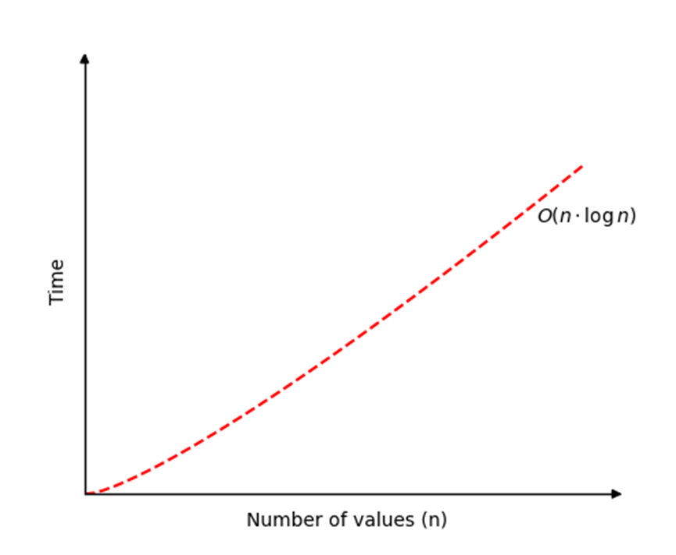
2. Merge Sort Performance Analysis
Graph: The subsequent graph depicts the performance of the Merge Sort algorithm. As a divide-and-conquer algorithm, Merge Sort exhibits predictable time complexity that remains unaffected by the arrangement of the input.

Best, Average, and Worst Case (All Inputs): The performance across all input types is notably consistent, maintaining a time complexity of O(n log n). This is evident in the graph, where the runtime increases at a logarithmic rate as the input size grows.
Theoretical Time Complexity: Merge Sort operates uniformly at O(n log n) time, irrespective of whether the data is sorted, reversed, or random. This represents a considerable enhancement over Insertion Sort, particularly for larger datasets.

3. Comparison Between Insertion Sort and Merge Sort

Time Complexity:

Insertion Sort: The complexities for both the worst-case and average-case scenarios of Insertion Sort are O(n^2), rendering it less effective for larger datasets. Conversely, in the best-case scenario, where the data is already sorted, it can function in O(n) time.
Merge Sort: The time complexity of Merge Sort consistently remains O(n log n), irrespective of the input, thus offering superior efficiency compared to Insertion Sort when handling large datasets.

Performance Trends in the Graphs:
Insertion Sort demonstrates a significant increase in execution time as the dataset size expands, particularly with reversed or random inputs. This quadratic escalation is illustrated by the sharp ascent of the orange and grey lines.
Merge Sort, on the other hand, maintains a more stable performance, with time increments occurring at a much slower rate due to its O(n log n) time complexity. This is depicted by the steady rise in the second graph across all input types.

Practical Implications:
For small datasets: Insertion Sort may yield better performance due to its lower overhead and smaller constant factors, despite its O(n^2) time complexity. However, its efficiency diminishes as the dataset size increases.
For large datasets: Merge Sort proves to be significantly more efficient with its O(n log n) time complexity. It will surpass Insertion Sort in performance as the dataset size increases, especially with random or reversed inputs.

