Duy Hoang

First sudo dmesg

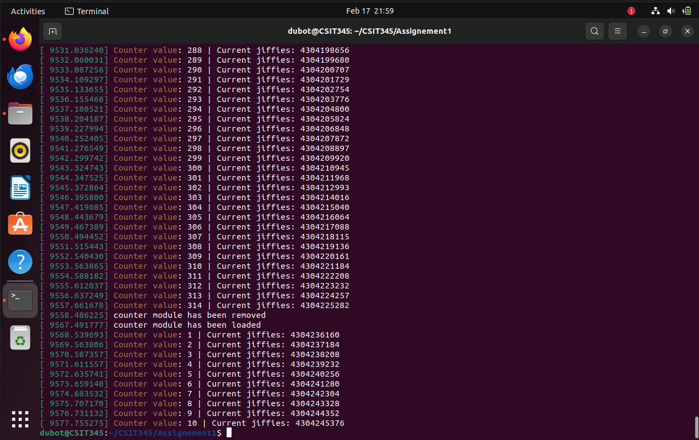

cat/proc/hw1
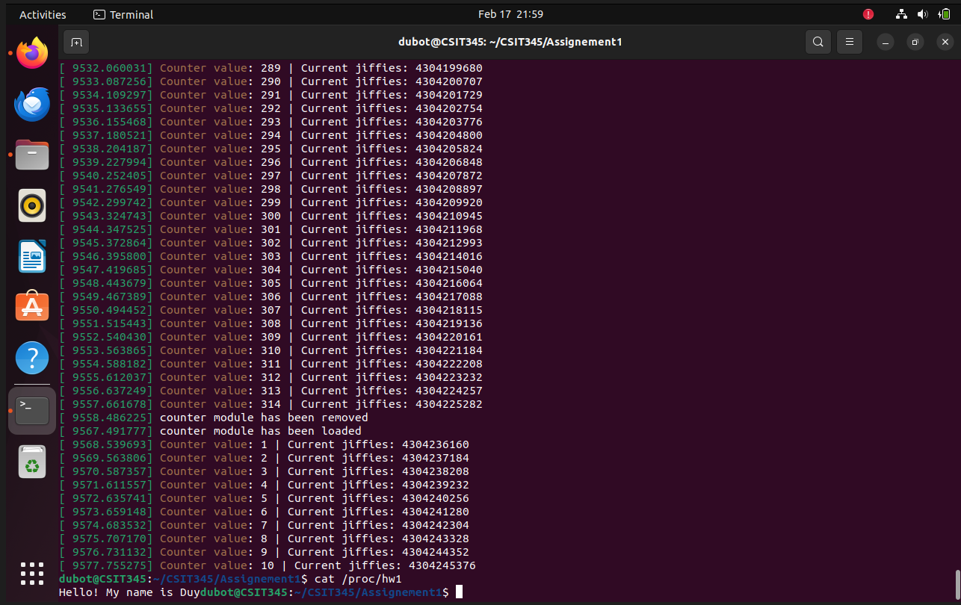
Second dmesg
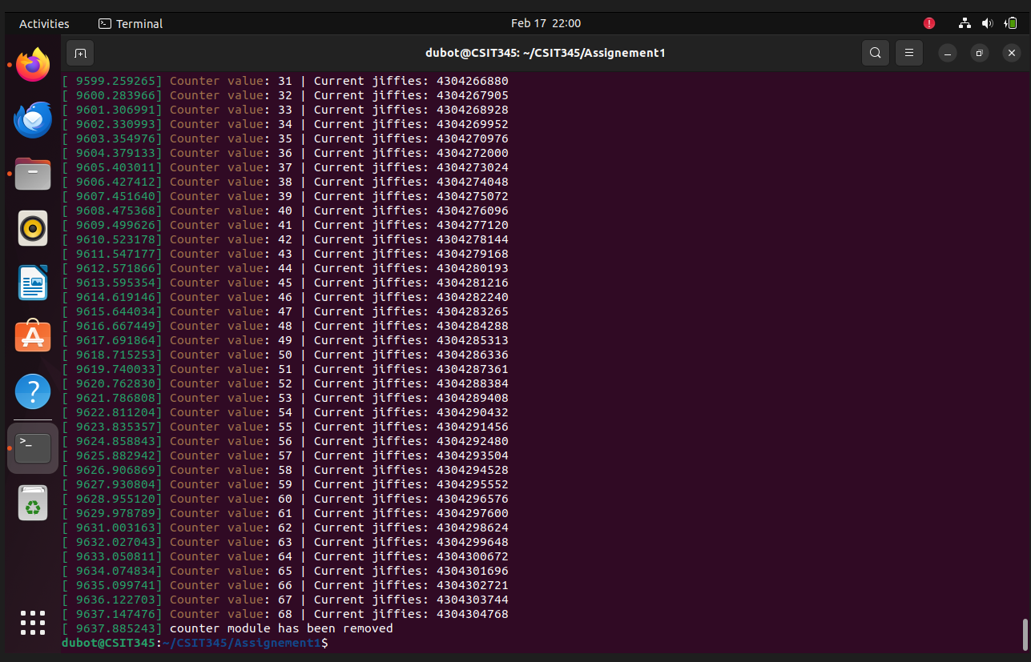

Make File Part g

Counter value: 1 | Current jiffies: 4304236160
Counter value: 227 | Current jiffies: 4304304768

4304304768 - 4304236160 = 68608 value of the differences of jiffies

