Project Toyota Corolla Report
Duy Hoang
AMAT 240 - Intro to Linear Algebra
Dr. Song
April 16, 2025

Abstract
This paper investigates the application of linear transformations to convert three-dimensional automotive model coordinates into two-dimensional projections. Using a dataset derived from a 1983 Toyota Corolla, this analysis implements various matrix operations including perspective projection, rotational transformations, and scalar multiplication within a homogeneous coordinate system to examine their effects on visual representation. The fundamental mathematical operations employed in this study involve projective geometry and matrix transformations. By implementing these techniques, we can simulate various viewpoints and manipulations of the subject vehicle to understand spatial relationships in computer graphics applications.

Question 1: Perspective Projection from (-5, 10, 10)
When applying the perspective projection formula with center of projection coordinates (-5, 10, 10), the resulting transformation matrix is formulated as:
P = [
[1, 0, 0.5, 0],
[0, 1, -1, 0],
[0, 0, 0, 0],
[0, 0, -0.1, 1]
]
The mathematical significance of this transformation is the creation of a two-dimensional projection as would be perceived by an observer positioned at the left posterior quadrant of the vehicle at a moderate elevation.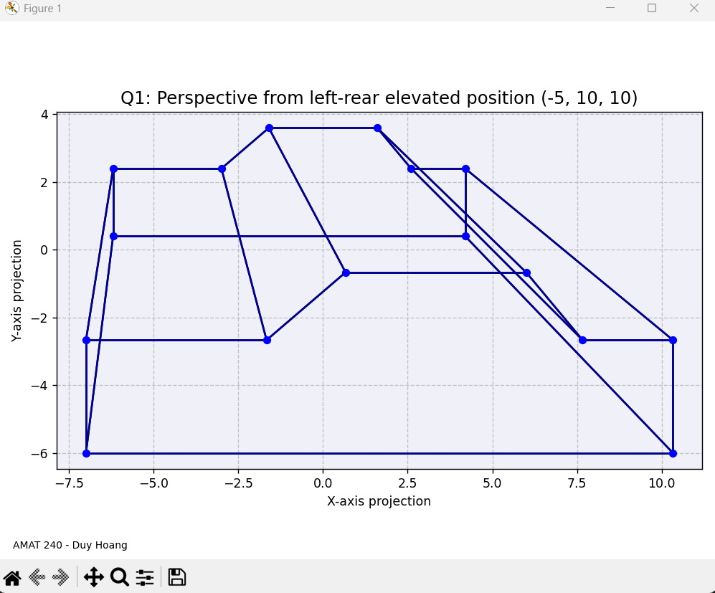

Question 2: Perspective Projection from (0, 10, 25)
For comparative analysis, a second projection was calculated using center of projection (0, 10, 25), yielding the transformation matrix:
P = [
[1, 0, 0, 0],
[0, 1, -0.4, 0],
[0, 0, 0, 0],
[0, 0, -0.04, 1]
]
This matrix represents a transformation that approximates visual perception from an elevated posterior position, offering a more comprehensive view of the subject model.
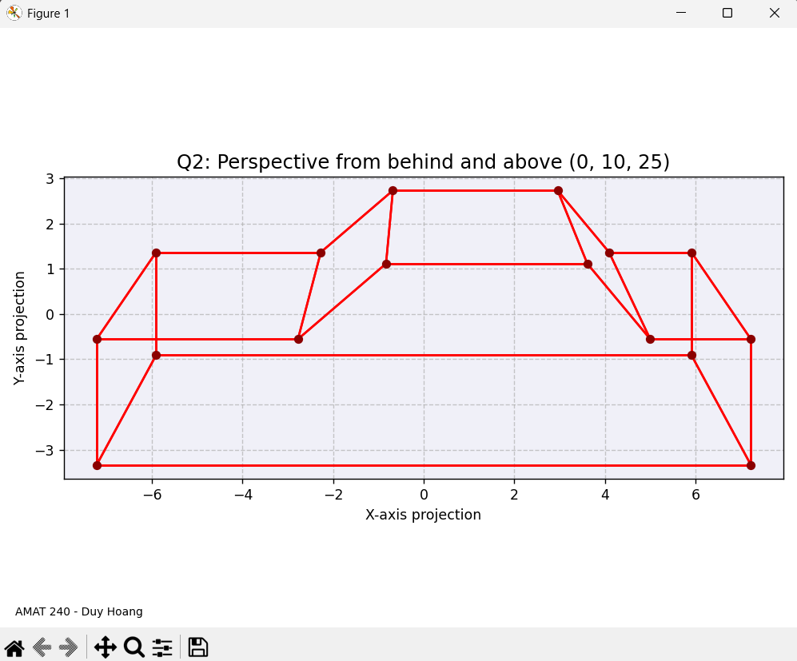

Question 3: Rotation 30° about Y-axis, then Projection
To examine the effects of vehicle orientation on projection, a 30° rotation about the y-axis was implemented prior to projection. The rotation matrix is defined as:
R_y(30°) = [
[cos(30°), 0, sin(30°), 0],
[0, 1, 0, 0],
[-sin(30°), 0, cos(30°), 0],
[0, 0, 0, 1]
]
The composite transformation R_y(30°) · P produces a visualization that simulates vehicular rotation while maintaining the observation point at (0, 10, 25).
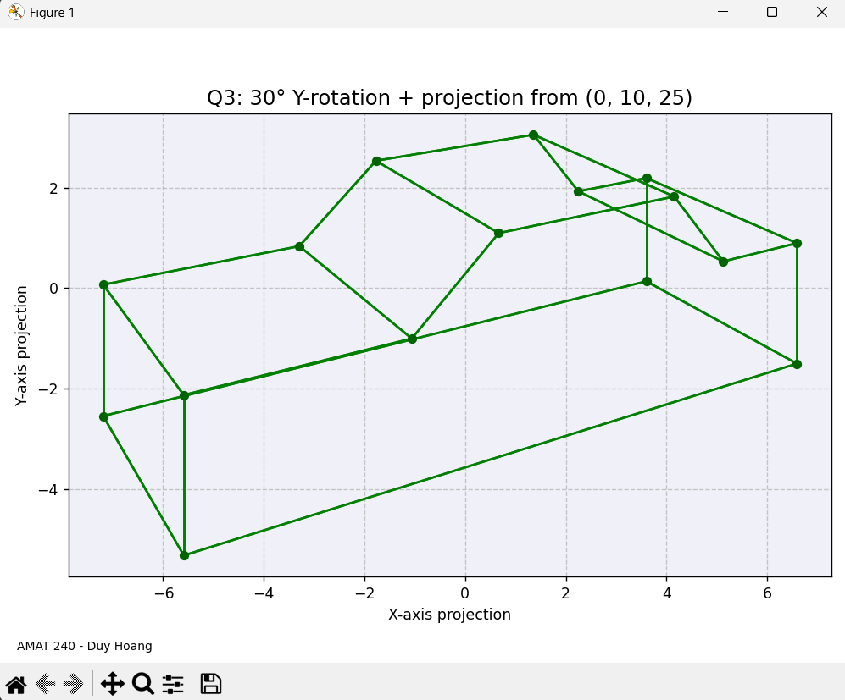

Question 4: Rotation 45° about Z-axis, then Projection
Further investigation incorporated a 45° rotation about the z-axis, represented by:
R_z(45°) = [
[cos(45°), -sin(45°), 0, 0],
[sin(45°), cos(45°), 0, 0],
[0, 0, 1, 0],
[0, 0, 0, 1]
]
When combined with the projection from position (0, 10, 25), this transformation simulates the visual effect of circumnavigating the vehicle, providing insight into perspective changes with observer movement.
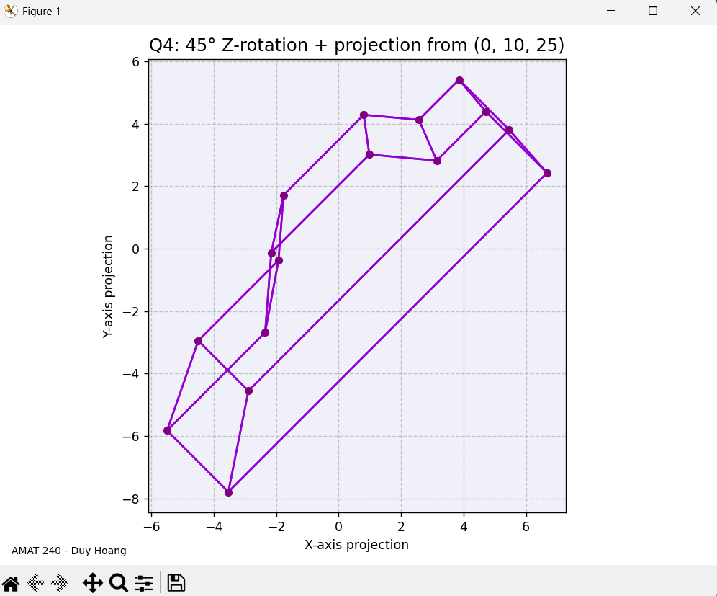

Question 5: 150% Zoom then Projection
The final analysis examines the effect of uniform scaling prior to projection. The scaling transformation with factor 1.5 is represented by:
Z = [
[1.5, 0, 0, 0],
[0, 1.5, 0, 0],
[0, 0, 1.5, 0],
[0, 0, 0, 1]
]
This magnification transformation, when applied before the projection from (0, 10, 25), provides insight into the mathematical basis of zoom functionality in computer graphics applications.
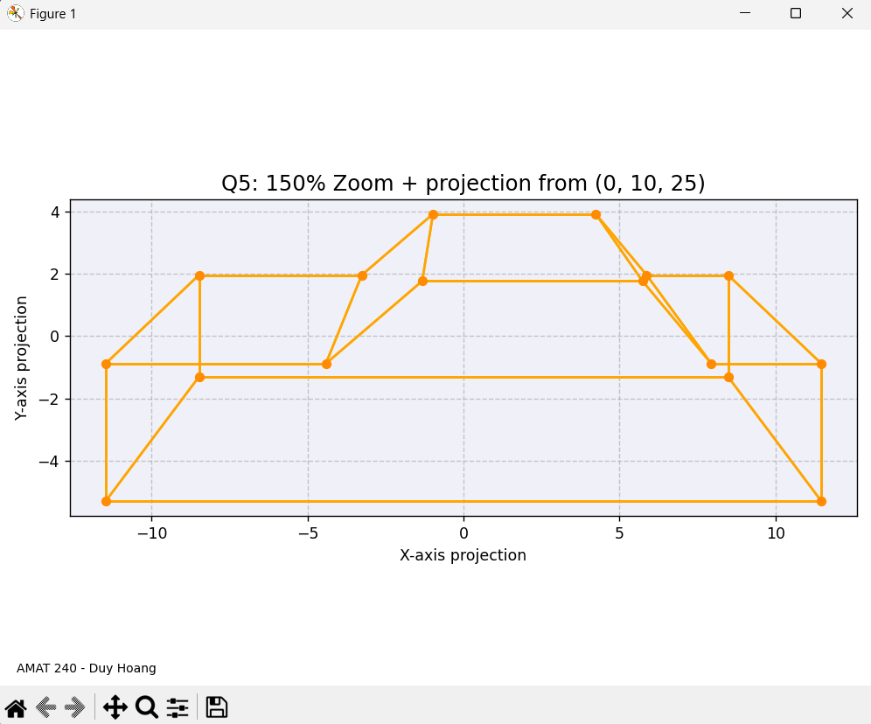

Conclusion
This study demonstrates the application of linear algebra concepts to computer graphics problems. Through sequential matrix operations and homogeneous coordinate transformations, we have successfully modeled various visual representations of three-dimensional data in two-dimensional space. The transformations analyzed illustrate the mathematical principles that enable virtual prototyping and visual modeling in contemporary design workflows.

