Chemistry 220 – Descriptive Inorganic Chemistry

Problem Set #2 – Complete Solutions (All Subparts)
This document provides full solutions to Problem Set #2. Each question and subpart is answered clearly with embedded figures such as Lewis structures, VSEPR geometries, MO diagrams, reaction sketches, and orbital plots. Answers are written at a bachelor’s level for clarity and precision.

1. Lewis Structures
a) CO₂: 16 valence e⁻. Linear O=C=O with lone pairs on O.
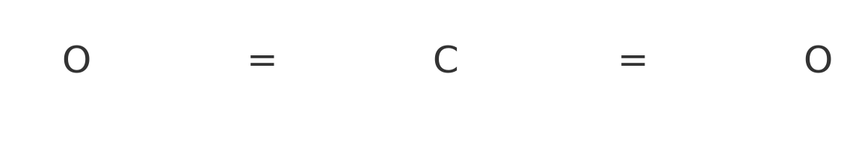
b) N₂: 10 valence e⁻. Triple bond N≡N with lone pair on each N.


2. VSEPR Geometries
a) BF₃: 24 valence e⁻. Geometry: trigonal planar, bond angle 120°.
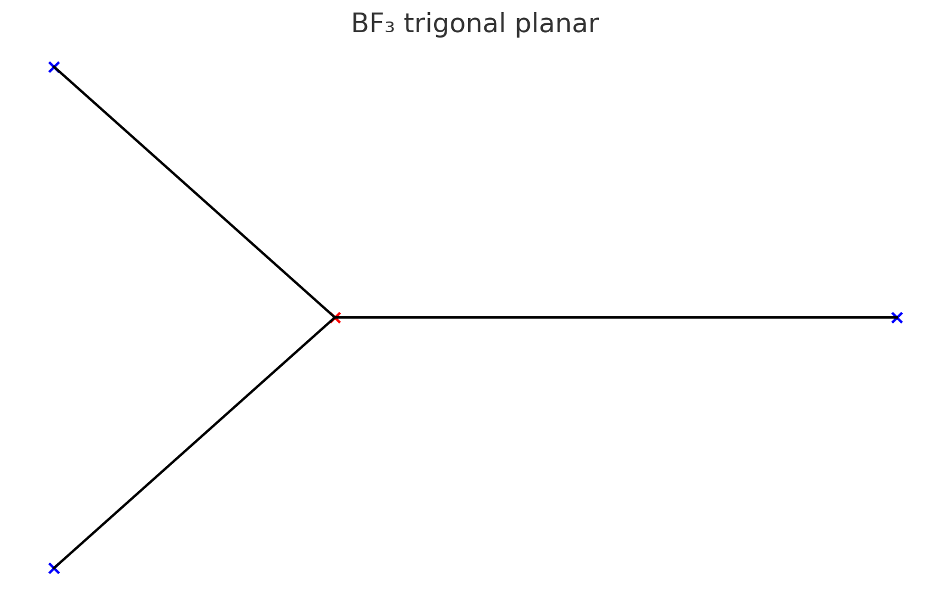
b) PH₃: 8 valence e⁻. Geometry: trigonal pyramidal, bond angle ~107°.
c) IF₅: 42 valence e⁻. Geometry: square pyramidal, ~90°.

3. Abbreviated Electron Configurations
i) Fe²⁺: [Ar] 3d⁶
ii) Ru²⁺: [Kr] 4d⁶
iii) Sb³⁻: [Xe]
iv) Sn²⁺: [Kr] 4d¹⁰ 5s²

4. MO Theory of He₂
a.i) He₂: 4 e⁻ → σ1s² σ1s*² → bond order 0 (unstable).
a.ii) He₂⁺: 3 e⁻ → bond order 0.5 (weakly bound).
a.iii) He₂⁻: 5 e⁻ → bond order –0.5 (unstable).
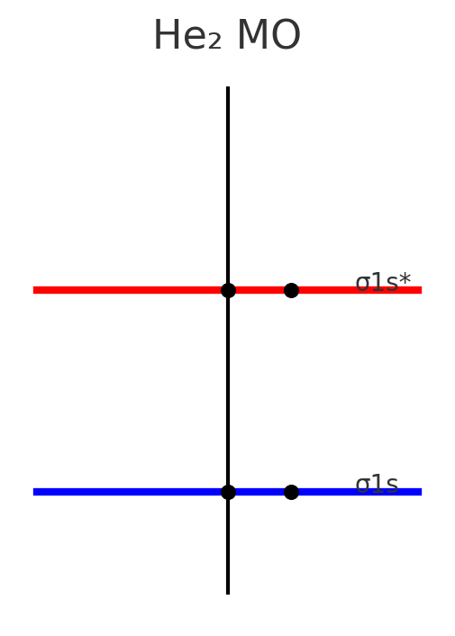
b) To form a He–He bond, antibonding electrons must be removed (He₂⁺). This is difficult due to helium’s high ionization energy and filled 1s shell.

5. Reaction Sketches
a) C(g) → C⁺(g) + e⁻ (first ionization of carbon)
b) Cs⁺(g) → Cs²⁺(g) + e⁻ (second ionization of cesium)
c) O(g) + e⁻ → O⁻(g) (electron affinity of oxygen)

6. Bohr vs Quantum Model of Fluorine
a) Bohr model sketch: nucleus (Z=9), 2 core e⁻, 7 valence e⁻ in circular orbits.
b) Quantum model: orbitals (1s² 2s² 2p⁵), probability clouds not fixed orbits.
c) Quantum predicts higher Zeff due to incomplete shielding.
d) For chlorine, add another shell (3s² 3p⁵).
e) Fluorine more electronegative than chlorine due to higher Zeff.
f) Fluorine has higher ionization energy because its valence electrons are closer and more tightly held.

7. MO Diagrams and Bonding in Diatomics
a.i) Li₂: bond order = 1 (σ2s²).
a.ii) C₂: bond order = 2 (π2px/π2py bonding).
a.iii) F₂: bond order = 1 (σ2pz filled).
b) Only F₂ exists as a diatomic gas under standard conditions.
c) Li is metallic solid; C forms diamond/graphite.
d) Li and C prefer extended bonding networks; F₂ satisfies octet as a diatomic.

