Duy Hoang
CSIT460
Lab 3
Part 2 Firewall Exploration Lab
1.)
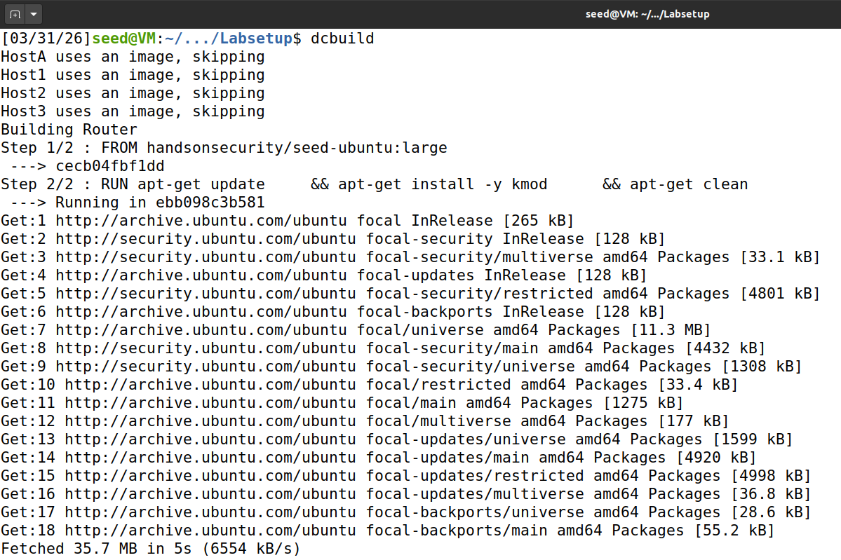
2.)
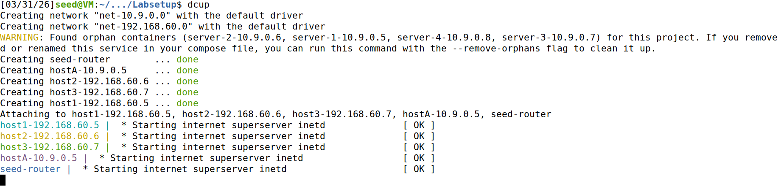
3.)

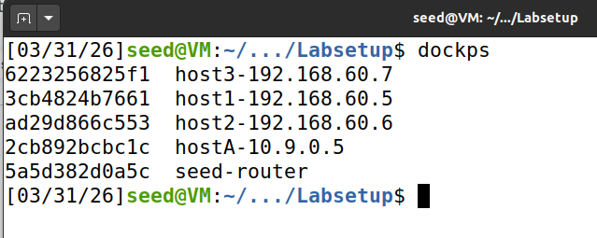
4.)
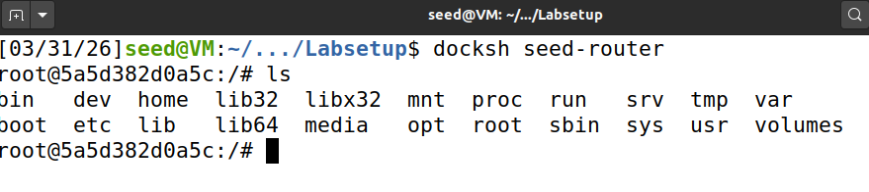
Task 2: Experimenting with Stateless Firewall Rules

Task2.A: Protecting the Router

5.)
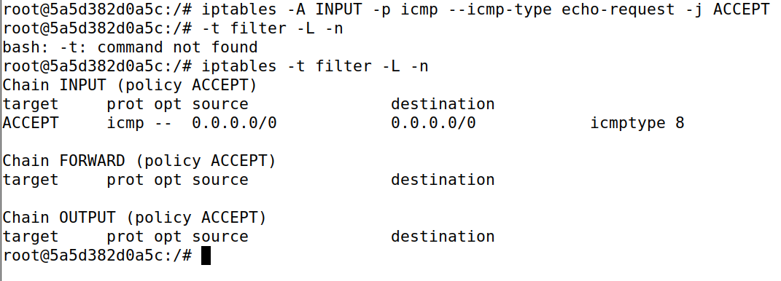
6.)
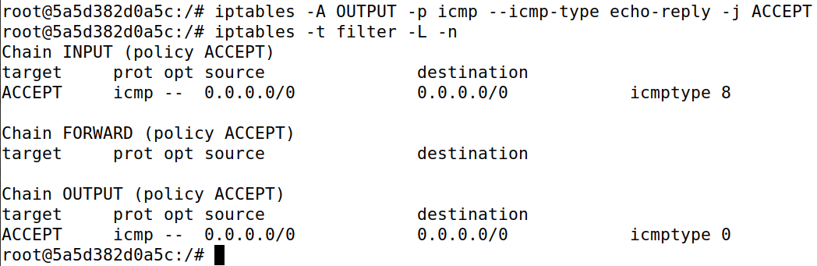
7.)
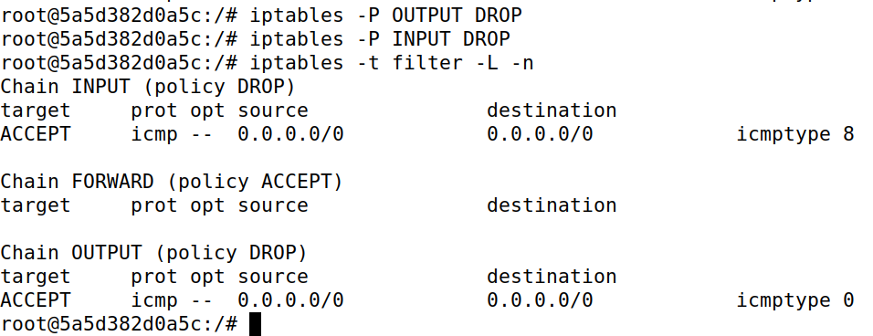
8.)
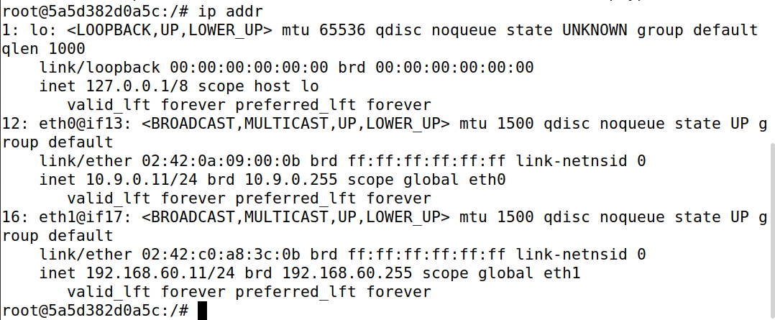

9.)
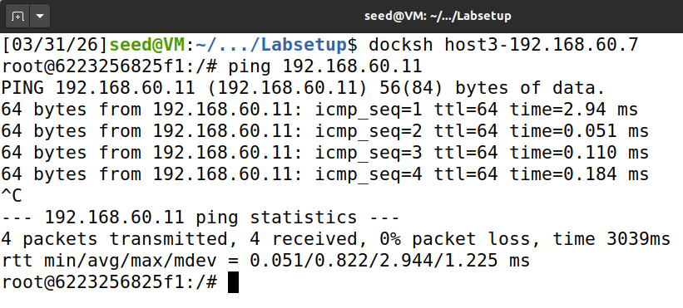
10.)
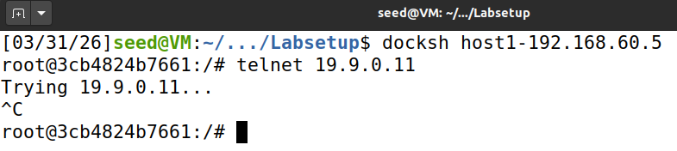
11.)
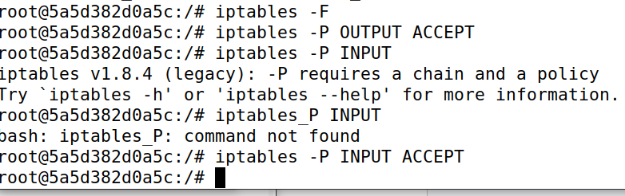

Task 2.B: Protecting the Internal Network

12.)
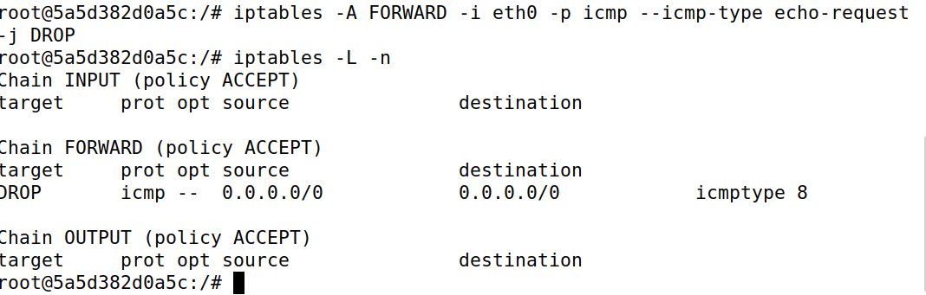
13.)
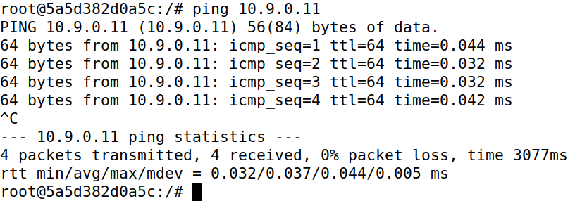
14.)
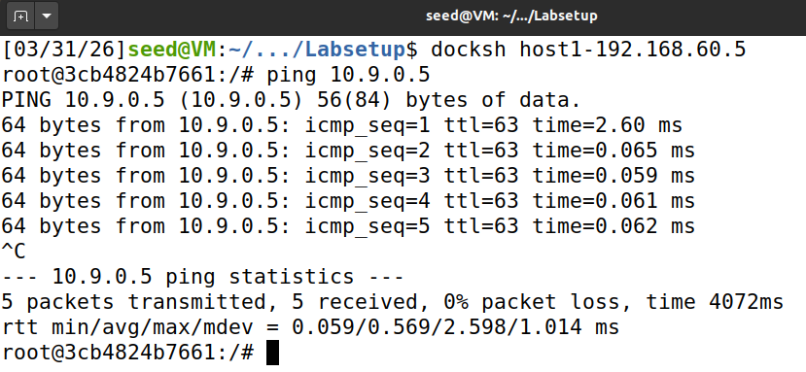
15.)
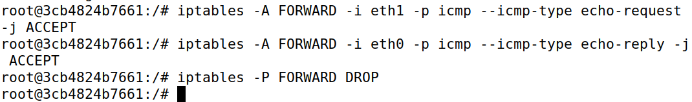
16.)
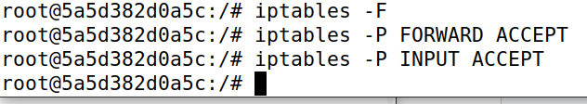
Task 2.C: Protecting Internal Servers
17.)
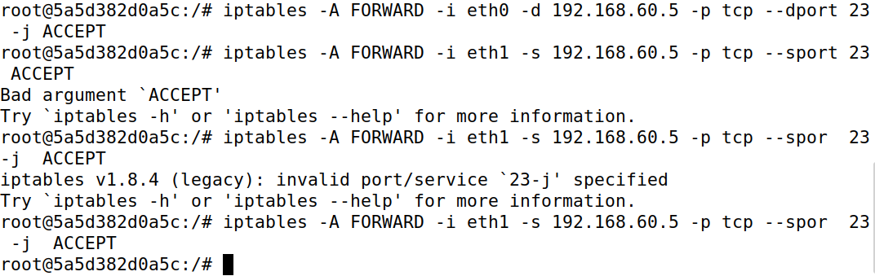
18.)
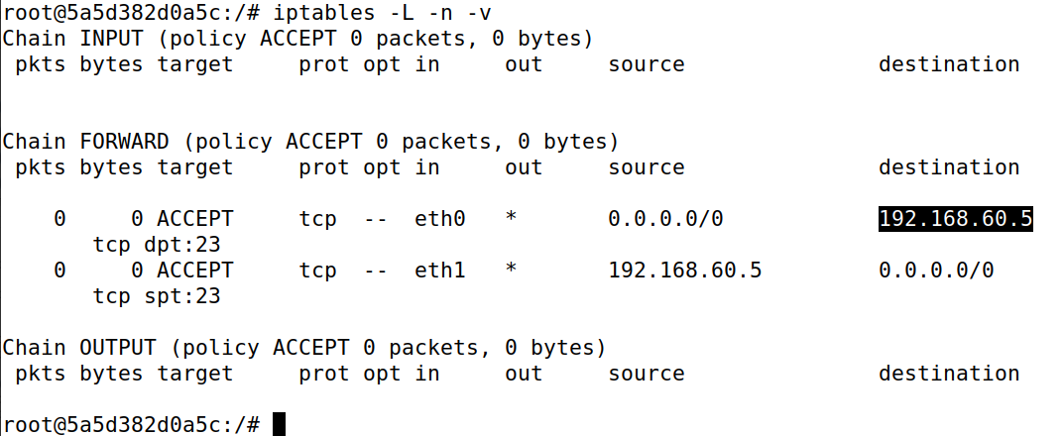
19.)
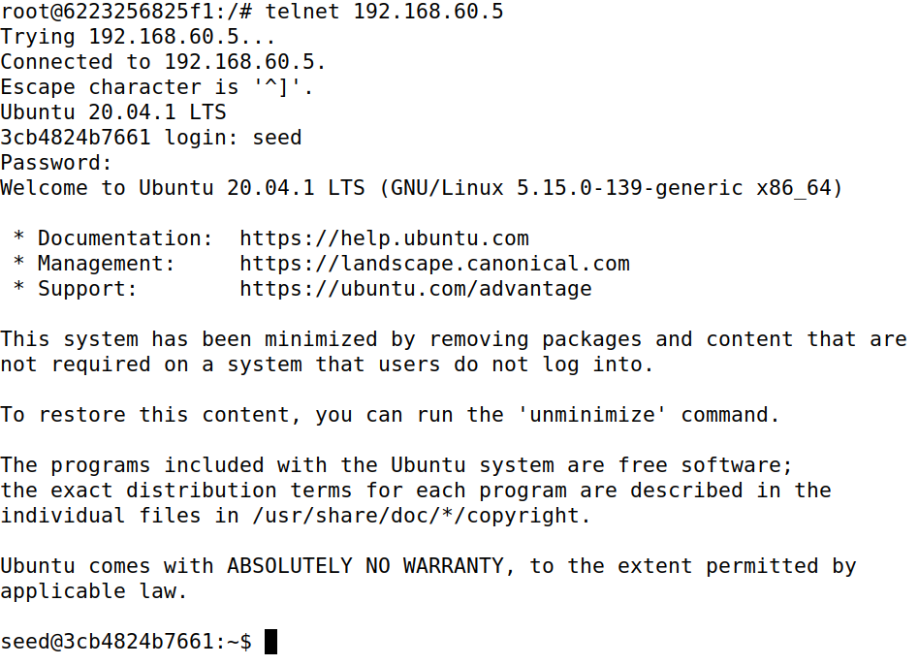
20.)
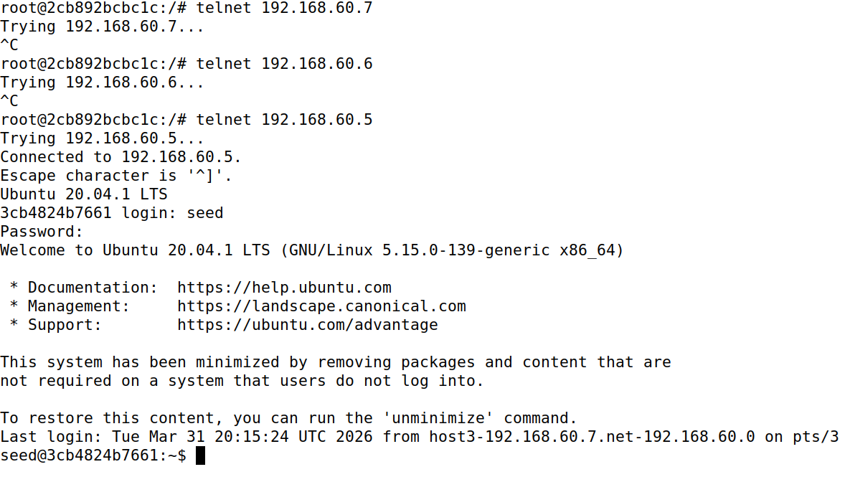

21.) 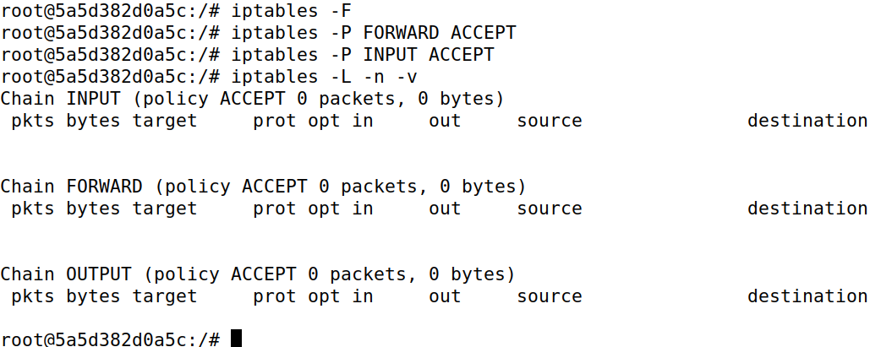

Task 3: Connection Tracking and Stateful Firewall

Task 3.A: Experiment with the Connection Tracking
22.)
23.)
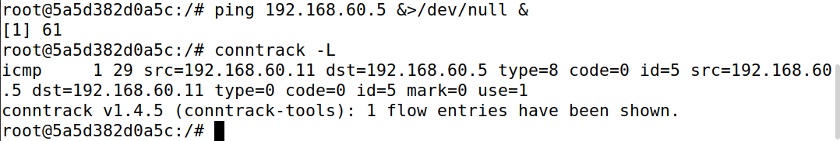
24.)
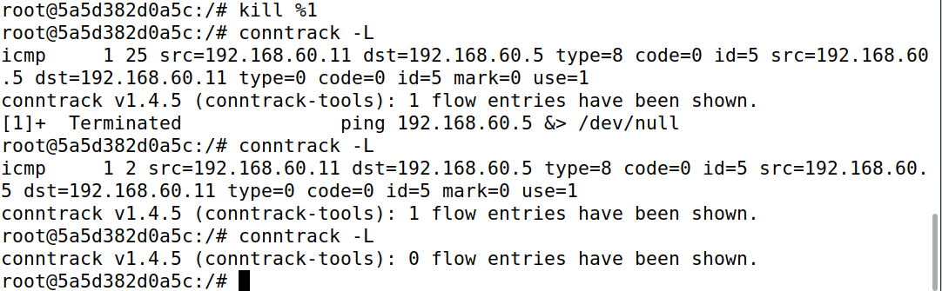

25.)
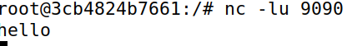
26.)
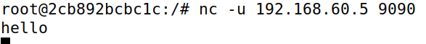
27.) It was around 20 seconds from 1 flow entry to 0.
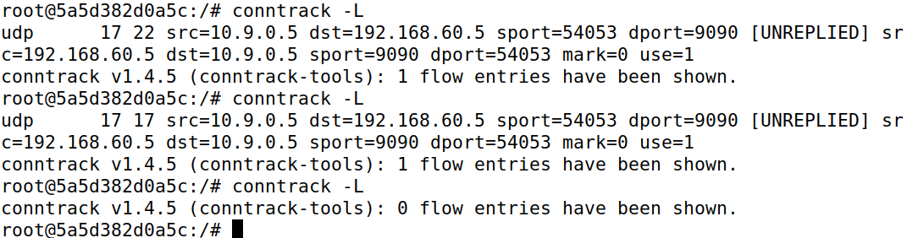
28.)
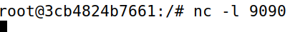
29.)
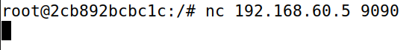
30.)
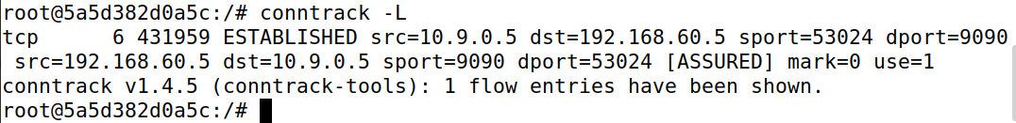
31.)
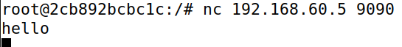
32.)I went back to the seed-router to see how long the connection is kept.
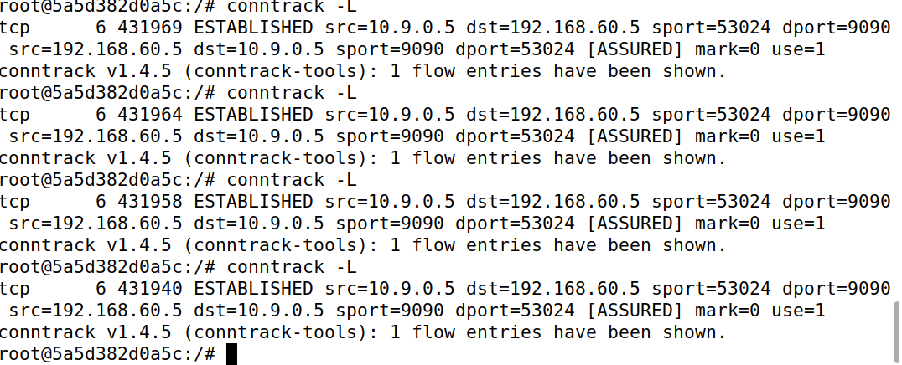
33.)The TCP connection continues for as long as the connection is still active. We will cancel it ourselves
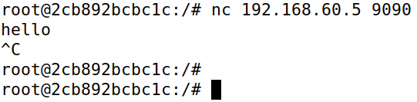
34.)
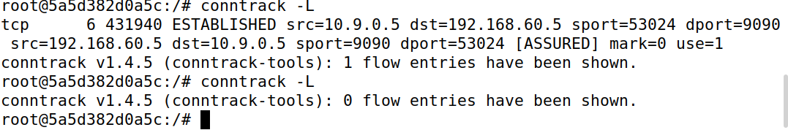

Task 3.B: Setting up a Stateful Firewall
35.)
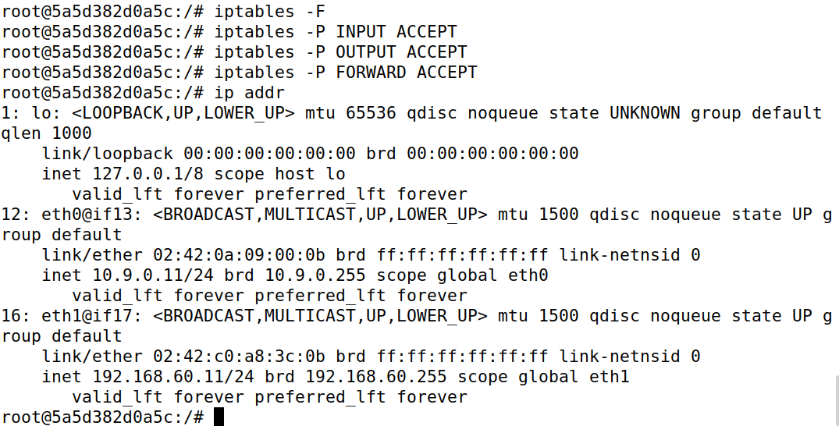
36.)
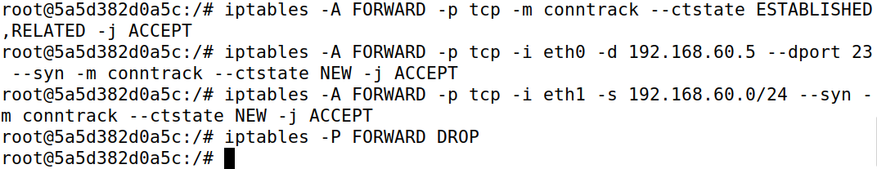
37.)
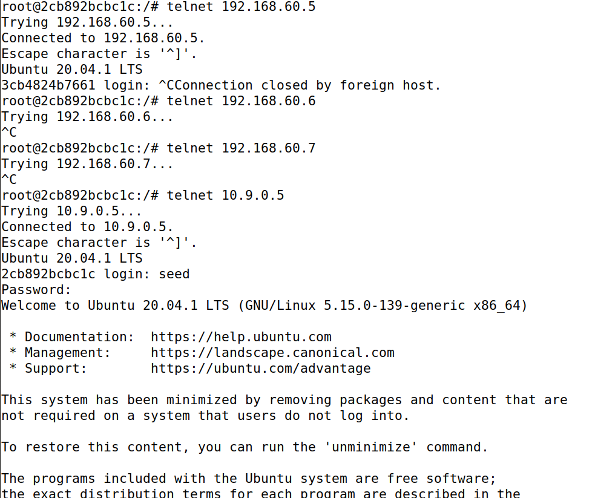
38.)
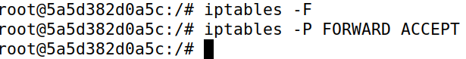

Task 4: Limiting Network Traffic
39.)
40.)
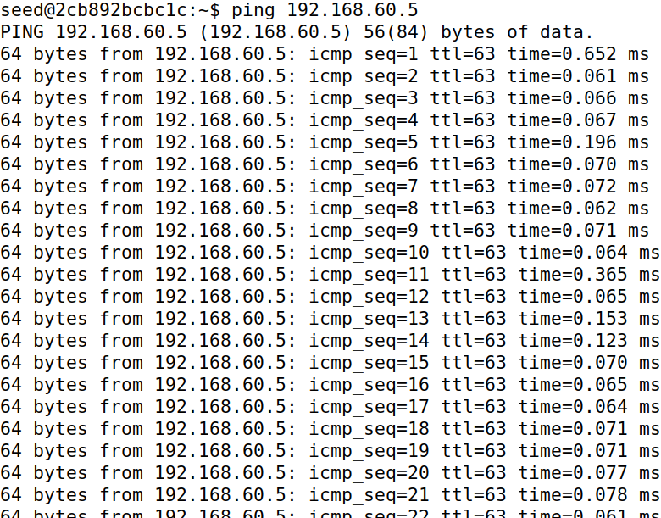
41.)
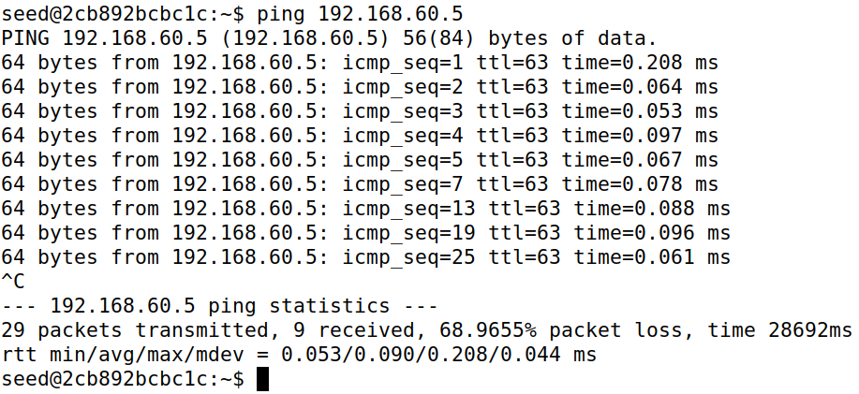
42.)
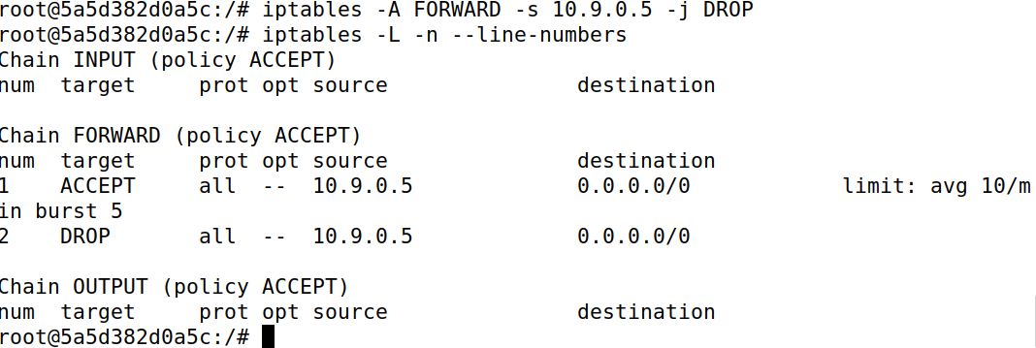
43.)
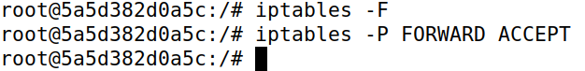

Task 5: Load Balancing

44.)Host 1
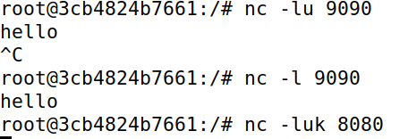
45.)Host 2
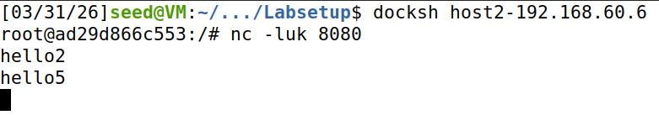
46.) Host 3
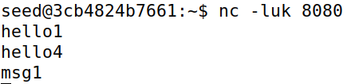
47.) Seed-Router
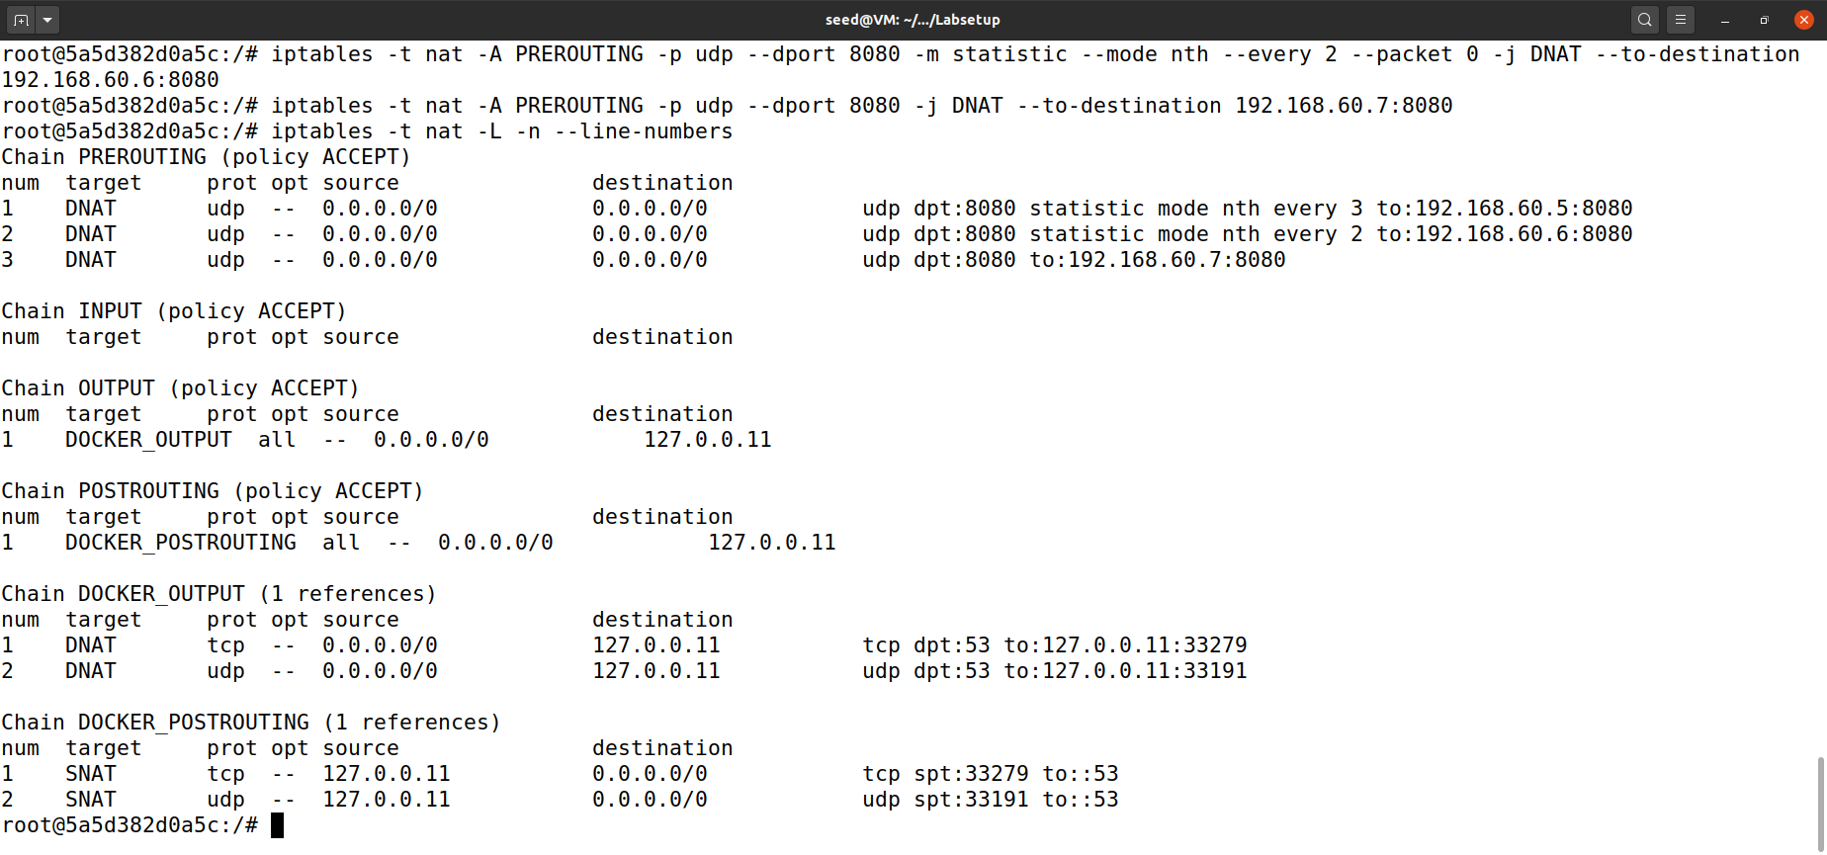
48.) Host A
