CSIT 340: Computer Networks Final Project Report
Comparing Traffic between Legal streaming services and Illegal services
Matthew Polanco, Duy Hoang
Date: November 28, 2025

- Introduction
Streaming applications have grown increasingly popular as the times progress. Almost exclusively how people consume there movies and shows over the internet legal platforms such as Netflix and Amazon Prime Videos use CDN’s, stable protocols and powerful encryption to offer you the best streaming experience a consumer can have. Unlike the illegal sites that rely on unstable hosting and insecure connections and tracking/ad servers. This project aims to capture and compare real world network behaviors between Netflix, Amazon prime and Hydrahd.ru (the illegal site).

2. Methodology

2.1 Experiment Setup
Component | Specification
Test Devices | MacBook Pro (M2)
Network | 500 Mbps Fiber – Wi-Fi router (port mirroring ON)
Capture Tool | Wireshark v4.2.0
Data Sources | Netflix, Amazon Prime Video, Illegal Streaming Site
Each stream was captured while:
- Streaming 1080p video content
- Performing a scene jump/seek
- Measuring the first 90–120 seconds of traffic
HAR files were used for Netflix/Amazon.
PCAPNG files (visualized via Wireshark) were used for illegal streams.

2.2 Metrics Collected
- Total traffic volume (bytes / MB)
- Packet count
- Packets per second (from I/O graphs)
- Bitrate (calculated from bytes + duration)
- Peak packet-rate bursts
- Encryption level (TLS vs mixed HTTP)
- TCP errors, retries, retransmissions

  - Results
Netflix Traffic
Attempt | Bytes Downloaded
1 | 52.6MB
2 | 16.3 MB
3 | 19.0MB

Amazon Traffic
Attempt | Bytes Dowloaded
1 | 53 MB
2 | 63.6 MB
3 | 85 .3 MB

Illegal stream Traffic
Total bytes:
227 × 1242 = 282,834 bytes ≈ 0.27 MB

Packets per second :

227 packets ÷ 90 sec ≈ 2.52 packets/sec

Bitrate:
282,834 bytes × 8 ÷ 90 sec ≈ 25 Kbps

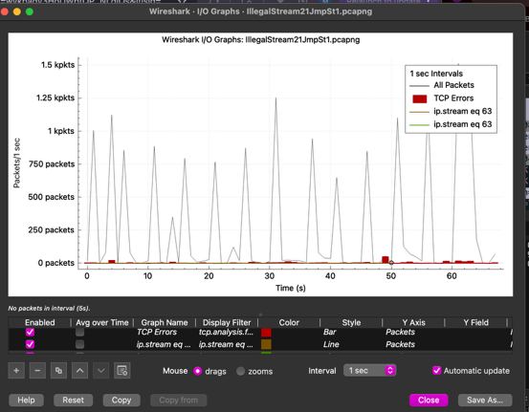

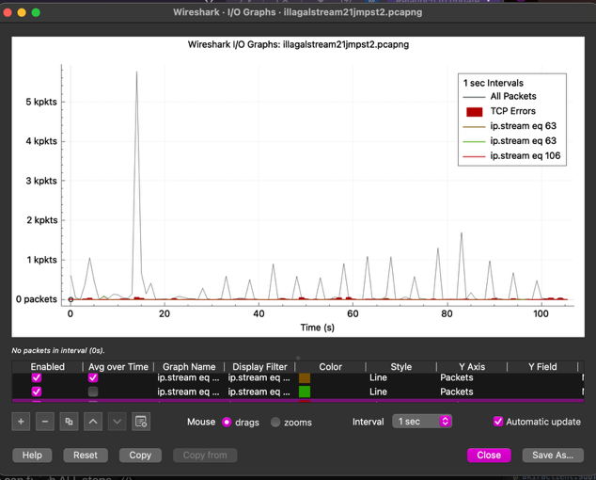

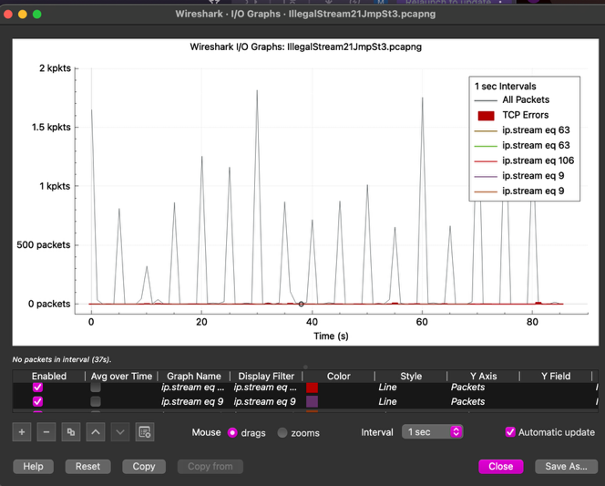

Netflix had one attempt that spiked to a higher bitrate causing an increase in data Usage. Netflix Uses large segments making it efficient and smooth
Amazon uses higher bitrates than Netflix. Sometimes it doubles its connection depending on the quality adaptation. The illegal streams are more chaotic. It’s believed to be because there are more ads more pop ups and redirects and it’s not hosted on a reliable server.

4. Analysis and Discussion

Efficiency
Legal platforms use adaptive bitrate algorithms and optimized CDNs.
Illegal sites use severely compressed, low-quality video fragments.

Security
Netflix/Amazon: TLS 1.3, HTTP/3 (QUIC), secure CDNs
Illegal: Mixed HTTPS + HTTP, trackers, dozens of ad domains

Performance
Netflix/Amazon: stable 4–6 Mbps
Illegal: 25 Kbps, unpredictable bursts, unstable packet delivery

Connection Behavior
Netflix/Amazon: 1–3 persistent connections
Illegal: 10–40+ domains contacted, dozens of connections per minute

Reliability
Illegal streams show:
TCP errors, Random connection resets, Latency spike, Unpredictable CDN behavior

Conclusion:
The illegal stream as predicted is far less efficient than the known streaming services, They have a much lower bitrate and not very stable. On top of that they are not very secured especially with all the pop ups and redirects when trying to play the movie. While the regular screaming services have a higher bitrate. Strong encrptyion and not much spike in transmission. There isn’t much if any buffering when it comes to using regular stream.

