Project 1

Duy Hoang
Montclair State University
Asja Alic
Stat 230_04
12/13/24

Data Science Article Questions
Part I: Write an Article Analysis (400-600 words)
Examine the Statistics: According to NAEP, two-thirds of the country's fourth and eighth graders need to read at the level for their respective grades. To critically analyze this, ask: Who conducted the study? Was the sample national or regional? Were such factors (like economic status or ability to acquire learning material) considered? NAEP is a reliable source; more information about its methodology will further support this statement.
Data Interpretation: The fact that the rate of absenteeism rose and nearly doubled from 2019 to 2023 requires more attention to be paid to the causes of this phenomenon. There are strong indications that such external factors as the COVID-19 pandemic have had a considerable influence. Did absentees have any correlation with health issues, the difficulties they encountered with online learning classes, or socio-economic factors? Certain factors might bias the results and contribute to the development of quite a reductive approach to interpreting the results that, at the same time, would underestimate the impact of the pandemic.
Consider the Source: The article is from The Free Press, and the authors might have bent their minds on presenting school choice as a possible solution to many of the problems that education faces today (Kearns, 2024). One should wonder what the author or the publication might gain from presenting such figures and cross-checking with other sources, such as educational unions, on the exact figures.
Compare Different Perspectives: Critics of school choice claim that it redirects funds from public to private schools. This article sets up this conflict in terms of ideology, but one has to wonder how a teachers’ union would approach data that illustrate the positive effect of money spent on public schools. Different advocacy groups may use the same statistics but may put different spins on it depending on their line of advocacy.
Question the Solutions: Microschools are the proposed alternative to the ineffective public school system, although no significant statistical data about the effectiveness of such schools are given in the article. Before fully supporting this solution, we would have to examine the facts by comparing student body data of micro-school students with those in traditional schools, with insights on class size and student-teacher ratios. Some existing sources of bias include the following: Thus, some possible biases, such as the socio-economic status of the microschool students, should undergo additional scrutiny.
Impact of External Factors: The article cites an impressive decrease from 2018 to 2023, mainly in mathematics. External shocks such as the pandemic will likely significantly impact this situation. More information on the effect these situations had, especially on students from poor backgrounds, would help in coming up with a better understanding of the future impacts of such incidences on the education of students.
Part II

Graph 1: NAEP Reading Proficiency (2019-2023)
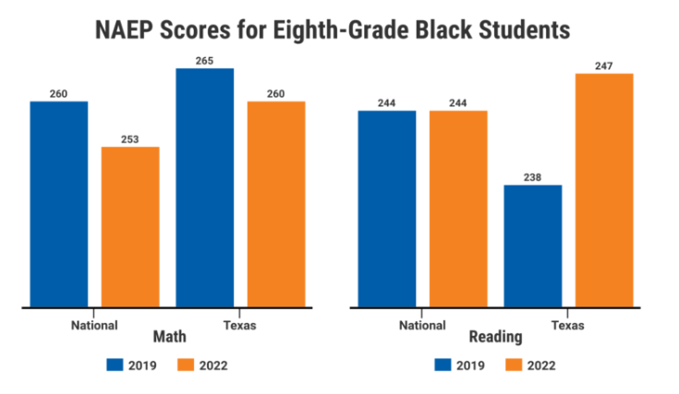
https://www.idra.org/resource-center/naep-scores-reveal-ongoing-inequities-and-new-questions-about-approaches-to-covid-19-learning-recovery/
Key Considerations:
Regional Variations: The graph could be split on a regional basis (Northeast et al.) to know whether the performance varies across each country.
Urban vs. Rural: Intentionally, the proportion of students categorized as proficient by location can be contrasted by comparing proficiency scores of specific urban and rural areas.
Socio-economic Factors: The students' socio-economic status could also be added as an overlay on the graph to compare the effects on the reading achievements of students from different income levels more directly.
CSLHM Application:
The trends represented in the graph above are of overall NAEP reading proficiency, but certain built-in biases may be further examined. We can accommodate the Critical Statistical Literacy Habits of Mind through sampling, geographical origin, distribution, or economic status while making sense of the presented data.
Graph 2: Absenteeism Trends (2019-2023)
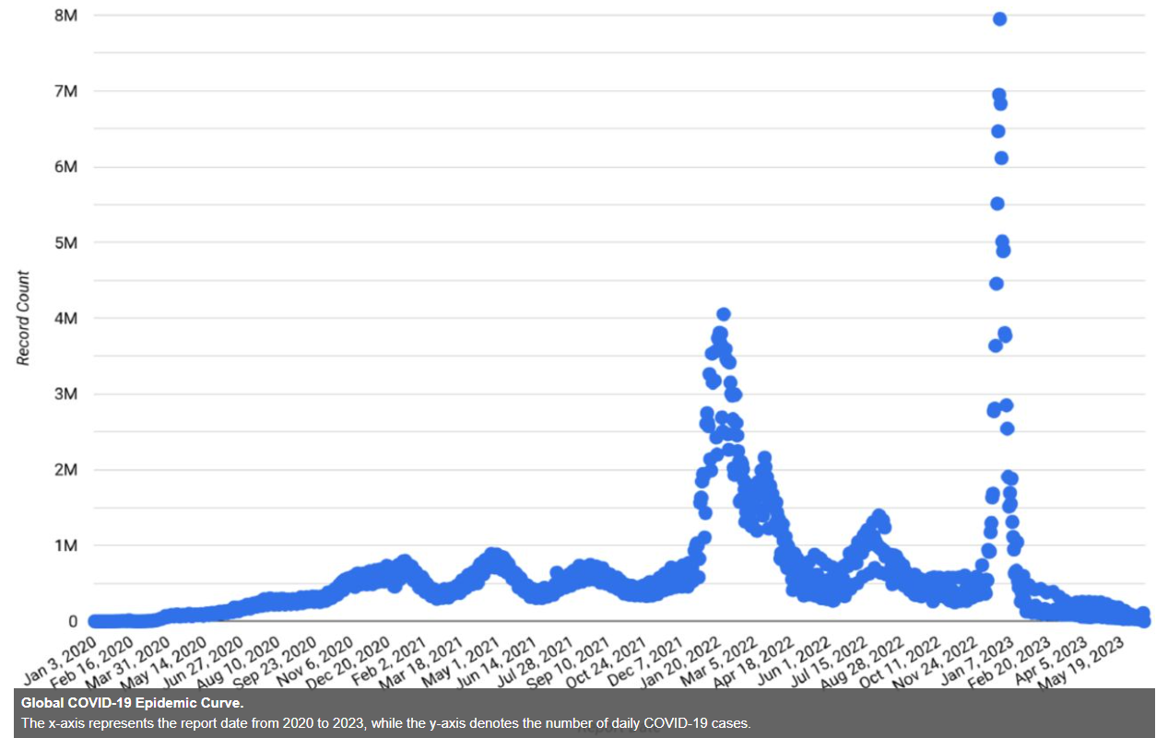

https://doi.org/10.1101/2023.08.16.23294160
Key Considerations:
COVID-19 Impact: This should be observed more easily on the graph to show that the pandemic influenced the rise in cases of absenteeism attained at the correct time (Bansilan & Rabajante, 2023).
Data Definition: The best form of absenteeism should be clearly stated, whether it involves virtual or physical absence.
Contextual Factors: The graph could further complement other factors, including school shutdowns, online learning instructions, and poverty-level shifts.
CSLHM Application:
The graph is appropriate, especially in showing the trends of the Absenteeism rates, but there is a need to analyze the information presented in the graph carefully. By considering the impact of the COVID-19 pandemic and the potential limitations of the data definition, we can apply the Critical Statistical Literacy Habits of Mind to gain a more nuanced understanding of the trends.
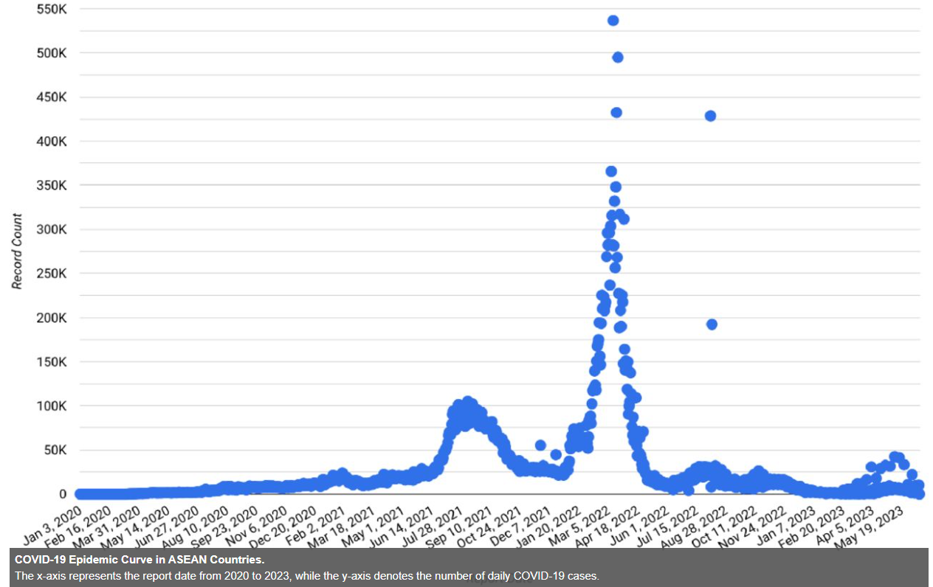
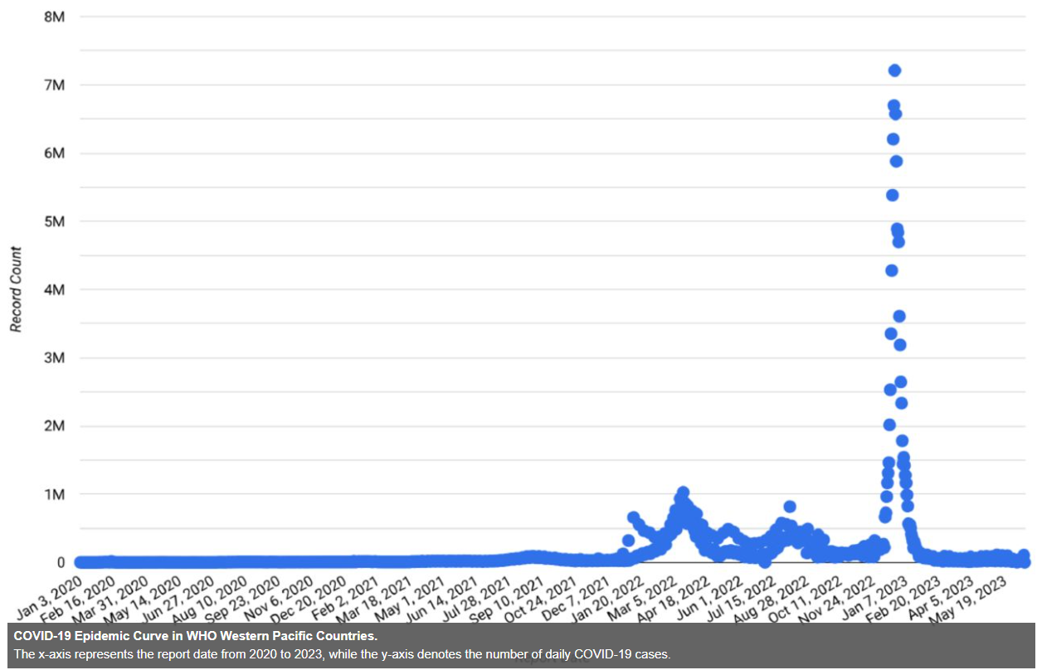
Graph3: Analyzing the Teacher "Leaver" Rates Over Time Graph

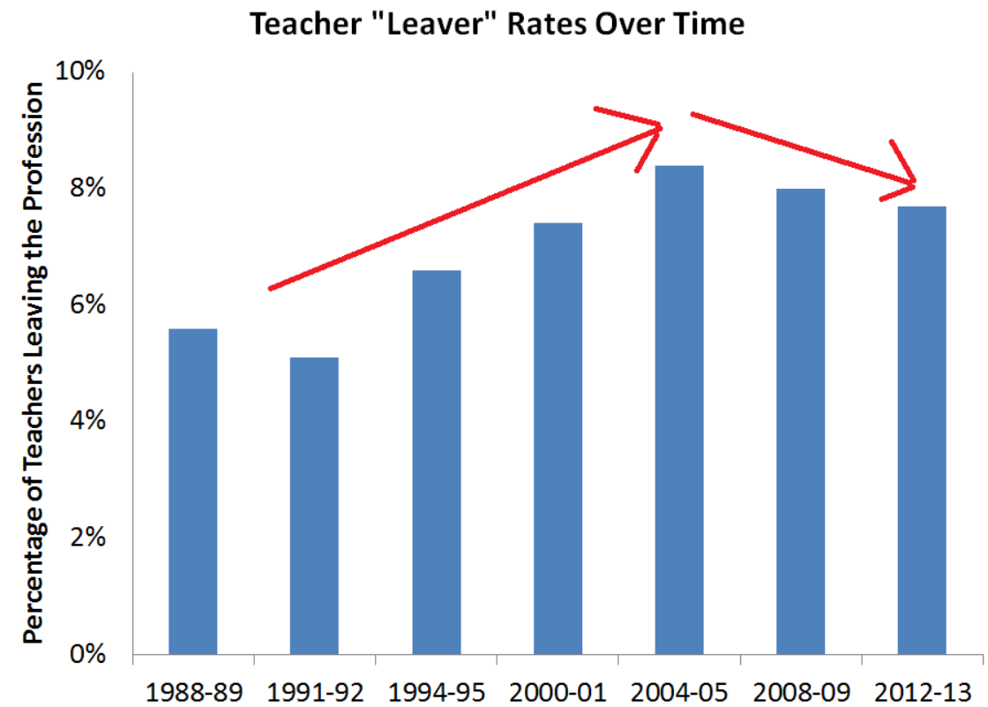
https://www.economist.com/
CSLHM Applied: Outcomes: Looking at the numbers, analytical reasoning, and considering origins and the author's perspective.
Key Observations:
• Overall Trend: An ascending trend of teacher 'leaver' rates over the period is evident from the graph. However, an increase was observed around 2004-05, and a significant surge was detected in 2008-09.
• Recent Decline: As for the leaver rates, there is a tendency for a slight decrease from 2008-09 to 2012-13, although whether this is a developing trend remains uncertain.

Part III : Analyzing a News Article: "The End of the World Is Not Coming"
Source: The Economist (Ad et al.: Center-Left, Reliable)
CSLHM Framework Analysis:
1. Examining the Statistics:
Data Source: The article uses data from several sources and bases its arguments on information from such a global organization as IPCC, the Intergovernmental Panel on Climate Change.
Data Interpretation: This paper offers a virtue epistemology examination of climate change data as containing risks and opportunities for adaptation and mitigation.
Questioning the Data: The article also notes the risks of climatic modeling and the difficulties of determining future scenarios.
2. Data Interpretation:
Framing: According to The Economist - News at Your Fingertips (2024), lots of information is provided in the article, and its tone is not alarmist, although it explains that climate change means real dangers.
Nuance: The article is aware of the multilayered nature of climate change, embracing all the challenges and opportunities to solve the problem.
Counter Arguments: The article briefly responds to such arguments as climate change is natural; however, the author proceeds to argue against such theories.
3. Considering the Source and Evaluating the Author's Lens:
Reliability: A two-week subscription to the printed version of The Economist will maximize the flow of up-to-date, objective, and credible information.
Author's Lens: Oliver Morton is a writer for numerous science and nature magazines with an appreciation for environmental science. His perception may be anchored on his experience and practice in the field.
4. Comparing Different Perspectives:
Alternative Views: The article could have been more informative had the author interviewed more subjectively and got answers from climate change deniers or more extreme opinionated people.
Balanced Approach: The author does a pretty good job of providing a frame that is aware of the ideology at work here that could be positively and negatively skewed towards and against climate change.

References
Bansilan, N. P., & Rabajante, J. F. (2023). Unraveling COVID-19: Descriptive analytics in a Middle-Income country, paving the path forward. medRxiv (Cold Spring Harbor Laboratory). https://doi.org/10.1101/2023.08.16.23294160
Kearns, M. (2024, September 19). Inside America’s Education Revolution. Plus. . . https://www.thefp.com/. https://www.thefp.com/p/inside-americas-education-revolution
NAEP Scores Reveal Ongoing Inequities and New Questions about Approaches to COVID-19 Learning Recovery - IDRA. (2022, December 15). IDRA. https://www.idra.org/resource-center/naep-scores-reveal-ongoing-inequities-and-new-questions-about-approaches-to-covid-19-learning-recovery/
Teacher turnover rates are down, not up. (2016, May 5). TeacherPensions.org. https://www.teacherpensions.org/blog/teacher-turnover-rates-are-down-not
The Economist - news at your fingertips. (2024, October 10). The Economist. https://www.economist.com/

