Project II-Graphical and Numerical Summaries of Data

Duy Hoang
Montclair State University
Stat 230
Professor’s Name
October 17, 2024

Project II-Graphical and Numerical Summaries of Data
Part I
The Fortune Global 500, also known as the Global 500, is an annual ranking of the top 500 corporations worldwide as measured by revenue. In total, the Global 500 generated $31.2 trillion in revenues in 2014. Fortune Global Data.xlsx on Canvas provides a list of the 30 companies with the highest revenues (in billions of dollars) in 2014.
- Generate a histogram in StatCrunch, and estimate its shape and center
Figure 1 shows the histogram generated from the Fortune Global 500, 30 companies with the highest revenues in billions of dollars in 2014. The shape of the histogram will be right-skewed because we have only a few companies with higher revenues than the rest of the companies. In this case, by observing the peak of the histogram, the center is estimated at around $200 billion.
Figure 1
Histogram
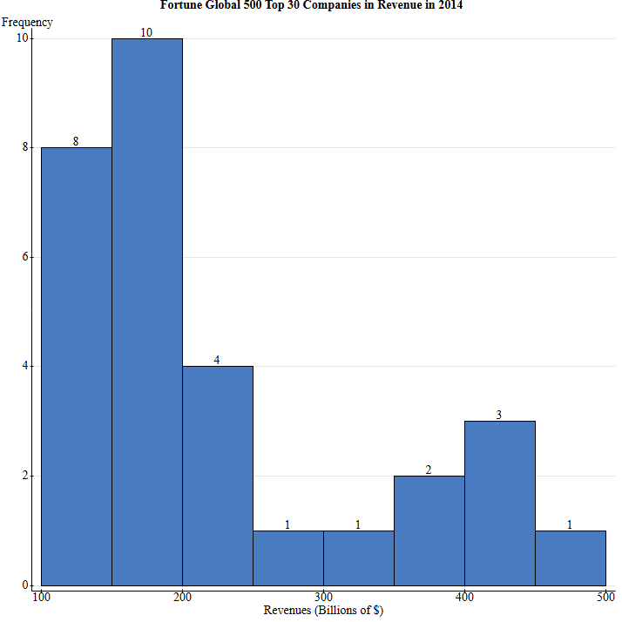
- Which measures of center and variability would be appropriate for this distribution? Why?
Appropriate measure of center: Median.
Appropriate measure of variability: Interquartile range (IQR).
It is evident that the histogram depicts a skewed distribution. The median is appropriate for this distribution because the mean is not always in the middle of the distribution. The interquartile range is the appropriate measure of variability as it always reduces the impact of outliers in a dataset.
- Generate Summary Stats in StatCrunch, what is the true typical value (a measure of center)? How close were you with your estimation?
Table 1 shows the summary statistics in StatCrunch for the Fortune Global 500, 30 companies with the highest revenue in billions of dollars in 2014. The true typical value (median) was $182 billion and the estimated value was $200 billion. The estimation is depicted to be quite close. The true median value is lower than the estimated value, but it is still within a reasonable range.
Table 1
Summary Statistics
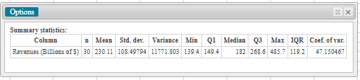

Part II
The National Health and Nutrition Examination Survey (NHANES) is a unique survey that combines interviews and physical examinations. It includes basic demographic information; questions about topics such as diet, physical activity, and prescription medications; as well as the results of a physical examination measuring a variety of variables, including blood pressure and cholesterol levels. The program began in the early 1960s, and the survey currently examines a nationally representative sample of about 5000 persons each year. You will work with the total cholesterol measurements (mg/dL) obtained from participants in the survey in 2009–2010. To examine changes in cholesterol with age, we consider only the 3044 participants between 20 and 50 years of age and have classified them into the three age categories 20s, 30s, and 40s. Please find Cholesterol Data.xlsx on Canvas.
- Generate the most appropriate graph for comparison between different age groups. You can generate several graphs and see which one gives you a better representation of your data. Hint: I’d go with one that starts with B- and ends with -oxplot.
The most appropriate graph for comparison between different age groups is the Boxplot. Figure 2 depicts boxplots for Cholesterol levels between different age categories.
Figure 2
Boxplots
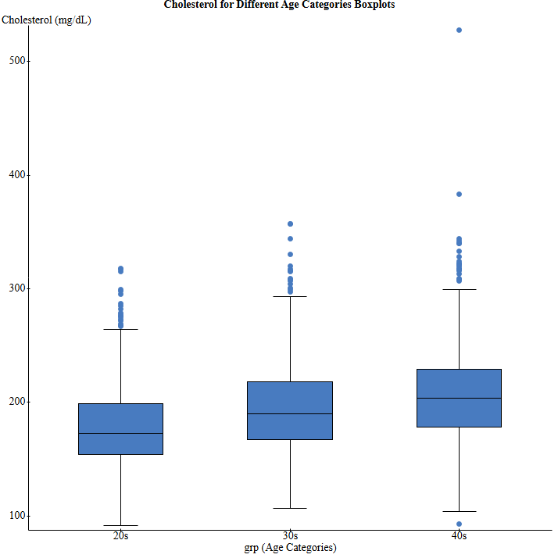
- Comment on shapes and outliers. How can you spot outliers?
The boxplots depict the distribution of cholesterol levels within each age group. In the age group 20s, the lower limit is 92, Quartile 1 is 154, the median is 173, Quartile 3 is 199, IQR is 45, and the upper limit is 264. There are 18 outliers and the furthest outlier is 318 mg/dL. In the age group 30s, the lower limit is 107, Quartile 1 is 167, the median is 190, Quartile 3 is 218, IQR is 51, and the upper limit is 293. There are 15 outliers and the furthest outlier is 357 mg/dL. In the age group 40s, the lower limit is 104, Quartile 1 is 178, the median is 204, Quartile 3 is 229, IQR is 51, and the upper limit is 299. There are 22 outliers and the lowest outlier is 93 mg/dL and the highest outlier is 528 mg/dL. The outliers are spotted as points outside the whiskers of the boxplots. These points are higher than the rest of the data for the 20s and 30s and are significantly higher than the rest for the 40s with one point lower than the rest of the points in the 40s. In this case, the median cholesterol levels for the 40s age group are greater than the levels for 30s which is also greater than the cholesterol levels for 20s.
- The ideal range of total cholesterol is below 200 mg/dL. For individuals with elevated cholesterol levels, prescription drugs are often recommended to lower levels. Among the 3044 participants between 20 and 50 years of age, 4 individuals in their 20s, 24 individuals in their 30s, and 117 individuals in their 40s were taking prescription medications to reduce their cholesterol levels. How do you think your comparison of the distribution would be changed if none of the individuals were taking medication? Explain.
If none of the individuals were involved in taking the medication, the distribution of the cholesterol levels would shift upwards, especially in the case of the 30s and 40s age group. This will be the case because of higher cholesterol levels, increased variability, and more outliers. Without medication, the individuals with higher levels of cholesterol will have extremely higher levels and thus increase the overall median of the cholesterol levels. The spread of data would also increase resulting in a larger interquartile range and more outliers. Since medication helps keep cholesterol levels within a healthier range, a lack of medication would result in more high-value outliers.

Part III
Construct boxplots for the full IQ scores (IQF) for the low lead level group (group 1) and the high lead level group (group 3) in the Data Set “IQ and Lead.xlsx” on Canvas. The low lead level group consists of children with low levels of lead in their blood, and the high lead level group consists of children with high levels of lead in their blood. What do the boxplots suggest about the effect of exposure to lead?
Figure 3 shows the boxplots for full IQ scores for the low lead level group (group 1) and high lead level group (group 3). For group 1, the lower limit is 70, the Quartile 1 is 85, the median is 94, the Quartile 3 is 101, the IQR is 16, and the Upper limit is 125. Group 3’s lower limit is 75, Quartile 1 is 80, the median is 85, Quartile 3 is 93, IQR is 13, and the upper limit is 104. The median full IQ score is lower for Group 3 (high lead level group) compared to Group 1 (low lead level group). This suggests that higher exposure to lead may be associated with lower IQ scores.
Figure 3
Boxplots full IQ scores for Groups 1 and 3

