Project 3 - Regression

Duy Hoang
Montclair State University
Asja Alic
Stat 230_04
12/13/24

Part 1
i.) The regression line indicates a positive and increasing slope. This means that as the x-values grow, the y-values also increase, demonstrating a linear relationship.
ii.) As the avenue number increases, the corresponding street numbers rise as well, which aligns with real-world expectations.
iii.) Using the regression line, I estimated that Broadway would be around 55th Street if it were located between 8th and 9th Avenue. However, Google shows that Broadway is actually between 41st Street and 54th Street, making my prediction slightly higher than its actual location.
iv.) While my prediction was not perfect, it was reasonably close. It was slightly higher than the actual range provided by Google but only off by a small margin, so it wasn't too far off.
v.) The R^2 value for the least squares regression model is reported as 0.99. This indicates that the model accounts for 99% of the variance in the data, showing it is highly accurate.
Part 2
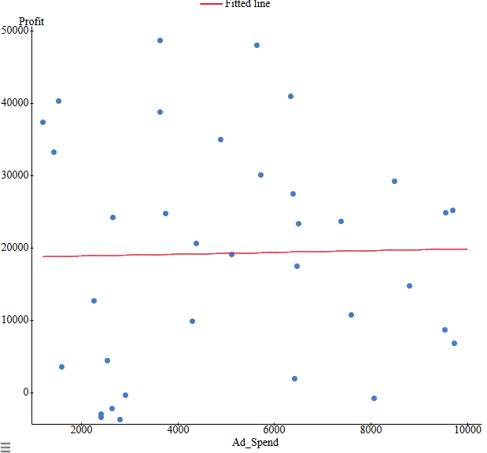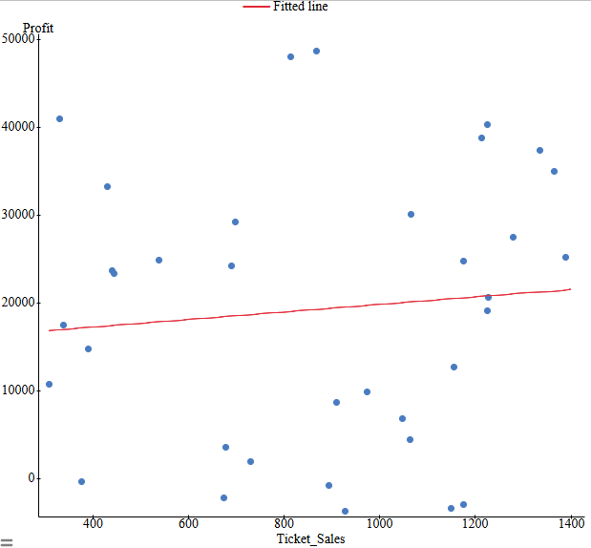
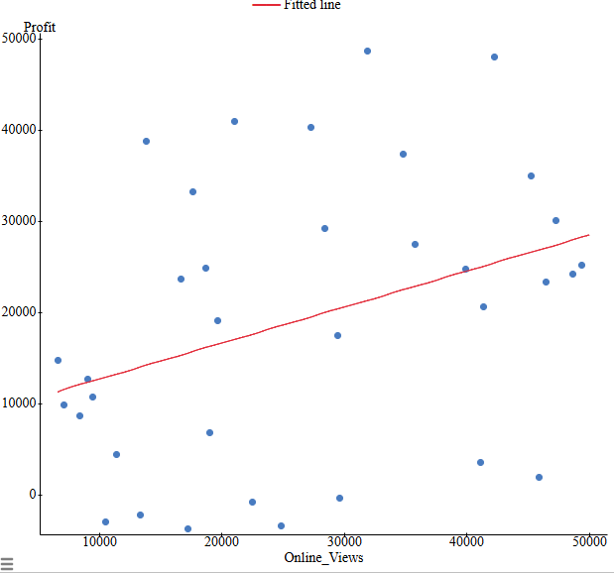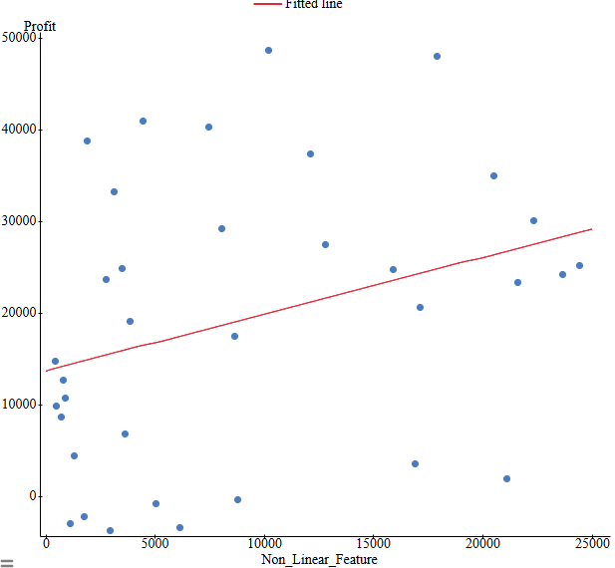
1.)
- Online views appear to have the strongest correlation with profit because the relationship is positive and shows the greatest increase.
- None of the graphs display non-linear behavior; however, the relationship between ad spend and profit is on the verge of becoming non-linear, as it shows a slight upward curve.
- Applying linear regression to non-linear relationships between variables can lead to inaccurate predictions and misinterpretations of the data.
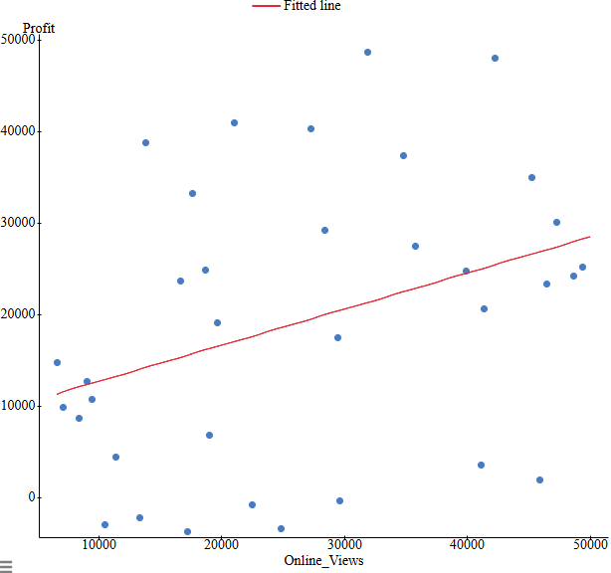
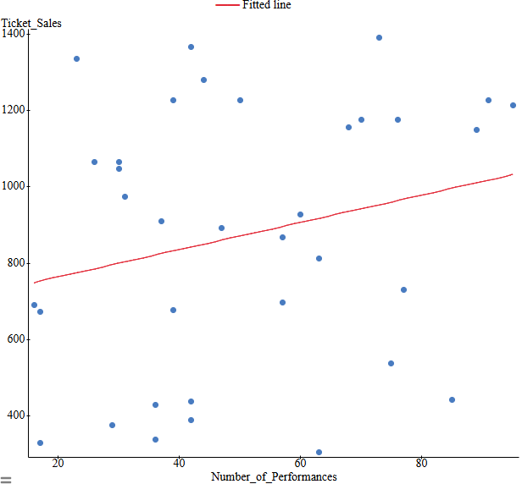
2.)

4.) Both of the graphs I selected show a positive, increasing trend and demonstrate a linear relationship with their respective variables. If the points on a residual plot exhibit a clear pattern, it may indicate that the model is not well-suited for predicting the relationship. Residual plots are also useful for determining if a relationship is linear, which is a key consideration. Using days of the week as a variable would not be appropriate for linear regression because the results would likely be very similar, as this factor does not significantly impact profit or ticket sales.

5.) The R² value for the relationship between Online Views and Profit is 0.1253. Meanwhile, the R² value for the relationship between Number of Performances and Ticket Sales is 0.0548.

6.) For Online Views vs. Profit, 12.53% of the variability in profit is explained by the independent variable. Similarly, for Number of Performances vs. Ticket Sales, only 5.48% of the variability is explained by the independent variable. A low R² value indicates that the model does not account for much of the variation in the data. The variable I analyzed, Online Views, is not a highly effective predictor of profitability, as it explains just 12.53% of the variance.

