Project 5 - Probability

Duy Hoang
Montclair State University
Asja Alic
Stat 230_04
12/13/24

Review of Key Concepts

- The Empirical Rule helps make predictions about data without knowing the exact values, provided the distribution is approximately normal.

  - A z-score indicates how many standard deviations an observation is from the mean and whether it is above or below the mean.
  - Standardized observations above the mean have positive z-scores, while those below the mean have negative z-scores.

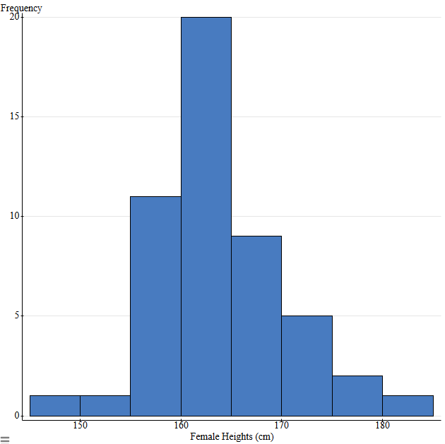
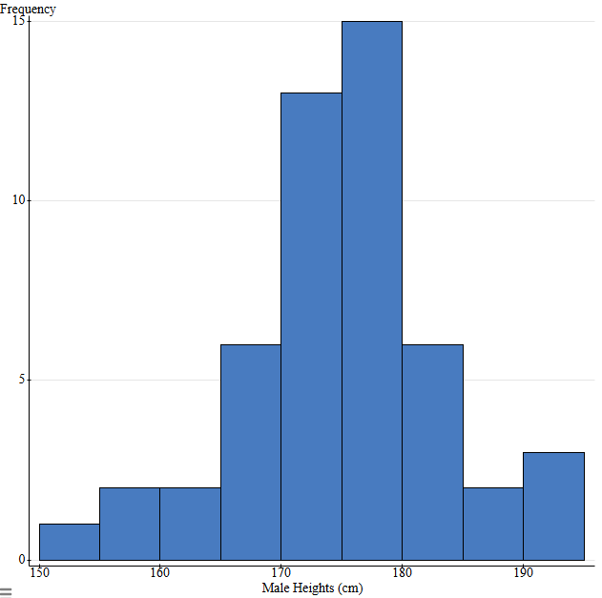
Exploring the Providing Dataset

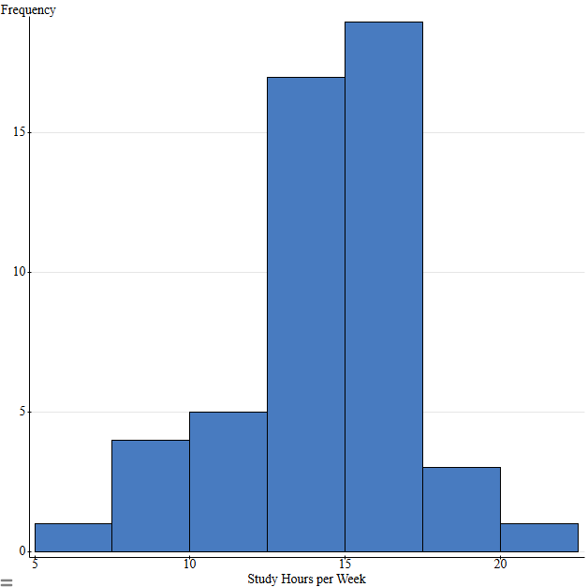
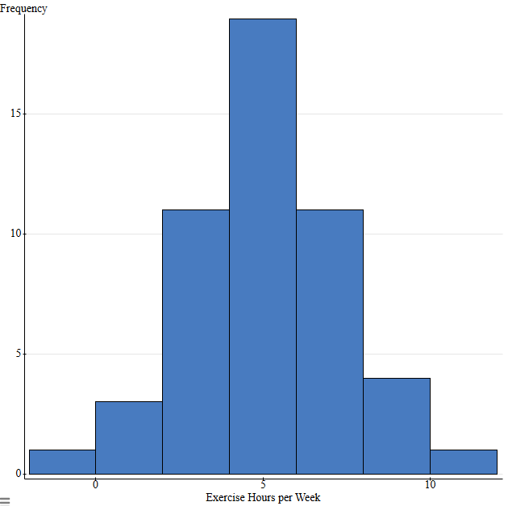

Name | Person 1 | Person 2 | Person 3 | Person 4 | Person 5
Resting Heart Rate(bpm) | 72 | 64 | 67 | 68 | 75
Height(cm) | 167 | 175 | 170 | 180 | 170
Social Media  Usage(hrs/day) | 2.5 | 1.5 | 4 | 3 | 1
Study Hours per Week | 15 | 20 | 10 | 18 | 25
Exercise Hours per Week | 4 | 6 | 2 | 5 | 3

Name | Person 1 (z-score) | Person 2 (z-score) | Person 3 (z-score) | Person 4 (z-score) | Person 5 (z-score)
Resting Heart Rate(bpm) | 0.426513902 | -0.711615256 | -0.28481682 | -0.14255067 | 0.853312337
Height(cm) | -0.97361095 | -0.00604727 | -0.61077457 | 0.598680030 | -0.61077457
Social Media  Usage(hrs/day) | -0.31796291 | -1.37783928 | 1.271851643 | 0.211975273 | -1.90777746
Study Hours per Week | 0.239284212 | 1.988437814 | -1.50986938 | 1.288776374 | 3.737591416
Exercise Hours per Week | -0.43937205 | 0.430671614 | -1.30941571 | -0.00435021 | -0.87439388

3.) Most of the data I collected falls within the expected distribution. However, Person 5's study hours per week exceed 3 standard deviations from the mean, indicating an outlier. Overall, the data I collected was fairly average, with most values being quite similar. The most surprising result was Person 5's z-score for study hours, as it stood out significantly, while the other z-scores were typical and unremarkable.

