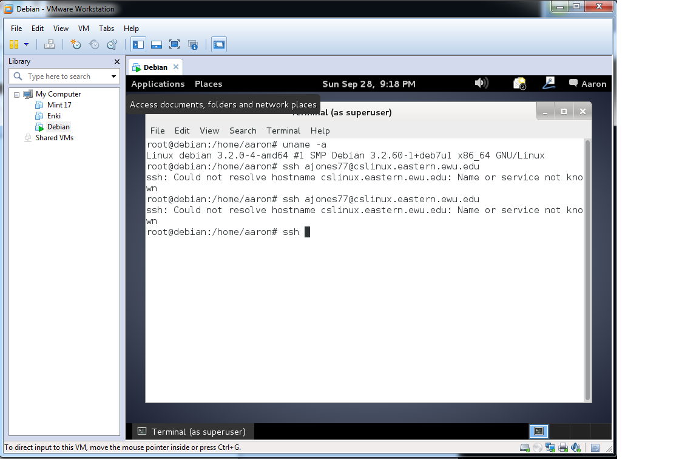

Demonstrates the Debian Virtual machine works while running the command uname -a in the root terminal.