CSCD 240 Homework 1

Problem Description
1, By following the instructions provided in the lecture notes, you are required to install Virtual Box and set up a virtual machine (instance of Debian 6 or 7) on your host computer.
2, After successfully setup your virtual machine, start the Debian virtual machine and login. Please provide a screen shot for this step to prove you have successfully installed the virtual machine and it works properly.
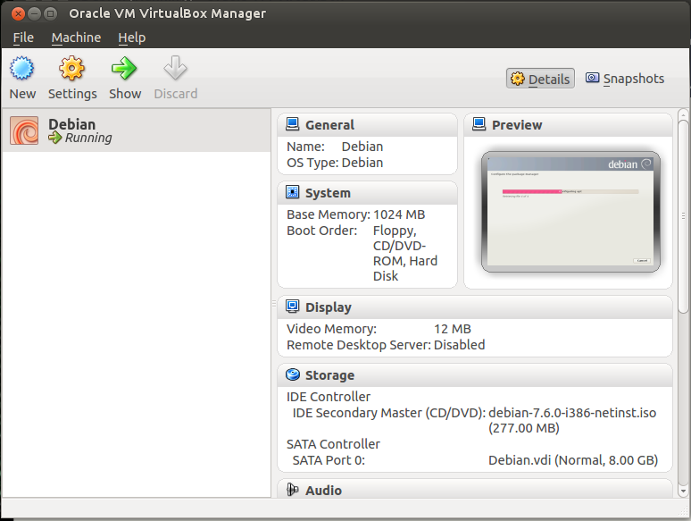

3, After you log in the virtual machine, click the menu on the top left corner, Applications→ Accessories→Terminal, which causes a terminal window to open up. Type the command uname –a in this terminal window then press Enter Key. Please provide a screen shot for this step to prove you have successfully typed in the command and executed it. Make sure the screen shot includes the result that the command uname –a returns.
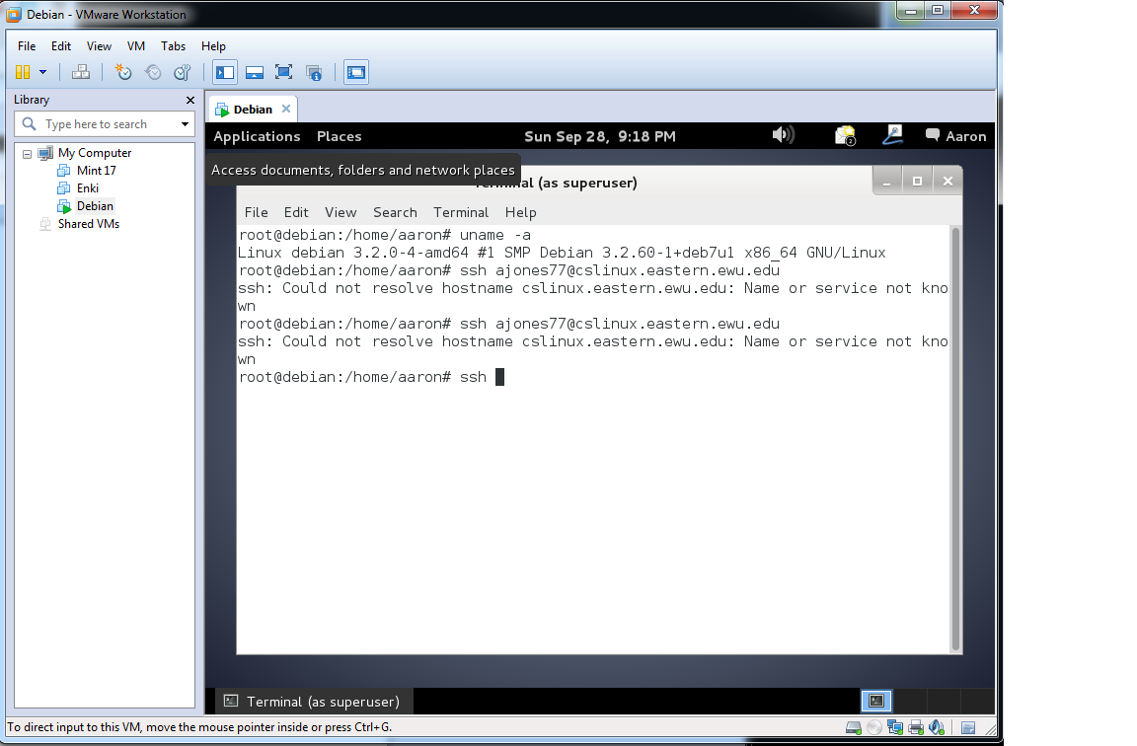

4, By following the instructions provided in the lecture notes, you are required to install anyConnect on your own computer in order to access VPN facilities. Please provide a screen shot for this step to prove you have successfully installed anyConnect and it connects properly.

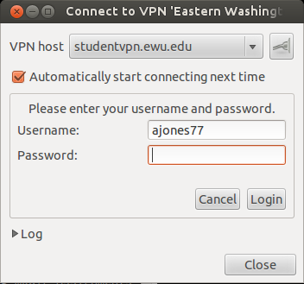

5, By following the instructions provided in the lecture notes, you are required to install WinSCP(with putty.exe, putty can be downloaded on the same page as WinSCP) on your own computer in order to access cslinux machine. Please provide a screen shot for this step to prove you have successfully installed WinSCP and it can connect to cslinux properly. (Start the installed anyConnect and connect first before you connect to cslinux if you are off campus.) If you are Mac user, you can skip this step.
6, Open a putty terminal window through WinSCP interface, remote log in cslinux.eastern.ewu.edu. Type the command uname –a in this terminal window then press Enter Key. Please provide a screen shot for this step to prove you have successfully opened the putty terminal window, and typed in the command and executed it. Make sure the screen shot includes the result that the command uname –a returns. ( Note it must be a putty terminal window. ) If you are Mac user, please show me the command you used in your terminal to remote login. After login, please provide result of the command of uname –a.

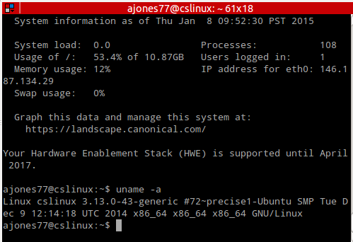

TO TURN IN:

- Copy your screen shot (images) into a word text file, on top of the each image in that word file, please specify the question number and provide information about what the image is for. I want the question copied and then the answer to the question below it.
- Convert your word file into a PDF file - Name this pdf file your last name plus first letter of your first name plus hw1.pdf. This file will contain all your answers. E.g. smithwhw1.pdf for Will Smith.
- A zip file that contains your pdf file.
- You should turn in through the EWU Canvas system. Go to EWU Canvas 2014 CSCD240-01 → Assignments → hw1 → Submit Assignment, then you can choose your zip file to upload.

You zip will be named your last name + first letter of your first name + hw1.zip (example smithjhw1.zip for John Smith)

