CSCD 240
Lab 4

Note: You have to complete this lab by ssh login into cslinux.eastern.ewu.edu.
Turn in on Canvas→Assignments→Lab4
In question 1 through 6, you should capture the prompt, the command, and the output from the command.
- What is the difference between a shell variable and an environment variable in the bash shell?

The difference between a shell variable and an environment variable in the bash shell is that a shell variable is a local variable valid in the current shell while an environment variable is valid systemwide.

- Define what a process is and what a job is, clearly explain how jobs differ from processes.

A process is any program running with it's own address space, while a job is a program within the shell that you interact with and doesn't detach.

- Consider the following command ls – al | less.

  - How many processes are created with that command?
Two
  - What exactly does “|” do in this command?
The “|” is called a pipe in which it connects the standard output of one command with the standard input of another.

- Using the man page for ps
  - Issue and capture the ps command with the appropriate options to allow listing of all processes in the system.
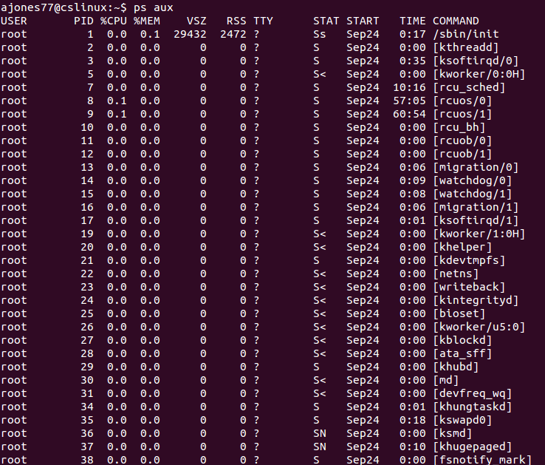
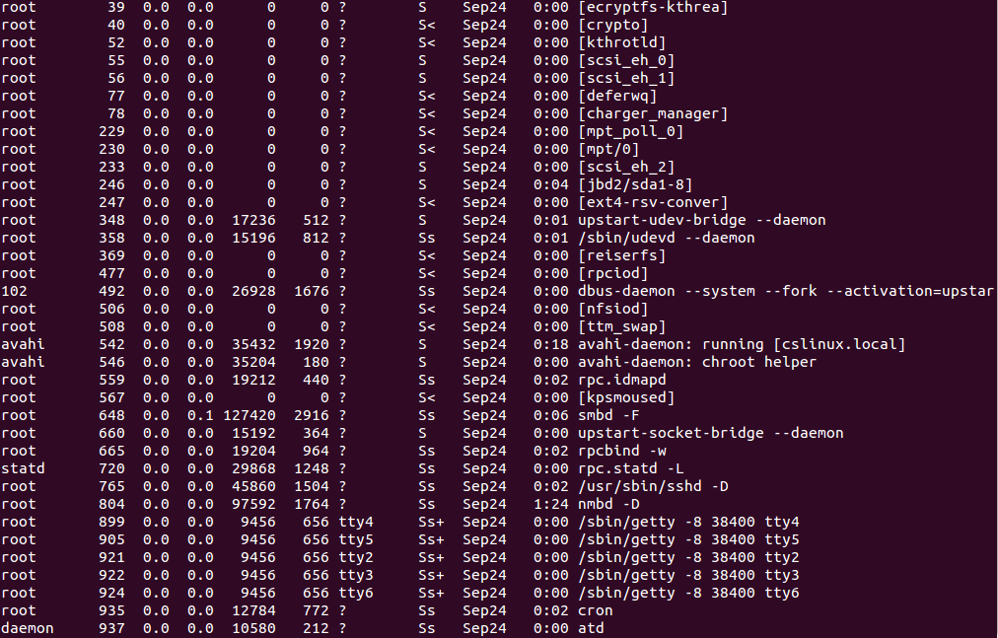
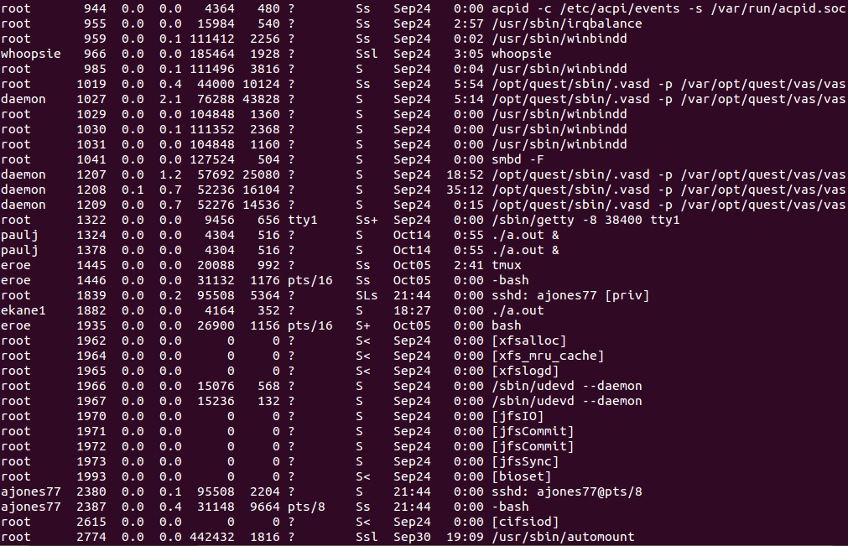
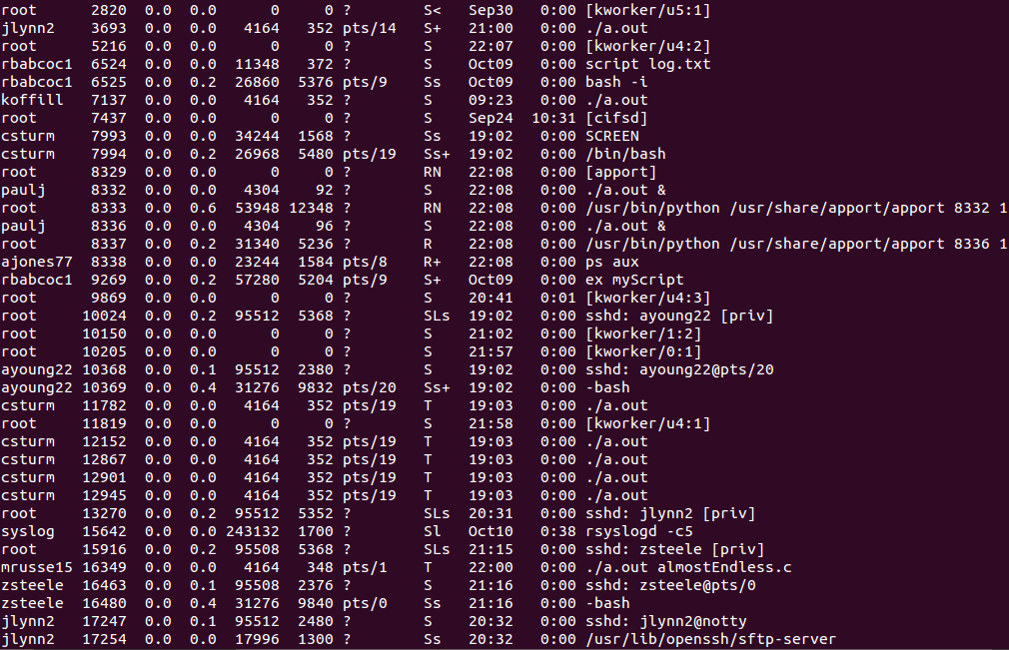
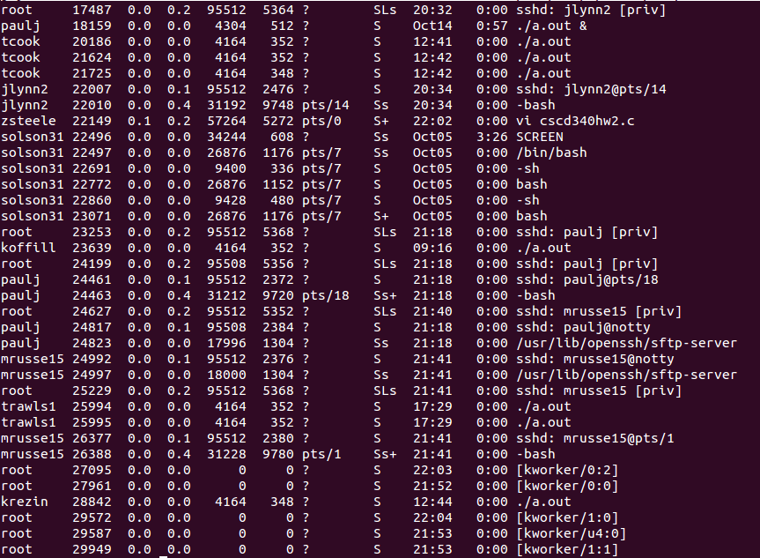
  - Using the output from part A, what was the first process started and by whom was it started?
The first command was issued by root with the PID of 1, the command being /sbin/init/.
  - What was the first non-root process that was started?
The first non-root process was dbus-daemon --system --fork –activation=upstart by 102.
  - What was the last process started and by whom?
The last process was started by root, running the command kworker.
- Using a text editor create the following C programmed named almostEndless.c
#include <stdio.h>

int main()
{

int x = 0;
while(x < 20000000)
{
printf("..");
fflush(stdout);
sleep(3);
x ++;
}// end while

return 0;
}// end main

  - Compile your program with gcc almostEndless.c
  - Start your program with ./a.out
  - With your program running, describe the commands you would use (without using ctrl-c) to terminate that program, from the same terminal window in which it was started.

I would use ctrl+z to suspend the program, then us ps -u myUsername to find out what the PID is and then use that PID with the kill command with the option -9 to terminate the program.

  - Execute and capture the commands, using process notation (PID), to terminate a.out
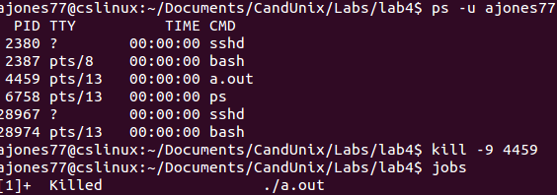
  - Restart your program with ./a.out
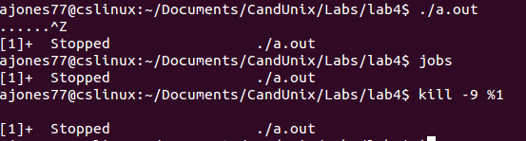
  - Execute and capture the commands, using job notation (job ID), to terminate a.out

- In a single terminal window capture the command to start a.out 3 times each running as background jobs: (Hint: redirection is useful here)
  - What are the job numbers of the above?
5, 6, 7
  - What are the process ID numbers of the above?
2320, 2321, 2322
  - Capture the command and output to bring the second a.out to the foreground.
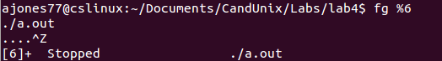
  - Capture the command(s) to send a.out back to the background.
  - Capture the command(s) to kill the third a.out using its job number.
  - Capture the command(s) to kill the first a.out using its process number.
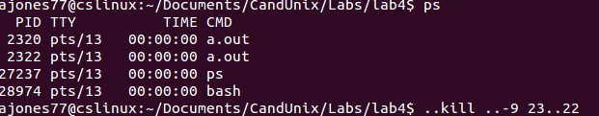
  - Can CTRL C be used to kill any job? Why or why not? Clearly explain why or why not.
CTRL + C cannot be used to kill any job because they are running in the background.

