CSCD 240
Lab 3
Requirements: all answers are to be produced by using ssh to login to cslinux.eastern.ewu.edu to complete this assignment. In all cases you should capture the prompt, the command, and the output from the command.
- Clearly explain the difference between which, grep, and find.

- Issue the find command looking for the file named ld starting at the root directory.
  - Assuming you are not logged in as root, you should get a list of errors as well as where the file was found. Capture the output and include it in your submission – you do not need to include all the permission errors just a few to get the idea but do include where the file was found.
  - Repeat the command (again not as root) – illustrating a method of eliminating the error messages and printing only what was found.

- Find all files (not folders) in your home directory and its subdirectories, with size greater than 100 bytes.
- In class we talked about the '–name' option for the find command.
  - Explain how to use the size option.
  - Issue and capture the results of the find command in your home directory that display all files that are greater than 1K. Do not display error messages.
  - Explain this command: find . -name "*.txt" -exec wc -l {} ‘;’
  - Explain this command: find . -name "*.txt" -exec rm {} ‘;’

- Use a text editor on the remote machine to create a file named frost.poem that contains the following text:
The Road Not Taken by Robert Frost
Two roads diverged in a yellow wood,
And sorry I could not travel both
and be one traveler, long I stood
And looked down one as far as I could
To where it bent in the undergrowth;

Then took the other, as just as fair,
And having perhaps the better claim
Because it was grassy and wanted wear,
Though as for that the passing there
Had worn them really about the same,

  - Use the grep command, capture both the command and the output, to finds all lines, including the line number, that end with a comma.
  - Use the grep command, capture both the command and the output, to finds all lines, including the line number, containing the word as.
  - Use the grep command, capture both the command and the output, to finds all lines, including the line number that starts with the word and (case DOES NOT matter).
  - Use the grep command, capture both the command and the output, to finds all lines, including the line number that starts with the word and (case DOES matter).

- Capture, creating a directory named lab3.
  - Capture placing a copy of frost.poem in the directory lab3. There should be one copy of frost.poem in your home directory and one in lab3.
  - Within your home directory, capture the grep command and its output that will recursively find all instances of the word I (case DOES matter) in all files that end with .poem.

- Using a text editor create a file named myScript that contains the following:
#!/bin/bash
string=”Hello World”
echo $string
  - Try to execute the script with ./myScript and capture the output.
  - Execute and capture the command that will change the permissions on myScript to be user executable without changing any other permissions.
  - Execute the script with ./myScript and capture the output.
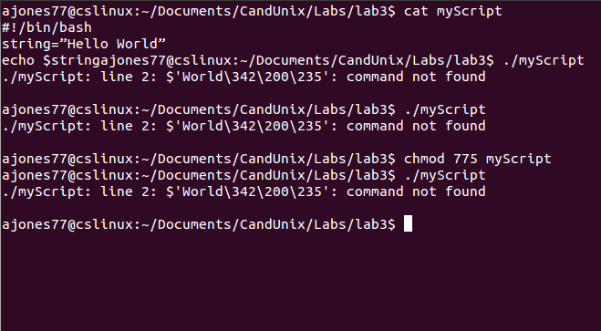
- Using the man page for env
  - Describe (in your own words not with captures from the man page) the output of env command with no arguments.
  - Describe the similarities and differences of printenv and env
  - Capture a command other than pwd that will show your current working directory.

- Capture the output of printenv in a file named penvout.txt.

- Capture the output of env in a file named envout.txt

- Capture the diff command, ignoring case and white space, on envout.txt and penvout.txt.

- What is a shell variable and what is an environment variable in the bash shell?

- In the lab3 directory create the C file named lab3.c with the following code.

#include <stdio.h>
int main()
{
printf(“Hello World\n”);
return 0;
}// end main

- Give the grep command that will start in your home directory and show the file names and line numbers containing the term “stdio” in all .c files in the home directory and all directories below the home.

- Consider the following command ls – al | less.
  - What does the command do?
  - How does this command show advantages over ls –al?

- Redirect the output of the command ls –lah ~/.bashrc to a file named details.txt.

- Write a single command that can redirect the output of command ls –l /bin/cp to the existing file details.txt generated in question 16, without overwriting the file.

- Provide a single command that can count how many lines of text are in details.txt created in question 17.

Note All is in the script and it will be attached like last time. Here are pictures of my output running in the terminal of that said script. Question 7 will be addressed seperately from the script. In this document.

TO TURN IN:
- A PDF file - Name this text file your last name, first letter of your first name lab3.pdf. This file will contain all your answers.
- I want the question copied and then the answer to the question below it.
- A zip file that contains your PDF, all files created during this lab ( C files, scripts, etc).
You zip will be named your last name first letter of your first name lab3.zip. Turn in your zip file on Canvas 2014 cscd240→ Assignments→Lab3→submit.



