Potential for Generative AI in the master thesis
Potential options:
Data Augmentation and Synthetic data generation:
- Generate synthetic melanoma images for training
- Create diverse skin tone representations
- Augment rare cases to balance datasets
Report Generation & Clinical Documentation:
- Generate automated diagnostic reports
- Create patient-friendly explanations
- Produce clinical documentation
Interactive Consultation System:
- AI-powered diagnostic assistance
- Multi-modal analysis (image + text)
- Treatment recommendation generation

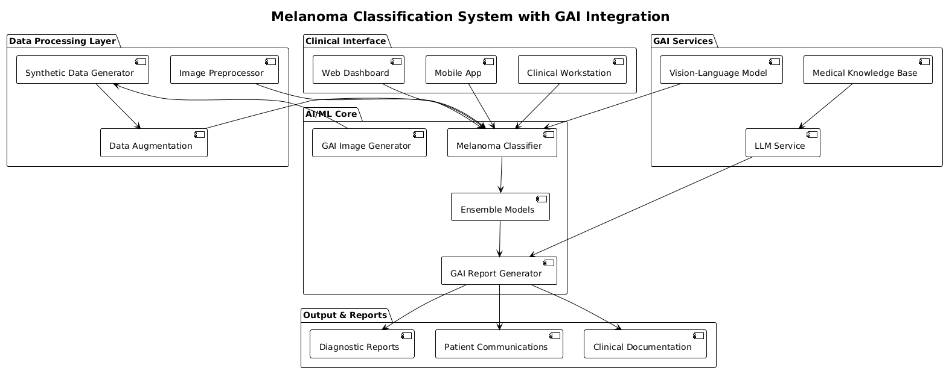

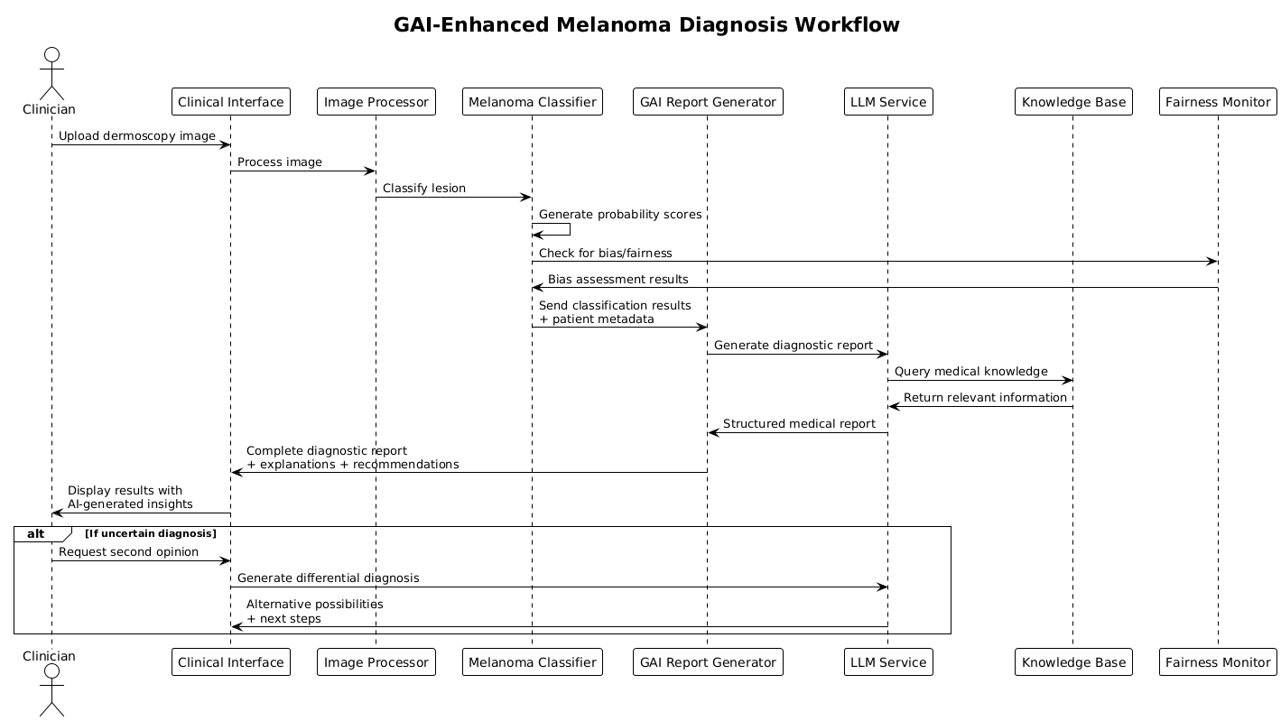

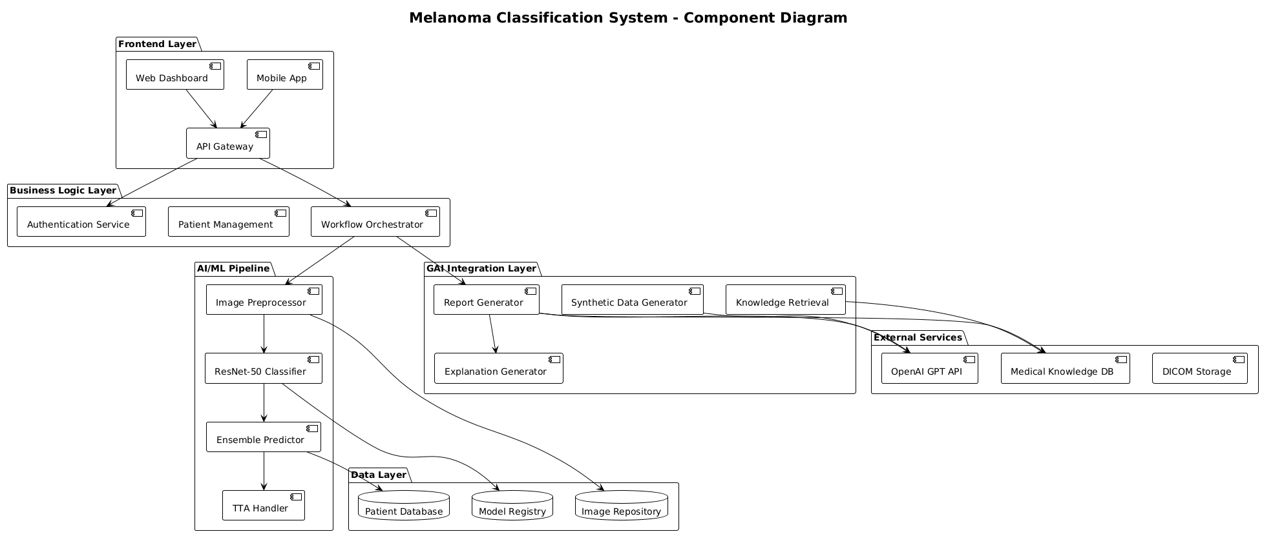

Potential Companies that could be considered:
Healthcare Technology Companies:
- Philips Healthcare – Medical imaging and AI diagnostics
- Siemens Healthineers – Digital health and AI solutions
- GE Healthcare – Medical imaging and AI platforms
AI/ML Healthcare Startups:
- Dermatology-focused AI companies
- Medical AI platforms
- Digital pathology companies
Digital Health Platforms:
- Telemedicine platforms integrating AI diagnostics
- EHR companies adding AI capabilities
- Medical device manufacturers with AI integration
