Revision History

|  |  |  |
| --- | --- | --- |
| Revision Description | Author/Modifier | Date |
| 0.1 - Initial Release (DRAFT) | Jose daVeiga | May 09, 2017 |

# Purpose

This document describes the User Experience and the general application functionality of the Smarter Balanced Braille Transcripts accessibility feature. The intent of this document is to illustrate the flow of the experience for the user and Test Administrator in the process of requesting, accepting, and embossing Braille transcripts created from the Closed Captioning content of listening passages.

# Definition

Students with both visual and hearing impairments may benefit from Braille Transcripts of the Closed Captioning associated with an ELA/literacy listening passage. Smarter Balanced is releasing Braille Transcripts to provide supporting materials to Students who are blind or visually impaired and deaf or hearing impaired. When a Student with the Braille Transcript accommodation requests embossing of a listening passage, the introductory text of the passage is combined with the Closed Captioning transcript content, and a single Braille (BRF) file is provided to the Test Administrator for embossing.

# User and Proctor Experience Workflow

The diagram below depicts the major steps for the Test Administrator as well as the Student in the process of taking a test and requesting the embossing of a transcript:

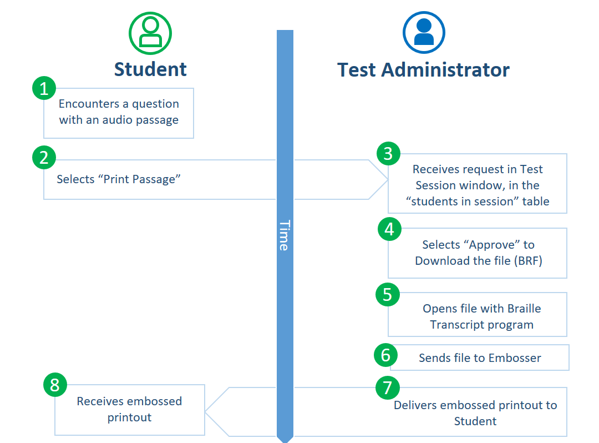

# Student Login and Accessibility & Accommodations Settings

A Student can select one of two options for embossing braille files. Emboss on demand (print on demand) allows the Student to request embossing of each stimulus and/or item as needed. Auto-embossing sends all item embossing requests to the Test Administrator automatically once the Student views a new page of content.

Students must have the following accommodations set in the registration system: Closed Captioning and Braille. Closed Captioning and Braille will allow the student to receive an embossed transcript of the ELA/literacy listening stimuli (Claim 3). The Student may have either Auto-Emboss or Emboss On-Demand selected for delivery of Braille files.

# Braille Transcript Embossing Request - Student Functionality

As the Student takes the summative ELA/literacy assessment, the Interim Comprehensive Assessment, or any Interim Assessment Block with Claim 3 stimuli and items, he/she will encounter a question with an audio passage. At this point, the student selects the Print Passage option to request embossing for that passage.

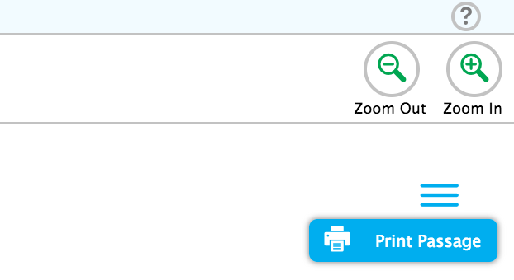

Student requests a passage or item to be embossed by selecting the Hamburgericon and selecting Print Passage as shown in (1) in the picture above.

# Braille Transcript Print Request - Administrator Functionality

When a student with the Braille Transcript accommodation requests embossing of an audio passage, the passage introductory text is combined with the audio transcript content, and a single BRF file is provided to the proctor for embossing:

|  |  |  |
| --- | --- | --- |
| **Standard / Contracted** | **Braille Transcript** | **Filename Example** |
| EBAE / Contracted | YES | passage_3726_enu_ecl_combined.brf |

The following is a description of the Test Administrator flow in the process of approving and embossing a Braille Transcript request from a student. The example describes the functionality in the Smarter Balanced Open Source Test Delivery System when using the sample test file provided at smarterapp.org under the Braille Transcript Implementation Readiness topic. However, other systems should follow this general ~~patter~~ pattern of use and functionality.

## Test Administrator: Approves Emboss Request

The approval process requires the Test Administrator to be already logged in to the Test Delivery System as a Test Administrator. To initiate the approval procedure, the Test Administrator should go to the proctor browser window or tab to download the braille file for embossing as follows:

1. Look for the orange highlighted Requests column and click the Print button.

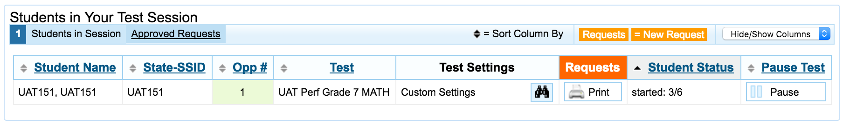

1. If the request is from a student who has the Braille Transcript accommodation enabled, the Test Administrator will see a request which says “Passage **and Transcript** for Items X (BRF).”



1. The Test Administrator should select the Approve button to download the Braille file.
2. The Test Administrator should be able to open the file with a braille transcription program and emboss it using the recommended braille embosser.

# Technical Specifications

The Braille Transcripts functionality is made available based on the individual student settings per ISAAP (Individual Student Assessment Accessibility Profile) guidelines. This feature is only available to the test taker when the settings have been configured in the registration system.

For information regarding the specifications of the item files containing the Braille Transcripts please refer to the following documents on SmarterApp.org:

*SmarterApp Assessment Item Format Specification (SAAIF)*

This document (the Specification) defines an XML document structure for the encoding and representation of assessment items. This Specification only describes the structure of the XML documents for assessment items.

*SmarterApp Item Packaging Specification*

The purpose of this document is to provide an item package specification that is used for Smarter Balanced Assessment Consortium item packages. This specification describes the assessment item file package including all files, dependencies, and folders that are zipped using the standard zip file format.