Smarter Balanced Assessment Consortium

Core Standards User Guide

Published December 31, 2014

Contents

Overview of Core Standards 4

Interrelation between Core Standards and other Smarter Balanced Systems 4

Required Applications 4

Introduction to This User Guide 5

Section I. Accessing Core Standards 6

Logging in to Core Standards 6

Resetting a Forgotten Password 6

Switching Between Smarter Balanced Systems (Single Sign On System) 7

Section II. Understanding the Core Standards Home Screen 8

Section III. Settings Tasks 9

Managing Publishers 9

Adding publishers 9

Editing publishers 10

Deleting publishers 10

Managing Grades 11

Adding grades 11

Editing grades 12

Deleting grades 12

Managing Subjects 13

Adding subjects 13

Editing subjects 14

Deleting subjects 14

Section IV. Publication Tasks 15

Viewing and Downloading a Publication 15

Creating a Publication 16

Appendix A. Common Errors with File Uploads 17

Appendix B. Publication Specifications 18

General Specifications for Preparing Publications 18

Data Entry Specifications by Workbook Tab 19

Publication tab 19

Categories tab 20

Standards tab 21

SOCKs tab 23

Benchmark Grades tab 23

Escape Sequences for Special Characters 24

Validation Rules 25

Appendix C. How Core Standards Generates Publication Numbers 27

Appendix D. User Support 28

List of Figures

Figure 1. Login Screen 6

Figure 2. Password Reset User Validation Screen 6

Figure 3. Core Standards Home Screen 8

Figure 4. Publisher Screen 9

Figure 5. Grade Screen 11

Figure 6. Subject Screen 13

Figure 7. View Publication Screen 15

Figure 8. Copy Existing Publication Screen 16

Figure 9. Format for Publication Numbers 27

Overview of Core Standards

Core Standards serves as a repository of the standards used to design tests. Users of the Test Authoring System can retrieve and review the standards stored in Core Standards, and associate tests with those standards.

The primary use of the Core Standards component is to grant access to the core standards information by way of the Application Programming Interfaces, or APIs. This interface spec (SmarterApp Interface Specification for Core Standards Component) can be found on the smarterapp.org site.

## Interrelation between Core Standards and other Smarter Balanced Systems

Core Standards has connections to the following Smarter Balanced systems:

* **Single Sign On (SSO)**: This system is responsible for user authentication and authorization, and allows you to log in to the Smarter Balanced systems. After logging in, you can switch between administrative systems such as Permissions, Monitoring and Alerting, and Program Management.
* **Test Authoring System**: This system constructs the tests for which students are registered. Test Authoring users associate their tests with the standards stored in Core Standards**.**

## Required Applications

To add publications to Core Standards, you need OpenOffice Calc, a spreadsheet application similar to Microsoft Excel. You can download OpenOffice Calc from <http://www.openoffice.org/>.

Introduction to This User Guide

This user guide provides information about using Core Standards to create and publish standards. This introduction describes the contents of this user guide and includes a key for identifying icons and elements.

This user guide includes the following sections:

* Section I, Accessing Core Standards, explains how to log in to Core Standards.
* Section II, Understanding the Core Standards Home Screen, describes the overall layout of the Core Standards interface.
* Section III, Settings Tasks, explains how to create, edit, and delete publishers, grades, and subjects.
* Section IV, Publication Tasks, describes how to create and publish standards.
* Appendix A, Common Errors with File Uploads, explains how to resolve some common errors that may occur while uploading files in Core Standards.
* Appendix B, Publication Specifications, explains how to construct publications in a spreadsheet format that Core Standards can upload.
* Appendix C, How Core Standards Generates Publication Numbers, describes how Core Standards automatically generates a publication number.

Table 1 describes icons and typographical elements that appear in this user guide.

Table 1. Key Icons and Elements

| Icon | Description |
| --- | --- |
|  | **Warning:** This symbol appears with text that contains extremely important information regarding actions that may cause errors. |
|  | **Caution:** This symbol appears with text that contains important information regarding a task. |
|  | **Note:** This symbol appears next to text that contains helpful information or reminders. |
|  | **Tip:** This symbol accompanies a best practice. |
|  | Text that appears in gray boxes provides instructions relevant to the task described.   * Numbered (ordered) lists provide step-by-step instructions. * Bulleted lists provide instructions that do not need to be done in a specific order. |
| [**Text**] | Text in brackets is used to indicate a link or button that is clickable. |
| Text | Text in bold italics indicates a screen name. |
| Text | Text in italics indicates field names or labels. |
| “Text” | Text in quotation marks indicates the value specified for a field. |

# Accessing Core Standards

This section contains information about logging in to Core Standards, resetting a forgotten password, and switching between other Smarter Balanced systems.

## Logging in to Core Standards

To access Core Standards, you must have an authorized username and password. Your system administrator sets up your user account and provides you with the login credentials.

To log in to Core Standards:

|  |  |
| --- | --- |
| 1. Open your web browser and navigate to Core Standards using the URL provided to you. You will be directed to the Single Sign On Login screen as shown in Figure 1. 2. In the Username field, enter your username. 3. In the Password field, enter your password. 4. Click [**Log In**]. The Core Standards home screen appears. | Figure 1. Login Screen |

## Resetting a Forgotten Password

If you forgot your login password, you can reset it. Figure 2 shows the reset user validation screen.

Figure 2. Password Reset User Validation Screen

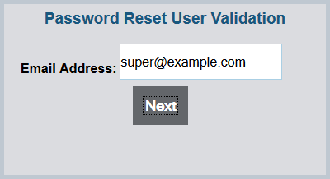

To reset a forgotten password:

|  |
| --- |
| 1. On the Core Standards login screen, click [**Forgot Your Password?**]. The Password Reset User Validation screen appears (see Figure 2). 2. Enter your e-mail address, and click [**Next**]. 3. Enter your answer for the selected security question. You will receive an e-mail containing new, temporary password information. You may log in with the new password and update it. |

## Switching Between Smarter Balanced Systems (Single Sign On System)

Core Standards use an integrated Single Sign On (SSO) system that allows users to log in one time and access the following applications:

* Permissions
* Program Management
* Monitoring and Alerting
* Portal

You can access these applications by typing the URL in your browser’s address field.

Depending on your user role, you may also be able to access other applications, such as the Administration and Registration Tools System and Test Authoring System.

# Understanding the Core Standards Home Screen

The first screen you see after logging in to Core Standards is the home screen (see Figure 3). You can click the task icon for a task to begin working on that task.

Figure 3. Core Standards Home Screen

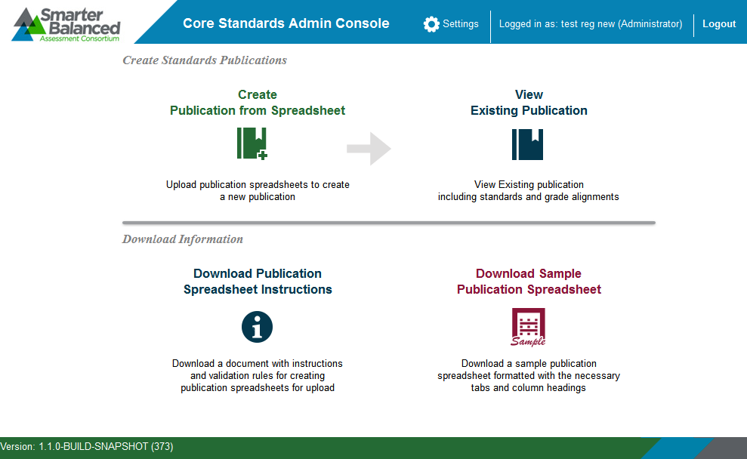

|  |  |
| --- | --- |
|  | **Warning:** Do not have more than one Core Standards browser tab or window open at one time. Changes made in one tab or window may overwrite changes made in another, resulting in loss of data. |

The Core Standards home screen provides brief directions for the workflow. The arrow () symbol indicates precedence: you must complete a task to the left of the symbol before performing the task to the right. For instance, you must create a publication from a spreadsheet before viewing the publication in Core Standards.

The upper-right corner of the home screen displays the following information and links:

* [**Settings**]—Click to add or edit publishers, grades, and subjects. For information about these settings, see Settings Tasks.
* Your user name.
* [**Logout**]—Click to log out of Core Standards.

# Settings Tasks

Each standard stored in Core Standards must be associated with the following items:

* **Publisher**—The organization that publishes the standard. Smarter Balanced is one example of a publisher that operates on behalf of many state-level boards of education. Some states are publishers for their own standards.
* **Grade**—The grades to which the standard applies. Some standards apply to a single grade, and others apply to a grade band, such as 10–11.
* **Subject**—The subject to which the standard applies. Typical examples are English-Language Arts, Mathematics, and Science.

This section describes how to create, edit, and delete these settings.

## Managing Publishers

A publisher is an organization that publishes a standard. This section describes how to add or edit a publisher.

|  |  |
| --- | --- |
|  | **Note:** Referring to Figure 4, a value in the Publisher Key column must appear in the PublisherName column of the Publication tab in the upload file. (For information about creating a publication upload file, see the section Creating a Publication.) |

### Adding publishers

Figure 4. Publisher Screen

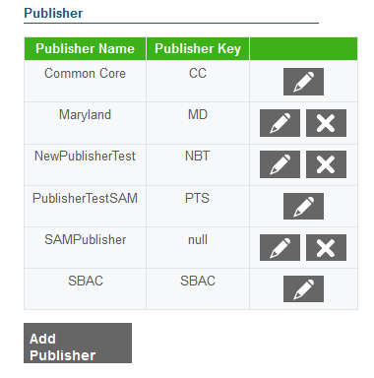

To add publishers:

|  |
| --- |
| 1. From the *Settings* drop-down list in the Core Standards banner, select “Publisher.” The Publisher screen appears (see Figure 4). 2. Click [**Add Publisher**]. The Publisher screen appears. 3. In the Name field, enter the publisher’s full name. 4. In the Key field, enter the publisher’s abbreviation. 5. Do one of the following:    * Click [**Save**] to finish adding publishers and return to the ***Publisher*** screen.    * Click [**Save and Add More**] to add additional publishers. |

### Editing publishers

To edit publishers:

|  |
| --- |
| 1. From the *Settings* drop-down list in the Core Standards banner, select “Publisher.” The Publisher screen appears (see Figure 4). 2. Click [] next to the required publisher. The Edit Publisher screen appears. 3. Update the information as necessary. All fields are editable. 4. Click [**Save**]. |

### Deleting publishers

To delete publishers:

|  |
| --- |
| 1. From the *Settings* drop-down list in the Core Standards banner, select “Publisher.” The Publisher screen appears (see Figure 4). 2. To delete a publisher, click [] next to the required publisher. Verify that the publisher is no longer listed on the screen. |

|  |  |
| --- | --- |
|  | **Note:** Once a publisher is associated with a publication, you cannot delete it. |

## Managing Grades

Publications are associated with a grade or range of grades. Item Authoring and Test Authoring allow designers to design tests for grades that appear in a Core Standards publication. For example, if a designer is creating a test for ELA against publication SBAC‑ELA‑v1, and that publication pertains only to grades 9–12, then Test Authoring allows the designer to design tests only for grades 9–12.

|  |  |
| --- | --- |
|  | **Note:** Referring to Figure 5, a value in the Grade Name column must appear in the Grade column of the Benchmark Grades tab in the upload file. (For information about creating a publication upload file, see the section Creating a Publication.) |

### Adding grades

Figure 5. Grade Screen

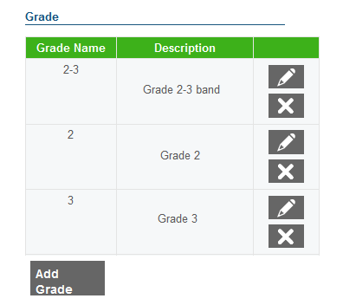

To add grades:

|  |
| --- |
| 1. From the *Settings* drop-down list in the Core Standards banner, select “Grade.” The Grade screen appears (see Figure 5). 2. Click [**Add Grade**]. The Grade screen appears. 3. In the Name field, enter the grade or grade band.    * If you specify a grade band, you must also add an individual grade for each grade in the band. For example, if you specify grade band 2–3, also add individual grades 2 and 3 to the table as in Figure 5. 4. In the Description field, enter a descriptive name for the grade. 5. Do one of the following:    * Click [**Save**] to finish adding grades and return to the ***Grade*** screen.    * Click [**Save and Add More**] to add additional grades. |

### Editing grades

To edit grades:

|  |
| --- |
| 1. From the *Settings* drop-down list in the Core Standards banner, select “Grade.” The Grade screen appears (see Figure 5). 2. Click [] next to the required grade. The Edit Grade screen appears. 3. Update the information as necessary. All fields are editable. 4. Click [**Save**]. |

### Deleting grades

To delete grades:

|  |
| --- |
| 1. From the *Settings* drop-down list in the Core Standards banner, select “Grade.” The Grade screen appears (see Figure 5). 2. To delete a grade, click [] next to the required grade. Verify that the grade is no longer listed on the screen. |

|  |  |
| --- | --- |
|  | **Note:** Once a grade is associated with a publication, you cannot delete it. |

## Managing Subjects

A subject is an area of instruction to which a standard applies. This section describes how to add or edit a subject.

|  |  |
| --- | --- |
|  | **Note:** Referring to Figure 6, a value in the Subject Name column must appear in the Subject column of the Publications tab in the upload file. (For information about creating a publication upload file, see the section Creating a Publication.) |

### Adding subjects

Figure 6. Subject Screen

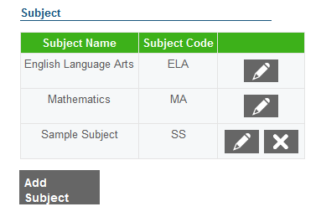

To add subjects:

|  |
| --- |
| 1. From the *Settings* drop-down list in the Core Standards banner, select “Subject.” The Subject screen appears (see Figure 6). 2. Click [**Add Subject**]. The Subject screen appears. 3. In the Name field, enter a descriptive name for the subject. 4. In the Code field, enter the subject’s abbreviation. (For an explanation of the Code field, see Appendix C, How Core Standards Generates Publication Numbers.) 5. Do one of the following:    * Click [**Save**] to finish adding subjects and return to the ***Subject*** screen.    * Click [**Save and Add More**] to add additional subjects. |

### Editing subjects

To edit subjects:

|  |
| --- |
| 1. From the *Settings* drop-down list in the Core Standards banner, select “Subject.” The Subject screen appears (see Figure 6). 2. Click [] next to the required subject. The Edit Subject screen appears. 3. Update the information as necessary. All fields are editable. 4. Click [**Save**]. |

### Deleting subjects

To delete subjects:

|  |
| --- |
| 1. From the *Settings* drop-down list in the Core Standards banner, select “Subject.” The Subject screen appears (see Figure 6). 2. To delete a subject, click [] next to the required subject. Verify that the subject is no longer listed on the screen. |

|  |  |
| --- | --- |
|  | **Note:** Once a subject is associated with a publication, you cannot delete it. |

# Publication Tasks

## Viewing and Downloading a Publication

You can download a publication and view it in OpenOffice Calc.

Figure 7. View Publication Screen

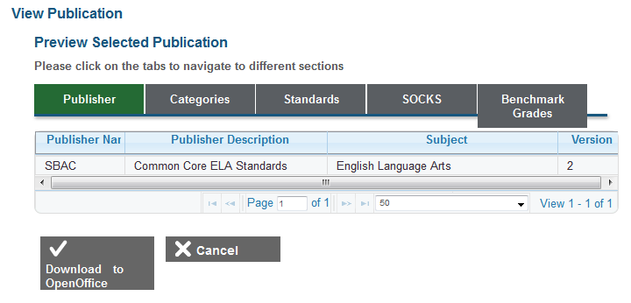

To view and download a publication:

|  |
| --- |
| 1. On the home screen, click [**View Existing Publication**]. The View Existing Publication screen appears. 2. From the Publisher, Subject, and Publication drop-down lists, make selections for the publication you want to view. 3. Click [**View**]. The View Publication screen appears (see Figure 7). 4. Review the publication’s properties by clicking the [**Publisher**], [**Categories**], [**Standards**], [**SOCKS**], and [**Benchmark Grades]** tabs. You can use the controls at the bottom of the listing to page quickly between rows of data. 5. To download the entire publication, click [**Download to OpenOffice**]. |

## Creating a Publication

Creating a publication involves two primary steps: designing the publication in an OpenOffice Calc spreadsheet, and then uploading the spreadsheet to Core Standards.

|  |  |
| --- | --- |
|  | **TIP: Creating publications from templates** The best way to create a publication is to start with the sample publication provided with Core Standards. The sample is an OpenOffice spreadsheet with five tabs. Each tab has a few rows of example data. You overwrite those rows or add new rows, as required, to design your publication. |

Figure 8. Copy Existing Publication Screen

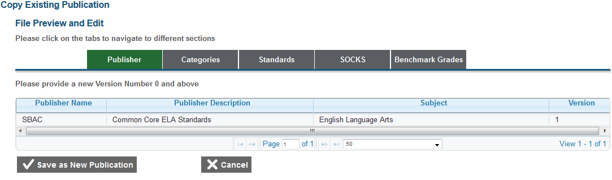

To create a publication:

|  |
| --- |
| 1. Download the publication template by clicking [**Download Sample Publication Spreadsheet**] on the home screen. Your browser downloads the file. Depending on your browser’s configuration, the file opens in OpenOffice Calc or is stored on your computer. 2. Develop and save the publication using OpenOffice Calc. Specifications for developing the publication appear in Appendix B, Publication Specifications. 3. On the home screen, click [**Create Publication from Spreadsheet**]. The Import Your OpenOffice Spreadsheet screen appears. 4. Click [**Browse**], and navigate to the file you saved in step 2. 5. Click [**Preview File**]. The Copy Existing Publication screen appears and displays a preview (see Figure 8). 6. Review the preview for accuracy, and then click [**Save as New Publication**]. Core Standards saves the publication, and makes it available in Test Authoring System. |

Core Standards assigns an ID to the publication, and this ID appears in Test Authoring System. For information about how Core Standards determines the publication ID, see Appendix C, How Core Standards Generates Publication Numbers.

|  |  |
| --- | --- |
|  | **Note:** Once you create a new publication, you cannot modify it. However, you can create a new version of a publication, with the Version column incremented by one. For example, if the current version is 2, the new version is 3. |

1. Common Errors with File Uploads

When processing an upload file, Core Standards generates error messages at the file level (if it cannot process the entire file) or at the record level (if it cannot process individual records). The following sections describe the error messages and how to address them.

## Missing required sheet <name> in file

**Cause:** This error occurs if your file is missing one of the required sheets: Publication, Categories, Standards, Some Other Category of Knowledge (SOCK), or Benchmark Grades. This error also occurs if one of the sheet names is misspelled.

**Impact:** When this error occurs, Core Standards imports none of the records. You must resubmit the entire file.

**Resolution:** Repair the file, ideally by taking a new sample and pasting your existing data into the sample. For information about taking a new sample, see the section Viewing and Downloading a Publication.

These are some other common errors:

* Having blank rows between records
* Inserting invalid characters (refer to appropriate user guide sections for information about accepted formats)
* Uploading a file that contains a publisher, grade, or subject that does not exist in Core Standards
* Uploading a publication version that already exists in Core Standards

1. Publication Specifications

This appendix provides specifications for composing a publication in a spreadsheet file. The appendix includes general specifications that apply to files and detailed specifications that apply to each tab inside the file. After you complete the publication, you upload it to Core Standards using the procedure described in the section Creating a Publication.

## General Specifications for Preparing Publications

The following specifications apply to files.

* Use one file per publication. If you need to upload both Mathematics and ELA publications, use separate files for each.
* Don’t modify the names of the spreadsheet tabs and the headings in each tab. The import procedure depends on the spreadsheet tabs and headings to be spelled exactly as in the template.
* Provide information that is as close as possible to the published standards. Do not change the hierarchy, add or delete levels, change standards names, provide grades that aren’t in the standards, or apply any other change that causes the standards to deviate substantially from that published by the governing body.
* Erase leading or trailing blanks around values.

## Data Entry Specifications by Workbook Tab

This section provides detailed instructions for entering data in each of the workbook tabs.

### Publication tab

The Publication tab identifies the publication. There is only one publication per template, so this tab contains only one row in addition to the header row. Table 2 shows the column headings and guidelines for input.

Table 2. Publication Tab

| Column Heading | Input Guidelines | Example |
| --- | --- | --- |
| PublisherName1 | The publisher’s name, typically the client’s name | Minnesota |
| PublicationDescription1 | A string that fully describes the publication | 2003 Minnesota Academic Standards Language Arts K–12 |
| Subject1 | The subject that this publication applies to as published by the client | English Language Arts |
| Version1 | The version number of this publication | 1 |

1 Required field.

The value you use for PublisherName must be identical to one of those in the Publisher screen (see Figure 4). If you need to add a new publisher for a publication, follow the procedure in the section Adding publishers. Similarly, the value you use for Subject must be identical to one of those in the Subject screen (see Figure 6). If you need to add a new subject for a publication, follow the procedure in the section Adding subjects.

The version number can be incremented to add copies of the same publication aligned to more than one standard. In addition to version numbers, state-level publications may include the year of publication in the PublicationDescription field.

### Categories tab

The Categories tab describes the standards hierarchy and names each level. This is client- and publication-specific. Entries in this tab may affect the behavior of Test Authoring or other systems that connect to Core Standards. Therefore, the levels and names should be familiar to users of those other systems.

Each row reflects the publication’s hierarchy. For example, if a publication has four levels, row 2 (below the header row) reflects the highest level, row 3 the next highest level, and row 4 the lowest level. Table 3 shows the column headings and guidelines for input.

Table 3. Categories Tab

| Column Heading | Input Guidelines | Example |
| --- | --- | --- |
| Category1 | A string that describes the content standard level. | SBAC Claim |
| Tree Level1 | An integer starting with 1 for the highest level and incremented by 1 for each subsequent level. | 1 |

1 Required field.

Table 4 is an example of a completed Categories tab for a three-level hierarchy.

Table 4. Categories Tab Example

| Category | Tree Level |
| --- | --- |
| SBAC Claim | 1 |
| SBAC Assessment Target | 2 |
| Common Core Standard | 3 |

### Standards tab

The Standards tab specifies the actual standards and the standards text. Table 5 shows the column headings and guidelines for input.

Table 5. Standards Tab

| Column Heading | Input Guidelines | Example |
| --- | --- | --- |
| Level1 | A number appearing in the Tree Level column of the Categories tab. For example, if four levels are defined in the Categories tab, then this column contains only the values 1, 2, 3, or 4. | 1 |
| Key1 | This is a pipe-delimited2 key value. Use the following syntax for different levels.   * Level 1 standards have standalone key strings. * Level 2 standards contain the key string of the first level, one pipe delimiter, and the key string of the second level. * In general, Level n standards contain key strings separated by n−1 pipe delimiters.   Keys must be unique across the publication.  All Level‑2 keys and lower must have an identifiable parent key. For example, if there is a Level‑3 key ELA‑III|B|2, then there must be a Level‑2 key ELA‑III|B. | Level 1 example: ELA-III  Level 2 example: ELA-III|B  Level 3 example: ELA-III|B|2  Level 4 example: ELA-III|B|2|2 |
| Name1 | This is the content standards or benchmark name consistent with the nomenclature used by the client. As a best practice, enter names that users of Test Authoring or Item Authoring can immediately recognize. | K.II.E.1 |
| Description1 | This is the text of the standard as published by the client. | Correctly form many of the uppercase and lowercase letters of the alphabet, monitor, and discuss the differences. |
| ShortName | An optional, abbreviated description of the content level. This name should reflect the nomenclature used by the client. | The student will use a variety of strategies to expand reading, listening, and speaking vocabularies. |

1Required field.

2The pipe character “|” is above the backslash key on the right side of the keyboard.

Table 6 is a short example of a segment of the Standards tab.

Table 6. Standards Tab Example

| Level | Key | Name | Description |
| --- | --- | --- | --- |
| 3 | 4-CR|5–3|3.W.2d | 3.W.2d | Write informative/explanatory texts to examine a topic and convey ideas and information clearly. D) Provide a concluding statement or section. |
| 3 | 4-CR|5–3|3.W.3d | 3.W.3d | Write narratives to develop real or imagined experiences or events using effective technique, descriptive details, and clear event sequences. D) Provide a sense of closure. |
| 3 | 4-CR|5–4|4.L.3a | 4.L.3a | Use knowledge of language and its conventions when writing, speaking, reading, or listening. A) Choose words and phrases to convey ideas precisely. |
| 3 | 4-CR|5–4|4.L.6 | 4.L.6 | Acquire and use accurately grade-appropriate general academic and domain-specific words and phrases, including those that signal precise actions, emotions, or states of being (e.g., quizzed, whined, stammered) and that are basic to a particular topic (e.g., wildlife, conservation, endangered when discussing animal preservation). |
| 3 | 4-CR|5–4|4.W.2d | 4.W.2d | Write informative/explanatory texts to examine a topic and convey ideas and information clearly. D) Use precise language and domain-specific vocabulary to inform about or explain the topic. |
| 3 | 4-CR|5–4|4.W.3d | 4.W.3d | Write narratives to develop real or imagined experiences or events using effective technique, descriptive details, and clear event sequences. D) Use concrete words and phrases and sensory details to convey experiences and events precisely. |
| 3 | 4-CR|5–5|5.L.3a | 5.L.3a | Use knowledge of language and its conventions when writing, speaking, reading, or listening. A) Expand, combine, and reduce sentences for meaning, reader/listener interest, and style. |
| 3 | 4-CR|5–5|5.L.6 | 5.L.6 | Acquire and use accurately grade-appropriate general academic and domain-specific words and phrases, including those that signal contrast, addition, and other logical relationships (e.g., however, although, nevertheless, similarly, moreover, in addition). |
| 3 | 4-CR|5–5|5.W.2d | 5.W.2d | Write informative/explanatory texts to examine a topic and convey ideas and information clearly. D) Use precise language and domain-specific vocabulary to inform about or explain the topic. |
| 3 | 4-CR|5–5|5.W.3d | 5.W.3d | Write narratives to develop real or imagined experiences or events using effective technique, descriptive details, and clear event sequences. D) Use concrete words and phrases and sensory details to convey experiences and events precisely. |

### SOCKs tab

The Some Other Category of Knowledge (SOCKs) tab contains reporting categories that are not part of the content standards hierarchy. SOCKs are not required, but if a particular category is important to the client and items are categorized or partitioned in some way using metadata that may affect the way assessment results are reported, create SOCKs to match each category. Table 7 shows the column headings and guidelines for input.

Table 7. SOCKs Tab

| Column Heading | Input Guidelines | Example |
| --- | --- | --- |
| Knowledge Category1 | A string that identifies the knowledge category | Cognitive Level C |
| Description | A string that provides informational description | Cognitive Level C |

1Required field.

### Benchmark Grades tab

The Benchmarks Grade tab associates a standard key defined in the Standards tab with a grade or a range of grades. The value you use for Grade must be identical to one of those in the Grade screen (see Figure 5). If you need to add a new grade for a benchmark, follow the procedure in the section Adding grades. Furthermore, the grades must match the grades in the content standards as published by the state or governing body.

You can enter multiple grades in one of the following ways:

* Use only one row for each key, and enter the grades as a comma-separated list. For an example, see Table 8.
* Use one row for each grade, repeating the key in each row. For example, if a key pertains to grades 7–9, create three rows containing the same key, and the grade changes from 7, 8, and 9. For an example, see Table 9.
* Use only one row for each key, and enter the grades as a range with a hyphen, such as 7‑9. If you use this method, then you must also add the key individually for each grade in the range. For an example, see Table 10.

Table 8. Benchmark Grades Tab Example—Comma-Separated Grades

|  |  |
| --- | --- |
| Benchmark Key | Grade |
| 1-IT|10–10|10.L.5b | 7,8,9 |

Table 9. Benchmark Grades Tab Example—Repeated Key for Individual Grades

|  |  |
| --- | --- |
| Benchmark Key | Grade |
| 1-IT|10–10|10.L.5b | 7 |
| 1-IT|10–10|10.L.5b | 8 |
| 1-IT|10–10|10.L.5b | 9 |

Table 10. Benchmark Grades Tab Example—Repeated Key for Grade Band

| Benchmark Key | Grade |
| --- | --- |
| 1-IT|10–10|10.L.5b | 7-9 |
| 1-IT|10–10|10.L.5b | 7 |
| 1-IT|10–10|10.L.5b | 8 |
| 1-IT|10–10|10.L.5b | 9 |

Table 11 shows the column headings and guidelines for input.

Table 11. Benchmark Grades Tab

|  |  |  |
| --- | --- | --- |
| Column Heading | Input Guidelines | Example |
| Benchmark Key1 | A benchmark key defined in the Standards tab. The key value must exactly match the key in the Standards tab, or the standards import fails. | ELA-II|B|9–12|5 |
| Grade1 | A single grade, a comma-delimited list of grades, or a grade range from the following set: KG, 1, 2, 3, 4, 5, 6, 7, 8, 9, 10, 11, and 12.  Other values must be explicitly represented by the content standards. | 5  1,2,3,4,5,6 |

1Required field.

## Escape Sequences for Special Characters

Any of the text fields described in the section Data Entry Specifications by Workbook Tab can include special characters such as single or double quotes. Table 12 lists the special characters and how to escape them in the spreadsheet.

Table 12. Escape Sequences for Special Characters

| Escape Sequence | Character Represented by Sequence |
| --- | --- |
| \' | A single quote (') character |
| \" | A double quote (") character |
| \b | A backspace character |
| \t | A tab character |
| \\ | A backslash (\) character |
| \% | A percent (%) character |
| \_ | An underscore (_) character |

## Validation Rules

When uploading a file, Core Standards makes the following validation checks:

* The uploaded file is an OpenOffice Calc spreadsheet with a .ods extension.
* Any special characters are properly escaped as described in the section Escape Sequences.
* All required spreadsheet tabs are present and are named as expected.
* All required columns in each required tab are present and are named as expected.
* For the Publication tab:
  + All required columns are filled in.
  + The Publisher exists in the Graphical User Interface (GUI) as described in the section Adding publishers.
  + The Subject exists in the GUI as described in the section Adding subjects.
  + Version must be whole numbers, and no other publications with the same Publisher-Subject-Version number already exist.
* For the Categories tab:
  + All required columns must be filled in.
  + At least one level is present.
  + Tree level values must be numeric, start at 1, and be sequential.
* For the Standards tab:
  + All required columns must be filled in.
  + Level must be numeric and must correspond to the levels in the Categories tab.
  + Keys must be unique across the publications.
  + Keys for every level defined in the Categories tab are defined.
  + Every level‑2 key and above must have a parent: for example, if a level 3 key “1‑LT|1‑10|10.RL.3” is defined, there must be a level 2 key “1‑LT|1‑10”.
  + The pipe character (“|”) cannot be used for any other purpose except as a delimiter separating the individual parts of a key.
  + At least one standard is required.
* For the SOCKs tab:
  + All SOCKs are optional. They are not required, and they are free-form strings.
* For the Benchmark Grades tab:
  + Must have at least one record.
  + Must have both a key and a grade.
  + All keys in this tab must be defined in the Standards tab.
  + Only the lowest level keys need to be associated with a grade; the upload process automatically associates the parent keys to every grade associated with that parent’s children.
  + All grades must be added as described in the section Adding grades.

1. How Core Standards Generates Publication Numbers

When you upload a publication, Core Standards assigns an ID to it. Test Authoring users associate their tests to this publication ID. Figure 9 illustrates how Core Standards assigns an ID to a publication.

Figure 9. Format for Publication Numbers



* The Publisher component is what you enter in the Publisher Name column in the Publication tab of the upload file.
* The Subject component is what you enter in the *Code* field of the Subject screen (see Figure 6).
* The version number is automatically assigned by Core Standards as you create a publication or as appears in the Publication tab of the workbook.

1. User Support

|  |  |
| --- | --- |
| **Contact Information** | |
| **Questions about state policies** | **Questions about technology and the overall administration procedures** |
| STATE  **Accommodations, Test Policy, Testing Irregularities**  {Blanks to fill in with your specific state information}   |  |  | | --- | --- | | Name: |  | | Phone: |  | | Email: |  |   **Your Smarter Balanced State Lead Contact (in the event of a security breach or irregularity)**  {Blanks to fill in with your specific state information}   |  |  | | --- | --- | | Name: |  | | Phone: |  | | Email: |  | | Assessment Program Name  Monday–Friday from 6:30 a.m. to 6:30 p.m. Eastern Time  800-555-5555  [demoHelpDesk@air.org](mailto:demoHelpDesk@air.org) |