Revision History

|  |  |  |
| --- | --- | --- |
| Revision Description | Author/Modifier | Date |
| 0.1 - Initial Release (DRAFT) | Jose daVeiga | February 27, 2017 |

# Purpose

This document describes the implementation and functionality of the Smarter Balanced Item Illustration Glossary accessibility feature. This Functionality Specification is intended as reference for all Implementation Readiness relative to this specific feature.

# Definition

An Illustration Glossary provides support functionality to provide definitions for certain words or phrases in the form of an image. The illustration depicts the defining concept of the word or phrase it corresponds to (Figure 1).

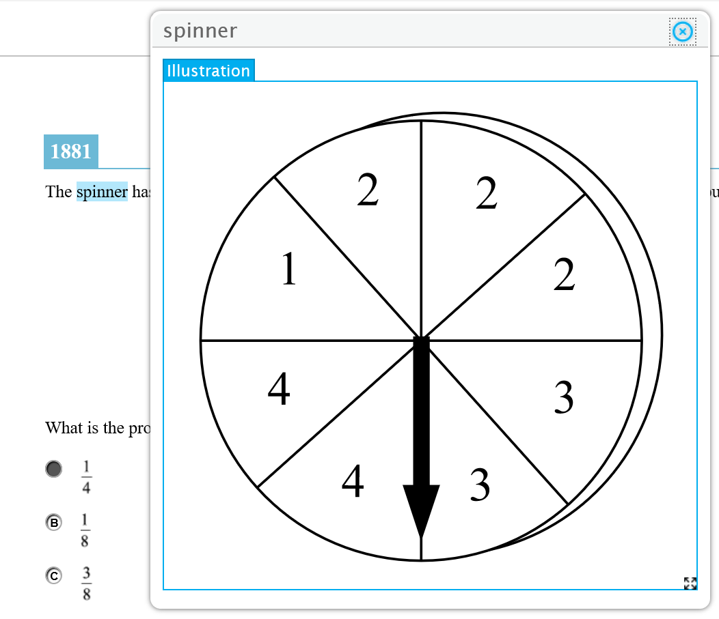

Figure 1. Example of an Illustration Glossary.

# Illustration Glossary Functionality

The Illustration Glossary works like other glossary features such as the English and Translated glossaries, except that an image is displayed instead of text and/or audio.

### Access

A user can access an Illustration Glossary by clicking the corresponding highlighted word or phrase. The word or phrase is highlighted with bars at the top and bottom (Figure 2).

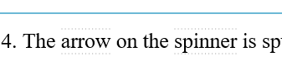

Figure 2. Example of an Illustration Glossary word highlighting.

When the cursor hoovers over the word or phrase, then an indication this is a word that can be looked up should be presented in the form of highlighting of the word and a small popup over the word instructing the user that this is a work to be looked up with “lookup word” as shown in Figure 3.



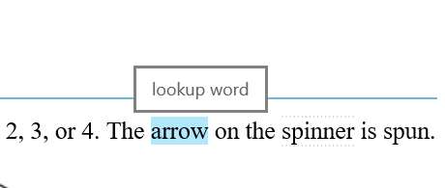

Figure 3. Example of hoover functionality in the form of   
feedback when cursor is over word or phrase.

When the user clicks on the word or phrase, the definition appears in the form of a popup window, placed close or at proximity to where the word is located in the browser window as depicted in Figure 1 (above).

### Moving the Popup Window

Like English and translated glossaries, the Illustration Glossary popup window may be moved around the screen by dragging the header bar (Figure 4).



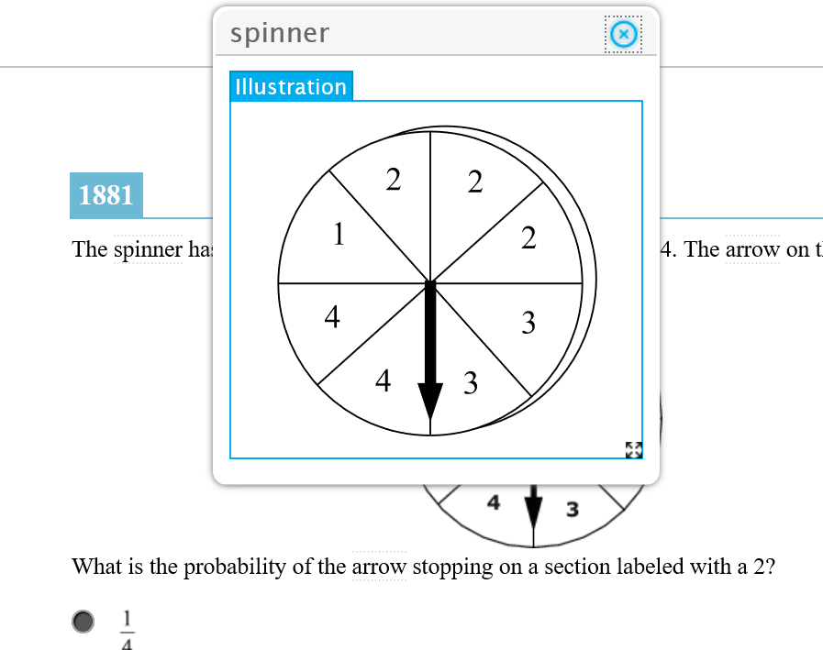

Figure 4. Users can click and drag the header bar to reposition   
the Illustration Glossary window.

### Resizing the Popup Window

The popup window can be re-sized, and thus the Illustration scales accordingly. The user accomplishes this by dragging the lower-right corner where the  (four-arrow) icon appears (Figure 5).





Figure 5. Users can click and drag the lower-right four-arrow icon   
to scale the popup window.

The initial image size is set by the item content creators and is defined in the Illustration Glossary HTML provided in the world-list item file. The minimum window width or height of the window should be set at 200 pixels, that is, the user should not be able to resize the window to a size smaller than 200 pixels in width or 200 pixels in height, whichever limit is reached first during resizing.

Resizing should only be allowed when in the Illustration tab. If the window contains more than one tab, the functionality should be such that the sizing of the window changes, and switches, depending on which tab the user has selected.

Resizing of the image should always take into account the image’s aspect ratio so not to distort or blur the image.





Figure 6. Example of a resized Illustration Glossary window.

### Closing the Popup Window

The popup window can be closed by clicking the upper-right corner where the  (encircled “X”) icon appears (Figure 7).





Figure 7. Users can click and drag the lower-right four-arrow icon   
to scale the popup window.

The window should maintain state even after closed in such way that if the user re-opens the window it reappears in the same location.

### Popup Window Information

The popup window should identify what word it refers to by displaying the corresponding word in the upper left side of the popup window header bar (Figure 8).



Figure 8. The popup window displays the corresponding word in   
the upper left-hand side of the header bar.

### Popup Window Glossary Tabs

The popup window should contain a tab identifying the type of glossary. In the case of an Illustration Glossary it should display a tab “Illustration. In the case there are more than one type of glossary available for the word, the window should display other types of glossaries in separate tabs the user can click through to view (Figures 9 and 10).





Figure 9. The popup window displays the corresponding word in   
the upper left-hand side of the header bar.





Figure 10. Example Illustration Glossary window

with more than one glossary type.

# Technical Specifications

The Illustration Glossary feature is made available based on the individual student settings per ISAAP (Individual Student Assessment Accessibility Profile) guidelines. This feature is only available to the test taker when the system has been configured to do so in the registration system.

For information regarding the specifications of the item files containing the Illustration Glossary please refer to the following documents on SmarterApp.org:

*SmarterApp Assessment Item Format Specification (SAAIF)*

This document (the Specification) defines an XML document structure for the encoding and representation of assessment items. This Specification only describes the structure of the XML documents for assessment items.

*SmarterApp Item Packaging Specification*

The purpose of this document is to provide an item package specification that is used for Smarter Balanced Assessment Consortium item packages. This specification describes the assessment item file package including all files, dependencies, and folders that are zipped using the standard zip file format.