Revision History

|  |  |  |
| --- | --- | --- |
| Revision Description | Author/Modifier | Date |
| 0.1 - Initial Release (DRAFT) | Jose daVeiga | February 27, 2017 |

# Purpose

This document describes the implementation testing procedure for the Smarter Balanced Illustration Glossary accessibility feature. The content of this document serves as reference guidelines for testing and Quality Assurance (QA) of the implementation of the Illustration Glossary feature.

# Definition

An Illustration Glossary is presented to the test-taking user providing definitions for certain words or phrases in the form of an image. Please refer to the Smarter Balanced Illustration Glossary Definition document for a full definition and functional specification. An example of an Illustration Glossary is provided in Figure 1.



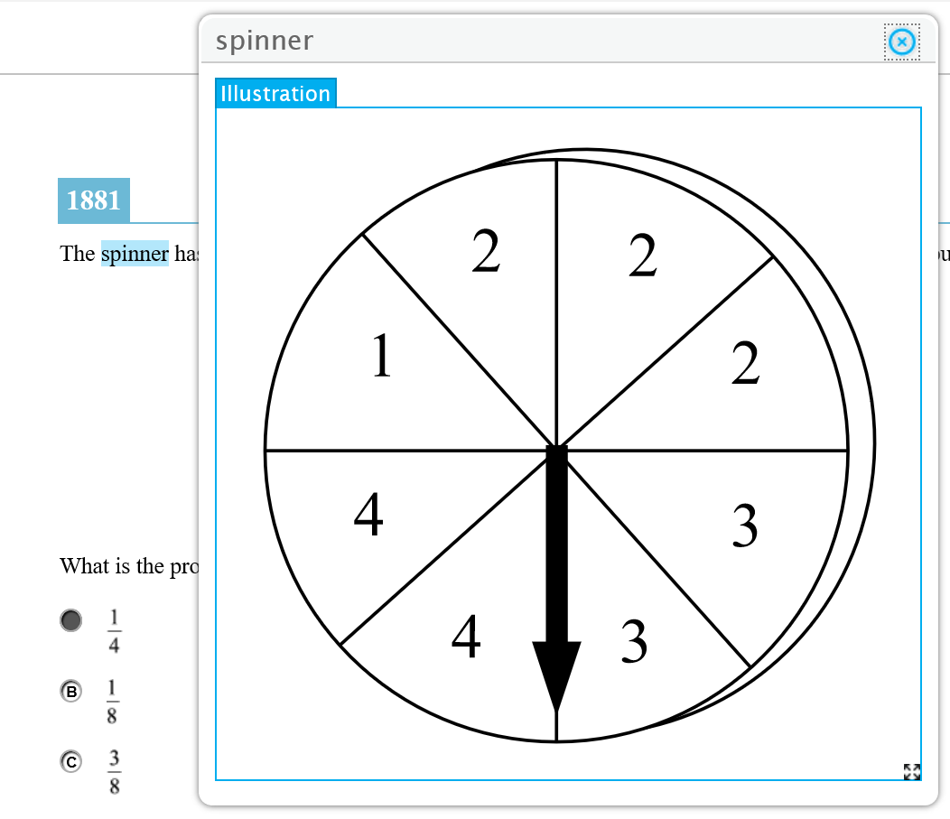

Figure 1. Example of an Illustration Glossary

# Item Loading

In the Implementation Readiness Package (IRP) on the SmarterApp.org website, you will find a Zip file with an example Test Package which contains a test item that includes an Illustration Glossary. Download the file and unpack the Zip file onto your Testing Delivery System (TDS) as you would with any other test item.

The following steps should be used as guidelines (not exactly the same for every TDS) to assist you in loading the provided example item onto your TDS:

* Find and load the example test package XML into the appropriate application
  + Registration Application (ART in OSS)
    - Test Package/ART/Registration
    - Includes the Registration package with general metadata about an assessment
  + Test Delivery (TDS in OSS)
    - Test Packages/Administration/
    - Includes all information needed to present a test to a student except for the items
  + Test Scoring (TIS in OSS)
    - Test Packages/TIS/Administration
      * Same Administration package used in TDS for each assessment plus "combined" packages which group the Performance and CAT assessments into a single scored assessment
    - Test Packages/TIS/Scoring
      * Scoring packages include details on how to score an overall assessment
      * Includes both individual assessments and the combined
  + Reporting
    - Test Packages/REP/Reporting
      * Reporting configuration data for each assessment.
* Copy item content to the TDS server
  + Move file to each TDS server
  + Unzip the content zip file located in /Content to the appropriate location
    - Note: this step is dependent on each TDS application and where it is configured to look for item content

# Item Format and Packaging Technical Specifications

For information regarding the specifications of the item files containing the Illustration Glossary please refer to the following documents on SmarterApp.org:

*SmarterApp Assessment Item Format Specification (SAAIF)*

This document (the Specification) defines an XML document structure for the encoding and representation of assessment items. This Specification only describes the structure of the XML documents for assessment items.

*SmarterApp Item Packaging Specification*

The purpose of this document is to provide an item package specification that is used for Smarter Balanced Assessment Consortium item packages. This specification describes the assessment item file package including all files, dependencies, and folders that are zipped using the standard zip file format.

# Example Item Testing

Keep in mind that the Illustration Glossary feature is made available based on the individual student settings per Individual Student Assessment Accessibility Profile (ISAAP) guidelines. This feature is only available to the test taker when the platform has been configured to do so in the registration system. Before you proceed, you should make sure the student user you are testing with has his/her settings appropriately configured to allow him/her to view/use the Illustration Glossary assistance.

Below are generic steps needed to user test the appropriate item in your TDS:

* Log in as a student, or as a proctor taking the test as a student user
* Set the student user’s individual settings per ISAAP to allow Illustration Glossaries viewing
* Choose the appropriate sample assessment
* At this point, the sample test item should load with the appropriate functionality
* Take the test

Once the item is displaying in the user interface you should refer to the Smarter Balanced Illustration Glossary Definition document that contains a full description of all the functionality and user interface specifications for this feature.

# Quality Assurance Checklist

Smarter Balanced is providing an itemized checklist that is intended to be used during your testing to ensure you perform a thorough functionality test of the Illustration Glossary feature. Once you are ready to begin the testing, you should use the Illustration Glossary Implementation Quality Assurance Checklist and proceed to fill it in as you verify that it works in accordance to the specifications in the Smarter Balanced Illustration Glossary Definition document.

The Illustration Glossary Quality Assurance Checklist is intended to be a verification of Implementation Readiness. Please complete it thoroughly and store it for reference as it might be requested as proof of testing and proper implementation compliance.