|  |  |
| --- | --- |
|  | Item Types and Accessibility Features  Updated 2 November 2016 |

|  |  |  |
| --- | --- | --- |
| Revision Description | Author/Modifier | Date |
| First full release with all content. | Brandt Redd | 2 November 2016 |

# **Introduction**

This document describes each item interaction type and each embedded accessibility feature for Smarter Balanced assessments. For each item type or accessibility feature a screenshot shows how the feature appears on the screen.

## Testing Application

In order to emphasize the item type or feature in question, the screenshots focus on just one section, feature or item. The following screen shot shows the entire test-taking application including a passage on the left and a question on the right.

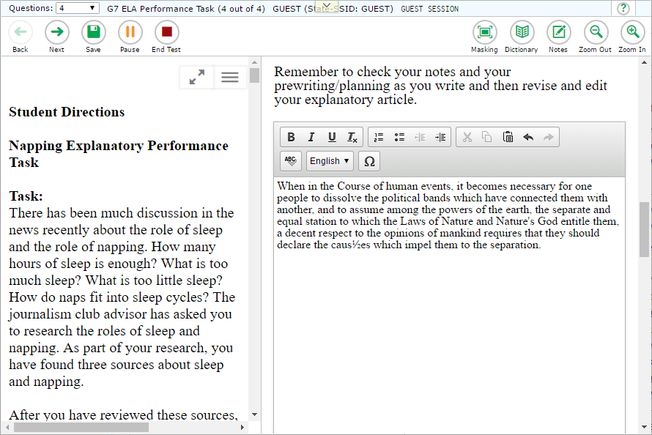

# **Item Types**

## Evidence-Based Selected Response (EBSR)

EBSR items combine two sets of stems and response options into a single item. Unlike MultipleChoice and Multi-Select item types, EBSR items cannot be displayed in horizontal or stacked layouts. EBSR items can only display response options vertically.

For Smarter Balanced, the first part of an EBSR item is multiple choice where only one answer can be selected. In the second part, multiple answers may be selected though the instructions may specify a limit to the student. In the example below, the student is only expected to select one answer from the second part.

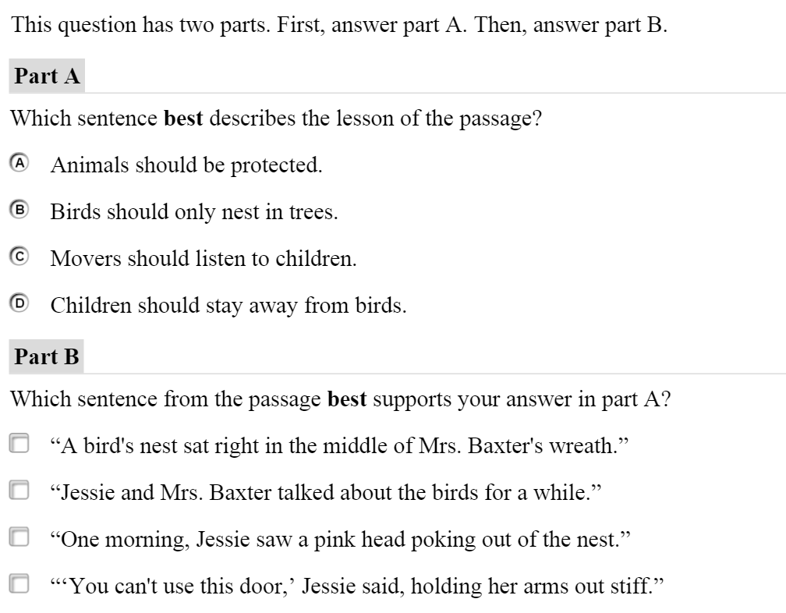

## Equation (EQ)

The Equation item response area consists of one or more entry boxes and an on-screen key panel containing mathematical characters. These items are 769 pixels wide or use 100% of the available response area width (whichever is smaller). The default height is 254 pixels. The item indicates which of 11 pre-defined layouts should be used for the math input key panel.

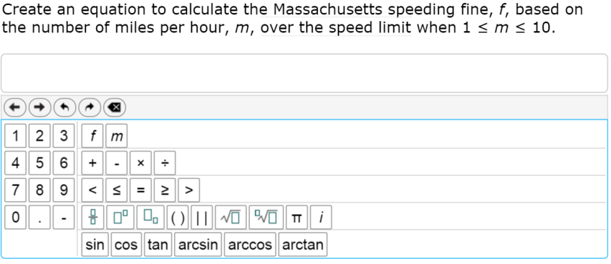

## Extended Response (ER) and Short Answer (SA)

The response areas for Extended Response (ER) and Short Answer (SA) item types essentially have the same appearance. Extended Response (ER) areas accommodate more text than Short Answer response areas. You can configure the character limit for both item types.

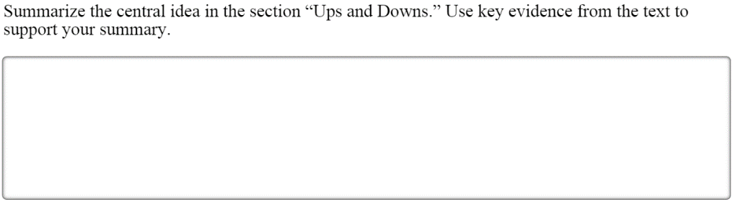

## Grid Item (GI)

Smarter Balanced uses three variations of the Grid Item type, each with a distinct appearance and interaction mode.

### Grid Item (GI) - Graphing

The Grid Item - Graphing variant response area consists of a grid in which students plot points and/or lines. The available tools include a select, delete, add point, and connect line. Depending on the item, the point or line tool may not appear. A text box below the grid offers hints on what the student can do with each tool.

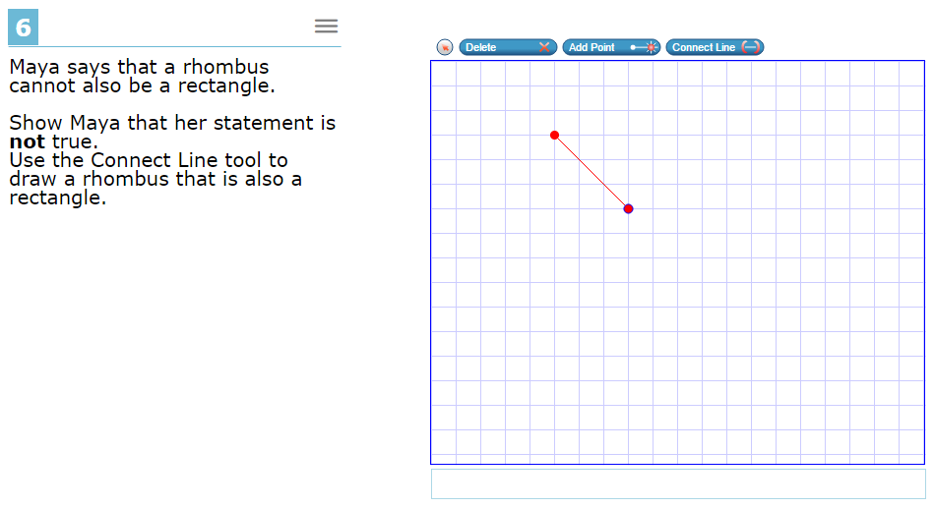

The response area may have a background image on which the student plots points or lines as in this example.

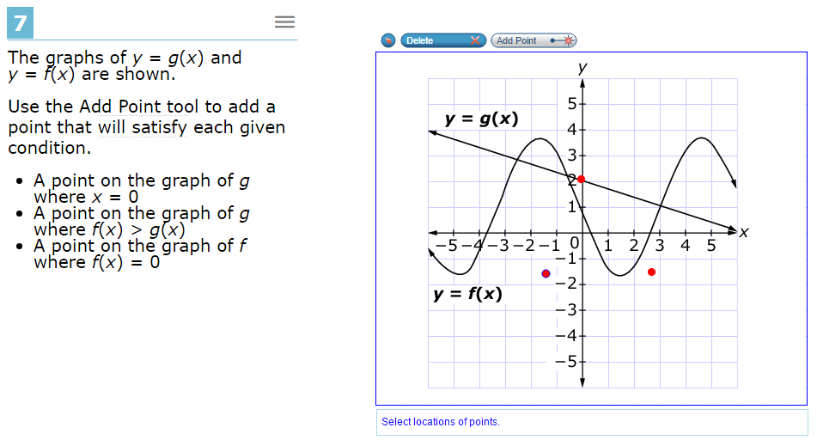

Grid Item – Graphing Variants may constrain points and lines; for example they may be constrained to a number line. The background, whether a simple grid, a graph with axes, or another image is simply a bitmap.

### Grid Item (GI) – Hot Spot

The Grid Item – Hot Spot Variant response area consists of a space in which images are displayed. Clicking on certain hot spot areas causes images appear or disappear. Transparent sections of the images allow the background to show through.

In this example, the clicking on the shapes causes the selection box to appear around the shape.

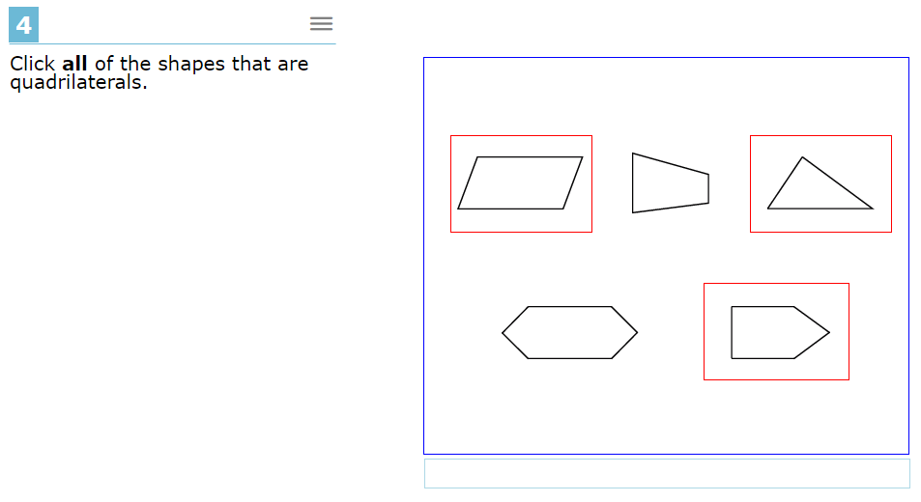

This is another example of a Grid Item – Hotspot variant. In this case there is a different image representing each level and they are selectively displayed according to the hotspot where the student clicks. The same technique is also used to create bar charts that may be manipulated by the student.

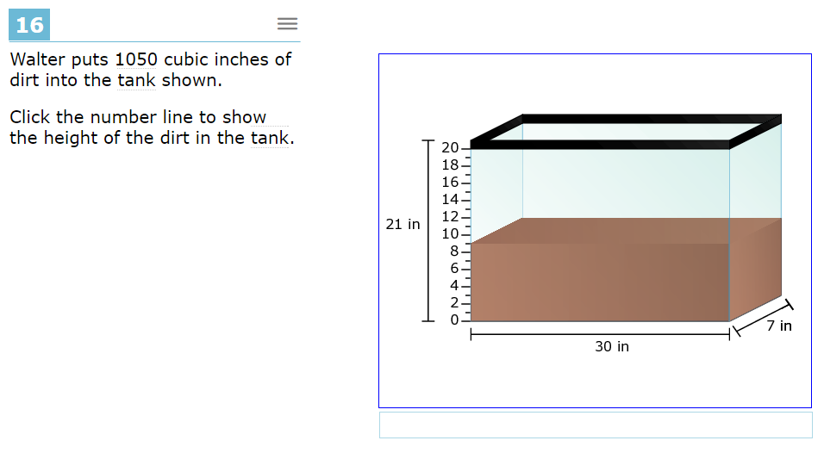

### Grid Item (GI) – Drag and Drop

The Grid Item – Drag and Drop variant has a workspace with a background image. Other images can be dragged and dropped into the workspace. The drop locations may or may not be constrained. When they are constrained, dropped images snap to nearby locaitons.

This example of the Drag and Drop variant includes a palette of items to the left that can be drag into the workspace. The same item may be used more than once. The student may use the delete tool can be used to remove an item from the workspace.

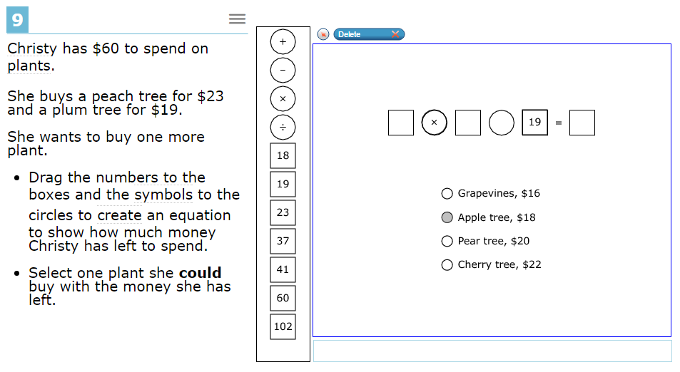

This example has images pre-located in the workspace that may be moved around by the student. They may be moved around but not added or deleted.

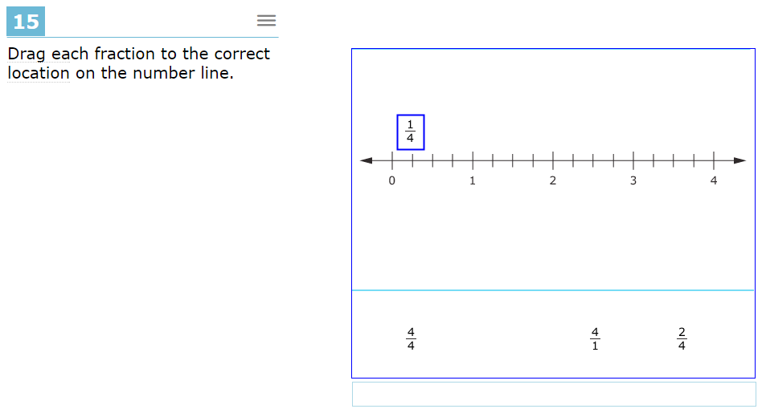

## Hot Text (HTQ)

The response area for Hot Text items consists of a section of text containing interactive words or phrases that students can either select (highlight) by clicking or rearrange by clicking and dragging. In the image below, the word ‘stacked’, outlined in light blue, is an example.

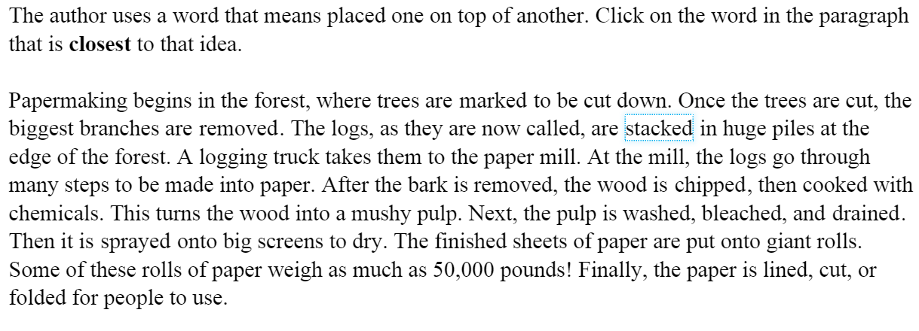

## Multiple Choice (MC)

For multiple choice responses, only one answer can be selected among several possibilities.

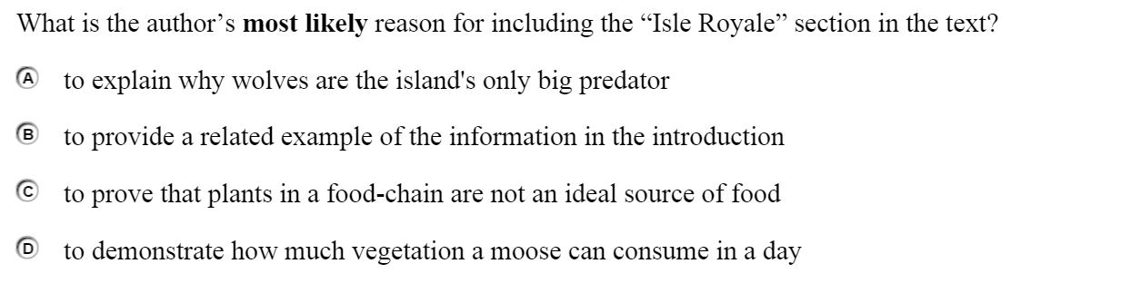

## Match Interaction (MI)

For the Match Interaction (MI) types, text or images in rows are matched values in columns. The student selects the boxes where a match is valid.

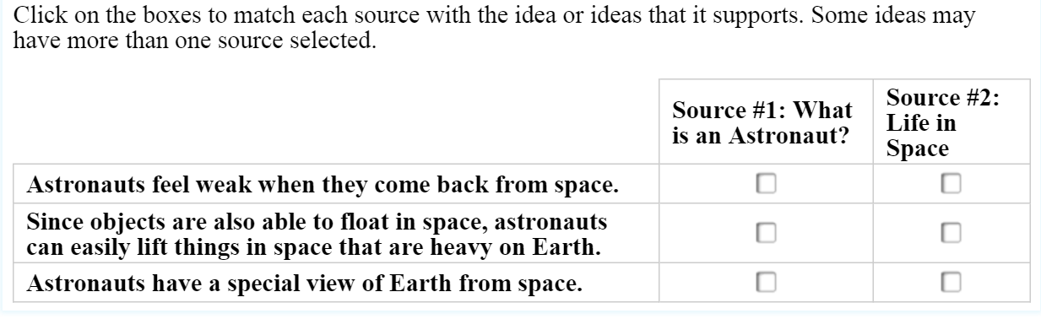

## Multi Select (MS)

For the Multi Select (MS) option, students are given a number of items to select to answer the questions. For the example below, two of the listed items will be selected.

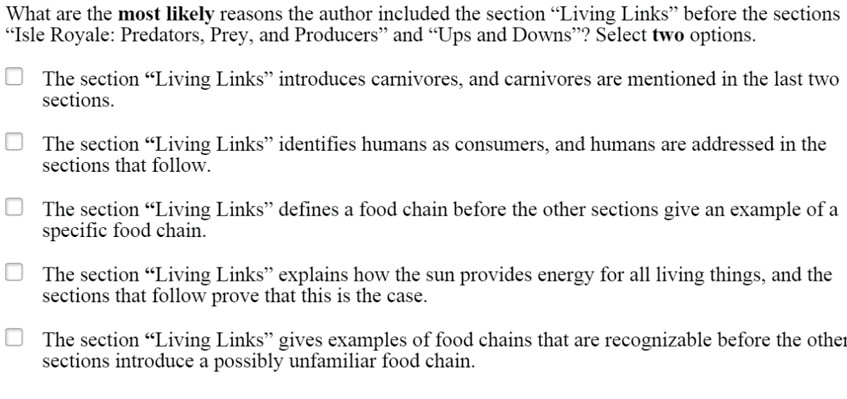

## Table Interaction (TI)

For Table Interaction (TI) item types, students are provided with a table that includes a separate area of cells in which students may enter text.

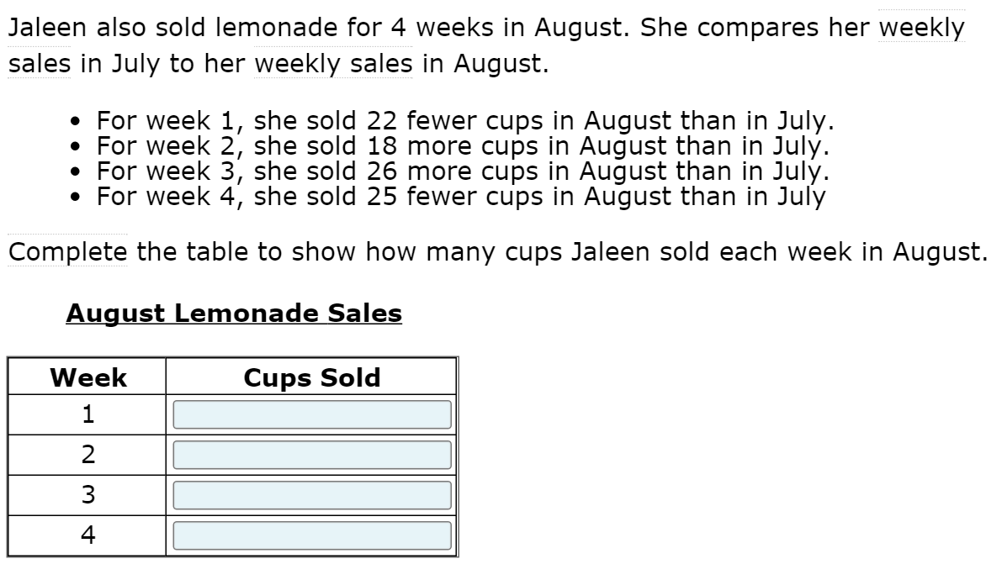

## Writing Extended Response (WER)

Writing Extended Response (WER) item types provide more space for students to provide a longer written response. It also includes text formatting tools – bold, underline, italic, numbered and bulleted lists, indentation, clipboard, undo, redo, and spell checking.

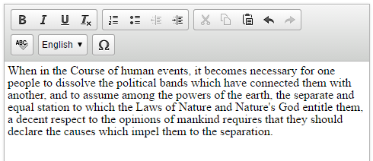

## Supplementary Item Types

Supplementary item types are, *Passage* (Pass), and *Tutorial* (Tut), and *Wordlist* (Glossary).

### Passage (Pass)

A passage is an extended stimulus that is referenced by multiple response items that follow. Typically a passage is an extended-length text in HTML format. However, it can include multimedia such as an audio listening passage or a video. As with response items, passages may have accessibility features such as ASL video and closed captioning.

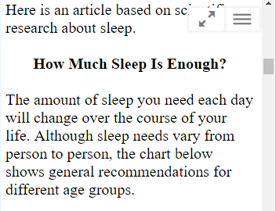

### Tutorial (Tut)

Like a passage, a tutorial is extended HTML text which may include multimedia and accessibility features. Each tutorial is associated with a particular response type and is used to inform students how to respond to that particular interaction type.

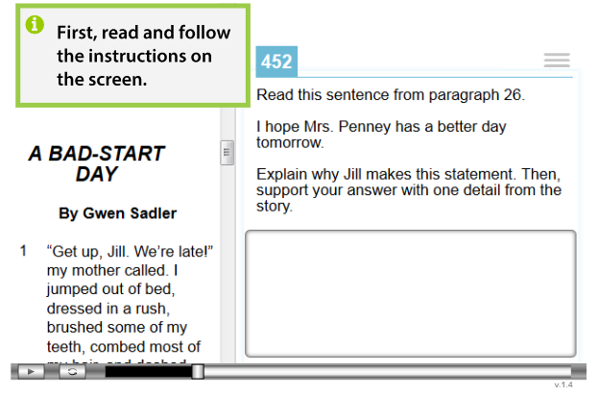

# Accessibility Features

There are three types of accessibility features:

* **Universal Tools** are made available to all students according to their preference.
* **Designated Supports** are made available to any student for whom the need has been indicated by an educator.
* **Accommodations** are made available to students for whom the need has been documented.

Accessibility features are also distinguished by how the content must be prepared and how they are made available to students. The categories are: Item-Embedded Features, System-Embedded Features, and Non-Embedded Features.

This document describes embedded features. Additional details about all accessibility features can be found in the Usability, Accessibility, and Accommodations Guidelines (UAAG) found on SmarterBalanced.org (<http://www.smarterbalanced.org/wp-content/uploads/2015/09/Usability-Accessibility-Accomodations-Guidelines.pdf>).

## Item-Embedded Features

Item-Embedded appear *within* the assessment items and often require custom content to match the specific item. This category includes information that may not be visible in a conventional browser but interacts with assistive technology, such as alternative spellings for text-to-speech and braille screen readers.

### American Sign Language (ASL) videos (Accommodation)

American Sign Language videos are provided for math items, math performance tasks (PTs), and ELA listening sets (audio stimulus and associated items). The student launches the video by clicking on the item menu (three bars in the upper-right) and selecting “American Sign Language”

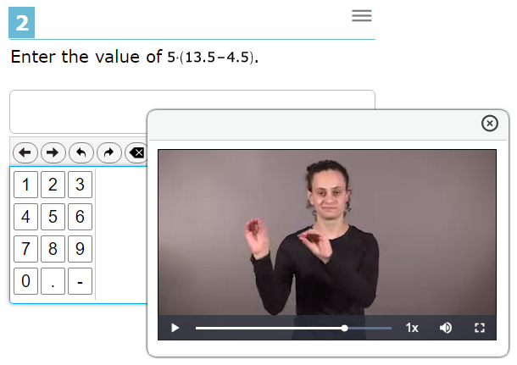

### Closed Captioning (Accommodation)

Closed captioning is offered for listening stimuli on ELA/Literacy tests and with other audio components in the test delivery interface. When closed captioning is enabled, it appears automatically when the student begins to play an audio passage.

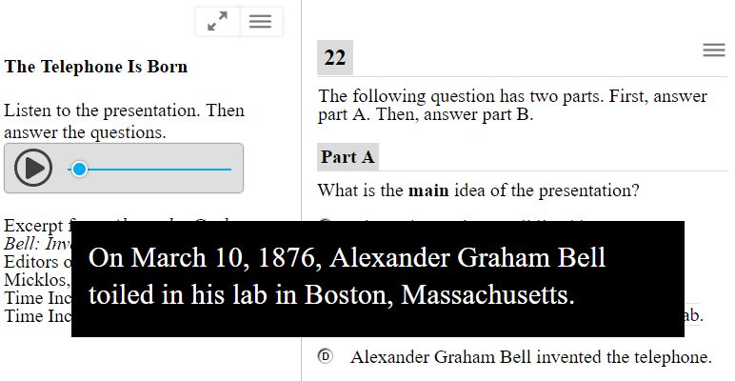

### Text-to-Speech (Designated Support for Math, Accommodation for ELA/Literacy)

Text-to-Speech uses a voice synthesizer to read the text of an item aloud to the student. It is invoked by clicking on the item menu (three bars in the upper-right) and selecting one of the “Speak” options such as “Speak Question”.

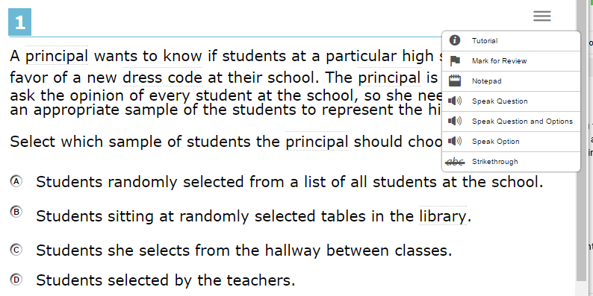

### Text-to-Speech Annotations

Text-to-Speech annotations are additional text added to an item to improve pronunciation by speech synthesizers and to provide descriptions for images and diagrams. They are used by the embedded text-to-speech feature described in section 3.1.3 and also by assistive technology such as screen readers. Special tags are embedded in the text according to WCAG and ARIA guidelines for this purpose.

### Braille Emboss-on-Demand (Accommodation)

Braille-reading students may have the text of an item embossed on paper in braille form. Certain math items may include tactile graphics along with the text. Text-only items include a .BRF file that can be embossed by pretty much any digital embosser. .PRN files are special-format braille files that include tactile graphics. A more limited set of embossers can handle .PRN files. Smarter Balanced provides embossing files that correspond to the practice and training tests here: <http://www.smarterbalanced.org/assessments/practice-and-training-tests/>

### Stacked Translation into Spanish (Designated Support)

Stacked Translation provides the assessment item in both Spanish and English. It is only available for math items. When stacked translation is enabled it appears automatically.

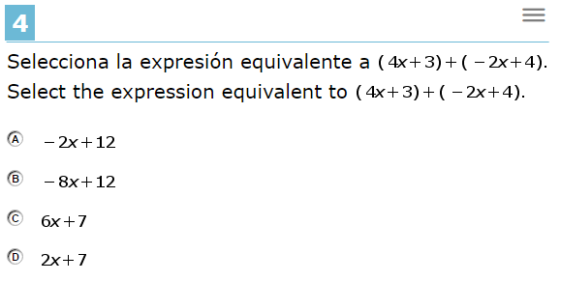

### English Glossary (Universal Tool)

English glossary provides definitions for certain words or phrases. The word or phrase will have highlight bars at top and bottom. When the student clicks on the word then a definition appears. The definition box can be moved around the screen and closed.

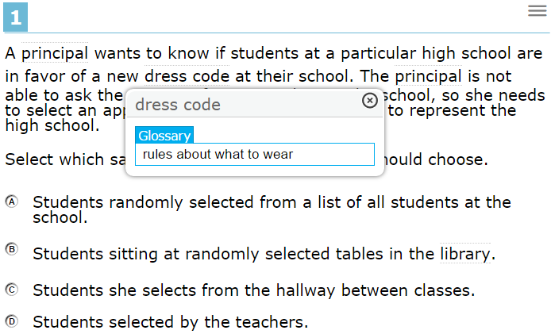

### Translated Glossary with Audio (Designated Support)

Translated glossary must be enabled for one of ten languages supported by Smarter Balanced. It may be combined with English Glossary. As with English Glossary, the student can click on a word highlighted by top and bottom bars and a translated glossary will appear. If both English and translated glossaries are enabled and the term has both forms then the student can choose which to view. The glossary box can be moved around the screen.

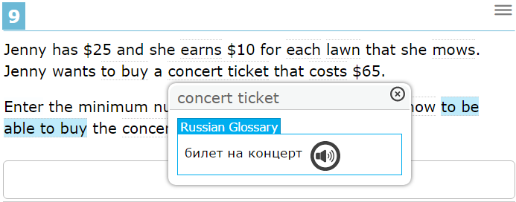

If the student clicks on the speaker icon next to the text they will hear a recording of the text from a native speaker of the language. Smarter Balanced provides translated glossaries in Arabic, Cantonese, Filipino, Korean, Mandarin, Punjabi, Russian, Spanish, Ukrainian, and Vietnamese.

### Image Glossary

Image glossary works like English and Translated glossaries except that an image is displayed instead text and audio. Like English and translated glossaries, the image may be moved around the screen by dragging the header bar. The size can also be changed by dragging the lower-right corner where the four-arrow icon appears.

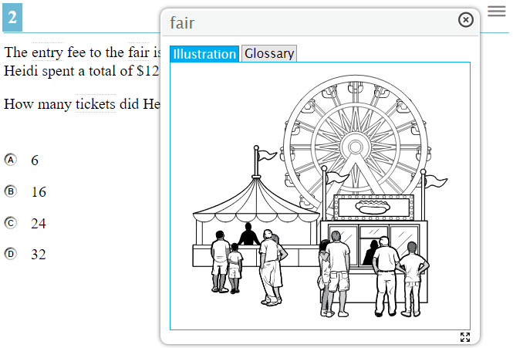

### Braille Transcripts of Closed Captions (Accommodation)

Braille Transcripts of Closed Captions are transcripts of the closed captions described in section 3.1.2 that may be embossed in the same way that item text may be embossed as described in section 3.1.5.

## System-Embedded Features

System-Embedded features are provided by the online test delivery system but are not embedded in the item.

### Breaks (Universal Tool)

A student may take a break by clicking the pause button. They are warned that if the break lasts longer than 20 minutes then they will not be able to go back and review any questions they have already answered. If there is a problem during testing such as a power failure, the internet connection is lost, or the student’s device fails then the test is automatically paused.

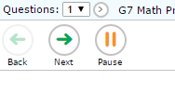

### Calculator (Universal Tool)

For math tests, the student may bring up an online calculator. However, certain items disable the calculator when it would interfere with the object of the item. The student brings up the calculator by clicking the calculator icon in the upper-right.

Different calculators are enabled according to the student’s grade. In advanced grades they may select from Scientific, Graphing, and Regression calculators.

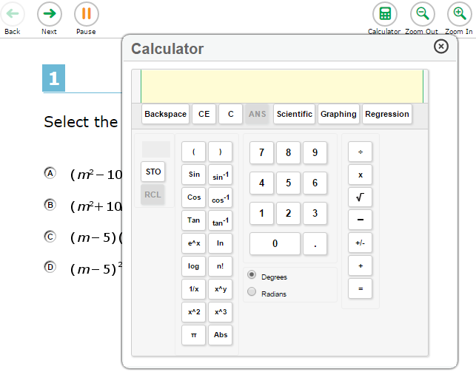

### Color Contrast (Designated Support)

Color contrast changes the foreground and background colors in which the test is displayed. The selection must be made in advance and affects all items on the test. Options are Black on White (default), Black on Rose, Yellow on Blue, Medium Gray on Light Gray, Reverse Contrast (white on black). This example is yellow on blue.

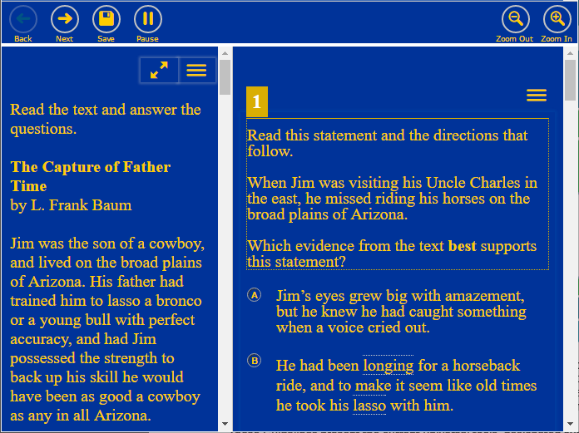

### English Dictionary (Universal Tool)

The embedded dictionary is only available for certain ELA/Literacy items. The student invokes the dictionary by clicking the dictionary icon in the upper-right (near notes and zoom tools). This brings up a dictionary window that the student can use to look up word definitions. The student can move the dictionary around on the screen and continue to work on their answer to the question while the dictionary is visible.

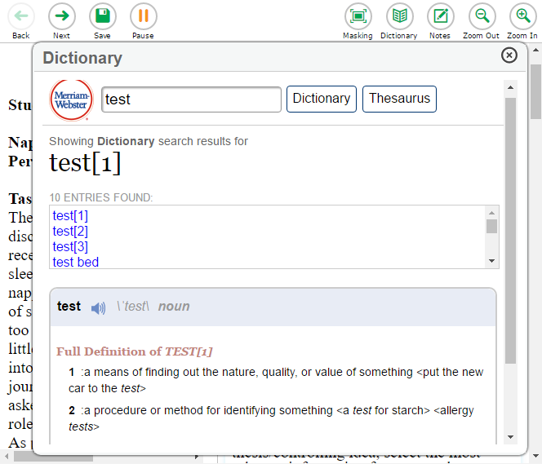

### Expandable Passages (Universal Tool)

Clicking on the expanding passages icon (two diagonal arrows, upper-right) expands the passage to take over most of the screen. Clicking the icon again returns the passage to normal size so that the adjacent questions may be seen.

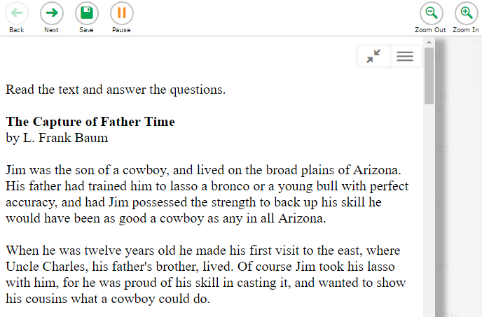

### Highlighter (Universal Tool)

The student may highlight text in a passage or a question. To highlight text a student selects the text, invokes the item menu (three bars in the upper-right) and selects “highlight selection”. Highlighting can be cleared by selecting “reset highlighting” in the item menu.

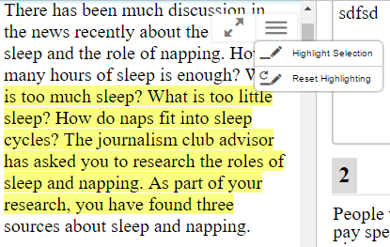

### Masking (Designated Support)

Masking lets a student block out certain parts of an item. The student clicks the “masking” button and then draws a rectangle over the area to be blocked off.

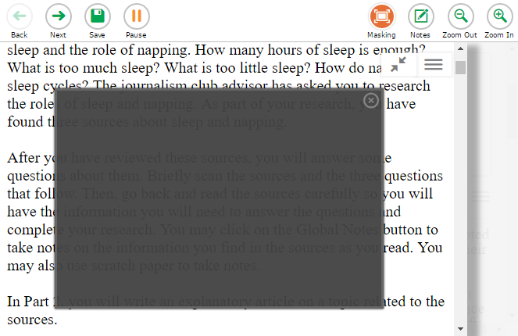

### Mark for Review (Universal Tool)

Mark for Review lets the student mark a question for later review. When the student reaches the end of a segment or of a test they are offered a list of all items and those marked for review will be highlighted. Mark for Review is invoked using the item menu (three bars in the upper-right).

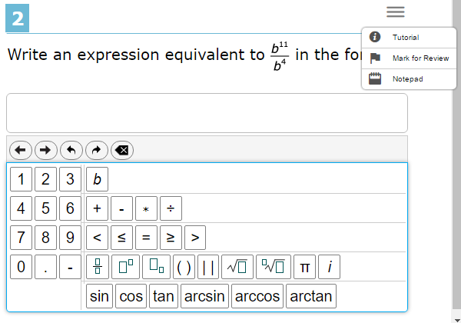

### Notepad (Universal Tool)

The notepad allows students to take notes associated with an item or with the test as a whole. It is invoked using the item menu (three bars in the upper-right).

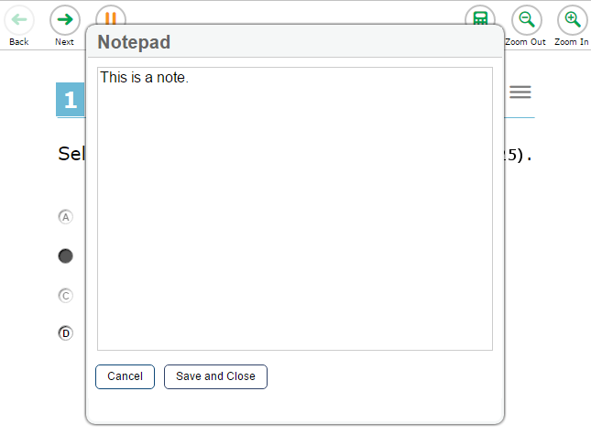

### Streamline (Accommodation)

When one or more questions are associated with a reading passage normal display is to show the passage on the left with the questions on the right. Each section can be scrolled independently. In streamline mode, the passage is displayed above with questions below. This works better with certain screen readers and may be better for certain students.

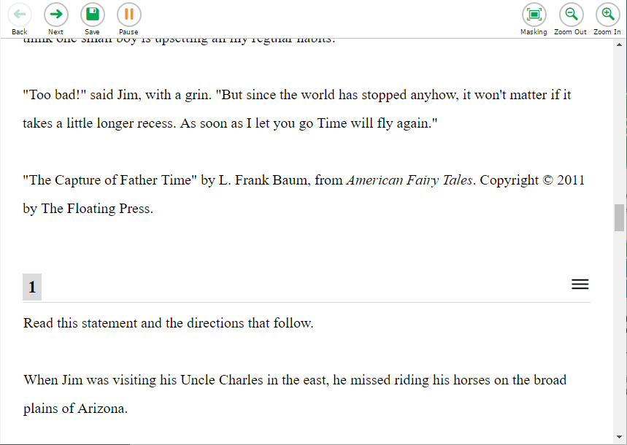

### Spell Check (Universal Tool)

Spell checking is only available for Writing Extended Response (WER) items. The text editor section of this item has a spell check button  that will highlight all misspelled words. Clicking on a misspelled word offers a selection of likely replacements from which the student can choose.

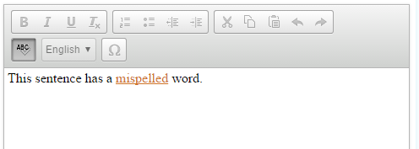

### Strikethrough (Universal Tool)

The strikethrough tool enables the student to strike out answers that they believe to be incorrect. It is invoked by clicking on the item menu (three bars).

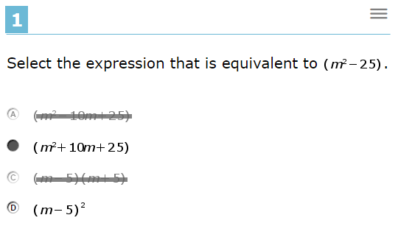

### Zoom (Universal Tool)

The zoom buttons in the upper-right allow the student to increase the size of text and graphics. This affects all items in the test including glossaries, graphics, and so forth.

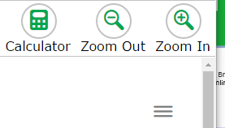

## Non-Embedded Features

Non-Embedded are provided by the test administrator or organization. Examples are a paper multiplication table, translated test directions, or a bilingual dictionary. See the Usability, Accessibility, and Accommodations Guidelines (UAAG) for more detail (<http://www.smarterbalanced.org/wp-content/uploads/2015/09/Usability-Accessibility-Accomodations-Guidelines.pdf>).