

**Smarter Balanced**

**Assessment Consortium:**

**Monitoring and Alerting User Guide**

**2014–2015**

**Revised December 31, 2014**

© Smarter Balanced Assessment Consortium, 2014   
.

**Table of Contents**

Introduction to This User Guide 4

Section I. Overview of the Monitoring and Alerting System 5

User Roles and Access 5

Section II. Getting Started with the Monitoring and Alerting System 6

Logging in to the Monitoring and Alerting System 6

Understanding the Monitoring and Alerting System Layout 7

Header 7

Task Icons 8

Task Screens 9

Section III. Performing Monitoring and Alerting Tasks 10

Viewing Logs 10

Viewing Alerts 14

Viewing Metrics 16

Managing Notification Groups 18

Search for a Notification Rule **Error! Bookmark not defined.**

Add a Notification Rule **Error! Bookmark not defined.**

Edit a Notification Rule **Error! Bookmark not defined.**

Delete a Notification Rule **Error! Bookmark not defined.**

Search for a Notification Group 20

Add a Notification Group 21

Edit a Notification Group 22

Delete a Notification Group 22

Managing Notification Rules 23

Search for a Notification Rule 23

Add a Notification Rule 24

Edit a Notification Rule 26

Delete a Notification Rule 27

Appendix A. User Support 28

**Table of Figures**

Figure 1. Login Screen 6

Figure 2. Monitoring and Alerting System Home Screen 7

Figure 3. Header 7

Figure 4. Monitoring and Alerting Task Icons 8

Figure 5. Sample Search Screen 9

Figure 6. Log Search Screen 10

Figure 7. Sample Component Log Details 12

Figure 8. Alert Search Screen 14

Figure 9. Metric Search Screen 16

Figure 10. Notification Group Search Screen 20

Figure 11. Add Notification Group Popup Window 21

Figure 12. Edit Notification Group Popup Window 22

Figure 13. Notification Rule Search Screen 23

Figure 14. Add Notification Rule Popup Window 24

Figure 15. Edit Notification Group Popup Window 26

Figure 16. Delete Notification Rule Popup Window 27

# Introduction to This User Guide

This user guide supports individuals using the Monitoring and Alerting System to monitor and maintain deployed components or applications. This introduction describes the contents of this document and includes a key for identifying icons and elements.

This user guide provides information about the Monitoring and Alerting System in a series of three sections, as follows:

* **Section I, Overview of the Monitoring and Alerting System**, provides an overview of the system and the user roles for accessing the system.
* **Section II, Getting Started with the Monitoring and Alerting System**, explains how to log in to the Monitoring and Alerting System and describes the overall layout of the Monitoring and Alerting System Interface.
* **Section III, Per****forming Monitoring and Alerting Tasks**, describes how to perform different monitoring tasks in the Monitoring and Alerting System.

Table 1. Key Icons and Elements

|  |  |
| --- | --- |
| Icon | Description |
|  | **Warning**: This symbol appears with text that contains extremely important information regarding actions that may cause errors. |
|  | **Caution**: This symbol appears with text that contains important information regarding a task. |
|  | **Note**: This symbol appears next to text that contains helpful information or reminders. |
|  | Text that appears in gray boxes provides instructions relevant to the task described.   * Numbered (ordered) lists provide step-by-step instructions. * Bulleted lists provide instructions that do not need to be done in a specific order. |
| [**Text**] | Text in brackets is used to indicate a link or button that is clickable. |
| *Text* | Text in italics indicates field names or labels. |
| “Text” | Text in quotation marks indicates the value specified for a field. |

# Section I. Overview of the Monitoring and Alerting System

The Monitoring and Alerting System is a web-based system and is one of the core applications that must be deployed with any other component used by one or more tenants at any given deployment level. It acts as a centralized repository for all the logs and alerts generated by the components being monitored. The Monitoring and Alerting System is non-tenanted; that is, its use is not tenant-specific.

This system serves as a powerful tool that can be used by system administrators to monitor the health of all the components being monitored. It allows administrators to view the logs and alerts generated by a running application and thereby monitor any errors, warnings, or debugging information generated during a program’s execution. It also allows administrators to create notification rules and groups of members or personnel to whom automatic notification emails can be sent in case the notification rules are met.

## User Roles and Access

The Monitoring and Alerting System is a core infrastructural application and is accessible to only a limited number of users. Currently only users with the *Administrator* or *MnA Modify* user roles can view and access the Monitoring and Alerting System.

# Section II. Getting Started with the Monitoring and Alerting System

This section provides information about getting started with the Monitoring and Alerting System:

* Logging in to the Monitoring and Alerting System
* Understanding the Monitoring and Alerting System layout

## Logging in to the Monitoring and Alerting System

To access the Monitoring and Alerting System, you must have an authorized user name and password. Your system administrator will be responsible for setting up your user account and providing you with the login credentials.

The Monitoring and Alerting System uses the Single Sign On (SSO) System, which is responsible for user authentication and authorization and allows you to log in to the Smarter Balanced systems. After logging in, you can switch between systems without having to log in and out of each system.

To log in to the Monitoring and Alerting System:

|  |  |
| --- | --- |
| 1. Open your web browser and navigate to the Monitoring and Alerting System using the URL provided to you.   You will be directed to the Single Sign On Login screen shown in Figure 1.   1. In the *Username* field, enter your user name. 2. In the *Password* field, enter your password. 3. Click the [**Log In**] button. You will be directed to the Monitoring and Alerting System home screen, provided your login is authenticated. | Figure 1. Login Screen |

## Understanding the Monitoring and Alerting System Layout

You can access the different features of the Program Management System from the home screen (see Figure 2) that appears when you first log in to the system.

|  |  |
| --- | --- |
|  | Use the on-screen tools and buttons to navigate within the system. Do not use your web browser’s back button. |

Figure 2. Monitoring and Alerting System Home Screen

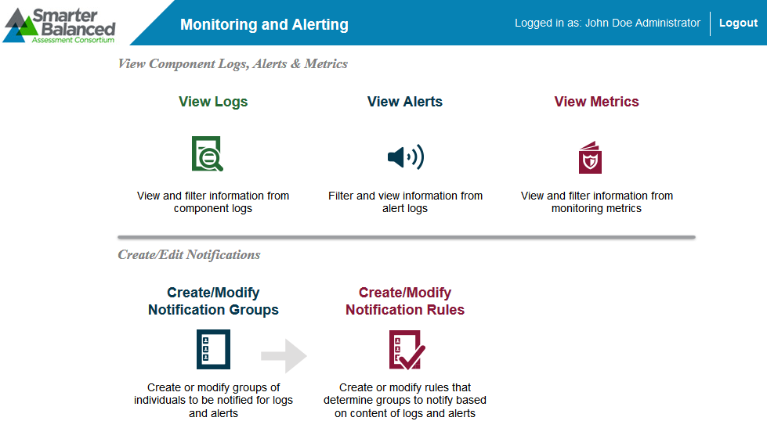

The Monitoring and Alerting System layout includes the features described below.

### Header

The header that appears on every screen provides information about the user logged in to the system and includes tools and buttons to perform different tasks, as shown in Figure 3.

Figure 3. Header



The header has the following features:

* User Identification: When you log in to the system, your name and user role are displayed on the header.
* [**Logo**]: The Smarter Balanced Assessment Consortium logo acts as a button that brings you back to the home screen.
* [**Logout**]: This button enables you to log out of the system.

### Task Icons

The different monitoring and alerting tasks are displayed as icons on the home screen. Each task icon acts as a link that takes you to the specified task screen.

Figure 4. Monitoring and Alerting Task Icons

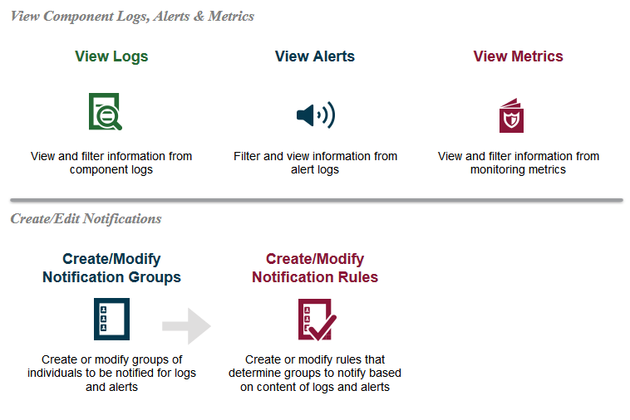

When you select a task, a menu is displayed on the screen. You can navigate through the different tasks using the menu. To return to the home screen and view the task icons, click the logo on the header.

### Task Screens

The Monitoring and Alerting System uses only one screen layout, which is the search screen. When you first access a task, you are taken to the task’s search screen by default. Figure 5 shows a sample search screen.

Figure 5. Sample Search Screen

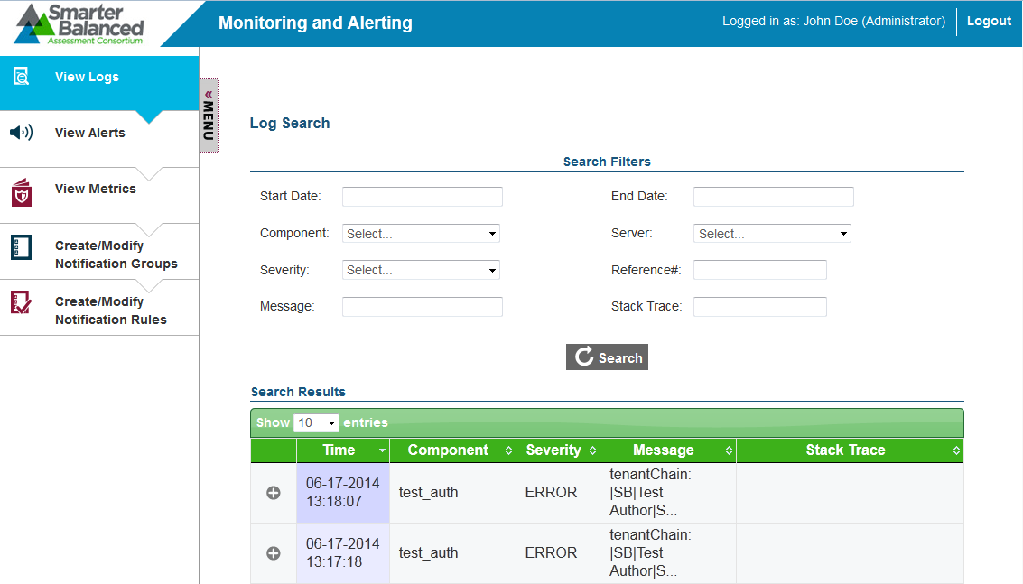

The search screen consists of the following two sections:

* Search Filters Section: This section allows you to search for records that have been created for the selected task. It consists of
  + search criteria fields applicable to the task that you are viewing, where you can specify the required search criteria; and
  + a [**Search**] button that enables you to search for records based on the specified criteria; and

|  |  |
| --- | --- |
|  | The Search Filters section may also consist of a [**New**] button that opens a popup window from which you can create a new record. However, the button is not available for all task categories. |

* Table of Records Section: The table of records displays the records that have been created for the selected task based on the search filter specifications. You can search for and filter the records using the search filters. The table consists of the following features:
  + You can sort the data displayed in the columns by clicking the column header. Not all columns can be sorted. If a column can be sorted, arrows will be displayed on the column header.
  + A navigation panel is displayed at the bottom of the table that enables you to navigate through the retrieved records. It also displays the number of records that matched the specified search criteria.

# Section III. Performing Monitoring and Alerting Tasks

The core functionality of the Monitoring and Alerting System is to allow system administrators to view and monitor logging information for deployed components.

The different monitoring and alerting tasks include the following:

* Viewing Logs
* Viewing Alerts
* Viewing Metrics
* Managing Notification Groups
* Managing Notification Rules

## Viewing Logs

The Monitoring and Alerting System allows you to view the logs generated for deployed components. A log is a routinely generated file that can list all the actions that have occurred for a component. You can enable or disable logging for a component based on the type of event that is being logged. For example, to reduce the large volume of logs, you may choose to only enable logging for events that generate an error or warning.

From the ***Log Search*** screen (see Figure 6), authorized users can search for and view component logs.

Figure 6. Log Search Screen

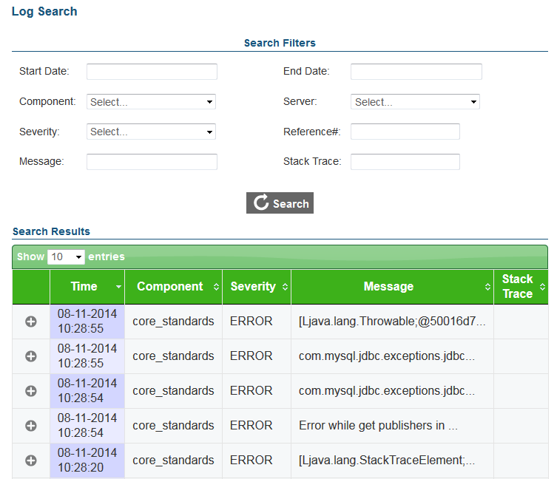

To search for component logs:

|  |
| --- |
| 1. On the homescreen (see Figure 2), click the View Logs icon. The ***Log Search*** screen appears listing all the existing logs for the deployed components. 2. Enter any search criteria you want to include using the available search filters. The different search filters are described in Figure 7. Sample Component Log Details      1. Table 2. 2. Click the [**Search**] button. The screen will display the search results table containing the logs that match the search criteria. 3. To view the log details, click the expand [] button next to the required log. A sample log detail is shown in Figure 7. |

Figure 7. Sample Component Log Details

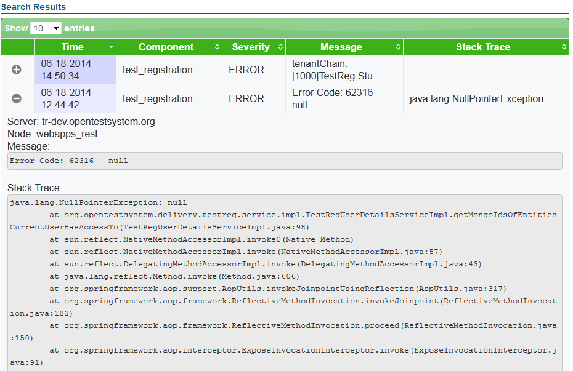

Table 2: Log Search Screen Search Filters

| Search Filter | Description |
| --- | --- |
| Start Date | Refers to the date when the log was started. You can select the specific date from the calendar that is displayed when you place your cursor in the text box. |
| End Date | Refers to the date when the log ended. You can select the specific date from the calendar that is displayed when you place your cursor in the text box. |
| Component | Refers to the component to which the log belongs. You can select the component from the drop-down list that displays the names of all the components for which logs have been generated. |
| Server | Refers to the server on which the component is installed. You can select the server name from the drop-down list that is a dynamic list containing the names of the servers associated with existing logs. |
| Severity | Refers to the type of event or information captured in the log entry. You can select the required type from the drop-down list that contains the following options:   * Error: Indicates a significant problem, such as a loss of functionality or data. * Warn: Indicates a problem that is not immediately significant but that may cause future complications. For example, an application can log a warning event if disk space is low. * Info: Indicates a significant successful operation. * Debug: Indicates troubleshooting information used for resolving software problems. * Trace: Indicates logging information about a program’s execution that is typically used for debugging and diagnosing software problems. |
| Reference# | Refers to the error code that may be displayed in the event message. All logged events may not contain a reference number or error code. |
| Message | Refers to the event message. You can search for events by the complete or partial message. |
| Stack Trace | Refers to the list of the methods that an application was calling at the time of the logged event. You can search by the exception listed at the top of the stack. Some examples of exceptions are java.lang.NullPointer and java.lang.RuntimeException. |

## Viewing Alerts

The Monitoring and Alerting System allows you to view alerts generated by deployed components. Each component has inbuilt alerts that are triggered by specific discrete events. You can be notified whenever an alert event occurs and thereby ensure the smooth running of the component. Not all alerts indicate problems or issues with the functioning of the component. Alerts can also be informational.

From the ***Alert Search*** screen (see Figure 8), authorized users can search for and view component alerts.

Figure 8. Alert Search Screen

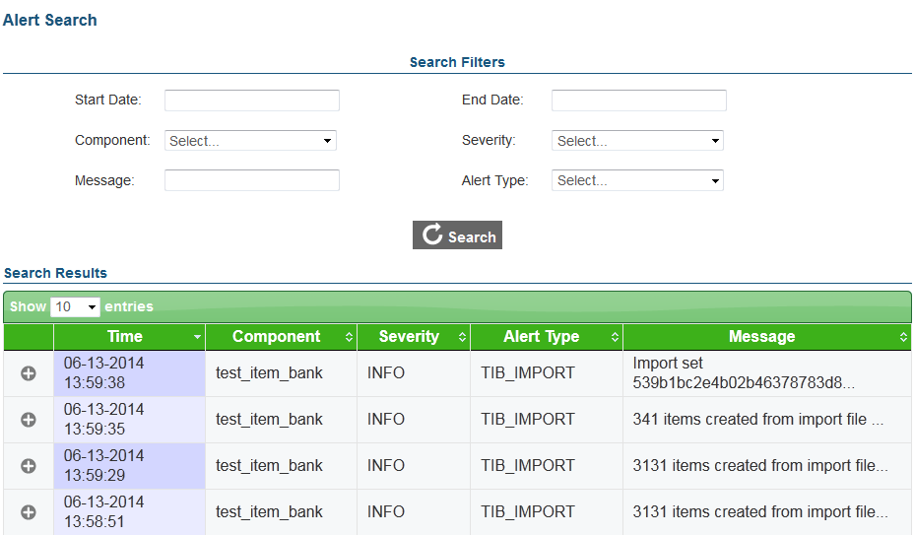

To search for component alerts:

|  |
| --- |
| 1. On the homescreen (see Figure 2), click the View Alerts icon. Alternatively, select the View Alerts option from the menu. The ***Alerts Search*** screen appears listing all the existing alerts for the deployed components. 2. Enter any search criteria you want to include using the available search filters. The different search filters are described in 3. Table 3. 4. Click the [**Search**] button. The screen will display the search results table containing the alerts that match the search criteria. 5. To view the alert details, click the expand [] button next to the required alert. |

Table 3: Alert Search Screen Search Filters

| Search Filter | Description |
| --- | --- |
| Start Date | Refers to the date when the alert was created. You can select the required date from the calendar that is displayed when you place your cursor in the text box. |
| End Date | Refers to the date when the alert ended. You can select the required date from the calendar that is displayed when you place your cursor in the text box. |
| Component | Refers to the component for which the alert was generated. You can select the component from the drop-down list that displays the names of all the components for which alerts have been generated. |
| Severity | Refers to the type of event or information captured in the alert entry. You can select the required type from the drop-down list. The available options are:   * Error: Indicates a significant problem, such as inability to perform an action. * Warn: Indicates a problem that is not immediately significant but that may cause future complications. * Info: Indicates a significant successful operation. * Debug: Indicates troubleshooting information used for resolving software problems. * Trace: Indicates logging information about a program’s execution that is typically used for debugging and diagnosing software problems. |
| Message | Refers to the alert message. You can search for alerts by the complete or partial message. |
| Alert Type | Refers to the component-specific alert name. You can select the specific type from the drop-down list that is a dynamic list containing all the alert types that have been generated. If an alert has not been generated for an alert type, the alert type will not be listed in the drop-down list. |

## Viewing Metrics

The Monitoring and Alerting System also allows you to view different types of metrics for the deployed components. Each component has inbuilt metrics that are used to measure different aspects of a component’s performance.

From the ***Metric Search*** screen (see Figure 9), authorized users can search for and view component metrics.

Figure 9. Metric Search Screen

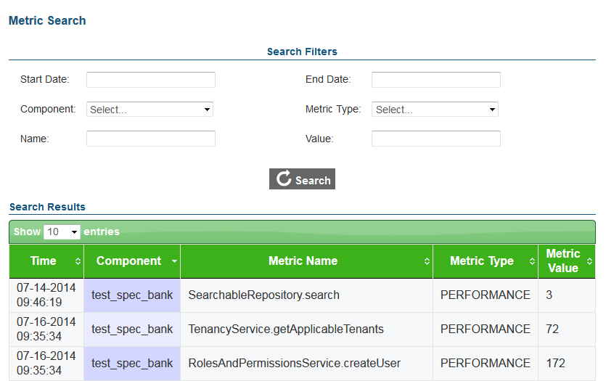

To search for component metrics:

|  |
| --- |
| 1. On the homescreen (see Figure 2), click the View Metrics icon. Alternatively, select the View Metrics option from the menu. The ***Metric Search*** screen appears listing all the existing metrics for the deployed components. 2. Enter any search criteria you want to include using the available search filters. The different search filters are described in Table 4. 3. Click the [**Search**] button. The screen will display the search results table containing the metrics that match the search criteria. |

Table 4: Metrics Search Screen Search Filters

| Search Filter | Description |
| --- | --- |
| Start Date | Refers to the date when the metric was started. You can select the specific date from the calendar that is displayed when you place your cursor in the text box. |
| End Date | Refers to the date when the metric ended. You can select the specific date from the calendar that is displayed when you place your cursor in the text box. |
| Component | Refers to the component for which the metric was generated. You can select the component from the drop-down list that displays the names of all the components for which metrics have been generated. |
| Metric Type | Refers to the type of metrics that have been recorded for the component. You can select the required type from the drop-down list. The available options are:   * Availability: Used to determine a component’s availability. * Performance: Used to determine a component’s performance and activities. * Throughput: Used to determine the database performance of a component. * Utilization: Used to determine a component’s utilization of resources. |
| Name | Refers to the name of the metric. You can only search by the complete metric name. |
| Value | Refers to the metric value. For example, the value can indicate the time taken to perform an action. The value is metric- and component-specific and can refer to a unit of time, a unit of size, or a unit of objects. |

## Managing Notification Groups

The Monitoring and Alerting System enables you to create groups of personnel to whom notification emails can be sent in case an alert or log generated for a component meets the user-specified notification criteria. From the ***Notification Group Search*** screen (see Figure 10), authorized users can search for, create, and manage notification groups.

|  |  |  |  |  |  |  |  |  |  |  |  |  |  |  |  |  |  |  |  |
| --- | --- | --- | --- | --- | --- | --- | --- | --- | --- | --- | --- | --- | --- | --- | --- | --- | --- | --- | --- |
|  | To receive notifications, you must first set up notification rules that specify the alert or log criteria that must be met for emails to be sent. For information on setting up notification rules, refer to Managing Notification Rules  The Monitoring and Alerting System enables you to create rules for sending out notification emails. Notification emails are sent to specified groups only when these rules are met. You can set up rules for both logs and alerts. From the ***Notification Rule Search*** screen (see Figure 13), authorized users can search for, create, and manage notification rules.  Figure 13. Notification Rule Search Screen   Search for a Notification Rule The ***Notification Rule Search*** screen lists all the existing notification rules.  To search for notification rules:   |  | | --- | | 1. On the homescreen (see Figure 2), click the Create/Modify Notification Rules icon. Alternatively, select the Create/Modify Notification Rules option from the menu. The ***Notification Rule Search*** screen appears listing all the existing rules. 2. On the ***Notification Group Search*** screen, enter any search criteria you want to include. The search criteria fields are described in Table 5. 3. Click the [**Search**] button. The screen will display the search results table containing the rules that match the search criteria. |  Add a Notification Rule From the ***Notification Rule Search*** screen, you can add new notification rules or criteria based on which notification emails can be sent to specified groups.   |  |  | | --- | --- | |  | Notification emails are only sent for rules that are marked as active and to groups that are marked as active. If a notification rule is inactive or if the group to whom the notification email should be sent is inactive, notification emails will not be sent. |   Figure 14. Add Notification Rule Popup Window    To add a notification rule:   |  | | --- | | 1. On the ***Notification Rule Search*** screen (see Figure 13), click the [**Add** **New**] button. The Add Notification Rule Popup Window appears. 2. Specify the notification rule details. The different fields are described in Table 5. 3. To save the notification rule, click the [**Save**] button. Verify that the new notification rule is listed on the ***Notification Rule Search*** screen. |   Table 5: Notification Rule Detail Fields   | Field | Description | | --- | --- | | Rule Type | Refers to the entity with which the rule is associated. You can set up notification rules for component alerts as well as logs. You can select the required entity from the drop-down list that displays the two available options:   * Alert * Log | | Active | Indicates whether the rule is active. To activate the rule, check the checkbox. | | Attribute | Refers to the log or alert field on which the notification rule should be performed. You can enter the required attribute in the text box provided.  The attributes are dependent on the selected rule type. The available attributes are:   * Alert:   + severity   + message   + alertType * Log:   + severity   + message   + stackTrace   + referenceNumber | | Regex | Regex or Regular Expression refers to a specialized syntax for matching patterns in strings. You can enter the required regular expression, which is matched against the value of the attribute specified for the rule. If the attribute value matches the regular expression, notification emails can be sent.  For more information on regular expression, refer to http://docs.oracle.com/javase/7/docs/api/java/util/regex/Pattern.html. | | Notification Groups | Refers to the groups to which notification emails should be sent in case the rule criteria are met. You can select the required notification group from the drop-down list. The list is only displayed after you start typing. For example, if you enter “c,” a list of all notification groups whose name contains the letter “c” appears.  You can also remove a notification group from the list by clicking the delete [] button next to the group. |  Edit a Notification Rule You can edit a notification rule if necessary. For example, if you want to receive notification alerts for a particular rule on specific days only, you can activate the rule on the required day and keep it deactivated at other times. You can edit all the details, such as the entity with which the rule is associated and the status of the rule. You can also add or delete the groups to whom notification emails should be sent.  Figure 15. Edit Notification Group Popup Window    To edit a notification rule:   |  | | --- | | 1. From the ***Notification Rule Search*** screen (see Figure 13), search for the rule you want to edit. 2. Click the [] button. The Edit Notification Rule Popup Window appears. 3. Update the information as necessary. All fields are editable. 4. To save the update, click the [**Save**] button. |  Delete a Notification Rule You can also delete a notification rule if the rule is no longer required.  Figure 16. Delete Notification Rule Popup Window    To delete a notification rule:   |  | | --- | | 1. From the ***Notification Rule Search*** screen (see Figure 13), search for the rule you want to delete. 2. Click the [] button. The Delete Notification Rule Popup Window (see Figure 16) appears. 3. To delete the rule, click the [**Delete**] button. |   . |

Figure 10. Notification Group Search Screen

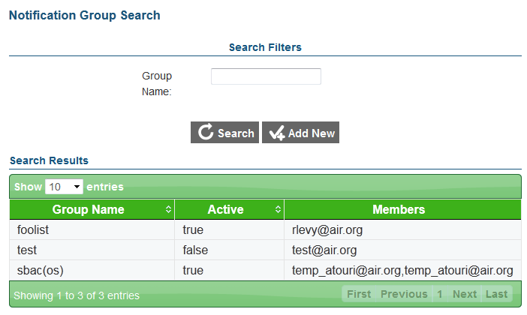

### Search for a Notification Group

The ***Notification Group Search*** screen lists all the existing notification groups. You can search for a notification group or groups by the group name.

To search for notification groups:

|  |
| --- |
| 1. On the homescreen (see Figure 2), click the Create/Modify Notification Groups icon. Alternatively, select the Create/Modify Notification Groups option from the menu. The ***Notification Group Search*** screen appears listing all the existing groups. 2. On the ***Notification Group Search*** screen, enter the group name. You can also enter partial names. 3. Click the [**Search**] button. The screen will display the search results table containing the groups that match the search criteria. |

### Add a Notification Group

From the ***Notification Group Search*** screen, you can add new notification groups to whom emails should be sent.

|  |  |
| --- | --- |
|  | A notification group must consist of at least one member. Furthermore, notification emails are only sent to groups that are marked as active. If a group is inactive, notification emails will not be sent to the group even if the specified notification criteria are met. |

Figure 11. Add Notification Group Popup Window

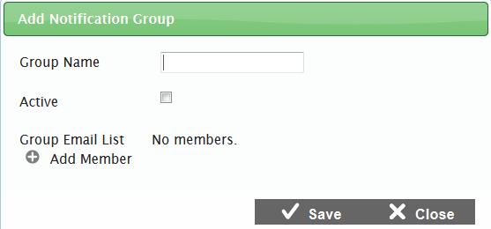

To add a notification group:

|  |
| --- |
| 1. On the ***Notification Group Search*** screen (see Figure 10), click the [**Add** **New**] button. The Add Notification Group Popup Window appears. 2. In the *Group Name* field, enter the group’s name. 3. To make the group active, check the checkbox in the *Active* field. 4. To add a member to the group, click the add [] button. A row containing a text box will be displayed where you can add the group member’s email address. 5. Enter the group member’s email address. 6. Repeat the above two steps to add more members to the group. To remove a member from the group, click the delete [] button next to the member’s email. 7. To save the notification group, click the [**Save**] button. Verify that the new notification group is listed on the ***Notification Group Search*** screen. |

### Edit a Notification Group

You can edit a notification group if necessary. You can edit the name of the notification group, add or delete members, and modify the status of the group.

Figure 12. Edit Notification Group Popup Window

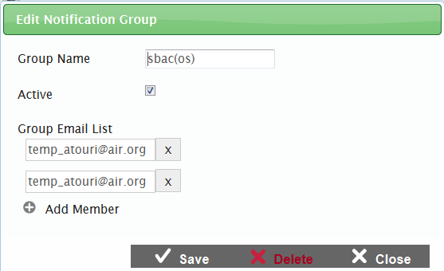

To edit a notification group:

|  |
| --- |
| 1. From the ***Notification Group Search*** screen (see Figure 10), search for the group you want to edit. 2. Double-click the selected row. The Edit Notification Group Popup Window appears. 3. Update the information as necessary. All fields are editable. 4. To save the update, click the [**Save**] button. |

### Delete a Notification Group

You can also delete a notification group if the group is no longer required.

To delete a notification group:

|  |
| --- |
| 1. From the ***Notification Group Search*** screen (see Figure 10), search for the group you want to delete. 2. Double-click the selected row. The Edit Notification Group Popup Window  (see Figure 12) appears. 3. To delete the group, click the [**Delete**] button. |

## Managing Notification Rules

The Monitoring and Alerting System enables you to create rules for sending out notification emails. Notification emails are sent to specified groups only when these rules are met. You can set up rules for both logs and alerts. From the ***Notification Rule Search*** screen (see Figure 13), authorized users can search for, create, and manage notification rules.

Figure 13. Notification Rule Search Screen

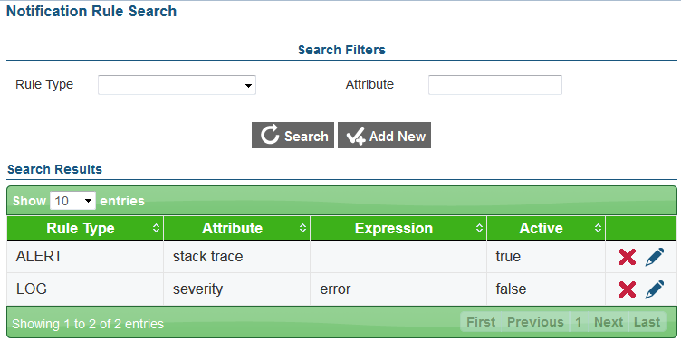

### Search for a Notification Rule

The ***Notification Rule Search*** screen lists all the existing notification rules.

To search for notification rules:

|  |
| --- |
| 1. On the homescreen (see Figure 2), click the Create/Modify Notification Rules icon. Alternatively, select the Create/Modify Notification Rules option from the menu. The ***Notification Rule Search*** screen appears listing all the existing rules. 2. On the ***Notification Group Search*** screen, enter any search criteria you want to include. The search criteria fields are described in Table 5. 3. Click the [**Search**] button. The screen will display the search results table containing the rules that match the search criteria. |

### Add a Notification Rule

From the ***Notification Rule Search*** screen, you can add new notification rules or criteria based on which notification emails can be sent to specified groups.

|  |  |
| --- | --- |
|  | Notification emails are only sent for rules that are marked as active and to groups that are marked as active. If a notification rule is inactive or if the group to whom the notification email should be sent is inactive, notification emails will not be sent. |

Figure 14. Add Notification Rule Popup Window

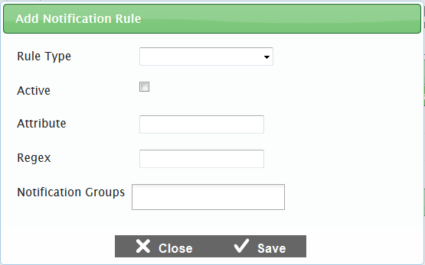

To add a notification rule:

|  |
| --- |
| 1. On the ***Notification Rule Search*** screen (see Figure 13), click the [**Add** **New**] button. The Add Notification Rule Popup Window appears. 2. Specify the notification rule details. The different fields are described in Table 5. 3. To save the notification rule, click the [**Save**] button. Verify that the new notification rule is listed on the ***Notification Rule Search*** screen. |

Table 5: Notification Rule Detail Fields

| Field | Description |
| --- | --- |
| Rule Type | Refers to the entity with which the rule is associated. You can set up notification rules for component alerts as well as logs. You can select the required entity from the drop-down list that displays the two available options:   * Alert * Log |
| Active | Indicates whether the rule is active. To activate the rule, check the checkbox. |
| Attribute | Refers to the log or alert field on which the notification rule should be performed. You can enter the required attribute in the text box provided.  The attributes are dependent on the selected rule type. The available attributes are:   * Alert:   + severity   + message   + alertType * Log:   + severity   + message   + stackTrace   + referenceNumber |
| Regex | Regex or Regular Expression refers to a specialized syntax for matching patterns in strings. You can enter the required regular expression, which is matched against the value of the attribute specified for the rule. If the attribute value matches the regular expression, notification emails can be sent.  For more information on regular expression, refer to <http://docs.oracle.com/javase/7/docs/api/java/util/regex/Pattern.html>. |
| Notification Groups | Refers to the groups to which notification emails should be sent in case the rule criteria are met. You can select the required notification group from the drop-down list. The list is only displayed after you start typing. For example, if you enter “c,” a list of all notification groups whose name contains the letter “c” appears.  You can also remove a notification group from the list by clicking the delete [] button next to the group. |

### Edit a Notification Rule

You can edit a notification rule if necessary. For example, if you want to receive notification alerts for a particular rule on specific days only, you can activate the rule on the required day and keep it deactivated at other times. You can edit all the details, such as the entity with which the rule is associated and the status of the rule. You can also add or delete the groups to whom notification emails should be sent.

Figure 15. Edit Notification Group Popup Window

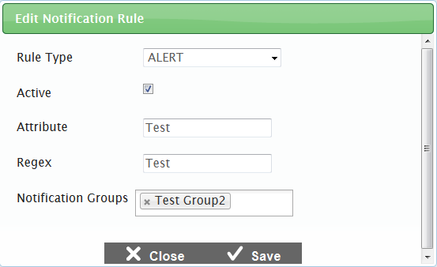

To edit a notification rule:

|  |
| --- |
| 1. From the ***Notification Rule Search*** screen (see Figure 13), search for the rule you want to edit. 2. Click the [] button. The Edit Notification Rule Popup Window appears. 3. Update the information as necessary. All fields are editable. 4. To save the update, click the [**Save**] button. |

### Delete a Notification Rule

You can also delete a notification rule if the rule is no longer required.

Figure 16. Delete Notification Rule Popup Window

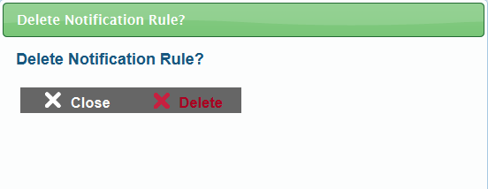

To delete a notification rule:

|  |
| --- |
| 1. From the ***Notification Rule Search*** screen (see Figure 13), search for the rule you want to delete. 2. Click the [] button. The Delete Notification Rule Popup Window (see Figure 16) appears. 3. To delete the rule, click the [**Delete**] button. |

# Appendix A. User Support

|  |  |
| --- | --- |
| **Contact Information** | |
| **Questions about state policies** | **Questions about technology and the overall administration procedures** |
| STATE  **Accommodations, Test Policy, Testing Irregularities**  {Blanks to fill in with your specific state information}   |  |  | | --- | --- | | Name: |  | | Phone: |  | | Email: |  |   **Your Smarter Balanced State Lead Contact (in the event of a security breach or irregularity)**  {Blanks to fill in with your specific state information}   |  |  | | --- | --- | | Name: |  | | Phone: |  | | Email: |  | | Assessment Program Name  Monday–Friday from 6:30 a.m. to 6:30 p.m. Eastern Time  800-555-5555  [demoHelpDesk@air.org](mailto:demoHelpDesk@air.org) |