

**Smarter Balanced**

**Assessment Consortium:**

**Program Management System User Guide**

**2014–2015**

**Published December 31, 2014**

© Smarter Balanced Assessment Consortium, 2014

**Table of Contents**

Introduction to This User Guide 5

Section I. Overview of the Program management System 6

User Roles and Access 6

Section II. Getting Started with the Program Management System 7

Logging in to the Program Management System 7

Understanding the Program Management System Layout 8

Header 8

Task Icons 9

Task Screens 10

Search Screen 10

Add/View/Edit Screen 11

Section III. Performing Program Management Tasks 12

Managing Tenants 12

Search for a Tenant 13

Add a Tenant 13

Edit a Tenant 15

Managing Components 16

Search for a Component 17

Add a Component 17

Edit a Component 18

Configuring Component Properties 19

Search for a Configuration 19

Add a Configuration 20

Add Component Properties 21

Edit a Configuration 22

View Configuration History 23

Delete a Configuration 24

Uploading Branding Images 25

View and Upload Branding Images for a Tenant 25

Delete an Uploaded Image 28

Configuring Component Branding 29

Search for a Component Branding Configuration 29

Add a Component Branding Configuration 30

Add Assets 31

Edit a Component Branding Configuration 32

Clone a Component Branding Configuration 33

Delete a Component Branding Configuration 34

Previewing Component Branding 35

Appendix A. User Support 37

**Table of Figures**

Figure 1. Login Screen 7

Figure 2. Program Management System Home Screen 8

Figure 3. Header 8

Figure 4. Program Management Task Icons 9

Figure 5. Sample Search Screen 10

Figure 6. Sample Add/View/Edit Screen 11

Figure 7. Error Message 11

Figure 8. Tenant Search Screen 12

Figure 9. Add Tenant Information Screen 13

Figure 10. Edit Tenant Information Screen 15

Figure 11. Component Search Screen 16

Figure 12. Add Component Information Screen 17

Figure 13. Edit Component Information Screen 18

Figure 14. Configuration Search Screen 19

Figure 15. Add Configuration Settings Screen 20

Figure 16. Edit Configuration Settings Screen 22

Figure 17. Configuration History Screen 23

Figure 18. Manage Branding Images Screen 25

Figure 19. Manage Branding Images Screen Listing Sample Branding Images for a Tenant 26

Figure 20. Sample File in Upload Queue 27

Figure 21. Component Branding Search Screen 29

Figure 22. New Component Branding Information Screen 30

Figure 23. View/Edit Component Branding Information Screen 32

Figure 24. Clone Component Branding Information Screen 33

Figure 25. Example Skinnable UI Screen 35

# Introduction to This User Guide

This user guide supports individuals using the Program Management System to manage the components or applications that are deployed for a tenant as well as the tenant’s assets or branding information. This introduction describes the contents of this document and includes a key for identifying icons and elements.

This user guide provides information about the Program Management System in a series of three sections, as follows:

* **Section I, Overview of the Program Management System**, provides an overview of the system and the user roles for accessing the system.
* **Section II, Getting Started with the Program Management System**, explains how to log in to the Program Management System and describes the overall layout of the Program Management System Interface.
* **Section III, Per****forming Program Management Tasks**, describes how to perform different program management tasks.

Table 1. Key Icons and Elements

|  |  |
| --- | --- |
| Icon | Description |
|  | **Warning**: This symbol appears with text that contains extremely important information regarding actions that may cause errors. |
| H:\Assessment\Interactive Content\Technical Writing_General Images and Logos\alert.png | **Caution**: This symbol appears with text that contains important information regarding a task. |
| H:\Assessment\Interactive Content\Technical Writing_General Images and Logos\note.png | **Note**: This symbol appears next to text that contains helpful information or reminders. |
|  | Text that appears in gray boxes provides instructions relevant to the task described.   * Numbered (ordered) lists provide step-by-step instructions. * Bulleted lists provide instructions that do not need to be done in a specific order. |
| [**Text**] | Text in brackets is used to indicate a link or button that is clickable. |
| *Text* | Text in italics indicates field names or labels. |
| “Text” | Text in quotation marks indicates the value specified for a field. |

# Section I. Overview of the Program management System

The Program Management System is a web-based system and is one of the core applications that must be deployed with any other component used by the tenant at any given deployment level.

It serves as a registry of components that are deployed for a tenant. It stores and provides property information about other components used by a tenant and allows the different components to access shared services. For example, the Program Management System provides the Test Authoring System with the location of the Core Standards System so that the Test Authoring System can retrieve standards publications and associate them with tenants and test subjects.

It also serves as a repository for a tenant’s branding assets, such as logos, images, etc., that can be used for customizing a component’s user interface.

## User Roles and Access

The Program Management System is a core infrastructure application and is accessible to only a limited number of users. Currently only users with the Administrator user role can access and perform all the tasks within the Program Management System.

# Section II. Getting Started with the Program Management System

This section provides information about getting started with the Program Management System:

* Logging in to the Program Management System
* Understanding the Program Management System layout

## Logging in to the Program Management System

To access the Program Management System, you must have an authorized user name and password. Your system administrator will be responsible for setting up your user account and providing you with the login credentials.

The Program Management System uses the Single Sign On (SSO) System, which is responsible for user authentication and authorization and allows you to log in to the Smarter Balanced systems. After logging in, you can switch among systems without having to log in and out of each system.

To log in to the Program Management System:

|  |  |
| --- | --- |
| 1. Open your web browser and navigate to the Program Management System using the URL provided to you.   You will be directed to the Single Sign On Login screen shown in Figure 1.   1. In the *Username* field, enter your user name. 2. In the *Password* field, enter your password. 3. Click the [**Log In**] button. You will be directed to the Program Management System homescreen, provided your login is authenticated. | Figure 1. Login Screen |

## Understanding the Program Management System Layout

You can access the different features of the Program Management System from the homescreen (see Figure 2) that appears when you first log in to the system.

|  |  |
| --- | --- |
|  | Use the on-screen tools and buttons to navigate within the system. Do not use your web browser’s back button. |

Figure 2. Program Management System Home Screen

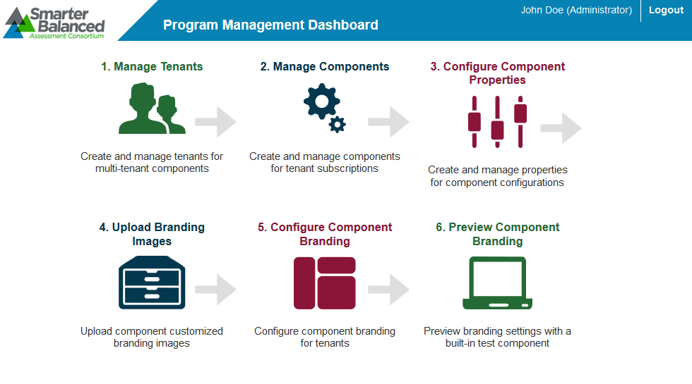

The Program Management System layout includes the features described below.

### Header

The header that appears on every screen provides information about the user logged in to the system and includes tools and buttons to perform different tasks, as shown in Figure 3.

Figure 3. Header



The header has the following features:

* User Identification: When you log in to the system, your name and user role are displayed on the header.
* [**Logo**]: The Smarter Balanced Assessment Consortium logo acts as a button that brings you back to the ***Home*** screen.
* [**Logout**]: This button enables you to log out of the system.

### Task Icons

The different program management tasks are displayed as icons on the home screen, as shown in Figure 4. Each task icon acts as a link that takes you to the specified task screen.

Figure 4. Program Management Task Icons

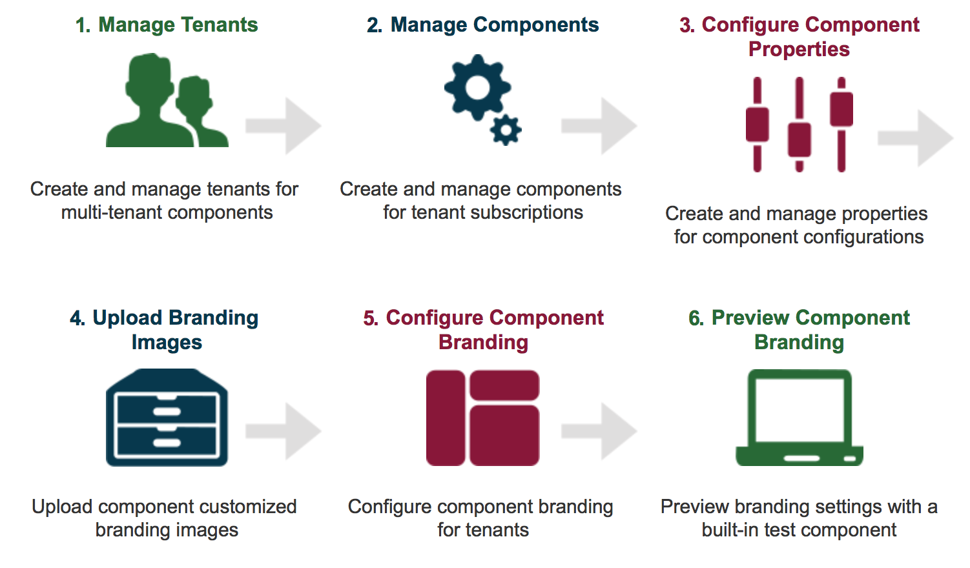

When you select a task, a menu is displayed on the screen. You can navigate through the different tasks using the menu. To return to the home screen and view the task icons, click the logo on the header.

### Task Screens

For ease of use, the Program Management System is designed to primarily use two types of screen layouts, the search screen and the add/view/edit screen.

#### Search Screen

When you first access a task, you are taken to the task’s search screen by default. Figure 5 shows a sample search screen.

Figure 5. Sample Search Screen

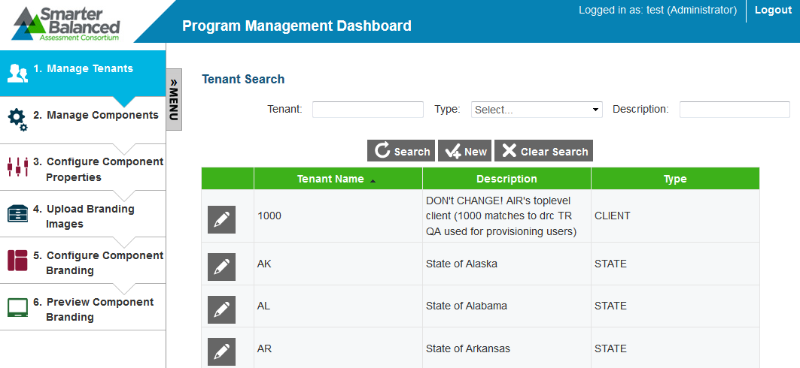

The search screen consists of the following two sections:

* Search Filters Section: This section allows you to search for records that have been created for the selected task. It consists of
  + search criteria fields applicable to the task that you are viewing, where you can specify the required search criteria;
  + a [**Search**] button that enables you to search for records based on the specified criteria; and
  + a [**Clear** **Search**] button that enables you to reset or clear the specified search criteria.

|  |  |
| --- | --- |
| H:\Assessment\Interactive Content\Technical Writing_General Images and Logos\note.png | The Search Filters section also consists of a [**New**] button that takes you to the Add/Edit/View screen where you can create a new record for the task. However, the button may not be available for all task categories. |

* Table of Records Section: The table of records displays the records that have been created for the selected task based on the search filter specifications. You can search for and filter the records using the search filters. The table contains the following features:
  + You can sort the data displayed in the columns by clicking the column header. Not all columns can be sorted. If a column can be sorted, arrows will be displayed when you hover over the column header. The column by which the data are sorted will display the arrows by default.
  + A navigation panel is displayed at the bottom of the table that enables you to navigate through the retrieved records. It also displays the number of records that matched the specified search criteria.

#### Add/View/Edit Screen

When you add, view, or edit a record, the same screen with slight variations is displayed. See  
 Figure 6 for a sample screen.

Figure 6. Sample Add/View/Edit Screen

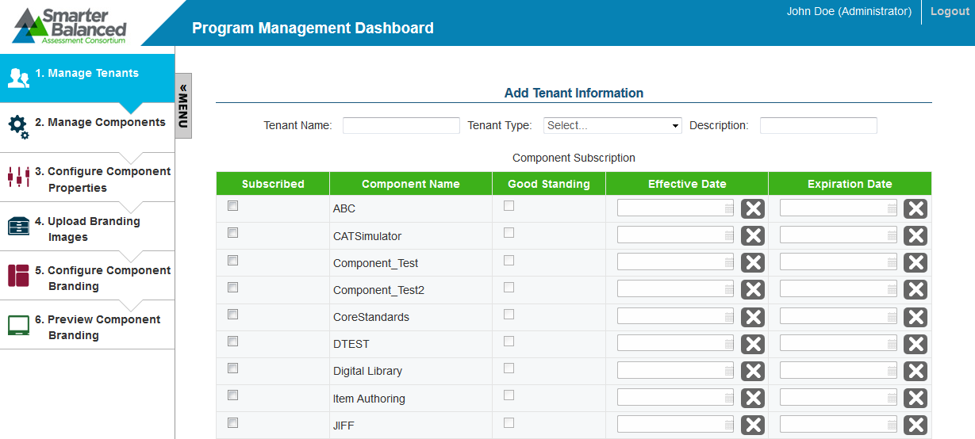

This screen has the following features:

* Displays a menu that enables you to access the different tasks for the selected test.
* Consists of task-specific fields where you can add or edit values.
* The [**Save**], [**Cancel**], and [**Return to Search**] buttons may be provided for a task. Additional task-specific buttons may also be displayed. For example, buttons to add component properties are displayed for the Configure Component Properties task category.
* Any errors that may occur while performing a task are displayed on the top of the screen, as shown in Figure 7. Additionally, the errors may also be displayed next to the field itself.

Figure 7. Error Message



# Section III. Performing Program Management Tasks

The core functionality of the Program Management System is to serve as a repository for component information of all the components deployed for a tenant and branding assets.

The different program management tasks include the following:

* Managing Tenants
* Managing Components
* Configuring Component Properties
* Uploading Branding Images
* Configuring Component Branding
* Previewing Component Branding

## Managing Tenants

The Program Management System enables you to set up tenants for whom you want to store component and branding information. Depending on the type of deployment, the Program Management System may consist of multiple tenants or a single tenant. For example, if the Smarter Balanced Assessment Consortium deploys only one instance of the Program Management System and all the states in the consortium access the same Program Management System, multiple tenants will need to be set up. However, if a separate instance of the Program Management System is deployed for each state in the consortium, only one tenant may need to be set up in the Program Management System.

From the ***Tenant Search*** screen (see Figure 8), authorized users can search for, create, and manage tenants.

Figure 8. Tenant Search Screen



To view the ***Tenant Search*** screen:

|  |
| --- |
| 1. On the homescreen (see Figure 2), click the Manage Tenants icon. The ***Tenant Search*** screen appears listing the tenants that have been created in the Program Management System. |

### Search for a Tenant

The ***Tenant Search*** screen allows users to search for tenants using the available search filters.

|  |  |
| --- | --- |
| H:\Assessment\Interactive Content\Technical Writing_General Images and Logos\note.png | All the search filters correspond to the tenant details that are specified at the time of creating a tenant. |

To search for tenants:

|  |
| --- |
| 1. On the ***Tenant Search*** screen, enter any search criteria you want to include. 2. Click the [**Search**] button. The screen will display the search results table containing the tenant records that match the search criteria. |

### Add a Tenant

The ***Add Tenant Information*** screen shown in Figure 9 allows you to add new tenants and specify the components to which the tenants are subscribed.

|  |  |
| --- | --- |
| H:\Assessment\Interactive Content\Technical Writing_General Images and Logos\note.png | By default, all the common open source system components are listed. If a tenant uses a different component, you can associate the component with the tenant after you have created the component. For more information on creating components, refer to Managing Components. |

|  |  |
| --- | --- |
| H:\Assessment\Interactive Content\Technical Writing_General Images and Logos\alert.png | When setting up a tenant, you must specify the components to which the tenant is subscribed. When logging in to a component, only users who are associated with tenants that are subscribed to the component and are in good standing are allowed access. |

Figure 9. Add Tenant Information Screen



To add a tenant:

|  |
| --- |
| 1. On the ***Tenant Search*** screen (see Figure 8), click the [**New**] button. The ***Add*** ***Tenant Information*** screen appears. 2. In the *Tenant Name* field, enter the tenant’s name. 3. From the *Tenant Type* drop-down list, select the type of tenant. The available options are “Client,” “State_Group,” “State,” “District_Group,” “District,” Institution_Group,” and “Institution.” 4. Optional: In the *Description* field, enter the tenant’s description. 5. From the Component Subscription table that lists all the components set up in the Program Management System, specify the following for the components to which the tenant is subscribed:    1. In the *Subscribed* column, check the box for the component to which the tenant is subscribed.    2. In the *Good Standing* column, verify that the box is checked. The box is automatically checked when you check the box in the *Subscribed* column. If you uncheck the box, users associated with the tenant will be prevented from accessing the component.    3. In the *Effective Date* field, specify the start date for the subscription. You can select the date from the calendar that appears when you click the text box. To delete the entered date, click the [] button.    4. Optional: In the *Expiration Date* field, specify the date when the subscription ends. You can select the date from the calendar that appears when you click the text box. If you do not specify a date, the tenant is subscribed to the component indefinitely. 6. To save the tenant details, click the [**Save**] button at the bottom of the screen. The button is only displayed after you have entered some data. 7. To return to the ***Tenant Search*** screen, click the [**Return to Search**] button. Verify that the tenant is listed on the screen. |

### Edit a Tenant

The ***Edit Tenant Information*** screen shown in Figure 10 allows you to edit tenant details, such as components to which a tenant is subscribed.

|  |  |
| --- | --- |
| H:\Assessment\Interactive Content\Technical Writing_General Images and Logos\alert.png | Once a tenant is created, you cannot delete the tenant. However, to prevent the tenant from accessing any component, you can unsubscribe the tenant from all the components associated with the tenant. |

Figure 10. Edit Tenant Information Screen

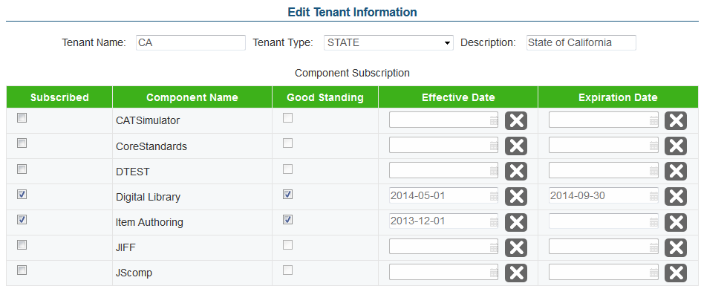

To edit a tenant:

|  |
| --- |
| 1. On the ***Tenant Search*** screen (see Figure 8), search for the tenant you want to edit. 2. Click the edit [] button next to the tenant. The ***Edit Tenant Information*** screen appears. 3. Update the information as necessary. 4. To save the updates, click the [**Save**] button. The button is only displayed after you have made a modification. 5. To return to the ***Tenant Search*** screen, click the [**Return to Search**] button. |

## Managing Components

The Program Management System enables you to manage the components that are used by a tenant. By default, all the common open source system components are included in the Program Management System. If a tenant uses any additional components, the components must be added in the Program Management System. For example, if a tenant stores test data in a customized data warehouse, the information about the data warehouse must be entered in the Program Management System.

From the ***Component Search*** screen (see Figure 11), authorized users can search for, create, and manage components.

|  |  |
| --- | --- |
| H:\Assessment\Interactive Content\Technical Writing_General Images and Logos\alert.png | The Manage Component task category only allows you to set up the name of the component. You can establish the component properties from the Configure Component Properties task category. |

Figure 11. Component Search Screen

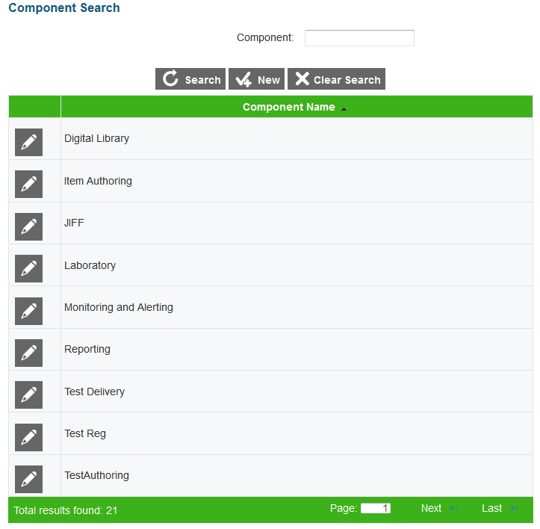

To view the ***Component Search*** screen:

|  |
| --- |
| 1. On the homescreen (see Figure 2), click the Manage Components icon. The ***Component Search*** screen appears listing the components that have been created in the Program Management System. Alternatively, select the Manage Components option from the menu. |

### Search for a Component

The ***Component Search*** screen allows users to search for components that have been created in the Program Management System using the available search filters.

To search for components:

|  |
| --- |
| 1. On the ***Component Search*** screen, enter the component name. You can also enter partial names. 2. Click the [**Search**] button. The screen will display the search results table containing the component records that match the search criteria. |

### Add a Component

The ***Add Component Information*** screen shown in Figure 12 allows you to add new components.

|  |  |
| --- | --- |
| H:\Assessment\Interactive Content\Technical Writing_General Images and Logos\alert.png | Once a component is created, you cannot delete the component. |

Figure 12. Add Component Information Screen

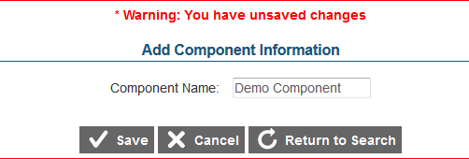

To add a component:

|  |
| --- |
| 1. On the ***Component Search*** screen (see Figure 11), click the [**New**] button. The ***Add Component Information*** screen appears. 2. In the *Component Name* field, enter the component’s name. 3. To save the component, click the [**Save**] button at the bottom of the screen. The button is only displayed after you have entered some data. 4. To return to the ***Component Search*** screen, click the [**Return to Search**] button. Verify that the component is listed on the screen. |

### Edit a Component

The ***Edit Component Information*** screen shown in Figure 13 allows you to edit a component’s name.

Figure 13. Edit Component Information Screen

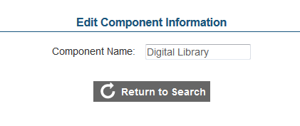

To edit a component:

|  |
| --- |
| 1. On the ***Component Search*** screen (see Figure 11), search for the component you want to edit. 2. Click the edit [] button next to the component. The ***Edit Component Information*** screen appears. 3. Update the component name. 4. To save the update, click the [**Save**] button. The button is only displayed after you have modified the name. 5. To return to the ***Component Search*** screen, click the [**Return to Search**] button. |

## Configuring Component Properties

The Program Management System stores configuration and localization information about the deployed components. The information may include the Uniform Resource Identifier (URI) that provides information about the location of a component, database usernames and passwords, and port information. A component accesses another component using the information retrieved from the Program Management System.

From the ***Configuration Search*** screen (see Figure 14), authorized users can search for, create, and manage property configurations for components.

Figure 14. Configuration Search Screen

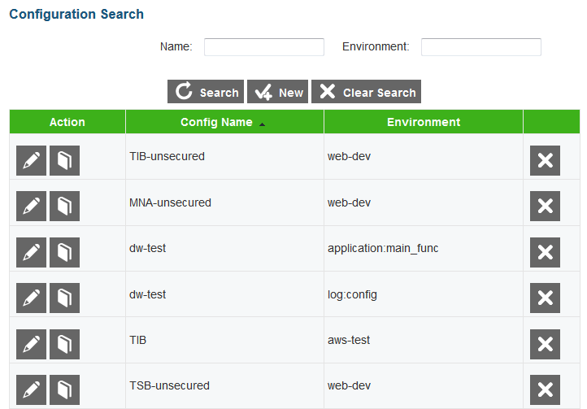

To view the ***Configuration Search*** screen:

|  |
| --- |
| 1. On the homescreen (see Figure 2), click the Configure Component Properties icon. The ***Configuration Search*** screen appears listing the configurations existing in the Program Management System. Alternatively, select the Configure Component Properties option from the menu. |

### Search for a Configuration

The ***Configuration Search*** screen allows users to search for existing configurations using the available search filters.

|  |  |
| --- | --- |
| H:\Assessment\Interactive Content\Technical Writing_General Images and Logos\note.png | All the search filters correspond to the configuration details that are specified at the time of creating a configuration. |

To search for configurations:

|  |
| --- |
| 1. On the ***Configuration Search*** screen, enter any search criteria you want to include. 2. Click the [**Search**] button. The screen will display the search results table containing the configuration records that match the search criteria. |

### Add a Configuration

The ***Add*** ***Configuration Settings*** screen shown in Figure 15 allows you to add new configurations and localization information for components to which a tenant is subscribed.

|  |  |
| --- | --- |
| H:\Assessment\Interactive Content\Technical Writing_General Images and Logos\note.png | You can create multiple configurations for the same component. For example, you can create Test Authoring System configurations for a development environment and a production environment. |

Figure 15. Add Configuration Settings Screen

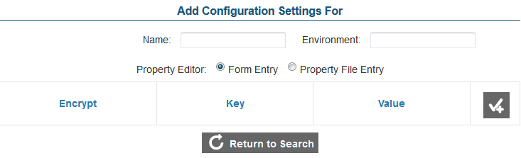

To add a configuration:

|  |
| --- |
| 1. On the ***Configuration Search*** screen (see Figure 14), click the [**New**] button. The ***Add*** ***Configuration Settings*** screen appears. 2. In the *Name* field, enter the name of the component for which the configuration is being created. 3. In the *Environment* field, enter the name of the environment for which the configuration is being created. 4. From the *Property Editor* section, select the appropriate radio button to indicate the method you want to use to add the component properties. The two options are    * Form Entry: Allows you to manually enter each property; and    * Property File Entry: Allows you to upload a property file in its entirety by copying the text and pasting it in the text area provided. 5. Enter the required component properties by the selected method. You must enter at least one property to be able to save the configuration. For more information, refer to Add Component Properties. 6. To save the configuration details, click the [**Save Configuration**] button at the bottom of the screen. The button is only displayed after you have entered some data. 7. To return to the ***Configuration Search*** screen, click the [**Return to Search**] button. Verify that the configuration is listed on the screen. |

#### Add Component Properties

There are two ways in which you can add component properties. You can either enter each property manually or upload the entire property file.

To enter properties manually:

|  |
| --- |
| 1. From the Property Editor section, select the [**Form Entry**] radio button. 2. Click the [] button to add a property row and specify the following:    1. In the Encrypt column, check the box if you wish to encrypt the property value.    2. In the *Key* field, enter the name of the property.    3. In the *Value* field, enter the property value. If the property is not encrypted, the value will be displayed in clear text. 3. Repeat the above step until all the required properties have been added. To delete a property, click the [] button. 4. To save the properties, click the [**Save Configuration**] button. |

|  |  |
| --- | --- |
| H:\Assessment\Interactive Content\Technical Writing_General Images and Logos\alert.png | When you encrypt a property value, the value is encrypted in the database in which it is stored. However, when a component retrieves that information, the value is decrypted. For example, if you encrypt the password for the Core Standards System, the password will be stored in an encrypted form in the Program Management database. However, when the Test Authoring System retrieves the information from the Program Management System in order to access the Core Standards System, the password is provided to the Test Authoring System in a decrypted form. |

To upload an entire property file:

|  |
| --- |
| 1. From the Property Editor section, select the [**Property File Entry**] radio button. A text area will be displayed. 2. Copy the required properties file and paste it in the text area. You can also manually enter the properties in the text area. 3. To save the properties, click the [**Save Configuration**] button. |

### Edit a Configuration

The ***Edit Configuration Settings*** screen shown in Figure 16 allows you to edit component configurations, such as the name, environment, and the component properties.

Figure 16. Edit Configuration Settings Screen

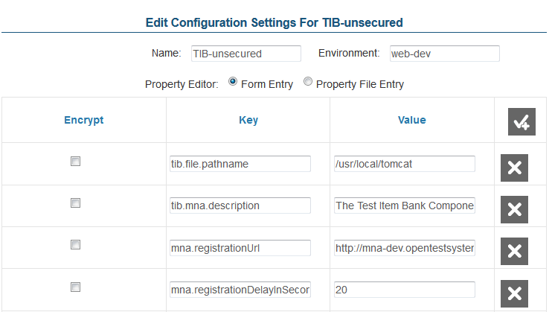

To edit a configuration:

|  |
| --- |
| 1. On the ***Configuration Search*** screen (see Figure 14), search for the configuration you want to edit. 2. Click the edit [] button next to the configuration. The ***Edit Configuration*** ***Settings*** screen appears. 3. Update the information as necessary. You can update the environment, property file key names and values; add new properties; and delete existing properties. 4. To save the updates, click the [**Save Configuration**] button. The button is only displayed after you have made an update. 5. To return to the ***Configuration Search*** screen, click the [**Return to Search**] button. |

|  |  |
| --- | --- |
| H:\Assessment\Interactive Content\Technical Writing_General Images and Logos\note.png | When you edit a component’s properties, the old version is automatically archived for historical purposes and a new version is created. You can view all the existing versions from the ***Configuration History*** screen. |

### View Configuration History

The ***Configuration*** ***History*** screen allows you to view all the versions created for a component configuration.

Figure 17. Configuration History Screen

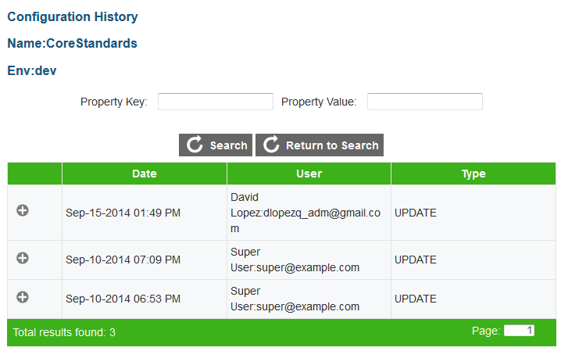

To view the configuration history:

|  |
| --- |
| 1. On the ***Configuration Search*** screen (see Figure 14), search for the configuration whose versions you want to view. 2. Click the view configuration history [] button next to the configuration. The ***Configuration History*** screen appears displaying all the existing versions for the selected configuration in chronological order with the latest version listed first. 3. Click the expand [] button to view the property details for the selected version. The changes between the selected version and the earlier version are highlighted. |

|  |  |
| --- | --- |
| H:\Assessment\Interactive Content\Technical Writing_General Images and Logos\note.png | **Searching for a configuration version**:  You can also search for versions containing a particular property key or property value. To search for versions, follow these steps:   1. On the ***Configuration History*** screen, enter the required search criteria in the *Property Key* or *Property Value* field. 2. Click the [**Search**] button. The version or versions containing the specified search criteria will be displayed. |

### Delete a Configuration

You can delete existing component configurations if required.

To delete a configuration:

|  |
| --- |
| 1. On the ***Configuration Search*** screen (see Figure 14), search for the configuration you want to delete. 2. Click the delete [] button next to the configuration. A popup message that asks whether you are sure you want to delete the configuration will appear. 3. To delete the configuration and all its versions, click the [**OK**] button. The configuration will no longer be listed on the ***Configuration Search*** screen. |

## Uploading Branding Images

The Program Management System serves as a repository for a tenant’s branding information, such as logos and background images. You can associate the uploaded branding images with the components to which a tenant is subscribed and thereby customize a component’s user interface, if necessary.

From the ***Manage Branding Images*** screen (see Figure 18), authorized users can view and upload branding images for the different tenants.

Figure 18. Manage Branding Images Screen

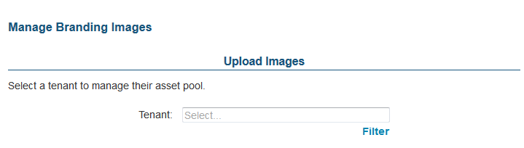

### View and Upload Branding Images for a Tenant

Select a Tenant

|  |
| --- |
| 1. On the homescreen (see Figure 2), click the Upload Branding Images icon. The ***Manage Branding Images*** screen appears (see Figure 18). Alternatively, select the Upload Branding Images option from the menu. 2. From the *Tenant* drop-down list, select the tenant to whom the branding images belong. All the branding images uploaded for the tenant will be listed on the screen along with buttons to upload more images or delete images (see Figure 19). |

|  |  |
| --- | --- |
| H:\Assessment\Interactive Content\Technical Writing_General Images and Logos\note.png | **Selecting a Tenant:**   * The *Tenant* drop-down list only displays the tenant names after you start typing. For example, if you enter “c,” a list of all tenants whose name contains the letter “c” appears. * You can also filter the tenants displayed in the drop-down list by tenant type. This is especially useful when there are a large number of tenants. To filter tenants by tenant type:   + 1. Click the [**Filter**] link underneath the *Tenant* drop-down list. This will open a popup window.     2. From the *Tenant Type Filter* drop-down list, select the tenant type by which you wish to filter the records. For example, select “Institution” to view only those tenants whose name contains the letter “c” and who are of the institution type.     3. Click the [**Filter**] button. The *Tenant* field on the ***Manage Branding Images*** screen will display the tenant type by which the field is being filtered. |

Figure 19. Manage Branding Images Screen Listing Sample Branding Images for a Tenant

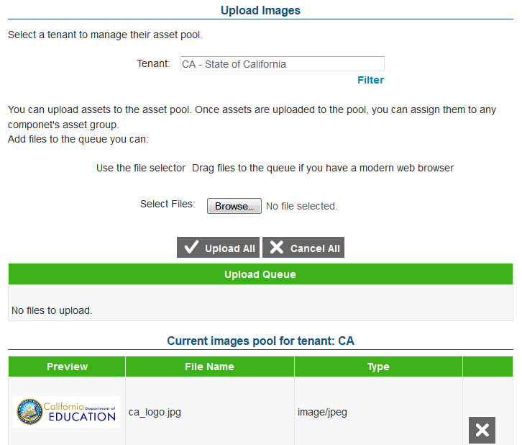

Upload Images

You can upload one or more assets or files simultaneously. You can either select the files that you want to upload using the file selector or you can drag the files and add them to the queue.

To select files using the file selector:

|  |
| --- |
| 1. On the ***Manage Branding Images*** screen (see Figure 18), click the [**Browse**] button. This will open a File Explorer window where you can select the file that you want to upload. 2. Select the file in a browser-specific manner. The file will be added to the Upload Queue section as shown in Figure 20.   Figure 20. Sample File in Upload Queue     1. Repeat the above steps to select other files, if necessary. 2. Click the [**Upload All**] button to upload all the files in the queue simultaneously. Alternatively, click the [**Upload**] button next to the file that you want to upload. If the files are in a valid format, a message will be displayed to indicate that the selected file or files have been uploaded successfully, and the files will be listed in the Current Asset Pool section. |

To drag and select files to upload:

|  |
| --- |
| 1. Open a File Explorer window and select the file you want to upload. 2. Drag the file to the Upload Queue section on the ***Manage Branding Information*** screen. The file will be listed in the same way as it is when you select a file from the file selector. 3. Repeat the above steps to select other files, if necessary. 4. Click the [**Upload All**] button to upload all the files in the queue simultaneously. Alternatively, click the [**Upload**] button next to the file that you want to upload. If the files are in a valid format, a message will be displayed to indicate that the selected file or files have been uploaded successfully, and the files will be listed in the Current Asset Pool section. |

### Delete an Uploaded Image

The ***Manage Branding Images*** screen allows users to delete branding images uploaded for a tenant.

|  |  |
| --- | --- |
| H:\Assessment\Interactive Content\Technical Writing_General Images and Logos\alert.png | When you delete an asset, the action cannot be undone and the asset will be instantly removed. |

To delete images:

|  |
| --- |
| 1. From the *Tenant* drop-down list on the ***Manage Branding Images*** screen, select the tenant whose assets you want to delete. All the existing branding assets will be listed on the screen. 2. Click the delete [] button next to the asset you want to delete. The asset will be removed from the list. |

## Configuring Component Branding

The Program Management System allows you to associate branding images uploaded for a tenant with the components to which the tenant is subscribed and thereby customize a component’s user interface. When a component launches, it retrieves this branding information and presents it to the tenant accordingly.

|  |  |
| --- | --- |
| H:\Assessment\Interactive Content\Technical Writing_General Images and Logos\alert.png | Not all components support a customizable user interface. The branding images will only be applied to components that support customization. |

From the ***Component Branding Search*** screen (see Figure 21), authorized users can search for, create, and manage component branding associations for a tenant.

Figure 21. Component Branding Search Screen

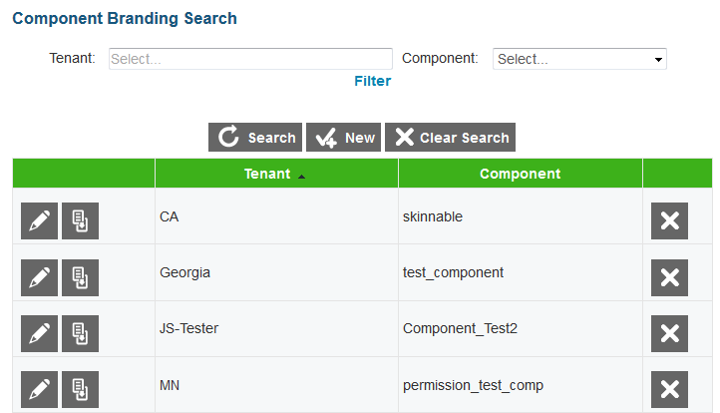

To view the ***Component Branding Search*** screen:

|  |
| --- |
| 1. On the homescreen (see Figure 2), click the Configure Component Branding icon. The ***Component Branding Search*** screen appears listing the component branding associations configured in the Program Management System. Alternatively, select the Configure Component Branding option from the menu. |

### Search for a Component Branding Configuration

The ***Component Branding Search*** screen allows users to search for existing component branding configurations using the available search filters.

To search for configurations:

|  |
| --- |
| 1. On the ***Component Branding Search*** screen, enter any search criteria you want to include. You can search for configurations by tenant and/or component. 2. Click the [**Search**] button. The screen will display the search results table containing the configuration records that match the search criteria. |

### Add a Component Branding Configuration

The ***New Component Branding Information*** screen allows you to add new component branding configurations for tenants.

|  |  |
| --- | --- |
| H:\Assessment\Interactive Content\Technical Writing_General Images and Logos\note.png | You can create one configuration per tenant and component. For example, you can create component branding configurations for all the existing components for the tenant AIR Demo State. However, you cannot create two configurations for the component Test Authoring System for the tenant AIR Demo State. Figure 22 shows the ***New Component Branding Information*** screen. |

Figure 22. New Component Branding Information Screen

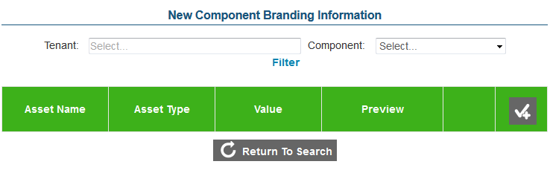

To add a component branding configuration:

|  |
| --- |
| 1. On the ***Component Branding Search*** screen (see Figure 21), click the [**New**] button. The ***New Component Branding Information*** screen appears. 2. From the *Tenant* drop-down list, select the tenant for whom the configuration is being created. The *Tenant* drop-down list only displays the tenant names after you start typing. For example, if you enter “c,” a list of all tenants whose name contains the letter “c” appears. You can also filter the tenants displayed in the drop-down list by tenant type. For more information, refer to View and Upload Branding Images for a Tenant. 3. From the *Component* drop-down list, select the component with which the configuration is associated. 4. Add the required assets. For more information, refer to Add Assets. 5. To save the configuration details, click the [**Save**] button at the bottom of the screen. The button is only displayed after you have entered some data. 6. To return to the ***Component Branding Search*** screen, click the [**Return to Search**] button. Verify that the configuration is listed on the screen. |

#### Add Assets

You can add as many assets as required for a component branding configuration. You can add two types of assets, images or properties.

To add images:

|  |
| --- |
| 1. On the ***New Component Branding Information*** screen, click the [] button to add an asset row. 2. In the *Asset Name* field, enter the name of the asset. 3. From the *Asset Type* field, select the asset type “Image.” 4. Click the upload image [] button. A popup window will appear. 5. From the Asset drop-down list on the popup window, select the image you want to upload. The drop-down list displays all the assets that have been uploaded for a tenant. For information on uploading images, refer to Uploading Branding Images. 6. To add the asset to the configuration, click the [**Use**] button. 7. Repeat the above steps to add other images if necessary. |

To add properties:

|  |
| --- |
| 1. On the ***New Component Branding Information*** screen, click the [] button to add an asset row. 2. In the *Asset Name* field, enter the name of the asset. 3. From the *Asset Type* field, select the asset type “Property.” 4. In the *Value* field, enter the property value. 5. Repeat the above steps to add other properties. |

### Edit a Component Branding Configuration

The ***Edit Component Branding Information*** screen shown in Figure 23 allows you to edit existing component branding configurations.

Figure 23. View/Edit Component Branding Information Screen

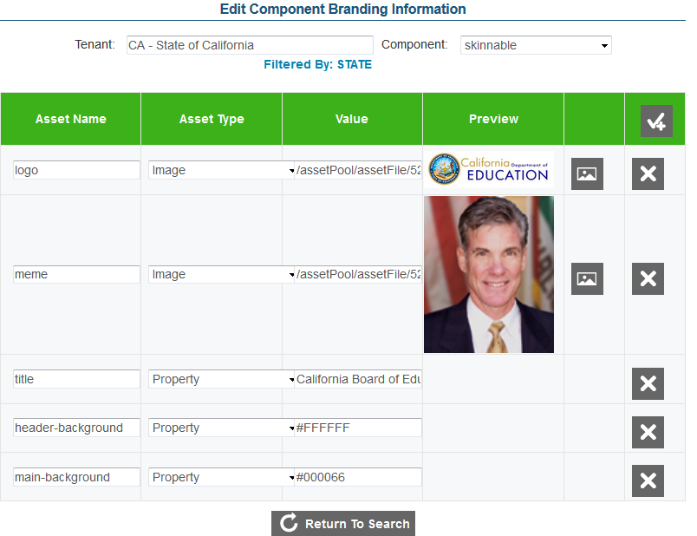

To edit a configuration:

|  |
| --- |
| 1. On the ***Component Branding Search*** screen (see Figure 21), search for the configuration you want to edit. 2. Click the edit [] button next to the configuration. The ***Edit Component Branding Information*** screen appears. 3. Update the information as necessary. You can update the tenant, component and asset information; add new assets; and delete existing assets. 4. To save the updates, click the [**Save**] button. The button is only displayed after you have made an update. 5. To return to the ***Component Branding Search*** screen, click the [**Return to Search**] button. |

### Clone a Component Branding Configuration

The ***Clone Component Branding Information*** screen shown in Figure 24 allows you to clone or copy existing component branding configurations. If a tenant is subscribed to more than one component that uses similar graphics and images, you can clone an existing configuration and then make modifications if necessary. You can clone component branding configurations across tenants and components.

Figure 24. Clone Component Branding Information Screen

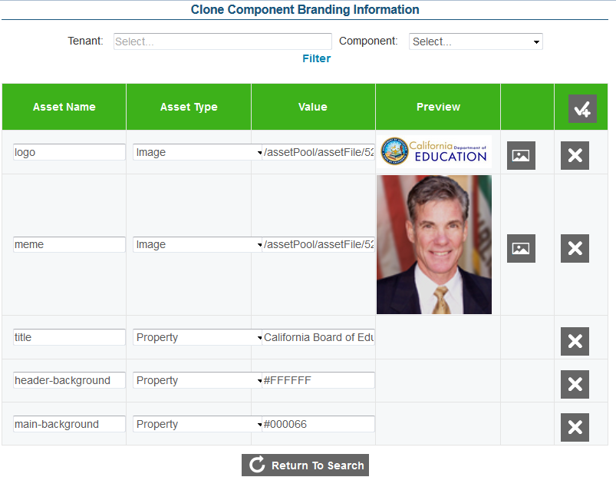

To clone component branding configurations:

|  |
| --- |
| 1. On the ***Component Branding Search*** screen (see Figure 21), search for the configuration that you want to copy. 2. Click the clone configuration [] button next to the configuration. The ***Clone Component Branding Information*** screen appears displaying all the assets created for the configuration. 3. From the *Tenant* drop-down list, select the tenant for whom the configuration is being created. The *Tenant* drop-down list only displays the tenant names after you start typing. For example, if you enter “c,” a list of all tenants whose name contains the letter “c” appears. You can also filter the tenants displayed in the drop-down list by tenant type. For more information, refer to View and Upload Branding Images for a Tenant. 4. From the *Component* drop-down list, select the component with which the configuration is associated. 5. To save the component branding configuration, click the [**Save**] button. The button is only displayed after you have selected a tenant or component or modified the assets. 6. To return to the ***Component Branding Search*** screen, click the [**Return to Search**] button. Verify that the configuration is listed on the screen. |

### Delete a Component Branding Configuration

You can delete component branding configurations that have been created for a tenant.

To delete a branding configuration:

|  |
| --- |
| 1. On the ***Component Branding Search*** screen (see Figure 21), search for the configuration you want to delete. 2. Click the delete [] button next to the configuration. A popup message that asks whether you are sure you want to delete the configuration will appear. 3. To delete the configuration, click the [**OK**] button. The configuration will no longer be listed on the ***Component Branding Search*** screen. |

## Previewing Component Branding

The Program Management System allows you to preview how a component may be customized using the branding images specified for a client. You can upload and configure the necessary assets for a tenant and view the outcome.

|  |  |
| --- | --- |
| H:\Assessment\Interactive Content\Technical Writing_General Images and Logos\alert.png | To be able to preview the customization, you need to ensure the following:   * The demo component Skinnable has been created and the tenant is subscribed to the component. * The Skinnable component has been configured with the tenant branding images that you want to preview. |

You can preview the sample UI customization from the ***Example Skinnable UI*** screen shown in Figure 25 below.

Figure 25. Example Skinnable UI Screen

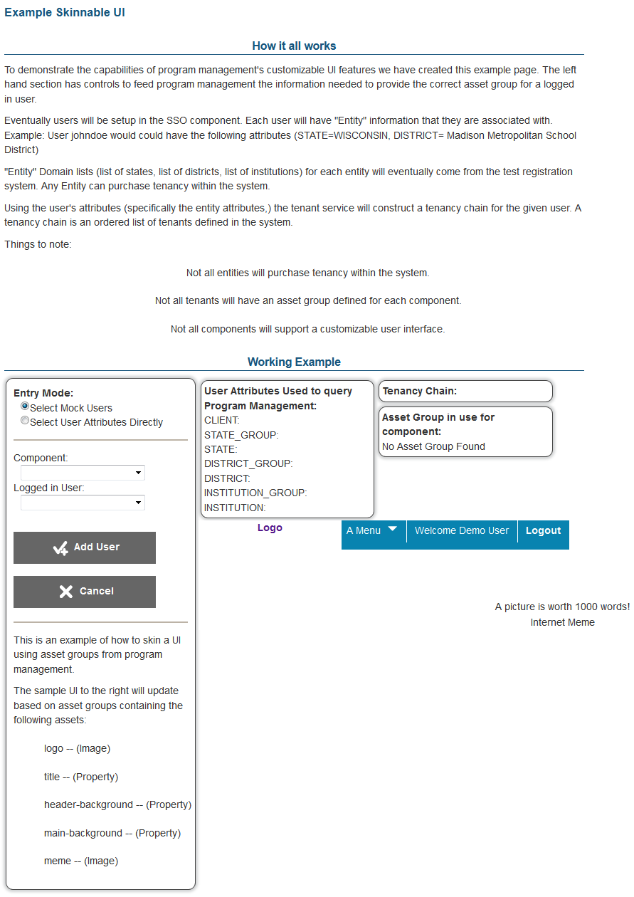

There are two ways in which you can preview the customization. You can either select the users directly or select mock users.

To preview the component branding by selecting the users directly:

|  |
| --- |
| 1. On the ***Example Skinnable UI*** screen (see Figure 25), click the [**Select User Attributes Directly**] radio button. 2. From the *Component* drop-down list, select the component that you wish to view. Note: The branding preview only works for the Skinnable component. 3. Specify the tenant for whom you wish to view the branding from the different drop-down fields. 4. The tenancy information and the component branding images will be displayed on the screen. |

To preview the component branding using mock users:

|  |
| --- |
| 1. On the ***Example Skinnable UI*** screen (see Figure 25), click the [**Select Mock Users**] radio button. 2. From the *Component* drop-down list, select the component that you wish to view. Note: The branding preview only works for the Skinnable component. 3. From the *Logged in* drop-down list, select the required user. You can also add a new user if required. 4. The tenancy information will automatically update based on the tenant with which the user is associated and the component branding images will be displayed on the screen. |

|  |  |
| --- | --- |
| H:\Assessment\Interactive Content\Technical Writing_General Images and Logos\note.png | **Adding a Mock User:**   1. On the Example Skinnable UI screen (see Figure 25), click the [**Select Mock Users**] radio button. 2. Click the [**Add User**] button. 3. In the *Username* field, enter the name of the user. 4. Enter the user’s tenancy information in the respective fields. 5. Click the [**Save User**] button. |

# Appendix A. User Support

|  |  |
| --- | --- |
| **Contact Information** | |
| **Questions about state policies** | **Questions about technology and the overall administration procedures** |
| STATE  **Accommodations, Test Policy, Testing Irregularities**  {Blanks to fill in with your specific state information}   |  |  | | --- | --- | | Name: |  | | Phone: |  | | Email: |  |   **Your Smarter Balanced State Lead Contact (in the event of a security breach or irregularity)**  {Blanks to fill in with your specific state information}   |  |  | | --- | --- | | Name: |  | | Phone: |  | | Email: |  | | Assessment Program Name  Monday–Friday from 6:30 a.m. to 6:30 p.m. Eastern Time  800-555-5555  [demoHelpDesk@air.org](mailto:demoHelpDesk@air.org) |