****

**Smarter Balanced**

**Assessment Consortium:**

**Test Administrator User Guide**

**Table of Contents**

[Overview of the Test Delivery System 8](#_Toc410293069)

[Systems for the Operational and Practice and Training Tests 8](#_Toc410293070)

[Operational Administration 8](#_Toc410293071)

[Practice and Training Test Administration 8](#_Toc410293072)

[Introduction to This User Guide 10](#_Toc410293073)

[Other Resources 11](#_Toc410293074)

[Section I. General Rules of Online Testing 12](#_Toc410293075)

[Test Administration Policies and Procedures 12](#_Toc410293076)

[About Test Settings (Embedded Universal Tools, Designated Supports, and Accommodations) 12](#_Toc410293077)

[Basic Test Rules 13](#_Toc410293078)

[Pause Rules 13](#_Toc410293079)

[Performance Task Tests 13](#_Toc410293080)

[Non-Performance Task Tests 13](#_Toc410293081)

[About Segmented Tests 14](#_Toc410293082)

[Test Timeout (Due to Inactivity) 14](#_Toc410293083)

[Section II. Accessing the Test Administrator Sites 15](#_Toc410293084)

[Accessing the TA Interface 15](#_Toc410293085)

[Accessing the TA Training Site for the Practice and Training Tests 15](#_Toc410293086)

[Switching between Smarter Balanced Systems (Single Sign On System) 17](#_Toc410293087)

[Section III. Understanding the Test Administration Sites 18](#_Toc410293088)

[TA Site Layout 18](#_Toc410293089)

[Recognizing the Difference between the TA Sites 18](#_Toc410293090)

[TA Site Quick Reference 20](#_Toc410293091)

[Student Lookup: Quick Search and Advanced Search 21](#_Toc410293092)

[Alert Messages 22](#_Toc410293093)

[Viewing Past Alerts 22](#_Toc410293094)

[Printing Session Information 22](#_Toc410293095)

[Section IV. Administering Online Tests 23](#_Toc410293096)

[Starting a Test Session 23](#_Toc410293097)

[Selecting Tests to Include in the Test Session 23](#_Toc410293098)

[Starting a Test Session 23](#_Toc410293099)

[Adding Tests to the Test Session 24](#_Toc410293100)

[Viewing Students’ Test Settings and Approving Students for Testing 25](#_Toc410293101)

[Notification of Students Awaiting Approval (Approvals Preview) 25](#_Toc410293102)

[Viewing and Editing Students’ Test Settings 25](#_Toc410293103)

[Approving Students for Testing 28](#_Toc410293104)

[Denying Students Entry to the Test Session 29](#_Toc410293105)

[About Student Test Settings 30](#_Toc410293106)

[Monitoring Students’ Testing Progress 32](#_Toc410293107)

[Student Statuses During Testing 33](#_Toc410293108)

[Pausing a Student’s Test 35](#_Toc410293109)

[Stopping a Test Session and Logging Out 36](#_Toc410293110)

[Stopping the Test Session 36](#_Toc410293111)

[Exiting or Logging Out of the TA Interface 36](#_Toc410293112)

[Closing the Browser/Unintentional Exit 36](#_Toc410293113)

[Test Session Timeout/Automatic Logout 37](#_Toc410293114)

[Logging Out 37](#_Toc410293115)

[Section V. Understanding the Student Testing Site 38](#_Toc410293116)

[Test Layout 38](#_Toc410293117)

[Global and Context Menus 39](#_Toc410293118)

[Global Menu 39](#_Toc410293119)

[Adjusting the System Volume 39](#_Toc410293120)

[Context Menus and Test Elements 40](#_Toc410293121)

[Opening a Context Menu on Desktops and Laptops 41](#_Toc410293122)

[Opening a Context Menu on Tablets 41](#_Toc410293123)

[Opening a Context Menu on Chromebooks 42](#_Toc410293124)

[Universal Tools Available in Online Tests 43](#_Toc410293125)

[Universal Test Tools 43](#_Toc410293126)

[ELA Performance Task Test Tools 44](#_Toc410293127)

[Mathematics Test Tools: Online Calculator 44](#_Toc410293128)

[Stimulus Expansion Tool 45](#_Toc410293129)

[Accessing Tools for Embedded Designated Supports and Accommodations 45](#_Toc410293130)

[American Sign Language Video Tool 46](#_Toc410293131)

[English Glossary and Translation (Glossary) Tool 47](#_Toc410293132)

[Masking Tool 48](#_Toc410293133)

[Print-on-Demand Tool 49](#_Toc410293134)

[Text-to-Speech Speak Tool 50](#_Toc410293135)

[Section VI. Taking Online Tests (Student View) 52](#_Toc410293136)

[Student Login and Test Selection 52](#_Toc410293137)

[Step 1—Logging In 53](#_Toc410293138)

[Troubleshooting Student Login Errors 53](#_Toc410293139)

[Step 2—Verifying Student Information 55](#_Toc410293140)

[Step 3—Selecting a Test 56](#_Toc410293141)

[Step 4—Verifying Test Information 57](#_Toc410293142)

[Step 4b—Audio Check for Tests with Text-to-Speech 58](#_Toc410293143)

[Step 4c—Sound Check for Tests with Listening Items 59](#_Toc410293144)

[Step 5—Viewing Test Instructions and Help and Starting the Test 60](#_Toc410293145)

[Proceeding through the Test 61](#_Toc410293146)

[Answering Test Items 61](#_Toc410293147)

[Marking Items for Review 61](#_Toc410293148)

[Reviewing Past or Marked Items 62](#_Toc410293149)

[Reaching the End of a Segment and Reviewing Items 62](#_Toc410293150)

[Pausing Tests 62](#_Toc410293151)

[Reaching the End of the Test 64](#_Toc410293152)

[End Test Review/Submit Page 65](#_Toc410293153)

[Test Submitted Confirmation Screen 66](#_Toc410293154)

[Appendix A. About the Secure Browser 67](#_Toc410293155)

[Forbidden Application Detection 67](#_Toc410293156)

[About Testing on iPads and Android Tablets 68](#_Toc410293157)

[Configuring iPads 68](#_Toc410293158)

[Configuring Android Tablets 68](#_Toc410293159)

[About Permissive Mode 69](#_Toc410293160)

[Secure Browser Error Messages 70](#_Toc410293161)

[Force-Quit Commands for Secure Browsers 70](#_Toc410293162)

[Appendix B. Transferring TA Test Sessions between Computers 71](#_Toc410293163)

[Appendix C. Accessing the Practice and Training Tests 72](#_Toc410293164)

[Appendix D. Keyboard Commands for Students 75](#_Toc410293165)

[Test Selection Screens and In-Test Pop-ups 76](#_Toc410293166)

[Keyboard Commands for Items with Add Point, Add Arrow, and Collect Line Tools 77](#_Toc410293167)

[Accessing an Element Context Menu with Keyboard Commands 78](#_Toc410293168)

[Context Menu: Highlighting Text with the Keyboard 78](#_Toc410293169)

[Appendix E. Calculators in the Test Delivery System 79](#_Toc410293170)

[About Online Calculators in the Test Delivery System 79](#_Toc410293171)

[Accessing the Sample Calculators 80](#_Toc410293172)

[Open a Sample Calculator on Windows/Mac/Linux 80](#_Toc410293173)

[Create a Desktop Shortcut to the Sample Calculator 80](#_Toc410293174)

[Open a Sample Calculator on a Mobile Tablet 81](#_Toc410293175)

[Save a Sample Calculator to your Home Screen (iPad) 81](#_Toc410293176)

[Bookmark and Add a Sample Calculator to Your Home Screen (Android) 82](#_Toc410293177)

[Available Calculators 83](#_Toc410293178)

[Basic (Four-Function) Calculator 83](#_Toc410293179)

[Scientific Calculator 84](#_Toc410293180)

[Graphing Calculator 85](#_Toc410293181)

[Regression Calculator 88](#_Toc410293182)

[Keyboard Shortcuts for Calculators 89](#_Toc410293183)

[Appendix F. Using Braille with Online Testing 90](#_Toc410293184)

[About Online Testing and Braille 90](#_Toc410293185)

[Braille Technology Requirements and Configuration 90](#_Toc410293186)

[Requirements for Test Administrator Computers 90](#_Toc410293187)

[Requirements for Student Computers 91](#_Toc410293188)

[Configure JAWS to Recognize the Secure Browser 91](#_Toc410293189)

[Applying Settings for Contracted/Uncontracted Braille 92](#_Toc410293190)

[Optional JAWS Voice Adjustment Settings 94](#_Toc410293191)

[Opening the JAWS Voice Adjustment Window 94](#_Toc410293192)

[Adjusting JAWS Voice Profile, Speaking Rate, and Punctuation Settings 94](#_Toc410293193)

[Approvals and Student Test Settings for Braille 95](#_Toc410293194)

[Student Print Requests 96](#_Toc410293195)

[Approving Print Requests 96](#_Toc410293196)

[Configuring Default Printing Preferences on the TA Computer 97](#_Toc410293197)

[BRF Files with the Duxbury Braille Translator Software 97](#_Toc410293198)

[PRN Files with the Tiger View Software 100](#_Toc410293199)

[Braille Interface Tools and Navigation 102](#_Toc410293200)

[JAWS Commands 102](#_Toc410293201)

[Navigating through the Login Screens 103](#_Toc410293202)

[Appendix G. Tools for Full-Write Item Types 104](#_Toc410293203)

[Using the Response Field Tools 104](#_Toc410293204)

[Spell Check 105](#_Toc410293205)

[Special Characters 105](#_Toc410293206)

[Appendix H. Dictionary and Thesaurus Tool 107](#_Toc410293207)

[User Support 108](#_Toc410293208)

[Smarter Balanced Help Desk 108](#_Toc410293209)

[Change Log 109](#_Toc410293210)

**Table of Figures**

[Figure 1. Portal Button for Operational Tests 15](#_Toc410293211)

[Figure 2. TA Interface Button 15](#_Toc410293212)

[Figure 3. Login Screen 15](#_Toc410293213)

[Figure 4. Portal Button for Practice and Training Tests 15](#_Toc410293214)

[Figure 5. TA Practice and Training Site Button 15](#_Toc410293215)

[Figure 6. Login Screen 16](#_Toc410293216)

[Figure 7. Sample SSO Drop-Down Menu 17](#_Toc410293217)

[Figure 8. TA Interface for Operational Tests 18](#_Toc410293218)

[Figure 9. TA Interface Banner for Operational Tests 18](#_Toc410293219)

[Figure 10. TA Practice and Training Site Banner for Practice and Training Tests 19](#_Toc410293220)

[Figure 11. Quick Search 21](#_Toc410293221)

[Figure 12. Advanced Search 21](#_Toc410293222)

[Figure 13. Sample Alert Message 22](#_Toc410293223)

[Figure 14. Sample Past Alert 22](#_Toc410293224)

[Figure 15. Test Selection Box 23](#_Toc410293225)

[Figure 16. Add Test to Session Confirmation Message 24](#_Toc410293226)

[Figure 17. No Students Awaiting Approval 25](#_Toc410293227)

[Figure 18. Students Awaiting Approval 25](#_Toc410293228)

[Figure 19. Approvals and Test Settings Screen 26](#_Toc410293229)

[Figure 20. Approvals and Test Settings for Selected Student 27](#_Toc410293230)

[Figure 21. Approvals and Student Test Settings Screen 28](#_Toc410293231)

[Figure 22. Deny Student from Testing 29](#_Toc410293232)

[Figure 23. Students in Your Test Session Table 32](#_Toc410293233)

[Figure 24. Students in Your Test Session Table 35](#_Toc410293234)

[Figure 25. TA Site Banner Containing Stop Session Button 36](#_Toc410293235)

[Figure 26. Sample Item Page 38](#_Toc410293236)

[Figure 27. Sample Global Menu 39](#_Toc410293237)

[Figure 28. Adjusting Volume Setting in the Test 39](#_Toc410293238)

[Figure 29. Overview of Elements for Selected-Response Items 40](#_Toc410293239)

[Figure 30. Sample Context Menu for Item Stem 40](#_Toc410293240)

[Figure 31. Sample Context Menu for Answer Options 40](#_Toc410293241)

[Figure 32. Context Menu on Tablet (for Strikethrough) 41](#_Toc410293242)

[Figure 33. Expand Stimulus Icon 45](#_Toc410293243)

[Figure 34. ASL Tool for Items 46](#_Toc410293244)

[Figure 35. Sample Glossary Window Displaying Two Glossaries 47](#_Toc410293245)

[Figure 36. Masking: Preview Area 48](#_Toc410293246)

[Figure 37. Masking: Masked Area 48](#_Toc410293247)

[Figure 38. Print Passage Icon 49](#_Toc410293248)

[Figure 39. Print Item Icon 49](#_Toc410293249)

[Figure 40. Print Request Submitted Message 49](#_Toc410293250)

[Figure 41. TA Interface Print Button 49](#_Toc410293251)

[Figure 42. Print Request Preview (TA Interface) 50](#_Toc410293252)

[Figure 43. Speak Tool Options for Items 50](#_Toc410293253)

[Figure 44. Secure Browser Login Page 53](#_Toc410293254)

[Figure 45. Sample “Is This You?” Screen 55](#_Toc410293255)

[Figure 46. Sample “Your Tests” Screen 56](#_Toc410293256)

[Figure 47. Waiting for TA Approval 56](#_Toc410293257)

[Figure 48. Sample “Is This Your Test” Screen 57](#_Toc410293258)

[Figure 49. Text-to-Speech Check Page 58](#_Toc410293259)

[Figure 50. Sound Check Page for Tests with Listening Items 59](#_Toc410293260)

[Figure 51. Test Instructions and Help Page 60](#_Toc410293261)

[Figure 52. Sample Item with Flag 61](#_Toc410293262)

[Figure 53. Sample End Segment Screen 62](#_Toc410293263)

[Figure 54. Pause Test Message 63](#_Toc410293264)

[Figure 55. Sample Item Page with End Test Button and Message 64](#_Toc410293265)

[Figure 56. End Test Alert Message 64](#_Toc410293266)

[Figure 57. Sample End Test Review/Submit Page 65](#_Toc410293267)

[Figure 58. Sample Test Submitted Confirmation Screen 66](#_Toc410293268)

[Figure 59 Unable to Establish Connection Message 70](#_Toc410293269)

[Figure 60. Sample Combined Calculator 79](#_Toc410293270)

[Figure 61. Basic Calculator 83](#_Toc410293271)

[Figure 62. Scientific Calculator 84](#_Toc410293272)

[Figure 63. Graphing Calculator (Default View) 85](#_Toc410293273)

[Figure 64. Graphing Calculator: Expressions 85](#_Toc410293274)

[Figure 65. Graphing Calculator: Window View 86](#_Toc410293275)

[Figure 66. Graphing Calculator: Table View 86](#_Toc410293276)

[Figure 67. Graphing Calculator: Graph View 87](#_Toc410293277)

[Figure 68. Regression Calculator 88](#_Toc410293278)

[Figure 69. TA Interface: Sample Math Test Settings for a Student with Braille 95](#_Toc410293279)

[Figure 70. TA Interface: Student Print Request(s) Screen 96](#_Toc410293280)

[Figure 69. Sample File Icons in TA Interface Help Window 97](#_Toc410293281)

[Figure 70. Sample Writing Response Field with Available Tools 104](#_Toc410293282)

[Figure 70. Special Characters Window (Updated) 105](#_Toc410293283)

# Overview of the Test Delivery System

The *Smarter Balanced Assessments* are available to participating states, districts, and schools. Students are required to use the secure browser to access the Smarter Balanced assessments.

The *Smarter Balanced Practice and Training Tests* allow students and teachers to practice using the testing software prior to testing. Other users may access the Practice and Training Tests site to get a feel for the online testing experience. These tests can be accessed using the secure browser or a supported Web browser.

## Systems for the Operational and Practice and Training Tests

Administering test sessions requires Test Administrators (TAs) to use a test administration site and students to access a separate student testing site.

### Operational Administration

For the operational administration, Test Administrators must use the Test Administrator Interface (TA Interface) to create test sessions and manage students’ online testing progress during the session. Students must use the secure browser to access the Student Testing Site.

### Practice and Training Test Administration

To prepare for operational administration, Test Administrators can create test sessions using the TA Practice and Training Site. Students can use the Practice and Training Tests site to practice answering items and navigating through a sample test. Students may use either the secure browser or a supported Web browser to access the Practice and Training Tests.

Key differences between the applications used for the Operational Tests and Practice and Training Tests are listed in Table 1.

|  |  |
| --- | --- |
|  | **Note:** The term “Test Delivery System” is generally used to refer to the operational and practice and training sites as a whole. For additional information about login options for the Practice and Training Tests, refer to Appendix C. Accessing the Practice and Training Tests. |

Table 1. Test Delivery System for Test Administrators and Students

|  |  |  |
| --- | --- | --- |
| Test Administrator Sites | TA Interface  (for the Operational Assessments) | TA Practice and Training Site  (for the Practice and Training Tests) |
| Description | Test Administrators use this site to   * create test sessions for students to log in to and access their grade-level online tests; * verify students’ test settings before approving students for testing; * track each testing student’s progress throughout the test; and * pause students’ tests. | Test Administrators can use this site to   * create test sessions for students to log in to and access available practice and training tests; * verify and edit students’ test settings before approving students for testing; * track each testing student’s progress throughout the test; and * pause students’ tests. |
| Student Sites | **Student Testing Site** | **Practice and Training Tests** |
| Description | *Used for taking the operational assessments.*  Students use this site to   * log in to a created test session and access online tests; * use tools such as zoom, strikethrough, and highlighting; * review answers before completing the test (subject to pause and timeout rules); and * pause a test if a short break is needed. | *Used to allow students to become comfortable with the online tests and practice using test tools and settings.*  Students can use this site to   * log in to a test session (if one is created by a Test Administrator in the TA Practice and Training Site); * practice answering sample item types that will be available in the online tests; * practice using test tools; * learn how to review answers before completing the test (subject to pause and timeout rules); and * pause a test if a short break is needed. |
| Access | Requires the use of the secure browser. | Requires the use of the secure browser or a supported Web browser.  *Note: Text-to-Speech is available only when using the secure browser.* |
| Login | Only students can log in to the Student Testing Site.  *Note: students must log in with their information as shown in Administration and Registration Tools (ART).* | Allows guest login. This allows students, teachers, families, and others to see what the Test Delivery System is like and to see sample items.  Also allows students to log in to a test session with their information as it appears in ART. |
| Expiration | All tests expire a certain number of days after they are started:   * Performance Task operational tests expire 10 calendar days after they are started. * All other operational tests (Non-PT tests) expire 45 calendar days after they are started or at the end of the test window, whichever comes first.   Students may start and resume tests in any test session proctored by a Test Administrator in their associated school. | Practice and Training Test opportunities expire at the end of each day. Thus, students must complete a practice or training test in one day, or they will need to start again from the beginning on another date.   * Students who do not complete a test in one session can resume the test that same day in another session proctored by the same TA. * Students who logged in to a guest session with their ID can resume the test the same day by logging in to another guest session. |

# Introduction to This User Guide

This user guide provides information about the Test Delivery System, including the TA and student applications, for the Smarter Balanced Tests in a series of six sections, as follows. Appendices provide additional information.

This introduction describes the contents of this document and includes a key for identifying icons and elements.

Each section and appendix begins on a new page, which allows for easy printing.

* [**Section I, General Rules of Online Testing**](#_Section_I._General), covers functional rules and limits for online testing.
* [**Section II, Accessing the Test Administrator Sites**](#_Section_II._Accessing), explains how to access and log in to the TA Interface and TA Practice and Training Site.
* [**Section III, Understanding the Test Administration Sites**](#_Section_III._Understanding), describes the overall layout of the TA Interface and highlights the important tasks and functions.
* [**Section IV, Administering Online Tests**](#_Section_IV._Administering),outlines the process for creating test sessions, approving students for testing, and pausing tests.
* [**Section V, Understanding the Student Testing Site**](#_Section_V._Understanding), describes the overall layout of an online test, as well as the functions and tools available to students.
* [**Section VI, Taking Online Tests (Student View)**](#_Section_VI._Taking), explains how students log in to a test session, complete a test, and submit the test.
* The [**Appendices**](#_Appendix_A._About) provide additional information about secure browsers, accessing the practice and training sites, keyboard commands students can use when a mouse is not available (for physical keyboards), using the online calculators, and support for braille testing.

Table 3 describes icons and typographical elements that appear in this user guide.

Table 2. Key Icons and Elements

|  |  |
| --- | --- |
| Icon | Description |
|  | **Warning:** This symbol appears with text that contains extremely important information regarding actions that may cause errors. |
|  | **Caution:** This symbol appears with text that contains important information regarding a task. |
|  | **Note:** This symbol appears next to text that contains helpful information or reminders. |
|  | Text that appears in gray boxes provides instructions relevant to the task described.   * Numbered (ordered) lists provide step-by-step instructions. * Bulleted lists provide instructions that do not need to be done in a specific order. |
| [Text] | Text in brackets is used to indicate a link or button that is clickable. |

## Other Resources

Administration manuals and other related documents for administering the Smarter Balanced Assessments are available on your state’s website. Resources for the Practice and Training Tests are in the Practice and Training Tests section.

Technology requirements are outlined on the Smarter Balanced website’s [Technology](http://www.smarterbalanced.org/smarter-balanced-assessments/technology/) page. This page contains information about supported hardware and operating systems for accessing the Operational and Practice and Training Tests.

The *Technical Specifications Manual for Online Testing* contains information about installing the secure browser and configuring district and school networks to ensure that students can access the secure Student Testing Site. This document is available your state website.

# Section I. General Rules of Online Testing

## Test Administration Policies and Procedures

This user guide does not provide information regarding administrative policies and procedures. Refer to your state’s *Online Test Administration Manual* to find the *Directions for Administration* and other information on test policies, including how to prepare for online tests. The *Online Test Administration Manual* is available on the [Smarter Balanced portal](http://sbac.portal.airast.org) (sbac.portal.airast.org) and on your state portal.

You will need to read the *Directions for Administration* to students before they begin their tests.

## About Test Settings (Embedded Universal Tools, Designated Supports, and Accommodations)

Students’ test settings must be reviewed prior to starting a test session. **Some test settings cannot be changed after a test has been started (see below).** A test has started (or resumed) when the student clicks the [**Begin Test Now**] button on the Test Instructions and Help page (the last login screen that students see).

**About Test Settings:**

In the Test Delivery System, “test settings” includes embedded universal tools, designated supports, and accommodations, as well as non-embedded designated supports and accommodations. Thus, “test settings” is used throughout this user guide to refer to all embedded and non-embedded universal tools, designated supports, and accommodations, unless otherwise indicated.

|  |  |
| --- | --- |
|  | **Caution:** Once any student has started a test and realizes that a required test setting is incorrect or not available (e.g., translation [stacked], text-to-speech, or American Sign Language), the test opportunity may need to be reset (see below). Refer to the (*Online Test Administration Manual)* and the *ART User Guide* for information about requesting test resets.  A student with incorrect information or test settings should not test until his or her record has been updated in ART. For information on viewing test settings in the TA Interface, see [Viewing and Editing Students’ Test Settings](#_Viewing_and_Editing). |

**Test Settings that Require a Test Reset:**

The following test settings cannot be changed after a test has been started. If any of these settings must be changed, the test must be reset. (Test reset requests must be submitted via the appeals process.)

* American Sign Language
* Braille (braille is a language setting)
* Closed Captioning
* Streamlined Interface (the streamlined interface is a test shell setting)
* Translation (stacked) *(for mathematics tests only)*

*Note: Stacked translations are automatically provided when the selected language is Spanish.*

* Translation (Glossary) *(for mathematics tests only)*

## Basic Test Rules

* Students must answer all test items on a page before going to the next page. Some pages contain multiple items. Students may need to use scroll bars to view all content on a page.
* Students may mark (flag) items for review and use the Questions drop-down list to easily return to those items, provided the test has not been paused for more than 20 minutes (see [Pause Rules](#_Pause_Rules)).
* Students may review previously answered items and change their answers only if the test has not been paused for more than 20 minutes (see the Pause Rules section below for exemptions).
* For tests that contain multiple segments, students may not return to a segment after it has been completed.

## Pause Rules

The following pause rules apply regardless of whether the student or the Test Administrator pauses the test or there was a technical issue (e.g., power outage or network failure) that resulted in the student being logged out.

* When students have paused a test, they must log back in to resume testing. Upon resumption, students will automatically be directed to the first page that has an unanswered item. Students’ ability to review previously answered items depends on the test they are taking.
  + Non-Performance Task (Non-PT) tests have a 20-minute pause limit rule.
  + Performance Task (PT) tests do not have a pause limit rule.
* In the event of a technical issue (e.g., power outage or network failure), students’ tests will be paused and the students will be logged out.

### Performance Task Tests

ELA Performance Task tests contain two segments. Once the first segment has been completed, the student cannot return to the items or task(s) in that segment. *The 20-minute pause limit does not apply to any PT tests.*

### Non-Performance Task Tests

Students are not permitted to change answers after their test has been paused for more than 20 minutes even if they have marked an item for review. The only exception to this rule is if a student was in the middle of a page containing multiple test items when the test was paused and at least one item on that page had not yet been answered. Students also cannot return to completed segments.

* **If a test is paused and the student resumes testing within 20 minutes**, the student is
  + presented with the test item or passage and associated items he or she was working on when the test was paused or shut down; and
  + permitted to answer previously shown items (both answered and unanswered).
* **When a test is paused for 20 minutes or more**, the student is
  + presented with the test page containing the test item(s) he or she was working on when the test was paused (if the page contains at least one unanswered item) OR with the next test page (if all items on the previous test page were answered); and
  + NOT permitted to change any previously answered test items (with the exception of items on a page that contain at least one item that was not answered yet).

### About Segmented Tests

Segmented tests are tests that contain two or more sections. When students complete a segment, they have an opportunity to review the items in the section just completed before moving on to the next segment. Once a segment is completed, students cannot return to it. The following tests have segments:

* **PT tests:** All ELA tests contain two segments.
* **Non-PT tests:**
  + All ELA tests contain two segments.
  + Mathematics tests contain multiple segments. Some tests contain two segments and others contain four segments. The availability of an online calculator depends on the segment the student is working on at the time.

## Test Timeout (Due to Inactivity)

As a security measure, students are automatically logged out after 20 minutes of test inactivity. This timeout also results in the test being paused automatically.

Activity is defined as selecting an answer or navigation option in the test (e.g., clicking [**Next**] or [**Back**] or using the Questions drop-down list to navigate to another item). Clicking an empty space on the screen is not considered activity.

*Before the system logs the student out of the test, a warning message will be displayed on the screen. If the student does not click [****OK****] within 30 seconds after this message appears, he or she will be logged out.*

# Section II. Accessing the Test Administrator Sites

The Test Administrator sites, including the Test Administrator Interface and the TA Practice and Training Site, are secure sites. To log in to either site, you must have an authorized username and password. If you have not yet received an email with your account information, contact your District or School Test Coordinator (as applicable).

The process for accessing the TA sites is the same although different paths are taken.

## Accessing the TA Interface

|  |  |
| --- | --- |
| 1. Open your Web browser and navigate to the [Smarter Balanced portal](http://sbac.portal.airast.org) (<http://sbac.portal.airast.org>). See Figure 1. 2. Click the blue button for the Operational Tests. | Figure 1. Portal Button for Operational Tests |
| 1. Click the [**TA Interface**] button as shown in Figure 2. You will be directed to the Single Sign On login page.   *The Single Sign On system allows you to log in to Smarter Balanced systems, including ART, the TA Interface, and the TA Practice and Training Site. After logging in, you can switch between systems without having to log in and out of each system.* | Figure 2. TA Interface Button |
| 1. Type your username and password in the respective text boxes and click [**Log In**]. See Figure 3. You will be directed to the system you selected.   *If you have forgotten your password, refer to the* ART User Guide *for instructions on resetting it.* | Figure 3. Login Screen |

## Accessing the TA Training Site for the Practice and Training Tests

|  |  |
| --- | --- |
| 1. Open your Web browser and navigate to the [Smarter Balanced portal](http://sbac.portal.airast.org) (<http://sbac.portal.airast.org>). 2. Click the green button for the Practice and Training Tests. See Figure 4. | Figure 4. Portal Button for Practice and Training Tests |
| 1. Click the [**TA Practice and Training Site**] button as shown in Figure 5. You will be directed to the Single Sign On login page.   *The Single Sign On system allows you to log in to the Smarter Balanced systems including ART, the TA Interface, and the TA Practice and Training Site. After logging in, you can switch between systems without having to log in and out of each system.* | Figure 5. TA Practice and Training Site Button |
| 1. Type your username and password in the respective text boxes and click [**Log In**] as shown in Figure 6. You will be directed to the system you selected.   *If you have forgotten your password, refer to the* ART User Guide *for instructions on resetting it.* | Figure 6. Login Screen |

## Switching between Smarter Balanced Systems (Single Sign On System)

The Single Sign On (SSO) system is designed to ease the login process and simplify navigation between Smarter Balanced systems. SSO integrates the following systems:

* Administration and Registration Tools (ART)
* Test Administrator (TA) Interface
* TA Practice and Training Site

|  |  |
| --- | --- |
|  | **Reminder:** Access to each system and its features is dependent on the access provided by your user role. |

The top left corner of your browser contains a drop-down menu listing the above applications. From this menu, select the application (e.g., ART) you want to switch to as shown in Figure 7. You will be directed to the main page for that application and will not have to log in again.

Figure 7. Sample SSO Drop-Down Menu

|  |  |  |
| --- | --- | --- |
| |  |  | | --- | --- | |  | **Warning:** Although navigating to another system is easy, it is important to understand how the system operates in order to avoid unintended consequences of switching systems.  *If you are using the TA Interface or TA Practice and Training Site and you navigate away from it,* ***your session will stop, and all students in the session will be logged out.*** *You cannot resume your session. You will have to create a new session, and your students will have to log in to the new session to resume testing.* | |

# Section III. Understanding the Test Administration Sites

This section applies to the test administration sites for Test Administrators.

* Test Administrators must use the *TA Interface* to administer the Operational Tests.
* Test Administrators must use the *TA Practice and Training Site* to practice setting up sessions and administering the training tests.

|  |  |
| --- | --- |
|  | **Warning:** Do NOT use the Student Testing Site or TA Interface for practice. For all training test sessions, use the TA Practice and Training Site and the Practice and Training Tests. |

## TA Site Layout

After you log in, you will see the TA Interface (or TA Practice and Training Site) as shown in Figure 8. All features and functions are identical between the two, except for the list of available tests.

Figure 8. TA Interface for Operational Tests

**Essential Tools and Information on Your Screen:**

1. Session ID
2. Test Selection table
3. Pending Approvals Notification and Preview table
4. Students In Your Test Session table

|  |  |
| --- | --- |
|  | **Note:** The Students in Your Test Session table automatically refreshes every 60 seconds. To manually refresh the page, click the [**Refresh Now**] button in the header row. |

### Recognizing the Difference between the TA Sites

The TA Interface and TA Practice and Training Site look almost identical. The primary difference is which tests are available. The site will show you in which interface you are located. The TA Interface will say “Operational Tests” and the TA Practice and Training Site will say “Training Test.” See Figures 9 and 10.

Both sites allow Test Administrators to create test sessions, approve students, and monitor their test progress but the test options (Operational Test or Practice and Training Test) are different.

Figure 9. TA Interface Banner for Operational Tests

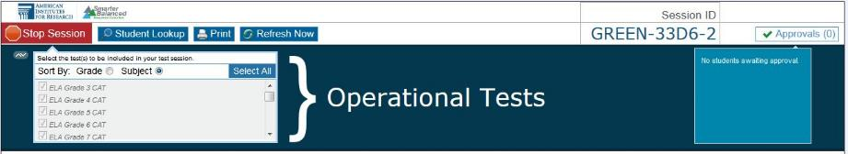

Figure 10. TA Practice and Training Site Banner for Practice and Training Tests

### TA Site Quick Reference

Table 3 provides descriptions of the various buttons and features that appear on the TA Site.

Table 3. TA Site Features

|  |  |  |
| --- | --- | --- |
| Sections and Buttons | Description | |
| Approvals/Pending Approvals preview section | The [**Approvals (#)**] button and Preview section show how many students are awaiting approval to begin testing. | |
| Expand/Collapse | Use this button to expand or collapse a specific viewable area of your screen. This feature can be applied to the area containing the Test Selection and Pending Approvals tables and on-screen instructions section. | |
| Help | Click [**Help**] to access this *TA User Guide* at any time. A new tab or window will open. |
| Log Out | Click [**Log Out**] to exit the TA Interface. You will be logged out of all online Smarter Balanced applications, and all students’ tests will be paused. |
| Print | This feature allows you to print the list of approved students and their test progress as it is displayed on the screen. To print, click the [**Print**] button. The regular print window will appear. Select the desired settings and click [**OK**].  *Federal law (FERPA) prohibits the release of any student’s personally identifiable information. Any printouts containing student information must be securely stored and then destroyed when no longer needed.* |
| Refresh Now | Use this button to manually refresh your screen while monitoring student progress. (The Students in Your Test Session table automatically refreshes every 60 seconds.) |
| Session ID | The Session ID is used by students to log in to a test session. Session IDs are unique to each test session. The Session ID links the students who are requesting access to the test session to the TA, who then approves or denies their access requests.  Because the Session ID is unique for each test session in the system, it provides an audit trail for students’ tests. The Session ID must be given to students exactly as it appears on your screen (including hyphens). |
| Start Session | After the TA has selected the test from the Test Selection table, the [**Start Session**] button will become active. Click this button to start the session and create the automatically generated Session ID. |
| Test Selection | Select the test(s) to include in the test session. A test cannot be removed from the session after it has been added. (The TA Interface includes a [**Select All**] button, which allows users to quickly and easily select all tests.) |
| Stop Session | Click this button to end the session. Any students who are still testing will have their tests paused and they will be logged out. You will not be able to resume the current session, and a new session will need to be created for students to finish testing. |
| Student Lookup | The Student Lookup tool allows TAs to search for students.   * Use *Quick Search* to look up students by State-SSID. * Use *Advanced Search* to find students by district, school, grade, and first/last name. |
| Students in Test Session Table | This table displays all the students who have entered the test session, the test each student is taking, and his or her progress throughout the test. |

### Student Lookup: Quick Search and Advanced Search

If a student is having trouble logging in, you can use the Student Lookup feature to search for that student. Figure 11 shows the Quick Search feature and Figure 12 shows the Advanced Search feature.

|  |  |
| --- | --- |
|  | **Caution:** Any incorrect student information in the required demographic fields must be updated in ART by an authorized user. After a student’s record is updated in ART, he or she can begin testing |

Figure 11. Quick Search

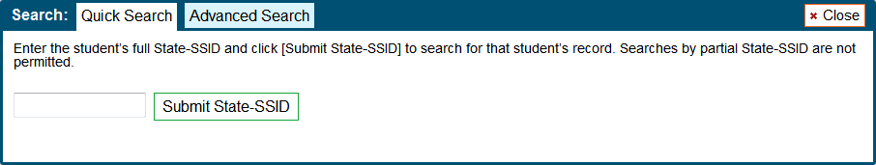

|  |
| --- |
| 1. Click the [**Student Lookup**] button in the top row of the TA Site. 2. Enter a student’s State-SSID. 3. Click [**Submit State-SSID**]. If the search results in a match, that student’s information will be displayed. |

Figure 12. Advanced Search

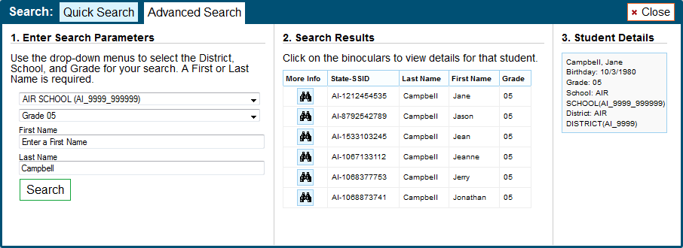

|  |
| --- |
| 1. Click the [**Student Lookup**] button, and then click the [**Advanced Search**] tab.    1. If necessary, select a district and school from the drop-down lists.    2. Select a specific grade or “all grades.”    3. Optional: Enter a student’s first name and/or last name. Partial names are allowed (e.g., enter “Fi” in the last name field to search for students whose last name begins with “Fi”). 2. Click [**Search**]. Search results that match the parameters will appear in the second column. 3. To see more information about a student, click the binoculars icon. A third column showing the student’s information will appear. |

### Alert Messages

The Smarter Balanced Assessment Consortium is able to send out alert messages to all Test Administrators (see Figure 13). These alerts will be displayed on the TA Interface. To ensure that you have read these messages, you will need to click [**OK**] to close the alert.

Figure 13. Sample Alert Message

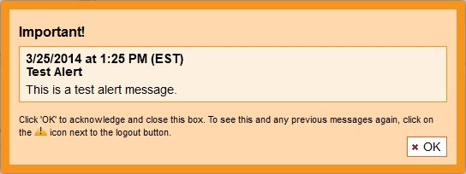

#### Viewing Past Alerts

A record of alert messages that you have read and acknowledged can be viewed by clicking the Alert Center  icon. This appears at the top right corner of the screen, next to the [**Log Out**] button. Click the icon to open a window that contains alert messages that have not yet expired (each message includes an expiration date). Figure 14 shows a sample past alert.

Figure 14. Sample Past Alert

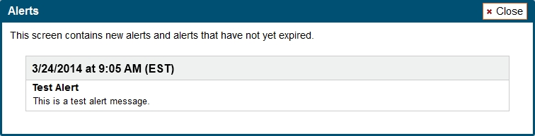

### Printing Session Information

This feature allows TAs to print the screen as it currently appears. Doing so can help track which students did not complete their tests and may need to be scheduled for another test session.

|  |
| --- |
| 1. To print, click the [**Print**] button. The computer’s standard/default print window will appear. 2. Select the desired print settings and then click [**OK**].   *Tip: Set the print options to landscape mode (horizontal). You can also use your Web browser’s “Print Preview” feature to scale content to fit on a single printed page.* |

|  |  |
| --- | --- |
|  | **Caution:** Federal law (FERPA) prohibits the release of any student’s personally identifiable information. Any printouts must be securely stored and then destroyed when no longer needed. |

# Section IV. Administering Online Tests

This section contains information on how to start a test session, add tests to the session, verify students’ test settings, approve students for testing, and monitor their progress.

|  |  |
| --- | --- |
|  | **Warning:** **Check students’ information and test settings before test sessions!**  Students who require test settings other than the default must have their settings updated in ART before testing begins. For information about test settings, including accommodations, refer to your state’s *Online Operational Test Administration Manual,* and the *Smarter Balanced Usability, Accessibility, and Accommodations Guidelines*. Both documents are available on your state’s portal.  *If you have a student whose test settings are incorrect, do not approve him or her for testing.* Contact your School or District Test Coordinator (as appropriate) to have the student’s information updated in ART. |

## Starting a Test Session

You must create a test session before students can log in to the Student Testing Site. In order for a student to take a specific test, it must be included in your test session.

|  |  |
| --- | --- |
|  | **Caution:** A test session automatically ends when you manually stop the session or log out of the TA Site. While a student can resume a test opportunity in a new session, the test session cannot be resumed. In order for students to resume testing, you will need to create a new test session and give them the new Session ID. Students cannot access previous (closed) test sessions. |

### Selecting Tests to Include in the Test Session

The test selection box is located in the upper left corner of the screen. Tests are automatically listed in order by grade level and then subject. You can select individual tests or select all tests. See Figure 15.

**About Test Names:** Tests labeled “NonPT” are non-performance task tests. Tests labeled “PT” are performance task tests.

Figure 15. Test Selection Box

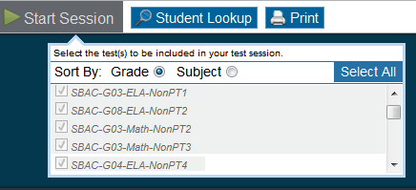

|  |  |
| --- | --- |
|  | **Note:** All Smarter Balanced Operational Tests are included on the test selection screen. Test proctors can sort and filter between Interim and Operational tests. . |

#### Starting a Test Session

|  |
| --- |
| 1. Go to the test selection box under the [**Start Session**] button in the top panel. 2. Click the checkbox next to each test you need to administer in the test session OR click [**Select All**] to include all available tests.  * *Once you have selected a test or all tests, the [****Start Session****] button will become active.*  1. After selecting the test(s), click the [**Start Session**] button.  * *The selected test(s) will be highlighted and grayed out.* * *The [****Stop Session****] button will replace the [****Start Session****] button.* * *The Session ID will be generated and appear below “Session ID.”*  1. Provide the Session ID to your students. You may want to write this down clearly on a board or other place where all students can see it or provide it to the students along with their login information. *Students must enter the Session ID exactly as it appears on the TA Site, including hyphens. The Session ID is not case sensitive.* |

|  |  |
| --- | --- |
|  | **Note:** You may want to write down your Session ID in case you accidentally close your browser or need to transfer your session to another computer.   * For information about accidentally closing your browser, refer to [Closing the Browser/‌Unintentional Exit](#_Closing_the_Browser/Unintentional). * For more information about transferring test sessions, refer to Appendix B. Transferring TA Test Sessions between Computers. |

#### Adding Tests to the Test Session

If you did not select all tests, you may add tests to a session at any time. This may be necessary if one of your students sees the “Test not available in this session” message on his or her “Your Tests” screen during the login process. Please identify and select only those tests that you will administer during the current test session. This should avoid confusion about which test a student should be completing first if multiple tests are to be completed.

|  |
| --- |
| 1. From the test selection box, click the checkbox next to the name of the test to be added to your session. (For security purposes, tests must be individually added to an active session.) 2. A pop-up window will ask you to confirm your selection (see Figure 16). 3. Click [**Yes**] to add the selected test to your session. |

Figure 16. Add Test to Session Confirmation Message

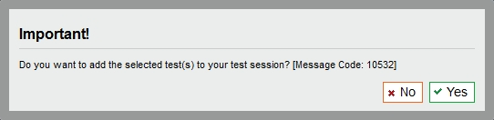

|  |  |
| --- | --- |
|  | **Note:** While tests may be added to an active test session after it has started, they cannot be removed from the session. |

## Viewing Students’ Test Settings and Approving Students for Testing

After you have started the test session and given the students the Session ID, they can begin the login process. (For additional information on the login and approval process from the student perspective, refer to [Section VI, Taking Online Tests [Student View]](#_Section_VI._Taking).)

You must approve students before they can begin testing. This process includes viewing each student’s test settings and verifying that they are correct.

### Notification of Students Awaiting Approval (Approvals Preview)

The right side of the top panel contains the [**Approvals (#)**] section, which displays the number of students awaiting approval and a preview list of students’ names and tests.

Once students begin requesting entry to your test session, the [**Approvals (#)**] preview table will become active as shown in Figures 17 and 18. The table will display those students who are awaiting approval. You will see each student’s name and the test he or she selected.

**Approvals Notification and Preview Table**

|  |  |
| --- | --- |
| Figure 17. No Students Awaiting Approval | Figure 18. Students Awaiting Approval |
| * Approvals button is not clickable * Approvals button says [**Approvals (0)**] * Preview table says “No students awaiting approval” | * Approvals button is clickable * Approvals button says [**Approvals (#)**] * Preview table lists each student and his or her selected test |

*Viewing students awaiting approval:*

|  |
| --- |
| 1. Click the [**Approvals (#)**] button to access the Approvals and Student Test Settings screen. |

|  |  |
| --- | --- |
|  | **Warning:** **Check students’ information and test settings before test sessions!**  Students who require test settings other than the default must have their settings updated in ART before testing begins. For information about test settings, refer to your state’s *Online Operational Test Administration Manual*.  *If you have a student whose test settings are incorrect, do not approve him or her for testing.* Contact your School or District Test Coordinator to have the student’s information updated in ART. |

#### Viewing and Editing Students’ Test Settings

The **Approvals and Student Test Settings** screen displays each student who is awaiting approval for entry to your session as shown in Figure 19. You will see each student’s name, State-SSID, current opportunity for the selected test, whether the test settings are standard or custom, and the option to approve or deny each student.

|  |  |
| --- | --- |
|  | **Important:** This screen does not automatically refresh. Therefore, students logging in to your session after you have already opened the Approvals Screen will not appear. To update the list of students awaiting approval, click the [**Refresh**] button in the top row of the Approvals Screen. |

Figure 19. Approvals and Test Settings Screen

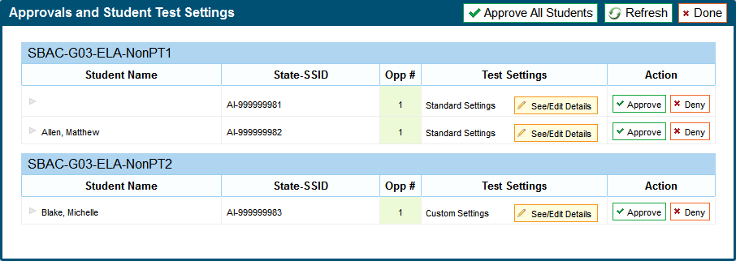

|  |  |
| --- | --- |
|  | **About the Test Settings column:**   * Students with **Standard** test settings are students whose test settings are set to default. * Students with **Custom** test settings are those who have at least one test setting that is not the default. Test settings include color choices, a different print size than the default, text-to-speech, American Sign Language, Translation (Glossary), etc.   For additional information about test settings, refer to [About Student Test Settings](#_About_Student_Test). |

*Viewing a student’s test settings:*

|  |
| --- |
| * Click the [**See/Edit Details**] button for that student. The screen will change to show the student’s test information. |

##### Adjusting a Student’s Test Settings and Accommodations

Some of the student’s information on this screen is read-only. Students’ default test settings should be preset in ART by the District or School Test Coordinator (as appropriate). Some test settings are editable on this screen as shown in Figure 20. For more information about editable test settings, refer to Table 4.

Figure 20. Approvals and Test Settings for Selected Student

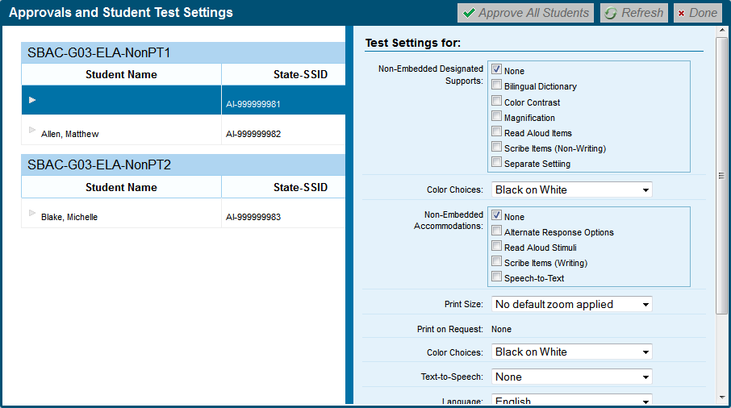

Review each student’s information to ensure that he or she has the correct test setting options. **If a student’s settings are incorrect, he or she should not test.**

|  |  |
| --- | --- |
|  | **Warning:** A student who is resuming a test will have the test settings that were established at the time the student began the test. If the settings are not correct when the student starts or resumes the test, the student’s test will need to be reset. |

*Changing/confirming a student’s settings:*

|  |
| --- |
| 1. For each editable test setting, select the correct option. 2. Confirm the test settings.  * Click [**Set**] to confirm the selected test settings and return to the list of students awaiting approval. You will still have to approve the student for testing. * Click [**Set & Approve**] to confirm the selected test settings and approve the student for testing. |

#### Approving Students for Testing

After you have confirmed students’ test settings, you may return to the list of students awaiting approval. On this screen, you can approve individual students or approve all waiting students at once as shown in Figure 21.

After all students in the list have been approved (or denied), whether individually or all at once, the Approvals Screen window will automatically close.

Figure 21. Approvals and Student Test Settings Screen

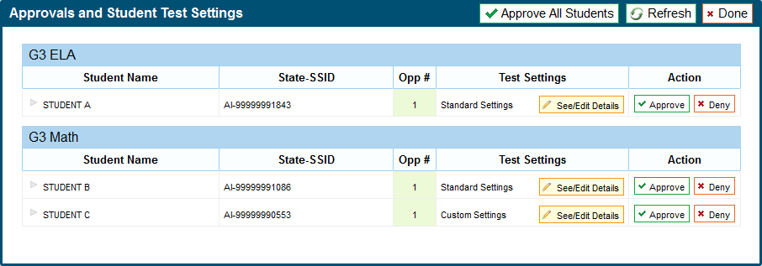

*Approving students for testing:*

|  |
| --- |
| * *To approve individual students*, click the green [**✓Approve**] button for each student. The student will be approved and will also disappear from the list. * *To approve all students currently displayed in the list*, click the [**✓ Approve All Students**] button at the top right. This will approve those students for testing. |

|  |  |
| --- | --- |
|  | **Note:** You may approve all students who appear in the list. However, subsequent students who log in to the test session after you have opened the Approvals Screen will still need to be approved. |

#### Denying Students Entry to the Test Session

Although Test Administrators can approve all students at the same time, students must be individually denied entry to the test session. See Figure 22. TAs may deny students for one of the following reasons:

* The student is not supposed to enter the session.
* The student’s demographic information is incorrect.
* The student’s required test settings are incorrect.

Figure 22. Deny Student from Testing

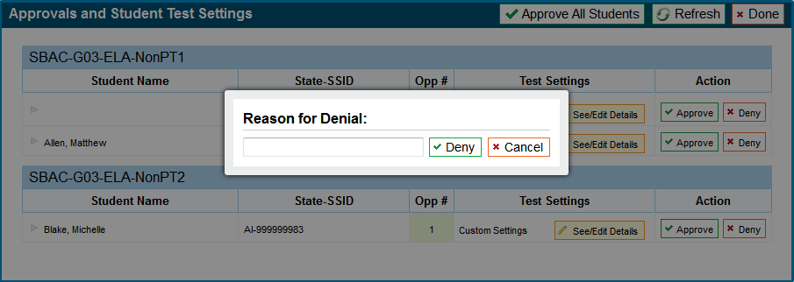

*To deny a student entry to the test session:*

|  |
| --- |
| 1. On the Approvals screen, click [**Deny**] for that student. 2. In the pop-up window that appears, enter a brief reason for denying the student. 3. Click the green [**✓Deny**] button.   The student will receive a message explaining the reason he or she was denied entry to the session. The student will then be logged out and directed to the login page. |

## About Student Test Settings

If a student’s default test settings have not been pre-set in ART, the student is automatically assigned the default for each test setting (for that respective test). It is important to note that the default settings can vary by test. Only the test settings available for that test will be displayed on the Approvals and Student Test Settings screen for that student.

Table 4 details the embedded test settings that can be assigned to a student’s test. The majority of these test settings are read only.

|  |  |
| --- | --- |
|  | **Warning:** If a student requires a different test setting and you cannot change it in the TA Interface, the student should not test. The student’s test settings must be updated in ART before testing begins. |

Table 4. Student Test Settings

| **Test Settings** | **Options** | **Descriptions and Notes** |
| --- | --- | --- |
| **Language** | **English (default)** | All tests are presented in English.  Students who require tests in braille should have the braille option selected.  Students whose language is set to Spanish for math tests will view items in both English and Spanish (stacked translation). *Test directions will also be translated into Spanish.* |
| Braille |
| Spanish (math)  Includes the following Designated Supports:  Translations (stacked) and Translated test directions |
| **American Sign Language** | **Do not show ASL videos (default)** | Allows students to view test content translated into ASL by a human signer. |
| Show ASL videos |
| **Closed Captioning** | **Off (default)** | Provides subtitles for slideshows and audio components of listening stims on ELA tests. |
| On |
| **Color Contrast** | **Black on White (default)** | By default, tests are presented with black text on a white background. Students who need a different combination of text and background should select the appropriate option. |
| Black on Rose |
| Medium Gray on Light Gray |
| Yellow on Blue |
| Reverse Contrast |
| **Masking** | **Masking Not Available (default)** | Allows the blocking of content that is not of immediate need or that may be distracting to the student. |
| Masking Available |
| **Permissive Mode** | **Permissive Mode Disabled (default)** | Permissive mode should be enabled for students who require access to accessibility software in order to interact with the test (screen readers, magnifiers, etc.).  When permissive mode is disabled, the only application that can be open on the computer is the secure browser. |
| Permissive Mode Enabled |
| **Print on Demand** | **None (default)** | Allows student to request printing of items and stimuli.  *Note: If a student requires items to be printed, and this is not set, you must deny the student and contact . You must provide the Help Desk with the student’s state and SSID information as well as the reason for the request.* |
| Items |
| Stimuli |
| Items and Stimuli |
| **Print Size** | **Level 0 (No Zoom) = 1X (default)** | The print size the student should have when starting the practice test. The selected print size becomes the default for all items in that test.   * The default print size (Level 0—No Zoom) for all tests is 14 pt. |
| Level 1 = 1.5X |
| Level 2 = 1.75X |
| Level 3 = 2.5X |
| Level 4 = 3X |
| **Test Shell** | **Standard (default)** | By default, all tests use the standard interface. This interface is compatible with all supported desktops and tablets.  The streamlined interface presents the test in an alternate, simplified format in which the items are displayed below the stimuli. All tool and navigation buttons are on the bottom of the screen.  ***Important:*** *The streamlined interface is not intended to be tablet compatible.* |
| Streamlined |
| **Text-to-Speech** | **No Text-to-Speech (default)** | Students with this test setting enabled may listen to the read-aloud of the items and/or stimuli in the assessment.  *Note: Text-to-Speech is not available in Spanish.* |
| Items *(ELA)* |
| Stimuli *(ELA)* |
| Stimuli and Items  *(ELA and mathematics)* |
| **Translation (Glossary)** | **English (default)** | Students can open a glossary to view terms presented on the test that may be unfamiliar to them.  By design, all students can access the English glossary word list as a universal tool, unless this is disabled (“No Glossary”) or overridden by another language.   * If a *combination glossary* is selected (e.g., English and Arabic or English and Russian), then the student will have access to both. * If a *single glossary* is selected (e.g., Mandarin), then the student will only have access to that glossary. The English glossary will not be available.   *Note: The English glossary is available for both ELA and mathematics tests. Translated glossaries are available for mathematics tests only.* |
| Arabic |
| Cantonese |
| Filipino |
| Korean |
| Mandarin |
| Punjabi |
| Russian |
| Spanish |
| Ukrainian |
| Vietnamese |
| No Glossary |

**\*** The default setting for each category is displayed in bold text.

## Monitoring Students’ Testing Progress

After students have logged in and you have approved them to begin testing, the Students in Your Test Session table will display each student currently logged in to your session as shown in Figure 23.

Figure 23. Students in Your Test Session Table

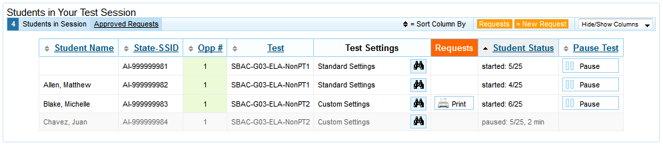

|  |  |
| --- | --- |
|  | **Note:** If a student’s row is grayed out, that student is not actively testing. This occurs when the student’s test is paused or the student has completed and submitted the test. |

The Students in Your Test Session (Table 5) displays the following for each student in the test session.

Table 5. Students in Your Test Session Column Descriptions

|  |  |
| --- | --- |
| Column | Description |
| Student Name | The first and last name of the student in the session (if populated in ART). |
| State-SSID | This column displays the State-SSID associated with the student (in ART). |
| Opportunity # | Each student’s record indicates the opportunity number for that student’s subject test.  *For the Smarter Balanced Operational Test, each student has only one opportunity for each test.* |
| Test | The name of the test the student is taking. |
| Test Settings | Each student’s test will display one of the following settings:   * **Standard Settings:** Indicates that the default test settings are applied for this student’s test opportunity. * **Custom Settings:** Indicates that one or more of the student’s test settings is different from the default settings.   The **binoculars** icon displayed in this column is clickable. Click the icon for a student to view his or her test settings. |
| Requests | When a student requests a printout of a reading passage or other test material, a [**Print**] button will appear in this column. Click the [**Print**] button to review and authorize or deny the student’s request.  *For more information about print requests, refer to the* [*Print on Demand Tool*](#_Print-on-Demand_Tool) *section.* |
| Student Status | This column lists the current status for each student in the test session.   * The numbers (#/#) listed after the status shows the student’s progress while he or she is taking the test. The first number is the number of items the student has answered. The second number is the total number of items that will be administered.   *For descriptions of each possible status, refer to* [*Student Statuses During Testing*](#_Student_Statuses_During)*.* |
| Pause Test | Click the [**Pause**] button to pause a student’s test. The student will be logged out.  *Reminder: See the Pause Rules section for information on pause time limits and students’ ability to review previously answered items.* |

### Student Statuses During Testing

The following statuses appear in the student status column in the Students in Your Test Session table.

Table 6 shows the statuses listed **chronologically** as displayed during the testing process.

Table 6. Test Statuses that Appear Chronologically During Testing

|  |  |
| --- | --- |
| Status | Description |
| Approved | The Test Administrator has approved the student for the session, but the student has not yet started or resumed the test. |
| Started (#/#) | The student has started testing. The number (#/#) after this status indicates how many items the student has **answered** out of the total number of items on the test.  *This number does not indicate which item or item page the student is actively viewing.* |
| Review | The student has answered all items and is currently reviewing his or her answers before submitting the test for scoring. *Note: A test with a review status occurs only at the end of the test. A test is not “completed” until the student submits the test.* |
| Completed | The student has submitted the test. No additional action can be taken by the student. |
| Scored | The Test Delivery System has processed the student’s responses to items on the test.  *Note: Student scores for the Operational Test will not be provided.* |
| Submitted | The test has been submitted for quality assurance review and validation. |

Table 7 shows other statuses may appear when a student is listed in the Students in Your Test Session table but is not actively answering items.

Table 7. Other Test Statuses

|  |  |
| --- | --- |
| Status | Description |
| Denied | The Test Administrator denied the student entry to the session. If the student attempts to enter the session again, this status will change to “Pending” until the Test Administrator approves or denies the student. |
| Paused (#/#) | The student’s test is currently paused. The following scenarios will result in a paused status:   * The student pauses his or her test by clicking the [**Pause**] button. * The student has been idle longer than 20 minutes, and the test was paused. * The Test Administrator pauses the student’s test. * The Test Administrator stops the session. * A technical problem with the student’s computer or browser has resulted in a loss of connection to the Test Delivery System.   *The time listed with this status indicates how long the student’s test has been in the paused status.* |
| Pending | The student is awaiting Test Administrator approval for a new test opportunity. |
| Suspended | The student is awaiting Test Administrator approval to resume a test opportunity. |

### Pausing a Student’s Test

Test Administrators can pause an individual student’s test using the Pause Test column in the Students in Your Test Session table shown in Figure 24.

Students whose tests are paused will be logged out and directed to the login page. If they want to reenter the session, they will have to log in and go through the approval process again. (If the session has been stopped, the student will have to obtain a new Session ID in order to resume testing.)

Figure 24. Students in Your Test Session Table



*To pause an individual student’s test:*

|  |
| --- |
| 1. In the Pause Test column, click the [**Pause**] button for that student. 2. Click [**Yes**] to confirm that you want the student’s test to be paused. |

|  |  |
| --- | --- |
|  | **Note:** When a student’s test is paused, the status column will display how long the test has been paused (in minutes).  **(Students taking Non-PT tests) who pause for more than 20 minutes will not be able to review previously answered items.** For more information, see the [Pause Rules](#_Pause_Rules) section. |

## Stopping a Test Session and Logging Out

### Stopping the Test Session

Although students’ tests can be resumed, test sessions cannot be resumed. Stopping a session will end the session and automatically pause all students’ tests in that session. The students will be logged out automatically. See Figure 25.

Figure 25. TA Site Banner Containing Stop Session Button



*To stop the test session:*

|  |
| --- |
| 1. Click the [**Stop Session**] button in the upper left corner of the screen. An “Important!” box will appear, requesting verification to end the session and log students out. 2. Click [**OK**] to continue. |

|  |  |
| --- | --- |
|  | **Reminder:** Because test sessions cannot be resumed, you will need to create a new session if your session has been stopped. When you start a new session, give the new Session ID to your students so that they can log in and resume testing. |

### Exiting or Logging Out of the TA Interface

**Users should exit or log out of the TA Interface only after stopping the test session.** Regardless of when or how users log out or navigate away from the TA Interface, student data will NOT be lost.

|  |  |
| --- | --- |
|  | **Caution:** As a security measure, TAs are automatically logged out after 20 minutes of user inactivity and student inactivity in the session, which will result in closing the test session.  **Reminder:** Students whose Non-PT tests are paused for more than 20 minutes will not be able to review previously answered items. For more information, see the [Pause Rules](#_Pause_Rules) section. |

#### Closing the Browser/Unintentional Exit

If you accidentally close the browser while students are still testing, your session will remain open until it times out. You can open the browser and navigate back to the TA Interface. You will be prompted to enter your active Session ID. (For more information about transferring a session to another computer or logging back in to an active session, refer to Appendix B. Transferring TA Test Sessions between Computers. **You must know your current Session ID.**)

* If you do not return to the TA Interface and reenter the active session within 20 minutes, you will be logged out, and all your students’ tests will be paused.
* In the case of an unintentional exit from the TA Interface caused by a system or computer error (such as the Web browser crashing or closing), a network or communication error, power loss, or other event, the 20-minute rule applies.

#### Test Session Timeout/Automatic Logout

If you are automatically logged out, the status of your session will change to “closed” and all in-progress tests in the session will be paused. You will need to log back in to the TA Interface, start a new session, and provide the new Session ID to students who need to resume testing.

#### Logging Out

To log out of the TA Interface (and all other Smarter Balanced applications), click the [**Log Out**] button in the top right corner of the screen.

Your session will be closed, and you will be directed to the Smarter Balanced single sign on page after you log out. You will not be able to resume the test session.

|  |  |
| --- | --- |
|  | **Alert:** This scenario also occurs when the TA navigates to another site from the TA Interface. If you need to access ART or another application, we encourage you to open a separate browser window to use for other applications.  If you unintentionally log out of the TA Interface while students are still testing, all in-progress tests will be paused and the students will be logged out. You cannot resume the original session. You will need to log back in, start a new session, and provide the new Session ID to students who need to log back in and resume testing. |

# Section V. Understanding the Student Testing Site

This section is designed to familiarize TAs with the Student Testing Site. It describes what students see and the tools they have access to while taking the operational tests. This section should address some of the common questions TAs and students may have.

This section covers the following:

* Test layout
* Online test tools

## Test Layout

Figure 26 shows the primary features and tools available to all students.

Figure 26. Sample Item Page

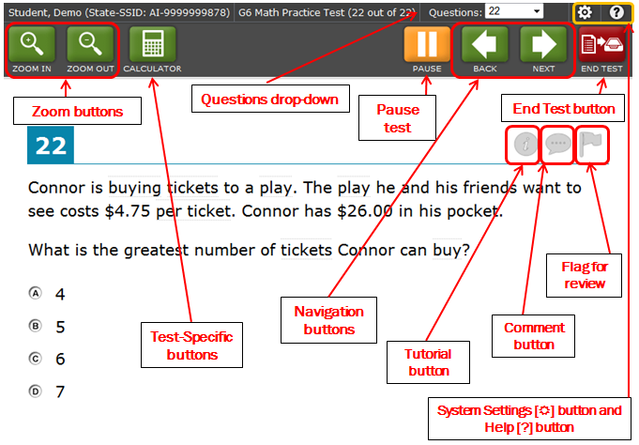

Each test has two major sections:

* **Global Menu bar** (contains global tools and navigation buttons, as well as system volume and student help buttons)
* **Test Content** (displays test content, including stimuli, items, and associated tools)
  + Some tools are available only by accessing a context menu for that passage or stimulus, item, or selected-response option. For more information, see the next page.

## Global and Context Menus

The Global and Context Menus allow students to access on-screen tools. These tools can be accessed using a mouse or keyboard shortcuts. On tablets, the context menus are accessed via a Menu button. For information about keyboard shortcuts, refer to Appendix D. Keyboard Commands for Students.

### Global Menu

The Global Menu contains all the visible tools displayed at the top of the student’s test screen as shown in Figure 27. Most universal tools are in the Global Menu, as well as the student help and system volume setting.

Figure 27. Sample Global Menu

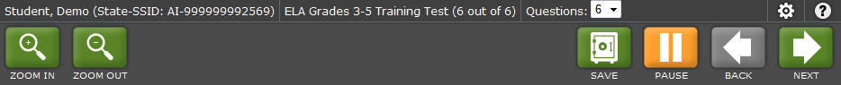

#### Adjusting the System Volume

Students who are taking a test that contains audio or text-to-speech can adjust the volume within the test as shown in Figure 28. (This feature is available only when using a desktop secure browser.)

Figure 28. Adjusting Volume Setting in the Test

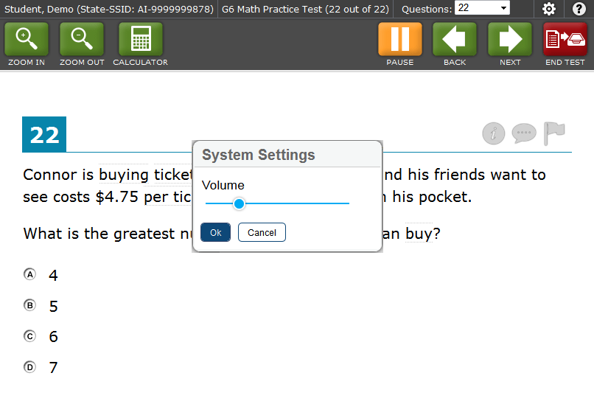

|  |
| --- |
| 1. Click the wheel icon in the upper right corner (next to the [?] help button). The System Settings window will open. 2. Move the Volume slider to adjust the loudness of the audio. |

### Context Menus and Test Elements

Tools such as text-to-speech, highlighter, and strikethrough, are accessed using context menus. These context menus contain the options available for each area of a test item on a page. These areas are called *elements*.

Elements include passages or prompts, test items, and answer options (A, B, C, and D). Each answer option is a single element. Each element has its own context menu.

The Context Menu options vary depending on the following:

* The element type (passage or stimulus, item stem, or selected-response answer option) (see Figures 29–31)
* The tools available to students (e.g., only students using text-to-speech who are using the secure browser can use the TTS “Speak” options)

Figure 29. Overview of Elements for Selected-Response Items

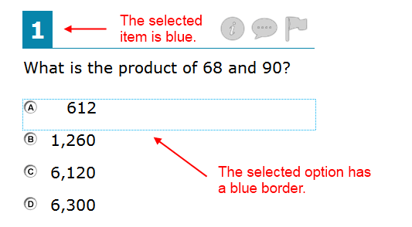

|  |  |
| --- | --- |
| Figure 30. Sample Context Menu for Item Stem | Figure 31. Sample Context Menu for Answer Options |

#### Opening a Context Menu on Desktops and Laptops

Accessing a context menu depends on whether the student is using a two-button mouse or track pad or a single-button mouse.

##### Two-Button Mouse or Track pad

Students using computers with a standard two-button mouse or laptops with a two-button track pad must open a context menu using the “right-click” function.

|  |
| --- |
| 1. Right-click anywhere on a stimulus, item stem, or answer option to display the context menu. 2. Select a tool to activate or open it. |

##### Single-Button Mouse (for use with Mac computers)

Students using Mac computers with a single-button mouse must open a context menu using a modified “right-click” function.

|  |
| --- |
| 1. Move the mouse to a desired element (stimulus, item stem, or answer option). 2. On the keyboard, press the [**Ctrl**] key and click the mouse button. 3. Select a tool to activate or open it. |

#### Opening a Context Menu on Tablets

Students using tablets can use an on-screen menu to open the context menu for passages/stimuli and answer options. The Menu appears in the upper left corner (next to the zoom buttons). See Figure 32 for an example.

Figure 32. Context Menu on Tablet (for Strikethrough)

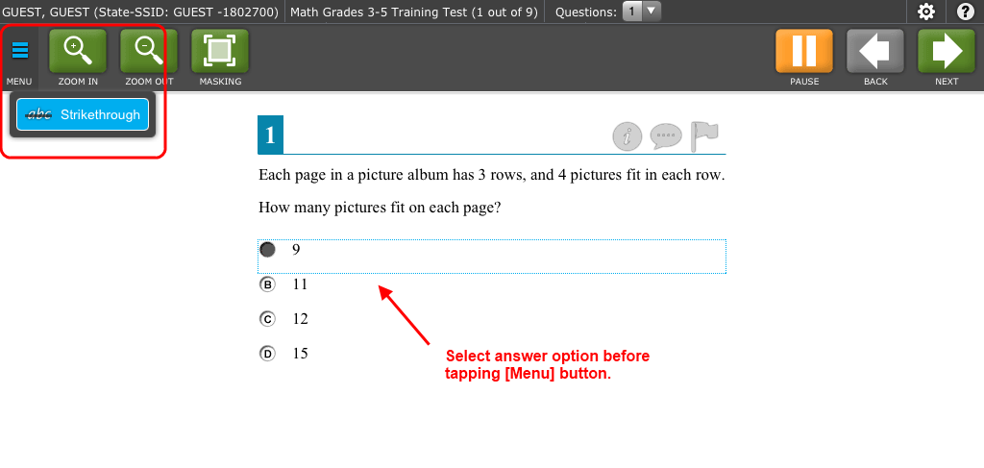

|  |
| --- |
| 1. Tap on a desired element (stimulus, item stem, or answer option). 2. Tap the Menu button in the upper left corner. The Context Menu will open. 3. Select a tool to activate or open it. |

#### Opening a Context Menu on Chromebooks

Chromebooks do not have track pads with mouse buttons. If students are using Chromebooks that do not have a mouse plugged in, they must follow these instructions to enable the “right-click” function.

|  |
| --- |
| 1. Move the mouse pointer to a desired element (stimulus, item stem, or answer option). 2. Press and hold the [**Alt**] key on the keyboard. 3. Press down on the track pad until it “clicks.” The context menu will open. 4. Select a tool to activate or open it. |

## Universal Tools Available in Online Tests

This section provides information about the online test tools available to students.

### Universal Test Tools

Table 8 shows the online tools available within all online tests for all students. These tools can be turned off in the TA Interface before students begin testing.

Table 8. Universal Test Tools

|  |  |
| --- | --- |
| Test Tool | Description |
| [?] (Help) | To access the Test Instructions and Help Screen at any time, click the question mark button. |
| [Zoom In] and [Zoom Out] | To enlarge or shrink the font and images, click the [**Zoom In**] and [**Zoom Out**] buttons. |
| English glossary | Some words have a light gray dotted outline. These words have synonyms or descriptions. Click on these words to open the glossary. |
| Stimulus Expansion Tool | Passages and stimuli can be expanded for easier readability. For more information, see the [Stimulus Expansion Tool](#_Stimulus_Expansion_Tool) section on the next page. |
| Highlighter | Highlight a section of text in a passage or test item.   * Select text on the screen, right-click with the mouse, and select [**Highlight**]. The selected text will become yellow.   *Notes: Text in images cannot be highlighted.* |
| Mark (Flag) for Review | Click the flag icon next to each item to mark it for review. |
| Notepad | Students can click the comment icon (looks like a speech bubble) for any item they would like to provide feedback for. |
| Strikethrough | Cross out answer options for selected-response items.   * Open the context menu for an answer option, and select [**Strikethrough**]. A thick gray line will appear over the answer option. |
| Tutorial [*i*] | Click the round [*i*] icon to view a brief video about the item type (selected-response, constructed-response, etc.). |

### ELA Performance Task Test Tools

Table 9 shows the online tools available for ELA Performance Task tests. *(Note: Spell check and Writing tools cannot be turned off.)*

Table 9. ELA Performance Task Test Tools

| Test Tool | Description |
| --- | --- |
| Global Notes | Students can access a notepad throughout the test. This notepad allows students to enter notes for themselves and is not item-specific.  To open the global notes notepad, click the [**Notes**] button in the Global Menu bar. |
| Dictionary  (and Thesaurus) | Students can open the Merriam-Webster dictionary and thesaurus within the test. This tool is available during the second segment of ELA Performance Task tests.  To open the Dictionary and Thesaurus, click the [**Dictionary**] button in the Global Menu bar. For more information, refer to Appendix H. Dictionary and Thesaurus Tool. |
| Spell check | For tests that contain writing responses, a spell check is available. For more information, refer to Appendix G. Tools for Full-Write Item Types. |
| Writing tools | For tests that contain writing responses, formatting tools are available. For more information, refer to Appendix G. Tools for Full-Write Item Types. |

### Mathematics Test Tools: Online Calculator

In addition to the above universal tools, students also have access to online calculators for mathematics tests:

* **Basic calculator**: grade 6
* **Scientific calculator**: grades 7 and 8
* **Graphing, Regression, and Scientific calculators**: High School (grades 9, 10, and 11)

Information about using these calculators is available in Appendix E. Calculators in the Test Delivery System.

### Stimulus Expansion Tool

Some items will be associated with a passage or other stimulus that appears on the left side of the screen. Students can expand the stimulus section so that it takes up a larger portion of the screen. This action will cover a portion of the items in the right pane.

Students will see an icon in the upper right corner of the left pane that shows a plus sign and a blue right arrow as shown in Figure 33.

Figure 33. Expand Stimulus Icon



*To expand and collapse the stimulus section:*

|  |
| --- |
| *To expand the section:*   * Click the blue arrow icon. The pane will expand to the right and cover the items.   *To collapse the section:*   * Click the same button, which is now orange and shows a minus sign and a left arrow. The pane will collapse to its original size and the items will be visible. |

### Accessing Tools for Embedded Designated Supports and Accommodations

The following embedded designated supports and accommodations require students to interact with on-screen buttons and menus:

* American Sign Language
* Masking
* Print on Demand
* Text-to-Speech
* Translation (Glossary)

This section provides information on how students can access these tools. These tools require flags to be set in ART.

#### American Sign Language Video Tool

Students who have the American Sign Language (ASL) accommodation can use the ASL tool to view test content translated into ASL by a human signer as shown in Figure 34.

Figure 34. ASL Tool for Items

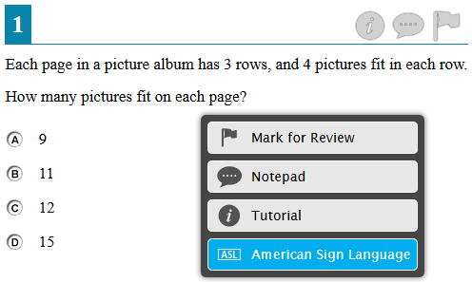

|  |  |
| --- | --- |
|  | **Warning:** Students who require ASL must have the accommodation enabled in ARTprior to starting a test opportunity. The ASL accommodation cannot be enabled after a student has started testing. |

*To access the ASL tool:*

|  |
| --- |
| 1. Open the context menu for the item stem or passage. The menu will appear with “American Sign Language” as an available option. 2. Select “American Sign Language” option to open the video.    * By default, the video will appear in the lower left corner of the screen. The video may be moved to another part of the screen as needed.    * The student may pause, restart, and replay the video. |

#### English Glossary and Translation (Glossary) Tool

The English Glossary tool is a universal tool. All students have access to the English glossary on ELA and mathematics tests, unless it is disabled in ART.

The Translation (Glossary) tool is a designated support and must be set in ART before students begin testing. Translations are available only for mathematics tests. See Figure 35 for a Translation Glossary.

Both the English Glossary and Translation tool work the same way.

Figure 35. Sample Glossary Window Displaying Two Glossaries

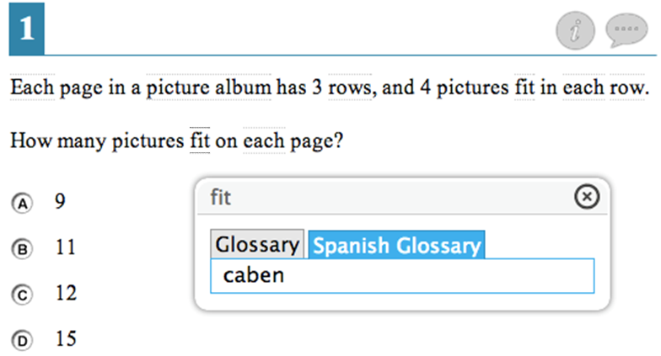

|  |  |
| --- | --- |
|  | **Note:** Not all terms with a glossary will display synonyms or phrasal explanations for multiple languages. |

*To open the glossary for a word or phrase:*

|  |
| --- |
| 1. Click or tap a word that has a dashed line above and below it (e.g., “fit” in the image above). The glossary window will open.    * If two glossaries are available for the selected word or phrase, two tabs will appear. The active tab is blue. To view the synonym or translation in the other glossary, click that tab. |

#### Masking Tool

Students who have masking as a designated support can use the Masking tool to allow them to focus on one part of the screen at a time. Students who activate the Masking tool can mask as many areas as needed. See Figures 36 and 37

|  |  |
| --- | --- |
| Figure 36. Masking: Preview Area | Figure 37. Masking: Masked Area |

*To activate the Masking tool on desktops and laptops (with a mouse):*

|  |
| --- |
| 1. In the Global Menu, select the [**Masking**] button. The button will become blue. 2. Using your mouse, click and drag until the area you want to cover is fully selected. (The preview will have a blue dashed border.) 3. Release the mouse button. The masked area will become dark gray.    * As long as the Masking tool is active, you can add other masked areas.    * To close a masked area, click the [**X**] button in the upper right corner.    * To exit the Masking tool, click the [**Masking**] button. The button will become green. *Note: Exiting the Masking tool will not automatically delete any masked areas on the screen.* |

*To activate the Masking tool on tablets:*

|  |
| --- |
| 1. In the Global Menu, tap the [**Masking**] button. The button will become blue. 2. Using your finger, tap and drag until the area you want to cover is fully selected. (The preview will have a blue dashed border.) 3. Release your finger. The masked area will become dark gray.    * As long as the Masking tool is active, you can add other masked areas.    * To close the masked area, tap the [**X**] button in the upper right corner.    * To exit the Masking tool, tap the [**Masking**] button. The button will become green. *Note: Exiting the Masking tool will not automatically delete any masked areas on the screen.* |

#### Print-on-Demand Tool

Students who are granted the print-on-demand accommodation can request printing of reading passages or test items or both.

|  |  |
| --- | --- |
|  | **Alert:** Important: Authorized users may enable print on demand for passages for students in TIDE. If students require print on demand for items, you must contact the Help Desk to enable that flag. For more information, refer to your state’s *Online Operational Test Administration Manual.* |

Students who have this accommodation will see the Print Passage icon and/or printer icon for each item. Students who do not have a print-on-demand accommodation will not see any printer icons.

The print-on-demand tool requires interacting with the TA, as students’ print requests are sent to the TA Interface first. This tool requires significant attention to security and impact of the support on other students. After the TA reviews and approves the print requests, the passages or items can be sent to a printer that is connected to the TA’s computer or tablet.

|  |  |
| --- | --- |
| 1. To request that a reading passage or item be printed, the student must click the Print Passage and/or printer icon as shown in Figures 38 and 39.  * **Passages:** The Print Passage icon appears in the header, next to the Zoom In/Zoom Out buttons. * **Items:** The printer icon appears in the top right corner of each item. | Figure 38. Print Passage Icon    Figure 39. Print Item Icon |
| 1. Once the print request has been sent, the student will see a pop-up message shown in Figure 40 indicating that the request has been sent to the TA for approval. | Figure 40. Print Request Submitted Message |
| 1. On the TA Interface, the [**Print**] button will appear in the Requests column as shown in Figure 41. Click the button to view the student’s request. | Figure 41. TA Interface Print Button |

|  |  |
| --- | --- |
| 1. Review the print request. If you approve the print request, click [**Approve**] as shown in Figure 42. A cover sheet containing the student’s name (if populated) and State-SSID will display in a new browser window. *Note: The requested test content will not be displayed on your screen at any time.* 2. Click [**Print**] in the new window to complete the print request and view the printer dialog box. If necessary, adjust the print settings for your printer (e.g., fit to page). 3. Click [**OK**] to send the request to the printer. | Figure 42. Print Request Preview (TA Interface) |

#### Text-to-Speech Speak Tool

Students who will use text-to-speech (TTS) can use the Speak tool to listen to passages and/or test items and answer options. Figure 43 shows the speak tool options.

Figure 43. Speak Tool Options for Items

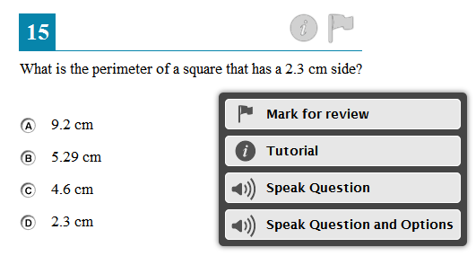

|  |  |
| --- | --- |
|  | **Warning:** Students who require TTS must have the accommodation enabled in ART prior to starting a test opportunity. The TTS accommodation cannot be enabled after a student has started testing. |

Students who use the Speak tool must use headphones to listen to the audio. (Smarter Balanced recommends that students use headphones with a built-in volume control for maximum audio adjustment capability.)

|  |  |
| --- | --- |
|  | **Reminder:** Text-to-speech settings should be tested and verified as working properly before students begin their tests. Students who have text-to-speech can ensure that their settings work as part of their test login process. For more information, refer to [Section VI, Taking Online Tests (Student View)](#_Section_VI._Taking). |

*To access the Speak tool:*

|  |
| --- |
| 1. Open the Context Menu for an area that contains text. The Context Menu will appear with the available “Speak” options.  * Students who select a portion of text and then open the Context Menu will be presented with the option to listen to the selected text. This feature is primarily used with reading passages.  1. Select the desired Speak option and the text will be spoken aloud. |

# Section VI. Taking Online Tests (Student View)

This section explains how students log in, begin and complete testing, and submit tests.

|  |  |
| --- | --- |
|  | **Warning:** Before students log in, their test settings should be verified in ART. Once students begin a test, most test settings cannot be changed. |

## Student Login and Test Selection

Students must go through a five-step login process before they can start or resume a test. This process ensures that students verify their information, as well as their test and test settings.

Students who will be using text-to-speech or taking an ELA test that contains listening items will have an additional step that allows them to check audio settings prior to beginning or resuming the test.

The steps and images in this section are for students using a desktop or laptop computer with the secure browser installed. The process is the same for students using a mobile secure browser.

### Step 1—Logging In

When the secure browser is opened, it automatically connects to the student login page as shown in Figure 44. (You may need to select a state before the student login page appears. (For more information, see Appendix A.)

Figure 44. Secure Browser Login Page

*Opening the secure browser and logging in:*

|  |
| --- |
| 1. Launch the secure browser by double-clicking the icon on the student’s desktop. 2. Students must enter the required login information in each of the three fields: 3. In the **First Name** field, enter the first name as it exists in the student record in TIDE (e.g., Julie). 4. In the **State-SSID** field, enter the two-letter state abbreviation, followed by a hyphen and SSID (e.g., ZZ-9999999). 5. In the **Session ID** field, enter the Session ID for the created session. This Session ID must be entered exactly as it appears in the TA Site, including any hyphens. (The Session ID is not case-sensitive.) 6. Click [**Sign In**]. |

#### Troubleshooting Student Login Errors

The system will generate an error message and associated code if a student cannot log in. The following are the most common student login errors. *Test Administrators may need to watch the student to ensure that he or she is entering all information properly.*

**Please check that your information is entered correctly. If you need help, ask your TA.** Verify that the student has correctly entered his or her First Name and State-SSID as they appear in ART. If this does not work, use the Student Lookup tool to verify the first name associated with the student’s State-SSID. The Student Lookup tool allows you to verify the student’s information as it appears in the system. This error can also occur when students do not enter their two-letter state abbreviation before their SSID.

**Session ID does not exist.** The student entered a Session ID that does not exist. Verify that the student entered the active Session ID correctly and that it does not contain any unnecessary spaces or characters. (Also verify that both you and the student are using the correct sites. For example, students logged in to the Practice and Training Test Site cannot enter a session that was created in the TA Interface.)

**The testing session is closed.** The Session ID entered corresponds with a session that is closed. Ensure that the student enters the correct Session ID for the active session. If this does not work, verify that your session is open. *Reminder: Test Administrators cannot resume sessions.*

If a session is stopped, a new one will need to be created. Doing so will result in a new Session ID. (Also verify that both you and the student are using the correct sites. For example, students logged in to the Practice and Training Test Site cannot enter a session that was created in the TA Interface. They may not realize they are attempting to access a training session that has since been closed, rather than accessing an operational test session.)

**The student is not associated with the school.** The student is not associated with the Test Administrator’s school, or the Test Administrator is not associated with the student’s school. The Test Administrator or student’s school association may need to be updated in ART.

### Step 2—Verifying Student Information

After logging in, students will see the **Is This You?** Screen shown in Figure 45. At this point, each student must verify his or her personal information.

Figure 45. Sample “Is This You?” Screen

*Verifying personal information:*

|  |
| --- |
| 1. Verify all the information on this screen is accurate. 2. Click [**Yes**]. The [**Your Tests**] screen will appear.   *If any of the information displayed is incorrect, the student should not proceed with testing. Have the student click [****No****]. He or she will be redirected to the login page. Tell your School or District Test Coordinator (as appropriate) that the student’s information needs to be updated.* |

### Step 3—Selecting a Test

After a student confirms his or her information, the **Your Tests** screen appears as shown in Figure 46, and all grade-level tests that the student is eligible to take are displayed. However, the only tests that will be available to students are those that were included in the test session and which are not yet completed.

Figure 46. Sample “Your Tests” Screen

**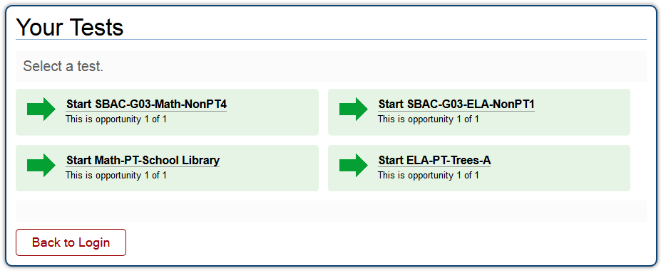**

* **Available tests are shaded green** and indicate whether the student will be starting a new test opportunity or resuming an opportunity.
  + A *solid* arrow indicates the student will be starting a new test opportunity.
  + A *striped* arrow indicates the student will be resuming a test opportunity.
* **Inactive tests are shaded gray** and indicate that they were not included in the test session or that the student has already completed the test(s).

Multiple tests may be available for selection. Students must select the correct test.

*Selecting an available test:*

|  |
| --- |
| * Click the test name. The request will be sent to the TA for approval.   *If the test the student needs to take is inactive or not displayed, the student should click [****Back to Login****]. The student will be logged out and returned to the login screen.* |

The student’s request will be sent to the TA. The student will see the display shown in Figure 47 while waiting for the TA to approve the request for entry to the session:

Figure 47. Waiting for TA Approval

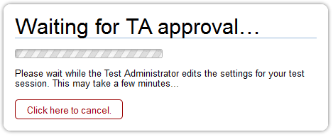

### Step 4—Verifying Test Information

After the TA has approved the student for testing, the student will need to verify the test information and settings on the **Is This Your Test?** Screen shown in Figure 48.

|  |  |
| --- | --- |
|  | **For Students with Permissive Mode Enabled:**  Students who have permissive mode enabled and need to configure their accessibility software must do so before clicking anywhere on this screen and proceeding with the login process. For more information about Permissive Mode, including instructions, refer to [About Permissive Mode](#_About_Permissive_Mode). |

Figure 48. Sample “Is This Your Test” Screen

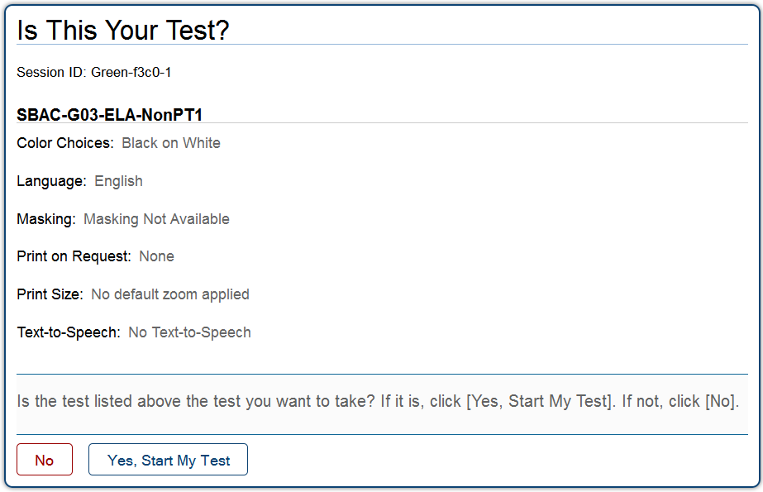

*Verifying test information:*

|  |
| --- |
| * *If the settings are* *correct*, click [**Yes, Start My Test**]. The student will proceed to the Test Instructions and Help page. (*Students who will use TTS will be prompted to check their TTS settings immediately after this step.) Prior to testing, Test Administrators should ensure that each computer has audio enabled and headsets are functioning correctly. Students will have the ability to adjust the volume and pitch for audio on their computer during the login process.* * *If the settings are* *incorrect*, the student should click [**No**]. He or she will return to Step 3, Selecting a Test. The student must select the test again and request approval. |

#### Step 4b—Audio Check for Tests with Text-to-Speech

Students who are taking a test that has text-to-speech enabled and who have headphones plugged in to their computers must verify that they can hear the sample audio as shown in Figure 49 before continuing the login process.

Figure 49. Text-to-Speech Check Page

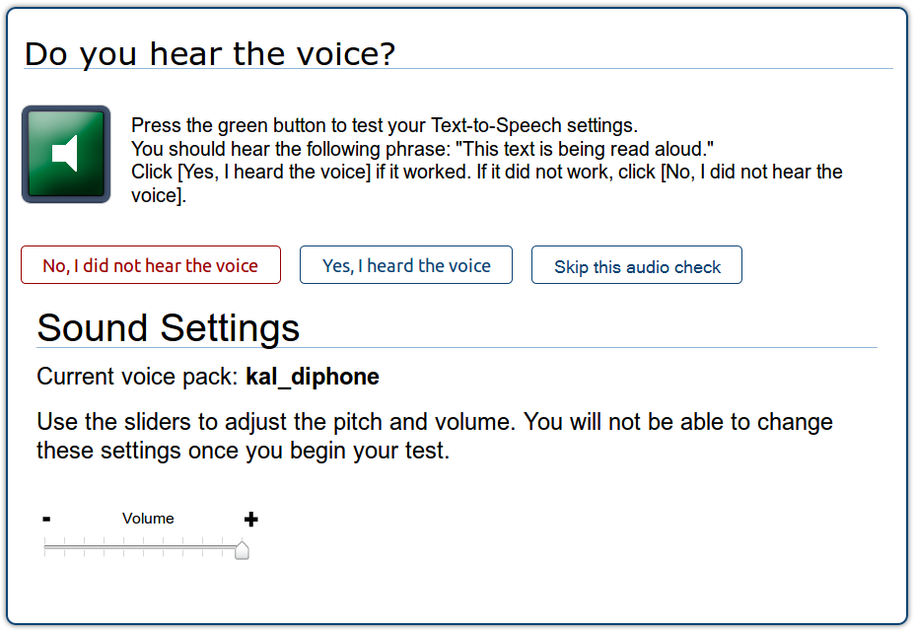

*Checking TTS/audio settings:*

|  |
| --- |
| * The student should click the green speaker icon and listen to the audio.   + If the voice was audible and clear, the student should click [**Yes, I heard the voice**]. The student will be directed to the Test Instructions and Help page.   + If the voice was not audible or clear, the student should adjust the settings using the Volume and Pitch sliders. Once the voice is clear, the student should click [**Yes, I heard the voice**] to continue.   + If the student still cannot hear the voice clearly, he or she should click [**No, I did not hear the voice**]. The student is then shown a message with instructions and offered the choice to continue without text-to-speech, try again, or log out. The student should either try again or log out. After a student logs out, he or she should close the secure browser. The TA can work with the student to adjust the computer’s audio settings. The student can then reopen the secure browser and log back in. For common audio issues, refer to [Troubleshooting Audio Issues](#_Troubleshooting_Audio_Issues) on the next page. |

|  |  |
| --- | --- |
|  | **Selecting a Different Voice Pack:** If a student wants to use a different voice that is available on the computer, he or she will have to log out, and you will need to help the student select another voice pack using the computer’s speech properties interface. Contact your technology staff with questions. |

|  |  |
| --- | --- |
|  | **Once the student confirms the audio settings and starts the test, the audio settings cannot be changed.** If a student wants to change the audio settings, he or she will have to pause the test and resume the login process to return to the TTS Check page. |

#### Step 4c—Sound Check for Tests with Listening Items

Students who are taking a test that contains listening items must verify that they can hear the sample audio as shown in Figure 50 before continuing the login process.

Figure 50. Sound Check Page for Tests with Listening Items

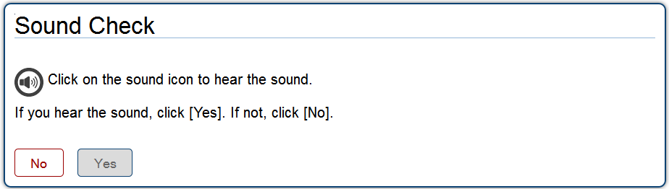

*Checking TTS/audio settings:*

|  |
| --- |
| * The student should click the black speaker icon and listen to the audio.   + If the sound was audible, the student should click [**Yes**]. The student will be directed to the Test Instructions and Help page.   + If the sound was not audible, the student should click [**No**].   + The *Sound Check: Audio Problem* screen will appear with a message telling students to notify their TA that they have an audio problem. Students also have two options:   + **Option A: Try Again.** Students can click [**Try Again**]. This will direct the students to the Sound Check screen.   + **Option B: Log Out.** Students can click [**Log Out**]. Troubleshoot the computer and headphones to see if there is a problem or move the student to another computer that has working audio. |

##### Troubleshooting Audio Issues

The following are common issues with audio for both text-to-speech and listening items. Before contacting a technology coordinator, ensure that students’ headphones are working correctly and are plugged in.

* + - Check to make sure headphones are securely plugged in and are plugged in to the correct jack or USB port.
    - If the headphones have a volume control, ensure the volume is not muted.
    - Ensure that the audio on the computer is not muted (often via a control panel or settings window).

### Step 5—Viewing Test Instructions and Help and Starting the Test

After the student has verified his or her test settings and clicked [**Yes, Start My Test**], the next page will show the **Test Instructions and Help** screen as shown in Figure 51.

Figure 51. Test Instructions and Help Page

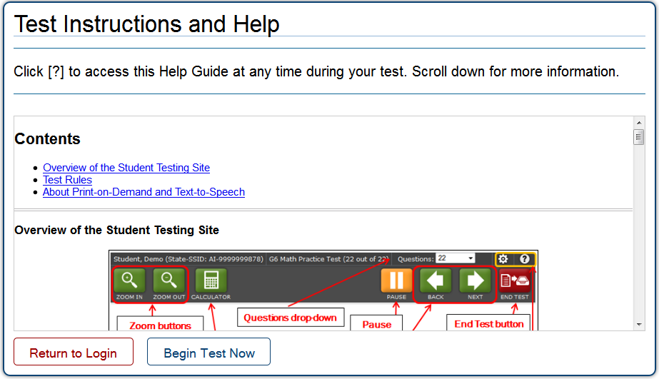

*To proceed and begin the test:*

|  |
| --- |
| 1. Students may review the information on this screen to understand what test tools are available and how to navigate through the online test. 2. After the student has finished reviewing this screen, he or she should click [**Begin Test Now**].   *When the student clicks the [****Begin Test Now****] button, he or she officially begins or resumes the current test opportunity.* |

## Proceeding through the Test

This section provides information on how students answer items and proceed through a test.

### Answering Test Items

Students must answer each test item that appears on a page before they can proceed to the next page in the test. Some pages may have only one test item, and others may have more.

The Smarter Balanced Tests include the following item types (though all tests may not contain all item types):

* **Selected-response items:** The student selects an answer option by clicking anywhere on the answer choice.
* **Constructed-response items:** The student types a response in a response box.
* **Technology-enhanced items:** The student uses the mouse or keyboard to manipulate items or draw responses in the response box.
* **Performance tasks:** The student completes an extended activity in preparation for answering questions.

|  |  |
| --- | --- |
|  | For constructed-response and technology-enhanced items, a [**Save**] button will appear in the top row next to the [**Pause**] button. Clicking this button is not required because students’ answers are automatically saved as they move to the next item. The [**Save**] button allows students to manually submit their response if they want to do so before continuing to the next item. |

After students have answered all items on a page, they must click [**Next**] to go to the next page.

### Marking Items for Review

Students may mark (flag) items for review if they are unsure that they selected or provided the correct answer as shown in Figure 52. The top right corner of each item has a flag icon.

Figure 52. Sample Item with Flag

*To mark an item for review:*

|  |
| --- |
| * Click the flag icon. The flag will turn blue and a check mark will appear. In the Questions drop-down list, “(marked)” will appear next to the item number. |

### Reviewing Past or Marked Items

While students must answer all test items on a page before moving on to the next page, they may return to a previous item if

* the test has not been paused for more than 20 minutes (Non-PT tests) OR
* the previous item is not in a segment that was already completed (see below).

Students can use either the [**Back**] button or the **Questions** drop-down list to navigate to the item(s) they want to review (see Figure XX).

### Reaching the End of a Segment and Reviewing Items

For segmented tests, students will see an **End Segment/Review** screen shown in Figure 53 at the end of each segment. They can review items only within the current segment.

After students click the [**Next**] button on the End Segment page, they have left the previous segment and started the new one. They cannot return to any items in the previous segment(s).

|  |  |
| --- | --- |
|  | **Alert:** If a student has paused a test within a segment and returns to the test after the 20-minute pause limit has expired, he or she will NOT be able to review the previously answered items. |

|  |  |
| --- | --- |
|  | **Note:** You may want to remind students that once they complete a segment and move on, they cannot return to the previous segment. For this reason, students taking a Non-PT test should review their responses before continuing to the next segment. |

Figure 53. Sample End Segment Screen

*To review items from the End Segment screen:*

|  |
| --- |
| * Click a question number on the left. The student will automatically be directed to the page containing that item. |

### Pausing Tests

Students are able to pause the test by clicking the [**Pause**] button in the top row. They can do so whether they are viewing a page with a single item or one with multiple items. See Figure 54.

|  |  |
| --- | --- |
|  | **Note:** You may want to remind students taking Non-PT tests that if their tests are paused for more than 20 minutes, they may be unable to change answers to previously seen items. For more information, refer to the [Pause Rules](#_Pause_Rules) section. |

Figure 54. Pause Test Message

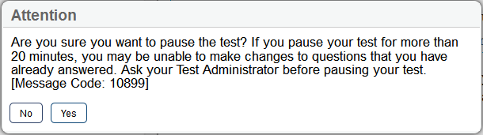

*To pause a test:*

|  |
| --- |
| 1. Click the orange [**Pause**] button. A confirmation message will appear. 2. Click [**Yes**] to acknowledge the message and pause the test. The student will be logged out and directed to the secure browser login page.   When the student is ready to resume testing, he or she will need to log in again and select the test. |

## Reaching the End of the Test

After students answer the last item on the test, the [**End Test**] button will appear in the upper right corner of the screen as shown in Figure 55. The top of the screen will also display the following message: “The test has been completed and is ready to be submitted when you are done reviewing your answers.”

Figure 55. Sample Item Page with End Test Button and Message

*To end a test:*

|  |
| --- |
| 1. Click the red [**End Test**] button. An attention message will appear (see Figure 56). 2. Click [**Yes**] to end the test and continue to the next screen. (If students want to continue working, they should select [**No**]. |

Figure 56. End Test Alert Message

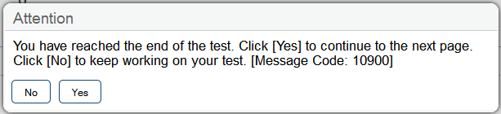

### End Test Review/Submit Page

After students select [**Yes**], a new screen presents two options as shown in Figure 57:

* Review answers
* Submit the test

Figure 57. Sample End Test Review/Submit Page

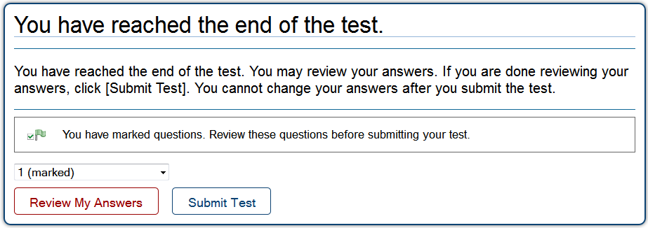

*End Test screen options:*

|  |
| --- |
| 1. To review answers and go back to the test, students must select an available item or test page from the list and then click [**Review My Answers**]. (The pause rule determines which items are available for review.)  * For segmented tests, students may review items only from the last segment.   *While students are reviewing their answers, the [****End Test****] button will remain on the screen. To return to the End Test screen, the student should click that button.*   1. To complete the testing process, students must click the [**Submit Test**] button. |

|  |  |
| --- | --- |
|  | **Alert:** After the student clicks [**Submit Test**], the test is officially completed. The student cannot log back in and review his or her answers. |

### Test Submitted Confirmation Screen

After the student submits the test, he or she will see the **Test Submitted Confirmation** screen shown in Figure 58. This screen will show the student’s name (if applicable) and State-SSID, the test name, and the date the test was completed and submitted.

Figure 58. Sample Test Submitted Confirmation Screen

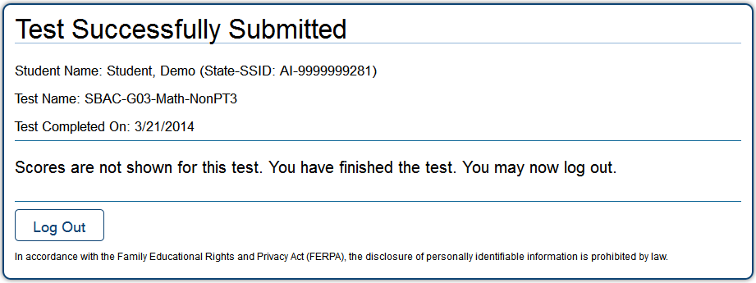

# Appendix A. About the Secure Browser

Students must use the secure browser installed on the computer to log in to the Student Testing Site. The secure browser is designed to ensure test security by prohibiting access to external applications or navigation away from the test.

Your school’s Technology Coordinator is responsible for ensuring that the secure browser has been correctly installed on all computers to be used for testing at your school. If you are not sure that the secure browser was installed or you have questions, contact your Technology Coordinator.

|  |  |
| --- | --- |
|  | For information about installing the secure browser, refer to the*Technical Specifications Manual for Online Testing*. This document is available on your state’s website. |

While the secure browser is an integral component of test security, Test Administrators perform an equally important role in preserving test integrity. In addition to the guidelines put forth by the Smarter Balanced Assessment Consortium and individual districts or schools, TAs should be aware of the following and employ the necessary precautions while administering online tests:

* **Close External User Applications**

Prior to administering the online tests, Test Administrators should check all computers that will be used and close all applications except those identified as necessary by the school’s Technology Coordinator. After closing these applications, the Test Administrator should open the secure browser on each computer. The secure browser will not work if the computer detects that a forbidden application is running (see below).

* **Prohibit Testing on Computers with Dual Monitors**

Students should not take online tests on computers that are connected to more than one monitor. Systems that use a dual monitor setup typically display an application on one monitor screen while another application is accessible on the other screen.

## Forbidden Application Detection

The secure browser and Student Testing Site automatically detect certain applications that are prohibited from running on a computer while the secure browser is open, *unless the student has Permissive Mode enabled for testing*. When the secure browser is launched, the system checks all applications currently running on a computer. If a forbidden application is detected, the student will not be able to log in. A message will also be displayed that lists the forbidden application(s) that need to be closed.

|  |  |
| --- | --- |
|  | **Warning:** *If a forbidden application is launched in the background while the student is already in a test, the student will be logged out and a message displayed.* This typically occurs when a process such as Internet Explorer is triggered in the background in order for a software auto-update to occur. Smarter Balanced recommends checking all software auto-updates and ensuring that they are done outside of planned testing hours. |

Before administering tests, Test Administrators should ensure that all software applications are closed before opening the secure browser on student computers. Contact your school’s technology staff if you need assistance in closing forbidden applications.

## About Testing on iPads and Android Tablets

Students taking tests on an iPad or Android tablet must use tablets that are already configured for secure online testing. These tablets should be ready for testing **before** giving them to students. For detailed instructions on configuring iPads and Android tablets, refer to the *Technical Specifications Manual for Online Testing* document, which is available on the Smarter Balanced website.

### Configuring iPads

|  |
| --- |
| 1. Tap the **AIRSecureTest** secure browser icon to open it. 2. Press the Home button three times in quick succession to enable Guided Access. (For more information about Guided Access, refer to the *Technical Specifications for Online Testing*.) 3. Tap the [**Start**] button in the upper right corner. Guided Access is now activated. 4. If prompted, select your state and then “Smarter Balanced Operational Test” as the test administration program. (This Launchpad page appears only once.) The student login page will display. 5. The student login page should be ready for students to log in. |

### Configuring Android Tablets

|  |
| --- |
| 1. Tap the **AIRSecureTest** secure browser icon to open it. 2. Follow the prompts on the screen. If the secure browser keyboard is not selected, you will need to do so. (For Android secure browser keyboard instructions, refer to the *Technical Specifications for Online Testing* manual.) 3. If prompted, select your state and then “Smarter Balanced Operational Test” as the test administration program. (This page appears only once.) The student login page will display. 4. The student login page should be ready for students to log in. |

## About Permissive Mode

Permissive Mode is a designated support option that must be enabled in ART. When Permissive Mode is enabled, students can use accessibility software in addition to the secure browser.

Permissive Mode becomes enabled when the student is approved for testing. Students who have the Permissive Mode setting enabled must NOT continue with the login process until their accessibility software is correctly configured. Otherwise, they will have to log out and resume the login process.

*Using accessibility software with the secure browser:*

|  |
| --- |
| 1. Open the required accessibility software. 2. Open the secure browser. Begin the normal login process through to TA approval (for login instructions, refer to [Student Login and Test Selection](#_Student_Login_and)). 3. When a student is approved for testing, two things happen:    * + - The student sees the **Is This Your Test?** page ([Step 4, Verifying Test Information](#_Step_4—Verifying_Test)).        - The secure browser allows the operating system’s menu and task bar to appear  * **Windows:** Start menu and bottom task bar * **Mac:** Apple menu and top task bar  1. The student ***must immediately switch*** to the accessibility software that is already open on the computer so that it appears “on top” of the secure browser. The student cannot click within the secure browser until the accessibility software is set up.    * **Windows:** Use [**Alt**] + [**Tab**] to switch to the accessibility software application or click the application in the task bar.    * **Mac:** Use [**Ctrl**] + [**Tab**] to switch to the accessibility software application or click the application in the dock. 2. The student configures the settings in the accessibility software. 3. After configuring the accessibility software settings, the student returns to the secure browser.   **Important:** Once the secure browser is back “on top,” the student can no longer switch back to the accessibility software. The taskbar and operating system menu will also be hidden. If changes need to be made, the student will need to log out and back in again.   1. The student clicks [**Yes, Start My Test**] and continues with the login process. |

|  |  |
| --- | --- |
|  | * Permissive Mode is available only for computers running supported desktop Windows and Mac operating systems. For information about supported operating systems, refer to the *Technical Specifications Manual for Online Testing*. * Accessibility software must be certified for use with the Smarter Balanced Test Delivery System. * Forbidden applications will still not be allowed to run. |

## Secure Browser Error Messages

* **Secure Browser Not Detected**

The Test Delivery System automatically detects whether a computer is using the secure browser to access the Student Testing Site. Students will not be able to access the Operational Test using a non-secure browser.

* **Unable to Establish a Connection with the Test Delivery System**

If a computer fails to establish a connection with the Test Delivery System, the message shown in Figure 59 will be displayed. This is most likely to occur if there is a network-related problem. The cause can be anything from a network cable not being plugged in to the school’s firewall not allowing access to the site.

Figure 59 Unable to Establish Connection Message

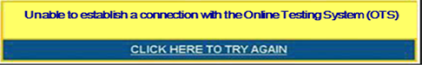

## Force-Quit Commands for Secure Browsers

In the rare event that the secure browser or test becomes unresponsive and you cannot pause the test or close the secure browser, you have the ability to “force quit” the secure browser.

If you cannot close the secure browser, contact your state’s help desk to obtain the force‑quit commands. *(Note: The force-quit command will log the student out of the test he or she is taking. When the secure browser is opened again, the student will have to log back in to resume testing.)*

Force-quit commands do not exist for the AIRSecureTest mobile secure browser for iOS and Android tablets. To close the secure browser:

* **iOS (iPads):** Triple-click the Home button to exit Guided Access, then close the app as you would any other iOS app.
* **Android:** Tap the [**Exit**] button in the upper right corner to close the secure browser.

# Appendix B. Transferring TA Test Sessions between Computers

Test Administrators can “transfer” an **active** test session from one computer/mobile device or browser to another without stopping the test session or interrupting in-progress tests. This feature is useful in scenarios in which a TA’s Web browser or computer encounters an issue while a test session is in progress or if the TA needs to change to a computer that is connected to a working printer.

|  |  |
| --- | --- |
|  | **Warning:** If you cannot remember your Session ID, you will be unable to transfer the session. Write down your Session ID BEFORE you transfer the session. |

The system ensures that a test session can be administered from only one browser at a time; therefore, when a session is moved to a new computer, the TA will no longer be able to administer the test session from the original browser or machine.

The instructions on this page apply to both the TA Interface and TA Practice and Training Site. If you started a session on the TA Interface, ensure that you log in to the TA Interface on the new computer or browser, and not the TA Practice and Training Site.

*To transfer a test session to a new machine or browser:*

|  |
| --- |
| 1. Log in to the TA Interface on the new machine or browser.   *Do NOT log out of or stop the test session on the original computer or browser; doing so will end the test session and pause all students’ tests.*  A Session ID prompt will appear (see Figure XX).   1. Enter the **active** Session ID in the text box and click [**Enter**].   *When the Session ID is validated, you will see the TA Interface and be able to continue monitoring your students’ progress and take action on any pending print requests.*   1. The test session on the previous computer or browser will automatically close. (This will not stop the session.) |

Figure XX. Enter Active Test Session ID

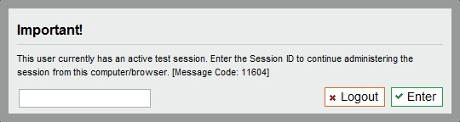

# Appendix C. Accessing the Practice and Training Tests

Practice and training tests are available to students and guest users so that they can become familiar with the online testing environment. These tests contain fewer items than the full-length Operational Tests.

Anyone can access the Smarter Balanced hosted practice and training tests using the guest login options. State service providers should also deploy instances of the practice and training tests using their test delivery system. The state-specific instances should include the Test Administration interface so that students and test administrators can practice logging into a proctored test session.

|  |  |
| --- | --- |
|  | The Practice and Training Tests must be accessed using a secure browser or a supported Web browser. If a student needs to use text-to-speech with these tests, the secure browser must be used. Text-to-speech is not available when a Web browser is used. Please refer to your state’s portal to access the secure browser and confirm supported browsers. The secure browser can be downloaded from the SmarterApp.org or a state-specific portal. |

|  |  |  |
| --- | --- | --- |
| **Accessing the Practice and Training Tests with the secure browser**   1. Open the secure browser on the computer. 2. At the bottom of the Sign In screen, click the link that says [**Go to the Practice and Training Test Site**]. | **Accessing the Practice and Training Tests with a Web browser**   1. Navigate to your state’s portal. 2. Click the [**Practice and Training Tests**] link. 3. Click the [**Student Interface Practice and Training Tests**] icon. | |
| **Options for Logging In (see Figure XX)**   1. *Guest User in Guest Session* 2. Make sure the checkboxes next to “Guest User” and “Guest Session” are checked. 3. Click [**Sign In**]. 4. *Guest User in Training Session with a TA* 5. Uncheck the box next to “Guest Session.” 6. Enter the Session ID provided by the TA. 7. Click [**Sign In**]. 8. *Student in a Guest Session* 9. Uncheck the box next to “Guest User.” 10. Enter your Confirmation Code and State-SSID. 11. Click [**Sign In**]. 12. *Student in a Training Session with a TA* 13. Uncheck the boxes next to “Guest User” and “Guest Session.” 14. Enter your and State-SSID. 15. Enter the Session ID provided by the TA. 16. Click [**Sign In**]. | | Practice and Training Tests Login Page  *(showing default Guest User/Guest Session)* |

**About Guest Sessions**

Guest sessions do not require TA approval, so users can access the practice and training tests directly and can also modify their own test settings (color choice and print size). Guest users will need to choose a grade level prior to selecting a practice or training test.

As with the regular login process, all students and guest users must go through a series of five login steps before they will see the first page of the test.

|  |  |
| --- | --- |
| **Select a Grade Level (Guest Users) and Confirm Information (Students)**   1. Guest users must select a grade level from the drop-down list; this will determine the item samplers you can access. Users should confirm the information on the screen. 2. Click [**Yes**] to continue. |  |
| **Select a Practice or Training Test (All Users)**  Click the name of the practice or training test you want to take. You will continue to the next screen.   1. If you want to access tests from another grade, click [**Back to Login**].   *Note: If you are a student who previously logged in to a training session and have already started a test, the text will say “Resume” instead of “Start.”* |  |
| **Choose Test Settings (Guest Sessions only)**  This page appears when you have logged in to a guest session. It allows you to select options for test settings, such as color choices, print size, and text-to-speech, if applicable. Click [**Select**] to continue.  *Note: If you log in in to a test session created by a TA, you will be unable to change test settings. If you log in to a guest session, you will be able to change test settings.* | *Reminder: For text-to-speech to be available, the secure browser must be used.* |

|  |  |  |
| --- | --- | --- |
| **Confirm Selected Test and Settings (All Users)**   1. Review the screen and confirm the test and settings. 2. Click [**Yes, Start My Test**] to proceed. |  | |
| **TTS Check**  Audio for text-to-speech can be accessed only when you are using the secure browser. When using the secure browser, you may be prompted to verify that you can hear the sample audio.   * Click the green audio button to listen to the sample audio. * You can adjust the volume and pitch using the available sliders. * If the voice is clear, click [**Yes, I heard the voice**]. * If you cannot hear the voice or it is not clear, click [**No, I did not hear the voice**]. You will be directed to a screen that will allow you to log out and adjust the computer’s voice settings. | | *Note: If your computer does not have audio or a voice pack correctly configured, you may see a page that says text-to-speech is not available. Check with your school’s Technology Coordinator for assistance.* |
| **Sound Check (for ELA tests)**  ELA practice and training tests contain listening items. This sound check screen appears during the login process for an ELA test.   * + Click the speaker icon to listen to the sample audio.   + If the sound is audible, click [**Yes**].   + If the sound is not audible, click [**No**]. | |  |
| The *Test Instructions and Help* page is next. Review the information on this page, and then click [**Begin Test Now**] at the bottom of the screen.  The first page of the test will automatically appear. *(If you resumed a practice or training test, you will be directed to the first page that has unanswered items.)* | |  |

# Appendix D. Keyboard Commands for Students

Students can use these keyboard commands to navigate between test elements, features, and tools. This appendix is also available on SmarterBalanced.org in the [Publications and Resources section](http://sbac.portal.airast.org/field-test/resources/#additional) (under the Resources & Events link) as a stand-alone document that can be printed for students’ use during testing.

| Button/ Image | Description of Function | Keyboard Commands |
| --- | --- | --- |
|  | Open the **GLOBAL MENU** | [**Ctrl**] + [**G**] |
|  | Go to the **NEXT** test page | [**Ctrl**] + [**🡪**]  (or use the Global Menu) |
|  | Go to the **PREVIOUS** test page | [**Ctrl**] + [**🡨**]  (or use the Global Menu) |
|  | Move to the **NEXT ELEMENT** (on a page containing multiple test items and/or a reading passage) | [**Tab**] |
|  | Move to the **PREVIOUS ELEMENT** (on a page containing multiple test items and/or a reading passage) | [**Tab**] + [**Shift**] |
| optionA.png | Select **OPTION A** | [**Ctrl**] + [**Tab**] to move between answer choices  [**Enter**] to select it as the answer |
| optionB.png | Select **OPTION B** |
| optionC.png | Select **OPTION C** |
| optionD.png | Select **OPTION D** |
|  | **PAUSE** your test | [**Ctrl**] + [**G**] (via Global Menu) |
|  | **END TEST** and submit it for scoring | [**Ctrl**] + [**G**] (via Global Menu) |
|  | Open the **SYSTEM SETTINGS** (volume) window | [**Ctrl**] + [**G**] (via Global Menu) |
|  | Open the **HELP GUIDE** | [**Ctrl**] + [**G**] (via Global Menu) |
|  | **ZOOM IN** (increase the size of text and graphics on a page) | [**Ctrl**] + [**+**]  or use the Global Menu |
|  | **ZOOM OUT** (decrease the size of text and graphics on a page) | [**Ctrl**] + [**−**]  or use the Global Menu |
|  | Open the **CALCULATOR** (selected Math tests/segments) | [**Ctrl**] + [**G**] (via Global Menu) |
|  | Open the **DICTIONARY**/**THESAURUS** (ELA PT tests) | [**Ctrl**] + [**G**] (via Global Menu) |
|  | Open the **MASKING** tool | [**Ctrl**] + [**G**] (via Global Menu) |
|  | Open the global **NOTES** tool | [**Ctrl**] + [**G**] (via Global Menu) |
|  | Send a **PRINT PASSAGE** request  *Only available to students who have the Print-on-Demand accommodation enabled.* | [**Ctrl**] + [**G**]  (via Global Menu) |
|  | **SCROLL UP** in an area of the test page | [**↑**] |
|  | **SCROLL DOWN** in an area of the test page | [**↓**] |
|  | **SCROLL** to the **RIGHT** in an area of the test page | [**→**] |
|  | **SCROLL** to the **LEFT** in an area of the test page | [**←**] |
|  | Open the **CONTEXT MENU**  (for the selected passage, item or answer option) | [**Ctrl**] + [**M**] |
|  | **MARK/UNMARK** an item for review | [**Ctrl**] + [**M**]  (via Context Menu) |
|  | Open the **NOTEPAD** to provide feedback on an item | [**Ctrl**] + [**M**]  (via Context Menu) |
|  | **HIGHLIGHTER** (highlight text on the page) | [**Ctrl**] + [**M**]  (via Context Menu) |
|  | **STRIKE THROUGH** an answer option | [**Ctrl**] + [**M**]  (via Context Menu) |
|  | Send a **PRINT** requestfor items and answer options  *Only available to students who have the Print-on-Demand accommodation enabled)* | [**Ctrl**] + [**M**]  (via Context Menu) |
|  | **SPEAK** (listen to a passage, item, answer choice, or specific portion of text)  *Available only to students who have Text-to-Speech enabled.* | [**Ctrl**] + [**M**]  (via Context Menu) |

## Test Selection Screens and In-Test Pop-ups

Use these keyboard commands to select options on the login pages or on pop-up messages that appear during the test. For example, if you see a screen with [**No**] or [**Yes**] buttons, you will need to navigate to those buttons to select them.

|  |  |
| --- | --- |
| Keyboard Command | Function |
| [Tab] | Move to the next option |
| [Tab] + [Shift] | Move to the previous option |
| [Enter] | Select the shaded option |

## Keyboard Commands for Items with Add Point, Add Arrow, and Collect Line Tools

|  |  |
| --- | --- |
| Technology-enhanced items with an add point or add line tool may have up to three main sections:   * Answer Space (the large area that takes up the most space) * Action button row (at least one action button will be present at the top). Action buttons include:   *Delete*, *Add* *Point*, *Add* *Arrow*, *Add* *Line*, and *Connect* *Line*   * Object Bank (a section that includes objects to move to the Answer Space) |  |

*Note: Not all technology-enhanced items contain all three sections. Some items may contain only an Answer Space (with objects already in the Answer Space). Some contain only action buttons and the Answer Space. Some may contain only the Object Bank and Answer Space.*

|  |  |
| --- | --- |
| Keyboard Command | Function |
| [Tab] | To move between the Object Bank, the action buttons at the top of the screen, and the main Answer Space, press the [**Tab**] key.  The “active” space will show a border to make it look different. The active button will be white. |
| [Enter] | Press the [**Enter**] key to move between the objects (images, dots, lines, and arrows) in the Answer Space.  The “active” object will show a border to make it look different. |
| [Space bar] | *Select Object:*  Press the [**space bar**] to select the “active” object or button (the one that shows a border). If you are selecting an object or adding a point, line, or arrow, it will move to the Answer Space in the top left corner. It will also have a blue border to show that it is still “active.”  *Delete Object:*  Press the [**space bar**] to delete an object (after you have selected the [**Delete Button**] option and moved to the object you want to delete). |
| [←] or [→] | Move the object to the left or right. |
| [↑] or [↓] | Move the object up or down.  *For items in the Object Bank, use the ↑ or ↓ arrows to navigate between the available objects. The selected object will have a blue background.* |
| [Shift] + [arrow key] | Move the object a smaller distance (left, right, up, or down). |

#### Accessing an Element Context Menu with Keyboard Commands

Students who cannot use a mouse can use the keyboard to navigate to and open an element.

*Navigating to an Element*

|  |
| --- |
| 1. Press the [**Tab**] key to navigate between test items (and the reading passage, if there is one). 2. Press [**Ctrl**] + [**Tab**] to switch from a test item to each answer option. |

*Opening a Context Menu for an Element Using the Keyboard*

|  |
| --- |
| 1. Press the [**Ctrl**] + [**M**] keys on the keyboard. The Context Menu for that element will appear. 2. Use the **Up** or **Down** arrow keys on your keyboard to move between options in the menu. Each option will be highlighted as you arrow up or down. 3. Press the [**Enter**] key to select the highlighted menu option. 4. Press the [**Esc**] key to close the Context Menu. |

### Context Menu: Highlighting Text with the Keyboard

|  |
| --- |
| 1. Navigate to the element containing the text you want to select. 2. Press [**Ctrl**] + [**M**] to open the Context Menu. 3. Select Enable Text Selection from the list of available options. A flashing cursor will appear. 4. Use the arrow keys on the keyboard to move the cursor to the beginning of the text you want to select. 5. Hold [**Shift**] and use the arrow keys to select your text. The text you have selected will appear shaded. 6. Press [**Ctrl**] + [**M**] to access the Context Menu again. Select the feature you want to use for the selected text (e.g., Highlighter, Speak Passage). |

# Appendix E. Calculators in the Test Delivery System

## About Online Calculators in the Test Delivery System

Students in grades 6, 7, 8, and 11 are able to use the online calculator for some mathematics tests. Available calculator types include *Basic,* *Scientific,* *Graphing,* and *Regression.* Students in grades 3, 4, and 5 are not permitted to use any calculators.

|  |  |
| --- | --- |
|  | **Note:** Only those students who require a braille or talking calculator are permitted to use hand-held calculators. For more information, refer to the *Usability, Accessibility, and Accommodations Guidelines* document, which is available on SmarterBalanced.org. |

Descriptions of each available calculator are provided in this appendix.

| **Calculator Type** | **Operational Test** | **Practice Test** | **Training Test** |
| --- | --- | --- | --- |
| Basic Calculator | Grade 6 Mathematics | Grade 6 Mathematics | Math 6–8 Training Test |
| Scientific Calculator | Grades 7 and 8 Mathematics | Grades 7 and 8 Mathematics | N/A |
| Scientific, Graphing, and Regression Calculator | Grades 9, 10, and 11 Mathematics | Grade 11 Mathematics | HS Math Training Test |

Students can use a mouse or keyboard to use the calculators on desktop and laptop computers. For tablets, students can simply tap the keys on the calculator’s keypad. Information about keyboard shortcuts for students who cannot use a mouse is also available in this section.

|  |  |
| --- | --- |
|  | Some calculators may be combined; that is, students may access both scientific and graphing calculators within the same calculator window, as shown in Figure 60. When multiple calculator types are available, a button will appear for each calculator type. |

Figure 60. Sample Combined Calculator

**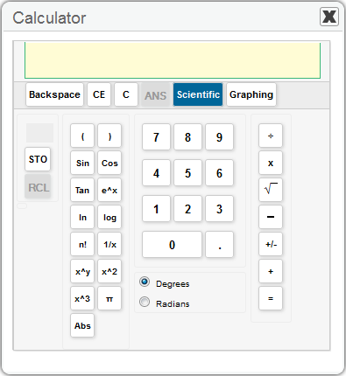**

## Accessing the Sample Calculators

All sample calculators are available on SmarterBalanced.org. We encourage bookmarking the sample calculators. Desktop/home screen shortcuts can also be created.

|  |  |
| --- | --- |
|  | Once the calculators are saved to the desktop or home screen, students can open them without needing a Wi-Fi or 3G/4G connection. |

### Open a Sample Calculator on Windows/Mac/Linux

|  |  |
| --- | --- |
| 1. Navigate to SmarterBalanced.org > Practice and Training Tests >Calculators page. | |
| 1. Click on a [**Calculator**] link.   The sample calculator you selected will open in the browser window.  *Note: The first time you load the sample calculator, you should see a pop-up message that says “This website (tds.airast.org) is asking you to store data on your computer for offline use.”*   1. Click [**Allow**]. | Firefox_AllowOfflineUse.png |

### Create a Desktop Shortcut to the Sample Calculator

|  |  |
| --- | --- |
| *Note: Ensure that the browser window does not take up the full monitor.*   1. Use your mouse to hover over the lock icon in the address bar as shown. 2. Click and drag the lock icon to the desktop. A shortcut will appear that says “Calculator” and have the browser icon. | Firefox_DragShortcut.png |
| 1. *Optional: Rename shortcut icon.* 2. Click in the icon text and it will become editable as shown in Figure XX. 3. Change the text to what you want (e.g., “Graphing Calculator”). 4. Double-click the icon to open the sample calculator. |  |

### 

### Open a Sample Calculator on a Mobile Tablet

|  |  |
| --- | --- |
| 1. Navigate to SmarterBalanced.org > Practice and Training Tests > Calculators page.   *For iPads, use Safari. For Android tablets, use Google Chrome.* | |
| 1. Tap on a [**Calculator**] link.   The sample calculator you selected will open in the browser window.  *Note: You will see a pop-up message encouraging you to add the calculator to the tablet’s home screen.* | Firefox_AllowOfflineUse.png |

#### Save a Sample Calculator to your Home Screen (iPad)

|  |  |
| --- | --- |
| 1. Tap the “share” icon [], which appears just to the left of the address bar. 2. Tap the [**Add to Home Screen**] icon as shown. | share popup.PNG |
| 1. *Optional: Rename shortcut icon.*   (By default, all sample calculators are named “Calculator.”)   1. Tap in the box that says “Calculator.” 2. Using the tablet keyboard, add or modify text (e.g., “Graphing Calculator”). 3. Tap the blue [**Add**] button. The shortcut icon will appear on the Home screen. | add to home popup-cropped.PNG |

### Bookmark and Add a Sample Calculator to Your Home Screen (Android)

|  |  |  |  |
| --- | --- | --- | --- |
| **Save the Sample Calculator as a Bookmark**   1. Tap the star icon [], which appears on the right side of the address bar. The **Add Bookmark** screen will open. 2. *Optional: Modify the bookmark name.* 3. Tap the text and then use the keyboard to change the name. 4. Tap the down arrow to close the keyboard. 5. Tap [**Save**]. | | share popup.PNG | |
| **Add the Calculator Bookmark to the Home Screen**   * 1. Tap the menu [] icon, which appears in the upper right corner. The menu will open as shown.   2. Tap [**Bookmarks**]. The list of your bookmarks will appear. | | | add to home popup-cropped.PNG |
| * 1. Tap and hold the calculator bookmark. A list of options will appear.   2. Tap [**Add to home screen**] as shown. The bookmark will be added to your tablet’s home screen. | add to home popup-cropped.PNG | | |

## Available Calculators

### Basic (Four-Function) Calculator

|  |  |
| --- | --- |
| The basic calculator shown in Figure 61 includes a number pad and buttons for adding, subtracting, multiplying, and dividing.  ***Calculation keys:***  **Division (÷)**  **Multiplication (x)**  **Subtraction (−)**  **Addition (+)**  **Equals (=)**  ***Function keys:***  **Backspace**—Clears the last numeral entered  **CE**—Clears the last numeric entry made; the previous operation is still current  **C**—Clears all numbers and operations | Figure 61. Basic Calculator  BasicCalculator.png |

### Scientific Calculator

|  |  |
| --- | --- |
| In addition to the functions available on the basic/standard calculator, the scientific calculator shown in Figure 62 includes exponential, logarithmic, and trigonometric functions.  ***Calculation keys:***  **Division (÷)**  **Multiplication (x)**  **\sqrt{\ } \!\,Square root ( )—**to find a square root, enter the number and then select **\sqrt{\ } \!\,**  **Subtraction (−)**  **Sign (+/-)**—to enter a negative number, click +/-, and then select the number(s).  **Addition (+)**  **Equals (=)** | Figure 62. Scientific Calculator  ScientificCalculator.png |

***Function keys:***

|  |  |
| --- | --- |
| **Backspace**—Clears the last numeral entered  **CE**—Clears the last numeric entry made; the previous operation is still current  **C**—Clears all numbers and operations  **ANS**—Retrieves last computed result  **M**—Indicates memory is full  **STO**—Stores displayed value in memory  **RCL**—Recalls stored value from memory  **C**—Clears stored value in memory  **Sin**—Displays “**sin(**” followed by expression: used to find sine values  **Cos**—Displays “**cos(**” followed by expression: used to find cosine values  **Tan**—Displays “**tan(**” followed by expression: used to find tangent values  **e^x**—Displays “**exp(**” followed by expression: used to find exponentials | **ln**—Displays “**ln(**” followed by expression: used to find natural logarithms  **log**—Displays “**log(**” followed by expression: used to find logarithms  **(**—Left parentheses  **)** —Right parentheses  **n!** —Finds factorial of displayed value  **1/x**—Finds multiplicative inverse of displayed value  **x^y**—Displays carrot symbol to represent exponential notation  **x^2**—Finds the square of the displayed value  **x^3**—Finds the cube of the displayed value  **π**—Displays the value of pi as 3.141593  **Abs**—Displays “**Abs(**” followed by expression: used to find absolute value  **Degrees**—Sets calculator in degrees mode  **Radians**—Sets calculator in radians mode |

### Graphing Calculator

In addition to the function and calculation keys available on a scientific calculator, a graphic calculator enables students to plot graphs and tables for up to four equations, as well as modify the graphing window parameters as shown in Figure 63.

Figure 63. Graphing Calculator (Default View)

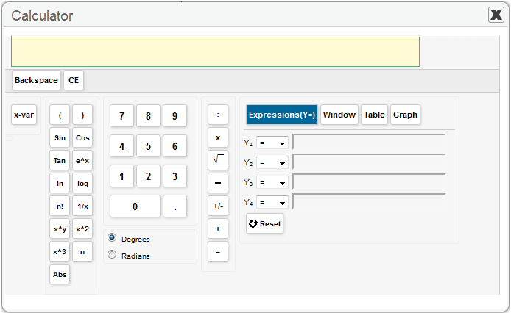

***Graphing function keys:***

**Expressions (Y=)**—Allows student to enter up to four (4) different expressions

**Window**—Allows student to set maximum and minimum axes values for graphing window

**Table**—Allows student to create a table of values for each entered expression

**Graph**—Shows graph for each entered expression using the window

**Reset**—Clears all expressions and resets window to default values

***x*-var**—Inputs *x*-variable

##### Expressions (Y=)

|  |  |
| --- | --- |
| By default, the [**Expressions (Y=)**] option is selected (shaded blue). Each expression can be an equality or inequality. (See Figure 64.)  From each drop-down list, select from the following:   * **Equals (=)** * **Greater than (>)**–shade above function * **Less than (<)**–shade below function   Enter an expression in to each desired Y text box.   * To display the graph of the expression(s), select the [**Graph**] button. * To change the parameters, click the [**Window**] button. | Figure 64. Graphing Calculator: Expressions  GraphingCalculator_Y-variables.png |

##### Window View

|  |  |
| --- | --- |
| This feature allows you to change the dimensions and scale for the graph output window.  Click the [**Window**] button shown in Figure 65 and verify or update the value in each text box.  **Xmin**—Sets the minimum *x* value displayed on the graph’s *x*-axis  **Xmax**—Sets the maximum *x* value displayed on the graph’s *x*-axis  **Ymin**—Sets the minimum *y* value displayed on the graph’s *y*-axis  **Ymax**—Sets the maximum *y* value displayed on the graph’s *y*-axis  **Trace Step Size**—This feature is comparable to the Xres feature on handheld graphing calculators and allows you to change the pixel resolution. This value does not need to be changed.  **Xscale**—Defines the distance between tick marks on the *x*-axis  **Yscale**–Defines the distance between tick marks on the *y*-axis | Figure 65. Graphing Calculator: Window View  GraphingCalculator_Window.png |

##### Table View

|  |  |
| --- | --- |
| Table view shown in Figure 66 allows you to change the initial value of *x* based on the expressions entered in the [**Expressions (Y=)**] section.  Changing the value of *Init X* will allow you to see the corresponding output values for each Y = expression.  After you have verified or updated the value in the Initial X (Init X) text box, click the [**Apply**] button.  ***Function keys:***  **Apply**—Shows *y*-values for the inputted *x*-value  **Previous**—Shows *y*-values for the preceding 5 values of *x*  **Next**—Shows *y*-values for the next 5 values of *x* | Figure 66. Graphing Calculator: Table View  GraphingCalculator_Window.png |

##### Graph (Output) View

|  |  |
| --- | --- |
| This feature allows you to view the graph output of the expressions entered in the [**Expressions (Y=)**] section as shown in Figure 67.  In addition to the graphing window, four arrow buttons and two radio buttons (Scroll and Trace) are available on this section of the graphing calculator.  ***Arrow Keys***  The arrow keys enable students to use the scroll and trace features. See below for more information.  ***Scroll and Trace Features***  **Scroll**—Allows students to pan (move) the viewing window up, down, left, and right. Select the ***Scroll*** radio button and then click an arrow:  **Up (↑) arrow**—pan upward  **Down (↓) arrow**—pan downward  **Left (←) arrow**—pan to the left  **Right (→) arrow**—pan to the right  **Trace**—Allows students to observe both the *x* and *y* coordinates of a point on a graph as the cursor moves along the graph of the function.  Select the ***Trace*** radio button. The trace square will appear on the graph. (By default, the trace square will appear on the Y1 expression.) Select an arrow button to move the trace square.  **Left (←) arrow**—move the trace square to the left on the selected graph  **Right (→) arrow**—move the trace square to the right on the selected graph  **Down (↓) arrow**—move the trace square to the next graphed Y= (e.g., from Y1 to Y2 and from Y2 to Y3)  **Up (↑) arrow**—move the trace square to the previous graphed Y= (e.g., from Y2 to Y1 and from Y3 to Y2) | Figure 67. Graphing Calculator: Graph View  Firefox_GraphCalcViewWindow.png  *Note: When the Xmin, Xmax, Ymin, and Ymax are set to values greater than 5 points from the center, the scale of tick marks will change. For example:*   * If the values are (–10, 10, –10, 10), then four tick marks for each quadrant will be visible, labeled in units of two (2, 4, 6, 8). The +/- 10 tick marks are the maximum and not labeled. * If the values are (–6, 6, –6, 6), then two tick marks for each quadrant will appear. These are also labeled in units of two (2, 4) and the +/- 6 tick marks are the maximum and not labeled.   ***Other keys include:***  **Zoom In**—Allows you to zoom in the viewing window  **Zoom Out**—Allows you to zoom out the viewing window  **Reset**—Clears all graphed expressions |

### Regression Calculator

The regression calculator shown in Figure 68 can be used to derive linear, quadratic, exponential, and power equations.

Figure 68. Regression Calculator

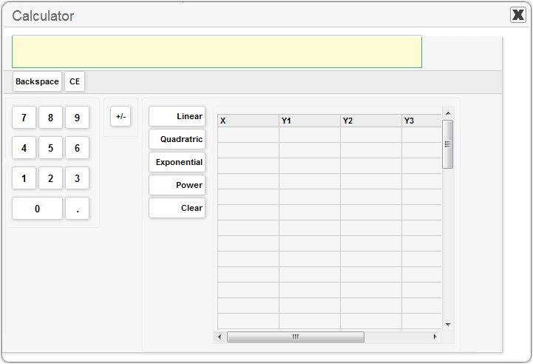

Enter values in the X column and at least one Y column and in at least two rows. Select a function key to derive the desired equation. *(Note: Values can be entered in up to four Y columns. Use the internal horizontal scroll bar to access the Y4 column.)*

***Regression Function keys:***

**Linear**—Displays the equation for the *x* and *y* values entered for each Y column in the viewing window

**Quadratic**—Displays the equation for the *x* and *y* values entered for each Y column in the viewing window

**Exponential**—Displays the equation for the *x* and *y* values entered for each Y column in the viewing window

**Power**—Displays the equation for the *x* and *y* values entered for each Y column in the viewing window

**Clear**—Clears all *x* and *y* values from the regression table

## Keyboard Shortcuts for Calculators

This section provides information on using keyboard shortcuts to enter calculations and equations. The keyboard shortcuts provided in this section work for all supported operating systems (Windows, Mac OS X, and Linux).

* The functionality is similar to navigating between elements on a test page.
* The [**Ctrl**], [**Shift**], and arrow keys are used to navigate, and the space bar is used to select a value or variable.

To open the calculator in a test environment using keyboard shortcuts:

* Press the [**Ctrl**] + [**G**] keys on the keyboard. This will open the Global Menu.
* Use the arrow up or down keys to navigate to the calculator tool.
* Press [**Enter**] to select and open the calculator.

*Note: For additional information about general keyboard shortcuts in a test, refer to* Appendix D. Keyboard Commands for Students*.*

**Navigating Within the Calculator**

|  |  |
| --- | --- |
| Each calculator has several “areas,” including the display, number keypad, and function keypad. You can navigate between each area and within each area using the following shortcut keys.  **To navigate between areas:**   * Press [**Ctrl**] + [**Shift**] + [**→**] OR [**←**].   **To navigate within an area:**   * Press [**Shift**] + any arrow key (up, down, left, right).   **To select a number or function to enter in the display:**   * Press the space bar. The selected value or variable will appear in the display. | *Sample Calculator*  calculator.png |

# Appendix F. Using Braille with Online Testing

## About Online Testing and Braille

Smarter Balanced l Tests are available to students who use braille. Students who have the braille accommodation will use the same Student Testing Site as other students, but they will be presented with the Streamlined Interface, which is braille friendly. The Streamlined Interface is optimized to allow supported screen reading software and printing of passages and test items to braille embossers.

This appendix provides specific guidance for Test Administrators (TAs) administering Smarter Balanced Tests to students using the Streamlined Interface.

* The Job Access with Speech (JAWS) screen reading software provided by Freedom Scientific can be used with this streamlined interface.
* The mathematics tests will present students with items in Nemeth Braille via a braille embosser.
* The ELA tests will present students with items in either contracted or uncontracted literary braille:
  + Items that contain only text will be sent to a Refreshable Braille Display (RBD).
  + Items that contain text and images that cannot be read by an RBD will be sent to a braille embosser.
* Ability to use the Zoom tool. Students who have some vision can use the Zoom buttons on the Streamlined interface to increase the size of text and graphics.
* Students may request embossing for any item or reading passage as they progress through the test.

District or School Test Coordinators may also designate a student to receive all items through the braille embosser instead of through the Refreshable Braille Display. This accommodation must be set in ART prior to the start of a given test opportunity (Refer to the Student Information section of the *ART User Guide*).

## Braille Technology Requirements and Configuration

Prior to administering tests using the Streamlined Interface, TAs must ensure that the technical requirements listed below are met. These requirements apply to the student’s computer, the Test Administrator’s computer, and the supporting braille technologies used in conjunction with the Streamlined Interface.

### Requirements for Test Administrator Computers

TAs administering tests to students who require braille must have the following software installed on their machine prior to testing. The software is necessary to process these students’ print requests.

* **ViewPlus Tiger Max Embosser**and the supporting **ViewPlus Desktop Embosser driver**

The Desktop Embosser Driver can be downloaded from <http://downloads.viewplus.com/drivers/desktop-braille-embosser/>. The download includes the Tiger Viewer software, which is needed to handle print requests for items and passages that contain tactile or spatial components.

* **Duxbury Braille Translator 11.1 or 11.2**

This software allows printing of items and reading passages (without images) and can be downloaded from <http://www.duxburysystems.com/dbt_main.asp>.

### Requirements for Student Computers

* The Student Testing Site currently supports braille testing using the Streamlined Interface on **Windows 7, 8.0, and 8.1** machines only.
* **Windows Secure Browser 7.0** must be installed on all machines used for student testing, including tests administered using the Streamlined Interface.
* **JAWS Screen Reader** (version 12, 13, 14, or 15).
* Braille display that is compatible with Windows 7, 8.0, or 8.1 and JAWS. We recommend that the braille display have a minimum of 40 cells.

For more information about JAWS, including product download and purchase, go to <http://www.freedomscientific.com/products/fs/jaws-product-page.asp>.

|  |  |
| --- | --- |
|  | The following JAWS configuration must be applied to each student computer prior to administering tests using the Streamlined Interface:   1. Configure JAWS to recognize the Secure Browser. 2. Apply settings for Contracted/Uncontracted braille through JAWS.   **Instructions for each requirement follow.** |

#### Configure JAWS to Recognize the Secure Browser

These instructions are based on JAWS 13 installed to the default location. If you have another version of JAWS or it is installed to a different location, navigate to the appropriate directory.

|  |
| --- |
| 1. Open the JAWS **ConfigNames.ini** file. This file may appear in two folders. Depending on how JAWS is installed on your computer, both files may need to be modified:    * Start > All Programs > JAWS 13.0 > Explore JAWS > Explore Shared Settings *(required)*    * Start > All Programs > JAWS 13.0 > Explore JAWS > Explore My Settings *(optional)* 2. In the **ConfigNames.ini** file, locate the line of text that contains Chrome=Firefox. At the end of this line, press [**Enter**] on your keyboard to create a new line. In the new line, type in the following string, exactly as written:   SBACSecureBrowser7.0=Firefox   1. Save the file.   **Note:** If you receive an error that you do not have permission to save the .ini file to this location, you will first need to save the file to your desktop as **ConfigNames.ini**. After saving the updated .ini file, copy it to the folder containing the original .ini file (referenced in Step 1). You will need to confirm that you want to replace the original file with the file you created. |

#### Applying Settings for Contracted/Uncontracted Braille

In order for students to use Contracted or Uncontracted Literary Braille, the correct JAWS setting must be applied *prior* to launching the secure browser.

|  |
| --- |
| 1. Open JAWS, and then select the *Utilities* menu. In the *Utilities* menu, select *Settings Center*. The *Settings Center* will open.      1. From the “Application” drop-down menu at the top of the *Settings Center* screen, select *firefox*. 2. In the “Search for settings” panel on the left side, scroll down to the Braille section and expand the sub-settings. Select *Contracted Braille Translation*:     The *Settings Center* will display the options for *Contracted Braille Translation*. |

|  |
| --- |
| 1. In the *Translation* section, select the correct option from the *Contracted Braille Translation* type drop-down list.    * For students who prefer **Contracted Braille**, select “Input and Output.”    * For students who prefer **Uncontracted Braille**, select “Off.”      1. In the *Braille Mode* section, ensure that the following three settings are checked (and only these settings are checked):    * Active cursor follows Braille display    * Enable Braille Auto Detection    * Enable Word Wrap      1. Click [**Apply**] and then click [**OK**]. |

## Optional JAWS Voice Adjustment Settings

JAWS voice settings may be adjusted for individual students based on their needs. The following settings must be set prior to administering assessments: *Voice Profile*, *Speaking Rate*, and *Punctuation*. Instructions for each setting follow.

|  |  |
| --- | --- |
|  | **Alert: Any optional JAWS settings for a student must be set prior to launching the secure browser.** Students should take one or more practice tests using JAWS so they can determine whether these settings need to be adjusted. |

### Opening the JAWS Voice Adjustment Window

|  |  |
| --- | --- |
| 1. Open JAWS and select the *Options* menu. In the *Options* menu, select *Voices* and then *Voice Adjustment*. The Voice Adjustment window will open. |  |

### Adjusting JAWS Voice Profile, Speaking Rate, and Punctuation Settings

The following settings can be adjusted: *Voice Profile*, *Speaking Rate*, and *Punctuation*.

|  |  |
| --- | --- |
| ***Voice Profile***   * + 1. In the *Profile* section, select a Voice Profile from the *Name* drop-down list.     2. Click [**Apply**].   ***Voice Rate***  In the *Voice* section, drag the slider to the desired rate speed. The lower the rate, the slower the words will be read aloud.  Click [**Apply**].  ***Punctuation***   1. In the *Voice* section, click the *Punctuation* drop-down list. Select from the following options: *None*, *Some*, *Most*, and *All*. 2. Click [**Apply**].   When all settings are saved, click [**OK**]. |  |

|  |  |
| --- | --- |
|  | **Warning regarding ELA tests and text-to-speech and JAWS**  Because the text-to-speech accommodation is not fully approved for use with the ELA tests (approved for items only), the sound on the student’s computer will be automatically muted when the student begins the first item on the braille form of an ELA test.  The sound will automatically turn on again when the student submits the ELA test or pauses the test and returns to the login screen.  Some students may require assistance with JAWS navigation during the reading test because they will not be able to hear the JAWS commands when the sound is muted. JAWS will still output all commands and text to the refreshable braille display, even with the sound on the computer muted. |

## Approvals and Student Test Settings for Braille

The approval process is the same for tests administered using the Streamlined Interface as for all other Smarter Balanced tests. A student’s braille accommodation must be set in ART before he or she can begin testing. This accommodation automatically applies braille as the default “language” setting for all of that student’s tests.

When viewing students before approving them for testing, TAs should verify that students who require braille have the following settings established (see Figure 69):

|  |  |
| --- | --- |
| * **Language:** Braille * **Braille Type:**   + Contracted/Uncontracted (ELA)   + Nemeth (mathematics) * **Emboss Request Type:**   + On-Request (ELA)   + Auto-Request (mathematics) * **Emboss:**   + Stimuli & Items   For ELA tests, students can request printing for individual passages and items as they go through the test. For mathematics tests, the test will automatically be delivered to the embosser. | Figure 69. TA Interface: Sample Math Test Settings for a Student with Braille |

## Student Print Requests

The embossed output for student print requests will vary depending on the type of file associated with a test item. There are two types of files:

* **PRN files:** Print requests containing tactile or spatial components such as images and diagrams. This file type is handled by the Tiger Viewer software.
* **BRF files:** Print requests for items containing only text, including formatted tables and poems. This file type is handled by the Duxbury Braille Translator software.

### Approving Print Requests

Print requests will display on the TA Interface and must be approved by the TA in order to be embossed. Print requests will be sent automatically to the TA for Mathematics tests items, as well as for ELA items that include graphics or other material that cannot be presented through the Refreshable Braille Display. For other ELA items, students must manually request embossing.

To maintain the security of printed test materials, all print requests are sent to the TA for approval, whether sent automatically to the TA or initiated by the student (see Figure 70).

|  |  |
| --- | --- |
|  | **Caution:** Printed materials are secure test information. Any printouts must be securely stored and then destroyed when no longer needed. |

Figure 70. TA Interface: Student Print Request(s) Screen

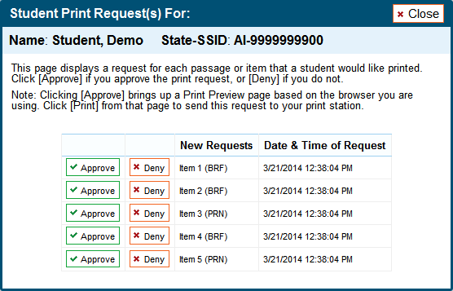

Upon approving a print request, the TA must send the file to the embosser using either the Duxbury software (for BRF files) or ViewPlus software (for PRN files).

The following section provides steps for embossing both types of files.

### Configuring Default Printing Preferences on the TA Computer

Refer to the following instructions to configure the software used to handle each file type (see Figure 71):

Figure 71. Sample File Icons in TA Interface Help Window

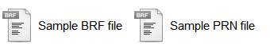

#### BRF Files with the Duxbury Braille Translator Software

|  |  |
| --- | --- |
| 1. Click the [**Help**] button in the upper right corner of the TA Interface. 2. Click [**Sample BRF File**]. The file dialogue window will open as shown.    * From the drop-down list next to “Open with, select *Duxbury Braille Translator*.” Click [**OK**]. This will open the sample file in the Duxbury Braille Translator program. Skip to Step 6.    * If the *Duxbury Braille Translator* is not available as a selectable program, follow steps 3–5 below. |  |
| 1. To add *Duxbury Braille Translator* as the default program for opening BRF files: 2. Click [**Browse**]. The *Choose Helper Application* window will open. 3. Click the [**Browse**] button. The *Choose Helper Application* window will list the available program files. 4. Scroll down or navigate to the *Duxbury* folder and open it. 5. Open the *DBT* folder and select *dbtw.exe*, then click [**Open**].   The *Duxbury Braille Translator* program will now appear in the *Open with* program selection window. |  |
| 1. In the *Open with* program selection window: 2. Make sure *Duxbury Braille Translator* is selected. 3. Check the box for “Always use the selected program to open this kind of file.” 4. Click [**OK**]. The *Duxbury Braille Translator* program will open and preview the file. |  |
| 1. In the *Duxbury Braille Translator* window, open the *Document* menu and then click [**Embosser Setup**].   The *Document: Embosser Setup* window will open. |  |
| 1. In the *Document: Embosser Setup* window, the following must be selected:    * *Brailler Device*: ViewPlus Tiger Max (or other ViewPlus embosser)    * The following Braille Document Formatting options must be set:      + *Top margin in lines: 2*      + *Binding margin in characters: 5* 2. When you are done, click [**OK**]. |  |
| 1. In the *Duxbury Braille Translator* window, select the *File* menu and click [**Emboss**]. The *File: Emboss*… window will open. |  |
| 1. In the *File: Emboss Window*…, ensure that only one copy is being printed and that the page range is set to “All.” 2. Click [**OK**]. |  |

#### PRN Files with the Tiger View Software

|  |  |
| --- | --- |
| 1. Click the [**Help**] button in the upper right corner of the TA Interface. 2. Click [**Sample PRN File**]. The file dialogue window will open.    * From the drop-down list next to “Open with, select *Tiger Viewer*.” Click [**OK**]. This will open the sample file in *Tiger Viewer*. Skip to Step 6.    * If *Tiger Viewer* is not available as a selectable program, follow steps 3–5 below. |  |
| 1. To add *Tiger Viewer* as the default program for opening PRN files: 2. Click [**Browse**]. The *Choose Helper Application* window will open. 3. Click the [**Browse**] button. The *Choose Helper Application* window will list the available program files. 4. Scroll down or navigate to the *ViewPlus* folder and open it. 5. Open the *Tiger* folder. 6. The *Tiger* folder may contain several “ViewPlus…” embosser folders. Open the *ViewPlus Max* folder. 7. In the ViewPlus Max folder, select *TigerViewer.exe*, then click [**Open**].   The *Tiger Viewer* program will now appear in the *Open with* program selection window. |  |
| 1. In the *Open with* program selection window: 2. Make sure *Tiger Viewer* is selected. 3. Check the box for “Always use the selected program to open this kind of file.” 4. Click [**OK**]. The *Tiger Viewer* program will open and preview the file. |  |
| 1. In the *Tiger Viewer* window, open the *File* menu and then click [**Print**].   The *Print current PRN File* window will open. |  |
| 1. In the Print current PRN File window, the following must be selected:    * *Printer*: ViewPlus Premier or other supported ViewPlus embosser    * *Copies*: Ensure that only one copy is being printed.    * *Printer Model*: Ensure the correct model is listed (e.g., ViewPlus Pro/Max/Cub). 2. When you are done, click [**Print**]. |  |

## Braille Interface Tools and Navigation

As TAs work with students to familiarize them with the Streamlined Interface and braille format of online tests, TAs should make students aware that, in some cases, the braille transcriptions may not follow the usual braille rules. When preparing to administer the Smarter Balanced tests to students who will be using braille, TAs should also check the JAWS settings to ensure optimal results.

### JAWS Commands

Students should use the following JAWS commands to navigate through their online tests using their refreshable braille display and/or computer keyboard. Users should provide embossed copies of these commands for students as an allowable resource prior to the Test window.

| **Action** | **Keyboard Command** |
| --- | --- |
| Navigate to the **next** landmark element on the page.   * In general, the following elements are landmarks:   + Banner at top of screen (contains test information)   + Navigation and test tools row   + Content section (contains passages and items) | **R** |
| Move to the **next** line on the page. | **DOWN Arrow** |
| Move to the **previous** line on the page. | **UP Arrow** |
| Move to the **next component** on the page.   * In general, the following test elements are components:   + Item number (and associated item stem text)   + Item context menu   + Response options   + Navigation and tool buttons (TBD) | **TAB** |
| Move to the **previous component** on the page. | **SHIFT + TAB** |
| Jump to the **next heading** on the page.   * In general, the following test components are defined with a heading:   + Test name (H1)   + Student name (H2)   + Passage title (H3)   + Item number (H3) (not the actual question text)   *Note: On test pages that have multiple items, students can jump directly from one item to the next. To do so, press H and then press the Down arrow TWICE. The item stem will then be read aloud.* | **H** |
| Jump to the **previous header** on the page. | **SHIFT + H** |
| Select an option or button. | **ENTER** |
| Read everything on the page (from your current place on the page). | **INSERT + DOWN Arrow** |
| Stop JAWS from reading. | **CTRL or Space bar** |

### Navigating through the Login Screens

**Login Screen**

To navigate between the fields, press the [**Tab**] key on the keyboard. There are five text boxes and a [**Sign In**] button.

1. Press [**Tab**] to navigate to the “First Name” field. Enter your first name.
2. Press [**Tab**] to navigate to the “State-SSID” field. Enter your State-SSID.
3. Press [**Tab**] to navigate to the first text box for the Session ID. Enter the text your TA provided.
4. Press [**Tab**] to navigate to the second text box for the Session ID. Enter the text your TA provided.
5. Press [**Tab**] to navigate to the third text box for the session ID. Enter the text your TA provided.
6. Press [**Tab**] to navigate to the [**Sign In**] button. Press the [**Enter**] key to log in.

**Is This You? Screen**

This screen requires you to verify your personal information.

1. To listen to each line of text, press the **Down** arrow.
2. To move to the [**No**] and [**Yes**] buttons, press [**Tab**].
3. To select the [**No**] or [**Yes**] button, press [**Enter**].

**Your Tests Screen:**

This screen lists the available tests for your grade level. Tests are listed in a two-column table. You will first hear the test name, then the opportunity number, and then the link to choose that test.

1. To move to the first test listed on this screen, press [**Tab**].
2. To navigate between the test names, press the [**Tab**] key. The order of navigation is from left to right and top to bottom, in a zigzag pattern.
3. To start or resume a test, press the [**Enter**] key.

**Is This Your Test? Screen:**

This screen lists your test information. You must verify the test information and settings are correct.

1. To listen to each line of text, press the **Down** arrow.
2. To move to the [**No**] and [**Yes, Start My Test**] buttons, press [**Tab**]. (You can also press the [**B**] key.)
3. To select the [**No**] or [**Yes, Start My Test**] button, press [**Enter**].

**Test Instructions and Help Screen:**

This screen provides a basic overview of test rules and available tools.

1. To listen to each line of text, press the **Down** arrow.
2. To move to the [**Return to Login**] and [**Begin Test Now**] buttons, press [**Tab**] until you reach the button you want. (You can also press the [**B**] key.)
3. To select the [**Return to Login**] or [**Begin Test Now**] button, press [**Enter**].

# Appendix G. Tools for Full-Write Item Types

In addition to the standard tools used for ELA tests, full-write items contain several additional features. The tools and buttons described in this section are displayed for certain constructed-response items.

## Using the Response Field Tools

The response field tools allow students to apply styling to text (e.g., **bold**, *italics*, etc.) and use standard word-processing features such as moving and indenting text as shown in Figure 72Figure 72.

Figure 72. Sample Writing Response Field with Available Tools

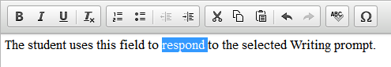

The cursor must be active in the response field in order to use response field tools. The tools can be accessed using a mouse or by using the [**Ctrl**] + [**M**] keyboard command to access the context menu. Using the keyboard command will display a tool menu on the screen that can be navigated using the up and down arrows. Table 10 describes all the Writing tools.

Table 10. Writing Tools

|  |  |
| --- | --- |
| Tool Button | Description of Function |
|  | **BOLD**, **ITALICIZE**, or **UNDERLINE** selected text |
|  | **REMOVE** formatting that was applied to the selected text |
|  | Start an **ORDERED** or **BULLETED** list or convert selected text to lists |
|  | **INDENT** a line of selected text |
|  | **OUTDENT** text that is indented |
|  | **CUT** selected text |
|  | **COPY** selected text |
|  | **PASTE** copied or cut text |
|  | **UNDO** reverses the last action in the response field (This feature applies to previous edits to text or formatting.) |
|  | **REDO** reverses the last undo action |
|  | Use **SPELL CHECK** to identify potentially misspelled words in the response field and provide suggestions. |
|  | Add **SPECIAL CHARACTERS**, such as math symbols or Spanish characters, in the response field |

**Tip:** In addition to the cut/paste options, text can also be moved manually using the mouse.

* To move text to another location of your response, click and hold the mouse button to select the text you want to move.
* Release the button, then click and drag the highlighted text to the desired location.

### Spell Check

The spell check tool identifies words in the response field that may be misspelled and provides suggestions for each.

|  |  |
| --- | --- |
|  | **Note:** *The spell check tool does not identify misspelled words in real time* (as they are typed on the screen). In order to check for misspelled words, the student must enable spell check mode. All words that are potentially misspelled will be indicated. The spell check menu will display the most likely alternatives based on the misspelled word. |

The spell check tool is accessed by clicking the ABC button [] from the toolbar or the context menu (accessed by pressing [**Ctrl**] + [**M**]).

When “Spell Check Mode” is enabled, the ability to write or access toolbar features is automatically disabled. Students can exit this mode by clicking the spell check button again. Unlike applications that automatically detect misspelled words as they are typed, the spell check tool highlights all words that are potentially misspelled. With the spell check mode enabled, a student can view the suggested spelling for a word by selecting the highlighted text.

A menu containing suggestions for the word is displayed on the student’s screen next to the response field. To replace the highlighted word with one of the suggestions, the student simply clicks on the desired word.

### Special Characters

|  |  |
| --- | --- |
| Students can select math and Spanish characters as well as other symbols by clicking the Omega button [] from the toolbar or the context menu.  Simply mouse over the available characters and click to select. | Figure 73. Special Characters Window (Updated) |

# Appendix H. Dictionary and Thesaurus Tool

The second segment of ELA Performance Task tests contains an embedded Merriam-Webster, Inc. Dictionary and Thesaurus tool shown in Figure 74that students can use. This tool allows students to look up a word in the dictionary or thesaurus without having to exit the test.

Figure 74. Dictionary and Thesaurus Tool

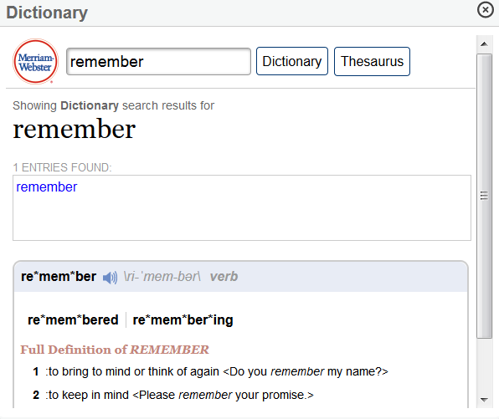

*To access the Dictionary/Thesaurus:*

|  |
| --- |
| 1. Click the [**Dictionary**] button in the Global Menu. The dictionary window will open in the lower left corner. 2. Enter a word or phrase into the text box and select either [**Dictionary**] or [**Thesaurus**]. The window will display available search results.   *Note: If multiple definitions or synonyms are displayed, you can click one to view information for that word or phrase.* |

# User Support

## Smarter Balanced Help Desk

|  |  |
| --- | --- |
| Smarter Balanced Operational Test Help Desk Contact Information | |
| Phone |  |
| Email |  |
| Hours of Operation |  |

# Change Log

|  |  |  |
| --- | --- | --- |
| Change | Section | Date |
|  |  |  |
|  |  |  |
|  |  |  |
|  |  |  |
|  |  |  |