# War

## - before the war

(what happened before the war) [wikipedia]

In 1920, a military depot was established on the small Westerplatte peninsula.

In 1924, the League of Nations gave the peninsula to Poland. The Gdańsk authorities gave the Poles a free and indefinite lease of Westerplatte.

In the same year, the League of Nations Council allowed the Poles to maintain a detachment of 88 soldiers on Westerplatte. The first guard detachment consisted of 22 people, including 2 officers. They were placed there on January 18, 1926.

Secretly later this number increased to 176 soldiers and 6 officers. From 1926, due to anti-Polish incidents, a small garrison of the Polish Army was stationed at Westerplatte.

On August 18, the battleship "Schleswig-Holstein" set sail from Kiel, leaving the territory of the Third Reich on August 23, entering Gdańsk on August 25 with a "courtesy visit", moored in the port channel 150 m from Westerplatte, but in fact the battleship was ordered to be there at the time of the outbreak war on August 26.

Due to the postponement of the attack on Poland from August 26 to September 1, the battleship was forced to stay there for another six days before the slogan "Fiske" was sent and the seizure of Gdańsk could begin.

On August 26, Comd. Gustav Kleikamp moved the Schleswig-Holstein up the canal between Gdańsk and Westerplatte. Major Henryk Sucharski put his garrison on high alert.

On the night of August 31 and September 1, Polish soldiers defending Westerplatte were on watch - of the crew were in their positions. The rest were asleep, ready for action within minutes of the alert. Meanwhile, about 400 meters from the Polish outpost, at the Wisłoujście fortress, the Kriegsmarine assault company disembarked from the deck of the "Schleswig-Holstein" under the cover of night. The battleship's powerful guns were aimed at Westerplatte. The commander of the ship, Comd. Kleikamp, knew the date of the attack - September 1, at 4:45. The disembarked soldiers took their starting positions to attack by the wall surrounding the depot from the south-east. German sappers planted explosives in several places to make breaches in the fence just before the attack began.

Around 4:00 "Schleswig-Holstein" lifted the lines and moved to the Five Whistle Turn, from where it had a better field of fire. At. At 4:43 the logbook reads: "The ship goes to attack Westerplatte."

## - the course of the Battle of Westerplatte

(how it started and what happened) [wikipedia, warhist.pl]

September 1 (Friday), at 4:45 in the morning, the German battleship "Schleswig-Holstein" opened fire from the bow 280 mm artillery turret, aimed at the Polish outpost. When the huge 330 kg missiles exploded, a railway gate and fragments of the wall flew into the air. A moment later, the Polish post was attacked by the SS company "Heimwehr Danzig" and an assault unit of the marines (3rd Maritime Company "Stoßtrupp"), previously embarked on a German vessel.

During the first attack on Westerplatte, the Germans concentrated their attack on the "Prom" facility, but when the Poles rolled a 75 mm gun to the position near the power plant and destroyed several German machine gun nests thanks to it, repelled the attack on the "Prom" facility and destroyed the Gdańsk facility. police by the wall, the Germans gave up and retreated after 90 minutes of fighting.

At. 4:50 Maj. Henryk Sucharski, commander of the Military Transit Depot in Westerplatte in the Free City of Gdańsk, reported to the Fleet Command: " *The battleship" Schleswig-Holstein "began at 4:45 hitting Westerplatte from all guns. The bombing continues.* "

After the fiasco of the first attack, the Germans prepared for the second. The fire of "Schleswig-Holstein" was, however, longer this time. It was directed towards the "Prom" outpost, which inflicted the greatest losses on the Germans during the first attack.

During the second attack, the depleted assault company Kriegsmarine was supported by a platoon from the SS formation "Heimwehr Danzig" hitting from the beach. While the Germans were approaching the "Prom", Lt. Leon Pajak ordered to open fire on the mortars located near the barracks. Their accurate fire dispersed and drove the attackers away.

At the same time, "Schleswig-Holstein" opened fire again, one of the fragments of his missiles badly injured Lieutenant Pajak, who gave command to Corporal Jan Gryczman. Other missiles from "Schleswig-Holstein" severely damaged the Polish seventy-five, knocking it over and smashing the sights. From that moment on, German machine guns could fire at Westerplatte from behind the port canal.

The German infantry started again. Choir. However, Gryczman did not manage to stop it and ordered his men to withdraw to guardhouse No. 1. The Germans also approached this redoubt, but withdrew under the accurate fire of Polish machine guns. Apart from the "one", guardhouses 2 and 5 were also shooting at them. At the same time, the crew of the "Fort" facility repelled attacks by SS men. Around 12:30 the second assault finally broke down.

After the defeats of the attacks carried out on September 1, the Germans, surprised by the stiff resistance of the Poles, abandoned the attacks on Westerplatte for the time being, which did not mean, however, that they left the defenders alone. Until the end of the day, they were plagued by the fire of "Schleswig-Holstein", artillery and mortar batteries, as well as cannons and machine guns, and German patrols tried to find weak points in Polish defense, which forced the crews of guardhouses and outposts to be constantly alert and prepared for further attacks .

German losses that day were 20 killed and 140 wounded soldiers. On the Polish side, there were four killed and 10 wounded, including three seriously.

Hitler and the local Gauleiter Forster wanted to conquer Westerplatte as quickly as possible, so as not to spoil the ceremony on the occasion of Gdańsk's incorporation into the Reich. For this reason, the German command intended to break the morale of Poles.

From September 2, the Germans limited themselves to conducting reconnaissance attacks aimed at examining the Polish defense. On the same day, at 6 p.m., bombers arrived. After arriving at Westerplatte, they began bombing. Guardhouse No. 5 was hit, and at least six defenders died there. The barracks were also heavily damaged, where bombs destroyed the kitchen and radio station, all mortars were destroyed and telephone communication was interrupted. The raid lasted a total of 40 minutes.

In the following days of the fighting for Westerplatte, the more and more exhausted Poles remained in their positions, repelling German attacks and enduring artillery fire. The morale of the crew was briefly improved by the news that Great Britain and France had declared war on the Third Reich. However, help, both from the countries of Western Europe and the Army "Pomorze", did not come, and the hope that it would come at all was weakened.

Meanwhile, the Germans were preparing for a general assault. On September 4, two torpedo boats began shelling Westerplatte. The Germans also brought in a pioneer company equipped with, inter alia, in flamethrowers as well as heavy 211 mm mortars.

On September 6, the Germans attempted to set fire to the forest growing on Westerplatte twice with cisterns, filled with oil, rolled onto the premises of the depot along the railway line. The first attempt was a failure and was stopped by the fire of a machine gun and 37 mm anti-tank gun, which destroyed the tank, and the second time the fire did not spread. On the same days (September 2–6), Westerplatte was repeatedly fired upon by heavy guns and bombed by German squadrons.

On the morning of September 7, the German artillery launched a powerful cannonade. On the same day, German troops arrived at the battlefield - a school sapper battalion and a police unit. After an hour of firing, the sappers started the attack, setting fire to the forest with flamethrowers, followed by the infantry. Mortar shells seriously damaged Guardhouse No. 2, but Polish machine guns stopped the attackers once again.

However, it was the last defense effort of the Westerplatte crew. Around 10:15 Maj. Henryk Sucharski, who had already demanded surrender in the previous days, gave the order to surrender, arguing it with losses (at least 20 soldiers were killed), hopeless situation, exhaustion of soldiers, terrible condition of the wounded and numerical superiority, and the fulfillment of the order to defend the facility during one day. Some of the defenders wanted to continue fighting, but the order was confirmed. The crew gathered at the barracks, and Maj. Sucharski with two soldiers went to the Germans. The commander of the German army, General Friedrich Eberhardt, in recognition of the bravery of Poles, allowed the major to change into his gala uniform and keep his saber.

The defense of Westerplatte also had, which is rarely mentioned in historiography, also the dimension of a soldier's drama. Major Sucharski, after repelling the first attacks and demonstrating the Polish rights to Gdańsk, wanted to end the unequal fight due to the lack of any hope for relief. Major Sucharski had a complete nervous breakdown when the Luftwaffe raided Westerplatte on September 2 in an effort to break the morale of Poles. The Germans almost achieved their goal then. This 40-minute raid seriously damaged the psyche of the defenders. Some soldiers then left their positions and fled, taking refuge in the barracks. The trembling Major Sucharski ordered the white flag to be raised as a sign of surrender. The crisis prevented his energetic deputy Capt. Franciszek Dąbrowski - supporter of continuing the defense until all possibilities of resistance are exhausted. He ordered the flag removed and Major Sucharski isolated until he recovered. Dąbrowski took command of the defense, although it was kept secret to avoid unnecessary ferment in the ranks. Probably several soldiers refused to return to their defensive positions and were shot for insubordination (the Germans found the graves of unidentified defenders after the surrender). The opponent, however, did not take advantage of the moment of the collapse and did not launch an attack right after the raid, which could end in the collapse of the Polish outpost.

## - battle effects

(how the battle ended and how it influenced the war as a whole)

Despite the fact that the soldiers were still an organized unit and successfully resisted the many times stronger opponent, their struggle had to be ended. Due to the exhaustion of ammunition and the terrible sanitary situation, Maj. Sucharski decides to surrender the facility.

Poles took advantage of the possibility of honorary surrender. They fought as far as they could, further resistance would be certain death. In recognition of the heroic attitude of Poles, General Eberhardt, who led the German attack, allowed Sucharski to keep his officer's saber.

German losses in the Battle of Westerplatte, according to the original Polish estimates, amount to approx. 300 killed and 700–1,000 wounded, however, according to more recent data, they amount to around 30–50 killed and at least 120 wounded, against approx. 15 dead and approx. 50 wounded on the side of Polish defenders. Krzysztof Komorowski lists 50 killed and 150 wounded on the German side.

The defenders of Westerplatte, who persevered in the execution facility until September 7, repelling 13 assaults, gained not only fame with their attitude and determination, but also the demonstrative respect of the opponent, which was something exceptional throughout the campaign. The Germans even called Westerplatte "little Verdun", which was supposed to illustrate the fury of their soldiers attacking the outpost.

The Polish troops in Westerplatte were supposed to defend themselves for 12 hours, and they lasted for as many as 7 days, building around themselves the myth of the tenacity and heroism of the Polish soldier. They have become a symbol of the Polish Army, which always fights to the end.

The myth of Poles in Westerplatte was quickly spread. The broadcasts of the Polish Radio, which kept you informed about events in the facility, were of great importance in this respect. The second element of building the legend was a poem written by Konstanty Ildefons Gałczyński during the September campaign. It is worth quoting his words, although in reality the defense of the Depot was slightly different. The myth about the soldiers from Westerplatte who "went to heaven in fours" has gone out into the world.

## about the defenders

Before 1939, the Westerplatte crew consisted of two officers, 20 non-commissioned officers and 66 soldiers (about 20 civilian employees were also employed, including those serving the power plant, railway and port facilities and warehouses).

In the spring and summer of 1939, the number of employees was increased. In September 1939, the depot was guarded by 182 soldiers, including 5 officers and a doctor (other sources say 205-210 soldiers, including over 70 non-commissioned officers). On the other hand, Bogusław Kubisz defined the Polish forces at Westerplatte on August 31, 1939 at 205-225 people, including six officers and 30 contract workers (mostly former military personnel who were mobilized and then took part in the defense).

The crew of the facility was armed with heavy weapons - 4 81 mm mortars, 2 37 mm anti-tank guns and a 75 mm infantry gun. The defenders were also equipped with 18 HMGs, 17 machine guns and 8 LMGs. The soldiers had around 160 rifles, around 40 pistols and around 1,000 grenades.

Food stocks could last a month. According to the plans, Westerplatte was supposed to defend itself for twelve hours, but in fact it defended itself for as long as 7 days.

# Important buildings

The facility consisted of 5 concrete, reinforced guardhouses and adapted for defense, reinforced, then the most modern barracks in Poland. In August, in the face of increasing German provocations and the threat of a war, timber and earth field fortifications were built in the area of Westerplatte as an external defense line. An anti-tank dam, rows of wire entanglements were also made, and some trees and bushes were cut to ensure better visibility and the field of fire. In order to hide the works from the eyes of German observers, they were carried out at night.

## - barracks

(what was it and what functions did it perform during the war) Old barracks [muzeum1939.pl]

The building of the so-called of the old barracks was originally a hotel built in 1890. It had two floors with a small basement.

The first project to convert hotel rooms into barracks was made in 1924.

New barracks were built to the west of the so-called old barracks in 1936. Over time, the old hotel was transformed into host facilities and a potential place to accommodate an oversized crew and seasonal civilian workers.

The old barracks survived the Battle of Westerplatte, but in the fall of 1939 it was meticulously demolished. According to the surviving reports, the materials from the demolition were to be used as a building material for the extension of the camp in Stutthof.

New barracks [gdansk.pl/turystyka]

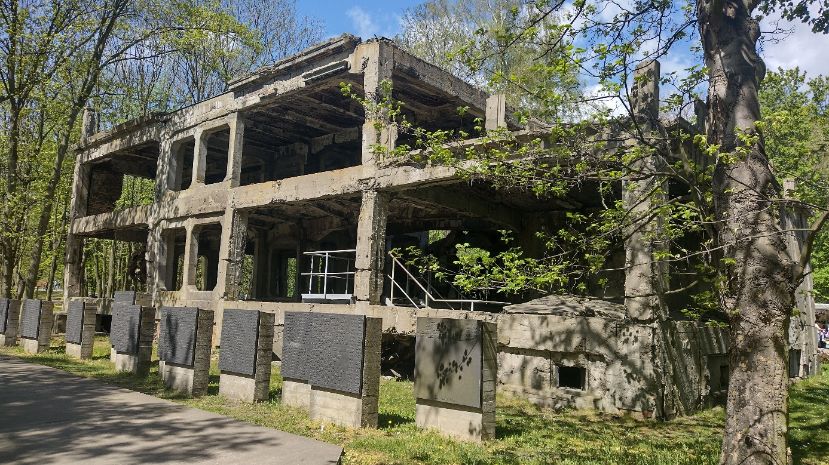

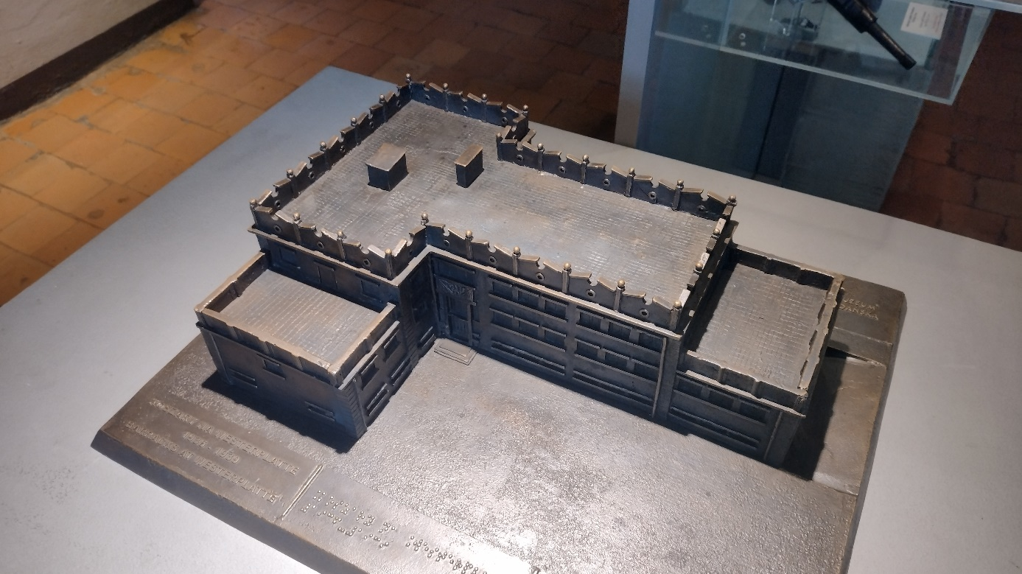

The building of the New Barracks. Miniature. Own photos

The building of the new barracks, built in 1934, in the shape of an asymmetrical T letter, had one floor and an area of 654 m2.

It performed many functions. In the basement there are rooms for a radio station, a combat cabin, a power plant and an ammunition store, a kitchen, a canteen, a food store and a garage. On the ground floor there is a telephone exchange, soldiers' quarters, washrooms and the headquarters of the company chief. On the first floor there was the office of the depot commander, the sick bay, rooms for officers and non-commissioned officers of active service.

The building was damaged during the bombing , but its defense capabilities were not impaired. Currently, the visible damage is the result of the deliberate blowing up of the facilities by Soviet sappers.

## - guardhouses

(what were they permanent and what functions they performed during the operation)

The frame was developed by the concept of Józef Silakowski. The core of the defense of constant defense (sometimes worth costly # 6).

Five guardhouses have reached the defense system of the Military Transit Depot. Arranged in a pentagon. Thanks to him, each expected direction of the attack, the enemy was covered with the fire of machine guns from the guardhouse, the second such direction, which was supported by fire due to quick technical support

Only guardhouse number 1 has survived to this day.

## - power plant

(what it was and what functions did it perform during the war) [muzeum1939.pl]

The power plant building with the transformer station and the pump system inside was planned to be erected as early as 1924. The necessity to start up one's own electro-generator station was dictated by problems in the event of interruptions in electricity supplies from Gdańsk, which were common at that time.

The Polish military unit, which was to be the user of the entire area, including warehouses, barracks and other facilities, could not afford to be dependent on electricity supplies. The facility housing combustion generators was to meet this task and secure work through electricity supplies, especially during the unloading and loading of war materials. The existing cable connection of the former health resort on Westerplatte with the power network of the city of Gdańsk would not provide enough energy. New cables had to be laid along the bottom of the Vistula port canal. As a result, the city network was used for everyday use, and the on-site power generators could be easily started in the reserve.

The building itself was erected at the end of 1926. However, the donated building required further work to equip it with specialized devices, without which it could not be used. The contract signed on December 21, 1926, closing this stage of works, also opened the possibility of placing combustion units in the facility. Their commissioning, not without obstacles, took place only in April 1928. Since then, the Military Goods Depot was able to use electricity independently from the inhabitants of Gdańsk.

This building was not used during the fighting, because, anticipating enemy fire, a separate generator was installed in the building of the new barracks.

The power plant is the only facility that has survived almost unchanged since 1939. After renovation and interior adaptation, it will be the site of the future temporary exhibition of the museum in Westerplatte.

## Obraz zawierający trawa, zewnętrzne, beton, cement Opis wygenerowany automatycznie- Ammunition magazines

The depot was established to secure Poland's supplies through the port of Gdańsk. In 1925, a new port basin was built, the so-called ammunition pool, to which the railway track was connected. There are six cranes and three warehouses on the quays.

The entire basin on the side of Nowy Port was covered with a high earth embankment, which has largely survived to this day. In order to store hazardous materials delivered by sea, 19 more ammunition stores were built, which were shielded with earth watts from the city side. During the years of use of the depot, two parallel railway sidings led to these warehouses; the path runs along the embankment of one of these sidings.

# Westerplatte areas

## - in the past

(how Westerplatte was created and what was there, how it was used, outside the war) [wikipedia]

Originally, it was an island at the mouth of the Martwa Wisła river into the Bay of Gdańsk. The peninsula was formed in the years 1845-1847.

From 1926 to 1939, the peninsula was an exclave of Poland within the territory of the Free City of Gdańsk. At that time, the Military Transit Storehouse operated there. It was her defense that became the symbolic beginning of World War II and the Polish resistance against the aggression of the Third Reich.

The name "Westerplatte" comes from the German language. "West" is western, and "platte" is a plate, in this case understood as an island. The name of this peninsula literally means "western island".

## - today and tomorrow

(what is currently there and doing and what is planned in the future)

Currently, there is a museum of Westerplatte and the War of 1939 on its premises, built in the years 1964-1966, a 25-meter Monument to the Defenders of the Coast. The monument, placed on a 20-meter mound, resembles a jagged bayonet stuck into the ground. During the reconstruction of the area, a significant part of the barracks ruins were demolished. In 1967, when widening the port canal, Guardhouse No. 1 was completely moved on rails.

From the end of the war, units of the Polish Army have been stationed in Westerplatte.

In 2019, a law was passed aimed at building a new Museum of Westerplatte and the War of 1939 by 2026, which at the cost of PLN 200 million is to be implemented on an area of 27.5 thousand square meters. The project provides for the reconstruction of seven buildings of the military transit depot and the creation of a permanent exhibition with an area of 3.5 thousand square meters.

In 2020, a competition was announced for the concept of the Military Cemetery of the Polish Army Soldiers in Westerplatte.

**Sections**

* Before the war
* The course of the attack
  + The beginning of the Second World War
  + Prolonged Defense
    - Coating
    - Guardhouses
    - Barracks
    - Worth it
  + Last attack and surrender
* Consequences of the attack
* Current state and future plans