**CARDLESS CASH WITHDRAWAL**

A Project Report submitted in partial fulfillment of the

Requirements for the award of the degree of

**BACHELOR OF TECHNOLOGY**

**in**

**COMPUTER SCIENCE AND ENGINEERING**

**With IBM specialization in MAINFRAME TECHNOLOGY**

**by**

|  |  |
| --- | --- |
| **Name** | **Roll No.** |
| **Ankita Rani** | **R610218008** |
| **Aman Kumar** | **R610218005** |
| **Subham Kumar** | **R610218030** |

***Under the guidance of***

**Mr. Sumit Kumar**Assistant Professor

Department of Systemics



**Department of Systemics**

**School of Computer Science**

**University of Petroleum & Energy Studies**

**TABLE OF CONTENTS**

|  |  |  |  |
| --- | --- | --- | --- |
| DECLARATION | | | 4 |
| CERTIFICATE | |  | 5 |
| ACKNOWLEDGEMENT | | | 6 |
| ABSTRACT | |  | 7 |
| 1 | INTRODUCTION | | 8 |
| 2 | LITERATURE REVIEW | | 10 |
| 3 | METHODOLOGY | | 14 |
| 4 | CONCLUSION | | 18 |
| REFERENCES | |  | 19 |

**FIGURE INDEX**

|  |  |  |  |
| --- | --- | --- | --- |
| FIG 1.1 | | | 10 |
| FIG 2.1 | |  | 12 |
| FIG 3.1 | | | 14 |
| FIG 3.2 | |  | 15 |
| FIG | 3.3 | | 16 |
| FIG | 3.4 | | 16 |
| FIG | 3.5 | | 17 |
| FIG | 3.6 | | 17 |
| FIG 3.7 | |  | 18 |

**DECLARATION**

I hereby declare that this submission is my own and that, to the best of my knowledge and belief, it contains no material previously published or written by another person nor material which has been accepted for the award of any other Degree or Diploma of the University or other Institute of Higher learning, except where due acknowledgement has been made in the text.

Ankita Rani (Enroll No. R601218008)

Aman Kumar (Enroll No. R610218005)

Subham Kumar (Enroll No. R610218030)

**CERTIFICATE**

This is to certify that the project titled **CARDLESS CASH WITHDRAWAL** submitted by Aman Kumar (Enroll. No. R610218005), Ankita Rani (Enroll. No. R610218008), Subham Kumar (Enroll. No. R610218030) to the University of Petroleum & Energy Studies, for the award of the degree of BACHELOR OF TECHNOLOGY in COMPUTER SCIENCE AND ENGINEERING is a bonafide record of project work carried out by them under my supervision and guidance. The content of the project, in full or parts have not been submitted to any other Institute or University for the award of any other degree or diploma.

Date: 08-12-2020

Mr. Sumit Kumar Dr. Neelu Jyoti Ahuja

**Name of Guide** **HOD (Dept. of Systemics)**

**ACKNOWLEDGEMENT**

We wish to express our deep gratitude to our guide **Mr. Sumit Kumar**, for all advice, encouragement and constant support he has given us throughout our project work. This work would not have been possible without his support and valuable suggestions.

We sincerely thank our Head of the Department, **Dr. Neelu Jyoti Ahuja, Professor and HOD, Dept. of Systemics** for her great support in doing our project in **Area** at **SoCS**.

We are also grateful to **Dr. Manish Prateek, Professor and Dean, SoCS**. UPES for giving us the necessary facilities to carry out our project work successfully.

We would like to thank all our **friends** for their help and constructive criticism during our project work. Finally, we have no words to express our sincere gratitude to our **parents** who have shown us this world and for every support they have given us.

**ABSTRACT**

People use ATM cards to withdraw the money through ATM which is provided by the Bank for their customers. Automated Teller Machine (ATM) transactions are found safe, reliable and inevitable these days for fulfilling our financial commitments. Traditional approach for using ATM mandates involvement of Debit card. There are some problems with physical cards. It can be stolen, skimmed, cloned, damaged or expired. One more drawback about physical cards is that we have to carry it when we have to withdraw the cash from ATM. Due to these problems we have to find an alternative way to withdraw cash. Hence, we propose a different way to withdraw money where there is no involvement of physical cards. We will use one time password for the authentication of the user. First user will enter user-id and password into the ATM machine then an OTP will be sent to the mail of the user which is registered in the bank. User have to enter that OTP then user can login to account and do cash withdrawal, balance enquiry, fund transfer etc. Due to security reasons we will also encrypt the user credentials like user id and password. We have used Caesar cipher algorithm to encrypt and decrypt the data. Using file handling we will store the OTP that is generated and retrieve the OTP for the transaction.

1. **INTRODUCTION**
   1. **Problem Domain**

Nowadays everyone uses debit card to do transaction in ATM. There are some issues they face while carrying it to the ATM like it can be stolen, skimmed , cloned , damaged. In early days when there was no ATM machine people used to go bank to withdraw cash. Today, there are almost 2 million ATM's around the globe. Although use of the machines has declined in recent years, likely because more people make purchases using credit and debit cards instead of cash. But still everything is not digital so people use debit cards to withdraw cash. People pay service tax to the American company Visa, Master card etc.

Our project “Card-less Cash Withdrawal” basically eliminates debit card in order to make a transaction through ATM. With the help of C programming language we will create an interface of the ATM where user have to login into his/her account using user-id ,password and an OTP which will be sent to the mail of the user. Once user login system will show all the menu like Balance enquiry, withdraw cash, money transfer. After successful transaction balance of the account will be updated. To increase the security we will also encrypt the user data with Caesar cipher algorithm.

* 1. **Problem Statement**

The existing ATM system authenticates transactions via the card and PIN-based system. But physical cards have some problems. It can be stolen, skimmed, cloned, hijacked, damaged or expired. Due to this problem, we need to think an alternate way to provide better Security. Users also want an assurance that they can perform a transaction in case of emergency whenever they want and wherever they are even if they do not have their ATM cards with them.

* 1. **Requirement Analysis**

1. Software Requirements:

❖ Windows 7 / 8 / 10 64-bit or Mac OSX Sierra or Linux

❖ Language: C

2. Hardware Requirements:

❖ Processor: Intel core i3 3220

❖ Processor Primary Clock Speed: 2.4 GHz

❖ 2 GB or above

**1.4 Overview**

To successfully execute the card less cash withdrawal the combination of following techniques have been used:

* **C language** - We have used C programming language as a platform to execute our code. It is a procedural and platform dependent language. With the help of C programming language we have added different libraries which is important for executing our code
* **ATM (Automatic Teller Machine)** - An automated teller machine (ATM) is an electronic banking outlet that allows customers to complete basic transactions without the aid of a branch representative or teller. Terminal generated after execution of the code will be the interface of the ATM machine where user can user ATM features like money withdrawal, money transfer etc.
* **Socket Programming**- Socket programming is a way of connecting two nodes on a network to communicate with each other. Sockets are low level endpoint used for processing information across a network. Common networking protocols HTTP, SMTP, FTP rely on sockets underneath to make connections. It can be used to both send and receive information. With the help of socket programming we can create client socket and sever socket which will be helpful to send mail using SMTP.
* **File Handling**- File handling in C enables us to create, update, read, and delete the files stored on the local file system through our C program. Here we are dealing with lot of data of the users. Without file handling it is not possible to store the data securely. In real time user data will be updated and stored in the database.
* **Authentication**- It is used to create a separate user ID and Password so that only the authorized users will able to access the data. In authentication process first ATM checks the user credentials is valid or not then gives the access to the account of the user.
* **Encryption & Decryption** - Encryption is the process of converting the data into meaning less message and decryption is the process of converting the message back to the normal original form. It is an important thing because it provides security to the user. With the help of Caesar cipher algorithm we will convert the Id-pass of the user into cipher text which will be not readable by anyone.
* **Password masking** is that familiar practice of hiding the password characters as entered by the user – behind bullets (●), asterisks (*), or similar camouflaging characters. The idea behind masking is to prevent nearby observers reading the password "over the user's shoulder" and thus stolen.
  1. **Objective**
* Our system enables an account holder to withdraw money instantly from their account **without using any physical card** or filling up any physical withdrawal slip.
* **Caesar Cipher** algorithm have been used for encryption and decryption for secure and safe ATM Transaction.
* **Password Masking** have been implemented to avoid any kind of security issues. The idea behind masking is to prevent nearby observers reading the password "over the user's shoulder“.
* **File Handling** using CSV file has been used to handle the large database of our customers efficiently .

**1.6 Pert Chart**

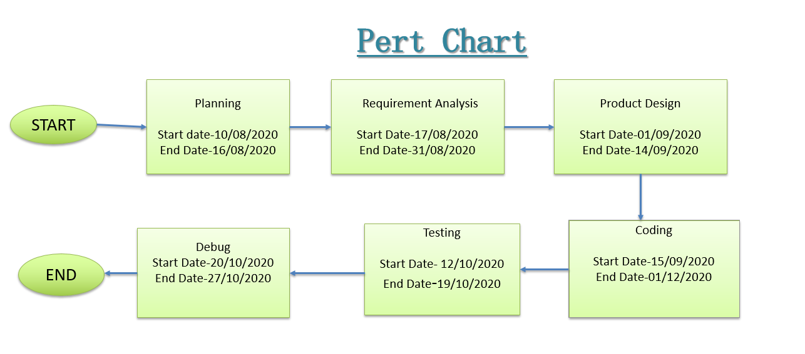

Figure 1.1

**2. Literature Review**

This project intends to solve some of the problems found while using Debit Card for cash withdrawal. Two of the most prevalent issues are:

1. Management

It is difficult to manage debit card and prevent it from being stolen, skimmed, cloned, and damaged.

1. Carrying Every time

It is difficult to carry debit card every time. It also increases the risk of debit card being stolen or lost.

**2.1 Automated teller machine**

Automated teller machine (ATM) is generally used to withdraw cash. An automated teller machine (ATM) or cash-point is an electronic telecommunications device that enables customers of [financial institutions](https://en.wikipedia.org/wiki/Financial_institution) to perform [financial transactions](https://en.wikipedia.org/wiki/Financial_transaction), such as cash withdrawals, deposits, funds transfers, or account information inquiries, at any time and without the need for direct interaction with bank staff. The automated teller machine consists of mainly two input devices and three output devices. Input devices are card reader and keypad. While output devices will be speaker, Display screen, Receipt printer. Card reader is used to fetch the information of debit card. Keypad is used to get the input through user in ATM machine. Receipt printer prints the transaction details and display screen provides an interface to the user.

**2.1.1 ATM Working Process**

Login: User inserts the card into the ATM machine. Card reader verifies whether card inserted is valid or not. Accordingly ATM interface displays the message. If the card is valid then ATM asks to select language. In user authentication ATM machine asks for 4-Digit Pin of the Debit Card. Machine verifies the pin and accordingly displays the menu. As soon as Menu is displayed that means user has successfully login into his/her account.

Money Withdrawal: User selects the Money withdrawal option after that ATM asks to enter the amount. User enters the amount then ATM verifies whether the entered amount is less or more than the balance. If the entered amount is more than more than balance error message is shown and if it is less transaction gets started. After successful transaction balance of the account gets updated.

Money Transfer: Bank also provides option of money transfer from one account to another. When money transfer option is selected bank asks for account no of the receiver.

Balance Enquiry: Using this option user can check the balance of the account. ATM also asks for printing receipt of the transaction detail.

Receipt Printing: After successful transaction receipt printer is called to print all the details of the transaction like withdraw amount, updated balance and time of transaction.

**2.2 Socket Programming**

Sockets are low level endpoint used for processing information across a network. Common networking protocols HTTP, SMTP, FTP rely on sockets underneath to make connections. It can be used to both send and receive information. With the help of socket programming we can create client socket and sever socket which will be helpful to send mail using SMTP. Bind function will return a unique address of the client which is combination of IP address and Port number. Listen function is used when one end point server waits for another end point client to connect. Connect function can be used to connect to a server. Generally user calls the connect function to connect to the server. After that server accepts the connection request from client and connection is established. Send/Recv can be used to exchange the data between the server and client

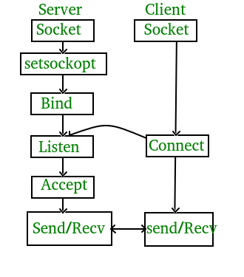

Figure 2.1

**2.3 File Handling**

Here, we are dealing with a huge amount of data so we can’t store the data in program itself so here is the demand for the file handling. Through file handling we store data in non-volatile file system.

Here, we have used a number of C library functions like:

* fopen()
* fprintf()
* fscanf()
* fgets()
* fclose()

Also we have used two different modes for file manipulation:

r (Read only mode)

a+(Read and Write mode)

2.3.1 Data handling Functions

* fgets(): It is used to read string values with spaces in C Language. The basic syntax is as follows:

char *fgets(char *str, int n, FILE *fp);

* fopen(): It is used open a file in different type of modes like read, read/write,append.

FILE *fopen( const char * filename, const char * mode );

* fclose(): It is used to close the open file.

int fclose(FILE *stream)

* fprintf(): It is used to print the data to the file.

int fprintf(FILE *stream, const char *format [, argument, ...])

* strtok(): It is a function defined in <string.h> for splitting a string by some delimiter. The basic syntax is as follows:

char*strtok(char str(), const char* delims);

where, str is the string which is meant to be splitted.

delims are the specified delimiters for splitting the string.

his function needs to be called in loop for splitting the whole string until a NULL value is returned.

* login(): This function has been implemented in order to search user information in the file. This function uses the basic C concepts and the file handling functions. We have used linear search in this case with a function stringcasecmp().
* strcasecmp(): It is a function defined in string.h which is used to compare two strings irrespective of the case.

The basic syntax is as follows:

intstrcasecmp(const char* s1, const char*f2):

The function returns 0 if both the strings are equal, otherwise it returns some integer.

**2.4 Encryption and Decryption**

Encryption is the process of converting the data into meaning less message and decryption is the process of converting the message back to the normal original form. Here we are using encryption/decryption to improve the security of the user’s data. When users enters user-id and password the entered text is converted into cipher text which is not readable by others. Data will be decrypted back to plain text at receiver’s end. Caesar cipher algorithm is used for encryption and decryption of the data.

**2.5 C Programming**

With the help of C programming language we have designed our code. We have used different functions to perform certain task. Using c program a menu driven interface is created. It is easier and clearer for user through menu driven interface. Switch case is used to provide a menu driven interface.

**User defined Functions**:

* Register() : This function is used to register the new customers of the bank. A new registration process will be started.
* Login() : This function is used when a existing user login into the his account. It will ask for user-id and password.
* Authenticate() : This function will verify the user details from the database.
* Transaction() : This function provides cash withdrawal and balance enquiry facilities
* Menu() :Provides a menu for user

**Predefined Functions:**

* Srand() : This function is used to generate a random number in for OTP
* System(“cls”) : To clear the screen
* Getch() : To get the input as character

**3. Methodology**

**3.1 Flow Chart**

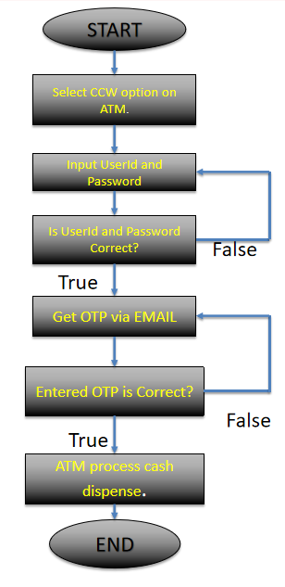

Figure 3.1

**3.2 User Authentication**

When user enters the detail it will be verified from the database of the bank whether the entered details are correct or not. We use file handling to store the data of users. Strcmpcase() will be used to verify it. If the entered details are correct then user can continue the transaction otherwise user have to re-enter the details correctly.

**3.3 Caesar cipher Algorithm for Encryption and Decryption**

Caesar cipher algorithm is used in this project to encrypt the password of the user for secure file handling and decryption can be done whenever required. The Caesar Cipher technique is one of the earliest and simplest method of encryption technique. It’s simply a type of substitution cipher. For example with a shift of 1, A would be replaced by B, B would become C, and so on.

**3.4 Encryption & Decryption Process**

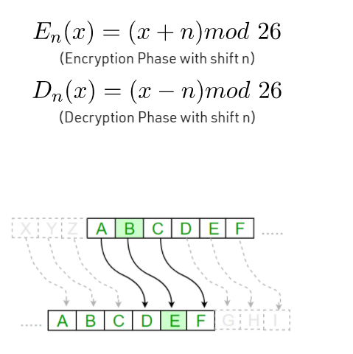

Figure 3.2

**3.5 Algorithm for Caesar Cipher:**

Input:

1. A String of lower case letters, called Text.

2. An Integer between 0-25 denoting the required shift.

**3.6 Procedure:**

Traverse the given text one character at a time.

For each character, transform the given character as per the rule, depending on whether we’re encrypting or decrypting the text.

Return the new string generated**.**

**3.8 Output**

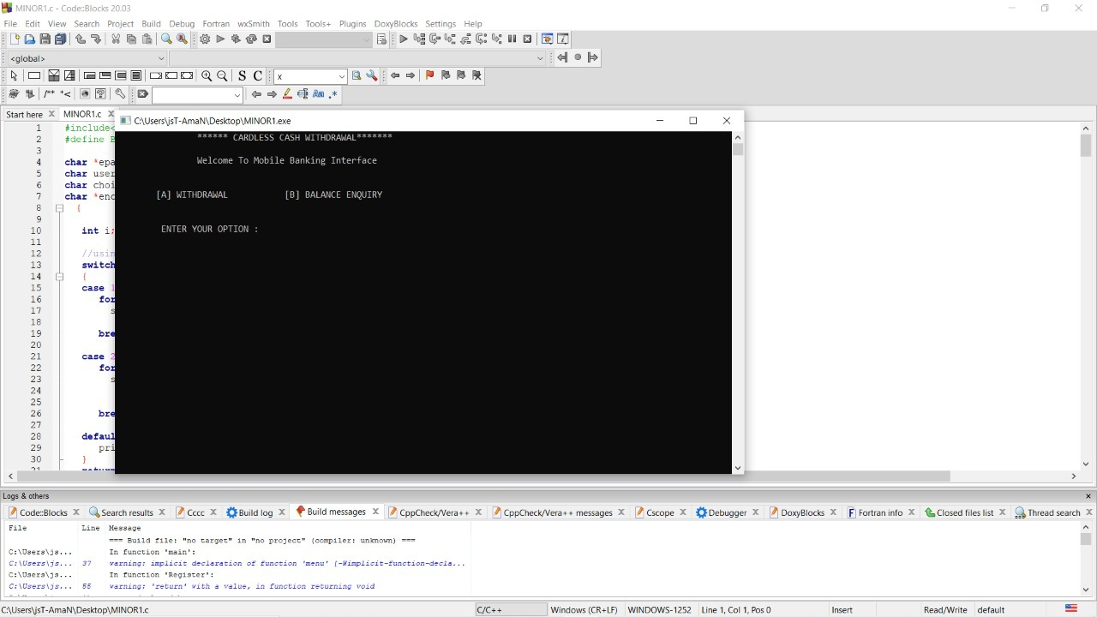

Figure 3.3

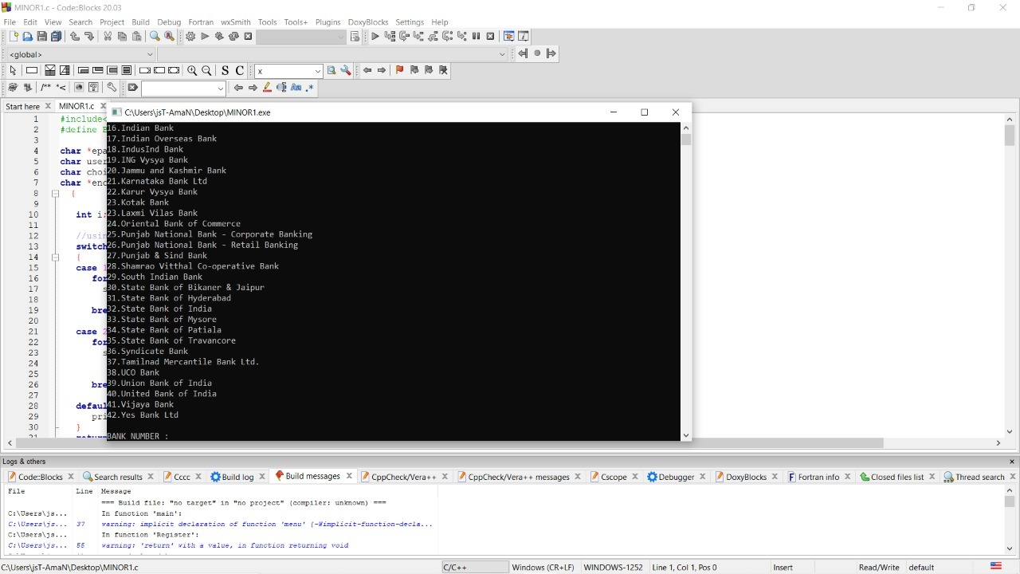

Figure 3.4

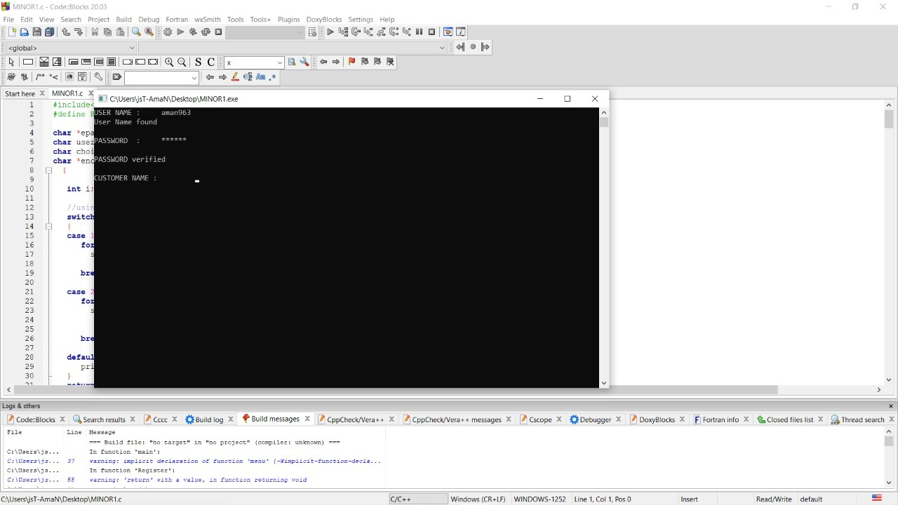

Figure 3.5

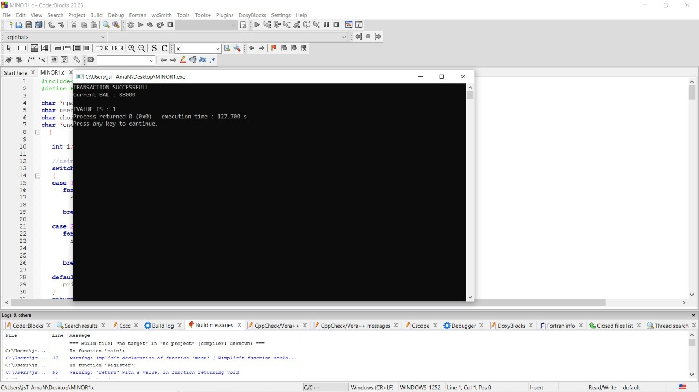

Figure 3.6

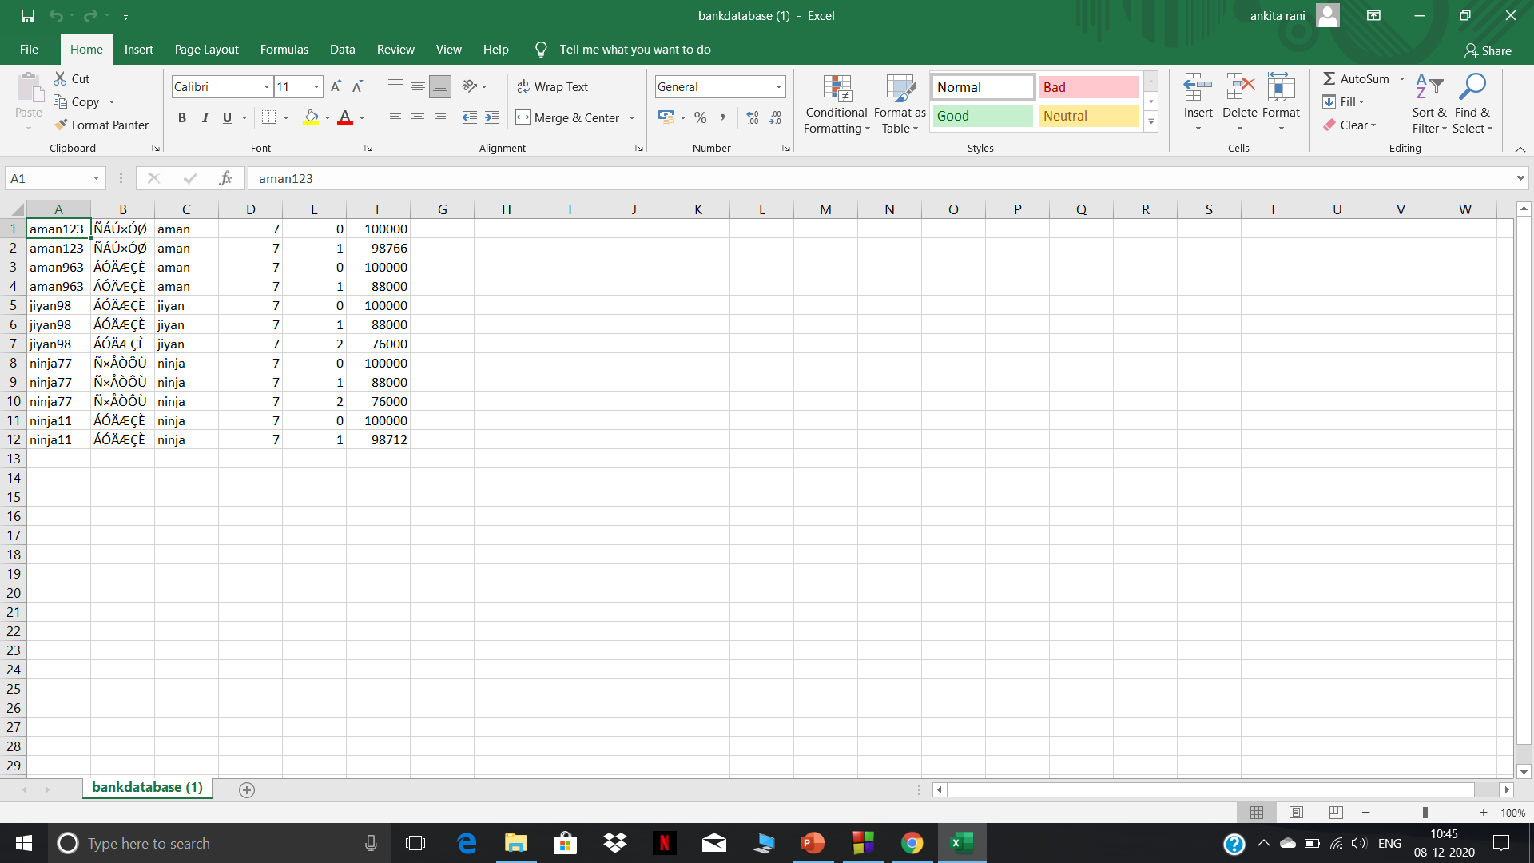

Figure 3.7

**4. CONCLUSION**

Till now we have studied about the C programming language and designed a methodology which proposes a style of cash withdrawal without the involvement of debit card. In the proposed model OTP (One Time Password) will be sent to user on their phone via mail which will be entered by the user on the ATM interface to complete a transaction without the hassle of carrying physical cards. In future we will implement this methodology using the C Programming Language. Our method is simple and effective and would definitely be preferred by all kinds of users. In general, it will positively impact the banking industry and the society by reducing the rising levels of crimes that are associated with ATM transactions. In this system, we propose the Secure-PIN- Authentication, OTP-based authentication so that the Transaction process becomes easier, reliable, secure, and eliminating the need of carrying any kind of swipe cards.

References

* Kamruddin Nur,M. Firoz Mridha Ph.D,(2019),ResearchGate. Retrieved from <https://www.researchgate.net/publication/331563962_OTP_Based_Cardless_Transction_using_ATM>
* Caesar Cipher in Cryptography – GeeksforGeeks, Retrieved from:   
  <https://www.geeksforgeeks.org/caesar-cipher-in-cryptography/>
* Shyamsundar Bhairam, M.Tech. Research Scholar(2018), Ijmemr.org,Retrieved from: <http://ijmemr.org/Publication/V6I3/IJMEMR-V6I3-003.pdf>
* Vijayaraj A, Jebamoses T, A Survey on Cardless Cash Access Using Biometric ATM Security System,Retrieved from: <http://saspublisher.com/wp-content/uploads/2015/05/SJET33A232-234.pdf>
* Relational Database from CSV Files in C : https://www.geeksforgeeks.org/relational-database-from-csv-files-in-c/